How does the artwork of Guangyi Wang comment on the Contemporary Condition?

Introduction

The feature of the contemporary world, evolving under the conditions of the fast globalization process, the rapid introduction of high technologies, and the change of ideologies, may be described as a multidimensional net of political, economic, cultural, and social relations. In post-Mao China, changes have been unprecedented and they involve social as well as political changes, and economic reform which shifted China from a command economy to a market economy creating conflicts between traditional and modern economies (Goldman, 2009. Among the pioneers of this art period, Wang Guangyi occupies a distinct place due to his meaningful approach to the change of image of China.

Wang Guangyi started to paint at the beginning of the 1980s, a time when the.cn was characterized by ideological confusion and the policy of opening and reform launched by Deng Xiaoping. The Great Criticism series—a blend of Cultural Revolution figures with American/Western themes and motifs—largely deals with the ideological ambivalence within today’s China. His works are not just ‘representations’ of China’s transitional socio-political reality but present the subject as a satirical comment on the commercialization of ideology in a postmodern world (lauren winter dawson, 2021).

His work includes factors that are outside and within the country such as globalization, competition, trade tensions and internal conflict of having communism roots while embracing capitalism. By carefully including elements of Maoist ideology in a row with logos of modern brands, Guangyi poses a question to the audience: is China ready for a new, post-communist future? His method of reiterating the widely recognized images contributes to constructing the notion of the globalization of the culture, which is based on the production of mass commodities. Further, the use of symbols in the work of art depicts an irony of history since the call for revolution coupled with power struggles of the past is juxtaposed with a drive for materialism in the present. Thus his art serves both visual and analytical purposes, delivering social and cultural critique of Chinese society and economy. In this way, Guangyi becomes recognized as one of the most significant voices in the growing discursive field of how art mediates the construction of modern Chinese identity.

This paper will focus on two pieces from Guangyi’s Great Criticism series to show how Wang Guangyi’s art addresses the conditions of the present. Those include juxtaposition, repetition, and symbolic imagery, with which Guangyi builds a semiotic code that speaks about the contradictions of China’s post-reform society. The current discussion will provide evidence for the hypothesis by explaining how his works reflect the cultural concerns of a society struggling to come to terms with its revolutionary heritage in the face of a modernising and globalising world.

Theoretical Background
Wang Guangyi is arguably one of the leading lights of the Chinese contemporary art scene as he takes head on the struggle between ideology and materialism. His work, especially the Great Criticism series, depicts highly the social, political and economic changes that China witnessed in the late twentieth century. Wang was born in 1957 in Harbin, China and was raised in the era of the Cultural Revolution that was between 1966 and 1976 when the government promoted its ideologies and banned any form of artistic freedom. Exploring the historical context of the Six Dynasties period, the author studied socio-political commentary as the major aspect of Wang’s creation. The purpose of this section is to examine (Wang, 2024). Wang’s works to understand them concerning Baudrillard’s theory of media and postmodernism and the notion of semiotics in contemporary China.

Wang Guangyi’s Background and Early Career
Artistic production in China was severely circumscribed during the Cultural Revolution as art became an organ of political propaganda of the state. Calm and positive worker and farmer images, soldier, and farmer images are some of the most common images seen as a symbolic representation of labour and progress in the nation. However, freedom of thought was suppressed and traditional approaches to producing art were condemned. This climate of repression not only formed his early experiences but also became the point of critical reflection in some of his later works. The works that Wang created in her early period include the Post-Classical series; 1986–1988 which is painted in a frieze format, contains the element of modernist art, minimalism, three-dimension and surrealism, and touches religion, belief and philosophy themes (Guangyi, n.d.)
.
The early eighties were the time of ideological and cultural awakening in China. Influenced by Deng’s economic reforms, Chinese artists sought new artistic ideals and styles based on aesthetic and humanistic values that originated from the West. The influences of pop art were notably seen to have affected Wang’s art in a big way. The Pop Art movement started in Britain in the 1950s, it used aspects of popular culture as its subject matter and integrated it with modern art techniques. Whereas most related pop artists of the Western world concentrated on the message of consumerism and culture (Lincot, 2004), Wang Guangyi introduced the same to reflect the socio-political reality of China after the reform and opening-up. His works put together elements of socialist realism and pop art businesslike images that he coined as political pop.

Wang was to receive national fame in 1989 when his three paintings of Mao Zedong were exhibited at the Modern Chinese Art Exhibition. This was a shift to what might be labelled political pop art in China, a movement that offered a commentary on the country’s fast-paced modernisation, and changes in its geopolitical and ideological beliefs. Wang’s Great Criticism series, launched in the early 1990s, epitomizes this approach by juxtaposing Cultural Revolution imagery with logos of multinational corporations such as Coca-Cola and Marlboro (He, 2022). These works, characterized by bold red, yellow, and black colours, evoke a strong visual impact and satirical tone, highlighting the commodification of ideology and the mass production of political symbols.

Theoretical Framework

Jean Baudrillard’s Theory of Media and Postmodernism
Jean Baudrillard is one of the leading postmodern theorists whose work provides useful information on how media and symbols influence society. Speaking about the latter, the author pays much attention to the notion of the ‘simulacrum’ as the representation of something that substitutes reality. In a postmodern world governed by media and consumerism symbols are said to have lost their original signification and are turned into mere commodities through the sociology of Baudrillard (Dino, 2019). This idea is very similar to Wang’s Great Criticism series in which socialist revolutionary images are removed from their political meaning and become simply beautiful objects. Placing these symbols next to corporate logos, Wang examines the erosion of ideology in today’s world dominated by consumerist values.

Semiotics and Postmodern Art

The other theoretical perspective under which Wang Guangyi’s art can be viewed is semiotics, the study of signs and symbols. According to Roland Barthes, every cultural product is semiotic and filled with many layers of meaning This paper aims to look into how Wang utilizes symbolism as a form of passing important messages. In the Great Criticism series, Wang does take pictures from both the realm of socialist realism and global advertising and juxtaposes them. These signs opposed to each other produce new connotations and it makes the viewer think of the meaning of ideology in today’s post-industrial society.
For instance, in one of Wang’s art pieces depicting several workers bearing a Maoist propaganda poster, the image superimposes a trademark of a global firm. This configuration begs for a semiotic decoding because symbols of revolutionary change are incorporated into the world of utility and commerce transforming them into products that have lost their function. In this sense, the use of such features as repetition characteristic of pop art further accentuates the essentially mass production and consumption of both political and commercial imagery which the artist outlines in his work (O’Keeffe, 2019).

Discussing Wang Guangyi’s art, both the framework of postmodernism described by Baudrillard and semiotic analysis can be of use. While Baudrillard paints a general picture of the subject area of postmodernism and critiques of the commodification of ideology and media domination, semiotics opens up the possibility of a more precise analysis of how Wang weaves meaning out of images

Methodology
The investigation of the works of Wang Guangyi conducted in the framework of this study uses a qualitative research approach and includes a secondary research method as well as case study research. Three primary methods are used:

1. Qualitative Study: This method consists of the analysis of esthetic features, subject matter and socio-political factors of Wang Guangyi’s artworks. In this case, the research seeks to decode the meaning behind specific messages which has been depicted by the artist through a critical analysis of the symbols and arrangement of the artwork selected for analysis.

2. Secondary Research: Journals, catalogues, and Wang Guangyi’s interviews are used to give the main context of the artist’s career and his theoretical background. From these sources, the reader can gain the cultural and historical background of his works and also criticism from art scholars.

3. Case Study: Two pieces, both from the Great Criticism series, are discussed in this paper. The case study method enables a detailed analysis of how contemporary conditions are represented in Wang Guangyi’s art by applying the theories of Baudrillard and semiotics. This approach helps in understanding the relation between ideology and consumerism in his works, in a much broader manner.

By such approaches, this study aims at showing how Wang Guangyi was using his art to express the current culture, ideology, and economic transformation in China. Specifically, the analysis of his works is placed into theoretical contexts to discuss his contribution to the debates on Chinese contemporary art as well as its function in addressing global and local social and political concerns.

Analysis #1 of Wang Guangyi’s Artwork and Social Commentary

In general, Wang Guangyi’s work stands as an example of an artistic comment on the socio-political situation within the frame of Chinese globalization, consumerist and ideological changes (Miao and Kluensuwan, 2022). His works, especially those from the Great Criticism series and other pieces, have been exhibited for addressing the socialist realism style with the addition of several elements from Western popular art which creates intellectual images of the conflict in the modern world. In this section, focus will be made on the aspects of technique and medium, themes, and Wang Guangyi’s perspective on the social situation in light of the selected theories by Jean Baudrillard.

This is one of the ways that the art of Wang Guangyi is characterized, based on the choice of bright tones. However, in the artwork provided as Virus Carrier, the immense background color is red which has immediate connotations of danger, revolution and urgency owing perhaps to its use in the Chinese Cultural Revolution. Red was used on the propaganda posters for nationalism and the socialist spirit, but Guangyi gives the colour a new meaning and much deeper, sarcastic overtones.

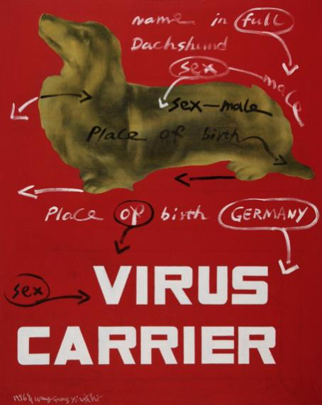
The central figure in the artwork, a dachshund labelled with annotations such as “sex: The text “occupation: male” and “place of birth: Germany,” is written in a boring hue of brown and green, which seems to be dead on the bright background. Such contrast underlines the outrageous and inhuman approach involved in the limitation of identity to tags and numbers. The big and capital letters of the phrase ‘VIRUS CARRIER’ located at the bottom of the composition play a dual role as its literal translation and as the metaphor of how ideological or cultural elements are seen as ‘pollutants’ inside the society.

As stipulated by Baudrillard’s theory of hyperreality, the given society is postmodern and grounded on the duality of the real and simulation. In Virus Carrier, this pet dachshund with a labelled tag is a pure symbol without a real and concrete referent but acts within the ideological field (Baudrillard, 1981).

Painting Theme: Consumerism, Ideology, and the Absurd
Wang Guangyi is one of the artists to whom the problem of consumerism and ideological control is most relevant. The stickers on the dachshund may be more taken as a satirical response to current trends of brand identity and nationalism. Guangyi examines widespread anxiety and xenophobia that accompanies cultural and ideological circulation in the age of globalization by using a seemingly insignificant subject matter – a dog – and representing it as a ‘virus carrier’. Even this choice of a German dachshund is symbolic, as it raises the concept of Western penetration and the traditional Chinese view of all things foreign as inimical to the country’s best interests.

There can be more talk here of Baudrillard’s notion of the ‘reification of signs’. In the artwork, the dog is replaced by an objectified representation of what is foreign, which is obscured by clinical identifiers. This is a commentary on how the present society tends to analyze cultural differences in terms of simplified consumer-oriented brands. The idea of a ‘carrier of the virus,’ is therefore taken as an extension of the conflict between the forces of globalization and nationalism, focusing on the notion of contamination by unwanted systems of thought in a new globalized world.
Further, the fact that the dog, which is an animal, can be given characteristics similar to human beings like ‘sex,’ and ‘place of birth’ is a satirical commentary on how identity is constructed abstractly. This brings into perspective what Baudrillard refers to as hyper-real where it is seen that people do not have real personalities but fake ones that are produced and managed by signs. The latter is evident like Guangyi’s work: in a globalized world, the peoples’ identities are hybrid, multiple, and marketable.

It can be said that all Wang Guangyi’s work are based on the socio-political changes that took place in post-reform China. The period after the 1980s Deng Xiaoping reforms is characterized by a rapid transformation from a planned to a market economy, along with the penetration of Western cultural and/or ideological values. This period of transformation also left people ideologically puzzled switching the socialist values with the values of consumption.

In Virus Carrier, Guangyi addresses this tension in a post-socialist China by incorporating signs of the ‘West’ such as consumerism with that of socialist history. The clinical annotations on the photographs and the propagandistically extolling text provoke a layout that is as much a part of the scientific catalogue as it is of political agitation, and such an aesthetics reflects the ambivalent social-political reality of modern China.

Critical Evaluation: Strengths and Limitations
Looking at the work of Wang Guangyi one can see the criticism of consumerism and ideological control but there are some drawbacks. Another asset of his method is the easy and natural incorporation of irony and satire into the work, which can help him explain difficult social and political phenomena. Combining elements of socialist realism and pop art the author has created a set of works that is both visually appealing and thought-provoking, referencing the paradoxes of modern culture.

But some people criticized that, in Guangyi’s work, those elements of humor are used in a rather superficial way and the work may just rely on these elements, which, do not have much content to criticize. Hedoin also points out that the cyclic pattern of his Great Criticism series is a sign of repetitiveness that makes social issues into a formulaic style. Furthermore, although his work has appealed to the audience by satirizing consumerism and ideological control, the work may not have presented the audience with the right antidote or choice.

On the other hand, it may cause the viewers to bounce out of the pictures not quite sure whether the artist is for something or against it, or what the purpose of the artwork is. Nonetheless, the value of Guangyi’s work is still situated profoundly in the area of contemporary art and his investigation into the socio-political condition of China in the post-reform era.

Analysis #2 Wang Guang Yi’s Coca-Cola and Marlboro work
It is for this reason that Wang Guang Yi’s Coca-Cola and Marlboro works in the Great Criticism series are symbolic of ‘socialist realism’ and ‘consumerism’. Guangyi effectively utilises strategies of the visible like binarism, symbolism, and redundancy to address and comment on the changing socio-political milieu of China following Maoism and the economic liberalisation period. Using themes that blend revolutionary aesthetics with Western advertisement iconography, he wages an arresting cultural critique of globalization, political transformations, and commodification. Based on Jean Baudrillard’s concepts of hyperreality and semiology, this section aims to interpret these artworks to understand how Wang Guangyi perform the intricate social context of contemporary China.
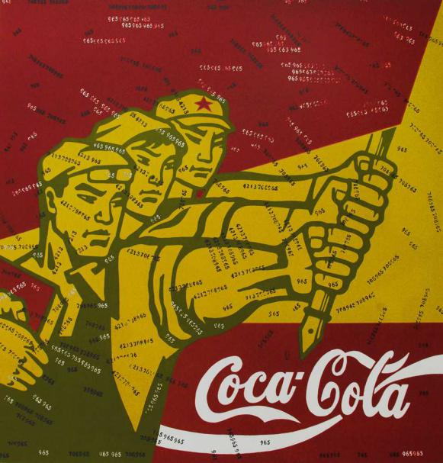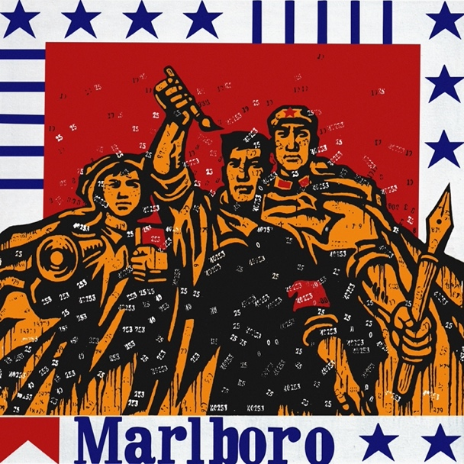
The pieces by Wang reflect on Cultural Revolution propaganda posters although the superimposed figures of Coke and Marlboro brands are typically Western. Such an amalgam of political and commercial logos brings an expressive contrast, which is reminiscent of the conflict between revolution and consumerism in China. About these works, there is no question that Baudrillard’s concept of hyper-reality where the distinction between the real and the virtual is blurred, fits perfectly. What is even more interesting is that using Maoist aesthetics and referencing global capitalist logos, Guangyi not only deconstructs the commodification of ideology but also challenges the phantasmagoria of both political and economic discourses. In this regard, the artwork as a post-socialist simulation inverts the real world where socialism and capitalism are articulated in a distorted commodity format.
In Coca-Cola, the composition is three giants with a simplified monumental layout common in the socialist realism pattern. These human shapes are painted in yellow color on the red background which refers to the revolutionary art of Mao’s era. However, they are not as ideologically innocent as one might think because there is a Coca-Cola logo displayed on the cartoon at the bottom.
Visual Techniques and Symbolism
Both Coca-Cola and Marlboro feature strong graphic lines, and the simplification of forms which are apparent references to the aesthetics of socialist propaganda, whose purpose was to send a simple and direct message to the public. Yet, Guangyi destabilises this clarity by including commercial logos – disrupters that introduce another layer of meanings and produce ideological uncertainty. Baudrillard described this as the mixing of the political and commercial signs which signify the erasure of the clear dividing line between different ideological types in the postmodern world that is when everything becomes a commodity (Miao and Kluensuwan, 2022).
The same thing is done in Marlboro. Three people, in the style of workers and soldiers of the Cultural Revolution, exultant and brandishing tools and a red flag. The layout is surrounded by blue and white stripes and stars of the American flag at the bottom and the Marlboro logo. The contrast between the socialist and capitalist motifs is enhanced by the highly vivid colors and thick lines. Such an intentional collision of logos speaks volumes about the socio-political landscape of China where communism is the proclaimed ideal, but capital is the operating reality.
Through the use of motifs in the Great Criticism series it is evident that Guangyi was portraying a criticism of mass production and commodification. In making many similar works, Guangyi uses techniques of copying the so-called mass production of both orthodox propaganda posters and consumer products. Such repetition serves not only to underscore the points concerning the commodification of ideological symbols but also those concerning the erasing of subjectivity in both socialist and capitalist paradigms. In this context, Baudrillard’s concept of simulacra – the signs that take the place of or mimic the real – is quite pertinent.
Criticism and Limitations
The artefacts of Guangyi do not tell a story; they construct a narrative in which ideologeme and commodity signs are desensitized and rendered into a dispensable signifier. On an analytical level, both Coca-Cola and Marlboro reflect the Chinese culture and the conflict created by China joining the globalization program of a free-market economy. The incorporation of well-known Western images and logos in pieces which signify socialist propaganda is the penetration of international consumerism in China. This theme is most relevant in light of China’s economic liberalization programmes that were instituted in the late 1970s by Deng Xiaoping. These reforms brought about an unexampled economic revolution but the social-cultural revolution was equally massive. Yet the images that Guangyi produces are part of this moment of change, of ambivalence and the contradictions of the post-Maoist China.
From the semiotic point of view, the common images of propaganda art and Western postmodern consumerist symbols that are painted by Guangyi are used to ask the viewers to look at these images differently. His subjects depicted as heroes of the revolution, actually resurrect corporate logos and trademarks in such a manner as to challenge the viewer as to the credibility and honor of both concepts. This re-contextualisation conforms to Baudrillard’s theory because, in a hyperreal environment, symbols cease to have their signifieds and become a kind of signifier in a process of barter (Avina, 2020).
However, while the Great Criticism series represents a strong visual statement and a rich statement of theme, some critics have complained that Guangyi’s works may themselves become commodified. Through borrowing from the techniques of propaganda and advertising, today Guangyi’s artwork is a popular commodity in the international art market. This commodification brings into discussion the efficacy of his critique. Whenever his works are consumed as high culture, do they stop becoming countercultural and reinforce mainstream culture? This situation sums up the problem that modern artists have, who aim to subvert consumerism and are involved in the art business.
Conclusion
The art of Wang Guangyi can be regarded as a true documentation of the social and cultural phenomenon that developed in the People’s Republic of China after Mao Zedong. His works especially the Great Criticism series depict the struggle between socialism in China and the fast-rising Capitalism. This critique of the consumerization of ideological images illustrates that, with the help of socialist and Western symbols, Wang Guangyi questions the diminished value of symbols by transforming them into objects of consumption. His combining of famous worldwide brands such as Coca-Cola and Marlboro together with revolutionary heroes describes how the Westernization of China took place during the last quarter of the century.

Based on Baudrillard’s theory on media and hyperreality, this paper aims to see how Wang Guangyi’s artwork reflects Postmodernism, where images are no longer merely an imitation of the real world but form a hyperreal that exists independently of history or social reality. In this essay, the works analyzed show that to achieve the purpose of making the audience consider consumer objects as mass-produced, Guangyi employs repetition and raw colors. In this regard, his paintings not only depict China’s socio-political reality but also comment on dehumanization caused by a market economy. With such visual features, Guangyi presents the themes of his work as reflecting on a society in between the nostalgia of an ideology and the desire for globalization while his art has both domestic and global significance.

Moreover, combining semiotics with Guangyi’s work helps viewers comprehend the multiple meanings hidden in his art. Articulating the symbols of revolutionary leaders, red stars, and corporate logos in his paintings is a critique of the commodification of different abstract ideas and ideologies into market products. His art is also about postmodern conditions with the issues of identity, history and meaning which are constantly unstable and shifting with the pace of new cultural and economic configurations.

Nevertheless, there are certain problems in the works of Wang Guangyi even if he is quite popular among critics. Some people claim that his repetitiveness weakens the impact of his words as time passes. However, his contributions to Chinese contemporary art are invaluable. In this manner, with the help of a combination of boldly political topics and Postmodern aesthetics, Wang Guangyi managed to become one of the influential figures in the discussion about changes in contemporary China. His works not only represent the opposite and the ambiguity of society in transformation but also address the world at the period of the new millennium as a critic of the sociopolitical landscape of the late capitalistic world.

Reference list

Avina, A.Z. (2020). Revolution in pain(t): a semiotic reading of Chinese Cultural Revolution propaganda posters and female motivated violence (1966-1968). Ed.ac.uk. [online] doi:https://hdl.handle.net/1842/37063.
Baudrillard, J. (1981). Hyperreality: JEAN BAUDRILLARD. [online] Available at: https://www.mlsu.ac.in/econtents/2289_hyper%20reality%20boudrilard.pdf.
Dino, F. (2019). Introduction to Jean Baudrillard, Module on Simulacra and Simulation. [online] Purdue.edu. Available at: https://www.cla.purdue.edu/english/theory/postmodernism/modules/baudrillardsimulation.html.
Goldman, M. (2009). Repression of China’s Public Intellectuals in the Post-Mao Era. Social Research, [online] 76(2), pp.659–686. Available at: https://www.jstor.org/stable/40972280.
Guangyi, W. (n.d.). Wang Guangyi Artworks | Weng Contemporary. [online] www.wengcontemporary.com. Available at: https://www.wengcontemporary.com/artist/wang-guangyi.
He, X. (2022). Guangyi Wang ’s Great Criticism: Coca Cola: A Compromising of Art Languages. International Journal of Education and Humanities, 6(2), pp.66–67. doi:https://doi.org/10.54097/ijeh.v6i2.3352.
lauren winter dawson (2021). Wang Guangyi’s ‘Political Pop’. [online] laurenwinterdawson. Available at: https://www.laurenwinterdawson.com/single-post/wang-guangyi-s-political-pop.
Lincot, E. (2004). Contemporary Chinese Art Under Deng Xiaoping. China Perspectives, [online] (53). doi:http://journals.openedition.org/chinaperspectives/2952.
Miao, H. and Kluensuwan, P. (2022). Chinese Political Pop Art -- Wang Guangyi’s Reference And Application Of Pop Art. [online] Available at: https://www.pnrjournal.com/index.php/home/article/view/8650.
O’Keeffe, A. (2019). From Propaganda to Pop Culture: How Maoist Propaganda Transformed Into a Global Art Commodity Citation. [online] Available at: https://dash.harvard.edu/bitstream/handle/1/42004066/OKEEFFE-DOCUMENT-2019.pdf.
Wang (2024). Artistcloseup.com - Your favorite place to discover new artists. [online] Artistcloseup.com - Your favorite place to discover new artists. Available at: https://www.artistcloseup.com/blog/wang-guangyi-a-convergence-of-ideology-and-commerce [Accessed 6 Jan. 2025].

