
Innovative solution to an operational problem
Submission date: 22 March 2024

Luciana Stafi – 2130653 Word count: 3560

Executive summary
This executive summary outlines the crucial role of creativity and innovation in driving company growth and profitability, emphasising the importance of a supportive organisational climate. Key to fostering innovation is brainstorming, a technique that pools diverse ideas by valuing every contribution equally, thereby enhancing the creative output.
The De Bono Six Hats methodology further enriches this process by encouraging a multifaceted exploration of ideas, ensuring a comprehensive and practical approach to creativity.
Leadership is identified as pivotal in nurturing an environment conducive to innovation. Leaders who listen, mentor, and support creative initiatives are crucial in building a culture where innovation flourishes. Additionally, the Force Field Analysis is highlighted as an essential tool for strategic innovation implementation, enabling companies to identify and address the forces that either facilitate or hinder change.
In summary, cultivating a vibrant, innovative company culture involves a multifaceted strategy that fosters a positive organisational climate, leveraging brainstorming and structured thinking techniques, embodying visionary leadership, and applying strategic analysis tools like the Force Field Analysis.

Table of Contents
1.0 Introduction 3
2.0 Main Findings 4
2.1 Introduction to The Cwtch Café: 4
2.1.1 Creativity 5
2.1.2 Innovation 5
2.2 The types of innovation 7
2.2.1 The 4 P's Model 7
2.3 The creativity process 8
2.3.1 Brainstorming 8
2.3.2 Edward de Bono's Six Thinking Hats 9
2.3.3 The four stages of creativity 10
2.4 The effectiveness of the solution 10
2.4.1 Force Field Analysis 10
2.4.2 The barriers and risks 12
2.5 Evaluation of the Organisational climate and leadership style 13
2.5.1Definition of climate 13
2.5.2 Leadership styles 14
3.0 Conclusion 15
4.0 Reference list 17

Introduction
In today's business environment, marked by fierce competition and rapid changes, a firm's ability to innovate and creatively respond to operational challenges becomes a crucial success factor. This report aims to illustrate the importance of creativity and innovation within the organisational framework, highlighting how they can provide innovative solutions to firms' operational problems. Organisations can improve efficiency and productivity by adopting creative approaches and differentiating themselves in their marketplace.
The report draws on various academic and professional sources, including reference books in creativity, innovation, brainstorming, force field analysis, The Bono Six hats, and the 4Ps’ of creativity and leadership to substantiate this analysis. This diversity of perspectives provides a deep understanding of how creativity and innovation can be cultivated and effectively applied to solving operational problems.
The report is structured into several key sections, each contributing to the central argument. We begin by exploring "Types of Innovation", where we differentiate between incremental and radical innovation and discuss their impact on organisational performance. The following section, "The Creativity Process," examines the stages by which new ideas are generated, evaluated, and implemented. The "Assessing Organisational Climate and Leadership Style" section examines how organisational culture and leadership approaches influence employees' ability to be creative and contribute to innovation. This analysis emphasises the importance of an environment that encourages experimentation and accepting failure as part of the learning process.
Through this report, we aim to demonstrate that, regardless of a company's size or field of activity, adopting a mindset oriented towards creativity and innovation is essential for identifying and implementing practical solutions to operational problems. In conclusion, creativity and innovation are desired and necessary to survive and thrive in the contemporary business landscape.

Main Findings

2.1 Introduction to The Cwtch Café:

The Cwtch Cafe is a small, modest cafe located in the centre of Chepstow in the private sector. It has been operating since 2014, always bringing flavour and taste to freshly prepared food and sweets. The Cafe offers freshly prepared food, homemade cakes, ice cream, and different types of coffee. As an employee at this Cafe, my position is that of a Barista. Thanks to loyal customers, the Cafe has maintained a 5-star level. The Cwtch Cafe will always live up to the customers' expectations and do everything possible to make them return with pleasure every time.
Small high-street cafes are a vibrant and essential part of urban life in many cities worldwide. These spaces are not just limited to serving coffee but also function as critical social nodes, fostering community, creativity and the exchange of ideas (Johnson, 2018).
Unlike large chain coffee shops, they can quickly adapt to changes in the market or customer preferences, which allows them to offer more personalised and innovative services (Kumar & Lee, 2020).

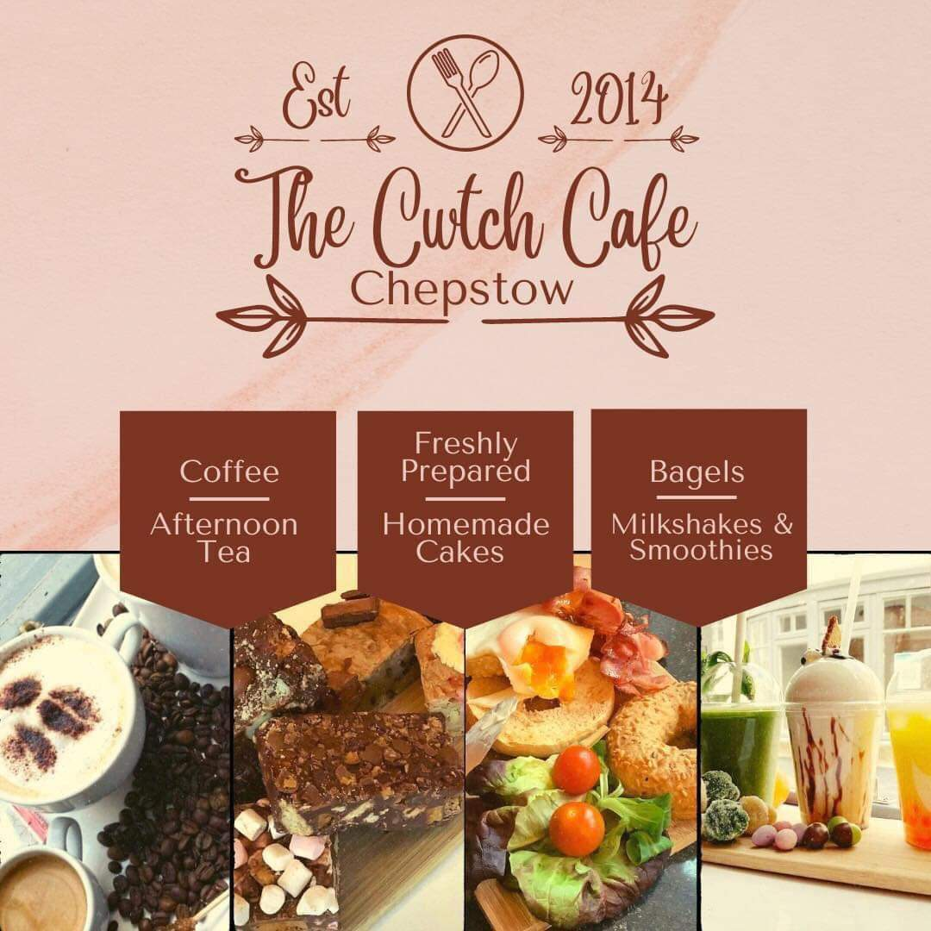

According to BBC 2023, in the private sector, there are different types of businesses like sold trader, multinational, partnership, ltd, pls and franchise. Private sector businesses are often sources of innovation because competition spurs them to improve products and services and develop new technologies ( Porter, M.E. 1990).

2.1.1 Creativity
Creativity is broadly defined as the ability to produce something new through imaginative skill, whether a novel idea, a solution to a problem, or a work of art. It involves thinking outside established patterns to develop unique and original concepts (Feinstein, 2006).
Creativity is crucial across various fields, including science, art, education, and business, facilitating innovation and progress. In psychology and organisational studies, creativity is often described as a mental and social process involving generating new ideas, concepts, or associations between existing ideas or concepts, leading to significant original outcomes (Csikszentmihalyi, M. 1996).
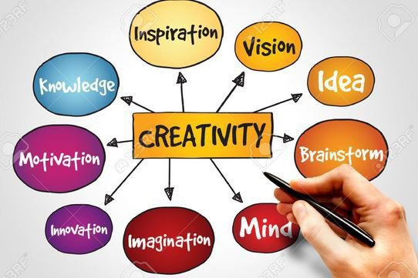

Creativity helps small businesses differentiate themselves from competitors through unique products, services or customer experiences. This differentiation can be the key to attracting and retaining customers in often saturated markets (Kelley și Littman, 2005).
For "The Cwtch Cafe", creativity means more than just offering quality coffee; it is about creating a unique experience for every customer that crosses its threshold. This includes everything from unique interior decor and innovative seasonal menus to community events that unite people. This approach attracts new customers and keeps existing ones returning, creating a loyal customer base.

2.1.2 Innovation
Innovation is applying novel and valuable ideas, primarily in developing new goods, services, processes, or technologies. It encompasses the entire process from the inception of an idea to its successful implementation in the market or within an organisation. Innovation is not just about creating new ideas but also involves the practical steps necessary to turn these ideas into valuable products or services that meet specific needs or solve problems. It is a crucial driver of economic growth, competitiveness, and improving quality of life (Drucker, P.F. 1985).


Start-ups and small firms demonstrating a solid commitment to innovation and creativity are often more attractive to investors. These qualities suggest the potential for rapid growth and significant returns on investment (Christensen, 1997).
The importance of creativity and innovation cannot be overstated. They are essential for driving economic growth, solving social problems, and enhancing personal development. By fostering an environment that encourages these elements, societies can ensure sustainable progress and adaptability in an ever-changing world. However, achieving this balance requires careful attention to the ecosystems supporting innovation, including policies, educational systems, and organisational cultures encouraging risk-taking and creative problem-solving (Amara, R. & Singh, J. 2022).

The core differences hinge on several factors: Creativity is conceptual, focusing on the birth of ideas without immediate application, whereas innovation is practical, emphasising the transformation of these ideas into tangible improvements (Smith, 2018). Creativity is about ideation, the free flow of thoughts without constraints, while innovation deals with the realisation and commercialisation of these ideas, requiring a structured approach to bring them to market (Jones, 2020).
In an increasingly competitive world, "The Cwtch Cafe" faces the challenge of distinguishing itself in a market saturated with cafes and fast food chains. Creativity and innovation thus become essential to its survival and prosperity. These two forces not only help to differentiate from the competition but also provide ways for the business to successfully navigate the rapid changes in the market while improving customer experience and operational efficiency.

2.2 The types of innovation

At the beginning of 2024, due to the high taxes and the new implementations of the government on organisations, the profit at The Cwtch Cafe was no longer the same as in previous years. After discussing with the company employees and considering the customer's opinions and feedback, the idea of ordering and taking away the offered products was implemented. The creativity of the idea came to help increase the profit.
The idea of takeaway expands when all the employees from The Cwtch Cafe, sitting at a table in the open air, analysed the company's situation, checking the financial situation, taking into account the reviews of customers and what future customers would like.
According to (Tidd & Bessant,2018), there are four stages in the innovation Process:
- Recognising the opportunity
- Finding the resources
- Developing the idea
- Capturing value.
Innovation allows "The Cwtch Cafe" to stay relevant by quickly adapting to new trends and consumer preferences. For example, coffee could introduce sustainable packaging options and ethical sourcing for its products in the context of increasing environmental awareness. These changes respond to consumer demands and demonstrate the business's commitment to social and environmental values, an aspect increasingly valued by customers.

2.2.1 The 4 P's Model
This model helps organisations understand how they can innovate and drive change across various aspects of their business (Tidd & Bessant,2018):
Product - changes in the things (products/services) that an organisation offers
Process - changing how products or services are created and delivered.
Position - changing the context in which products/services are framed and communicated
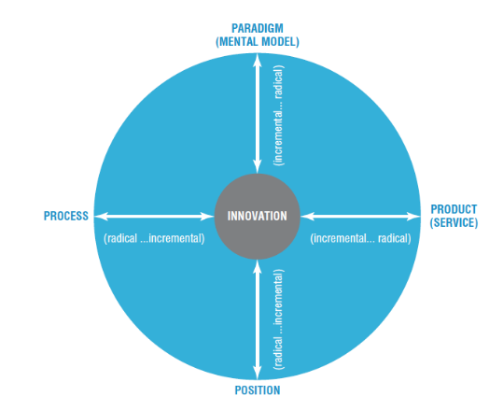
Paradigm - a change in the underlying mental models which frame what the organisation does

According to Christensen and Raynor (2013), with the help of disruptive innovation, established companies can identify and exploit growth opportunities in emerging markets or create new markets. Due to the strategic framework, products or services can be created to disrupt the existing industry, emphasising the importance of understanding unmet customer needs.
The innovation to introduce the takeaway idea is incremental, by offering something already existing but in a different way.
Product | Takeaway products
Process | Improve the waiting time to receive the order.
Position | Targeting the clients who do not have time to sit in
Pradium | The new beginning of The Cwtch Cafe

2.3 The creativity process

2.3.1 Brainstorming

According to Michalko (2006), adopting advanced brainstorming techniques and creating an environment conducive to freely expressing ideas is essential for individual and group innovation and creativity. These unconventional methods encourage lateral thinking and can lead to innovative solutions that give organisations an advantage in a competitive environment.


At this stage, quality is less important than quantity. Ideas can range from new products, innovative services, and creative marketing methods to customer loyalty strategies. No idea is too bold or too simple at this stage.
The idea of takeaway is good for increasing the company's profit and helping customers who do not have time to sit at the table to enjoy lunch. For this reason, teamwork and decisions are the best, especially if we can think outside the box. According to Osborn (1953), brainstorming allows participants to freely explore ideas, promoting creative thinking without immediate restrictions or criticism.
Brainstorming is a powerful idea-generation technique that can help The Cwtch Cafe explore new opportunities to increase profits. This method encourages free participation, eliminating criticism and filtering ideas initially to stimulate creative thinking and identify innovative solutions.
By implementing brainstorming techniques, The Cwtch Café can discover and apply creative solutions to improve the customer experience and strengthen its market position.
According to (Gardner, 2024), a creative idea from a cafe in Wiltshire was to introduce a unique table in the Cafe for people with no one to communicate with or who are lonely. This idea is creative and innovative for the Cafe and brings beneficial comfort to the customers.

2.3.2 Edward de Bono's Six Thinking Hats
Edward de Bono's Six Thinking Hats is a powerful tool for enhancing group discussion and individual thinking. This method provides a structured way to think more effectively and collaboratively (De Bono. E, 1985).
The six hats represent six modes of thinking, each identified by a different colour:
- White (factual thinking),
- Red (emotions and feelings),
- Black (judgment and caution),
- Yellow (speculative-positive),
- Green (creative thinking),
- Blue (process control).
This approach helps reduce confrontations, enables more efficient meetings, and fosters a culture of constructive collaboration.



The Cwtch Café is generally a creative organisation. When it comes to implementing something new, the employees and the company's superiors consider how creative the ideas that will be implemented are, as well as their benefits. The Takeaway idea used the white hat from de Bono's Six Hats, bringing a plus to the company's profit.

2.3.3 The four stages of creativity
The stages of creativity outline how creative ideas develop and evolve from inception to realisation.
The four stages of creativity describe how innovative ideas are generated and developed. In 1926, in his book, “The Art of Thought,” Graham Wallas conceptualised these four stages: preparation, incubation, illumination and verification. This framework provides a comprehensive understanding of the creative process, emphasising that innovative ideas are the result of a complex process involving both conscious and unconscious work:
The Cwtch Café use these four stages to identify the innovation idea as follows:
Preparation - communicating with the team and sharing new ideas helps achieve and implement new solutions to the problem.
Incubation - to become creative and innovative, one needs a pleasant environment. The organisation allocated a recreation space for employees to "think in harmony".
Illumination - this is the moment of realisation and discovery of new ideas.
Verification - for everything to be okay, all the details of the idea must be checked to determine if it will be effective if it involves additional costs, and if it lasts.

2.4 The effectiveness of the solution

2.4.1 Force Field Analysis

Force Field Analysis is a tool developed by Kurt Lewin (1947), and it is used for decision-making and problem-solving in various fields such as business, psychology, and social sciences. It provides a framework for analysing the forces that influence a situation, including those that drive change (driving forces) and those that resist change (restraining forces).
By identifying and evaluating these forces, individuals and organisations can develop strategies to strengthen the forces supporting a desired change and reduce the impact of opposing forces. This analysis helps understand the dynamics of change within an organisation and implement effective change management strategies.

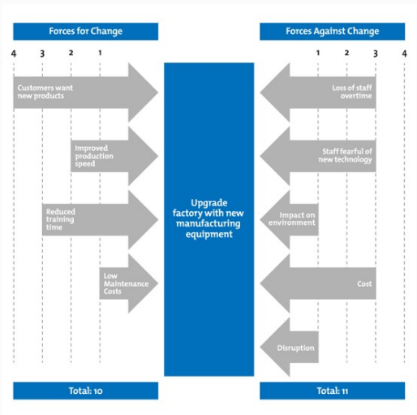

The pros and cons must be considered to know if the innovative idea the company wants to apply is a success. The Cwtch Cafe analysed these fields before applying the idea to the market. The basic idea consists of the takeaway of the products offered by the company by customers who do not have time to eat in a restaurant or perhaps have limited time and therefore want to eat at the office.
Pros:
- Customer demand - customer preferences for quick and convenient options.
- Increase Sales - the potential to attract more customers and increase sales.
- Competition - the pressure to remain competitive in the face of competitors
Cont:
- Initial costs - investment is required for packaging, marketing, and possible space adaptation.
- Logistics - the challenges of maintaining the quality of food and beverages in transit.
- Production capacity - the need to handle additional orders without affecting quality or lead time.
The takeaway idea can simultaneously be achievable and productive, substantially impacting competitors offering takeaway services.



Thanks to customer feedback, The Cwtch Café can successfully implement takeaway services. To survive in the market and not go bankrupt, all small businesses must consider the customers' wishes, but at the same time, they must also consider the competition.

2.4.2 The barriers and risks

Kotler et al. (2020) highlight the importance of understanding the market and consumer behaviour in successfully adapting and implementing takeaway services in the hospitality industry while highlighting specific challenges such as logistical needs and quality management.
Introducing a takeaway service can offer many opportunities for a coffee shop, but it also has specific barriers and risks. Understanding and managing these challenges is critical to the success of the initiative.
Barriers:
High initial costs - the investment in additional equipment,
Logistics management - maintaining the quality of products to the customer requires well-designed logistics.
Limited production capacity - adapting to increased order volume without compromising customer quality or service time at the location can be challenging.
Regulatory compliance - strict adherence to food safety standards and local regulations can add additional layers of complexity.
Risks:
A decline in quality - maintaining high standards in the face of increased order volume can be difficult.
Overstaffing - Increasing workload without proper staffing adjustments or training can lead to human error and low employee morale.
Sustainability - Increasing consumption of single-use packaging can raise sustainability issues.
To introduce the takeaway service, The Cwtch Café considered the barriers and the risks that may appear along the way. If the Cafe does not maintain the quality of its products to the same standard, this will be a significant risk to accept. Again, one frequently encountered barrier is increased costs for purchasing new equipment or products for the services offered.

2.5 Evaluation of the Organisational climate and leadership style

2.5.1Definition of climate

Organisational climate refers to the collective perceptions of an organisation's members about their work environment, including the attitudes, feelings, and behaviours promoted or discouraged by the organisation's policies, practices, and procedures (Schneider, Ehrhart, & Macey, 2013). Factors that contribute to organisational climate include leadership style (Goleman, Boyatzis, & McKee, 2002), internal communication, performance recognition and reward (Amabile & Kramer, 2011), peer relationships, and workplace equity (Cox & Blake, 1991).

The difference between organisational climate and culture is significant. In contrast, culture focuses on the values and norms shared in an organisation, and climate describes members' perceptions of implementing these values in the organisation's day-to-day life (Schein, 2010). A positive organisational climate can significantly influence motivation, job satisfaction and commitment (Luthans, 2011), contributing to overall organisational performance.

The climate in The Cwtch Café is friendly and relaxing, as the employees have a separate room from the customers where they can have lunch and relax. Even if, as a barista employee, sometimes there is no time to relax because you must always be active and attentive in what you are doing, a good climate at work benefits employees.
A favourable climate is beneficial for a company. Some people seek to become more creative thinkers, which is why the team environment in which they work is essential. For the workplace to have a pleasant climate, building trust, encouraging people to share their ideas, and encouraging teamwork can bring positive results to a company (Ainscough, 2017).

2.5.2 Leadership styles

According to Northouse (2018), influential leaders play a crucial role in organisational success by inspiring and motivating employees and setting the strategic direction needed to achieve organisational goals.
Effective leaders can articulate a clear vision and inspire employees to work together to achieve it. They define strategic purpose and direction, helping the organisation navigate change and challenges (Kotter, 1996).

Bass & Bass (2008) state that effective leadership includes developing and mentoring employees. By investing in team professional development, leaders can ensure continued skill growth and the preparation of future leadership talent.
The Cwtch Café, with its intimate team comprising one manager and four dedicated employees, epitomises the essence of a small but thriving business operation. The manager, a seasoned professional over fifty years old, brings to the table a wealth of experience in marketing and leadership, showcasing exceptional professionalism in today’s fast-paced business environment. This expertise guides the café’s strategic direction and fosters an environment where innovation and creativity are highly encouraged.

Under his stewardship, the café thrives on a culture of open communication and collaborative idea generation. He demonstrates an exemplary openness to new ideas proposed by the employees, creating a dynamic where every suggestion is carefully considered.

This approach ensures that innovation is encouraged and meticulously aligned with the café's core objectives and potential benefits to the business. The manager’s ability to listen actively and engage in thoughtful analysis with the team exemplifies a balanced leadership style that values innovation and strategic alignment.
Further cementing this culture of continuous improvement and growth is the manager's commitment to the team's professional development. Recognising the importance of keeping abreast of the latest industry trends, techniques, and skills, he ensures periodic investments in training courses for the employees. This enhances their capabilities and motivates them, reinforcing their value within the company and spurring them to contribute their best.

Such a holistic leadership and team development approach sets The Cwtch Café apart. It is a testament to how a small team, led by visionary leadership and rooted in a culture of mutual respect, open dialogue, and continuous learning, can achieve remarkable success. The manager's blend of experience, willingness to embrace new ideas, and commitment to team development create a robust foundation for the café’s continued prosperity and innovation.

Takeaway services can help cafes make a profit, even during the pandemic. If the space allocated to the Cafe is insufficient for customers to serve inside, then this takeaway service is preferable and will increase the business's profit (Speciality Food Magazine, 2020).

3.0 Conclusion
This report explored the complex dynamics of creativity and innovation in the intimate context of a small coffee shop, highlighting how various brainstorming techniques and Edward de Bono's Six Thinking Hats model can stimulate the discovery and development of innovative ideas. By analysing the application of these methods in a non-conformist environment, we discovered that they favour a deep and diversified thinking process, essential for generating original and practical solutions.
The main findings indicate that the success of brainstorming in the studied Cafe is due not only to the flexibility and openness of the participants but also to a structured framework provided by the "Six Thinking Hats" method. This model encouraged participants to explore diverse perspectives, reducing conflict and fostering collaboration. Moreover, an effective leader who navigated and guided the discussion was vital to channelling creative energy and ensuring that brainstorming sessions were productive and goal-oriented.
The importance of leadership in this context cannot be underestimated. Leaders who adopt a flexible style and are open to new ideas play a crucial role in facilitating creative dialogue and encouraging valuable contributions from all team members. They serve as moderators and sources of inspiration, shaping a culture of innovation that transcends conventional boundaries.
However, the study also identified limitations, including the tendency toward conformity in small groups and the difficulty of maintaining a constant creative environment without new external stimuli. This underscores the need to continue exploring and integrating new approaches and techniques that can enrich the creative environment.
In conclusion, the discovery and development of innovative ideas in a small coffee shop, through brainstorming and the "Six Thinking Hats" method, demonstrates the ability of non-conventional environments to stimulate creative and collaborative thinking. Effective leadership is pivotal in this process, facilitating a space where freedom of expression and diversity of thought is accepted and encouraged. This study encourages further exploration of the synergy between leadership, creativity and innovation, opening new horizons for organisations that wish to cultivate a dynamic and innovative environment.

4.0 Reference list

- Ainscough, K. (2017) Building an organisational climate that encourages creative and innovative outcomes, Freestyle. Available at: https://www.freestyleinnovation.co.uk/post/2017/11/20/building-an-organisational-climate-that-encourages-creative-and-innovative-outcomes (Accessed: 21 March 2024).
- Amabile, T.M. and Kramer, S.J. (2011). The Progress Principle: Using Small Wins to Ignite Joy, Engagement, and Creativity at Work. Boston, MA: Harvard Business Review Press.
- Amara, R. & Singh, J. (2022). Innovation and Creativity: Pillars of the Future. 1st ed. Cambridge: Cambridge University Press.
- Bass, B.M. și Bass, R. (2008). The Bass Handbook of Leadership: Theory, Research, and Managerial Applications. New York, NY: Free Press.
- Christensen, C.M. (1997) The Innovator's dilemma when new technologies cause great firms to fail. Boston: Harvard Business School.
- Christensen, C.M. and Raynor, M.E. (2013) The Innovator’s solution: Creating and sustaining successful growth. Boston, MA: Harvard Business Review Press.
- Cox, T., & Blake, S. (1991). Managing Cultural Diversity: Implications for Organizational Competitiveness. Academy of Executive Management, 5(3), 45-56.
- Csikszentmihalyi, M. (1996). Creativity: Flow and the Psychology of Discovery and Invention. New York, NY: HarperCollins.
- De Bono, E. (1985). Six Thinking Hats. London: Little, Brown and Company.
- Drucker, P.F. (1985). Innovation and Entrepreneurship: Practice and Principles. New York, NY: Harper & Row.
- Feinstein, J.S. (2006) Nature of Creative Development. Stanford, California: Stanford University Press.
- Gardner, K. (2024) Bistro in calne piloting chatty table for lonely customers, BBC News. Available at: https://www.bbc.co.uk/news/uk-england-wiltshire-68085142 (Accessed: 21 March 2024).
- Goleman, D., Boyatzis, R.E., & McKee, A. (2002). Primal Leadership: Learning to Lead with Emotional Intelligence. Boston, MA: Harvard Business School Press.
- Johnson, M. (2018). Community Spaces and Urban Dynamics. CityScape Press.
- Jones, B. (2020). Innovation Unveiled: From Ideas to Impact. Cambridge: Cambridge University Press.
- Kelley, T., și Littman, J. (2005). The Ten Faces of Innovation: IDEO's Strategies for Defeating the Devil's Advocate and Driving Creativity Throughout Your Organisation. New York: Currency/Doubleday.
- Kotler, P., Bowen, J.T., Makens, J.C., Baloglu, S. (2020). Marketing for Hospitality and Tourism. 7th ed. Harlow: Pearson Education.
- Kotter, J.P. (1996). Leading Change. Boston, MA: Harvard Business School Press.
- Kumar, V., & Lee, H. (2020). Adapting to Change: Small Businesses and Market Flexibility. Business Dynamics Review
- Lewin, K. (1947). Frontiers in Group Dynamics: Concept, Method and Reality in Social Science; Social Equilibria and Social Change. Human Relations, 1(1), 5-41.
- Luthans, F. (2011). Organisational Behavior: An Evidence-Based Approach. 12th ed. New York, NY: McGraw-Hill.
- Michalko, M. (2006). Thinkertoys: A Handbook of Creative-Thinking Techniques. Berkeley: Ten Speed Press.
- Northouse, P.G. (2018). Leadership: Theory and Practice. 8th ed. Thousand Oaks, CA: SAGE Publications.
- Osborn, A.F. (1953). Applied Imagination: Principles and Procedures of Creative Thinking. New York: Scribner.
- Porter, M.E. (1990). The Competitive Advantage of Nations. New York: Free Press.
- Private sector - types of organisations - higher business management revision - BBC bitesize (2023) BBC News. Available at: https://www.bbc.co.uk/bitesize/guides/zjfxvk7/revision/1 (Accessed: 19 March 2024).
- Schein, E.H. (2010). Organisational Culture and Leadership. 4th ed. San Francisco, CA: Jossey-Bass.
- Schneider, B., Ehrhart, M.G., and Macey, W.H. (2013). Organisational Climate and Culture. San Francisco, CA: Jossey-Bass.
- Smith, A. (2018). The Essence of Creativity. Oxford: Oxford University Press.
- Speciality Food Magazine (2020) Eat-in vs takeaway: What’s Right for your café?: News, Speciality Food Magazine. Available at: https://www.specialityfoodmagazine.com/news/eat-in-vs-takeaway-whats-right-for-your-cafe (Accessed: 20 March 2024).
- Tidd, J. and Bessant, J.R. (2018) Managing innovation: Integrating technological, market and organisational change. 6th ed. Hoboken, NJ: Wiley.
- Wallas, G. (1926). The art of thought. London: Jonathan Cape.

