Managing enterprise in the 21st century BMSW4006
Nogzi Ibeji

VANTASTIC FOODS
Group business plan
Wendy barrier 2019211
Chistina Ackah- 2017469
Nicole Styler- 2018970
Georgi Todorov Valkanov 2015940
Wilangela Vaz 2017020



Table of content.
1 business, company overview
1.1the business.
1.2 about us
1.3 our mission
1.4 our vision

2 product and services

3 market audits

4 Swot analysis

5 pestle analyses

6 target market
6.1 questionnaire

7 Marketing plan

8 Management team

9 financial plans

10 references

1 Business/company overview

1.1the business.

We are a group of 5 students that wish to apply for funding from the lottery company for our business. We noticed a gap in the market for a hot food vender outside of our university. We noticed many of the students studied all day and, on the break, could only get cold food from a vending machine. The university have told us that they have been looking for a vender to serve the university students. We had all had some catering experiences so have devised a business plan for a company called Vantastic foods, a hot food van that could serve the students and other members of the public outside of the university.
1.2 about us
Wendy Barrier, I started my working life working in a food van in a factory serving hot snacks and although it was not a career, I pursued I have worked for many years in retail serving the public, I have worked my way up to manager and doing the accounts for a spar shop.
Nicole Styler, I worked as a food and beverage manager in a casino
Chris Ackha I have worked in catering since leaving school and am now a manager at a top local restaurant
Georgie Todorov Valkanov I presently manager a transport company, that delivery’s goods both local and internationally
Wilangela Da Graca Garcia Vaz. I have working in advertising and visual merchandising for ten years and now manage the company I work for.
We wanted advice on how to go about planning for my future career, so we arranged a meeting with Rosie Grindy, founder, and CEO of miss macaroon. Rosie is now the proud founder and CEO of Miss Macaroon which she set up with just £500 of her own money in 2011. Since its foundation Rosie has now achieved a wide range of accolades to her name including her most recent award of MBE for her work mentoring young people with multiple and complex needs. (Rosie Ginday MBE – Founder and CEO | Miss Macaroon, 2021)
We talked about how she had opened such a successful business which is a social enterprise that works with basically anyone with a need for help getting into work. Rosie explained about the long hours and commitment needed to open your own business. You should be prepared to fail, and in America loan companies and banks are more likely to give loans to someone who has failed in business as they will know the pit falls and ways to avoid them.

1.3 mission statement
Mission statement, our aim being to present and serve quality food to all our customer, offering a wide and varied range of the best foods in our city

1.4 our vision Vision statement, In serving the best quality food to our customer our aim is to corner the market in the fast-food industry in the area of the UWTSD university and beyond.
Our goal is to expand from one vantasic vehicle to a fleet of at least 3.
We hope to reach our goal by 2027

2 Products and services
At Vantastic Food we pride ourselves of providing top quality burgers and to do so we make sure that all our ingredients are fresh and in compliance with the Food Standard Agency; on top of that we value inclusivity, so all our meats are Halal, and we offer vegetarian options as well.
Vantastic Food was created to fill up the homesickness that me and colleagues feel when thinking of our home countries, hence why each and every burger has authentic recipes that will bring a taste of our home to our customers. The countries we have been inspired from are the UK (the classic burger), the USA (the Great American), Bulgaria (the Kufteta), Portugal (the Frango) and Jamaica (the Jerky).
As part of our menu, we also offer homemade chips and salad as sides, and we have a variety of drinks such as: organic smoothies, mainstream fizzy drinks ie. Coca-Cola, Fanta and Sprite, fresh pressed juices, and mineral water.
A meal at Vantastic Food will cost less than £15, and we have come up with this decision because we mainly target university students and office workers around the area since our van will be situated outside the Birmingham Campus of the University of Wales Trinity Saint David and will be open Monday to Friday from lunchtime.

3 Market Audit
Competitor analysis

Competitor Analisis
Factors | Your company Vantastic Food | Competitor A MC’DONALDS | Competitor B FISH AND CHIPS | Competitor C SUBWAY
Industry | Food and Drinks | Food and Drinks | Food and Drinks | Food and Drinks
products or services | Jamaican dishes British dishes American dishes Bulgarian dishes Portuguese dishes | Burgers, French fries, Salads. | Fish, Chips. | Sandwiches
Key success factors | Multinational dishes  Locally scored ingrediants | Worldwide company  Nothing local | Providing cheap and nourishing meals  No variation | Healthy food, transparent company
strategies | Flexible locations and free delivery | Large chain of restaurants delivery charges and promotional offers | Delivery  charges | Delivery  charges
advertising front | Email Text message Instagram page  Targeting local people | Ad. Everywhere | Leaflets | Ad. Everywhere
strengths and  weaknesses | Multinational customers, change of locations  New in the market | Strong brand name Global brand value of about 97.7 billion U.S. dollars  Nothing personal | Limited starts up risk high barriers to entry | One of the leading players in the sandwich chain business  Nothing personal
Distribution |  | Many of McDonalds restaurants are open 24 hours per day which satisfies the customers’ needs and wants especially for exists their hunger |  | Subway uses direct marketing channels since it deals directly with its consumers Although Subway's  product is a shopping good it uses selective distribution

Our food will be locally scored with no additives
The shiny new trademarked food philosophy at McDonald's is, "The Simpler, The Better," but pull up the ingredient list to any sandwich, and it can take up a full page! The company has made a notable effort to simplify its contents since 2017, when media outlets caught wind of the staggering 19-item ingredient list for McDonald's French fries. Though the chemicals and preservatives were selectively axed from particular menu items due to the backlash, you're still likely to be surprised at some of the contents post-rebranding: maltodextrin, sodium phosphate, sodium nitrate, and artificial caramel coloring, to name a few. (10 Worst McDonald's Facts About the Fast Food Chain — Eat This Not That, 2021). Take a look at ingredients for some varieties of Subway's bread and you'll find a chemical that may seem unfamiliar and hard to pronounce: azodicarbonamide. (Elizabeth Landau, 2021) although some additives are good those that preserve are less healthy (branen, 2021)

4 Swot analysis

Strengths | weakness
- Location  - Movable  - Fresh food daily  - No renting costs | - Limit capital  - Cost of buying fresh  - Cost of ingrediencies
Opportunities | treats
- Chance to expand  - Set up with partners  - Apply for permits | - Other food venues  - legal requirements  - Hygiene regulations

A swot analysis is an Import part of planning for our food truck's future. First, we will be looking at the strengths of opening our food van, so we are going to be looking at what we do better than others and what makes us different from other food venues (Winik, 2021) Our food van will be in an ideal location, but we could also be moved early to any other location we like. We will also have fresh food daily; this will be more appealing to customers and hopefully gain a wider customer range. Another strength is that we will save on renting costs. Next, we looked at weaknesses in opening a food van, these are areas in which we could improve. By finding and understanding our weaknesses we can make changes to make our business do better (bdc 2021). Limited capital. The cost of buying fresh food every day and ingrediency are some of the weaknesses we found. There are many opportunities for a mobile food business, we have lots of room for development and improvement. Some opportunities are: We could look to expand our business and get more vans. We could also set up Partnerships with bars and clubs. We also have Permits that we could apply for so that we could open later. Last we looked at threats. Treats are issues that we could face. Preparing and planning for treats now can help us plan for issues that may affect us in the future. Other food venues may cause a threat. We will also need to take into consideration the legal requirements of running a food van and constantly check got change in hygiene regulations or licenses. (Bubenik, 2021).

5 Pestle Analysis

P  Political | E  Economical | S  Social | T  Technological | L  Legal | E  Environmental
 | affordability |  | advertising | legislation | Area
 |  |  | Social media | Tax | Housing
 |  |  | Business modelling | Training

We have chosen to open a burger van to keep our overheads low and therefore the cost to the customer
We needed to discover the pros and cons on this, so we looked at the burger van via a pestle analysis
The political landscapes are crucial to this as government restrictions play a big part in what we can and can’t do. There are tax policies to consider as well as licences. Staff will need training in the relevant certification for example food hygiene. When
Economically factors will include the money that students will be able to afford, a burger van would be more affordable to them that a sit-down meal in a restaurant. To sustain our business, we need to keep our prices affordable to those around us.
When looking at social factors we can consider the timing whereas a restaurant will take possible an hour to sit down, order and eat the burger van will be quick allowing student to have hot comforting food during a short break.
Technology will help us to employ the minimum number of staff in creating the best business model for timing etc we would also use it for our financial planning, and advertising. (Solution, 2021) using social media will be of a large benefit as the students use of facebook, twiter,insta and other platforms to constantly communicate. Social media plays an important role in every student’s life. It is often easier and more convenient to access information, provide information and communicate via social media. Tutors and students can be connected to each other and can make good use of these platforms for the benefit of their learning and teaching. (Why use social media? | MyCumbria, 2021)
In conclusion the pestle has shown us the by keeping within government legation we can make the maximum profit in our area by keeping prices low and sticking to a staffing budget

6 Target Market

Target market is a segment of the population to whom you intend to sell your goods services. Each group can be subdivided into subgroups or segments (Australian Government, 2021).
Vantastic food is located on Victoria house, Edward Street B1 2RA which is next to UWTSD which targets UWTSD students and workers from surrounding companies. Vantastic food aims to fill the void of homesickness we feel.
The goal of our target market strategy is to produce a product that satisfies customers and invites them to return. Our business is proud of the one-of-a-kind product we make, and we sell it to clients.
Vantastic food will focus on offering a diverse menu to our customers. Our organisation will place a heavy emphasis on product quality because we believe it is a critical component of the business, as were as ensuring client loyalty so that they will continue to purchase our product. Knowing and understanding consumer problems and attempting to address them is one of the phases in defining a good target market (Leboff, 2016).



Based on the studies carried out in this module, we applied the concept of segments to better understand our target audience. Market segmentation can be done in a variety of ways, depending on how you want to divide the pie, but the three most popular methods are demographic segmentation, geographic segmentation, and psychographic segmentation (WARD, 2020)
We did a survey and based on the data we collected we present the following results.

Segmentation Method | Description | Estimated size of segments
Geographic | Residents within 2 miles of university | 800, 000
Demographic | Age 18-60  Full- time students | 90, 000  40, 000
Psychographic | Active lifestyle | 30, 000
Behavioural | Food person  Friendly  happy  Extroverted | 100, 000  70,000  60, 000  30, 000

6.1 Questionnaire
QUESTIONNAIRE
- Do you bring packed lunch at University?
- Yes
- No

- How much would you spend for a burger meal?
……………………………………………………………….
- Do you eat Halal meat?
- Yes
- No
- Don’t know

- Do you eat burgers?
- Yes
- No

- Are you vegetarian?
- Yes
- No

- Select your age group
- 16 – 25
- 26 – 35
- 36 +

- What drinks would you like to have with a burger meal? (You can select Multiple choiches)
- Fizzy drinks (coke, Fanta, lemodade etc…)
- Smoothies
- Milkshakes
- Water

- Would you buy food from a van?
- Yes
- No

7 Marketing plan

Our way of advertising our company will be through flyers spread across the campus in Birmingham, as we are a new company whose main objective is still to meet the needs of UWTSD students, because we were aware that the university needs a canteen, we took advantage of this to do our business. We will use social media as way of getting custom from our younger students using Facebook and Instagram.
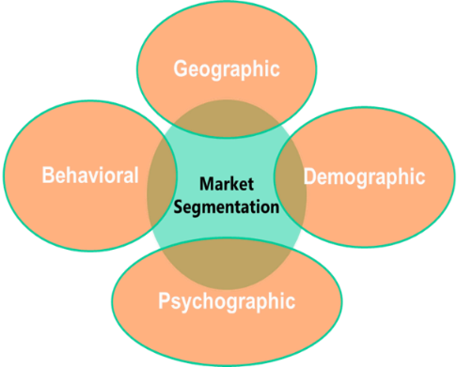

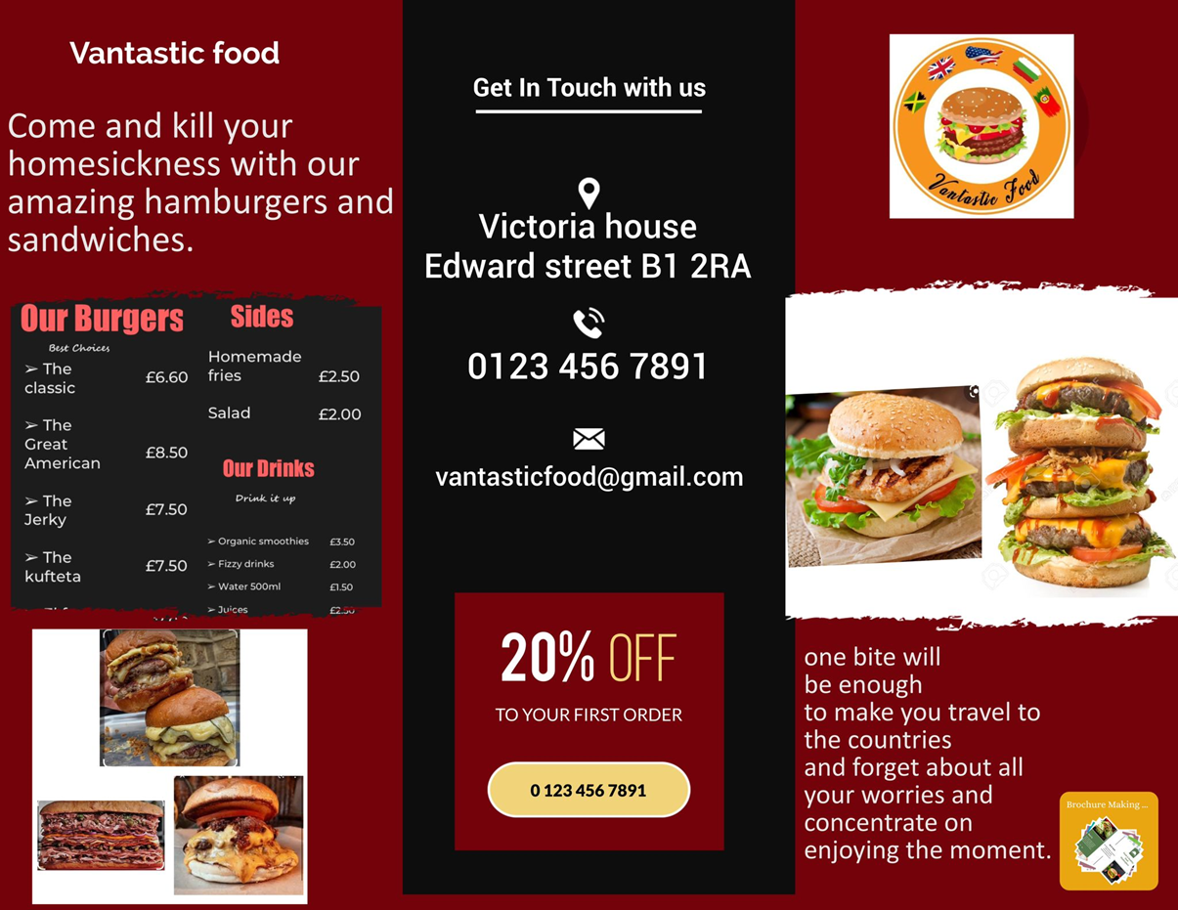

8 financial planning

Looking at our table of planning as we can see the business is not yet operational, so it is purely predictive, by using our questionnaire and piecing of stock we looked at a 12-month forecast with hiring the equipment rather than buying. This option seems the best way to go as we can afford to keep the initial costs low. Pricing has been calculated based on a warehouse menu. And local farm shops Bulk buying make the costing cheaper so therefore prices will be cheaper, below is our cash flow chart for the first 12 months of trading. Here you can see we will take drawings to replace wages for the first nine months to enable a more stable financial stepping before wages are taken. The deposit on the catering van will cost £15000 as it will be kitted out with everything we need, after the initial £15000 it is just £500 per month.

10 Management team

All of these are managing directors:

Cristina stock Manager and buying manage

Georgi transport manger/licensing manager

Nicole visual manager

Wendy accounts manager


Wilangela marketing manager

We are Vantasic foods

<https://www.similarweb.com/corp/blog/research/company-research/swot-analysis-for-market-researchutm_source=adwords&utm_medium=paid&utm_campaign=Dynamic_BLG_EuropeT1_TCPA&gclid=CjwKCAiAhreNBhAYEiwAFGGKPOrBcj2TEnMKYat1OJh9X-79yz4hIC5rB1zW4rkLAlmqBWVtnmBmqRoCTIgQAvD_BwE> [Accessed 6 December 2021].

Australian Government. (2021). Identify your target market. Available: https://business.gov.au/marketing/identify-your-target-market. Last accessed 13th nov 2021.

BDC.ca. 2021. SWOT analysis: An easy tool for strategic planning. [online] Available at: <https://www.bdc.ca/en/articles-tools/business-strategy-planning/define-strategy/swot-analysis-easy-tool-strategic-planning> [Accessed 6 December 2021].

branen, l., 2021. food additives revised and expanded.

Bubenik, S., 2021. Gaining a Competitive Edge By Conducting A SWOT Analysis On Your Workforce. [online] Forbes. Available at: <https://www.forbes.com/sites/scholleybubenik/2019/03/13/gaining-a-competitive-edge-by-conducting-a-swot-analysis-on-your-workforce/?sh=1961d87d380d> [Accessed 6 December 2021].

Elizabeth Landau, C., 2021. Subway to remove chemical from bread - CNN. [online] CNN. Available at: <https://edition.cnn.com/2014/02/06/health/subway-bread-chemical/index.html> [Accessed 6 December 2021].

Grant Leboff. (2016). Six steps to defining your target market. Available: https://www.marketingdonut.co.uk/marketing-strategy/your-target-market/six-steps-to-defining-your-target-market. Last accessed 06th Dec 2021.
Harvard Case Studies. (2021). Food Truck Forecaster Harvard Case Study Solution & Online Case Analysis. Available: https://caserighted.com/food-truck-forecaster. Last accessed 18 November 2021.

Ibeji, N 2021, Exploring Your Market, lecture notes, Managing Enterprise in the 21st Century BMSW4006, University of Wales Trinity Saint David, delivered 22 October 2021.
Eat This Not That. 2021. 10 Worst McDonald's Facts About the Fast Food Chain — Eat This Not That. [online] Available at: <https://www.eatthis.com/reasons-mcdonalds-worst-fast-food-chain/> [Accessed 6 December 2021].

Miss Macaroon | Macarons That Make a Difference. 2021. Rosie Ginday MBE – Founder and CEO | Miss Macaroon. [online] Available at: <https://missmacaroon.co.uk/about-us/meet-the-team/rosie-ginday-mbe/> [Accessed 4 December 2021].

My.cumbria.ac.uk. 2021. Why use social media? | MyCumbria. [online] Available at: <https://my.cumbria.ac.uk/Student-Life/it-media/Social-Media-Guidance/Why-use-social-media/>

[Accessed 5 December 2021].
SUSAN WARD. (2020). Target Marketing and Market Segmentation. Available: https://www.thebalancesmb.com/target-marketing-2948355. Last accessed 06th Dec 2021.

