

Changemakers: Creativity and Value Creation
Module Code - BMHP5014

Assignment – Written Assignment (Report)

Student Name - Shumon Ahmed
Student Number - 2310119

Lecturer – Elena Leonova

Date – 24/11/2025

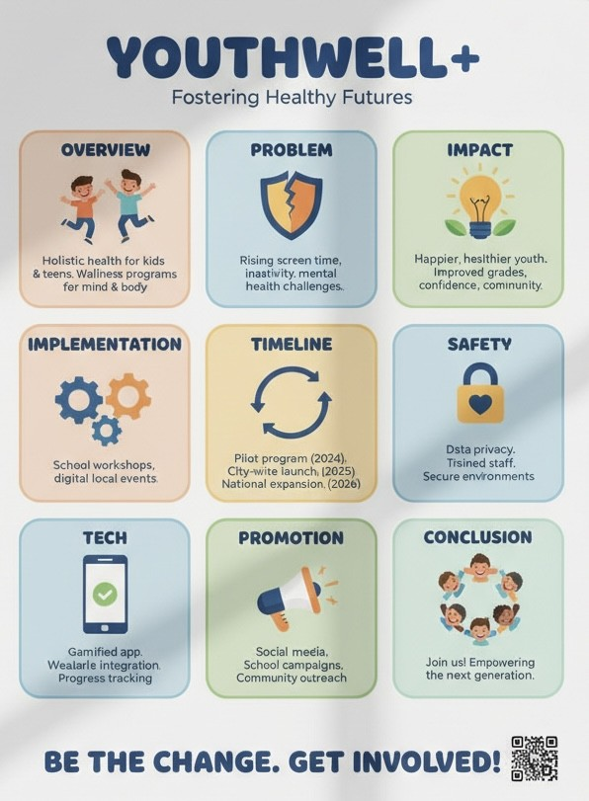
Pitch - YouthWell+ is an integrated health and social care innovation designed to support the wellbeing, development and resilience of young people aged 8–16. At a time when children and adolescents face increasing mental health challenges, social pressures and barriers to accessing appropriate care, YouthWell+ provides a coordinated, youth-friendly and accessible model that bridges the gap between education, families, and healthcare services. The innovation combines digital technology, school-based support systems, and community involvement to create a holistic framework that empowers young people to understand, manage and strengthen their mental and emotional wellbeing.
At its core, YouthWell+ centres around a digital wellbeing app built specifically for young users. The app offers secure mood-tracking features, interactive coping tools, educational content, and age-appropriate guidance on managing common emotional issues such as stress, anxiety, friendship conflicts and low confidence. It also facilitates safe communication by allowing young people to request help, access calming techniques, or receive supportive messages from trained wellbeing mentors. YouthWell+ recognises the importance of safeguarding, so the app is designed with strict privacy controls, child-friendly security, and clear reporting mechanisms to ensure that support is not only accessible but also safe.
Beyond digital tools, YouthWell+ embeds trained wellbeing mentors directly into schools, youth organisations and community hubs. These mentors provide early intervention support, lead group wellbeing sessions, deliver preventive mental health education, and work alongside teachers and pastoral teams to ensure that young people have someone they can trust and talk to. The programme also provides structured pathways for early identification of emerging mental health concerns, reducing stigma and ensuring that young people who require additional help can be referred quickly and appropriately.
Another key innovation is the incorporation of peer support and positive social development. YouthWell+ includes structured activities where young people can build resilience, practise communication skills, and participate in group challenges that promote teamwork, empathy and self-expression. These activities help children and adolescents feel more connected to their school and community environment, reducing feelings of isolation and strengthening their sense of belonging.
YouthWell+ also addresses the essential need for improved communication between families, schools and health professionals. Parents are given access to a secure companion version of the app, allowing them to view general wellbeing trends and receive guidance on how to support their child at home. Schools receive anonymised dashboards that highlight overall wellbeing patterns, enabling staff to identify common stressors and tailor support strategies. This creates a unified care network where adults can collaborate effectively while maintaining the confidentiality and autonomy of young people.
By integrating digital innovation, school-based support and community involvement, YouthWell+ offers a scalable and sustainable model for modern youth wellbeing. It reduces barriers to early support, enhances emotional literacy, strengthens resilience, and promotes a culture of openness around mental health. Ultimately, YouthWell+ equips young people with the tools, confidence and connections they need to thrive during a formative stage of life—building a healthier, more empowered generation.

1. Innovation Overview
YouthWell+ is an innovative health and social care initiative designed to support the wellbeing, development and resilience of young people aged 8–16. Combining digital technology, school-based support and community involvement, YouthWell+ provides an accessible, youth-friendly approach to early intervention and emotional health education.
At the centre of the innovation is a dedicated wellbeing app created specifically for children and teenagers. The app offers mood tracking, interactive coping tools, educational resources and safe communication features that connect young people to trained wellbeing mentors. This ensures immediate, stigma-free access to support whenever it is needed. Safeguarding and privacy protection are integrated throughout the platform, creating a secure digital environment.
Alongside the digital component, YouthWell+ embeds mental health mentors in schools and youth organisations. These professionals deliver group workshops, provide one-to-one support, and help teachers identify early signs of emotional distress. Peer-support activities and social development sessions further strengthen confidence, resilience and positive relationships among young people.
YouthWell+ also enhances communication between families, schools and health services through anonymised wellbeing dashboards and guidance for parents. This coordinated system helps adults understand emerging needs and respond proactively.
Overall, YouthWell+ offers a holistic, preventative and empowering model that equips young people with the emotional tools and supportive networks they need to thrive.
- A digital wellbeing app tailored for young users
- Access to school-based mental health mentors
- Peer support and safe social spaces
- Interactive learning modules on health, emotions and social skills

2. The Issue / Gaps in Health & Social Care for Young People
Young people aged 8–16 face growing challenges, including rising anxiety, stress, bullying and social isolation. Many struggle to access mental health support due to long waiting times, limited school resources and the stigma surrounding emotional difficulties. Communication gaps between families, schools and healthcare services often delay early identification of problems, leaving young people without timely intervention. Digital pressures, including social media and online risks, further impact emotional wellbeing. These gaps highlight the need for an accessible, youth-friendly solution that offers early support, strengthens resilience and connects young people with trusted adults—addressing issues before they escalate.
- Rising rates of anxiety, bullying and stress among young people
- Barriers to accessing mental health services (long wait times, stigma)
- Limited communication between schools, families and health professionals
- Social pressures (including online influences) affecting wellbeing
YouthWell+ provides early intervention, safe communication and accessible support.

3. Target Audience & Impact
YouthWell+ supports young people aged 8–16, particularly those experiencing stress, anxiety, social pressures or difficulties accessing traditional mental health services. It also benefits parents, teachers, youth workers and school support teams by strengthening communication and early intervention pathways. The programme’s impact includes improved emotional resilience, better coping skills and increased confidence among young people. Through digital tools, mentoring and peer-support activities, YouthWell+ reduces stigma around mental health and creates safe, supportive environments. It enhances school engagement, builds positive relationships and promotes healthier social behaviours—helping young people thrive both academically and personally.
Who Benefits:
- Children & teens ages 8–16
- Parents & guardians
- Teachers, pastoral teams & youth workers
Positive Impact:
- Stronger emotional resilience
- Safe spaces to talk about mental health
- Increased support networks and confidence
- Improved coping skills, behaviour and academic engagement

4. Implementation
YouthWell+ is implemented across schools, youth clubs and community centres to ensure accessible, everyday support for young people. Trained wellbeing mentors, school counsellors and youth workers deliver the programme through weekly group sessions, one-to-one support and digital engagement via the YouthWell+ app. Teachers receive training to recognise early signs of emotional distress and to integrate wellbeing activities into the school environment. The app provides continuous support, mood tracking and safe communication between young people and mentors. Schools and families access anonymised wellbeing insights to guide timely intervention. This coordinated approach creates a consistent, supportive network across home, school and community settings.
Where: Schools, youth clubs, community centres, online platforms
Who Delivers: Mental health mentors, school counsellors, youth workers, trained volunteers

How It Works:
- Weekly wellbeing sessions in schools
- Digital app access for students & parents
- Crisis support and referral pathways
- Staff workshops on youth mental health

5. Programme Timeline
The YouthWell+ programme begins with a 3-month co-design phase, where young people, parents and educators help shape content, digital tools and support strategies. This is followed by a 3-month pilot phase in selected schools to test the app, mentoring model and group sessions. During months 7–12, YouthWell+ expands into additional schools and youth centres, accompanied by staff training and continuous monitoring. In Year 2, the programme is evaluated through user feedback, wellbeing data and impact assessments. Based on these findings, YouthWell+ is refined and scaled regionally or nationally to ensure long-term sustainability and effectiveness.
- Months 1–3: Co-design with youth, parents and educators
- Months 4–6: Pilot testing in selected schools
- Months 7–12: Full rollout of app + school programmes
- Year 2: Monitoring, evaluation and national expansion

6. Regulations & Safeguarding
YouthWell+ is built on a strong foundation of safeguarding, ethical practice and regulatory compliance to ensure young people receive safe, high-quality support. The programme fully adheres to GDPR, the Data Protection Act, and the Online Safety Act, ensuring all personal information is handled securely, transparently and responsibly. The digital wellbeing app includes encrypted data storage, strict access controls, age-appropriate safety settings and clear reporting features to protect users from online risks.
All YouthWell+ mentors, counsellors and youth workers undergo enhanced DBS checks, comprehensive safeguarding training and continuous professional supervision. The programme aligns with NICE guidelines for early mental health intervention and follows local authority child protection frameworks and school safeguarding policies.
YouthWell+ also incorporates robust risk-assessment procedures, confidentiality protocols and secure communication pathways between young people, families and professionals. By embedding regulatory compliance into every aspect of the service, YouthWell+ ensures a trustworthy, safe and supportive environment for all young people.

YouthWell+ complies with:
- GDPR & Online Safety Act
- Safeguarding and child protection policies
- Mental health support guidelines (NICE)
- School health & wellbeing frameworks

7. Technology Integration
Technology is central to YouthWell+, providing young people with accessible, engaging and secure wellbeing support. The YouthWell+ app includes mood tracking, interactive coping tools, guided breathing exercises and educational resources designed specifically for ages 8–16. Integrated AI features identify patterns of emotional distress and prompt early intervention from trained mentors, while safeguarding controls ensure all alerts are secure and age-appropriate. Schools access anonymised wellbeing dashboards to monitor trends and inform support strategies. All data is encrypted and stored securely, ensuring compliance with child safety standards. Through these tools, YouthWell+ enhances engagement, early support and communication between young people and trusted adults.
- Wellbeing App: Mood tracking, coping tools, supportive messaging
- AI Alerts: Flags emotional distress patterns (fully safeguarded)
- School Dashboard: Helps teachers monitor wellbeing trends
- Secure Data Systems: Protect student information
Tech strengthens access, early support and youth engagement.

8. Dissemination & Promotion
YouthWell+ is promoted through a coordinated strategy involving schools, families, communities and digital platforms. Schools introduce the programme through assemblies, parent information evenings and staff briefings, ensuring everyone understands the support available. Social media campaigns, youth-friendly videos and school website updates help raise awareness among young people and families. Partnerships with local councils, mental health charities and youth organisations extend the programme’s reach and credibility. Educational conferences, teacher training events and professional networks further promote YouthWell+ across the health and education sectors. Together, these dissemination efforts build visibility, trust and engagement, encouraging widespread adoption of the programme.
- Assemblies & school awareness campaigns
- Social media content for teens & families
- Partnerships with local councils & youth organisations
- Teacher training events and wellbeing conferences
Conclusion
YouthWell+ empowers young people through accessible wellbeing tools, early intervention and strong support networks. It enhances mental, emotional and social health—helping every young person thrive.
YouthWell+ represents a transformative approach to supporting the health, wellbeing, and social development of young people aged 8–16. At a time when children and adolescents are facing increasing emotional pressures, rising mental health concerns and growing social challenges both online and offline, this innovation offers a comprehensive and accessible solution. By integrating digital wellbeing tools, school-based mentoring, peer support and collaborative communication pathways, YouthWell+ ensures that young people receive the right support at the right time, in environments where they feel safe, understood and empowered.
The strength of YouthWell+ lies in its holistic and preventative design. Rather than waiting for young people to reach crisis points, the programme promotes early intervention, emotional literacy and resilience-building—key factors that contribute to long-term mental health and positive life outcomes. The inclusion of a youth-centred wellbeing app, trained mentors and tailored group activities helps to normalise conversations about mental health, reduce stigma and create supportive networks that extend across homes, schools and communities.
YouthWell+ also prioritises safeguarding, inclusivity and accessibility, ensuring that every young person—regardless of background, ability or circumstances—can benefit from the programme’s resources. By strengthening the relationship between families, educators and health professionals, the initiative fosters a collaborative ecosystem that places the needs and voices of young people at its centre.
In essence, YouthWell+ is not just a service; it is a proactive investment in the next generation. It equips young people with essential emotional tools, promotes healthier peer interactions and supports their overall wellbeing, helping them to grow into confident, resilient and thriving individuals.

References

Information Commissioner’s Office (ICO) (2025) UK GDPR guidance and resources. Available at: https://ico.org.uk/for-organisations/uk-gdpr-guidance-and-resources/ (Accessed: 20 November 2025).
Kirkbride, J.B., Anglin, D.M., Colman, I., Dykxhoorn, J., Jones, P.B., Patalay, P., Pitman, A., Soneson, E., Steare, T. & Wright, T. (2024) ‘The social determinants of mental health and disorder: evidence, prevention and recommendations’, World Psychiatry, 23(1), pp. 58-90. doi: 10.1002/wps.21160.
National Institute for Health and Care Excellence (NICE) (n.d.) Mental health guidelines (In development GID-HUB10005). Available at: https://www.nice.org.uk/guidance/indevelopment/gid-hub10005 (Accessed: 20 November 2025).
Navigo Health and Social Care CIC (2025) Workshops for professionals – Children and Adolescent Mental Health Services (CAMHS). Available at: https://navigocare.co.uk/CAMHS/professionals/workshops-professionals Accessed: 20 November 2025).
NHS (2025) Mental health support for children and young people. Available at: https://www.nhs.uk/mental-health/children-and-young-adults/mental-health-support/ (Accessed: 20 November 2025).
Ringdal, R., Bjørnsen, H.N., Espnes, G.A., Eilertsen, M.-E.B. & Moksnes, U.K. (2021) ‘Bullying, social support and adolescents’ mental health: Results from a follow-up study’,Scandinavian Journal of Public Health, 49(3), pp. 309-316. doi: 10.1177/1403494820921666.
The Children’s Society (2022) Net Gains? Young people’s digital lives and wellbeing. Available at: https://www.childrenssociety.org.uk/information/professionals/resources/young-peoples-digital-lives-and-well-being(Accessed: 21 November 2025).
World Health Organisation (WHO) (2025) Mental health of adolescents [Fact sheet]. Available at: https://www.who.int/news-room/fact-sheets/detail/adolescent-mental-health(Accessed: 21 November 2025).
Youth Careers Collective (2025) Online safety policy and mentor agreement (v2). Available at: https://youthcareers.org.uk/wp-content/uploads/2025/11/Youth-Careers-Collective-Online-Safety-policy-and-mentor-agreement-v2.pdf (Accessed: 19 November 2025).
YouthWell (2025) Youth & Family Resources. Available at:https://youthwell.org/ (Accessed: 19 November 2025).

