Name: Rehina Zinovieva
Student Number: 2425418
Programme: BSc Applied Computing
Module: Data Security and Compliance
Lecturer: Dr. Mohamed Ben Farah
Submission Date: 30.07.2026

Table of Contents
1. Analysis 3
Task 1: Critical Analysis of Zero Trust Architecture in Modern Data Security 3
1.1 The changing nature of organisational security risks 3
1.2 From traditional security models to Zero Trust Architecture 4
Table 1. Comparison between Traditional Security and Zero Trust 4
1.3 Core principles of Zero Trust Architecture 5
1.4 Technologies supporting Zero Trust implementation 5
1.5 Critical evaluation of Zero Trust Architecture 6
Task 1 conclusion 7
Task 2: Designing a Cybersecurity Programme for the Equifax Data Breach 7
2.1 Lessons learned from the Equifax incident 7
2.2 Organisational Structure and Accountability 8
2.3 Policies and Procedures 10
2.4 Governance and Strategic Alignment using NIST Cybersecurity Framework 2.0 11
Table 2. Application of NIST Cybersecurity Framework 2.0 to Equifax 12
2.5 Risk Management and Assessment 14
Table 3. Equifax Cybersecurity Risk Assessment 14
2.6 Compliance, Incident Response and Protection Controls 15
Conclusion 18
References 19

Analysis
The way organisations protect information has changed significantly due to the increased use of cloud computing, remote working and interconnected digital services. Traditional security approaches were mainly based on protecting a defined network perimeter, where users and devices inside the organisation were often considered trusted. However, modern organisations operate across multiple environments, making it increasingly difficult to maintain clear security boundaries.
Cybersecurity incidents such as the 2017 Equifax data breach demonstrate that technical vulnerabilities can become major business risks when combined with weaknesses in governance, monitoring and security processes. The exploitation of an unpatched Apache Struts vulnerability showed that organisations require proactive approaches rather than relying only on traditional defensive controls.
This report focuses on Zero Trust Architecture as a modern cybersecurity approach that aims to reduce security risks by continuously verifying users, devices and access requests [1]. The first part critically evaluates the principles, supporting technologies, advantages and challenges of implementing Zero Trust. The second part applies these concepts to the Equifax breach by designing a structured cybersecurity programme based on governance, risk management, compliance requirements and technical protection measures.

Task 1: Critical Analysis of Zero Trust Architecture in Modern Data Security

The changing nature of organisational security risks
Historically, organisations protected their information systems using a perimeter-based security model. This approach was based on the assumption that internal networks were relatively secure, while external networks represented the main threat. Security controls such as firewalls, antivirus software and Virtual Private Networks (VPNs) were commonly used to protect the boundary between trusted and untrusted environments [2].
Although this model provided reasonable protection in traditional office-based environments, it has become less effective due to changes in how organisations use technology. Modern businesses increasingly depend on cloud platforms, Software as a Service (SaaS) applications, mobile devices and external suppliers. Employees may access corporate resources from different locations and devices, creating a much wider attack surface.
Another major challenge is the increase in identity-based attacks. Attackers often do not need to directly compromise network infrastructure if they can obtain valid user credentials through phishing, malware or data leaks. Once access is gained, attackers may move through internal systems and access sensitive information. [3] [1]
Therefore, modern cybersecurity requires a shift from protecting only network boundaries towards protecting identities, applications and data. Organisations must assume that threats can exist both outside and inside their environments, making continuous verification and monitoring essential.
This shift is also reflected in sector-wide research. The Cloud Security Alliance observes that as organisations increasingly rely on cloud infrastructure and third-party platforms, a growing share of enterprise data and workloads exist entirely outside any physical perimeter that a traditional firewall could protect [14]. The European Union Agency for Cybersecurity reaches a similar conclusion, noting that identity-related attack methods, particularly phishing and credential compromise, remain among the most frequently reported initial access techniques used against organisations of all sizes [13]. These findings support the view that the Equifax breach was not an isolated failure but an example of a broader pattern in which attackers exploit the gap between where sensitive data actually resides and where traditional security controls are applied. This gap is precisely what Zero Trust Architecture is designed to close, by extending verification and access control to the level of individual resources rather than relying on the assumption that anything inside the network boundary can be trusted by default.

1.2 From traditional security models to Zero Trust Architecture
Zero Trust Architecture represents a change from the traditional idea that users inside an organisation’s network should automatically receive a higher level of trust. Instead, Zero Trust follows the principle of “never trust, always verify”, meaning that every access request must be evaluated before permission is granted. [1]
Unlike perimeter-based security, Zero Trust focuses on protecting individual resources rather than protecting only the network. Access decisions are based on multiple factors, including user identity, device security status, location, behaviour patterns and the sensitivity of requested information.
For example, an employee accessing a sensitive database from a company-managed device in the office may receive different access permissions compared with the same employee attempting to access the same resource from an unknown device in another country. This approach reduces the possibility that stolen credentials automatically provide attackers with unrestricted access.
However, Zero Trust should not be misunderstood as a single security product. It is a security strategy that requires changes in technology, processes and organisational culture. Successful implementation depends on combining multiple controls, including identity management, monitoring systems, access policies and risk assessment processes. [4]

The Zero Trust model was first formally proposed by Kindervag in 2010 as a response to the failure of perimeter-based security to prevent lateral movement once an attacker gained internal access [2]. This concept was later standardised by the National Institute of Standards and Technology in NIST Special Publication 800-207, which defines Zero Trust Architecture as a set of guiding principles for designing and operating information systems in which no implicit trust is granted based on physical or network location [1]. Major technology vendors have since adopted similar principles in commercial security offerings; for example, Microsoft describes Zero Trust as an approach built around explicit verification, least privilege access and the assumption that a breach has already occurred, closely mirroring the NIST definition [4]. The consistency between academic, governmental and commercial descriptions of Zero Trust suggests that the model reflects a genuine shift in industry practice rather than a marketing term, which strengthens its relevance as a framework for analysing incidents such as the Equifax breach.

Table 1. Comparison between Traditional Security and Zero Trust
Area | Traditional Security Model | Zero Trust Model
Trust assumption | Internal network users are usually trusted | No user or device is trusted automatically
Main protection focus | Network perimeter | Data, identity and resources
Access decisions | Based mainly on network location | Based on identity, context and risk
Monitoring approach | Periodic security checks | Continuous verification
Response to compromise | Detect after breach occurs | Assume compromise and limit damage

1.3 Core principles of Zero Trust Architecture
The Zero Trust model is based on several key principles that help organisations reduce security risks.
Verify explicitly
The first principle requires organisations to verify every access request using available information. Authentication should not rely only on usernames and passwords because these can be stolen or compromised.
Multi-Factor Authentication (MFA) is an important example of this principle because it requires additional verification factors, such as a security application or biometric confirmation. Even if a password is exposed, attackers still face another security barrier.
Apply least privilege access
The principle of least privilege ensures that users receive only the access necessary to complete their tasks. Excessive permissions increase the potential impact of compromised accounts because attackers may gain access to larger amounts of sensitive information.
For example, an employee working in marketing should not automatically have access to financial records or customer databases unless there is a clear business requirement.
Assume breach
Traditional security approaches often focus on preventing attackers from entering systems. However, Zero Trust assumes that breaches may occur and focuses on reducing their consequences.
This approach encourages organisations to implement segmentation, monitoring and rapid response processes. If an attacker gains access to one part of the environment, their ability to move further should be restricted.
These principles are supported by formal guidance rather than general best practice alone. The NIST Digital Identity Guidelines specify requirements for authenticator assurance levels and recommend that organisations use multiple independent authentication factors for access to sensitive systems, providing a technical basis for the verify explicitly principle [5]. Academic literature also supports the theoretical foundation of Zero Trust; a review of the model describes it as a response to the limitations of static, network-based trust boundaries in environments characterised by cloud adoption and remote access [15]. This reinforces the argument that least privilege access and assume breach are not simply defensive slogans but principles grounded in recognised authentication and architecture standards, which makes them applicable well beyond a single organisation's internal policy preferences.

1.4 Technologies supporting Zero Trust implementation
Zero Trust Architecture cannot be implemented through one specific technology. Instead, it requires a combination of security solutions that work together to provide identity verification, monitoring, access control and automated response capabilities. [5]
One of the most important technologies supporting Zero Trust is Multi-Factor Authentication (MFA). Traditional authentication methods based only on passwords have become insufficient because passwords can be stolen through phishing attacks or data breaches. MFA reduces this risk by requiring additional verification factors before access is granted. However, MFA should not be considered a complete security solution because attackers may still use advanced social engineering techniques to bypass authentication processes.
Another important component is Zero Trust Network Access (ZTNA). Unlike traditional VPN solutions that provide broad access to a corporate network after successful authentication, ZTNA provides access only to specific applications or resources that a user is authorised to access. This reduces the possibility of lateral movement by attackers after an account has been compromised.
Security Information and Event Management (SIEM) platforms are also essential within Zero Trust environments. SIEM systems collect and analyse security events from different sources, including servers, applications and user devices. By identifying unusual patterns, organisations can detect potential attacks earlier. However, SIEM effectiveness depends on correct configuration and skilled security professionals who can analyse alerts. [6]
Endpoint Detection and Response (EDR) solutions provide continuous monitoring of endpoint devices such as laptops and workstations. EDR can identify suspicious behaviour, isolate compromised devices and support faster incident response. This is particularly important because modern attacks frequently target endpoints rather than directly attacking network infrastructure.
Data Loss Prevention (DLP) technologies support Zero Trust by protecting sensitive information from unauthorised transfer or misuse. DLP solutions can monitor data movement and apply policies to prevent accidental or intentional data leakage. [7] Finally, Secure Access Service Edge (SASE) combines network and security capabilities through cloud-based services. SASE is particularly relevant for organisations with remote employees because it allows security controls to be applied consistently regardless of user location.
Although these technologies strengthen security, organisations should avoid focusing only on purchasing security tools. A common implementation mistake is treating Zero Trust as a technical project rather than an organisational security transformation. Without appropriate policies, staff awareness and governance structures, security technologies alone may not provide the expected level of protection.
The effectiveness of these technologies is well documented in industry research. Miller notes that SIEM platforms improve an organisation's ability to correlate security events across multiple systems, which reduces the time required to identify an attack in progress compared with manual log review [6]. Gartner's market analysis of endpoint detection and response similarly highlights that EDR tools provide behavioural detection capabilities that signature-based antivirus software cannot match, making them a necessary component of a Zero Trust environment rather than an optional addition [7]. The Cloud Security Alliance further emphasises that as organisations migrate workloads to cloud platforms, security controls must be applied consistently across on-premises and cloud environments, which is the underlying rationale for SASE architectures [14]. Taken together, this evidence indicates that Zero Trust technologies are most effective when deployed as an integrated set of controls rather than as isolated products purchased in response to a single incident.

1.5 Critical evaluation of Zero Trust Architecture
Zero Trust provides several advantages compared with traditional security models, but its implementation also introduces significant challenges. A balanced evaluation is necessary because adopting Zero Trust does not automatically guarantee complete protection against cyber threats.
One of the main benefits of Zero Trust is the reduction of the attack surface. By applying least privilege access and continuous verification, organisations can limit the amount of information available to users and devices. This reduces the potential damage if an account becomes compromised. For example, if an attacker gains access to one employee account, segmentation and restricted permissions can prevent access to critical systems.
Another advantage is improved visibility. Traditional security models may have limited awareness of activity occurring after a user successfully enters the network. Zero Trust requires continuous monitoring, allowing organisations to identify suspicious behaviour earlier. This supports faster detection and response, reducing attacker dwell time.
Zero Trust is also suitable for modern working environments. The increase in remote working and cloud services means that users are no longer located within a single corporate network. Zero Trust allows organisations to provide secure access without depending entirely on physical network boundaries.
However, implementing Zero Trust can be challenging. One significant issue is the complexity of migration, particularly for organisations with older systems. Many legacy applications were designed around implicit trust and may not support modern identity-based security controls. Replacing or modifying these systems can require considerable financial investment.
Another challenge is organisational resistance. Employees may view additional authentication steps and access restrictions as inconvenient, especially if security controls affect daily workflows. Therefore, successful implementation requires communication, training and support from management.
There is also a risk that organisations focus too heavily on technology while ignoring governance. Purchasing MFA, SIEM or EDR solutions does not create a Zero Trust environment by itself. Organisations must first understand their assets, define access policies and establish clear security responsibilities.
Overall, Zero Trust should be considered a strategic security approach rather than a single solution. It improves resilience by reducing unnecessary trust and increasing visibility, but its effectiveness depends on proper planning, investment and alignment with business objectives.
This evaluation is consistent with wider industry findings. The European Union Agency for Cybersecurity reports that identity-related attacks, including credential theft and phishing, remain among the most common initial access methods used by attackers, which supports the argument that identity-focused controls such as MFA and continuous verification should be prioritised during Zero Trust adoption [13]. However, the same evidence also confirms that technology alone does not resolve the underlying governance and awareness challenges identified earlier in this report, reinforcing the conclusion that Zero Trust must be implemented as a strategic organisational programme rather than a single technical project.

Task 1 conclusion
Zero Trust Architecture represents a significant change in how organisations approach information security. Traditional perimeter-based models are increasingly unsuitable because modern organisations operate across cloud environments, remote locations and complex supply chains. Zero Trust addresses these challenges by focusing on identity verification, least privilege access and continuous monitoring. These principles are grounded in recognised standards rather than vendor marketing, which is what makes them a credible foundation for redesigning an organisation’s security posture after an incident such as the Equifax breach [1].
However, Zero Trust is not a replacement for all cybersecurity practices. It must be combined with strong governance, compliance processes and incident response planning. When implemented correctly, Zero Trust can provide organisations with a stronger foundation for protecting sensitive information and responding to modern cyber threats.
Overall, the evidence reviewed in this section, drawn from standards bodies, vendor practice and academic literature, converges on the same conclusion: Zero Trust is most effective when treated as a long-term architectural principle rather than a one-time deployment [1] [15]. This conclusion directly informs the design decisions applied to the Equifax case in Task 2.

Task 2: Designing a Cybersecurity Programme for the Equifax Data Breach

2.1 Lessons learned from the Equifax incident
The Equifax data breach in 2017 represents an important example of how technical weaknesses combined with organisational failures can result in a large-scale cybersecurity incident. Attackers exploited a known vulnerability in Apache Struts, a web application framework used by Equifax. Although a security patch was available before the attack occurred, the vulnerability remained unaddressed, allowing attackers to gain unauthorised access to sensitive systems. [8]The breach exposed personal information belonging to approximately 147 million individuals, including names, addresses, dates of birth and Social Security numbers. However, the incident was not only caused by a failure to apply a software update. It also demonstrated weaknesses in vulnerability management, asset visibility, security governance and monitoring processes.
One of the main lessons from the Equifax case is that organisations cannot rely only on preventive security measures. A strong cybersecurity programme must include continuous identification of risks, clear accountability and the ability to detect and respond quickly when incidents occur.
A modern security strategy based on Zero Trust principles could have reduced the impact of the breach. Continuous verification, restricted access permissions, network segmentation and improved monitoring would have limited attacker movement and reduced the amount of sensitive information exposed.
These findings are consistent with the official investigation into the breach, which concluded that Equifax failed to patch a known vulnerability for an extended period despite internal awareness of the risk, and that the organisation lacked adequate processes to identify and remediate the exposure before attackers exploited it [8]. This confirms that the incident resulted from a combination of a specific technical failure and broader weaknesses in vulnerability management governance, rather than from a single unavoidable technical flaw.

2.2 Organisational Structure and Accountability
A major weakness identified in many large-scale breaches is the lack of clear responsibility for cybersecurity decisions. Security cannot be treated only as an IT department responsibility because cybersecurity risks directly affect business operations, reputation and legal compliance.
To address the governance problems demonstrated by the Equifax incident, an improved organisational structure should provide clear reporting lines and executive visibility. [9]
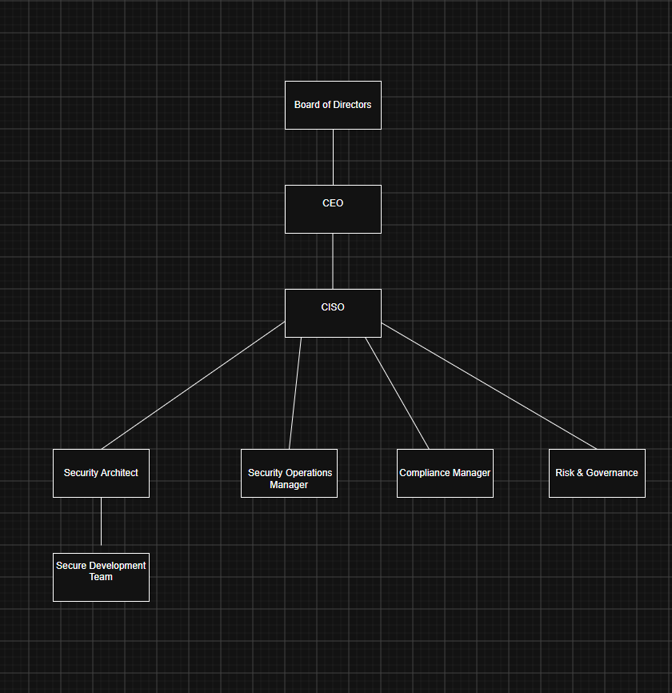
Figure 1 Proposed cybersecurity governance structure
Chief Information Security Officer (CISO)
The CISO should have responsibility for the overall cybersecurity strategy and should report directly to senior leadership. This ensures that security risks receive appropriate attention and funding.
The CISO responsibilities should include:
- developing cybersecurity strategy;
- reporting security risks to executives;
- ensuring regulatory compliance;
- coordinating incident response activities.
Security Architect
The Security Architect should ensure that systems are designed according to security principles. This role is especially important when implementing Zero Trust because security must be considered during system design rather than added after deployment.
Responsibilities include:
- designing secure architectures;
- implementing access control models;
- supporting network segmentation;
- reviewing security requirements.
Security Operations Manager
The Security Operations Centre (SOC) team should monitor systems continuously and investigate suspicious activity.
Responsibilities include:
- analysing security alerts;
- managing SIEM monitoring;
- coordinating incident response;
- detecting abnormal behaviour.
Risk and Governance Manager
This role ensures that cybersecurity activities are aligned with business objectives. Security decisions should be based on organisational risk rather than only technical priorities.
Responsibilities include:
- conducting risk assessments;
- maintaining security policies;
- measuring security performance.
Compliance Manager
The compliance function ensures that security practices meet regulatory requirements such as GDPR and industry standards including ISO 27001.

Why this structure improves Equifax’s security posture
The proposed structure addresses one of the key problems demonstrated by the Equifax incident: insufficient accountability. When responsibility for cybersecurity is unclear, vulnerabilities may remain unresolved because no individual or department is directly responsible for managing the risk.
By creating clear ownership, organisations can ensure that vulnerabilities are identified, prioritised and addressed within defined timeframes. Additionally, direct communication between the CISO and executive leadership allows cybersecurity risks to be considered as part of wider business decision-making. [10]

This governance model also aligns with recognised international standards. ISO/IEC 27001:2022 requires organisations to define information security roles and responsibilities as part of establishing an Information Security Management System, and explicitly expects top management to demonstrate leadership and commitment to information security objectives [11]. Positioning the CISO with a direct reporting line to executive leadership therefore satisfies both a practical lesson from the Equifax breach and a formal certification requirement that many enterprise customers and regulators now expect organisations handling sensitive personal data to meet.

2.3 Policies and Procedures
A cybersecurity programme requires formal policies that translate security objectives into measurable actions. In the Equifax case, the existence of a known vulnerability that remained unpatched demonstrates the importance of effective operational procedures.
The following policies would reduce similar risks. [11] [12]

Patch Management Policy
A structured patch management process should be introduced to ensure that known vulnerabilities are resolved within appropriate timeframes.
The policy should include:

Critical vulnerabilities - Patched within a defined timeframe (for example, 7–14 days)
Vulnerability scanning - Regular automated scanning of systems
Verification - Testing that patches were successfully applied
Reporting - Regular reports to security management
This policy would directly address the Apache Struts vulnerability exploited during the Equifax breach.

Asset Management Policy
Organisations cannot protect systems they are unaware of. Therefore, maintaining an accurate inventory of hardware, software and applications is essential.
The policy should require:
- identification of all internet-facing systems;
- ownership assigned to every asset;
- regular asset reviews;
- removal of unsupported software.
Improved asset visibility would help organisations identify vulnerable systems before attackers discover them.

Secure Software Development Lifecycle (Secure SDLC)
Applications should include security considerations throughout the development process rather than relying only on security testing after deployment.
Secure SDLC activities should include:
- code review;
- vulnerability scanning;
- penetration testing;
- security approval before release.
This reduces the likelihood that insecure applications become entry points for attackers.

Data Protection Policy
Since Equifax stored highly sensitive personal information, strong data protection controls should be mandatory.
The policy should include:
- data classification;
- encryption of sensitive information;
- access restrictions;
- regular access reviews;
- secure data disposal procedures.

Monitoring and Logging Policy
Continuous monitoring is a key element of Zero Trust. Organisations should define requirements for collecting and analysing security information.
The policy should include:
- centralised logging;
- SIEM monitoring;
- alert investigation procedures;
- retention requirements.
This would reduce attacker dwell time by improving the organisation’s ability to detect suspicious behaviour quickly.

2.4 Governance and Strategic Alignment using NIST Cybersecurity Framework 2.0
A successful cybersecurity programme should not operate separately from organisational goals. Security decisions must support business continuity, customer trust and regulatory responsibilities. The Equifax breach demonstrated that cybersecurity failures can create significant financial, legal and reputational consequences. Therefore, cybersecurity should be managed as a business risk rather than only a technical issue.
The National Institute of Standards and Technology (NIST) Cybersecurity Framework 2.0 provides a structured approach for organisations to manage cybersecurity risks. The framework contains six key functions: Govern, Identify, Protect, Detect, Respond and Recover.
Applying this framework to Equifax would create a more proactive security strategy.

The Cybersecurity Framework is not intended to replace existing security controls, but to provide a common structure for organising and communicating them to both technical staff and senior leadership [3]. Applying it to Equifax is particularly relevant because the breach investigation found that technical staff were aware of the unpatched vulnerability, but this information was not effectively escalated to decision-makers with the authority to prioritise remediation [8]. A framework that explicitly links technical activities such as vulnerability scanning to governance functions such as executive reporting directly addresses this communication failure.

Table 2. Application of NIST Cybersecurity Framework 2.0 to Equifax
NIST Function | Application to Equifax Security Programme
Govern | Establish cybersecurity responsibilities, policies and executive oversight through the CISO role
Identify | Maintain asset inventory, perform risk assessments and identify critical vulnerabilities
Protect | Implement MFA, encryption, least privilege access and patch management
Detect | Use SIEM, EDR and continuous monitoring to identify suspicious activity
Respond | Develop incident response procedures and define communication responsibilities
Recover | Maintain backups, disaster recovery plans and post-incident improvement processes

Govern
The Govern function establishes accountability and ensures cybersecurity decisions support organisational objectives. In the Equifax case, stronger governance could have improved communication between technical teams and senior management.
The organisation should establish:
- clear security responsibilities;
- regular risk reporting to executives;
- cybersecurity performance measurements;
- security policies approved by leadership.
This ensures that cybersecurity receives appropriate resources and attention.

Identify
The Identify function focuses on understanding organisational assets and risks. One of the failures demonstrated by the Equifax incident was poor vulnerability management.
A strong identification process should include:
- complete asset inventory;
- classification of sensitive data;
- regular vulnerability assessments;
- third-party risk evaluation.
Without accurate knowledge of systems and vulnerabilities, organisations cannot effectively protect their information.

Protect
The Protect function focuses on reducing the likelihood and impact of security incidents.
Recommended controls include:
- Multi-Factor Authentication;
- encryption;
- least privilege access;
- secure software development;
- employee security training.
These controls support Zero Trust principles by reducing unnecessary access and protecting sensitive resources.

Detect
The Detect function focuses on identifying threats as early as possible.
The Equifax breach showed that attackers remained inside the environment for an extended period. Improved detection capabilities could have reduced this period.
Recommended controls:
- SIEM monitoring;
- endpoint monitoring;
- behavioural analysis;
- automated security alerts.

Respond and Recover
Even with strong preventive controls, organisations must prepare for successful attacks.
An effective response strategy should define:
- who is responsible during an incident;
- how systems are isolated;
- how evidence is collected;
- how customers and regulators are informed.
Recovery processes should include restoring affected systems, reviewing security failures and improving controls to prevent similar incidents.

2.5 Risk Management and Assessment
A cybersecurity programme requires continuous risk assessment because threats and vulnerabilities constantly change. The Equifax breach demonstrates the importance of identifying risks before they become incidents.
The following high-level risk assessment identifies key vulnerabilities and recommended mitigation strategies. [13]

Table 3. Equifax Cybersecurity Risk Assessment
Risk | Likelihood | Impact | Risk Level | Mitigation
Unpatched software vulnerabilities | High | Critical | Critical | Automated patch management and vulnerability scanning
Unknown internet-facing assets | Medium | High | High | Continuous asset discovery and inventory management
Excessive user privileges | High | High | High | Least privilege access and regular permission reviews
Weak monitoring capabilities | Medium | High | High | SIEM and EDR implementation
Third-party security weaknesses | Medium | High | High | Supplier security assessments
Data exposure | Medium | Critical | High | Encryption and DLP controls
Lack of network segmentation | High | High | High | Implement micro-segmentation and restrict lateral movement between systems

Risk prioritisation and justification
The highest priority risk is unpatched software because this was the direct entry point used during the Equifax attack. Vulnerability management should therefore receive immediate attention.
Internet-facing systems also represent significant risk because attackers can easily identify exposed services. Organisations should continuously scan external assets and remove unnecessary services.
Excessive access permissions increase the potential damage caused by compromised accounts. Implementing least privilege access reduces the amount of information available to attackers.
Prioritising risks in this way ensures that limited security budgets are directed first towards controls that address the root cause of the Equifax breach, rather than being spread evenly across lower-impact issues, which reflects the risk-based approach recommended by the NIST Cybersecurity Framework [9].
Monitoring weaknesses are also critical because delayed detection allows attackers to remain inside systems for longer periods. SIEM and EDR solutions improve visibility and enable faster response.

Lack of network segmentation is also a high-priority risk, since it was the mechanism that allowed attackers to move from the initially compromised web application to internal databases containing sensitive records. Without segmentation, a single point of compromise can expose an entire environment rather than being contained to one system.

2.6 Compliance, Incident Response and Protection Controls

Cybersecurity programmes must consider both technical protection and regulatory obligations. Organisations that process personal information must comply with data protection requirements and demonstrate that appropriate security measures are in place.

Regulatory alignment
The General Data Protection Regulation (GDPR) requires organisations to protect personal data through appropriate technical and organisational measures. A breach involving personal information may require notification to relevant authorities within 72 hours. [14]
For an organisation such as Equifax, compliance would require:
- protection of personal data;
- documented security procedures;
- breach response processes;
- evidence of risk management activities.
These requirements are formally set out in Regulation (EU) 2016/679, which obliges organisations to implement appropriate technical and organisational measures to protect personal data and to notify supervisory authorities of a qualifying breach without undue delay, and in any event within 72 hours of becoming aware of it [10]. Alignment with ISO/IEC 27001:2022 would further support compliance by providing a certifiable Information Security Management System that demonstrates ongoing risk assessment, control implementation and management review, which regulators and customers increasingly expect from organisations handling large volumes of personal data [11].
Compliance should not be viewed only as a legal requirement. Effective compliance improves customer trust and encourages better security practices. It also provides a defensible evidence base if regulators later investigate an incident, since documented controls demonstrate that reasonable steps were taken to protect personal data.

Incident Response Plan
A structured incident response process reduces confusion during cybersecurity events.
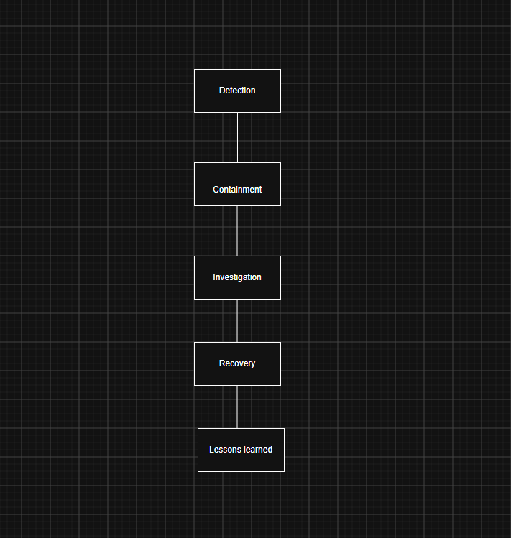
Figure 2 Incident Response Lifecycle
Detection
Security monitoring tools such as SIEM and EDR identify unusual activity and generate alerts.
Containment
The organisation isolates affected systems to prevent attackers from causing additional damage.
Investigation
Security teams analyse logs, identify the attack method and determine affected systems.
Recovery
Systems are restored safely, vulnerabilities are removed and normal operations resume.
Lessons Learned
After the incident, organisations should review what failed and improve security controls.

Technical safeguards
A modern security programme for Equifax should include:
Multi-Factor Authentication (MFA)
Reduces the risk of compromised credentials.
Encryption
Protects sensitive information if unauthorised access occurs.
Endpoint Detection and Response (EDR)
Provides visibility into endpoint activity and supports automated containment.
Security Information and Event Management (SIEM) [15]
Improves threat detection through centralised monitoring.
Automated vulnerability scanning
Identifies weaknesses before attackers exploit them.
Network segmentation
Limits attacker movement between systems after compromise.

Each of these controls directly addresses the dwell time problem demonstrated by the Equifax breach, in which attackers remained undetected for more than two months. Automated vulnerability scanning and patch management would have removed the initial entry point before it could be exploited; SIEM and EDR would have shortened the detection phase by identifying abnormal access patterns; and network segmentation would have limited the attacker's ability to move from the initial point of compromise to the systems containing Social Security numbers and other sensitive records. Applying the NIST Cybersecurity Framework's Detect and Respond functions in combination with these controls therefore provides a direct, evidence-based justification for reducing both the likelihood and the impact of a similar incident in the future [9].

Conclusion
The Equifax breach demonstrates that cybersecurity failures are rarely caused by a single technical weakness. Although an unpatched vulnerability was the initial cause of the incident, weaknesses in governance, vulnerability management and monitoring significantly increased the impact.
This report has shown that Zero Trust Architecture provides a suitable approach for modern organisations because it removes unnecessary trust assumptions and focuses on continuous verification. However, Zero Trust must be supported by strong governance, effective policies and recognised frameworks such as NIST Cybersecurity Framework 2.0.
By implementing clear accountability, proactive risk management and advanced security controls, organisations can reduce the likelihood of similar incidents and improve their long-term resilience. Together, these measures translate the lessons of the Equifax breach into a governance, risk and technology programme that is auditable, measurable and aligned with recognised frameworks such as NIST CSF 2.0 and ISO/IEC 27001 [3] [11].

References

[1] | O. B. S. M. a. S. C. S. Rose, Zero Trust Architecture, N. I. o. S. a. Technology, Ed., NIST Special Publication, 2020.
[2] | J. Kindervag, Build Security Into Your Network’s DNA: The Zero Trust Network Architecture, 2010.
[3] | N. I. o. S. a. Technology, Cybersecurity Framework, 2024.
[4] | Microsoft, Zero Trust Security: Never Trust, Always Verify, 2024.
[5] | N. I. o. S. a. Technology, Digital Identity Guidelines: Authentication and Lifecycle Management, 2020.
[6] | D. Miller, Security Information and Event Management (SIEM): Improving Security Monitoring and Incident Response, 2021.
[7] | Gartner, Market Guide for Endpoint Detection and Response Solutions, Gartner Research, 2023.
[8] | U. H. C. o. O. a. G. Reform, The Equifax Data Breach: Investigation Report, Washington DC, 2018.
[9] | N. I. o. S. a. Technology, Cybersecurity Framework, 2024.
[10] | E. P. a. Council, Regulation (EU) 2016/679: General Data Protection Regulation, 2016.
[11] | I. O. f. Standardization, ISO/IEC 27001:2022 Information Security Management Systems - Requirements.
[12] | N. I. o. S. a. Technology, Digital Identity Guidelines: Authentication and Lifecycle Management, 2020.
[13] | E. U. A. f. C. (ENISA), Cybersecurity Threat Landscape Report, 2023.
[14] | C. S. Alliance, Security Guidance for Critical Areas of Focus in Cloud Computing, 2021.
[15] | C. R. e. al., Zero Trust Architecture: Security Model for Modern Enterprises, Journal of Information Security, 2022.

