Business Report – Comparison of Corinthia Hotels and Ibis Hotels

POPA LAURENTIU COSTEL
2126893
Financial Management for the Hotel Industry (BMIH5007)
Tristan Hawkins
Word Count: 2,184
Contents
1.0 Introduction 3
1.2 Objective of Study 3
2.0 Discussions 4
2.1 Documentation of difference regarding revenue position of both businesses 4
2.2 Acknowledgement of recent market structure and engagement for both businesses 7
2.3 Investigation of general evolution related to both Organisations. 8
2.4 Global CSR processing related to both businesses based on current position. 10
3.0 Recommendation 11
4.0 Conclusion 12
References 13

Introduction

1.1 History of this research
A framework for applied engagement of financial management has been developed, which incorporates operating analysis support to manage business growth. Within the scope of strategic management, benchmarking serves as the primary conceptual structure that enables a comparison between two distinct businesses operating within the same industry, thus facilitating the evaluation of operating and financial compatibility initiatives (Drury et al., 2011).
The application of this benchmarking or comparative analysis provides an opportunity to assess whether the current operational positioning structure of the business can gain a competitive advantage through financial statutory positioning support.

1.2 Objective of study
The report evaluates various factors to determine the current operational engagement of two distinct businesses and their overall compatibility position. The targets of this report are:
- To conduct a comprehensive comparative analysis of the performance of Corinthia Hotel Group and Ibis Hotels.
- To determine the current revenue positioning support of Corinthia Hotel Group and Ibis Hotels.
- To assess the general market structure and position of both organisations.
- To evaluate the overall approach of Caesar's engagement and sustainability in both businesses.

2.0 Discussions

2.1 Documentation of difference regarding revenue position of both businesses
The assessment of a business's financial viability is a crucial aspect that entails the determination of its revenue. Revenue is a primary indicator of a business's competitive position and its ability to optimize profitability. It is a valuable metric that measures a business's overall value. By computing revenue, businesses can identify their competitive edge and sustain their value proposition. In the current financial environment, profitability is a critical factor that organisations rely on to maintain financial stability and drive profit initiatives (Walker, 2021).
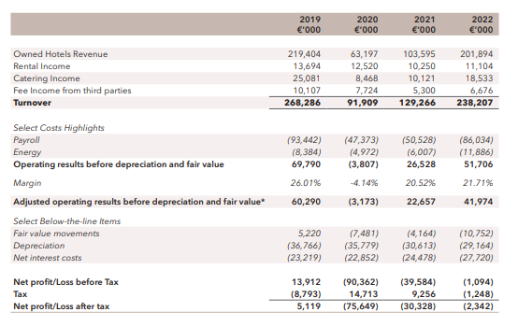
Corinthia Hotel Group

Ibis Hotels
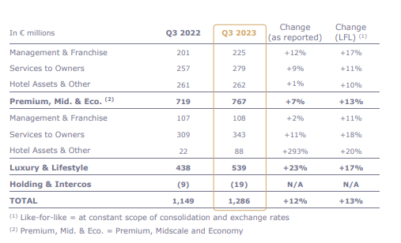
According to the evaluation conducted, it has been identified that the business revenue generated by Corinthia has exhibited a relatively expanded approach during the current accounting period as compared to the preceding year. However, the profit accrued by the business has demonstrated a declining trend, with a negative percentage change of 0.46% in the current period. These findings, when presented in a business or academic setting, would provide valuable insights into the current financial standing of the corporation.
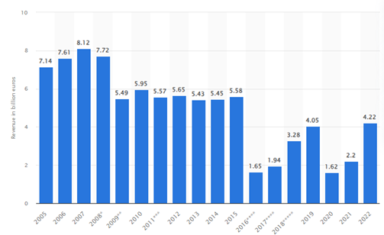
Figure 1: Accor Group’s revenue position
(Source: Statista, 2022)

Nevertheless, the present volume of revenue positioning and overall profitability level of Ibis, as a business, appears to be a relatively well-developed and optimized support in the current period, which is both progressive and accountable in generating positive opportunities. According to fundamental identifications, the 10% expansion represents a 92% expanded approach related to the revenue position, which, in turn, represents the current initiated strategic formulations by the parent company Accor. The increase in revenue positioning may be attributed to the implementation of strategic formulations by the parent company Accor (Statista, 2022).
Considering these developments, it is evident that Ibis is performing well in terms of revenue and overall profitability, which bodes well for the future of the business.
Accor, a leading hospitality company, has undertaken a significant project consisting of 93 hotels. The project encompasses a support of 15300 rooms and its primary goal is to augment business profitability volume. According to Accor Press in 2014, the project is expected to achieve a growth support of 2.40%. This ambitious endeavour is indicative of the company's commitment to expanding its operations and maintaining its position as a market leader.
Moreover, a new hotel portfolio project has been launched by a particular group. The project involves the introduction of a fresh hotel chain comprising 5,357 hotels and 789,152 rooms, alongside a pipeline of 1,218 hotels and 212,000 rooms. The management has high expectations for the project and anticipates that it will generate significant revenue, with a RevPAR volume of up to 83%. The strategic support provided by the project is expected to expand the group's revenue position to €1,149 million in the upcoming financial period (Zhang, 2022).
Based on the analysis, Ibis appears to have a sustainable and optimized revenue structure in comparison to its competitors. This suggests that Ibis Hotel is well-positioned to achieve financial stability and growth in the upcoming period (Kainthola, 2021).

2.2 Acknowledgement of recent market structure and engagement for both businesses
To optimize operational support, it is imperative to process and formulate positive market analysis. This requires developing a growth strategy that is attuned to value support. To facilitate internal development and maintain a strong competitive position, it is critical to uphold a sound market structure, which has enabled the company to expand its market successfully. The market capitalization position serves as an essential benchmark to analyse the business's performance and provide a comparative analysis against other companies.

Corinthia Hotel Group
The operational structure of the business in question represents a diverse range of 23 different hotel classifications situated across 16 nations. This strategic approach has likely facilitated the business's marketing efforts. As of the current year, the business's equity volume is valued at 817892 million GBP, while the market capitalisation of the parent company, IHI Plc, stands at €278.29 million (reuters.com, 2023).
The overall operational position of the business highlights the crucial importance of branding initiatives to effectively manage growth and systematically implement marketing strategies. In line with this, the management and parent company are keen to initiate a new project that would support the company's growth agenda. The proposed project involves the development of 18 luxury beachfront villas and the establishment of the Corinthia Yacht Club, aimed at promoting marketing and development activities (Corinthia Hotels, 2022).
Corinthia Hotel Bucharest is an organisation that offers a range of luxurious suites and fine dining options, including support for a grand ballroom, which presents a unique marketing opportunity for businesses (Metaxas and Romanopoulos 2023).
With its present position in the market, Corinthia Hotel Bucharest has established itself as a premier provider of luxury accommodation in the city. The hotel's 30 luxurious suites and fine dining options are sure to appeal to those seeking a high-end experience. Additionally, the hotel's grand ballroom provides a unique opportunity for businesses to host events and connect with potential clients. Overall, Corinthia Hotel Bucharest is a top choice for those looking to enjoy a luxurious stay in the city, while also providing ample opportunities for businesses to market their products and services.

Ibis Hotels
The current market position of the business has been evaluated through an assessment of its performance in relation to its parent company, Accor, as well as its level of operating support. Based on this evaluation, the market capitalization level of the business is presently valued at 8.87 billion GBP, with a beta level of 1.28, which indicates a lower risk assessment approach in the current market economy. Additionally, the business's volume of price-earning position is at 17.32%, which results in an EPS structure of 2.03 times in the current market economy (uk.finance.yahoo.com, 2023).
These figures provide valuable insights into the business's current market position and its potential for growth and profitability within the larger market context.
The organisation has currently adopted a consolidated leadership approach for three prominent brands, namely, Ibis, Novotel, and Pullman. This approach has rendered a positive impact by enhancing the network density and formulating a strong branding initiative for the business. Besides, the consolidated leadership approach has enabled the business to formulate a standardized marketing development position along with an economic formulation approach (Accor Press, 2023).

2.3 Investigation of general evolution related to both Organisations.
An optimized approach towards evaluating marketing growth, along with accountability support for business operating positions, results in a heightened level of accountability that ultimately manages formulated growth initiatives. The assessment of the overall operating growth structure pertinent to both businesses is provided in connection to the general operating position (Bello and Sensini, 2020).

Corinthia Hotel Group
The organisation has recently issued rollover bonds amounting to €45 million, accompanied by a 6% interest support, to provide financial development positioning support for the business. The primary objective of this new financial engagement is to commence seven hotels in the pipeline through 2026, with locations spread across Europe, the US, the Middle East, and South Asia. These business chains are expected to be established in Brussels, Bucharest, Rome, New York, Doha, Diriyah, and the Maldives.
Despite the company's current operating position, the management team has taken the initiative to launch the 126-room Corinthia Hotel Brussels, which includes a range of amenities such as a fully restored grand ballroom, an 850 sqm spa, and other features that offer positive business marketing opportunities and a strategic development approach. The launch of these new ventures is anticipated to have a significant impact on the business's long-term prospects (Fenech, 2023).

Ibis Hotels
As part of its market expansion strategy, the parent company of Accor has entered a joint venture with InterGlobe Hotels. This move is aimed at formulating a business formulation progress support, and with the launch of this joint venture, the management of Accor intends to commence on 25 new Ibis hotels with 3,000 rooms across India (InterGlobe Enterprises, 2023).
Additionally, the company has also initiated a new strategy of Ibis Styles Phuket Bangtao in Thailand, with plans for 73 new hotel projects (InterGlobe Enterprises, 2023).
Aligned with its general operating initiatives and strategic priorities, the current dynamic approach of Accor is geared towards achieving a RevPAR growth rate of 15-20% compared with 2022 in the present accounting period. This indicates a targeted EBITDA level of €920 million to €960 million in the present accounting position.
The company's present operating structure also indicates a return of €3 billion to its shareholders, supported by an optimized financial positioning. It is expected that these initiatives will have a significant impact on the business's long-term prospects, with the company poised for growth and expansion in the coming years (InterGlobe Enterprises, 2023).
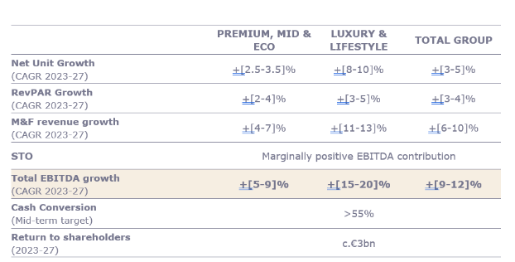
Figure 2: Accor Group’s market growth
(Source: Accor Press, 2023)

2.4 Global CSR processing related to both businesses based on current position.
Corporate Social Responsibility (CSR) has emerged as a crucial factor in determining the operational growth and performance management of individual businesses. It is an essential factor in determining which of the operating growth including the performance management position of individual businesses has been managed. Currently, the applied CSR engagement for both businesses supports a formulated growth on a sustainable basis.

Corinthia Hotel Group
The engagement of 13 board members has initiated the establishment of a Corporate Social Responsibility (CSR) committee within the organisation to cater to the development of social and environmental progress (Guilding, 2022).
The committee is primarily focused on managing the business's operating initiatives efficiently to maximize productivity while minimizing energy consumption. The CSR committee's mandate includes the distribution of resources, sustainability, philanthropic assistance, charitable giving, employee welfare, and community involvement. The committee is committed to developing a methodical strategy for implementing waste management processes.
Additionally, the organisation has collaborated with the SOAR group to provide support for positive stability growth initiatives. This collaboration aims to eliminate violations against women and children and offer appropriate CSR support. The partnership with the SOAR group aligns with the organisation's vision of promoting social responsibility and environmental sustainability (Anguera-Torrell et al., 2021).

Ibis Hotels
The present operational management of the enterprise has established a Corporate Social Responsibility (CSR) committee that has formulated a development-oriented positioning and environmental structure for managing the strategic support initiatives of the business.
The current marketing development strategy incorporates environmental initiatives aimed at achieving a trajectory of +1.5°C by 2050, and this approach forms the basis for supporting the growth of the business in a structured manner (Ibis Tallinn Center, 2023).
Furthermore, the present waste management approach of the organisation is aligned with standardized positioning support that manages sustainability initiatives in an orderly manner.

3.0 Recommendation
Based on the analysis of the current revenue position, present market structure and the general growth with the CSR approach, the following recommendations are proposed for both businesses.
For Corinthia Hotel Group
The present generated volume of business revenue for the organisation is insufficient to gain a competitive edge. Therefore, it is imperative to adopt a statutory development approach that focuses on revenue expansion with proper market promotional strategies. Additionally, the organisation must establish a cost-controlling approach to ensure future profit expansion (Alvarez et al., 2021).
Aside from the revenue positioning approach, the overall market structure of the organisation, including its parent company, does not indicate a formulated development of the positioning approach, which needs to be reformulated.
Moreover, it is crucial to control the beta level for risk management purposes. Finally, the organisation may benefit from incorporating market growth initiatives and additional projects to facilitate overall market development.

For Ibis Hotels
When compared to its competitors, the business appears to be in a favourable position in terms of revenue and profitability. However, in the long term, the business must augment its operating development and revenue streams to attain a profitability level of 25%.
In addition, the business must restructure its promotional attributes, including its social media engagement and corporate social responsibility initiatives, to enhance its goodwill formulations and customer engagement volume.
Although the parent company's market structure demonstrates comparatively formulated support with a low-risk assessment approach, the management department must concentrate on internal operating positions and controlling approaches to successfully initiate service expansions and new projects. By doing so, the business can productively expand its operations and revenue streams (Mueller and Sensini, 2021).

4.0 Conclusion
To conclude, it can be stated that contemporary positioning support requires the meticulous maintenance of individual accounting details and non-financial analysis, contingent upon the accuracy of data and positive evaluation basis that represents competitive positioning support. The application of strategic tools can significantly enhance the overall performance of hotels. Companies must consider both CSR approaches and cost control measures to foster a positive public image and improve profitability.

References
Alvarez, T. et al. (2021) ‘Management accounting practices and performance of SMEs in the Hotel industry: Evidence from an emerging economy’, International Journal of Business and Social Science, 12(2), pp.24-35.
Accor Press (2014) Ibis family reaches over 1,700 hotels and pursues its pioneering revolution. press.accor.com. Available at: https://press.accor.com/la-famille-ibis-depasse-les-1-700-hotels-et-poursuit-sa-revolution-pionniere_5714_5714/?lang=en (Accessed: 7 February 2024).
Accor Press (2023) Accor unveils its strategic priorities and its medium-term growth ambitions. press.accor.com. Available at: https://press.accor.com/accor-unveils-its-strategic-priorities-and-its-medium-term-growth-ambitions/?lang=en (Accessed: 7 February 2024).
Anguera-Torrell, O. et al. (2021) COVID-19: Hotel industry response to the pandemic evolution and to the public sector economic measures. Tourism Recreation Research, 46(2), pp.148-157.
Bello, C. and Sensini, L. (2020) ‘Financing decisions of SMEs in the hotel industry’, International Journal of Academic Research in Accounting, Finance and Management Sciences, 10(2), pp.9-14.
Corinthia Hotels (2022) UPLIFTING LIVES. www.corinthia.com. Available at: https://www.corinthia.com/globalassets/corinthia-global/documents/development/corinthia-development-presentation-may-2023-compressed.pdf (Accessed: 7 February 2024).
Drury, C. (2021) Management and Cost Accounting (11th edition), London, Prentice Hall.
group.accor.com (2022) Annual report. group.accor.com. Available at: https://group.accor.com/-/media/Corporate/Investors/Documents-de-reference/ACCOR_RI_2022_UK_vlast.pdf (Accessed: 7 February 2024).
Fenech, R. (2023) Corinthia to inaugurate seven new hotels by 2026. whoswho.mt. Available at: https://whoswho.mt/en/corinthia-to-inaugurate-seven-new-hotels-by-2026#:~:text=Corinthia%20Group%20has%20seven%20hotels (Accessed: 7 February 2024).
Guilding, C. (2014) Accounting Essentials for hospitality managers (3rd ed.), London, Routledge. Available at: ProQuest Ebook Central - Reader (Accessed: 7 February 2024).
Ibis Tallinn Center (no date) SUSTAINABILITY. www.ibistallinncenter.ee. Available at: https://www.ibistallinncenter.ee/sustainability/ (Accessed: 7 February 2024).
InterGlobe Enterprises (2024) InterGlobe Announces Major Expansion of ibis Hotel Network in India. www.interglobe.com. Available at: https://www.interglobe.com/InterGlobe-Announces-Major-Expansion-of-ibis-Hotel-Network-in-India (Accessed: 7 February 2024).
Kainthola, V.P. (2021) Principles of hotel management. Global Media. Available at: Principles of Hotel Management (gci.edu.np) (Accessed: 7 February 2024).
Metaxas, T. and Romanopoulos, A. (2023) A literature review on the financial determinants of hotel default. Journal of Risk and Financial Management, 16(7), p.323.
Mueller, A. and Sensini, L. (2021) Determinants of financing decisions of SMEs: evidence from the hotel industry. International Journal of Business and Management, 16(3), pp.117-127.
Vella, M. (2021) Difficult pandemic year costs Corinthia Hotels owner IHI €90 million in losses. www.maltatoday.com.mt. Available at: https://www.maltatoday.com.mt/business/business_news/110107/difficult_pandemic_year_costs_corinthia_hotels_owner_ihi_90_million_in_losses (Accessed: 7 February 2024).
reuters.com (2023) Market value of International Hotel Investments PLC. www.reuters.com. Available at: https://www.reuters.com/markets/companies/IHI.MT (Accessed: 7 February 2024).
Statista (2022) Accor Group: revenue 2022. Statista.com. Available at: https://www.statista.com/statistics/266261/revenue-of-the-accor-group/#:~:text=The%20revenue%20of%20Accor%20Group (Accessed: 7 February 2024).
uk.finance.yahoo.com (2023) Accor SA (AC.PA) stock price, news, quote & history – Yahoo Finance. Available at: https://uk.finance.yahoo.com/quote/ac.pa/ (Accessed: 7 February 2024).
Walker, J. R. (2021) Introduction to Hospitality, (Eight, Global edition.), Harlow, Pearson. Available at: ProQuest Ebook Central - Reader (Accessed: 7 February 2024).
Zhang, C (2022) Third-quarter 2022 revenue of €1,149 million up 83% like-for-like. Accor – Newsroom. Available at: https://press.accor.com/third-quarter-2022-revenue-of-e1149-millionup-83-like-for-like/?lang=en (Accessed: 7 February 2024).

