Module: BMPF7010
Work-Based Learning Project (Extended)

A modern study of acting through song:
A document analysis.

By Lydia Froud
1921124

Word Count: 14,333

Contents
Table of Contents
Project Proposal 3
Context 3
Justification 3
Project aims 4
Intended impact 4
Learning objectives 4
Project 5
Context 5
Justification 5
Project aims 6
Intended impact 7
Learning objectives 7
Projected plan of study; GANNT chart. 8
Methodology 9
Ethical Considerations 9
Insider Research 10
Methods 10
Overview of research undertaken 12
Data Production 21
Findings 22
Limitations 41
Summary/Conclusion 41
Future directions 43
References 44

Project Proposal

Context
I am a graduate and ex-musical theatre performer, in 2018 I moved away from performing to focus solely on contemporary commercial music (CCM) (LoVetri, 2002) singing voice teaching. Many of the clients I work with are aspiring to train and work professionally in musical theatre, and this work happens in my own studio and in an independent school. This research is inspired by my experiences as a student in tertiary musical theatre education, as a private singing teacher, and from previous studies I have undertaken. The students I work with want to authentically embody a character for performance and to find appropriate emotion, something I have found difficulty instructing them to do. There was a realisation that I had been teaching the way I was taught, asking students to recall a time they felt the way their song intends, and to replicate it in the present. This exercise is something both I, and my students, all struggle with and lead me to searching for better methods. In 2021, I undertook a course in EmoVerity for emotional induction aimed at adults (aged 18+) wanting to emote in performance more authentically, whilst it helped my skills, its foundation of emotional effector patterns is not commonly recognised in the United Kingdom. This course made me aware of the nuances of induced and perceived emotion for actors and I now seek out the same for my students. There is a lack of research for acting through song techniques, and this study hopes to develop a framework for educators to regulate teaching practices, and that might inform my own pedagogy to help learners under my instruction and find a consensus of the best way to guide them.

Justification
There is a need for clear teaching protocols and evidence-based frameworks because research in this area is scant. Literature on this topic is primarily founded in anecdotal and personal opinions either as published books or word of mouth, or via paid private courses where certification is required to use the taught methodology. Whilst there is great value in teaching perspectives and experiences, this project is searching for evidence-based knowledge to serve as the groundwork for singing teachers to safely and confidently coach acting through song in adolescent and adult pre-professional musical theatre singers. Analysing the current themes in the literature this study would support our understanding of what acting through song means and what should teachers be offering their clients in terms of skills that develop awareness of emotional granularities, accessibility for inducing and stepping out of appropriate emotion, and protects the singing voice in response to emotive physiological changes. Singing teaching is an unregulated industry with no qualifications required to start (Norton, Ginsborg, and Greasley, 2019) which, alongside a lack of framework for guiding clients through emotive work, raises an ethical question regarding potential abuse of power, lack of boundaries, and damage to client wellbeing (Moor, 2023) if improperly instructed.
Acting through song is an important part of Musical Theatre students’ training (Glasheen, 2007; Weaver, 2019). Young performers incorporate elements of movement and acting with singing guided by their voice tutors, but when it comes to the acting elements teachers often use personal cues to encourage singers to find the emotional or mental connection. Typically, these cues are founded in methodologies that ask students to draw upon their own memories and experiences to bring an emotion into the present, such as Stanislavski’s emotional recall, later known as emotion memory (Benedetti, 1991; Dunbar, 2016), and Lee Strasberg’s The Method (Hetzler, 2020). Recalling memories have the potential to lead students to their emotional vulnerabilities or trauma responses, something many teachers are ill-equipped to handle if they occur (Vickers, 2023), and students who experience high intensity emotion might find it difficult to separate away from after a taught session when this happens; it would be problematic (Hetzler, 2020; Verma, 2020). Baik, Larcombe & Brooker (2018) recognised that students are an at-risk population for developing mental health problems and dysregulated emotions, and that afflicted students are far more likely to abandon their studies before the end of their first year (Baik, Naylor & Arkoudis, 2015). To teach singers blindly about accessing emotion without proper instruction and allowing students to interpret vague instruction could be seen as negligent teaching practices. In creating a framework for acting through song this project hopes to both support teachers from ethically crossing boundaries in class, therefore protecting student wellbeing and resilience, and for students to be offered clearly instructed and reliable techniques for emotional induction and connections for character embodiment in singing.
I will conduct this study as a document analysis rather than as in-person research with participants because to truly understand the current field of research there needs to be a deeper look into what documents already exist and what they reveal about teaching acting through song (Moilanen, Sivonen, Hipp, et al. 2022). Document analysis can allow the researcher to engage with a wider array of source materials, such as audio-visual, social media posts, digital interviews, and written articles as sources (Deacon et al, 2007; Karpinnen & Moe, 2011) that can be qualitatively transcribed to text. Using grounded theory, this text can be examined, coded, and categorised to reveal the underlying themes and information across a selection of documents to make best sense of the modern approaches to acting through song. Together document analysis and grounded theory will form a rigorous process for building knowledge (Mediani, 2017).

Project aims
- Answer my research question “A modern study of acting through song: a document analysis?”
- Critically review recent literature around acting through song methodologies and student wellbeing.
- Create an evidence-based framework of study that singing voice teachers can use to teach acting through song to musical theatre students, safely and appropriately.

Intended impact
Using a framework can offer educators a clear process to add to, and guide, their pedagogy in a way that can empower students and protect them by using evidence-based best practices. This project seeks methods that can induce sustainable emotional connections in singing that can be adapted for a variety of vocal repertoire and is led by emotionally literate and empathetic teachers in a safe environment. If students are an at-risk population (Baik, Naylor & Arkoudis, 2015), building a framework founded on trust and positive mental wellbeing practices could positively impact student wellbeing by bleeding from classroom practices throughout student’s personal lives, offering further mental and emotional resilience. Educators using a framework to teach from helps prevent over-stepped boundaries and add a protective layer to learner’s processes that both makes the acting through song process easier and seeks to reduce exacerbating mental and emotional wellbeing issues. Some musical theatre courses are not adequately catering to all students, creating, and implementing this would a be step towards better inclusivity and accessibility in professional training (Weaver, 2019).

Learning objectives
- To learn about acting through song techniques used by teachers and the impact they may have on student singers.
- To understand the experiences of others and how subjective emotion can be performed.
- Share this projects framework with college and tertiary musical theatre programmes in the United Kingdom to influence their current practices towards safer choices.
- To develop and use this framework in group and individual lesson scenarios to support safe and sustainable emotive singing methodology.

Project

A modern study of acting through song: a document analysis

Context
In 2018, I moved away from performing full-time following an injury, and into sung voice teaching. I teach privately from my own studio and as a peripatetic teacher at an independent school, where all the learners I work with are only interested in working with Contemporary Commercial Music (CCM) (LoVetri, 2002), and many only in musical theatre repertoire. The musical theatre singers aspire to train and work professional in London’s west end. To prepare them for the competitive industry, I regularly attend continuous personal development courses for strategies and frameworks to teach that will best support their goals, but I have found no consensus on how to teach acting through song. With no clear pathway I am surely not alone in feeling confused and lost with how expand on my current knowledge. This project stems from my own experiences in education, previous studies in this degree, and daily encounters with clients who strive to perform authentically but do not know how. I aim to grow my teaching pedagogy and assist singers to embody appropriate emotion and character, sustainably. This project seeks to learn the current trends in acting through song practice using a document analysis to extract then synthesize data from recent papers to better understand best practice.

Justification
Document Analysis is a tool for systematically surveying information (Bowen, 2009), although it can be used in conjunction with other methods, it is often used to solely “gain access to the best source of data for completing a project”, through pre-existing documents (Morgan, 2022, p.66). Being a novice researcher, undertaking a document analysis as my primary research method ensures a deeper insight into information has already been published and analysing it to understand the foundations of current acting through song trends (Corbin & Strauss, 2008; Bowen, 2009).
In musical theatre training students have regular lessons to develop their singing, dancing, and acting skills (Glasheen, 2007; Dunbar, 2016; Curtis, 2020). To master singing, they draw upon vocal technique to safely support the voice (Bourne and Kenny, 2016; Loth & Pensalfini, 2020), acting methodologies to embody characters (Mirodan, 2015; Weaver, 2019), and music theory to understand and connect to their vocal accompaniments (Davidson, 2021). Young performers trust their teacher’s guidance, but evidence-based studies on acting through song techniques are missing from published sources of literature and their knowledge is often passed from teacher to student through an oral tradition. TThe disconnect between singing education and acting techniques leaves teachers directing learners to embody personal experiences as the main source of emotion and connection in their practice (Holmes, 2018). These cues are popularly founded in a methodology that asks students to draw upon their own experiences to pull emotion from the past to the present to inspire their character (Hetzler, 2020). Stanislavski’s emotional recall, later known as emotional memory, and translated into Lee Strasberg’s affective memory exercise, more colloquially known as ‘the method’ (Shirley, 2018) draws on this and is debated by Hetzler (2020) as having a “dangerous reputation”. Encouraging students to delve into their personal memories and feelings might trigger an unwanted experience or trauma response that they do not consent to re-living, nor is this is not something most singing teachers have any knowledge or training on how to handle (Hetzler, 2020; Vickers, 2023). Ethically, educators should be working in a way that recognises and protects the most vulnerable person in any class, “you’re only as strong as your weakest link” (D’Elia, 2013).
Students are an at-risk population for developing worsened mental health and dysregulated emotions (Baik, Larcombe & Brooker, 2018), and students affected at tertiary level have a higher likelihood of not finishing their first year of study (Baik, Naylor & Arkoudis, 2015). Kahu and Picton (2019) studied student-tutor satisfaction during their first year of study, finding that attentive tutors who recognised when students struggled or were failing and subsequently reached out to them aided student wellbeing and increased course retention rates, “A caring tutor increases student motivation and engagement- in particular facilitating help seeking- and improves student belonging, wellbeing, and positive emotions” (p. 31). Music and acting students can feel affected by their work as they seek to embody and tell a story, it is no surprise that some students have reported feeling impacted negatively by their music practice as it exacerbated their own emotional health (Pecen, Collins, and MacNamara, 2018). When looking for information of student-tutor relationships in drama schools I found two damning studies. In 2014, Equity studied abuse in drama schools and, as reported in Prior, Maxwell, Szabó, et al. (2015), key figures alleged 87% of female identifying respondents were bullied, or harassed into sexual relationships, by staff in positions of power during their training. An anonymous joint study named ‘Dignity in Study’ between Equity UK, Incorporated Society of Musicians, and the Musicians Union in 2018 found, “57% reported experiencing inappropriate behaviour, 42% experienced bullying, 36% experienced gender discrimination, and 27% experienced sexual harassment”, but most concerning was 42% reporting their perpetrator of harassment, bullying, discrimination, or abuse came from a permanent faculty member at their institution (Equity, ISM, and MU, 2018). Educators have a duty of care to protect students under their guide, and pre-professional vocational training might leave young adults away from home for the first-time facing homesickness (Thurber and Walton, 2012; Pecen, Collins, and MacNamara, 2018) impacting their self-perceptions and resilience, performance anxiety induced emotional distress (Arias, 2019, and a lack of ‘emotional literacy’ or ‘emotional intelligence’ to articulate these issues (Francombe, 2002). Potential negative student experiences stemming from over feeling due to a lack of taught technical emotional induction, and the possibility of abuse by full-time staff in positions of power is a worrying prospect. This study looks not only for answers on how to teach acting through song as a technical process, holding space for ethical teaching approaches that might regulate teachers from over-stepping student boundaries, and empowers learners to self-discover their character with reliable accuracy.

Project aims
- Answer my research question ‘A modern study of acting through song practice’.
- Critically and thoroughly review selected literature in a document analysis to discuss acting through song techniques and practices.
- Form an evidence-based understanding of the key elements revealed from the documents on teaching acting through song to musical theatre students, both safely and appropriately.

Intended impact
This project aims to surface a detailed knowledge of the components required for acted song practice and offer solutions to the individual singing teachers as well as educators leading group sessions. Empowering teachers to feel confidence in guiding clients to sustainable, safe, and repeatable, emotionally connected embodiment of their character whilst offering student’s the autonomy to recognise when boundaries might be pushed and help them find the emotional literacy in their vocabulary to communicate this as part of their training (Davidson, Maxwell, and Shergill, 2022). Teachers can use the data found to inform their own practices, clarifying the ‘how’s’ and ‘why’s’ about certain vocal and acting techniques prevalence’s over others and offering a better overview of what is out there for them to try. Whilst this project will not create a framework, it does intend to support the future development of one that can be implemented into both private studios and alongside technical practitioner-based studies in full-time vocational tertiary musical theatre training as a safeguarding first, coaching second tool that is accessible, sustainable, and holds tutors accountable in the learning environment.

Learning objectives
- To learn about current trends in acting through song techniques.
- To better understand the subjective emotional experiences learners might experience in class, and how to mitigate unhelpful negative feelings as part of practice.
- Improve my knowledge of acted vocal pedagogy.
- To lay the foundations of expert knowledge in this field of study.

Projected plan of study; GANNT chart.
BMPF7010- Dissertation | Months in weeks |  |  |  |  |  |  |  |  |  |  |  |  |  |  |  |  |  |  |  |  |  |  |  | 2024-2025
Tasks | Sept |  |  |  |  | Oct |  |  |  |  | Nov |  |  |  | Dec |  |  |  |  | Jan |  |  |  |  | Feb |  |  |  |  |  | Mar
Choose Topic and Title
Proposal
Tutorials with Advisor
Draft Methodology
Draft Methods
Draft Lit Review
Sourcing Papers
Revise Methodology
Revise Methods
Data Collection
Draft Findings
Draft Conclusion
Submit First Draft
Revisions
Submit Second Draft
Draft Presentation
Finalise Project and Presentation
Presentation Deadline
Project Deadline
My project timeline has changed since the start of this project. I have selected two weeks for the both the project and presentation deadline which is due to an extension in my project deadline to account for a personal health issue that has impacted my studies. The navy blue indicates the differentiated deadline date I was allowed on this project.

Methodology
Recognising my research paradigm is an important part of structuring my project (Cacciattolo, 2015; Keong, Husin, and Kamarudin, 2021), it can help clarify my worldview (Mertens, 2012) and guide me towards the most suitable research design and methods (Ugwu, Ekere, and Onho, 2021). Whilst authors debate whether researchers should structure their project by first choosing with paradigm or methodology (Okesina, 2020), I believe that by knowing my paradigm, I will best know my methodology (Ugwu, Ekere, and Onho, 2021).
A research paradigm consist of three parts: Ontology, Epistemology and Methodology (Yong, et al., 2021). In Cohen et al (2007), Hitchcock and Hughes (1995) propose all research is founded in philosophy and it is there we find our ‘ontological assumptions’, that lead to our ‘epistemological assumptions’, and helps us to determine our methodological approaches. As a novice researcher it is this information that will inform the way the research question is answered (Chilisa and Kawulich, 2012).
Outside this research, I work primarily with adolescent singing voices and adapt my teaching to suit the individual, and acting-through-song requires descriptive, often emotive language to help them find appropriate affective experiences. Emotion is subjective as we all experience it differently (Hetzler, 2020) and I must assume clients have experienced certain emotion to be able to find it for performance. Subjectivity of emotion means recognising that there are multiple realities (Morgan, 2020), my experience of sadness might differ to yours, but working with the voice means knowing research has proven and established that as we change our vocal pitch, our vocal folds oscillate thicker or thinner in relation to the frequency vocalised (DeJonckere and Lebacq, 2019) which is not subjective but known, arguing that there is only one reality. This leaves the open possibility that both single and multiple realities co-exist, and I believe both subjectivity and fact can be of value, I find myself aligned with the pragmatic paradigm. Pragmatism allows flexibility for the researcher to use the tools best suited to answer the research question and is a mixed methods paradigm (Felizer, 2010). In this project I will be using a qualitative research design under a pragmatic paradigm to answer the research question as this will best serve the project (Kaushik and Walsh, 2019). Without participants, a document analysis means the data analysed will be drawn from qualitative sources of information that already exist () and contextualise the research with

Ethical Considerations
To ensure due respect and consideration is given to both this project and original source materials, ethics must be considered. Cacciattolo (2015) believes that good research attends to a professional code of conduct, responsible data collection and participant safety. The present research does not involve recruited participants but collects data through other researchers published intellectual property, and it must be considered how this information is used to maintain project validity and trustworthiness without problematic choices leaving the research open to vulnerability (Bouma and Ling, 2004; Cacciattolo, 2015).
This project focusses on emotion and acting-through-song and by choosing to not use participants, it can mitigate the risk associated with participants mental, emotional, and physical health (Cacciattolo, 2015) from potential underlying or additional factors that cannot be controlled during the course of the study. The resulting potential for harm has been minimised but cannot be zero. By respecting researchers’ intellectual property, this document analysis will endeavour to represent their work accurately and without mistranslation to “assure good faith” (Whitehead and McNiff, 2006, pg.77) and build trust with the reader.
Any practices learned about during the research stage of this project will not be engaged with. Upon completion, an informed decision will be made as to whether the trends are applicable to my pedagogy and to protect my clients from harm (O’Leary, 2014; Conway, 2020) and safeguard them (Whitehead and McNiff, 2006) until the evidence-based project has been finished.

Insider Research
Having undertaken musical theatre voice training as a student, and guiding students through it as a teacher I have prior knowledge of acting through song which Merten (1972) has defined as insider research.
This project benefits from my knowledge of the language and terminology often used in teaching acting through song making it easier to choose search terms and feel desensitised to the culture of how students and teachers alike approach the subject with less judgement (Aguiler,1981). Mercer (2007) shares the advantageous nature of having researchers able to recognise and translate data. It must also be considered that my “greater familiarity” (Greene, 2014) might mean objectivity is lost, putting the research at risk based on personal assumptions (DeLyser, 2001), and liable to bias relating to previous interest and experience in this area of practice, possibly influencing the discussion or conclusions to this project (Greene, 2014).

Methods
Whilst pragmatism is a mixed methods paradigm, this project bases this research solely in qualitative methods because it can “offer a multi-layered view of the nuances of social reality” (Hesse-Biber, 2010, p.546) and “foster a more accurate description of views held” (Howe, 2004, p.54). Mixed methods have often placed qualitative data collection second to quantitative, using it to confirm the quantitative results, but the use of qualitative data and analysis gives power to “social justice and social change as primary research objectives” (Hesse-Biber, 2010, p.456). Geertz (1973) felt qualitative methods can provide thorough data, whilst Pistrang and Barker (2012) respect the access to under-researched areas of study, valuing generation of data from literary sources. Working under the guide of pragmatism allows me to choose the methods best suited to answering the research question (Felizer, 2010), and Gillespie et al. (2024) places each method’s meaning into their consequence, “…the meaning of a research method is in what it does” (p.78). Allowing for my worldview and the information that is being analysed, a qualitative pragmatic methodology for this project was chosen.
Grounded Theory is amongst the earliest “systematic approaches to qualitative research” (Pistrang and Barker, 2012), with Mediani (2017) describing it as a rigorous, inductive research method for data acquisition that seeks to form new theories rather than build upon old ones. This project aims to explore modern research on how to act through song, and by using grounded theory, the work can be approached without prior opinions nor biases that may impact the validity of this study.
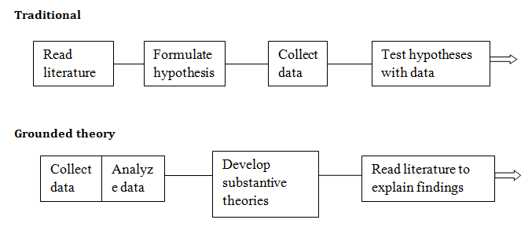

Figure 1: Found in Mediani, 2017, adapted and based upon Jones (2005) model

Document Analysis is a qualitative research method used to extract data from existing sources of information (Kaae & Traulsen, 2015; Moilanen, Sivonen, Hipp, et al. 2022) and what this reveals about the world (Karppinen & Moe, 2011). In Karppinen & Moe (2011) the researchers debate what constitutes a document, highlighting that documents are items which can be transcribed with language, and that primary sources are reliant upon the researcher and their question to decide what is worth studying and, therefore, a primary document (Altheide, 1996). Deacon et al. (2007) acknowledges the flexibility and inclusivity of document analysis’ accepting audio-visual or artwork as artefacts (Syvertsen, 2004, translated in Karppinen & Moe, 2011; Moilanen, Sivonen, Hipp, et al., 2022). To systematically search for documentation, search terms that align with the eligibility criteria will be selected, which in turn decides what will be included and excluded from my study (Meline, 2006).
Journaling is a qualitative method used to process thoughts on the work that is being done throughout the project. This project will utilise more than one journaling process to best capture my understanding of the work as it becomes clearer.
Reflexive memo is a form of journaling that is specific to grounded theory, it is a written account from the researcher’s insight of the analysis as it happens through the coding process (Mohajan and Mohajan, 2022; Rogers, 2018). The codes discovered are from my interpretation of the documents analysed, using a memo will support my chosen descriptions and connections (Saldãna, 2016) but become an important step between data collection and starting to write up my project (Charmaz, 2006; Mohajan and Mohajan, 2022). This felt relevant to my project especially because it could be written formally, informally, or conversationally (Glaser, 2013), the latter aligning best with the subjective nature of my project but also true of a grounded theory study, “do what works for you” (Charmaz, 2006).
Reflection-on-action is a journaling procedure that follows an event rather than being completed concurrently to it (Veine, et al, 2019). Reflection is a core process to learning as both learning and reflection are connected and needed for competent integration of new theories in practice (Schön, 1983). It can help to develop critical self-assessment skills (Austin, Gregory, and Chiu, 2008), independence in personal study (Dillon, 2010), and a chance to recognise progress made against my initial learning goals (Giguere, 2012). It will be important to reflect upon my practices in line with the data collected and the conclusions drawn from this study to gain a better understanding of the impact of my current pedagogy and assess how I can improve (Myllkyoski-Laine, et al. 2024).
Self-taped body doubling is the name this project has assigned to this process. It involves filming myself working as a form of body doubling. Body doubling is a “community-driven phenomenon primarily employed by neurodivergent individuals”, often facilitated using phone and video calls, or live streams but it is not necessary for this action to be live (Eagle, Baltaxe-Admony, and Ringland, 2024). Only one paper exists regarding body-doubling, but anecdotally it is a helpfully regarded process for persons with Attention Deficit Hyperactivity Disorder (ADHD) to complete tasks and fulfil goals (Villines, 2024). The self-tapes will be uploaded to an Instagram social media account under the handle, @lydiashutup, where the caption of the recorded session can be used as a reflection-on-action journal entry.

Overview of research undertaken
The process for selecting documents began by creating an inclusion and exclusion criterion, this was followed to evaluate the suitability of peer-reviewed papers. Searches were limited to be within Journal of Voice and Voice and Speech Review as reputable publications that would plausibly be the first place singing teachers might access to source information on acting through song. Stanislavski studies has been included due to the prevalence of emotion recall and other Stanislavskian exercises.

Inclusion | Exclusion
1. Literature published in Journal of Voice, or Voice and Speech Review, or Stanislavski Studies. | 10. Literature published in another journal, website, or found in web searches.
2. Published in English with full-text online access | 11. Not published in English, and without full-text online access.
3. Published within the last 5 years, from 3rd September 2019. | 12. Anything published before 3rd September 2019 will not be considered.
4. Includes the terms, ‘acting through song’ or, ‘emotion’ or, ‘musical theatre’ or, ‘drama school’ within the titles, abstract, or keywords. | 13. Papers that do not include the search terms ‘acting through song’, ‘emotion’, ‘musical theatre’, and ‘drama school’.
5. Discusses singing with emotion, the student or teacher experience of acting through song, or expert performance pedagogies dealing with this topic. | 14. Does not focus on acting through song or singing with emotion, regardless of author or pedagogy.
6. Reviewing or collating data from adult participants or environments. | 15. Data/information involving children.
7. Discusses or uses Contemporary Commercial Music (CCM) only. | 16. Focus on Classical styles.
8. Qualitative studies, interviews, or documents involving spoken or written word as the basis of the study | 17. Quantitative studies, data involving statistics, or
9. Inclusion based on additional reason. | 18. Exclusion based on additional reason.
Table 1: Inclusion and exclusion criteria for the Document Analysis

Criterion were selected following a guideline laid out in Meline (2006) who highlights most criteria belong to the following categories: a) study population, (b) nature of intervention, (c) outcome variables, (d) time-period, (e) cultural and linguistic range, (f) methodological quality. Evaluating prospective studies against my criteria means all studies are considered with equal respect and admitted to review based on their individual relevance to my research question (Robey and Dalebout, 1998).
The journals searched were all treated to the same search terms and filters to ensure validity in capturing documents methodically. All journals were searched through their primary databases. Journal of Voice via their website, both Voice and Speech Review and Stanislavski Studies via Taylor and Francis Online who facilitate all their peer-reviewed pieces with digital accessibility.

Journals Searched | Search Terms
Journal of Voice  Voice and Speech Review  Stanivslaski Studies | ‘Acting through song”  “Emotion”  “Drama School”  “Musical Theatre”
Table 2: List of sources and search terms

The search terms used were “acting through song”, “emotion”, “drama school”, and “musical theatre”. Each search was completed independently of each other to cast a wide enough net that raised the chances for related papers to be discovered.
Journal of Voice | >5 years | # of found documents | # selected of documents
"Acting through song" |  | 23 documents | 3 selected
"Emotion" |  | 64 documents | 4 selected
"Drama School" |  | 1 document | 1 selected
"Musical Theatre" |  | 14 documents | 2 selected
Voice and Speech Review | >5 years | # of found documents | # selected of documents
"Acting through song" |  | 232 documents | 10 selected
"Emotion" |  | 134 documents | 5 selected
"Drama School" |  | 128 documents | 3 selected
"Musical Theatre" |  | 154 documents | 10 selected
Stanislavski Studies | >5 years | # of found documents | # selected of documents
"Acting through song" |  | 4 documents | 3 selected
"Emotion" |  | 13 documents | 5 selected
"Drama School" |  | 3 documents | 0 selected
"Musical Theatre" |  | 4 documents | 3 selected

Eighteen documents were selected for review after document sourcing, removing duplicates where search terms found the same papers. All documents were selected based upon relevance from the title, abstract, and keywords. Papers were then lined up against the inclusion/exclusion criteria to ensure all papers met all inclusion, and no exclusion, criterions.
Author and Year | Title | 10 | 11 | 12 | 13 | 14 | 15 | 16 | 17 | 18
Blanchet, S. & Atkin, A.E. (2023) | A focus on the voice: Attention as a unifying mechanism underlying vocal training and mindfulness
Ekberg, M., Stavrinos, G., Andin, J., Stenfelt, S., & Dahlström, O. () | Acoustic features distinguishing emotions in Swedish speech
Flynn, A. (2022) | Assessment in musical theatre: A tool for transparency, equity, and student learning
Gassull, C., Molins-Macau, N., & González-Sanvisens, L. (2024) | Bodywork and singing voice: An educational tool for voice optimization.
Innes, J. (2021) | Communication and resilience in acting students: A qualitative study
Hakanpää, T., Waaramaa, T., & Laukkanen, A-M. | Comparing contemporary commercial and classical styles: Emotion expression in singing
Cox, L.K., (2023) | Creativity and Innovation in performance pedagogy: Beginning with the self
Hyde, J., Feenaughty, L. & van Mersbergen, M. () | Does vocalization increase the positive valence of emotion?
Fritz, R., Porcaro, C.K., & Gollery, T. () | Effectiveness of vocal training techniques in school-aged drama students
von Germeten, G. (2023) | Exploring original cast recordings as "Vocal Scripts": Navigating "Vocal Omnivorousness" and learning "The Sungs" of Musical Theatre
Papa, A., Cabral, A. & Gonzales, E. (2021) | Intellectual, emotional, and spiritual approaches to the Fitzmaurice voicework focus line.
Davidson, A. (2021) | Konstantin Stanislavski and Emile Jaques-Dalcroze: Historical and Pedagogical connections between actor training and music education
Evangelatou, A. (2021) | Konstantin Stanislavski and Michael Chekhov: tracing the two practitioners' "lures" for emotional activation
Shevtsova, M. (2023) | Music, singing, word, action": the Opera-Dramatic Studio 1935-1938
Conroy, C. (2024) | Nonso Anozie: It's going to come from your voice.
Vickers, S. (2023) | Origins of theatre performance and voice training in Canada: Consciously bringing trauma-informed voice into view
Moulton, B. (2023) | Professional voice and text coaching: Sparking innovation in the classroom.
Whitaker, A. (2024) | Prosodic presumptions: Challenging the monological bias of voice pedagogy and how it reinforces the prosodic somatic norm.
Melton, J., Bradford, Z. & Lee, J. () | Speak like you sing: Integrating classic techniques from theatre and music in spoken dialogue for opera.
Jones, J. (2020) | Stanislavski and the theatre of the absurd.
Ingleson, D. (2022) | Stanislavski training and mindfulness: Being in the moment
Autant-Mathieu, M-C. (2024) | Stanislavsky and voice training
Manternach, B. & Manternach, J. (2019) | Survey of University acting majors regarding the most useful elements on singing training
Ouston, J.W. (2021) | The feeling voice: A linklater approach to freeing the voice through embodied connection to image.
Kemp, R.J. (2023) | The secret of action: A cognitive exploration of eye-witness accounts of Stanislavsky’s active analysis.
Hakanpää, T., Waaramaa, T., & Laukkanen, A-M. () | Training the vocal expression of emotions in singing: Effects of including acoustic research-based elements in the regular singing training of actors.
Weaver, E.D. (2019) | Utilizing circles of attention in musical theatre acting: A personal perspective
D'haeseleer, E., Quintyn, F., Kissel, I., Papeleu, T., Meerschman, I., Claeya, S, & Van Lierde, K. () | Vocal quality. Symptoms and habits in musical theatre actors
Adams, B.J. & Morris, C. (2020) | Vocal Traditions: Acting and singing with archetypes
Carey, D. (2020) | Vocal traditions: Cicely Berry and the Central School Tradition
Norris, G. (2022) | Vocal Traditions: Steiner Speech
Boston, J. (2023) | Voice Praxis: Social Positionality in UK Spoken word practice
Brunk, A. (2023) | Voicing for life: A study to explore the benefits of Linklater voice in a community music curriculum.
Yurchak, P.M. (2019) | Walking the talk: Teachers as practitioners of Fitzmaurice voicework.

The criterion is displayed with bright yellow indicating a document passed the inclusion, orange showing the individual criteria that was accepted, and the red showing the ones which were failed. The colour palette was green and red but updated to be colour blind inclusive (Jonauskaite, et al. 2021).
Only four papers entirely met the requirements of this study, a further three may have failed on the 13th criteria, ‘Does not focus on acting through song or singing with emotion, regardless of author or pedagogy’, were, however, supportive of answering the research question therefore chosen to include. Although not focussed on singing, they have focussed on emotional experiences in acting which pedagogically can translate into singing. Whilst seven papers were selected that centred around acting through song, there was a lack of singing focus within those papers. “A limitation that systematic reviewers sometimes face is a shortage of relevant studies- those that address the purpose of the review” (Meline, 2006). The criterion was altered to accept documents from within the last ten years to expand the scope of finding vocal focussed papers.

3. Published within the last 10 years, from 3rd September 2014. | 12. Anything published before 3rd September 2014 will not be considered.
(refer to previous incl/excl/ table)
All databases were re-searched with the time-periods altered to search 2014-2019 avoiding overlap from the searches already completed.
Journal of Voice | 2014-2019 | # of found documents | # selected of documents
"Acting through song" |  | 292 documents | 3 selected
"Emotion" |  | 361 documents | 5 selected
"Drama School" |  | 43 documents | 1 selected
"Musical Theatre" |  | 100 documents | 5 selected
Voice and Speech Review | 2014-2019 | # of found documents | # selected of documents
"Acting through song" |  | 203 documents | 2 selected
"Emotion" |  | 116 documents | 3 selected
"Drama School" |  | 128 documents | 1 selected
"Musical Theatre" |  | 144 documents | 5 selected
Stanislavski Studies | 2014-2019 | # of found documents | # selected of documents
"Acting through song" |  | 48 documents | 7 selected
"Emotion" |  | 93 documents | 2 selected
"Drama School" |  | 91 documents | 4 selected
"Musical Theatre" |  | 147 documents | 5 selected

Twenty documents were pulled from a second round of sourcing and by repeating the process, removing duplicates, and comparing against the criterion, this was narrowed down to seven papers. Upon reading the papers in full, some were not helpful in answering my research question and were removed, leaving three papers entered to the study.
Author and Year | Title | 10 | 11 | 12 | 13 | 14 | 15 | 16 | 17 | 18
Moore, T, and Bergman, A. (2008) | Acting the song: Performance skills for the Musical Theatre Performer
Wilson, D. (2016) | Actor-Centred rehearsals: giving freedom and voice in the rehearsal room
Holmes, S. (2017) | Autoethnography and Voicework
Gillett, J. (2016) | Experiencing through the voice in Stanislavski's Psycho-physical approach
Watson, L., and Nayak, S. (2015) | Fitzmaurice Voicework Pilot Study
Shirley, D. (2016) | His dream of passion: reflections on the work of Lee Strasberg and his influence on British actor training
Strandberg-Long, P. (2018) | Mapping Meisner- how Stanislavski’s system influenced Meisner's process and why it matters to British drama school training today
Glasheen, K. (2017) | Negotiating the contrary craft of the triple-threat
Maxfield, L., and Manterrnach, B. (2018) | Perceptual differences between novice and professional musical theatre singers
Dunbar, Z. (2016) | Stanislavski's system in musical theatre actor training- anomalies of acting song
Samur, S. (2017) | Stanislavski's tempo-rhythm in the twenty-first century
Moor, A. (2018) | The authentic actor: An examination of vocal training in the Australian conservatory Model
Dromey, C. et al. (2015) | The effects of emotional expression on vibrato
Elchuk, T. (2018) | The neurobiological basis of emotion and imagination in relationship to breath and guts: Smuklers swamp as case study
Moore, JL. (2017) | The utilization of non-classical approaches to teaching musical theatre repertoire to the undergraduate soprano voice major
Green, K., Freeman, W., Edwards, M., Meyer, D. (2014) | Trends in musical theatre voice, an analysis of audition requirements for singers
Weaver, E. (2019) | Utilizing circles of attention in musical theatre acting- A personal perspective.
Bourne, T. (2016) | Vocal qualities in Musical Theatre Voice
Linklater, K. (2018) | Vocal Traditions- Linklater Voice Method
White, AR., (2017) | Vocal traditions- Somatic Voicework. The LoVetri method

The documents selected were done to capture a current picture of modern acting through song practices by using journals where singing, acting, and vocal performance are the dominant topics. Not all documents selected are directly comparable but will be due to the lack of dedicated articles on acting through song. This study gains peripheral vision from various pedagogies and focusses which may provide additional depth and insight to this study.
Finalised sourced document list is as follows:
 | Author; Year | Title | Journal | Document summary | Document type
1 | Cox, L.K. (2023) | Creativity and innovation in performance pedagogy: Beginning with the self | Voice and Speech Review | Finding the source of authenticity of the performer in both personal and professional life, to  facilitate better connections on stage. | Forum
2 | Davidson, A. (2021) | Konstantin Stanislavski and Emile Jaques-Dalcroze: historical and pedagogical connections between actor training and music education. | Stanislavski Studies | Comparisons between Stanislavski's acting methodology and Jaques-Dalcroze's eurythmics  education systems. A shared belief in holistic performance. | Article
3 | Evangelatou, A. (2021) | Konstantin Stanislavski and Michael Chekhov: tracing the two practitioners' "lures" for emotional activation | Stanislavski Studies | Exploring two practitioners approaches to finding authentic emotion in performance focus on stimulating the emotion response | Article
4 | Vickers, S. (2023) | Origins of theatre performance and voice training in Canada: Consciously bringing trauma-informed voice into view | Voice and Speech Review | Trauma and singing voice work, heavy emphasis on the need for embodied somatic procedures in voice training to support students with trauma or emotional dysregulation to effectively engage. | Article
5 | Dunbar, Z. (2016) | Stanislavski's system in musical theatre actor training: anomalies of acting song | Stanislavski Studies | Balancing vocal integrity with believable sung voice performance using Stanislavski exercises. | Article
6 | Autant-Mathieu, M-C. (2024) | Stanislavsky and Voice Training | Stanislavski Studies | Pedagogical frameworks using Stanislavski's work supporting singing voice work exist but not clearly recognised, paper explores the principles of his work that support the singer to act appropriately. | Article
7 | Ouston, J.W. (2021) | The feeling voice: A Linklater approach to freeing the voice through embodied connection to image | Voice and Speech Review | Overview of Kristin Linklaters work, methods, and goals. Focus on freeing the breath and unnecessary muscle tension to engage the voice in an embodied and unrestricted manner. | Article
8 | Elchuk, T. (2018) | The neurobiological basis of emotion and imagination in relationship to breath and guts: Smuklers swap as Case Study | Voice and Speech Review | Discovering the application of neurobiological research onto voice and actor training, how we sensate emotion, what is happening in the body and why is it helpful knowledge in professional training | Article
9 | Weaver, E.D (2019) | Utilizing circles of attention in musical theatre acting: a personal perspective. | Stanislavski Studies | Weaver describes the application of a technique they use called the 'circles of attention'. The author talks about experiences in his classroom with each circle and the challenges that arose from this, and how he moved to overcome obstacles. Teacher perception of student experience. | Article
10 | Adams, B.J. & Morris, C. (2019) | Vocal Traditions: Acting and Singing with Archetypes | Voice and Speech Review | Description of Archetypes, history of its conception, how a class utilising Archetypes typically runs and the certification process. | Forum

Journal of Voice documents that had been selected in the sourcing stage were either not relevant to the research question or involved qualitative data that does not match my qualitative research design. Half of the papers selected were from Voice and Speech Review and Stanislavski studies respectively.

Data Production
Data was extracted from the documents following inductive Straussian grounded theory; open, axial, and selective coding (Qureshi and Ünlü, 2020). Open coding (Saldana, 2016) was completed manually onto hard copies of the documents, reading through them multiple times to achieve saturation (Urquhart, 2013; Saunders, B. et al, 2017) allowing me to best interpret the data as presented without prior biases. A word-by-word method was used for this stage of the coding (Charmaz, 2006; Quershi and Ünlü, 2020).
Axial coding was performed by grouping themes that arose in the open coding stage. By compiling each papers codes together, categories were created using coloured highlighters to organise and form themes in a visual way revealing each documents trend. A second round of axial coding occurred to ensure the information was fully understood, this was done using diagrams connecting the subcategories that could be linked, which resulted in merging and renaming the categories more precisely.
Supported by writing a reflexive journal, the synthesized data was explored through a more critical lens (Olmos-Vega, et al. 2023) and addressed my thoughts and reactions concurrently to the coding.
Selective coding was the final process and was used to integrate all categories into a definitive, unifying theme for this data: ‘psychophysical voicework’.

Findings
These findings will explore the codes, categories, and data that were extracted from the documents. The time-period covered the ten years from 3rd September 2014- 3rd September 2024, the commencement date of this project.
None of the papers examined presented original findings. The papers were dominantly literature reviews of practitioners (Dunbar, 2016; Elchuk, 2018; Weaver, 2019; Adams & Morris, 2020; Davidson, 2021; Evangelatou, 2021; Ouston, 2021; Vickers, 2023; Autant-Mathieu, 2024, interview discussions (Cox, 2023), or personal recollection of methods in action (Weaver, 2019). Only two papers involved voices from more than a single perspective, Cox (2023) discusses creativity in performance with Shannon Vickers, and Adams & Morris (2020) joint authored their paper on vocal archetypes.
The trends from the documents were found through coding, and in the axial coding stage, they were categorised to narrow down the information. Two top level categories were found:

‘Self’-Awareness | Teaching Strategies and Considerations
- Muscle tension  - Somatic sensing  - Nervous system regulation  - Movement  - Breathwork | - Methods  - Lyrical analysis  - Emotional literacy  - Holistic approach

The codes revealed a trend in somatic sensing suggesting actors listen to their body’s responses, feelings, and tensions, and approach characterisation with ‘self’-awareness. Teaching strategies inform the educator how to find ‘self’-awareness through exploration of methods to experience emotion without forcing it that help vocal embodiment. The research question seeks to understand recent acting through song practices. To best answer the questions, the categories and sub-categories were broken down to understand why these are so prominent from the selected papers.
The documents selected came from two journals, Voice and Speech Review and Stanislavski Studies, their subject contextualised from vocal and acting pedagogy, some blended. Six papers came from an acting pedagogical background, and seven from voice. Three papers were from a place of shared pedagogy, informed jointly. The practices laid out in the documents are acting methodology heavy, but even if not designed for the voice, they are applicable to singing voice work.
Teaching strategies and considerations
The papers examined recognised eleven exercises that teach character development and embodiment. The practitioners will be acknowledged by their surnames in this paper, Stanislavski, Chekhov, Linklater, Jaques-Dalcroze, and Armstrong & Rodgers. All were discussed in the documents in various capacities for their methods or individual exercises.
In the documents, Stanislavski is spelled with both an ‘i’ and ‘y’ at the end of his surname. For continuity, ‘Stanislavski’ was adopted as the most used spelling for in quotes and discussions in this paper (Froud, 2020). Stanislavski and his exercises from ‘system of physical action’ were discussed prominently and referenced five exercises amongst the papers.
- Actioning
- Circles of attention
- Emotion memory
- Given circumstance
- Tempo-rhythm
Weaver (2019), a musical theatre acting teacher, believes Stanislavski’s exercises provide accessible lyrical analysis for Musical Theatre singers to embody sung character. Stanislavski’s approach to text applies directly to song lyrics “it’s not so much the words as the intonation, the melodic patterns, the sound, and the rhythm that define the meaning” (Autant-Mathieu, 2024, p.3). Stanislavski’s ‘system’ is crafted for actor training but he himself saw no difference between the actor and singer enabling ‘actors, during the process of preparing for a role, to approach a song and its lyrics as they would a play and its spoken word” (Dunbar, 2016, p.64). Dunbar (2016) suggests that a blended internal approach to “psychophysical work and emotions” (p.3) is ideal to current musical theatre actor study, integrating the core principles of triple threat work in “an emotionally invested way” (p.3). Stanislavski is taught popularly in acting classes, being able to transfer the terminology and exercises students already have familiarity can be of benefit to their development (Weaver, 2019).
Actioning is an exercise for working the emotional journey a character follows through lyrical analysis, representing sung lyrics as a spoken monologue (Dunbar, 2016). Dunbar (2016) explores actioning as it involves breaking a story into coordinated narrative driving actions, they create an internal score which works along to the music in a “shared language such as ‘beats’, ‘intentions’, tempo-rhythm’, ‘structure’, ‘phrases’, and ‘through-lines’” (Dunbar, 2016, p.67). Singers read lyrics and music comparably, from left to right, and treating our understanding of the music and lyrics similarly helps us to process the information we are receiving but not all texts align with the music, “The text and music may work against each other to tell a story” (p.67). To get the most out of the process, actioning can be done by mastering the physical “(‘relaxation’, ‘fitness’, ’flexibility/control’, ‘concentration’, ‘awareness, ‘imagination’, and ‘spontaneity’)” and the vocal “(‘voice production, rhythm and pulse, diction and appreciation of words’, and ‘characterisation’)” (p.68) independently to each other as they may inspire a singer in different ways. Whilst actions and intentions may shift in line with the given circumstances, the “musical notation concretises sound in more or less exact durations, rhythms, and pitches, and such predetermined temporal-spatial frameworks demand from the actor a qualitatively different sense of spontaneity or performance experience from that accorded by text verse” (p.67). Psychophysical approaches need both the physical and psyche, but vocal mastery is needed to embody a character’s emotional intentions accurately (Dunbar, 2016).
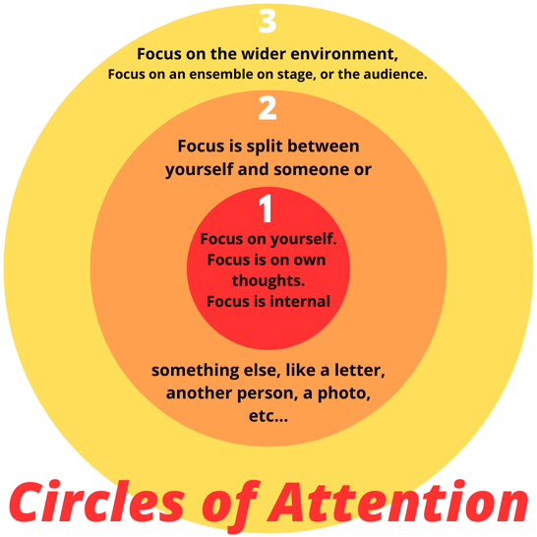
Weaver (2019) is the only paper to discuss the exercise of Circles of Attention.
Circles of attention is an exercise used to find a character’s focus, intended to help the performer zone in on a specific attention. Each layer widens or narrows the characters worldview, depending on whether you are moving outwards or inwards. Weaver asked students to select contrasting songs for each focus to work on ‘out of context’ giving their character a new given circumstance in each piece. Weaver recounts how students embodied the transfer of personal energy centres between focusses, how this interacted with movement and character intentions, and how these aligned with the music they are singing, pauses, pitches, and rhythm.
Stanislavski’s given circumstances is a process that takes a performances circumstance and context from being represented by a performer, to live with a full commitment to the stakes of the imaginary world their character finds themselves in (Elchuk, 2019; Evangelatou, 2021). It is recognised that an embodied full belief of the action “triggers a strong emotion” (Evangelatou, 2021, p.26). Using given circumstance and circles of attention to support each other, Weaver (2019) found he can guide students from “analysis of the text (that) was solely based on emotional feelings and not on active solutions to the obstacle” (p.249).
Authenticity was a priority to Stanislavski, his system sought integration of psychological and physical techniques to anchor actors analytically and emotionally in their work (Davidson, 2021). Inspired by Théodule-Armand Ribot and his view that the nervous system holds all past experiences and a stimulus to one of these might induce the memory in the present, Stanislavksi developed emotion memory, a ‘sixth sense’ tool for actors (Davidson, 2021). Emotion Recall is an exercise in recalling past experiences to harness personal memories for performance before it was abandoned and reframed as ‘affective memory’. Whilst there is ethical criticism of emotion recall “Stanislavski’s early experiments in emotional memory brought actors to the point of hysteria and affected their nervous systems” (Moore in Evangelatou, 2021, p.27), he argued the validity of actors always bringing their own relevant experiences on stage with them, and that they need to learn to keep “safe artistic distance to the events that caused similar experiences in real life” (p.27). Stanislavski maintained emotion should not be faked, nor forced, but induced with props and scenery as a lure for emotional embodiment (Evangelatou, 2021). Working with emotion memory is not about reliving the past in the present but recognising what was experienced (Evangelatou, 2021) and generating versions of that emotion in the present instead (Evangelatou, 2021; Autant- Mathieu, 2024).
Tempo-Rhythm is discussed by Autant-Mathieu (2024), it involves actors mimicking singers, exploring rhythms “three- and four-beat measures, triplets, syncopations etc” (p.9) and using metronomes whilst sight reading monologues “allegro, presto, largo, andante” (p10). Stanislavski wanted to develop the imagination and musicality of speech, using piano accompaniment to set a pace in rehearsals through embodied dynamic phrasing. He aspired for students who would have an innate sense of vocal mastery, able to bring musicality to speech, and motion to the whole experience. It was noted how singers were able to hear action expressed through the music but struggled to connect to the characters plots, the intentions, and motivations.
Stanislavski’s exercises are all psychophysical, meaning they support the bodies physical system with our internal world of feeling. For the modern musical theatre singer, it is not enough to just sing well, but show and experience the journey too. Like Stanislavski, Michael Chekhov’s work consists of psychophysical exercises for bringing an actor’s inner life out. Psychological gesture externalises a character’s super-objectives condensed into a single action as an entry point to internal experience (Evangelatou, 2021).
Evangelatou’s (2021) paper learns that qualities of movement are for inducing and developing emotional nuance and granularities of emotion, “a physical action performed with a certain quality awakens sensations that in turn bring forth feelings” (p.31). Active gestures and movement are altered to inspire and learn new ‘lures’ for organic emotional embodiment, overtime building receptiveness to induced emotion.
Subjectively, we all sense mood in an atmosphere and objective atmospheres acknowledges that an accurate embodiment of emotion can influence an audience,
Atmospheres can therefore turn the cerebral into the visceral and, as a result, the audience that previously engage only intellectually will begin to breathe and live together with the characters onstage once the right atmosphere has been created (Evangelatou, 2021, p.32).
The inner life of a performer is impacted by the “powerful field of energy that penetrated the actor and activates their individual feelings” (p.32) asking them to allow the current of feelings to happen and add to the atmosphere.
‘Purified feelings’ build upon the previous process, asking performers to visualise their character and picture themselves stepping into the life they are acting, their imagination providing a rich canvas more interesting than “their own personal and unvarying mannerisms” (Evangelatou, 2021, p.33). Purified feelings simply mean the actor feels their characters authentic embodied emotion, unspoiled, without intrusion from their everyday self’s ego (Evangelatou, 2021).
Eurhythmics, ‘good flow’, is devised by Emile Jaques-Dalcroze and connects the body to the location of spontaneous expressions (Davidson, 2021). It is made up by working on:
- Rhythmics
- Solfège
- Improvisation
Eurhythmic exercises are designed to engage the whole self in space and time, and in music and movement; the body develops a new embodied aural and physical knowledge of how the music flows through muscle memory (Davidson, 2021). This approach was advanced during a time where affect was not considered important in music, only intellectual progress (Davidson, 2021).
Kristin Linklater sought a free, feeling voice, one which is connected to the self and produces a “profound richness of resonance, emotional connection and meaning which instantly echo in the hearts of the audience” (Ouston, 2021, p.221). Linklater Voice Method is taught through three exercises:
- Pure voice work
- Sound and movement
- Deconstructing text
Pure Voicework, told by Ouston (2021), brings people back to themselves, progressively releasing unnecessary bodily tensions, connecting to a full natural breath, vocalising an /f/ to relax the vocal apparatus, and sighing varying lengths and depths following prompts through imagery and action. Exploring resonance and articulation, the progression builds an inner world that can be externally shown through uninhibited vocal expression. Character objectives are broken down through sound and movement,
“Exercises play with breath and sound as a physical energy dynamic. They explore colors, consonants, and vowels- digging beneath the language into meaning, and they physically, vocally, and creatively probe text, language, and verse form” (Ouston, 2021, p.226).
Movement and voice vibrations can regulate the nervous system expanding the range of expression, and immersive imagery carries the creative freedom without need to analytically understand the process in the moment. Imagination can be so connected to the body that visualisation can have a “physical signature” (Doidge, 2007 p.213 in Ouston, 2021, p.228).
Merging the self with the literary intentions of text or lyrics involves deconstructing text to find the trigger to make the appropriate mental and physical connections for performance (Ouston, 2021). There is focus on the words that become part of our daily vocabulary that can provide as much insight and knowledge as the big and perceivably important words,
“While the physical and vocal exploration of the ‘big’ words is intense and informative, it is the exploration of the ‘little big words’ which often produces the most surprises for workshop participants” (Ouston, 2021, p.229).
Linklater would use a variety of seven processes to motivate and inspire the inner world:
- Throwing Breath
- Colours
- Body-Mouth
- Vowels and Consonants
- Text and Images
- River Stories
- The Vowel Ladder (Zoo Woe Shaw) (Ouston, 2021)
Inspired from Linklaters work, Elchuk’s (2018) paper focusses on the work of David Smukler. Smukler’s swamp lives in the lower torso where breath and emotional access originate in the body. A physiological delve into what connection means for the body, Smukler’s swamp challenges our assumptions of vocal scientific knowledge relating to the body and its processes through ideokinesis. Ideokinesis aligns our self-knowledge and provides a new perspective that both feelings and vibrations occur much deeper in the body and are viscerally felt in the guts.
“The metaphor of the swamp provides a reframing for the actor’s perception, a reorienting of the origin of impulse- indeed, of their imaginative, emotional, and intellectual life- from the familiar locus in the head into the unknown depths of the body” (p.150).
To access the swamp, free moving breath (habitual tensions released) collects information from surrounding organs and viscera it connects with, picking up inner changes of mood and rhythms, only a few of these inner state changes are consciously perceived by the brain. Emotion is about survival, either advancing us towards or away from a stimulus and by stopping breath we stop emotion. Breath after tension release may bring intense feelings to the surface, Smukler invites this playfully somatically exploring these state changes. The swamp holds 70-80% of the body’s immune cells adding to our gut-based feelings, “we simply must play from our guts” (p.157).
Vocal archetypes, devised by Janet Rogers and Frankie Armstrong, is the exploration of essences or primordial forms that are recognisable to all cultures throughout the world as a foundation for accessible, expressive character building (Adams and Morris, 2020). The commonality is the familiarity of character spirits within mythologies, ballads, folk tales, and epics: “The mother, the lover, the trickster, the spiritual and temporal leader, the devil” (p.335). The workflow for vocal archetypes follows a five-point structure:
- General vocal and physical warmup
- Vocal/physical preparation for the specific archetype
- The archetypal journey
- Stepping out
- Reflection and discussion
Adams and Morris (2020) found whilst there is a flow, this is just a flexible base for leaders to adapt depending on the group they are working withs needs. The leader guides participants through a spoken story which the group in their own space begin to embody, free from expectation and judgement, sometimes using music to emphasise moments within the story. They might be guided to speak or move specifically and if they do not know already know which archetype, they are embodying they will start to see the reveal in the process which is digested in a meditative couple of minutes at the tail of the practical work (Adams and Morris, 2020). The sessions can flexibly move into journaling or drawing if it feels necessary to the process, or into a step out procedure which neutralises intense emotion by calming the nervous system and bringing the group back to themselves (Adams and Morris, 2020). The intention of vocal archetypes is to understand the core-essence of the character they are working on and how to embody that spirit whilst working on specific nuances that liven the character.
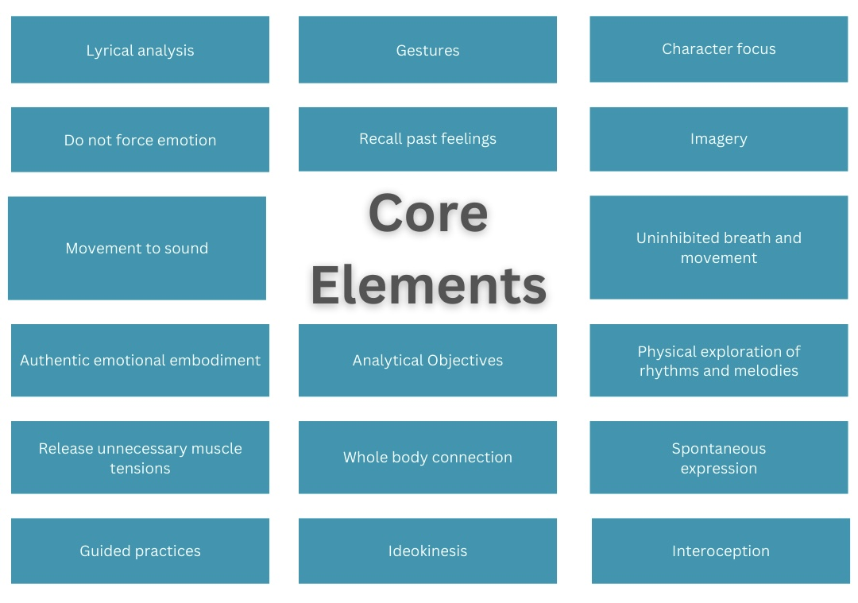
Breaking down the features and intentions of the above exercises was done by recognising the common trends and organising them into core elements. There is an emphasis on holistic approaches: interoception, whole body connection, spontaneous expression, and do not force emotion, and there is a recognition of practical exercise: lyrical analysis, gestures, movement to sound and physical exploration of rhythms and melodies.
Of the thirteen exercises presented, none were centred on the sung voice. Linklaters voicework concerns itself with freeing the self from tension and reclaiming natural breath patterns to liberate the voice, and whilst it is applicable to singing, that is not the primary focus. The core elements only inform part of the data, some documents were not limited to only discussing teaching strategies in the form of designed methods, there was another focus on specific issues within voice training that might impact or aid acting through song abilities.
Shannon Vickers’ paper “Origins of theatre performance and voice training in Canada: Consciously bringing trauma-informed voice into view” explores inclusivity in voice training and how traumatic experiences follow the student into the studio given the chance. Vickers’ concern is the potential number of trauma survivors in any given undergraduate class, acknowledging invisible disabilities too, current training might impact those students disproportionately. She advocates for the integration of trauma informed practices, for her that prioritises embodied somatic methods that build resilience and emotional regulation. Trauma survivors experience tension at high rates because the body being an archive holds onto tension as a protective armour, but through mindful and practical exercises that encourage relaxation of these holds, an empowered voice and body might be revealed. Some students may be sensitive to addressing their pasts, Vickers feels that the
“(…) focus can and should be placed on the present-moment somatic experience and how that can be supported toward greater liberation and freedom through an explicit application of cues of safety in theatre pedagogy and curricular design” (Vickers, 2023, p.330).
The goal is safety and growth, and teachers who consider empathetic, compassionate, and trauma informed classroom practices.
In a transcribed interview, Shannon Vickers talks to Lisa Karen Cox (2023) about her classroom practices and how she sees bodies as archives,
“The body itself as an archive means that there is so much knowledge contained within the body, that if you allow the body to express on its own, it’s going to have a level of authenticity and truth that you just cannot get if you’re coming from the prefrontal cortex” (Cox, 2023, p.337).
She encourages her students to find love and respect for themselves, offering a “soft landing for that authentic self” (p.339) through brave spaces that help to “connect inward without our experience, our body, our knowledge, our lived experience” (p.342). Cox and Vickers both resonate similar thoughts in their discussion regarding the body as an archive and how as educators they look to guide students “back to themselves” (p.338).
- Reclaiming body and breath
Finding personal pulses, rhythms, and expressions that each person can use to reconnect to their organic and most authentic selves.
- Brave spaces
An alternate studio practice to safe spaces. Cox acknowledges that culturally safe spaces were created for certain people in a certain culture. Brave spaces, however, are environments where challenges and mistakes happen, and gives a soft place to land for students when they mistakes are encountered.
- Bi-directional relationships
Rapports between students and teachers, not broken down but flattened out allowing learning to be a fluid current back and forth without distinct hies. Students learn from the teacher and build a relationship where “students feel safe enough to challenge you” (p.364), and teachers listen, act on feedback, and open to the student perspective.
- Interdependent community
A trusting environment where each person supports, cares, and socially engages with each other. Respect and patience for your peers while embracing who you feel most authentic being. A big emphasis on gentle encouragement and never forcing expectations.

- Empathetic inclusivity
Respecting student’s boundaries and needs for each given session, adapting and encouraging them to take what they need when they need it. Every person “regardless of identified or unidentified, labelled or unlabelled, all of them have needs” and teaching them to regulate and identify what their body needs shows they “take on that accountability and responsibility personally to engage in the work” (p.344).
- Self-reflection
Taking stock of all the above elements, Cox refers to “reflecting upon your pedagogy” as a gift because it gives you chance to “think and reframe, or change. An opportunity to change is a gift, I think” (p.346).
Educators must be prepared for the needs of their class, “the pedagogue must have around 20 thousand new exercises ready to go” (Stanislavski in Davidson, 2021), and part of that includes a duty of care to their students empowering them, creating a comfortable and welcoming environment that supports growth relevant to their training, and respects everyone has different needs (Cox, 2023).
Methods as training approaches are helpful processes, but there is a resounding need for ‘self’-awareness in these papers. The codes revealed several types of ‘self’ focus:
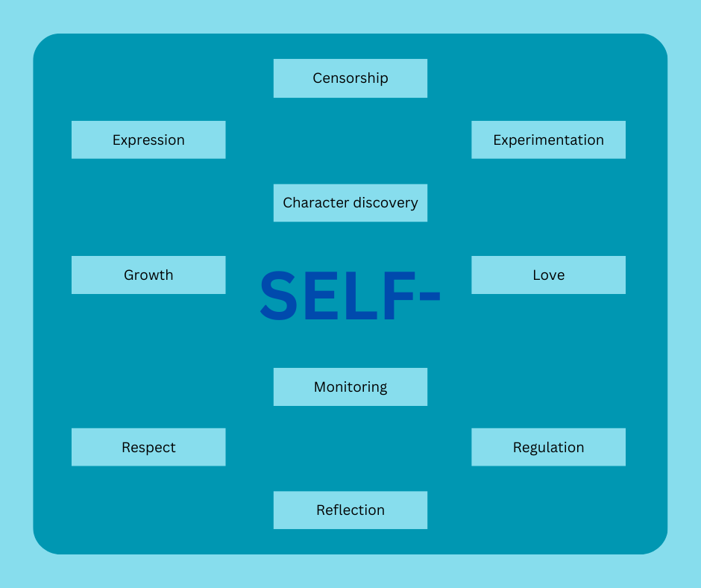
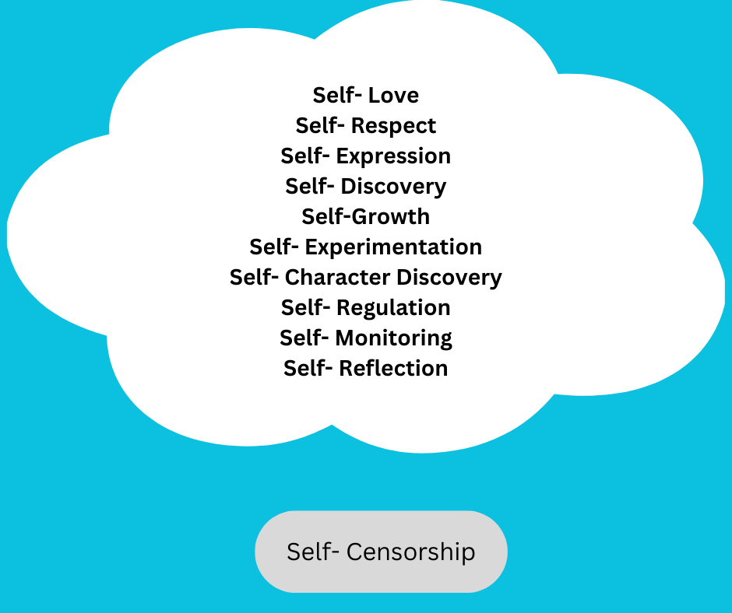
The findings shift from a sole teaching practice to an embodied ‘self’ focussed experience. The codes emphasise that students need to sense changes in their bodies and tune into interoception to inform their work. As seen in figure 3, the codes when shifted show that self-love and respect become the foundations for expression and discovery, which lead to growth and the confidence to experiment with character discovery. Being able to do those means achieving or working towards self-regulation, monitoring, and reflection. Coxs’ (2023) experience is that student’s resist the concept of just ‘being’ and the notion they are beautiful. Self-censorship resists the freedom of letting go, guarding the self as a protective armour, and therefore set apart from the other codes, but could be the start of a cycle. Methods provide guidance in varying capacities to have holistic teaching experience, but there is a shift to focusing on the internal life, somatic sensing.

‘Self’- Awareness of the body, and the mind, and the emotions we feel in ourselves are qualities voice teachers strive to help students achieve in their voice practice (Ouston, 2021). It is an acknowledgment of the whole being, and for singers it is about somatically becoming attuned to which musculature holds and tensions may be affecting vocal freedom (Ouston, 2021). Muscular tension is referenced in the documents as a barrier to singers and actors. In Autant-Mathieu (2024), Stanislavski’s approach to vocalising freely strongly relies on relaxing each of the voice and face muscles, whilst in Vickers (2023) she discusses how voicework intends to liberate the body to discharge tension, both looking to breath as a tool for tension release. Ouston (2021) commented on Linklaters approach noting ‘voice training is dealing with unconscious emotional survival responses which may restrict the freedom and range of vocal expression and stifle the acting process’ (p.223) and that ‘physical awareness and the release of muscle tension are key’ (p.225). Jaques-Dalcroze’s work believed ‘muscular action produces harmonic tension and release’, meaning that certain devised muscle patterns can be beneficial to a vocalist’s musicality (Davidson, 2021, p.189), and this is echoed too in Dunbar (2016) “‘muscular patterning’, a physiological activity that entails learning the appropriate anatomical alignments to produce specific qualities that suit that style of a song…” (p.68). Dunbar sides with Autant-Mathieu and Vickers by bringing awareness to the restrictions muscle tension causes to the breathing apparatus. Lisa Karen Cox’s interview is more spiritually guided and rather than addressing tension or releasing tension, she calls it ‘aligning spirit, body, voice, and expression authentically’ (Cox, 2023, p.338). The documents highlight three areas to combat unnecessary muscle tensions.
- Breath work,
- Physical muscle patterns and movement,
- Understanding the root cause of why the muscles might be tense, individual wellbeing.

Breath work
When tension affects the breath, singers present with tensions across the breathing apparatus; abdominal and intercostal muscles, diaphragm, jaw, mouth, and larynx (Dunbar, 2016; Ouston, 2021; Autant-Mathieu, 2024). Singing relies on the breathing apparatus sustaining a tension-free amount of controlled air-pressure to keep an even vocal quality (Dunbar, 2016). Singing technique aligning with quantity and quality of airflow allows different emotive vocalisations, but whilst we look to rid our bodies of unnecessary tensions, what if we require tension to convey a character’s intentions (Dunbar, 2016)? Acting through song requires an emotive journey, restricting or relaxing our muscles and altering our breathing pattern to embody sadness, anger, or joy (Dunbar, 2016). Dunbar (2016) is the only paper to address how changes to a singer’s respiration rate and body tension might translate to altered vocal colours,
“the singer might feel herself happy, angry, or saddened by the song as a whole, and this may affect the breathing patterns. For example, in an angry state, human breathing tends to become shorter and shallower, which in turn may affect laryngeal muscles, constricting the air flow in the breathing passages. The diaphragm, lungs intercostal muscles and ribcage in turn may be affected and, consequently; the singing process”. (p.70-71)
If emotional states can influence our breathing patterns, can the reverse be true? Can we access emotion through breath? Autant-Mathieu (2024) begins to answer this, she explores the non-traditional approaches of Lev Dodin’s work that differ from conservatoire training that allows actors to sing and dance as part of actor training by engaging the breath to find depth of character. This idea is founded in a Western adoption of Eastern practices, in the yogic principles of breath work there is indication that breath holds the power to induce a holistic experience (Dunbar, 2016). Whilst a briefly interesting thought, few papers raise a distinct understood relation between breath and emotional connection (Elchuk, 2021), and those who do, do not delve into the ‘why’ of it, and yet it is no secret that breath is a central need in voiced communication (Dunbar, 2016; Elchuk, 2021; Ouston, 2021), and that includes an emotional language. If we are to believe legends, Iris Warren, a holistic voice trainer for the royal Shakespeare company and the London Academy of Music and Dramatic Art (LAMDA) (Ouston, 2021), was approached in the 1930’s by a Freudian practitioner looking for help with a patient rendered unable to speak (Vickers, 2023).
“Iris got him to relax, breathe deeply and feel the sound of his voice in his body. He immediately began crying, and with a flood of tears came a flood of words. That emotion had freed his voice. Iris adapted her exercises to include the sensory impulses of thought and feeling.” (Linklater, 2018, in Vickers, 2023)
Some papers reported idiosyncratic habitual tensions from daily life bleed into our creative work creating barriers to freedom of breath (Ouston, 2021). Elchuk defines freedom of breath as “breath that is unimpeded by unnecessary tensions”, and they are the only paper that attempts to define it at all. During inhalation a free-flowing breath should make room for large volumes of air in the torso, the diaphragm descends making space for the lungs to fill, this expanding behind the ribcage sees a release in both the intercostal and abdominal muscles, this should be completely uninhibited by unnecessary tensions (Elchuk, 2021). This bleeding of emotion lives within muscle tension, it leads to interrupted performance and carries into the singer’s personal life as the muscles become habitually tense over time. Susana Bloch devised a procedure that aims to reduce this emotional bleed as part of her method, Alba Emoting, utilising a “structured physicalized breath exercise” (p. 337) and for character development practitioners teaching archetypes use this to calm the nervous system “removing the mask” to ease in and out of a role (Adams and Morris, 2020). Using breath to release the tension is one approach, but most of these also require an active body to become involved with the relaxation process.
Motion
Observing my initial coding, yellow represented the external feeling and awareness our bodies encounter; movement, physicality, and performed expression. Every document discussed the body in terms of physical movement or bodily alignment to some degree.
Each paper’s codes on the body and alignment were condensed to narrow down the core concerns. This raised repeated phrases ‘the body is an archive’, ‘relaxation’, and ‘posture’ into the foreground, and in a broader sense, the need for physical release.

 | Author; Year | Title | Journal | Document summary | Body Centric Codes
1 | Cox, L.K. (2023) | Creativity and innovation in performance pedagogy: Beginning with the self | Voice and Speech Review | Finding the source of authenticity of the performer in both personal and professional life, to  facilitate better connections on stage. | Motion, the body is an archive, embodied approach.
2 | Davidson, A. (2021) | Konstantin Stanislavski and Emile Jaques-Dalcroze: historical and pedagogical connections between actor training and music education. | Stanislavski Studies | Comparisons between Stanislavski's acting methodology and Jaques-Dalcroze's Eurythmics  education systems. A shared belief in holistic performance. | Movement and motion, muscular awareness, the body is an archive.
3 | Evangelatou, A. (2021) | Konstantin Stanislavski and Michael Chekhov: tracing the two practitioners' "lures" for emotional activation | Stanislavski Studies | Exploring two practitioners approaches to finding authentic emotion in performance focus on stimulating the emotion response | Authenticity of presented emotion, emotional activation, avoid using own memories, do not use own memories, motion, gesture, separation of performed and personal emotion.
4 | Vickers, S. (2023) | Origins of theatre performance and voice training in Canada: Consciously bringing trauma-informed voice into view | Voice and Speech Review | Trauma and singing voice work, heavy emphasis on the need for embodied somatic procedures in voice training to support students with trauma or emotional dysregulation to effectively engage. | Relaxation, motion, the body is an archive, trauma impacting physical ability to perform, release unnecessary tensions.
5 | Dunbar, Z. (2016) | Stanislavski's system in musical theatre actor training: anomalies of acting song | Stanislavski Studies | Balancing vocal integrity with believable sung voice performance using Stanislavski exercises. | Acting and singing can be complex, whole self-analysis, phonetic interpretation, relaxation, physiological patterns of muscle activation, vocal physiology, physical and vocal patterns may incur imagery.
6 | Autant-Mathieu, M-C. (2024) | Stanislavsky and Voice Training | Stanislavski Studies | Pedagogical frameworks using Stanislavski's work supporting singing voice work exist but not clearly recognised, paper explores the principles of his work that support the singer to act appropriately. | Silent communication, altering vocal tone and quality, motion, posture.
7 | Ouston, J.W. (2021) | The feeling voice: A Linklater approach to freeing the voice through embodied connection to image | Voice and Speech Review | Overview of Kristin Linklaters work, methods, and goals. Focus on freeing the breath and unnecessary muscle tension to engage the voice in an embodied and unrestricted manner. | Body centric emotive language, release unnecessary tensions, vocal restriction from tension, physical and emotional resilience, relaxation, the body remains active in stillness.
8 | Elchuk, T. (2018) | The neurobiological basis of emotion and imagination in relationship to breath and guts: Smuklers swamp as Case Study | Voice and Speech Review | Discovering the application of neurobiological research onto voice and actor training, how we sensate emotion, what is happening in the body and why is it helpful knowledge in professional training | Relax & release unnecessary tension, anatomical knowledge, alignment, the body is emotion.
9 | Weaver, E.D (2019) | Utilizing circles of attention in musical theatre acting: a personal perspective. | Stanislavski Studies | Weaver describes the application of a technique they use called the 'circles of attention'. The author talks about experiences in his classroom with each circle and the challenges that arose from this, and how he moved to overcome obstacles. Teacher perception of student experience. | Difficulty applying acting methods to singing pedagogy, physical manifestations of the voice, change physical movements, active actions, muscle memory, disconnect between voice and body in difficult phrasing.
10 | Adams, B.J. & Morris, C. (2019) | Vocal Traditions: Acting and Singing with Archetypes | Voice and Speech Review | Description of Archetypes, history of its conception, how a class utilising Archetypes typically runs and the certification process. | Movement, physical posture, moving for the voice.

Tensions might not only afflict the vocal apparatus but disrupt physiological understandings of alignment and anatomy (Dunbar, 2016). Technical vocal mastery precedes authentic emotion in performance (Dunbar, 2016), and practically applying music theory and knowledge to the physical form reinforces “the primacy of the human body as the source of all expressive impulses” (Davidson, p.190), however the threat of emotional faculties overloading the vocal ability means technical security is important (Dunbar, 2016). Voice teachers should be focussed on resolving tensions by opening the body and looking to resolve and understanding the cause of tensions (Vickers, 2023). In Elchuk (2018) tells of students who understood their ‘bodymind’, their minds understanding of their own anatomy, but often their understanding of the body is incorrect and by reorientating the bodymind to an accurate internal/external map helps students relax and enter the depths of their ‘swamp’. Stanislavski wanted the body to work with the voice to embody rhythms and phrasing by physicalising the voice, moving to learn the music internally and externally (Davidson, 2021). When the body becomes engaged in the music there is a “physical understanding that matches their aural understanding and informs their intellectual understanding” (Davidson, 2021, p.190). The body is an archive (Cox, 2023), it keeps score of all our experiences and these manifest in tensions (Vickers, 2023). Linklater, in pursuit of finding ways to unblock emotion, explored eastern practices such as T’ai Chi and Yoga to deeply know the self and relax the body of unnecessary tensions (Vickers, 2023). Another relaxation technique might be ‘stepping out’, a physicalised breathing exercise that supports self-emotional regulation, requiring action from the body to contract and release muscles alongside breathwork to align the nervous system (Adams and Morris, 2020). In calming the body and releasing tensions we are able to find The documents reveal that movement works on a deeper level, where the body learns the memory of the music somatically, neuroscience research finds there is a link between “actual, observed, and imagined movement and stimulation of the motor cortex” (Davidson, p.190).
Some papers discuss the neurobiological basis of how embodying emotion and connecting with an audience can happen; how a mood can be set. Evangelatou (2021) looks at the emotional current between actors and their audience, how they feed off each other emotionally through mirror neurons.
“This link between the feelings of the performer and the feelings of the spectator can now be further understood through the discovery of mirror neurons, the neurons that fire both when we perform and observe an action. More to the point, mirror neurons are also activated both when we experience and when we observe someone experiencing an emotion, and are therefore believed to be the neural mechanism responsible for empathy” (Evangelatou, 2021, p.23-24)
Rhonda Blair (2008) in Elchuk (2021) follows this stating that multivalent networks are built upon social learning, the more we experience the more we emotionally develop and grow, and Hanson (2009) in Elchuk (2021) agrees, “neurons that fire together, wire together”. Ouston (2021) Moods and atmospheres are not created solely by emotions, but emotions can be created by atmospheres and an “audience that previously engaged only intellectually will begin to breathe and live together with the characters onstage once the right atmosphere has been created” (Evangelatou, 2021, p.32). Neural pathways transmit information to the brain from the vocal tract, organs, head, and body which are interpreted and translated into physiological emotional responses (Ouston, 2021). Imagery relies on neural pathways to connect rising emotion and the body changes that we sense to our thoughts (Elchuk, 2021). Our senses have traditionally been known as smell, sight, touch, taste, and hearing, but Siekel, King, and Drumright (2010) in Elchuk (2021) suggest there are “at least 21 senses, and some place the number much higher” (p.525). Senses lay the foundations for translating text into an embodied and visceral experience for a character’s life to surface (Elchuk, 2021).
Polyvagal theory reinforces the scientific basis of embodiment, explaining why singers might feel a deep emotional, physical, and mental visceral connection in their characterisation (Ouston, 2021). Porges (2021) in Vickers (2023) tells us that polyvagal theory “focuses on the phylogenetic changes in the neural regulation of bodily organs” and “the theory emphasises that the human autonomic nervous system has a predictable pattern of reactivity, which is dependent on neuroanatomical and neurophysiological changes that occurred during evolution” (p.253). The vagus nerve, the tenth cranial nerve, forms a neural pathway between the body through the brainstem and, most relevantly for singers, connects to the larynx, abdomen, neck, and striated facial muscles (Ouston, 2021). Enders (2015) in Elchuk (2021) show how this can influence our internal world “experiments on humans have shown that people can be made to feel comfortable or anxious by stimulating their vagus nerve at different frequencies” (p.128). The vagus nerve transfers large quantities of information across the physical system to regulate the nervous system and influence our emotions based on sensory stimuli, yet it has been found that ninety percent of information sent from the gut to the brain is sensory, and ninety five percent of the mood regulating hormone is being produced in the gut (Elchuk, 2021; Levine, 2010). Levine’s work as reported in Elchuk (2021) finds “for every one motor nerve fiber that relays commands from the brain to the gut, nine sensory nerves send information about the state of the viscera to the brain” (2010, p.121).
The enteric nervous system is the nervous system of the gut and revealing a deep link to emotional processing. The gut sends signals to “the insula, limbic system, prefrontal cortex, amygdala, hippocampus, and anterior cingulate cortex, areas correlating roughly to the functions of “self-awareness, emotion, morality, fear, memory, and motivation”, and these signals change depending on the foods consumed, altering systemic mood and pain receptors (Enders, 2015, p.126).
Linguistically, emotions have been known to originate in the depths of the body, people might have ‘gut feelings’ about a person or situation which can be interpreted with both positive and negatively valences (Ouston, 2021; Elchuk, 2021)

Lingering disgust | Bad taste in our mouth
Disappointed | Swallow disappointment
Let down | Digest a defeat
Fearful | Scared shitless
Terrified | Shitting ourselves with fear
Anger | Making my blood boil
Revulsion | It made my skin crawl
Heartbroken | It cut my heart in two
Emotional Pain | It hit me in the heart
Anxiousness | Butterflies in my stomach

The gut is important to emotional regulation, arousal, processing, and memory formation (Elchuk, 2021).
Curricular reform was a common thread in the documents. Weaver (2019) found his time working on the University of Central Florida BFA musical theatre acting module unfocussed and open to interpretation of the chosen teacher at that time, “you can teach whatever you want in those classes” (p.246). Vickers (2023) observes a 1980’s study of performing arts training in Canada found an educational and curricular oversight to adequate training for the graduates entering the industry (Black, 1978). Educators from performing backgrounds tend to teach how they were taught engaging students in frameworks that allow “systemic racist, sexist, colonial, and albeist” views and tutors may be unable to guide students in a process that remains free from abuse (Vickers, 2023). Vickers acknowledges this is likely due to schools prioritising student success over accessible pedagogical methods (2023). Weaver (2019) does not see a difference between acting and musical theatre classes, they draw upon the same principles that would be learnt in a straight acting class, just here applied to the musical elements. However, other papers seem to feel institutions are missing that critical approach. Music students feel there is a lack of dedicated acting pedagogy for musicianship “if we as musicians are required to “pour out the real feelings of our hearts”, why do we not receive any training in the emotional life of music?” whilst acting students respond to this wonder why “if our colleagues in the music department get no training in how to feel “sad” while playing “sad” music, is it necessary for us as actors to feel “sad” while we’re playing a “sad” scene?” (Davidson, 2021, p.196). Several papers choose to utilise Stanislavski as the base to their acting curriculums (Dunbar, 2016; Weaver, 2019; Davidson, 2021), but few truly utilise the benefits of actor-musicianship skills in training (Davidson, 2021). Many musical theatre acting courses focus primarily sits on singing repertoire and improving the sung ability rather than developing acting skills (Weaver, 2019). Teachers of voice should be open to expanding their pedagogical horizons by embracing research from diverse fields of study, deepening understanding of the self from diverse science informed backgrounds (Elchuk, 2021). All papers agree that holistic psycho-physical approaches are needed to act song safely and appropriately (Dunbar, 2016; Elchuk, 2018; Weaver, 2019; Adams & Morris, 2020; Davidson, 2021; Evangelatou, 2021; Ouston, 2021; Cox, 2023; Vickers, 2023; Autant-Mathieu, 2024).
An undertone to these papers calls for teachers to consider student wellbeing as part of their classes. Cox (2023) believes in compassionate and empathetic teaching that empowers students in her classes to take what they need to succeed,
“I have literally lied down on the floor with people (…) let me know if you need something else, if you want me to interact with you, if you don’t want me to. It’s all good” (p.344).
Treating the student as an equal and flattening the studio hierarchy supports trust building in a collaborative community rather than expecting students to obey (Cox, 2023). Vickers (2023) advocates for trauma informed knowledge to become part of a voice teachers skill set, especially relevant to acting through song. She calls for continuous professional development for all theatre trainers as a standard that increases awareness of voice and theatre pedagogy and the cross disciplinary work in neuroscience, traumatology, and compassion to holistically support students build resilience and autonomy over their bodies and voices in their practice (Vickers, 2023).
“It is imperative that theatre trainers become trauma-informed to dismantle not only inherited oppressive systems in education, but to also support students as they move through the bodywork in our studios safely and with the leadership of trained educators who have some knowledge and understanding of how trauma shows up in the body, and what may happen when a student is triggered in a studio or rehearsal hall setting.” (Vickers, 2023, p.324)
Sessions finishing with a ‘Step Out’, as devised by Susan Bloch, is a process to ease high intensity of feelings by calming the nervous system and reduce tensions lingering in the body after emotional work (Bloch, 2017; Adams and Morris, 2020).

Limitations
Limitations in this project included a restriction on quantity of databases incorporated into this study which led to a limited sample size of documents. This was due to a finite window of time I had to complete my data analysis and had more documents and sources been explored; the study may not have been completed in time. The journals selected were ones that I have engaged with often and previously relevant to other studies, this knowledge led to convenience sampling to avoid learning new databases and spending time exploring new sources. By narrowing my field of vision to journals I am already familiar with I was able to direct additional time into analysis and coding the papers. Whilst the document analysis has been managed in a way that should prevent bias, my knowledge outside of this study still exists alongside it and my analysis or interpretation of the data could be subjectively impacted. The documents selected were all but one single authored that means the worldviews of the papers might be biased or narrow sighted. The only paper that was co-authored was by Bill Adams and Christine Morris (2020), however, although this provides two points of view, both authors are certified trainers in vocal archetypes which is the topic of the paper examined leading to a potential conflict of interest. Morris has served for a time on the board of VASTA (voice and singing teacher association) who publish the voice and speech review where their paper was published, and Shannon Vickers (2023) also published to the Voice and Speech review and was at the time of publication and editor for the same journal. Although neither of them reported a conflict of interest within their respective publications, there could be potential bias and these may impact the validity of the information they provide.

Summary/Conclusion
The codes developed and revealed from the documents of this study determined the themes and categories used to form the findings section. The intention was to learn about current acting through song practices and identify the trends in the literature. The codes established ‘self’-awareness and teaching strategies and considerations which provided a better overview of the students need for self-knowledge and ways a teacher can help the student find themselves. Searching for documents from within a set time frame of ten years allowed me to examine recent documents that are relevant to the present day to better understand what methods are popularly being incorporated into acting through song practice. The documents scrutinised leant heavily into psychophysical acting methodologies to teach emotional embodiment rather than dedicated approaches designed for singer; that is not unequivocally favourable because the foundations of acting would remain the same (Dunbar, 2016; Weaver, 2019). It was found because of this, singers may not be achieving their full performance potential as their curriculum lacks education on embodying emotional connections to the music (Davidson, 2021). Whilst practitioners like Armstrong and Rodgers (Adams and Morris, 2020), Stanislavski (Dunbar, 2021, Davidson, 2021; Evangelatou, 2021, Autant-Mathieu, 2024), and Chekhov (Evangelatou, 2021) are discussed because of their approaches to emotionally connecting to characters through their methods, only Linklater and Jaques-Dalcroze centre their work on embodying voice and music respectively. Some musical theatre courses are focussing on vocal repertoire exploration rather than furthering students’ performance development knowledge (Weaver, 2019), but the papers have strongly linked a rich, emotionally connected voice with freedom of breath and body (Ouston, 2021). Bringing singing repertoire into the acting studio would be of great benefit to the singer, guided by both an acting and singing voice teacher to blend pedagogies ensuring a unified learning experience for the singer.
Teachers should be encouraged to guide students to find connected authentic storytelling by providing “safe places for them to land” when they make mistakes (Cox, 2023, p.339). Offering learners a somatically attuned knowledge of their ’selves’ might help them to recognise restrictive tensions when they occur (Elchuk, 2018; Ouston, 2021; Cox, 2023; Vickers, 2023; Autant-Mathieu, 2024) and build an anatomically correct bodymind (Elchuk, 2018) from psychophysical methods. Moving forwards considerations should be made for equally considered physical and mental connections to appropriately step into the role of a character (Dunbar, 2016; Davidson, 2021; Evangelatou, 2021; Autant-Mathieu, 2024).
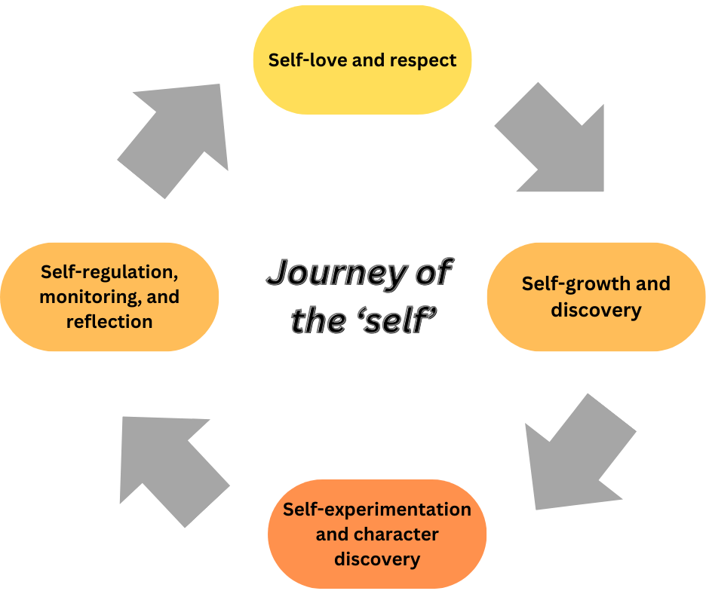

Achieving internal connection is important for musical theatre singers but there is a debate on which order the vocal mastery and acting skills should be approached (Dunbar, 2016). Even with mastery of their instrument, authentic emotion is favoured over vocal ability, but when there is too much emotion the vocal quality can be disrupted (Dunbar, 2016). If the voice is overcome with emotion, “stepping out” can be undertaken to calm the nervous system through physicalised breath-work allowing the high intensities of emotion to reduce (Adams and Morris, 2020). There is a trust needed when approaching psychophysical acting and voice work where teachers must be open to bi-directional mentorship in the studio, patiently and actively listening to learners needs and giving them space to take whatever it is that helps them absorb the work best (Cox, 2023). Having an awareness of each body’s potential archive (Vickers, 2023) that thinks, feels, and responds to stimuli differently is needed to overcome emotional blockages in the work (Ouston, 2021), create accessible and inclusive practices (Adams and Morris, 2020), and empathises with the person who we are working with (Cox, 2023).
Whilst finding authentic emotion and embodying developed characters are trends in the papers, it is psychophysical voice-work that unifies this project. It acknowledges somatic and holistic practices in musical theatre acting work and respects that the current landscape of acting through song requires a blended pedagogy between voice and acting. Educators must be open to taking on continuous personal development from within their own fields and consider that of neuroscience and traumatology to aid their knowledge professionally and ethically of emotional experiences and how that might show up in body and behaviours (Vickers, 2023). There is not one approach that currently covers all the bases needed for singers to incorporate acting into their practice but educating teachers on how to work with students to induce and experience emotional currents (Evangelatou, 2021) safely and appropriately using acting methodologies could be the way forwards.

Future directions
Looking beyond this study towards future directions, it would be of benefit for future studies to test the efficacy of psychophysical acting methods in relation to the sung voice and examining the teaching process, the learner’s experiences, and an audiences’ perceptions of successful conveying of character and emotion with and without acting methods. Exploring a selection of exercises under the same conditions in different studies would provide data to compare success rates across all data sets. No published studies that exclusively focus on the student experience of learning and performing exist, and as the population who will engage with the methods practically, their voices in the literature would be valuable for educators to learn from. Neglecting to highlight the effectiveness of methods leaves a theoretical knowledge gap (Miles, 2017). This study can be used as a starting point for future work that maps method efficacy, student wellbeing, and educator success towards building a framework in how to teach acting through song, safely, reliably, and authentically.

References
Altheide, D. (1996) Qualitative Media Analysis. Qualitative Research Methods, SAGE Publications, Inc.
Arias, G. (2019) In the wings: Actors and Mental Health: A critical review of the literature. Expressive Therapies Capstone Theses. P.109
Austin, Z., Gregory, P, Chiu, S. (2008) Use of Reflection-in-Action and self-assessment to promote critical thinking among pharmacy students. American Journal of pharmaceutical education, Vol.72, 3.
Baik, C., Larcombe, W., & Brooker, A. (2018) How universities can enhance student mental wellbeing: the student perspective. Higher education research and development. Vol.38, 4. 674-687.
Baik, C., Naylor, R., and Arkoudis, S. (2015) The first-year experience in Australian universities: Findings from two decades, 1994-2014. Melbourne centre for the study of Higher Education.
Bartlett, I. (2014) Reflections on contemporary commercial singing: an insider’s perspective. Voice and Speech Review, Vol 8, 1, 27-35
Black, M. (1978) “Report of the Committee of inquiry into theatre training in Canada”: Canada Council.
Bloch, S. (2017) Alba Emoting: A scientific Method for Emotional Induction. CreateSpace Independent Publishing Platform.
Bouma, G., and Ling, R. (2004) The research process. Fifth Ed. Oxford University Press.
Bourne, T, and Kenny, D. (2016) Vocal qualities in Music Theater Voice: Perceptions of expert pedagogues. Journal of Voice. Vol. 30, 1. 128e1-128e12
Bowen, G. (2009) Document Analysis as a qualitative research method. Qualitative Research Journal. Vol.9, 2. 27-40
Cacciattolo, M. (2015) “Ethical considerations in research”. In The Praxis of English Language Teaching and Learning (PELT). Leiden, The Netherlands: Brill. (Accessed online chapter, 15/12/24)
Charmaz, K. (2006) Constructing grounded theory: A practical guide through qualitative analysis. Sage Publications.
Charmaz, K. (2006) Constructing grounded theory. A practical guide through qualitative analysis. Sage Publications, Inc.
Chilisa, B. and Kawulich, B. (2012) “Selecting a research approach: paradigm, methodology, and methods”. In Doing social research: A global Context. Vol.5, 1. 51-61
Cohen, L., et al. (2007) Research Methods in Education. Sixth Edition. Routledge, Taylor and Francis.
Conway, C. (2020) “Chapter 1: Ethics and qualitative research in music education”. In Collecting, Analyzing and Reporting Data: An Oxford handbook of qualitative research in American Music Education, Vol 2. Oxford University Press.
Corbin, J. and Strauss, A. (2008) Basics of Qualitative Research (3rd Ed.): techniques and procedures for developing grounded theory. Sage Publications, Inc.
Cox, L. K. (2023) Creativity and innovation in performance pedagogy: Beginning with the self. Voice and Speech review.
Davidson A. (2021) Konstantin Stanislavski and Emile Jaques-Dalcroze: historical and pedagogical connections between actor training and music education. Stanislavski Studies.
Evangelatou,A. (2021) Konstantin Stanislavski and Michael Chekhov: tracing the two practitioners’ “lures” for emotional activation. Stanislavski Studies
Vickers, S> (2021) Origins of theatre performance and voice training in Cananda: Consciously bringing trauma-informed voice into view. Voice and Speech Review.
Dunbar, Z. (2016) Stanislavski’s system in musical theatre actor training: Anomalies of teaching acting song. Stanislavski Studies.
Autant-Matheiu (2024) Stanislavsky and voice training. Stanislavski studies.
Ouston, J.W. (2021) The feeling voice: A Linklater approach to freeing the voice through embodied connection to image. Voice and Speech review.
Elchuk, T. (2018) The neurobiological basis of emotion and imagination in relationship to breath and guts: Smuklers’ swamp as caste study. Voice and speech review.
Weaver, E.D. (2019) Utilizing circles o attention in musical theatre acting: a personal perspective. Stanislavski studies.
Adams, B, and Morris, C. Vocal Traditions: Acting and Singing with Archetypes. Voice and Speech Review.
Curtis, J. (2020) The mental health of musical theatre students in tertiary education: a pilot study. Studies in Musical Theatre. Vol.12, 3. 333-348
Davidson, A., Maxwell, I., and Shergill, P. (2022) Resilience and Wellbeing in Actor Training. ResearchGate, self-published.
Deacond D. et al. (2007) Researching Communications: A practical guide to methods in media and cultural analysis. Second Ed. Bloomsbury Publishing.
DeLyser, D. (2001) ‘Do you really live here?’ Thoughts on insider research. Geographical review. Vol.91, 1. 441-453
Dillon, L. (2010) Listening to voices of self: digital journaling among gifted young adolescents. Qualitative research journal. Vol.10, 1. 13-27
Enders, G. (2015) Gut: The inside story of our body’s most underrated organ. Greystone Books.
Equity, ISM, and MU, (2018) Dignity in Study: A survey of higher education institutions. https://www.ism.org/images/images/Equity-ISM-MU-Dignity-in-Study-report.pdf (accessed 17.03.2024)
Felizer, M. (2010) Doing mixed methods research pragmatically: Implications for the rediscovery of pragmatism as a research paradigm. Journal of Mixed Methods Research. Vol.4, 1. 6-16
Froud, L., (2020) Performers and Emotion: Is there a best way to teach emotion in singing and acting? Unpublished Essay, Voice Study Centre, University of Wales Trinity Saint David.
Giguere, M. (2012) Self-reflective journaling: A tool for assessment. Journal of Dance education. Vol.12, 3. 99-103
Gillespie, A., Glãveanu, V., and de Saint Laurent, C. (2024) Pragmatism and methodology: Doing research that matters with mixed methods. Cambridge University Press.
Glaser, B. (2013) Introduction: free style memoing. The grounded theory review. Vol.12, 2. 3-14
Greene, M. (2014) On the inside looking in: Methodological insight and challenges in conducting qualitative insider research. The qualitative report. Vol.19, 29. 1-13.
Hesse-Biber, S. (2010) Qualitative approaches to mixed methods practice. Qualitative Inquiry. Vol.16, 6. 455-468.
Hetzler, E. (2020) Emotion memory: “A dangerous reputation”, Stanislavski Studies. Vol.8, 1. 87-96
Holmes, S. (2018) Acting the song performance: Skills for the musical theatre. Voice and Speech Review. Vol.12, 3. 369-378.
Howe, K. (2004) A critique of experimentalism. Qualitative Inquiry. Vol.10. 42-61
https://caddac.ca/how-to-boost-productivity-with-body-doubling/ (accessed, 16/02/2025)
Jones, M. (2005) ‘Lights… action… grounded theory’: Developing an understanding for the management of film production.
Kaae, S., and Traulsen, J. (2015) Qualitative methods in pharmacy practice research. In Babar, Z. Pharmacy practice research methods. p.49-68.
Karppinen, K., & Moe, H. (2011) Chapter 10: What we talk about when we talk about document analysis.
Kaushik, V. and Walsh, C. (2019) Pragmatism as a research paradigm and its implications for social science research. Social sciences, Vol.8, 9. 255.
Keong, Y., Husin, M., and Kamarudin, S. (2021) Understanding Research Paradigms: A scientific guide. Journal of contemporary issues in business and government.
Kivunja, C. and Kuyini, A.B. (2017) Understanding and Applying research paradigms in Educational Contexts. International journal of higher education. Vol.6 (5). 27-41
LeBacq, J. and DeJonckere, P. (2019) The dynamics of vocal onset. Biomedical signal processing and control. Vol 49. 528-539.
Levine, A. (2010) In an unspoken voice: how the body releases trauma and restores goodness. North Atlantic Books.
Loth, J., & Pensalfini, R. (2020) Body. Breath. Text. Freedom: an investigation of concurrent training in Linklater voice and the Suzuki actor training method. Theatre, Dance, and Performance training.
﻿LoVetri, J. 2002. “Contemporary Commercial Music: More than One Way to Use the Vocal Tract.” Journal of Singing 58 (3): 249–252.
McCambridge, J., Witton, J. and Elbourne, D., (2014) Systematic review of the Hawthorne effect: new concepts are needed to study research participation effects. Journal of Clinical Epidemiology. Vol. 67, 3. 267-277.
Mediani, H.S. (2017) An introduction to classical grounded theory. SOJ Nursing and Healthcare. Vol.3, 3. 1-5.
Meline, T. (2006) Selecting studies for systematic review: Inclusion and Exclusion Criteria. In “Contemporary issues in communication science and disorders”. Vol.33. 21-27.
Mertens, D. (2012) Transformative Mixed Methods. American Behavioural Scientist. Vol.56, 6. 802-813.
Merton, K. (1972) Insiders and outsiders: A chapter in the sociology of knowledge. American Journal of Sociology. Vol.78, 1. 9-47
Mirodan, V. (2015) Acting the metaphor: the Laban-Malmgren system of movement psychology and character analysis. Theatre, Dance, and Performance Training. Vol. 6, 1.
Mohajan, D., and Mohajan, H. (2022) Memo writing procedures in grounded theory research methodology. Munich Personal RePEc Archive. Paper No. 115246.
Moilanen, T., Sivonen, M., Hipp, K., et al. (2022) Developing a feasible and credible method for analyzing healthcare documents as written data.
Morgan, H. (2022) Conducting a Qualitative Document Analysis. The Qualitative Report. Vol.27, 1. 64-77
Myllykoski-Laine, S., Parpala, A., Hailikari, T., Postareff, L., (2024) Using self-reflection to support higher education teaching. Reflective Practice, International and Multidisciplinary Perspectives. Vol.25, 5. 589-604.
Norton, N., Ginsborg, J., & Greasley, A. (2019) Instrumental and vocal teachers in the United Kingdom: demographic characteristic, educational pathways, and belief about qualification requirements. Music education research. Vol.21, 5. 560-581
O’Leary, Z. (2014) Doing your research project. Second ed. London. SAGE Publications Ltd.
Okesina, M. (2020) A critical review of the relationship between paradigm, methodology, design, and method in research. Journal of Research and Method in Education. Vol.10, 3. 57-68.
Olmos-Vega, FM., et al. (2023) A practical guide to reflexivity in qualitative research: AMEE guide No.149. Medical Teacher. Vol.45, 3. 241-251
Pecen, E., Collins, C., and MacNamara, Á., (2018) “It’s your problem. Deal with it.” Performers’ experiences of psychological challenges in music. Frontiers in Psychology.
Pistrang, N., & Barker, C. (2012) Varieties of qualitative research: A pragmatic approach to selecting methods. In Cooper, H., et al. (eds) APA handbook of research methods in psychology, Vol.2 research designs: Quantitative, qualitative, neuropsychological, and biological. American Psychological Association. 5-18.
Porges, S. (2021) Polyvagal Theory: A biobehavioral journey to sociality. Comprehensive Psychoneurondocrinology. Vol.7.
Prior, R., Maxwell, I., Szabo, M., & Seton, M. (2015) Responsible care in actor training: effective support for occupational health training in drama schools. Theatre, dance, and performance training. Vol.6, 1.
Qureshi, H., and Ünlü, Z. (2020) Beyond the Paradigm conflicts: A four-step coding instrument for grounded theory. International Journal for Qualitative Methods. Vol. 19
References
Aguiler, J. (1981) Insider research: An Ethnography of a debate. In D.A. Messerschmidt (ed.) Anthropologists at home in North America. Cambridge University Press. 15-26
Rogers, R. (2018) Coding and writing analytic memos on qualitative data: A review of Johnny Saldana’s The coding manual for qualitative researchers. The qualitative report. Vol.23, 4. 889-892
Saldana, J. (2016) The coding manual for qualitative researchers. Sage Publications Inc.
Saunders, B., et al, (2017) Saturation in Qualitative research: exploring its conceptualization and operationalization. Quality and Quantity. Vol.52, 4. 1893-1907
Schön, D. (1983) The reflective practitioner: how professional think in action. Basic books, New York.
Seikel, J., King, D., & Drumright, D., (2010) Anatomy & Physiology for speech, language, and hearing (4th Eds). Thomson Delmar Learning, New York.
Shirley, D. (2018) His dream of passion: reflections on the work of Lee Strasberg and his influence on British actor training- part two. Stanislavski Studies. Vol.6, 2. 165-182
Syvertsen, T. (2004) Citizens, audiences, customers, and players: A conceptual discussion of the relationship between broadcasters and their publics. European Journal of cultural studies. Vol.7, 3. 275-282.
Thurber, C. and Walton, E. (2012) Homesickness and adjustment in university students. Journal of American College Health. Vol.60, 5. 415-419
Ugwu, C., Ekere, J. and Onoh, C. (2021) “Research paradigms and methodological choices in the research process”, In Journal of applied information science and technology. 116-124.
Veine, S. et al. (2019) Reflection as a core student learning activity in higher education – insights from nearly two decades of academic development. International journal for academic development. Vol.25, 2. 147-161
Villines, D. (2024) What is ‘body doubling’ for ADHD? Medical News Today (https://www.medicalnewstoday.com/articles/body-doubling-adhd) Accessed on 16/02/2025
Visser, W. (2011) Schön: Design as a reflective practice. Collection 2010, Art and design and Psychology. Vol.2. 21-25
Whitehead, J. and McNiff, J. (2006) Action Research: Living Theory. London. SAGE Publications Ltd.
Yong, K., Husin, M., and Kamarudin, S. (2021) Understanding research paradigms: A scientific guide. Journal of contemporary issues in business and government. Vol.27, 2.
D'Elia L. (2013). Complete Guide for Functional Training [in Portuguese]. Sao Paulo: Phorte
Moor, A. (2023) Consent-based actor training as the only way forward. Theatre, dance, and performance training. Vol.14, 2. 86-102.
Jonauskaite, D., et al. (2021) Colour-emotion associations in individuals with red-green colour blindness. PeerJ. Vol.7, 9.

