Developing GrocerQuick’s delivery service

Introduction:
GrocerQuick is an online grocery delivery service that has recently encountered significant challenges in managing its delivery routes efficiently. The company is facing increased delivery delays and rising fuel costs, both of which negatively impact customer satisfaction and overall business performance. As a result, GrocerQuick requires a more structured and strategic approach to planning and optimising its delivery operations.
The purpose of this report is to deconstruct the problem into manageable components in order to clearly identify the key areas that require improvement. A proposed solution will then be outlined, accompanied by a flowchart that demonstrates the logical steps involved in enhancing delivery route efficiency. The well established MoSCoW prioritisation technique will be applied to support the analysis and guide the decision making process.

Deconstructing the problem:
To organise the business’s requirements effectively, the MoSCoW prioritisation technique will be utilize to categorise each requirement in accordance with its level of importance. This method helps classify what the company needs to address immediately and what improvements can be implemented later. The technique consists of four categories known as ‘Must Have, Should Have, Could Have and Won’t Have’. It is particularly useful in this circumstance as it highlights which aspects of the delivery service need urgent attention in order to improve performance [1].
The MosCoW analysis outlines GrocerQuick’s key priorities for enhancing the accuracy and efficiency of its delivery operations.
- Must Have requirements highlight the need for a clear and structured delivery manifest that shows each driver’s assigned route, including the order of stops from first to last. They also include reducing total travel distance to lower fuel consumption and ensuring that no delivery exceeds a thirty-minute delay.

- Should have requirements support smoother delivery operations by collecting nearby stops so drivers can walk between houses without repeatedly using the vehicle. They also include providing customers with delivery timeframes, options to reschedule, and the ability to notify the driver about their availability or request a safe place delivery, reducing time wasted at the door.

- Could Have requirements emphasise additional features that would further enhance efficiency, such as live traffic information to avoid delays, a spare sweeper driver to assist colleagues who fall behind, and a pre-sorted delivery app containing all route information. The company could also consider introducing electric vehicles to reduce fuel costs and employing a sorter to help drivers load their vans, preventing fatigue and allowing them to focus solely on delivering.
- Won’t Have requirements outline elements which are intentionally excluded from GrocerQuick’s delivery optimisation strategy due to their negative impact on feasibility or efficiency. In this situation, long distance drives between stops are considered counterproductive, due to increase fuel consumption and longer delivery times, which reduce overall route efficiency. By reducing such routes from planning, GrocerQuick may focus on compact, well structured delivery zones that support timely and cost effective operations.

MoSCoW Prioritisation Table
The below table 1.1 presents a structured MoSCoW analysis of GrocerQuick’s delivery service requirements. This technique categorises each element based on its level of importance, in this case, ‘Must Have, Should Have, Could Have and Won’t Have’ to support decision making and resource allocation. It assist with identifying which features are essential for instant implementation and which can be accounted for future improvement or excluded altogether.

Must Have | Should Have | Could Have | Won’t Have
A manifest with a route number which showing each driver’s assigned deliveries | Multi location grouped stops so driver can walk to nearby houses | A spare driver as a sweeper to help delayed drivers | Long distance drive between stops
Shorter travel distances between stops to reduce fuel consumption | Live traffic information to avoid late deliveries | App with all the stops pre sorted with timeframes
Deliveries delivered no more than 30 minutes late | Customers notifications with delivery timeframes | Electric vehicles
 | Sufficient number of drivers to cover all routes | Sorter to help drivers load vans
Table 1-1: MoSCoW Prioritisation Table for GrocerQuick's Delivery Services

Variables:
The variables in this delivery business are the factors that change on a daily basis and can affect the business overall performance. These include the number of items customers order, the total number of delivery stops, the distance between each delivery location, and the number of drivers available on a given day. Since these elements are not constant, GrocerQuick needs a flexible operational plan which can adapt to daily fluctuations or last minute changes in demand or resources [1].

Constraints:
The constraints in this delivery business are the fixed limits that GrocerQuick should work towards when planning routes. One of the most important constraints is the number of drivers available, as this determines whether all routes can be covered and whether spare drivers are available to cover sickness or support colleagues who fall behind. Fuel cost also act as a constraint, because they must be kept as low as possible to maintain profitability. Time is another crucial constraint, since deliveries should not be more than thirty minutes late. In addition, external factors such as traffic conditions, weather, and customer availability can also affect how quickly drivers can complete their route and must therefore be considered during planning [2].

Proposed Solution:
The proposed solution is illustrated through a flowchart below, which outlines the logical steps required to optimise GrocerQuick’s delivery process. The process starts with the collection of essential input data, including customer orders, delivery addresses, expected delivery time windows, and the number of drivers available for that day. These inputs are then pre-processed by geocoding each address and calculating the distances between delivery points, which provides the foundation for accurate route planning [2]. In order to create efficient delivery zones, deliveries within the same geographical area are grouped together, minimising unnecessary travel and supporting efficient route allocation.

Algorithms are widely used in logistics as they reduce total travel distance and fuel consumption while ensuring that operational constraints, such as vehicle capacity and delivery time windows, are met. Once the initial routes are generated, the system will calculate the estimated delivery time for each stop to determine whether all deliveries can be completed within the required timeframe. A decision point is then introduced to check whether any deliveries are expected to be more than thirty minutes late, if delays are recognised, the stops are adjusted and recalculated until the route meets the required time constraints. This process ensures that the final routes are both realistic and efficient.

After the routes are calculated and validated, the routes are then assigned to drivers, and a manifest with all the stops is printed for each route. The manifest includes all delivery stops in the correct sequence, assisting drivers follow the planned route without any confusion. Drivers will then collect their deliveries according to their assigned routes and load them into the van in the same sequence as the manifest. This step is important for reducing the time spent searching for items during the delivery process and maintaining organisation. In addition, loading deliveries in order also reduces the likelihood of errors or delays and supports a smoother workflow.

When drivers begin their routes, they follow the planned order of stops generated by the optimisation process. During this stage, the system continues to monitor progress, and a second decision point checks whether any stops are late. If no delays are identified, the driver continues the route as planned. However, if delays are detected, due to traffic, unexpected disruptions or customer unavailability, a spare driver is dispatched to assist. This additional support helps prevent further delays and confirms that all deliveries remain within the expected timeframe. The use of a sweeper driver also adds resilience to the delivery process, enabling the company to respond promptly to unforeseen issues [2] [3].

The process concludes when all deliveries are completed on time. By incorporating route optimisation algorithms, time window validation, and real-time support, this solution significantly improves the efficiency of GrocerQuick’s delivery operations. It minimises fuel consumption by reducing travel distance, highlighting punctuality via continuous time check and improves customer satisfaction by ensuring timely deliveries. Overall, the proposed solution determines a structured data driven approach, which supports operational efficiency and improves GrocerQuick’s ability to meet customer satisfaction consistently.
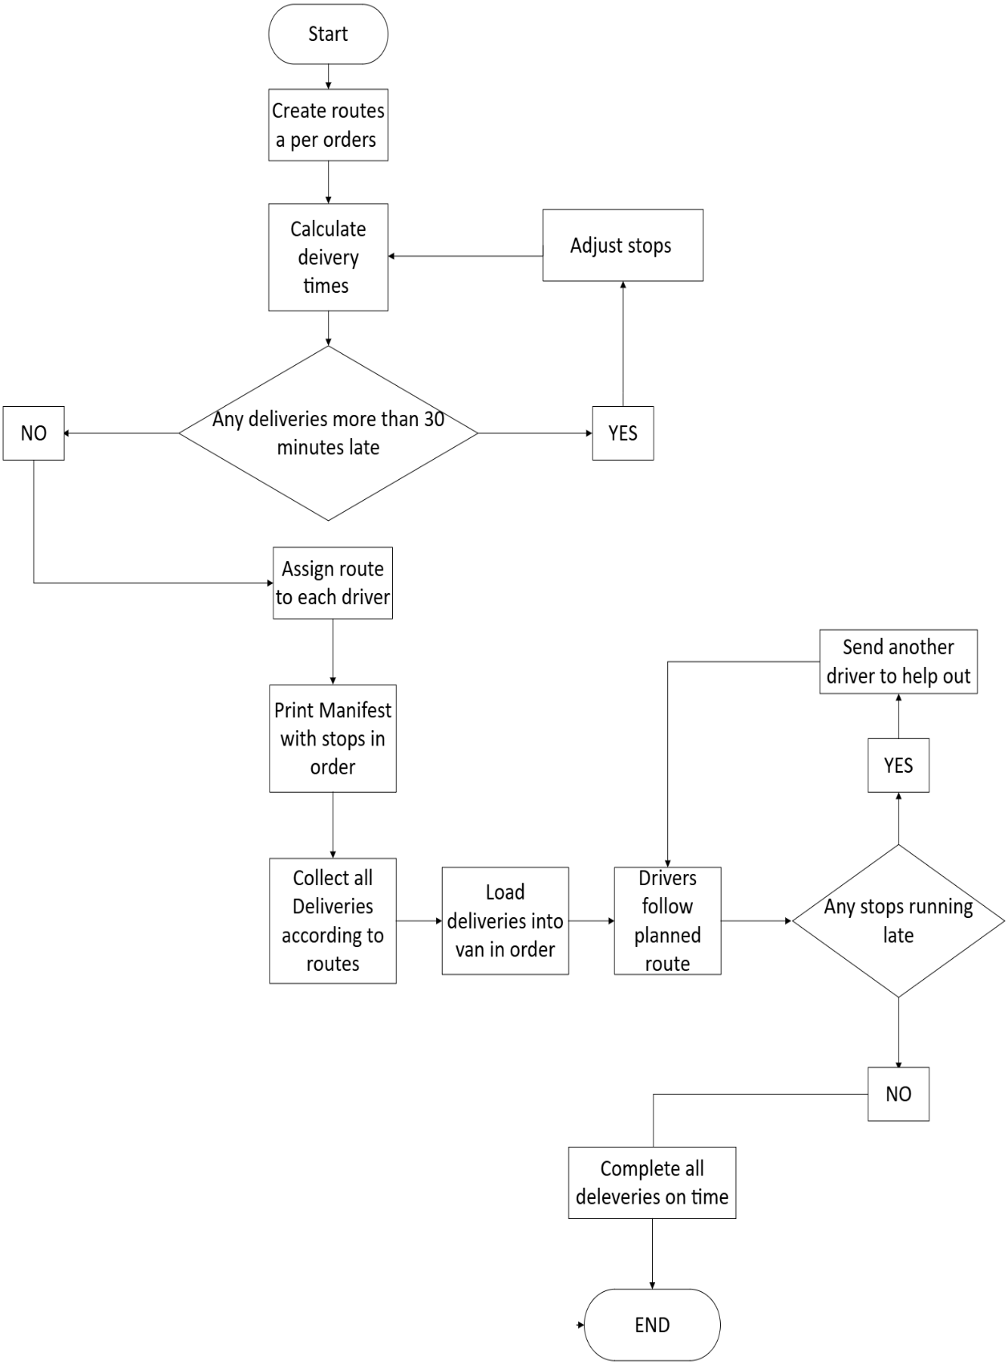
Figure 4-1 - GrocerQuick Flowchart

Reflection and Justification:

In developing the solution for GrocerQuick, a variety of problem solving techniques were applied to gain a clear and structured understanding of the challenges within the delivery of process. The main techniques used was abstract thinking, which enabled the problem to be viewed from a broader perspective rather than focusing solely on individual tasks. By investigating the delivery operation as a whole and stepping back, it became easier to understand how essential factors such as travel distance, delivery time, fuel consumption and driver availability plays and influence on another [1]. This holistic perspective was essential because inefficiencies in one area, such as route planning, can quickly cause significant delays or increased costs in another.

The next technique used was subdividing the problem into smaller, manageable components. Breaking the scenario into parts such as delivery timing, driver allocation, route planning and external effects made the analysis further focused and easier to manage. This approach assisted with separating specific issues, such as identifying where delays were most likely to occur or determining how much fuel consumption could be reduced through shorter travel distances. Subdividing also endorsed the development of a step by step solution, which is important for producing a logical and implementable process [1].

Systems thinking played a crucial role in shaping the final solution. This technique highlights the connection of different elements within a system, and in the context of GrocerQuick, it eased how external factors such as traffic conditions, customer availability and weather can directly affect delivery performance [2]. For instance, heavy traffic can cause delays that impact not only one driver but the entire delivery schedule. Similarly, poor weather conditions can slow down driving speeds or require further safety precautions. Systems thinking make sure that the solution accounted for these real world variables rather than assuming ideal conditions.

These problem solving techniques were effective as they encourage a structured analytical approach to understanding the delivery challenges. The techniques also supported the development of a solution that is both adaptable and practical, enabling GrocerQuick to respond to daily variations in order of driver availability, volume and route complexity. The use of route optimisation algorithms and time window checks reflects the application of these techniques in a real operational context [3] [4].

Nevertheless, despite the strengths of the proposed solution, various limitations must be agreed. First limitation is the reliance on accurate and up-to-date traffic information and mapping data. If this information is delayed or incorrect, the route optimisation process can produce unrealistic delivery times or inefficient routes. An additional limitation is the assumption that a spare driver will always be available to support delays. In reality, resourcing may vary, and during peak hours, having an additional driver can not be feasible. The solution also assumes that customers will be available within their delivery window, but unexpected situations such as customers not answering the door can still cause delays [3] [4].

On the whole, the combination of abstract thinking, problem subdivision and systems thinking provided a strong foundation for creating a clear and effective solution. While the approach is robust, identifying its limitations ensures that GrocerQuick can continue refining and improving its delivery operations over time. It is worth noting that, when considering the overall benefits of the proposed solution such as improved route efficiency, reduced fuel consumption, and enhanced delivery punctuality, the limitations are recognised as having minimal impact. The strengths of the solution significantly outweigh the constraints, making it a practical approach for supporting GrocerQuick’s long term operational performance.

Conclusion

This report has demonstrated how GrocerQuick can improve its delivery service by applying clear problem solving methods and a structured analytical approach. Breaking the problem into smaller components made it easier to understand what the company needs to fix and which areas matter most. The MoSCoW technique helped identify key requirements, such as reducing travel distance, improve fuel efficiency and ensuring that deliveries are not more than thirty minutes late. Although the approach has some limitations, the techniques used were effective in producing a clear and organised solution. Overall, the proposed solution provides a strong foundation for improving GrocerQuick’s delivery operations and helping the business run more smoothly.

References

[1] | E. K. J. Holyoak and R. G. Morrison, The Oxford Handbook of Thinking and Reasoning. Oxford, U.K.: Oxford University Press, 2012.
[2] | D. H. Meadows, Thinking in Systems: A Primer. White River Junction, VT, USA: Chelsea Green Publishing, 2008.
[3] | M. Fartookzadeh and M. M. H. R. Fartookzadeh, "Enrichment of systems thinking for problem solving in engineering systems using the hermeneutic loop,” Malaysian Management Journal , vol. 28, 2024.
[4] | A. H. C. Salado and A. N. A. Salado, “Systems thinking and mathematical problem solving,” School Science and Mathematics, vol. 119, no. 1, pp. 49–58, 2019.

