
Problem solving and Analysis
(FMEA – Report)
Management Innovation & Sustainability
Mechanical and Manufacturing Engineering (2nd year)
Tom Pettifer
20/11/19

Executive summary

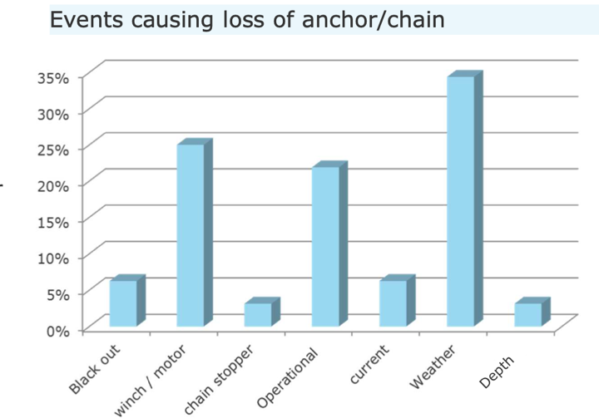
A chain link on an anchor chain has failed and resulted in damages to the vessel and another moored up vessel costing £350,000. An analysis and review of equipment and current procedures was initiated to try and prevent the event happening in future. This report looks into both design/manufacturing aspects of the anchor chain links and the procedures for the raising, lowering and inspection of the anchor chains.
Figure 1 shows that the 3 most common reasons for loss of anchor and chain were severe weather conditions, operational errors and winch/motor problems.

The analysis identified that an increase in dry dock inspections, would increase the possibility of a defect being detected before the link failed. Reducing the occurrence of the failure. During current inspections a visual test, measuring the diameters of the chain links and looking for fractures and loose studs on chain links is carried out. It is recommended that NDT testing such as magnetic particle testing is also introduced in order to help better identify surface cracks, which could cause the link to fail. Visual inspections and tests should also be carried out on the vessels hawse pipe, windlass and storage locker to reduce abrasion and equipment failures leading to excessive stress.
Figure 1- Graph to show most common reasons for loss of anchor/chain (DNV GL, Gard and The Swedish Club, 2016)

As well as an increase in the frequency of dry dock inspections, a review and improvement of the control processes used when raising and lowering the anchor would also help prevent stretching and fractures occurring during raising and lowering of the anchor. 3 clear strategies were identified to reduce excessive tension and excessive impact loads.

- A visual observation when raising the anchor, ensuring the chain is as vertical as possible when being winched in, will reduce the force required and therefore reduce tension in the chain.
- Use of windlass to lower chain in a controlled manor to 10m above the seabed before letting go, especially on a rocky seabed will reduce the impact that could occur and cause a brittle fracture when dropping the chain.
- Procedures to ensure the anchor isn’t raised or used in severe weather conditions where possible will reduce the amount of failures caused by severe weather, which is currently one of the main causes of failure.

Table of Contents
Executive summary 2
List of Figures and Tables 4
Introduction 4
FMEA Analysis 5
Corrective action plan 7
Other tools/ Techniques that could be used to investigate the problem 8
Recommendations 9
Bibliography 10

List of Figures and Tables
Figure 1- Graph to show most common reasons for loss of anchor/chain (DNV GL, Gard and The Swedish Club, 2016) 2
Figure 2- FMEA Analysis 5
Figure 3- FMEA Analysis continued 6
Figure 4- IACS recommended Proof and breaking load tests (IACS, 2014) 7
Figure 5 Specifications of Force sensing tension links (Strainsert, 2019) 8

Introduction

The purpose of this report is to investigate into why and how one of the links in a ship’s anchor chain snapped, and what possible action can be taken in future to prevent this from reoccurring.
Failure Mode Effect Analysis (FMEA) will be used to identify possible ways in which the chain link could fail and how and why the failures would occur. This tool of analysis will also help identify what current process controls are in place, and ways in which to improve upon these process controls, to try and minimise risk. A study conducted on Failure modes in lifting equipment for future U.S. Navy vessels identifies that corrosion, wear, stretching, ductile or brittle fractures or fatigue are the most common failures of an anchor chain link. It also suggests that even though poor material selection and inadequate manufacturing processes can cause failures, it is generally believed that most failures result from unexpectedly severe operating conditions. (National Research Council, 1980)
This report will look into the process controls in place regarding, the specifications of the anchor chain, the maintainace and inspections that should be carried out, as well as the process controls in place for lowering and raising the anchor.

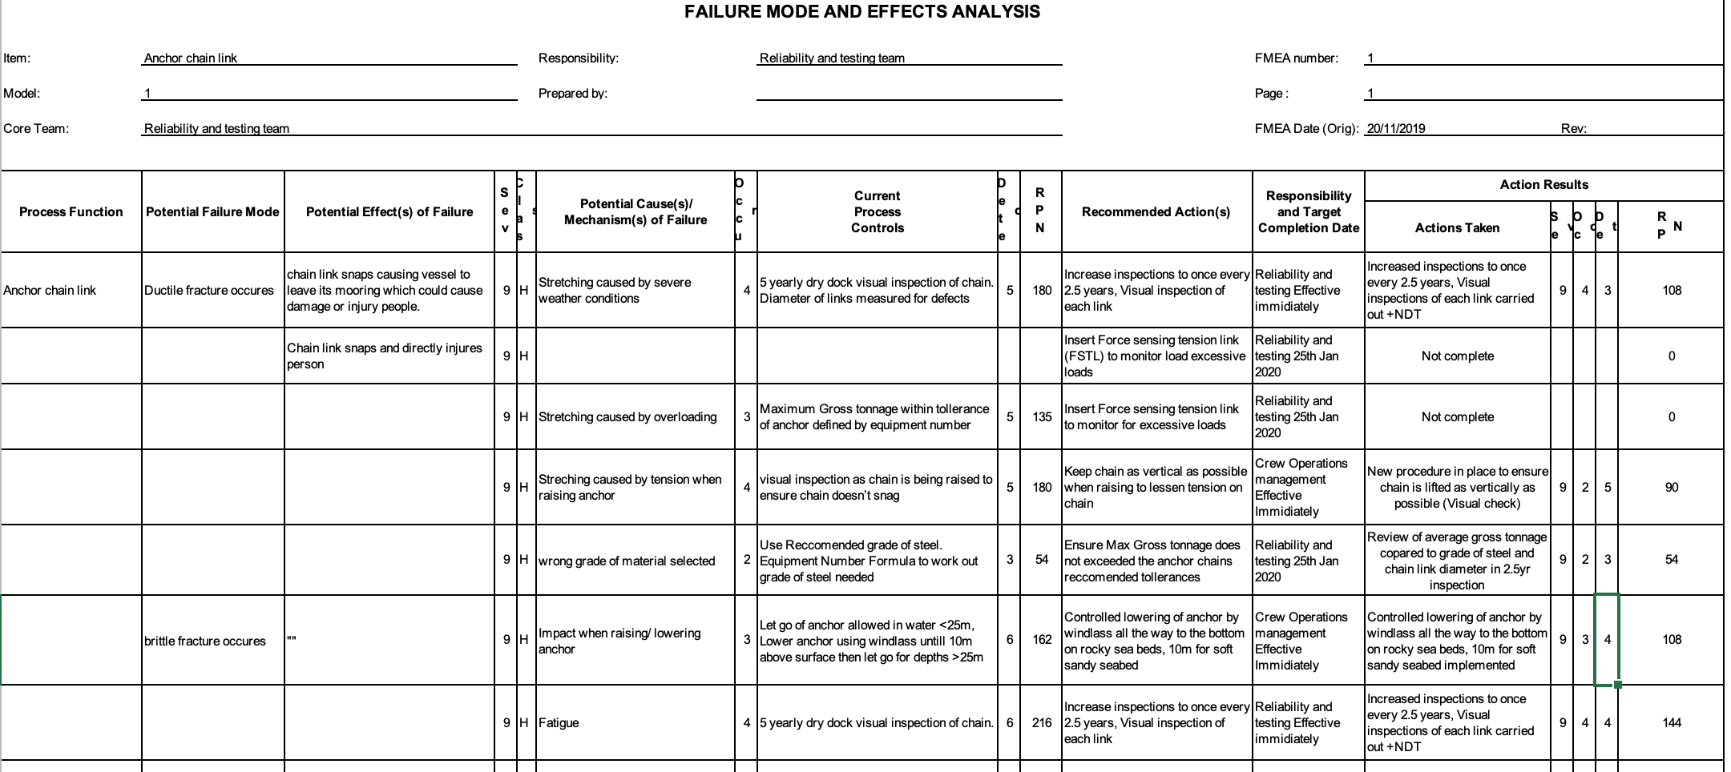
FMEA Analysis
Figure 2- FMEA Analysis
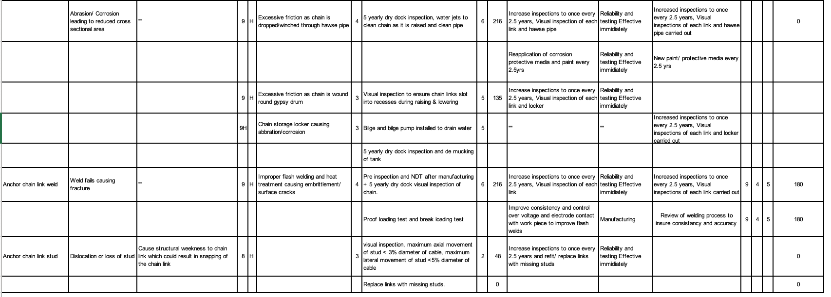
Figure 3- FMEA Analysis continued

Corrective action plan

An anchor chain link has failed and resulted in damages costing £350,000. An analysis and review of equipment and current procedures has been undertook to try and prevent the event happening in future. This report looks into both design aspects of the anchor chain links and the procedures for the raising, lowering and inspection of the anchor chains.
The most common reasons for the loss of chain and anchor are:
- Severe weather conditions causes unexpectedly severe operating conditions
- Operational errors when raising/lowering anchor
- Failures of motors/winch causing excessive tension/impacting
(DNV GL, Gard and The Swedish Club, 2016)
Failure mode and Effect analysis highlighted that the severity of the event could not be viably reduced, so focus on lowering occurrences and improving detection would be key. For most circumstances it became apparent that the most effective way of minimising the risk of an incident would be to implement a more regular and intensive visual check on the anchor chain, carried out in a dry dock every 2.5 years. This inspection should follow “Guidance for anchoring equipment in service” – IACS Recommendation 79 (IACS, 2014) and include a form of NDT such as magnetic particle testing. More frequent inspections for detecting chain links with missing studs and signs of stretching/fracturing, especially near the flash weld, and replacing/ repairing them with certified welds before failure, would improve the chances of detection and lessen the chances of failure. A past report carried out on a failed chain link states that “Better inspections and maintenance would have led to early detection of the surface crack during any of the periodic non – destructive testing.” (Sridhar Idapalapati, 2018)
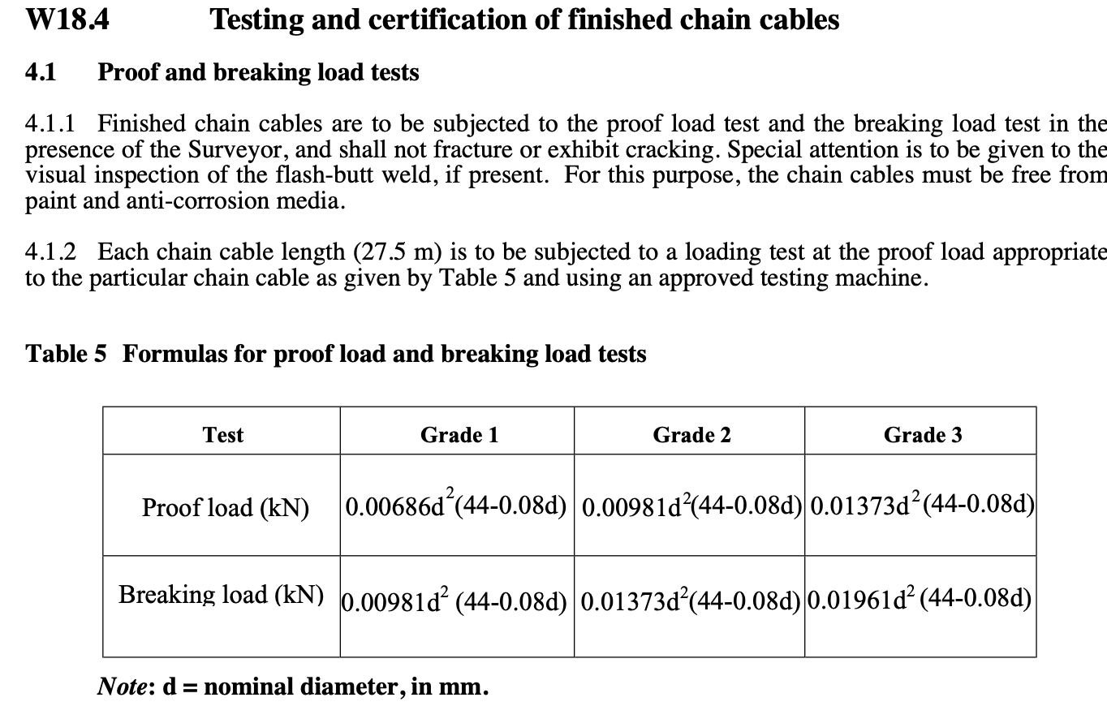
After manufacturing of chain, Proof loading and break loading tests should be undertaken to ensure the chain has no defects and can cope with the forces recommended for each diameter and process stated in Figure 4.
In addition to this, Implementing more control factors and closely monitoring the raising and lowering of the anchor with the aim to either reduce tension in the chain, i.e. Ensuring the chain is as vertical as possible when being raised from water, or reduce impact loading by using the
Figure 4- IACS recommended Proof and breaking load tests (IACS, 2014)
windlass to lower the anchor till a maximum of 10m above the seabed and using the brake when letting go of the anchor, especially above rocky sea beds will also reduce the occurrence of failures during these procedures. Consistent and slow speeds should be used when lowering/raising the anchor to avoid jerking of anchor chain resulting in unexpected overloading. (DNV GL, Gard and The Swedish Club, 2016)
A review of the Average Gross tonnage of the vessel and comparison with the Max tolerances the anchor chain can withstand should be carried out with the 2.5year inspection, to ensure the chain is not overloaded.

The flash welds used to seal the chain link should be made in accordance with IACS recommendations 79 (IACS, 2014). Flash welding is an automatic machined process. “If flashing voltage is too high or forward speed too low, deep craters can be formed on the flashed surfaces which increases the risk of weld interface flaws” (TWI Global, 2019) To improve consistency and quality a review into how to avoid high voltages and low forward speeds should be undertaken. The International Association of Classification Societies (IACS) recommends the use of NDT testing such as Magnetic particle or liquid particle examinations.
Magnetic particle testing involves magnetizing the specimen to create magnetic lines of flux in the material. If a crack on the surface is present, secondary lines of flux are produced. These can be revealed by applying metal powders or liquids to the surface, making the crack visible. (TWI Global, 2019)

In severe weather conditions it’s easy to snag anchor and incur excessive tension on the chain. To avoid this, crew should be trained to monitor weather conditions and leave anchorage before severe weather hits. A focus on maintainace of the windlass, clutch and hydraulic pumps used to winch in the anchor in would reduce tensional/impact loads caused by failure of lifting equipment.

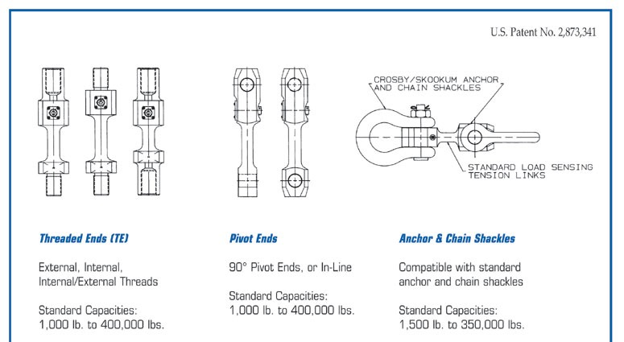
Other tools/ Techniques that could be used to investigate the problem
Figure 5 Specifications of Force sensing tension links (Strainsert, 2019)

Use of a Force sensing tension link within the chain to show how much tensile force has been applied to the chain links would flag up when unexpectedly severe operating conditions occur. This data could be used to prompt inspection of the chain links, and give a better insight into how much stress the links are under when lowering and raising anchor. This feature is usually used on smaller vessels or in situations where the total force applied to the sensor is lower. The standard capacity of an FSTL for an anchor chain is between 1500-350,000lbs (As seen in Figure 5, Right), which would not be applicable on this vessel. (Strainsert, 2019) Also the FSTL would have to be submersed to a variety of depths and may not be practical.
Radiography can also be used to identify defects such as fractures, but this process takes time and requires suitable protective measures to ensure radiation does not harm operators.

Recommendations

After analysis the following actions are recommended in order to reduce the occurrence and improve the detection of a failure in the anchor chain links.

- Increase dry dock inspections of anchor chain from 5 years to 2.5years.
- Improve thoroughness of inspections by introducing NDT procedures (Magnetic particle testing)
- Increase dry dock inspections of hawse pipe, windlass and storage locker, ensuring equipment works properly and is in a suitable condition to avoid abrasion.
- Train Crew to raise and lower anchor using windlass and brake rather than let go in order to avoid unnecessary overloading and impact loading.
- Improve control processes during flash welding to improve quality and consistency of join.
- Ensure precautions are in place to avoid being caught in severe weather conditions.
- Ensure low speeds are used when lowering and raising anchor

Bibliography
DNV GL, Gard and The Swedish Club, 2016. Anchor loss - technical and operational challenges and recommendations. [Online]
Available at: http://www.gard.no/Content/22945571/ANCHOR%20LOSS.pdf
IACS, 2014. Guidance for anchoring equipment in service - IACS Reccomendation 79. [Online]
Available at: http://www.iacs.org.uk/publications/recommendations/61-80/rec-79-rev-cln/
National Research Council, 1980. Anchor Chain for Future U.S Navy Vessels, Washington, DC: The National Academies Press.
Sridhar Idapalapati, A. R. A. K. L. Y., 2018. Failure analysis of failed anchor chain link. In: Engineering Failure Analysis vol. 89. s.l.:Elsevier, pp. 257-270.
Strainsert, 2019. Strainsert. [Online]
Available at: https://www.strainsert.com/products/anchor-chain-tension-links/
[Accessed Nov 2019].
TWI Global, 2019. TWI Global. [Online]
Available at: https://www.twi-global.com/technical-knowledge/faqs/faq-what-are-the-principles-of-magnetic-particle-inspection-mpi-in-non-destructive-examination-nde
[Accessed November 2019].
TWI Global, 2019. TWI Global - Important parameters for flash welding procedures. [Online]
Available at: https://www.twi-global.com/technical-knowledge/faqs/faq-what-are-the-important-parameters-in-a-flash-butt-welding-procedure
[Accessed November 2019].

