Santiana Rutkowska
North west London
•07915858407 • 1917604@student.uwtsd.ac.uk

Personal statement

My name is Santiana Rutkowska I am 23 years old female and I am a carer for my relatives since I’m 14 years old and I am a single mother of a toddler. I am a fully qualified beautician. I am also a trilingual speaker and writer. I am a fast learner I adapt to an environment very quickly and. I always give 100% of my self in my work place.
I am currently in university and studying evolving my business knowledge. My career goals are not certain yet but I definitely would love to have my own successful business.

Key Skills

- Trilingual speaker and writer ( speak and write in 3 languages. English, polish and romany)
- I have good communication skills
- Time management
- Patience
- I can work long hours

Employment History

Beauty salon, Pavillon ( now known as Naz hair and beauty), Edmonton green
(16th August 2014- 29th August 2014)

Responsibilities :
- Eyebrow and face threading
- Facials
- Waxing
- Makeup
- Cleaning the workplace

Education

The College of Haringey, Enfield and North East London - Enfield Centre
(September 2013- may 2014)
Barnet and southgate college wood street campus
( September 2014- February 2015)

- English C
- Mathematics D
- Level 2 beauty therapy

Hobbies & Interests

My hobbies and interests are definitely home interior design, cleaning and small DIYs
I love gardening, cooking and baking. I do night out makeup for my friends and family.

References

References are available upon request

.

Santiana rutkowska
NW9 7DZ | 07914858407 | 1917604.student@uwtsd.ac.uk

Elegant beauty salon in Fitzrovia, London
38 Foley St, Fitzrovia,
London, W1W 7TW,
United Kingdom

20/08/2020
Dear Hiring manager,

I wish to apply for the role of beautician in your salon, I would be very excited and proud to accomplish my journey as a beautician to work in your prestige salon. Please find my enclosed cv and kindly take me in your consideration.
As you can see from my cv I am a qualified beautician i’ve worked in a salon and I know my roles.
I haven’t worked for a while as I become a mother at young age and I am a full time carer for my mentally ill mother since I am 14 years old. I may not have a lot of work hours in beauty industry but I do volunteer beauty treatments for friends and family for many years. I am very patient, disciplined, hard working, I have a very energetic and positive vibe, I am friendly, punctual, I have good problem solving skills and excellent communication skills. I adapt quickly to any situation and work placement.

Situation:
When I was young I had a different life than other children/teens because my parents did not know how to speak or write English.at age 14 my life has became even more independent and grown up as I became a full time carer for my sick mother.
Task:
I had to always manage my parents bills, correspondence, my brothers school reports and parents evenings. even help my father with my brothers and around the house plus school. I’ve done problem solving in housing matters, doctors appointments and car insurance enquires. Also I had to be a translator.
Approach:
My approach to all of that was not professional as I was still a child, it was always very stressful for me. I had to think of this as I am an adult I could not leave it, it had to be done. I took that situation in a point of view that this is the best way to learn life.
Result:
This has resulted into moulding me into a strong independent woman a confident, hardworking individual and never fear whats next. I am always prepared to multi task
The outcome was very beneficial for me.

I hope that you consider my application, thank you very much for your time.
Hope to hear from you in the near future.

Yours sincerely, Santiana Rutkowska

Santiana Rutkowska
Student no: 1917604
Lecture name: Anita naan
BMSW4001_LON

Reflective report

Introduction: The purpose of this report is to reflect on term 2 academic and employability skills modules using the Driscoll’s model (1994).
Reflections on giving a presentation

Presenting a presentation is based on confidence, practice, body language, clear speech and smile.
Preparation is key, this is some for a power point presentation.

Pre-talk preparation is key, .Handouts so others can follow, .Opening,Speaking,
Body Language, Questions,.Length, Behaviour and Conclusion

Pre talk presentation, so I learned I have to arrive few minutes early so I set up and test my equipment and get prepared. Give out Hand outs. Audience will read ahead also there wont be Distractions, Printouts that don’t show any animations, might look boring. Waste of paper – encourage the audience to take notes

Opening .

Ive learned to use the opening to catch the interest and attention of the audience
To Briefly state the problem or topic I will be discussing
To Briefly summarise my main theme for an idea or solution
To not improvise at the last moment

Speaking

To Talk at a natural rate of speech
To Project your voice
To Speak clearly and distinctly
To Repeat critical information
To Pause briefly to give my audience time to digest the information on each new slide
To not read the slides aloud

Body language

To Keep my eyes on the audience use natural gestures
To not turn my back to the audience
Only use notes as reference points to keep myself on track
Smile, in my situation and others in my class we have to present online so its a bit more difficult. So look in the camera. My teacher taught me to move around a bit and the camera faced not just on the face but chest and shoulders so gestures can be shown.

Questions?

To not take questions during the talk (unless I am are very experienced)
Always leave time for a few questions at the end of the talk
Some questions are too specific or personal
If I can’t answer a question, I will say so

Reflections on analytical thinking skills
This term I have learned about Analytical thinking skills.

•Ive learned what analytical thinking is
•examples of analytical skills
•how to improve analytical thinking skills

Analytical thinking is the mental process of disintegrating difficult information or comprehensive data into smaller parts

Examples of analytical thinking skills

•Data analysis
•Efficient problem solving (Troubleshooting)
•Creative thinking
•Organisation
•Reporting
•Effective research
•Budgeting
•Diagnostics
•Metrics

This lesson taught me that analytical thinking makes myself marketable and makes me a better problem solver it also encourages critical thinking.
Also I have learned that I can improve analytical thinking skills in very easy steps which i have never thought of. Like, playing brain games
•sudoko
•crosswords
•chess
•scrabble
• spot the difference
•word memory

Another way is to read books or even join a book club and taking online courses.
Learning one new thing everyday is also a step to improve my analytical thinking skills and volunteering for new projects. And Learning other languages
The many cerebral benefits of learning languages are unquestionable. People who speak more than one language have improved memory-problem-solving and critical-thinking skills, enhanced concentration, ability to multitask, and better listening skills, I myself am a trilingual I speak three
Languages.

Reflection on cv writing
This term I have learned how to write a CV
Correctly and the steps to make a perfect CV.

A CV is a concise documentation which summarises an individual’s distinctive skills, character, experience and achievements. CV is short for Curriculum Vitae, which is a Latin phrase which loosely translated means ‘the course of my life’. A CV outlines a person’s academic and professional history which is usually used for applying for jobs.

First of all in a cv I started with personal contact details like,
name, email and phone number
Address and social media is optional but can be important, so an address is important because the employer can see what area you live in and if it will be convenient and easy for you to travel to the work place. Social media can also be used as a very good way because the person who is reading my cv can go through potentially my blog, instagram or Pinterest to see my skills lets say as a fashion blogger or interior designer or even fitness instructor and healthy eating program and so many more.

Personal statements should be brief, clear, concise, should be no longer than three lines or maybe two or three sentences

Education and qualifications ,work experience , additional responsibilities and activities Also hobbies and interests. Hobbies and interests might seem a bit odd to add to a cv but its actually crucial its not just letting know the employer what I like to do, in fact I show who I am, people can also tell by your hobbies and Interests what personality and character I have. If I am a energetic and hardworking if I am lazy ( lets say I wrote I love laying down watching tv) idealist, artistic or creative.

Cv presentation and formatting is important
No spelling mistake No longer than two pages Bold, italics, or underlining are great ways to ensure keywords in your CV stand out Bullet points provide key information rather than full sentences – much more pleasing to read Colour – CV’s will usually be photocopied so too many colours will become irrelevant

Analysis about CV writing is about being passionate in my writing and being precise and to make sure you’re cv is not boring but also not too complicated and too colourful. I Always make sure to write about myself so I sound interesting and the person reading it will feel a nice warm side about me.And the rest of cv is general things like education and skills, work experience, responsibilities and activities etc…

Gibbs reflective cycle

I’ve learned about gibbs reflective cycle 1988 I’ve learned that theres 6 stages to complete the cycle. Description, feeling, evaluation, analysis conclusion and action plan

I think the gibbs reflective cycle is important to know and to do because it gives me a better structure on the task that i will be doing. It also gives a easier and better understanding.

Professor Graham Gibbs released his Reflective Cycle in his 1988 book "Learning by Doing." It's specifically useful for helping people like myself to learn from situations that they experience regularly, especially when these don't go well.

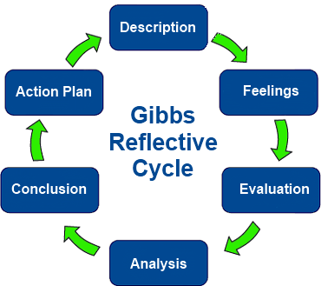

I will be now showing a analysis from my reflections using Driscoll’s model:
- What?. What I’ve learned is how to prepare myself for work or business the cv, analytical thinking skills the presentation. My reaction to the lessons was insightful because I learned that presentation is very important and analytical thinking is not just identifying and problem or issue its Gathering information Developing solutions or furthering your understanding of the topicTesting solutions or new ideas based on what I have learned Post-analysis, or reviewing what solutions worked, or assessing your new knowledge

So what?: I felt a bit confused at the time my lecturer Anita Naan is a very inventive and clever her teaching strategies are effective. The thing that troubles me is that it’s significantly complex for me to learn in online sessions just because I have a toddler at home. And in addition its much more harder to concentrate. But I can say that I did well this term well at-least hope so. But the positive aspects are that we are safe in our homes and still have the luxury of high education through our electronic devices.

- Now what?: what needs to happen now is I need to mentally stabilise my mindset that doing online lessons is just the same real life session and to stop making excuses that I cannot or will not do that because it’s not in classroom. My key learning points from this experience must be absolutely everything, each subject is crucial.

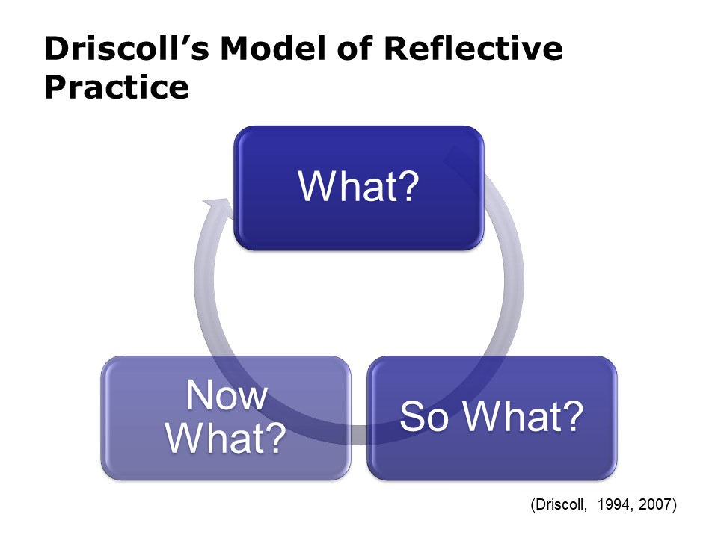

Referencing:
Anita naan lecturer 2020 BMSW4001
Academic and employability skills moodle module slides https://www.allassignmenthelp.co.uk/blog/driscoll-model-of-reflection/
https://www.mindtools.com/pages/article/reflective-cycle.htm
http://www.open.ac.uk/choose/unison/develop/my-skills/cv-writing
https://www.leadwithlanguages.org/why-learn-languages/top-ten-reasons-to-learn-languages/

