
blog and posture
Population health Digital health promotion

KARTIKKUMAR PATEL
STUDENT ID: 2307819

Contents
NutriCare: Fuelling Recovery - Combating Anorexia in Teenage Girls with Nutritional Support 2
Bringing Clarity: MindMate's Innovative Approach to Alzheimer's Assistance 4
REFERENCES 6
POSTURE OF DIGITAL TECHNOLOGY 7


NutriCare: Fuelling Recovery - Combating Anorexia in Teenage Girls with Nutritional Support

What is Anorexia nervosa?
Anorexia nervosa, a serious mental health condition characterized by an intense fear of gaining weight and a distorted body image, continues to pose a significant public health concern, particularly among teenage girls in the UK (Neale, and Hudson, 2020).

According to recent statistics from the National Institute for Health and Care Excellence (NICE), the prevalence of eating disorders among young people, including anorexia, has been steadily rising, with girls aged 15-19 being the highest risk group.

NutriCare App

NutriCare is a new digital technology for promoting health among individuals with eating disorders. It offers personalized meal plans, calorie tracking, and expert-curated educational content to foster a healthier relationship with food. It bridges users to registered dietitians and mental health professionals, ensuring tailored support for sustainable recovery from eating disorders (Chen et al, 2018).
Features of App:

Here are the features of the NutriCare app…
- Nutritional education
- Personalized Meal Plans
- Calorie Tracking
- Nutritional Guidance
- Meal Reminders
- Progress Tracking
- Community support
- Integration with wearables
- Feedback
- Recipe library
- Book an appointment with a Dietician or Psychologist
Let’s know about the Advantage of App
- Gives users a sense of control over their nutritional intake and recovery (Kasaai, 2018).
- Connects users with a supportive network of peers and professionals (Kasaai, 2018).
- Promotes physical and mental well-being through proper nutrition (Kasaai, 2018).
- Provides users with valuable nutritional knowledge to aid long-term recovery (Kasaai, 2018).
- Accessible anytime, anywhere, providing support when it's needed most (Kasaai, 2018).
Some disadvantages of the App
- Risk of exacerbating obsessive behaviors or unhealthy thoughts around food (Villasana et al, 2019).
- Concerns about the accuracy and credibility of nutritional information provided (Villasana et al, 2019).
- Lack of comprehensive mental health support alongside nutritional guidance (Villasana et al, 2019).
- Difficulty in creating personalized plans that address unique needs effectively (Villasana et al, 2019).
Revitalizing NutriCare: Innovative Solutions for Enhancing User Experience and Effectiveness
- Incorporate cognitive-behavioural therapy exercises to address underlying psychological factors (Suryadevara, 2023).
- Ensure the involvement of qualified healthcare professionals to monitor and guide users (Suryadevara, 2023).
- Regularly update information based on the latest research and expert recommendations (Suryadevara, 2023).
- Solicit feedback from users to identify areas for improvement and adapt the app accordingly (Suryadevara, 2023).
- Offer a range of features beyond nutritional guidance, including mindfulness exercises and peer support networks, to address the multifaceted nature of anorexia recovery (Suryadevara, 2023).
Bringing Clarity: MindMate's Innovative Approach to Alzheimer's Assistance

Alzheimer disease:
Alzheimer's disease, a progressive neurological disorder, poses one of the most formidable health challenges. Marked by the accumulation of abnormal protein deposits in the brain, it triggers the degeneration of nerve cells, resulting in a gradual decline in cognitive function. This insidious onset begins with mild forgetfulness, eventually progressing to severe memory impairment, disorientation, and difficulties in communication and motor skills (Knopman et al, 2021; Self, and Holtzman, 2023).
Alzheimer's disease impacts millions worldwide, robbing individuals of memories and independence. In the UK, around 850,000 struggle with dementia, urging innovative support for patients and caregivers.
APP NAME: MindMate
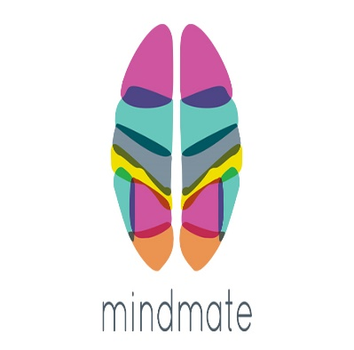
MindMate, a groundbreaking mobile application designed to assist individuals with Alzheimer's and their caregivers, offers a beacon of hope in navigating this complex condition. With its innovative features and user-friendly interface, MindMate aims to enhance the quality of life for those affected by Alzheimer's (McGoldrick et al, 2021; Presswala et al, 2021).
MindMate serves as a comprehensive resource hub for individuals living with Alzheimer's and their caregivers. Its features include:
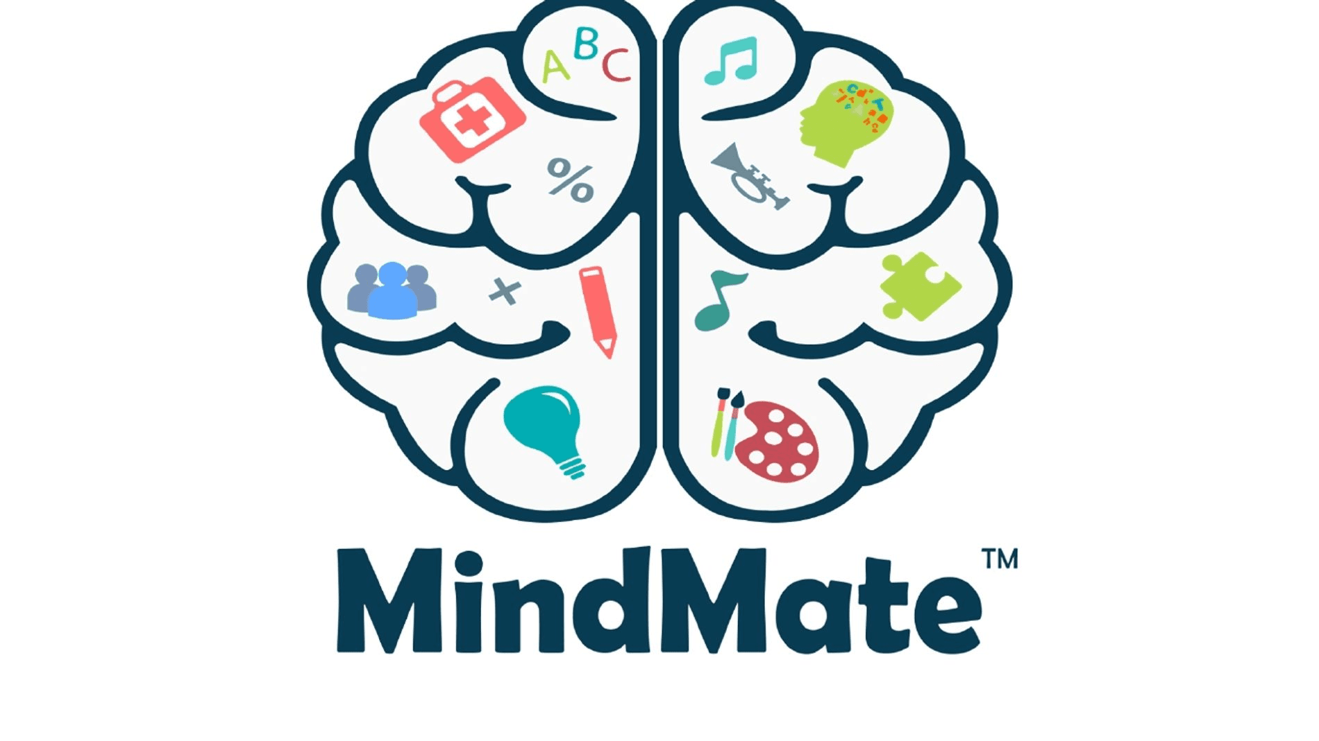
- Memory games and exercise
- Medication reminders
- Daily planner
- Nutritional guidance
- Community support
- Privacy and data security
- Book an appointment
- Educational resources and information
- Personalized care plan
- Nutrition and hydration tracker
(Kang et al, 2016; McGoldrick, 2021)

What are the benefits of the App?

MindMate empowers users with enhanced cognitive function through engaging memory games, aiding in cognitive preservation. It ensures improved medication adherence with timely reminders, minimizing the risk of missed doses (Lee-Cheong et al, 2022; Presswala et al, 2021). By facilitating daily task management, the app fosters independence among individuals with Alzheimer's, promoting autonomy. Moreover, MindMate eases caregiver stress through care coordination features, providing support networks and educational resources for comprehensive assistance (Lee-Cheong et al, 2022; Presswala et al, 2021).
What are the shortfalls of the App?

MindMate addresses technical challenges for users, especially older adults or those with limited tech skills, by ensuring navigation ease. Robust security measures are a priority to safeguard user data, alleviating privacy concerns (Lee-Cheong et al, 2022; Presswala et al, 2021). Moreover, the app is committed to expanding customization options and enhancing flexibility for individual needs. MindMate's dedication to usability, privacy, and customization solidifies its role as a reliable ally in Alzheimer's care (Lee-Cheong et al, 2022; Presswala et al, 2021).

Approaches to rectify any potential deficiencies:
To enhance user experience and address potential concerns, MindMate is committed to ongoing improvements in its design, privacy measures, and customization options. By prioritizing user feedback, the app ensures that navigation remains intuitive and accessible to users of all ages and abilities. Robust security protocols are continuously implemented to safeguard user data and maintain confidentiality (Munteanu et al, 2022). Moreover, MindMate is dedicated to providing expanded customization options, allowing individuals to tailor the app to their unique preferences and requirements, fostering greater flexibility and personalization. Through these efforts, MindMate aims to continually evolve and adapt, ensuring that it remains a trusted and valuable resource for those affected by Alzheimer's disease and their caregivers (McGoldrick et al, 2021).

REFERENCES
Chen, J., Gemming, L., Hanning, R. and Allman-Farinelli, M., 2018. Smartphone apps and the nutrition care process: current perspectives and future considerations. Patient Education and Counseling, 101(4), pp.750-757.

Kang, K., Choi, E.J. and Lee, Y.S., 2016, November. Proposal of a serious game to help prevent dementia. In International Conference on Games and Learning Alliance (pp. 415-424). Cham: Springer International Publishing.

Knopman, D.S., Amieva, H., Petersen, R.C., Chételat, G., Holtzman, D.M., Hyman, B.T., Nixon, R.A. and Jones, D.T., 2021. Alzheimer disease. Nature Reviews Disease Primers, 7(1), p.33.

Lee-Cheong, S., Amanullah, S. and Jardine, M., 2022. New assistive technologies in dementia and mild cognitive impairment care: A PubMed review. Asian Journal of Psychiatry, 73, p.103135.

McGoldrick, C., Crawford, S. and Evans, J.J., 2021. MindMate: A single case experimental design study of a reminder system for people with dementia. Neuropsychological rehabilitation, 31(1), pp.18-38.

Munteanu, D., Bejan, C., Munteanu, N., Zamfir, C., Vasić, M., Petrea, S.M. and Cristea, D., 2022. Deep-learning-based system for assisting people with Alzheimer’s disease. Electronics, 11(19), p.3229.

Neale, J. and Hudson, L.D., 2020. Anorexia nervosa in adolescents. British Journal of Hospital Medicine, 81(6), pp.1-8.

NICE, (2019)https://cks.nice.org.uk/topics/eatingdisorders/background-information/prevalence/

Presswala, A., Pathak, S., Jhanwar, G. and Katre, N., 2021. Neuromemorize—Mobile Application for Alzheimer’s Patients Using AI-Based Face Recognition. In Data Intelligence and Cognitive Informatics: Proceedings of ICDICI 2020 (pp. 363-377). Springer Singapore.

Self, W.K. and Holtzman, D.M., 2023. Emerging diagnostics and therapeutics for Alzheimer's disease. Nature Medicine, 29(9), pp.2187-2199.

Suryadevara, C.K., 2023. Revolutionizing dietary monitoring: a comprehensive analysis of the innovative mobile app for tracking dietary composition. International Journal of Innovations in Engineering Research and Technology, 10(88).

Villasana, M.V., Pires, I.M., Sá, J., Garcia, N.M., Zdravevski, E., Chorbev, I., Lameski, P. and Flórez-Revuelta, F., 2019. Mobile applications for the promotion and support of healthy nutrition and physical activity habits: A systematic review, extraction of features and taxonomy proposal. The Open Bioinformatics Journal.

POSTURE OF DIGITAL TECHNOLOGY



