Taraneh Adibmehr (2005918)

Architecture BSc

History and Theory 2 (M5X01981)

Critical Analysis Of Architecture Post 1945: The Shard

How did Renzo Piano succeed in transforming UK’s tallest structure into a statement?

Introduction

This essay is a critical analysis of The Shard which is the UK’s tallest building adjacent to London Bridge, designed by architect Renzo Piano. I start by introducing my building of interest including some background information about the building, its context along with its achievements and client details. This is followed by the theories and philosophies underpinning the design, in which I mainly focus on the concepts, meanings and symbolism. Some of the issues that the scheme faced are analysed as they had an influence on other topics that I discuss such as the construction. The particular buildings construction methods and material choices are then discussed, with each topic having smaller areas of interest that I address such as sustainability and lighting strategies. Lastly, I analyse the buildings’ function and overall purpose through plans and sections. I will be answering the topic question through the key points that I raise and argue. I will address this question in different ways while making connections with other topics and buildings.

The Background Of The Building

Since its completion in 2012, Renzo Piano's futuristic London Bridge Tower popularly known as The Shard, has held the title for the UK's tallest building, soaring to nearly 310 metres and towering over London’s 235-meter tall One Canada Square building. (Designing Buildings, 2020)
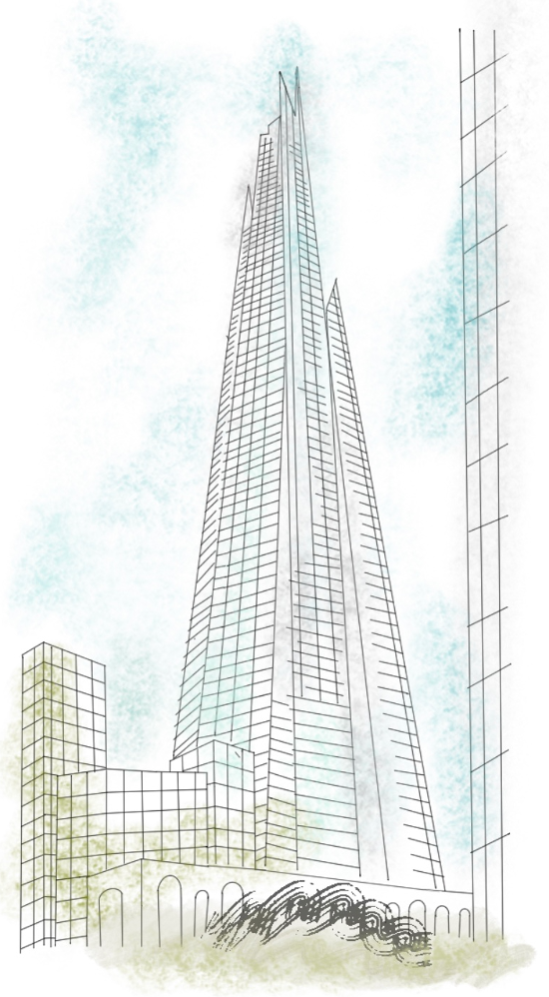
The Shard achieves an unprecedented height in the UK, winning numerous awards, including the Most Eagerly Anticipated Luxury Launch in 2013 (The View From The Shard, 2022), followed by the Best Commercial Building award from The Royal Institution of British Architects in 2014, along with a number of other awards over the years. (The Shard, 2014)

Irvine Sellar, the founder of Sellar Property Group, and owner of the 1970s Southwark Towers was keen to redevelop the 25 storey office block when the UK
government began encouraging
developers to build high density
complexes near transportation links to reduce carbon emitted by cars. When it came to procuring the services of Renzo Piano, Sellar was the driving force behind the project, since Piano had a totally different perspective on high-rise buildings, characterising them as "arrogant and aggressive." The elegance of the
Figure 1: A drawing of The Shard in context of surrounding buildings. (Author, 2022)
river Thames bordering the site,
however, compelled Piano, and the
idea of creating a multi-functional
building, given the site's close proximity
to transportation interchanges, sparked his interest (Marcus Fairs, 2012). As a result, he agreed to work with Sellar over lunch in Berlin, sketching out the initial concept for The Shard on a napkin with his characteristic green pen. Sellar envisioned the new building as a world-class structure, and in 2009, he began demolishing the towers that had previously occupied the site to make way for it. (The Shard, 2022)
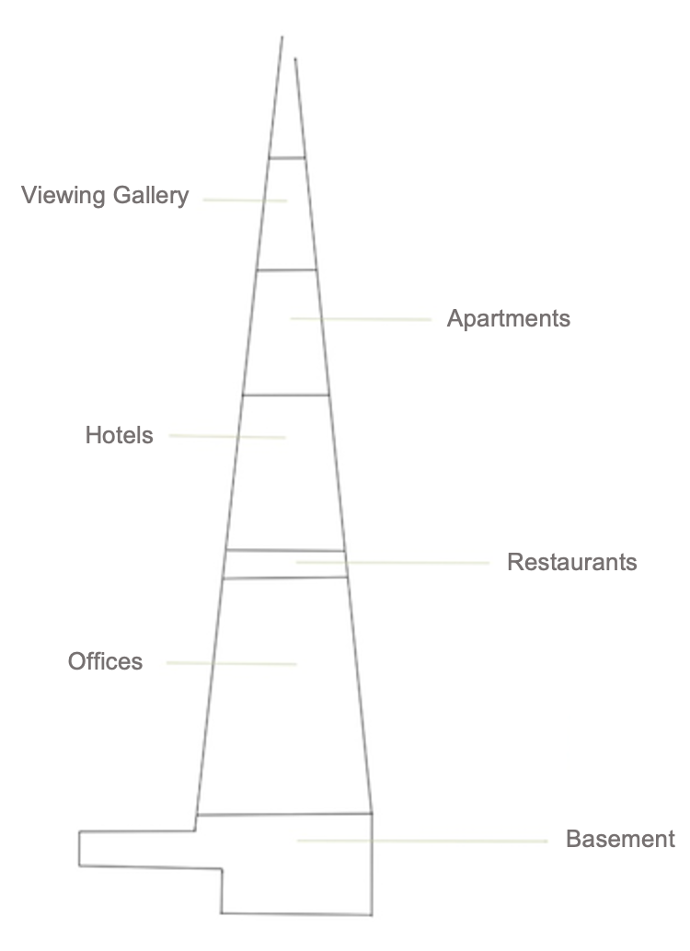
The innovative vertical city approach of the Italian architect houses 95 storeys with 72 storeys being functional. The pyramidal structure includes a diverse range of utilities such as offices, residences, restaurants and a Shangri-La hotel and features a 360-degree panoramic view of the city that stretches for 40 miles. (The Shard, 2022)

The Shard's initial cost of 350 million pounds was exceeded as a result of the tumultuous economic crisis that emerged in 2007 (Manoj Singh, 2021), increasing the overall cost of the skyline to an estimated 1.5 billion pounds. As a result of this unanticipated rise, Qatari investors offered to finance the
Figure 2: A drawing showing floor distribution in The Shard. (Author, 2022)

project, therefore making the
Qatari state and Sellar co-
owners of The Shard. (The
Richest, 2012)

The divergence between The Shard and London Bridge Station along with the rest of the Victorian neighbourhood can be unexpected, conveying the contemporary building as incongruous in its restricted site that is situated between Guy’s hospital and London Bridge Station. While The Shard is an awe-inspiring (The Shard, 2022) piece of architecture and an embodiment of high tech modernism, its neighbouring structures such as the London Bridge Station, are of an entirely clashing style, displaying 19th century architecture.

The Philosophy Of The Architect

When it comes to architecture, Renzo Piano believes he doesn't have a distinct style, but rather a sense of logic and a drive for practicality. Although, when examining his designs, a 1960s style of architecture which emphasises the structural aspects of a building is apparent especially in the centre Pompidou. Despite the fact that high-tech architecture has been a common element in his work, his designs are diverse. (Amy Frearson, 2019)

Piano values lightness and transparency in his buildings, most specifically in The Shard where he demonstrates that skyscrapers have the potential to be delicate. Piano felt that tall buildings which are the same shape from bottom to top are “aggressive and arrogant” used to symbolise power (Marcus Fairs, 2012). On the contrary, The Shard is designed to portray the opposite and display elegance through both its irregular pyramidal shape and glass façade that reflects differently throughout the day. (JLL, 2018)

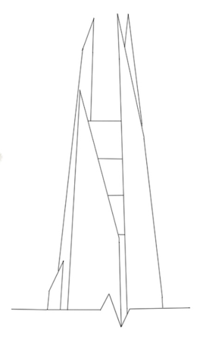
Piano succeeds in transforming UK's highest structure into a statement, which is the opposite of traditional office and Chicago school skyscrapers. The first skyscraper was constructed in 1885 In Chicago, starting a style which includes square buildings with regular repeating rows of windows, while the shard is a pyramidal structure with irregularities that are the antithesis of Chicago school skyscrapers. Chicago school also includes mostly masonry facades, while the The Shard is covered in glass which provides a more dynamic aesthetic that changes with lighting throughout the day.
Renzo Piano’s ideologies about tall buildings massively influenced other architects in the UK and became a role model for buildings such as the Buckingham Gate building and 240 Blackfriars Road near The Shard which looks as though it is aspiring to reach its inspiration. (Oliver Wainwright, 2014)
Figure 3: A drawing of the roof of The Shard showing glass spikes. (Author, 2022)

Renzo Piano's design for The Shard is partly driven by his childhood fascination with boats and sailing (Amy Frearson, 2019) and therefore, desired something that arose from the themes, similarly to the way ships do (The Shard, 2022). He was inspired by the masts of sailing ships in a painting of London by Canaletto, an Italian painter from the 18th century. Church spires provided other sources of inspiration. The vision of breaking scale and creating a building that gets narrower towards the top grew swiftly from this, and developments were influenced by sketches of wooden splinters found in Piano's workshop, which resulted in his decision to use fragmented glass spikes instead of a pyramid shaped roof (Rowan Moore, 2011). Even though some may believe this feature makes the building look unfinished, it benefits the buildings performance as it allows air flow through the building and offers an organic connection between the inside and outside. (The Shard, 2022)

Due to Piano’s confidence, his design was chosen over Broadway Malyan’s , who had initially proposed a design, but then became consultant architects on the project (Rowan Moore, 2011). Incidentally, his initial concept was planned to be 380 meters high but this was rejected by local authorities as it was perceived as too ambitious. (Skyscraper News, 2016)

A third building by Renzo Piano was designed for Sellar Property Group, a multi-functional 27-story residential tower with 150 apartments, retail spaces, and a roof garden, to replace the 1970s Fielden house as part of the London Bridge Street regeneration plan. This new development served as a complementary structure to The Shard. (Karissa Rosenfield, 2014)

Difficulties and Obstacles

This project underwent some difficult years; there were challenges with planning, public inquiries, financial concerns, and the general timing of the project provoked a lot of controversy. Renzo Piano stated in an interview with WSP that some aspects of the project were about having "belief in the building" owing to the lack of credibility from the outside. Sellar and Piano’s interminable journey of justifying their ideas to the public took a significant amount of effort, causing Sellar to spend lots of time going back and forth with city officials, trying to persuade them that this project would be a great foundation for London's regeneration. (WSP, 2022)

During construction, questions concerning the glass façade arose, pointing out that the visuals Piano had previously assured were in fact prosaic (Rowan Moore, 2011). Although it is self-evident that computer graphics deviate from reality, this just serves to demonstrate certain people's ignorance of The Shard's overall accomplishments as a structure.

The Shard was proposed during a period when the world was through major upheavals, such as the global financial crisis of 2007-2008 and, prior to that, the terrorist attack on the twin towers in 2001. The tragic historic incident had a profound impact on people's perceptions of skyscrapers. While it did not deter Sellar and Piano from moving forward with their proposal, it did result in significant modifications and a shift in their perspective on how it should be constructed. As a result, upgrades were made to the building's central core and evacuation routes. (Mike Phillips, 2019)

Another factor that had an impact on The final appearance of The Shard was the realisation that removing the Southwark Towers foundation would be too onerous, therefore the new foundation had to be built around it. (JLL, 2018)

Due to issues, getting approval from the planning authorities was difficult, but it was eventually granted in November 2003. Interestingly, the secretary of state's office described the decision as "disappointing but inevitable." Furthermore, the design council wrote a design evaluation of the proposal for The Shard in 2005, expressing concern about the high degree of expectation from the space, although supporting the overall scheme subject to the concerns they identified. (Design Council, 2005)

Some of the public reacted negatively to the London Bridge Tower, and it was given the abbreviated nickname "The Shard" in response to criticism from English Heritage, who stated that it would be a "Shard of glass through the heart of historic London." Along with the public inquiries, there was concern that it would obstruct views of St Paul's Cathedral (Rowan Moore, 2011). Auspiciously, The Shard was soon welcomed by the public as one of London's most iconic landmarks (JLL, 2018). The project is "architecturally cultured and a great addition to the London skyline," according to London's chief of planning, Peter Rees. (The Shard, 2022)
Construction and Sustainability / Materials and Light

The building’s aesthetics and structural performance are a reflection of the commitment and obsession with building from both the architect and engineers. Since the rise of the first skyscraper in Chicago, building technologies have come a long way and the evolution of buildings and skyscrapers specifically reflects the drive in human’s to aim for better.
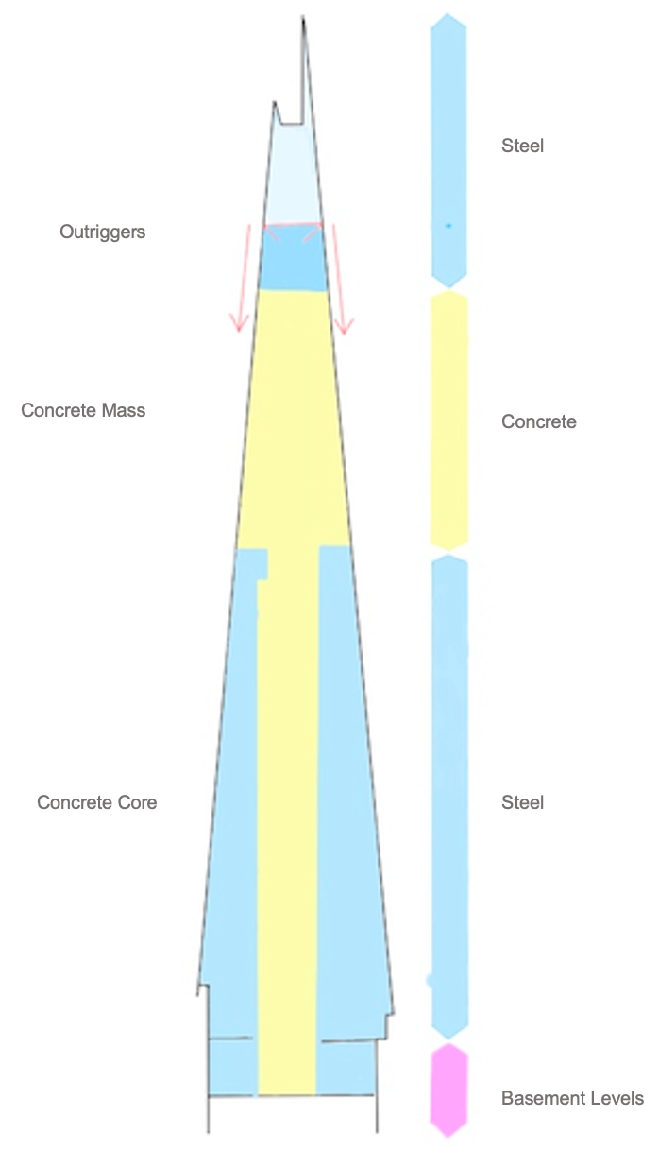
The engineers for The Shard used the latest tools and techniques so that the building would be able to withstand possible complications in the future. And structured The Shard with the catastrophic collapse of the twin towers in mind, therefore the scheme was pushed to achieve more rigidity. One way that this was achieved was through building all parts offsite; ensuring that all parts fit together, as they already had once before. This method also resulted in less construction time (JLL, 2018). The main structural form of the building involves a “top-down” construction. This innovative way of building influenced other engineers ever since (John Parker, 2012). This meant constructing the first 23 storeys which make up the concrete core and provide stability for the structure of the building first, prior to excavating basement levels. This was due to the site previously being occupied by the Southwark towers, therefore, removing all the weight of the material off the ground would relax it and potentially
Figure 4: A drawing showing structural use of different materials. (Author, 2022)
affect other neighbouring buildings.
As seen in figure 3 the structure comprises
of a mix of steel and concrete. There is concrete used in the basement, steel from ground level up to level 40, concrete again in levels 41 to 69 and finally steel again for the remainder. (HP development company, 2019)

The meaning of historic structures like the Great Pyramids has always been a mystery to humanity. Leaving people in reverence of what the civilisation of the period was like and how they were built. Modern skyscrapers, on the other hand, are the essence of man-made. The Shard's gleaming pyramidal shape is strong evidence of modern-day technological advances.

Mankind has always pushed the capabilities of materials further and with modern technologies and influences there are a lot of ways in which a building can become sustainable. It is critical to consider sustainability when building in the twenty-first century and architects have a unique chance to influence their work in a sustainable direction. This is something that The Shard represents through its materials and general role as a multi-functional structure. This vertical settlement in a densely populated location has changed the way cities can grow, allowing England to grow upwards rather than outwards. (CBC News, 2012)
The Shard achieved a 'Excellent' rating on the BREEAM evaluation because it is designed to use 30% less energy than other high-rise buildings, and 90% of the materials used in its construction, including 20% of its 500-tonne steelwork, are recycled. The structure's double-skin, energy-efficient glass covering consists of 11,000 glass panels that allow a plethora of natural light to flow through the building, offering a lightness that echoes the exterior. A single glazed outer layer is followed by a double glazed inner wall that acts as a cavity and provides ventilation (HP development company, 2019). The outer layer features a low-emissivity coating and woven glass fibre blinds to reduce the sun's radiation impact. (Engineering and Technology, 2011)

Piano’s poetic concept of having a reflective glass façade that responds to its surroundings and varies with the sky was achieved (JLL, 2018). Although, considering the bleakness of the UK sky this vision has turned out slightly different.
Analysis of The Buildings Plans and Section
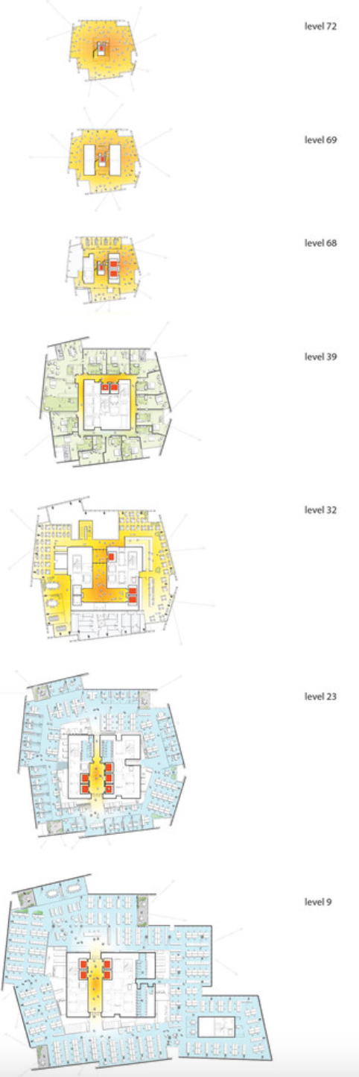
The 72 occupied levels of The Shard feature everything required in a small village, including office spaces, public areas such as restaurants and bars, residential levels, a Shangri-La hotel, and an observation gallery (The Shard, 2022). Although constructing taller can be a practical means of development for highly populated cities, having everything in one spot, can encourage individuals to become secluded.

There is approximately 1.4 million square feet of floor space in the building. Main entrances into the building as well as entrances for the hotel, bar, restaurant and viewing gallery are through the first floor. Then on the second floor there is a reception for the offices followed by the managerial areas on the third floor. Followed by that, HCA Healthcare services occupy three of the next floors. Two retail floors are then provided including a Tiffany and Co shop. Up to level 28, offices representing a range of organizations occupy the space. Levels 31-34 are occupied by restaurants such as Hutong and Oblix. Rooms and suits take up 17 levels, bringing the pool area which features an infinity pool up to level 52. After this there are several apartment levels, some using up an entire floor. Finally, from here onwards is the viewing gallery. (The Shard, 2022)

When it came to distributing the building's floors, Renzo Piano quickly realised which areas would be best suited for their purpose, such as offices, hotels, and residential areas, which require larger
Figure 5: The Shard plans (ArchDaily, 2022)
platforms, should be located on the lower levels where the floor spaces are larger, while other areas, such as the viewing gallery, should be located on the highest levels to provide better views across the city.
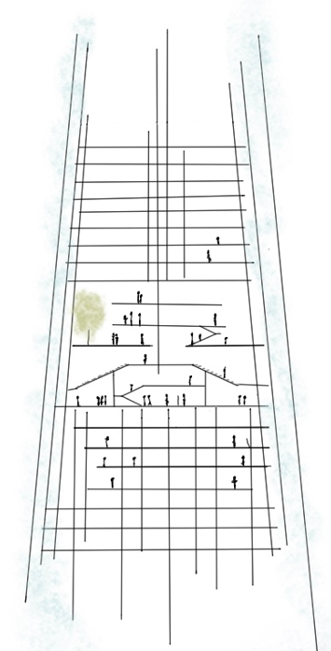
There are a total of 306 flight of stairs as well as 36 lifts, some of which are double decker, with an average speed of 6 metres per second (The Shard, 2022).

For years, London has been seeking for measures to minimise pollution and congestion caused by cars, introducing things like congestion charges and ULEZ charges, which were recently implemented for diesel and older cars in particular areas of the city that appear to be getting busier. The Shard is located over London's main transportation connection, providing a quick and easy method to commute without having to use one's own vehicle, therefore decreasing traffic and pollution in the city.
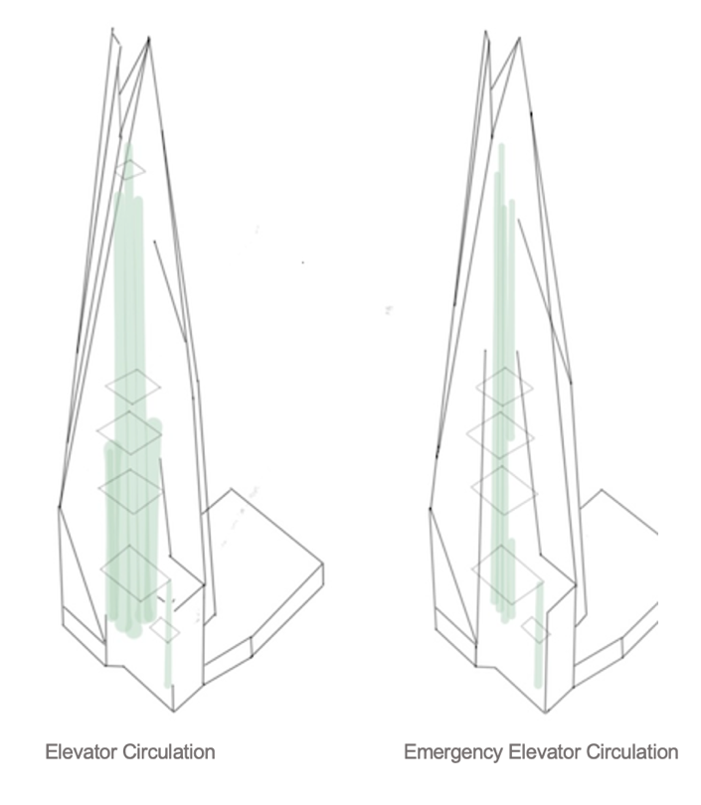
Figure 6: A Section drawing showing the restaurant and bar areas. (Author,2022)

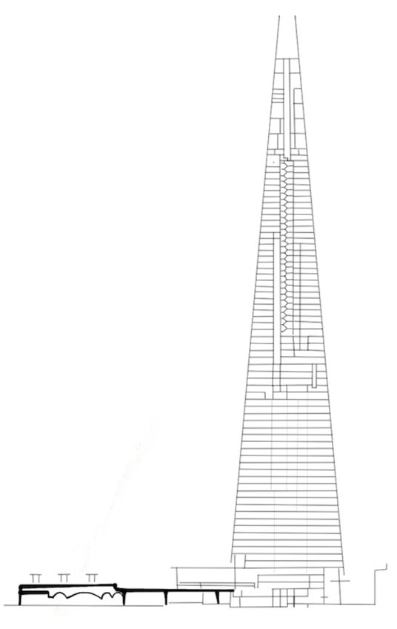
Figure 7: An axonometric view of The Shard showing elevators. (Author, 2022)

Figure 8: Elevation drawing of The Shard. (Author, 2022)
cv
Conclusion

Renzo Piano deviated from what has traditionally been the norm in London, both in scale, design and materials. This always attracts criticism and it requires courage and a confidence in vision to not be deterred and change the design to something more conservative. But it also carries risk in that what the designers envision could be received differently than what they hoped for. The Shard as an architectural and engineering project fits this pattern, and at the end it has managed to become a meaningful and appropriate feature of architecture that serves as an economic, social and cultural hub which has set the stage for the future wave of architecture projects in London. It has certainly left its mark as a significant site in London, and it will without a doubt affect the way architectural projects in similar settings are seen from the outset elsewhere in London.

Bibliography

Designing Buildings (2020) Tallest Buildings in the UK Available at: https://www.designingbuildings.co.uk/wiki/Tallest_buildings_in_the_UK

List of awards won by The Shard (2022) Available at : https://www.theviewfromtheshard.com/awards/

The Shard (2014) The Shard wins RIBA London ‘Best Commercial Building’ Award Available at: https://www.the-shard.com/news-events/news/the-shard-wins-riba-london-best-commercial-building-award

The Shard (2022) A Vertical City Available at: https://www.the-shard.com/about

Council on tall buildings and urban habitat (2022) Southwark Tower Available at: https://www.skyscrapercenter.com/london/southwark-towers/28265/

The Shard (2022) Vision Available at: https://www.the-shard.com/about/vision

Manoj Singh (2021) The 2007-2008 financial crisis in review Available at: https://www.investopedia.com/articles/economics/09/financial-crisis-review.asp

The Richest (2012) The Shard, London: Cost of Europe’s Tallest Building Available at: https://www.therichest.com/technology/shard-london-bridge/

Amy Frearson (2019) Renzo Piano is the Italian High-Tech architect Available at: https://www.dezeen.com/2019/11/26/Renzo-Piano-high-tech-architecture/

Johnathan Glancey (2002) That’s-nice, but what’s it doing there? Available at: https://www.theguardian.com/culture/2002/mar/18/artsfeatures

JLL (2018) Why The Shard stands out on London’s skyline Available at: https://www.jll.co.uk/en/trends-and-insights/cities/why-the-shard-stands-out-on-londons-skyline

Oliver Wainwright (2014) Shardenfreude: London’s copycat craze is crystal clear https://www.theguardian.com/artanddesign/architecture-design-blog/2014/may/28/shardenfreude-londons-copycat-craze-is-crystal-clear?utm_medium=website&utm_source=archdaily.com

Rowan Moore (2011) The Shard: A symbol of towering ambition Available at : https://www.theguardian.com/artanddesign/2011/jan/30/shard-Renzo-Piano-london-bridge
Architect Journal Building Library (2012) The Shard https://www.ajbuildingslibrary.co.uk/projects/display/id/6948

Marcus Fairs (2012) Interview: Renzo Piano on The Shard Available at: https://www.dezeen.com/2012/05/18/interview-Renzo-Piano-on-the-shard/

Skyscraper News (2016) The Shard Available at: http://www.skyscrapernews.com/buildings.php?id=46

The Shard (2022) Offices Available at: https://www.the-shard.com/offices/inspiring-workspaces

Karissa Rosenfield (2014) Renzo Piano-designed residential tower planned to neighbour The Shard Available at: https://www.archdaily.com/467206/Renzo-Piano-designed-residential-tower-planned-near-the-shard?ad_source=search&ad_medium=projects_tab&ad_source=search&ad_medium=search_result_all

Mike Phillips (2019) Irvine Sellar: My battle to create The Shard Available at: https://www.propertyweek.com/london/irvine-sellar-interview-my-battle-to-create-the-shard/5087936.article

Design Council (2005) Designed by Renzo Piano Building workshop Available at: https://www.designcouncil.org.uk/sites/default/files/asset/document/The%20Shard.pdf

WSP (2022) The Shard, London Available at: https://www.wsp.com/en-SA/projects/the-shard

John Parker (2012) Building the Shard Available at: https://www.ingenia.org.uk/ingenia/issue-52/building-the-shard

HP development company (2019) Apex of design Available at: https://cdn.cnetcontent.com/0e/41/0e416005-5020-4060-9042-4a734bec6da4.pdf

CBC News (2012) ‘The Shard’: The building that will change London forever Available at: https://abcnews.go.com/International/shard-building-change-london-forever/story?id=15306546

Fred Wagner (2015) From The Shard to the Kingdom tower, are ‘vertical villages’ bad for cities? Available at: https://www.theguardian.com/cities/2015/feb/12/shard-kingdom-tower-vertical-villages-skyscrapers-bad-cities

Engineering and Technology (2011) The Shard- Europe’s tallest building Available at: https://eandt.theiet.org/content/articles/2011/09/the-shard-europes-tallest-building/

The Shard (2022) Level Guide Available at: https://www.the-shard.com/about/level-guide

Figures

Figure 1: A drawing of The Shard in context of surrounding buildings. (Author, 2022)
Figure 2: A drawing showing floor distribution in The Shard. (Author, 2022)
Figure 3: A drawing of the roof of The Shard showing glass spikes. (Author, 2022)
Figure 4: A drawing showing structural use of different materials. (Author, 2022)
Figure 5: The Shard plans. (ArchDaily, 2022)
Figure 6: A Section drawing showing the restaurant and bar areas. (Author,2022)
Figure 7: An axonometric view of The Shard showing elevators. (Author, 2022)
Figure 8: Elevation drawing of The Shard. (Author, 2022)

Word Count: 2,650

