Database Systems

Rhys Harding 1809709

Submitted in partial fulfilment for the award of the degree of
MSc (Hons)/PgDip/PgCert Software Engineering (Web Development)
University of Wales Trinity Saint David
January 2019

Introduction
This report will aim to critically analyse the database scenario for wHole Bus Company, demonstrating, through an Entity Relationship Diagram, the data structure for each relation along with the respective primary and foreign keys, and check constraints. This report will describe the level of normal form of the database and will indicate any assumptions made during design. Also, this report will discuss options available for a multi-user database. In addition, the database scenario will be implemented using SQL statements including particular features that attribute to the functionality of the database. Finally, this report will outline the differences between relational databases and the NoSQL database model that is Mongo DB, a short demonstration will show how a sample from the relational design is implemented in Mongo DB.

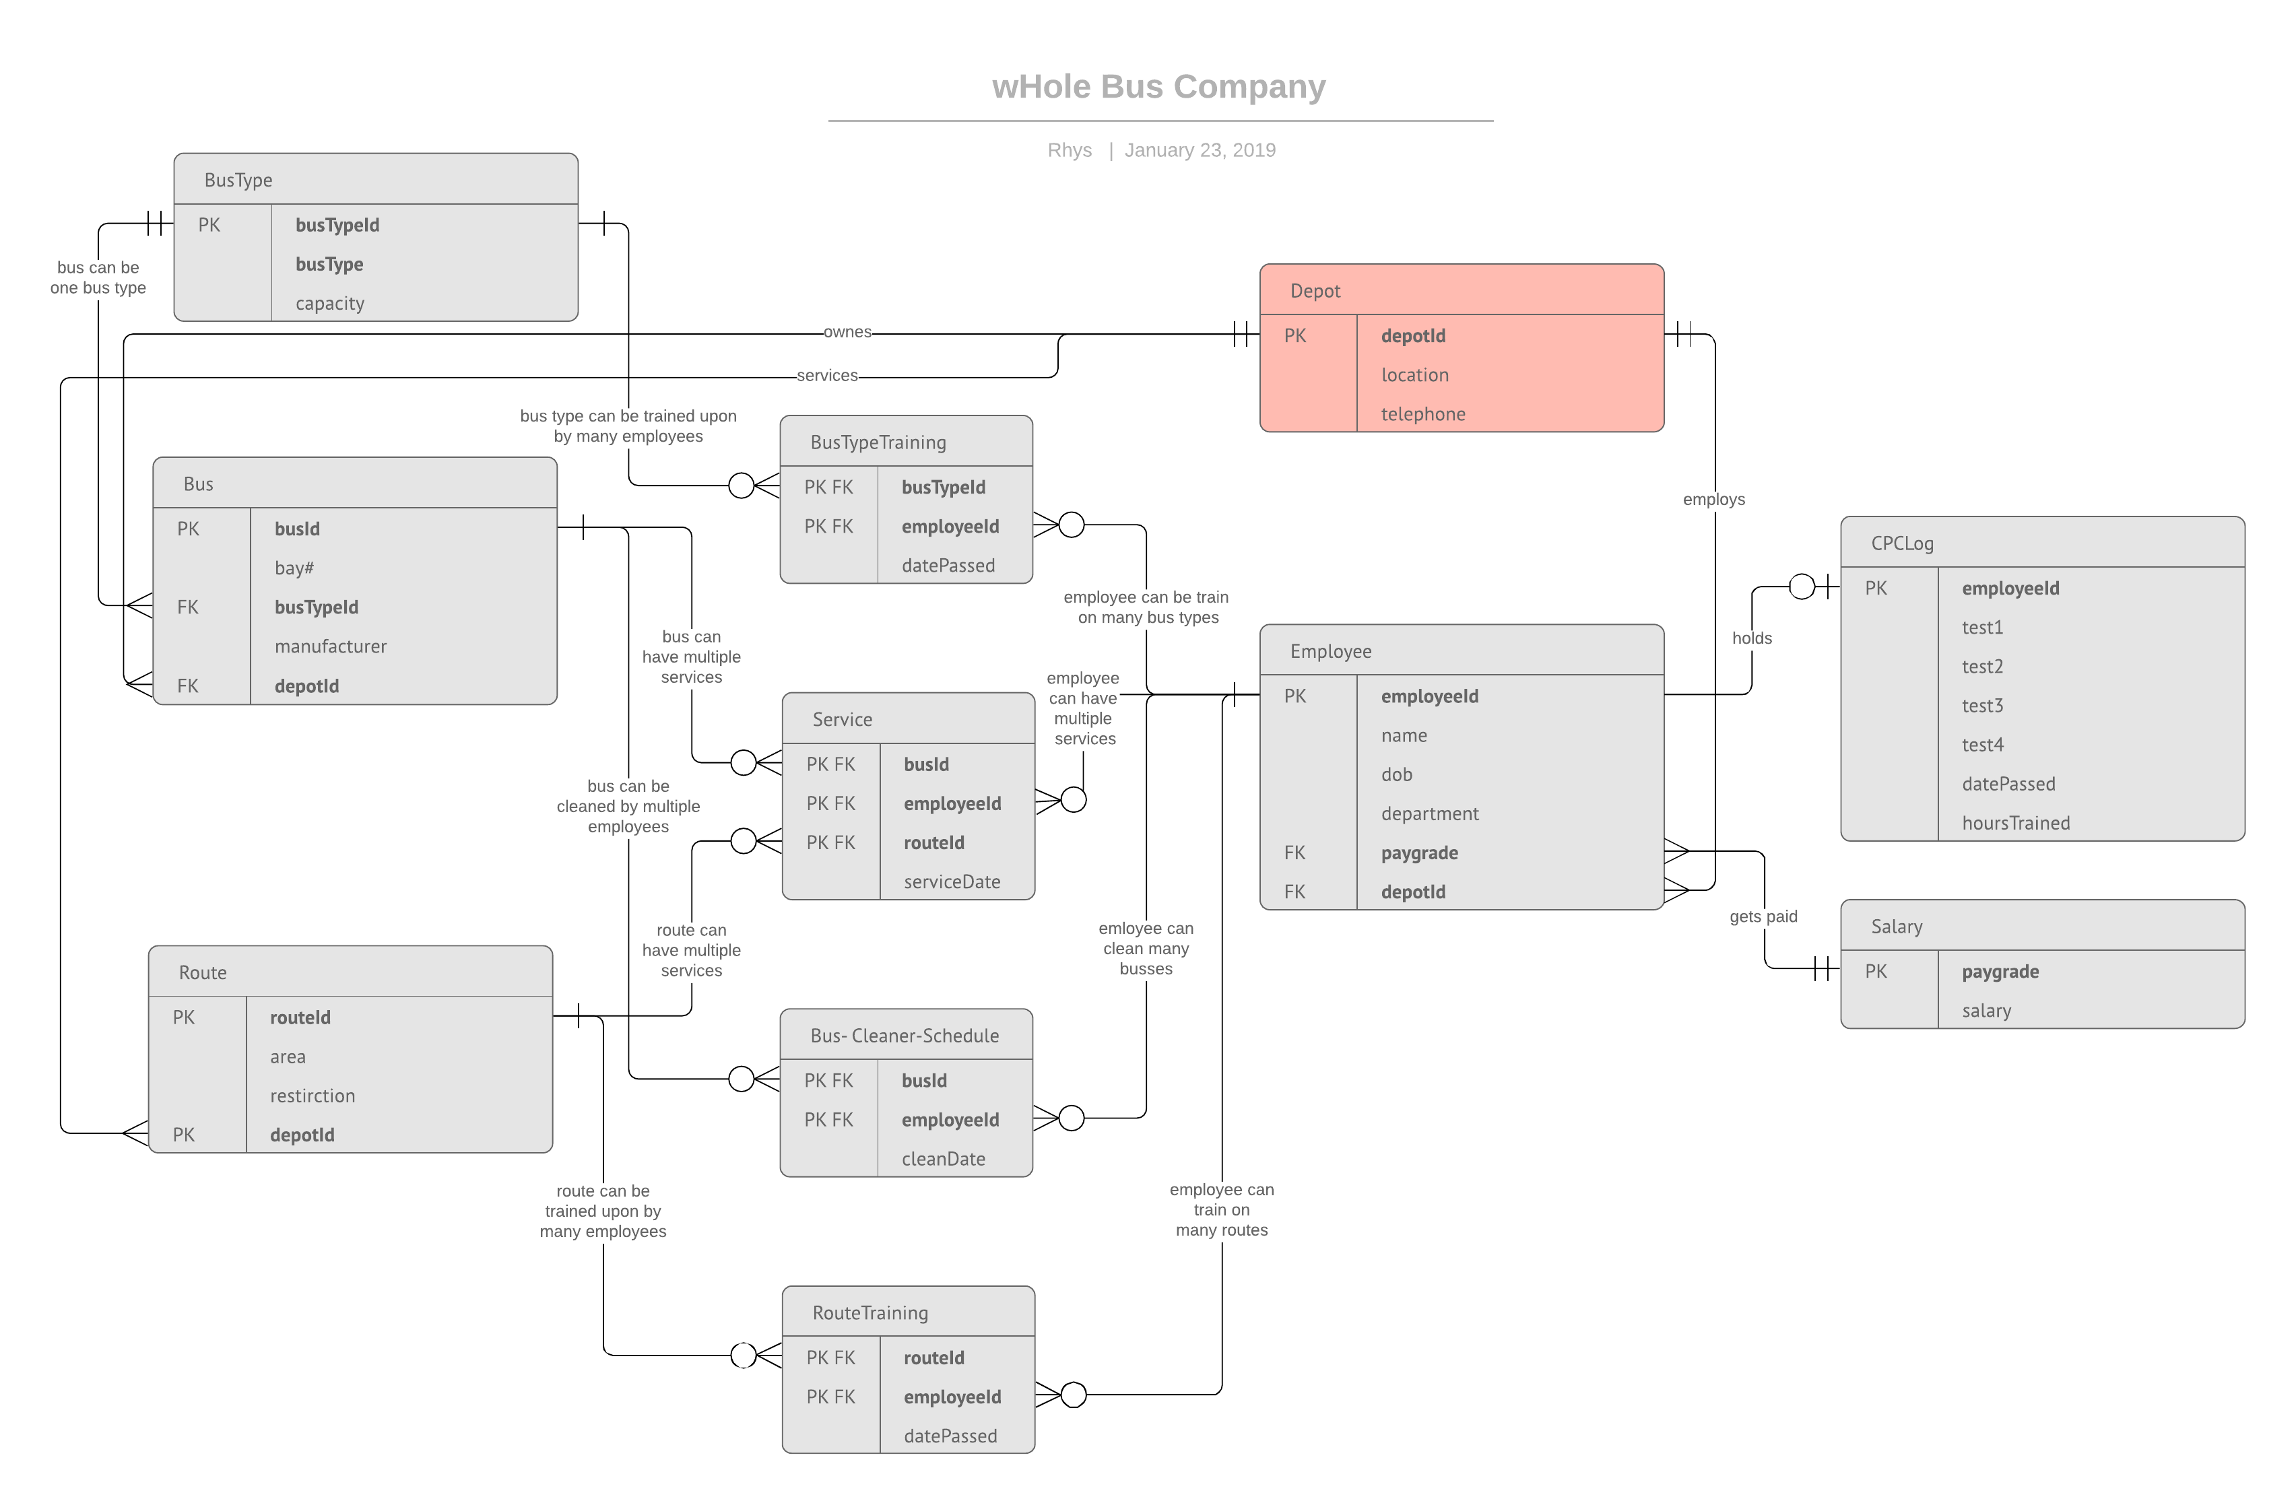
Entity Relationship Diagram

The Entity Relationship Diagram (ERD) above illustrates the database and how each entity within the wHole Bus Company relates to one another. An Entity Relationship Diagram achieves this through connecting lines that show which entity is related to another and indicates the relationship cardinality and ordinality at the endpoints of these lines, when they meet the relation. The diagram shows multiple one-to-many, one-to-one and many-to-many scenarios. The diagram also shows how many-to-many relationships are derived into interconnecting relations containing a composite primary key, linking the relations. The use of composite primary keys together with them being foreign keys enables us to create these interconnecting relations that can be seen in the diagram. The diagram shows the relations created for those entities, and where a many-to-many relationship exists the following separate relations were created:

- Bus Type Training (linking Bus Types and Drivers)
- Route Training (linking Routes and Drivers)
- Bus Cleaner Schedule (linking Buses and Cleaners)
- Service (linking Bus, Route and Drivers)

The relations displayed in the ERD are in third normal form, each having a primary key that has attributes that are entirely dependent on it whilst also being mutually independent.

Assumptions
The ERD was designed with a set of particular assumptions considered:
- A driver will not be assigned a bus if the bus does not belong to the depot that the driver is employed by.
- A cleaner will not be assigned a bus if the bus does not belong to the depot that the cleaner is employed by.
- A driver will not be assigned a route if the route is not serviced by the depot that the driver is employed by.
- A driver will not be assigned if he has not completed all parts of the CPC training tests.
- A driver will not be assigned to drive if they have not completed 35 hours of training after 5 years of completing their CPC training.
- A driver’s pay-grade will be incremented once CPC training has been completed and will do so with every year of experience.
- A cleaner’s pay-grade will be incremented with every year of experience.

Multi-User Capability
A single-user database is one where only one user is supported to access the database at one time [1]. Any other user must wait until the user before is finished. Single-user databases are easier to maintain since they are less complex and less resources are used. Furthermore, these databased handles a task at a time and also have a lesser chance of damage [1]. However, the system limits the access to one user at a time and tasks take longer to complete.

Multi-user databases, on the other hand, support multiple users simultaneously and it is possible for the database to exist on multiple computers [2]. These multiple computers are able to update the information in parallel and give access to up to date information. Although the structure can be more complex than a single-user system, switching between projects on a multi-user system is easier and usage is optimized for various users [1].

A multi-user database can take many different forms, depending on how the database is implemented. A workgroup database is used to support small numbers of users, often used by departments or instances with fewer than 50 users [1]. For databases that are used by greater number of users, perhaps entire organizations, an enterprise database may be more adequate. Some database types are more to do with the location of the supported data.

A centralized database is one where the data is supported at a specific location, whereas a distributed database is one that distributes the data across many locations [1]. This distribution of data can be achieved using data replication, where the fragmented data copies are stored at multiple locations or nodes, which all serve to meet a particular requirement and, by the CAP Theorem, a database system that achieves a high distribution of data yields properties of consistency, availability and partitioning tolerance [3].

This means that the database shows up-to date information that is consistent across multiple nodes, whilst being available at all times, even when a particular node is at failure. These types of databases are dependent on defined infrastructure, whereas a cloud database makes use of a cloud environment, a service offered by the likes of Amazon Web Services and Microsoft Azure [4]. These environments offer measures such as availability and storage and have no need for the database owner to be affiliated with how the database is supported.

These databases on these such environments involve NoSQL, which skew from the relational model of SQL, focusing on being able to handle large scalability and high performance [1]. Although for databases used through the likes of MongoDB are flexible and unstructured data is handled well, querying can be difficult across documents.

I would recommend that wHole Bus Company use a relational database, moreover, using one that his distributive. Relational database systems like PostgreSQL are able to handle complex structured data that is quickly stored and retrieved like in the case of the bus company [5]. Also, highly distributive databases enable the multiple depots to access the same up-to-date information with the benefit of a stable and consistent database [1].

Constraints
Suitable check constraints have been enforced within the relations, are evident in the creation of the relations, and are as follows:
- Telephone numbers must be of exactly 11 digits
- Capacity of busses must be positive and not 0
- Pay-grade must be positive and not 0
- All relevant fields are to be not null

Triggers
The following constraints have been enforced in the form of functions and triggers and are intended to enforce selected business rules within the Service relation:
- A bus cannot be driven by a driver who is yet to complete the respective bus type training
- A route cannot be driven by a driver who is yet to complete the respective route training
- A route cannot be serviced by a bus where the route has a restriction and the bus is of a certain bus type (double decker or large coach)
The following audit tables have been implemented through the use of triggers and functions and include referential integrity constraints:
- An employee audit table that logs the changes made to salary including insertions, updates and deletions.
- A service audit table that logs the changes made to the relation including insertions, updates and deletions.
- A training audit table that logs the CPC training whilst also including a trigger that maintains data integrity within the service relation

- CREATE TABLE employee_audit (
- operation char(1) NOT NULL,
- stamp timestamp NOT NULL,
- userId text NOT NULL,
- name varchar(25) NOT NULL,
- paygrade integer NOT NULL
- );

- CREATE OR REPLACE FUNCTION process_employee_audit() RETURNS TRIGGER AS $employee_audit$
- BEGIN
- IF (TG_OP = 'DELETE') THEN
- INSERT INTO employee_audit
- VALUES('D', now(), user, OLD.name, OLD.paygrade);
- RETURN OLD;
- ELSIF (TG_OP = 'UPDATE') THEN
- INSERT INTO employee_audit
- VALUES('U', now(), user, NEW.name, NEW.paygrade);
- RETURN NEW;
- ELSIF (TG_OP = 'INSERT') THEN
- INSERT INTO employee_audit
- VALUES('I', now(), user, NEW.name, NEW.paygrade);
- RETURN NEW;
- END IF;
- RETURN NULL;
- END;
- $employee_audit$ LANGUAGE plpgsql;

- CREATE TRIGGER employee_audit
- AFTER INSERT OR UPDATE OR DELETE ON employee
- FOR EACH ROW EXECUTE PROCEDURE process_employee_audit();

- CREATE TABLE service_audit (
- operation char(1) NOT NULL,
- stamp timestamp NOT NULL,
- userId text NOT NULL,
- busId integer NOT NULL,
- employeeId integer NOT NULL,
- routeId integer NOT NULL,
- serviceDate date NOT NULL
- );

- CREATE OR REPLACE FUNCTION process_service_audit() RETURNS TRIGGER AS $service_audit$
- BEGIN
- IF (TG_OP = 'DELETE') THEN
- INSERT INTO service_audit
- VALUES('D', now(), user, OLD.busId, OLD.employeeId, OLD.routeId, OLD.serviceDate);
- RETURN OLD;
- ELSIF (TG_OP = 'UPDATE') THEN
- INSERT INTO service_audit
- VALUES('U', now(), user, NEW.busId, NEW.employeeId, NEW.routeId, NEW.serviceDate);
- RETURN NEW;
- ELSIF (TG_OP = 'INSERT') THEN
- INSERT INTO service_audit
- VALUES('I', now(), user, NEW.busId, NEW.employeeId, NEW.routeId, NEW.serviceDate);
- RETURN NEW;
- END IF;
- RETURN NULL;
- END;
- $service_audit$ LANGUAGE plpgsql;

- CREATE TRIGGER service_audit
- AFTER INSERT OR UPDATE OR DELETE ON service
- FOR EACH ROW EXECUTE PROCEDURE process_service_audit();

- CREATE TABLE training_audit (
- audit_id SERIAL PRIMARY KEY,
- employeeId integer NOT NULL,
- hoursTrained integer NOT NULl,
- dateLogged timestamp(6) NOT NULL);

- CREATE OR REPLACE FUNCTION log_hoursTrained()
- RETURNS trigger As
- $BODY$
- BEGIN
- IF NEW.hoursTrained IS NULL THEN
- RAISE EXCEPTION ' hours trained cannot be null';
- END IF;
- IF NEW.hoursTrained < 0 THEN
- RAISE EXCEPTION ' hours cannot be negative ';
- END IF;
- IF NEW.hoursTrained > 35 THEN
- RAISE EXCEPTION ' hours cannot exceed 35 hours';
- END IF;
- IF NEW.hoursTrained <> OLD.hoursTrained THEN
- INSERT INTO training_audit(employeeId, hoursTrained, dateLogged)
- VALUES (OLD.employeeId, OLD.hoursTrained, now());
- END IF;
- RETURN NEW;
- END;
- $BODY$
- LANGUAGE plpgsql VOLATILE
- COST 100;

- CREATE TRIGGER hoursTrained_changes
- BEFORE UPDATE
- ON CPCLog
- FOR EACH ROW
- EXECUTE PROCEDURE log_hoursTrained();
- CREATE OR REPLACE FUNCTION check_restriction() RETURNS TRIGGER AS $service_restriction$
- BEGIN
- IF EXISTS (
- SELECT bus.busId, bus.busTypeId
- FROM bus
- JOIN service
- ON bus.busId = service.busId
- HAVING
- (bus.busTypeId = 1 OR bus.busTypeId = 2)
- )
- THEN
- RAISE EXCEPTION 'BUS TYPE RESTRICTED';
- ROLLBACK;
- END IF;
- END;
- $service_restriction$ LANGUAGE plpgsql;

- CREATE TRIGGER service_restriction
- BEFORE INSERT OR UPDATE ON service
- EXECUTE PROCEDURE check_restriction();

- DROP TRIGGEr service_restriction ON service

- CREATE OR REPLACE FUNCTION check_bus_training() RETURNS TRIGGER AS $service_bus_training$
- BEGIN
- IF EXISTS (
- SELECT *
- FROM ((busTypeTraining
- JOIN service
- ON busTypeTraining.employeeId = service.employeeId)
- JOIN bus
- ON bus.busId = service.busId)
- HAVING
- (busTypeTraining.busTypeId = bus.busTypeId)
- )
- THEN
- RAISE EXCEPTION 'NO BUS TYPE TRAINING';
- END IF;
- END;
- $service_bus_training$ LANGUAGE plpgsql;

- CREATE TRIGGER service_bus_training
- AFTER INSERT OR UPDATE ON service
- FOR EACH ROW EXECUTE PROCEDURE check_bus_training();

- CREATE OR REPLACE FUNCTION check_route_training() RETURNS TRIGGER AS $service_route_training$
- BEGIN
- IF EXISTS (
- SELECT *
- FROM (routeTraining
- JOIN service
- ON routeTraining.employeeId = service.employeeId)
- HAVING
- (routeTraining.routeId = service.routeId)
- )
- THEN
- RAISE EXCEPTION 'NO ROUTE TRAINING';
- END IF;
- END;
- $service_route_training$ LANGUAGE plpgsql;

- CREATE TRIGGER service_route_training
- AFTER INSERT OR UPDATE ON service
- FOR EACH ROW EXECUTE PROCEDURE check_route_training();

Transaction Management
Serializable and Repeatable reads have been used that enforce appropriate transaction management that enables an execution to take precedent before the next, ensuring that the database remains consistent. These transactions satisfy atomicity, consistency, isolation and durability (ACID) properties and ensures that after a transaction, the system succeeds or fails and isn’t left in a partial state, it also ensures that the database remains uncorrupted by a transaction. Also isolation ensures that transactions are performed simultaneously and finally once a transaction has been completed it is recorded in the case of system failure. Evidence of transaction management follows.
Repeatable reads:
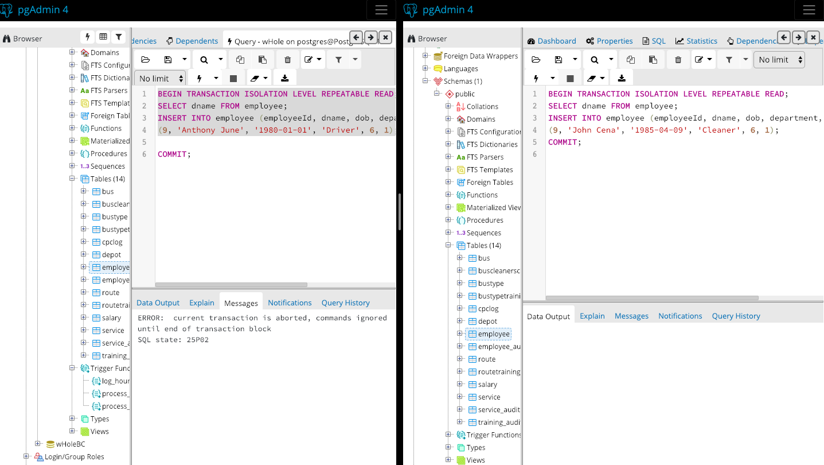
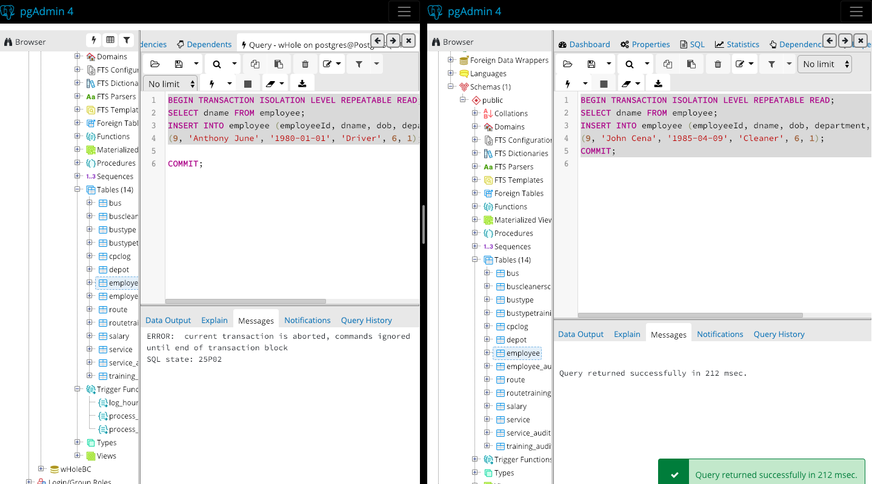

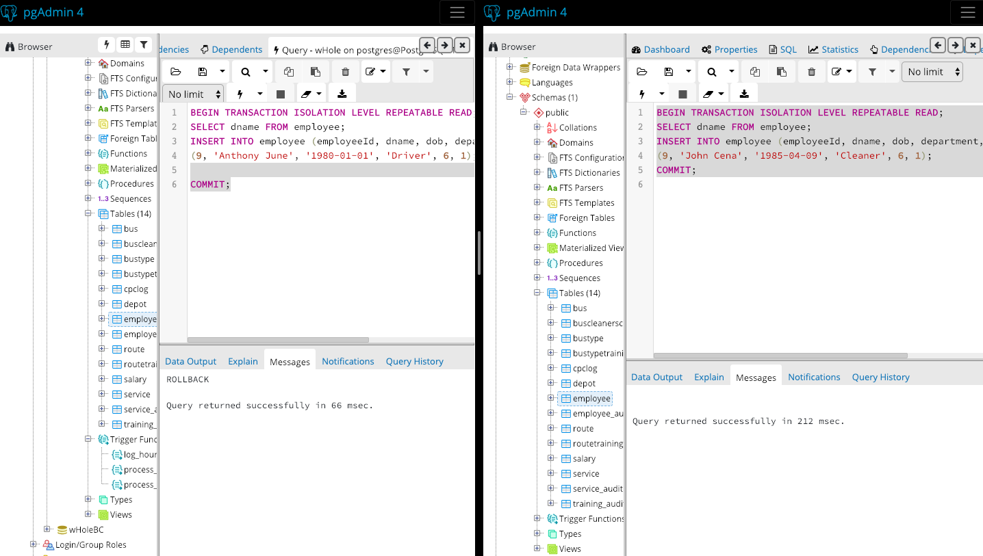

Serializable:

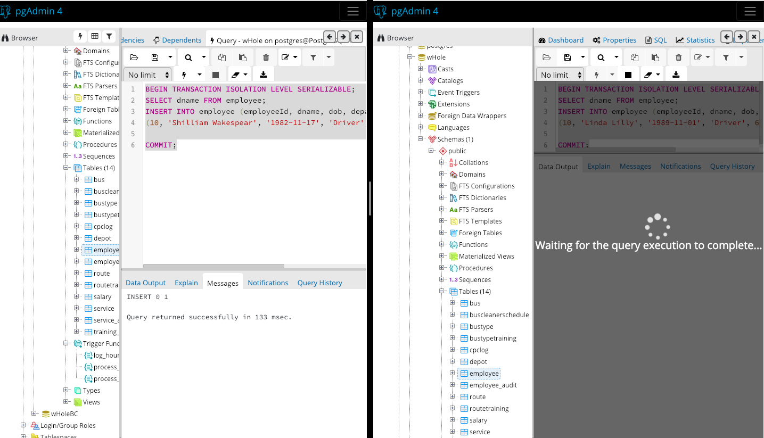

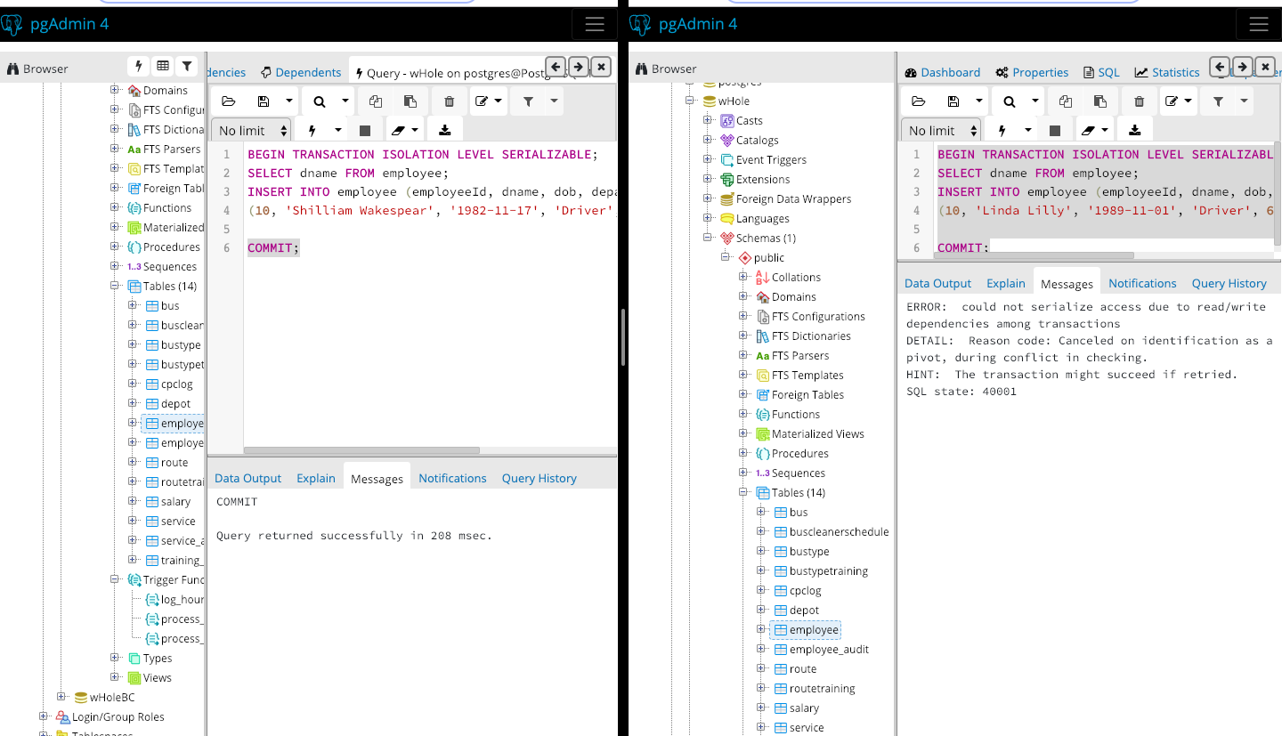

Creation of Relations and Insertion of Data
- CREATE TABLE depot (
- depotId integer NOT NULL,
- location varchar(15) NOT NULL,
- telephone varchar(11) NOT NULL,
- CONSTRAINT chk_telephone CHECK (LENGTH(telephone) = 11),
- CONSTRAINT depot_depotId_pk PRIMARY KEY (depotId)
- );

- CREATE TABLE route (
- routeId integer NOT NULL,
- area varchar(15) NOT NULL,
- restriction char(1) NOT NULL,
- depotId integer NOT NULL,
- CONSTRAINT route_routeId_pk PRIMARY KEY (routeId),
- CONSTRAINT route_depotId_fk FOREIGN KEY (depotId) REFERENCES depot (depotId)
- );

- CREATE TABLE busType (
- busTypeId integer NOT NULL,
- busType varchar(20) NOT NULL,
- capacity integer NOT NULL,
- CONSTRAINT chk_capacity CHECK (capacity > 0),
- CONSTRAINT busType_busTypeId_pk PRIMARY KEY (busTypeId)
- );

- CREATE TABLE bus (
- busId integer NOT NULL,
- bayNo integer NOT NULL,
- busTypeId integer NOT NULL,
- manufacturer varchar(15) NOT NULL,
- depotId integer NOT NULL,
- CONSTRAINT bus_busId_pk PRIMARY KEY (busId),
- CONSTRAINT bus_busTypeId_fk FOREIGN KEY (busTypeId) REFERENCES busType (busTypeId),
- CONSTRAINT bus_depotId_fk FOREIGN KEY (depotId) REFERENCES depot (depotId)
- );

- CREATE TABLE salary (
- paygrade integer NOT NULL,
- salary integer NOT NULL,
- CONSTRAINT chk_paygrade CHECK (paygrade > 0),
- CONSTRAINT salary_paygrad_pk PRIMARY KEY (paygrade)
- );

- CREATE TABLE employee (
- employeeId integer NOT NULL,
- name varchar(25) NOT NULL,
- dob date NOT NULL,
- department varchar(20) NOT NULL,
- paygrade integer NOT NULL,
- depotId integer NOT NULL,
- CONSTRAINT employee_employeeId_pk PRIMARY KEY (employeeId),
- CONSTRAINT employee_depotId_fk FOREIGN KEY (depotId) REFERENCES depot (depotId),
- CONSTRAINT employee_paygrade_fk FOREIGN KEY (paygrade) REFERENCES salary (paygrade)
- );

- CREATE TABLE CPCLog (
- employeeId integer NOT NULL,
- test1 varchar(1) NOT NULL,
- test2 varchar(1) NOT NULL,
- test3 varchar(1) NOT NULL,
- test4 varchar(1) NOT NULL,
- datePassed date,
- hoursTrained integer,
- CONSTRAINT CPCLog_employeeId_pk PRIMARY KEY (employeeId)
- );

- CREATE TABLE service (
- serviceName varchar(30) NOT NULL,
- busId integer NOT NULL,
- employeeId integer NOT NULL,
- routeId integer NOT NULL,
- serviceDate date NOT NULL,
- CONSTRAINT service_pk PRIMARY KEY (busId, employeeId, routeId),
- CONSTRAINT service_busId_fk FOREIGN KEY (busId) REFERENCES bus (busId),
- CONSTRAINT service_employeeId_fk FOREIGN KEY (employeeId) REFERENCES employee (employeeId),
- CONSTRAINT service_routeId_fk FOREIGN KEY (routeId) REFERENCES route (routeId)
- );

- CREATE TABLE busCleanerSchedule (
- busId integer NOT NULL,
- employeeId integer NOT NULL,
- cleanDate date NOT NULL,
- CONSTRAINT busCleanerSchedule_pk PRIMARY KEY (busId, employeeId),
- CONSTRAINT busCleanerSchedule_busId_fk FOREIGN KEY (busId) REFERENCES bus (busId),
- CONSTRAINT busCleanerSchedule_employeeId_fj FOREIGN KEY (employeeId) REFERENCES employee (employeeId)
- );

- CREATE TABLE busTypeTraining (
- busTypeId integer NOT NULL,
- employeeId integer NOT NULL,
- datePassed date NOT NULL,
- CONSTRAINT BusTypeTraining_pk PRIMARY KEY (busTypeId, employeeId),
- CONSTRAINT BusTypeTraining_busTypeId_fk FOREIGN KEY (busTypeId) REFERENCES busType (busTypeId),
- CONSTRAINT BusTypeTraining_employeeId_fk FOREIGN KEY (employeeId) REFERENCES employee (employeeId)
- );

- CREATE TABLE routeTraining (
- routeId integer NOT NULL,
- employeeId integer NOT NULL,
- datePassed date NOT NULL,
- CONSTRAINT routeTraining_pk PRIMARY KEY (routeId, employeeId),
- CONSTRAINT routeTraining_routeId_fk FOREIGN KEY (routeId) REFERENCES route (routeId),
- CONSTRAINT routeTraining_employeeId_fk FOREIGN KEY (employeeId) REFERENCES employee (employeeId)
- );

- INSERT INTO depot (depotId, location, telephone) VALUES
- (1, 'Swansea', '01792676543'),
- (2, 'Cardiff', '02209879902'),
- (3, 'Newport', '02209126111'),
- (4, 'Brecon', '01234909656'),
- (5, 'Aberystwyth', '01892333568')
- ;

- INSERT INTO route (routeId, area, restriction, depotId) VALUES
- (1, 'Uplands', 'N', 1),
- (2, 'TownHill','N', 1),
- (3, 'Marina','N', 1),
- (4, 'Mumbles','Y', 1)
- ;

- INSERT INTO busType (busTypeId, busType, capacity) VALUES
- (1, 'Double Decker', 80),
- (2, 'Large Coach', 60),
- (3, 'Single Decker', 60),
- (4, 'Mini Bus', 25),
- (5, 'Small Coach', 40)
- ;

- INSERT INTO bus (busId, bayNo, busTypeId, manufacturer, depotId) VALUES
- (1, 1, 1, 'Renault', 1),
- (2, 2, 3, 'Mercedes', 1),
- (3, 3, 3, 'Volvo', 1),
- (4, 4, 5, 'Mercedes', 1)
- ;

- INSERT INTO salary (paygrade, salary) VALUES
- (1, 10000),
- (2, 12000),
- (3, 15000),
- (4, 18000),
- (5, 20000),
- (6, 23000),
- (7, 28000),
- (8, 32000),
- (9, 36000),
- (10, 40000),
- (11, 50000)
- ;

- INSERT INTO employee (employeeId, dname, dob, department, paygrade, depotId) VALUES
- (1, 'John Davies', '1970-12-01', 'Driver', 10, 1),
- (2, 'Paul Jenkins', '1985-04-09', 'Driver', 7, 1),
- (3, 'Rupert Williams', '1989-09-22','Driver', 6, 1),
- (4, 'Helen Davies', '1984-01-30', 'Driver', 6, 1),
- (5, 'Daniel Clark', '1991-06-02', 'Cleaner', 1, 1),
- (6, 'Wiliiam Thompson', '1987-11-11','Cleaner', 1, 1),
- (7, 'John Davies', '1994-02-18','Cleaner', 1, 1),
- (8, 'Beth Rees', '1989-12-14','Cleaner', 2, 1)
- ;

- INSERT INTO CPCLog (employeeId, test1, test2, test3, test4, datePassed, hoursTrained) VALUES
- (1, 'y','y','y','y','2016-10-05', 0),
- (2, 'y','y','y','y','2017-10-05', 0),
- (3, 'y','y','y','y','2018-10-05', 0),
- (4, 'y','y','y','y','2018-10-05', 0)
- ;

- INSERT INTO busTypeTraining (busTypeId, employeeId, datePassed) VALUES
- (1, 1,'2017-10-07'),
- (2, 1,'2017-10-07'),
- (3, 1,'2017-10-07'),
- (4, 1,'2017-10-07'),
- (5, 1,'2017-10-07'),
- (1, 2,'2017-10-07'),
- (2, 2,'2017-10-07'),
- (3, 2,'2017-10-07'),
- (4, 2,'2017-10-07'),
- (5, 2,'2017-10-07'),
- (1, 3,'2017-10-07'),
- (2, 3,'2017-10-07'),
- (3, 3,'2017-10-07'),
- (4, 3,'2017-10-07'),
- (5, 3,'2017-10-07')
- ;

- INSERT INTO routeTraining (routeId, employeeId, datePassed) VALUES
- (1, 1,'2017-10-07'),
- (2, 1,'2017-10-07'),
- (3, 1,'2017-10-07'),
- (4, 1,'2017-10-07'),
- (1, 2,'2017-10-07'),
- (2, 2,'2017-10-07'),
- (3, 2,'2017-10-07'),
- (4, 2,'2017-10-07'),
- (1, 3,'2017-10-07'),
- (2, 3,'2017-10-07'),
- (3, 3,'2017-10-07'),
- (4, 3,'2017-10-07')
- ;

- INSERT INTO busCleanerSchedule (busId, employeeId, cleanDate) VALUES
- (1, 5, '2019-01-12'),
- (2, 6, '2017-01-12'),
- (3, 7, '2017-01-12'),
- (4, 8, '2017-01-12')
- ;

MongoDB NoSQL Database

Databases are utilized in the everyday workings of large, successful businesses’ & companies for the efficient storage, retrieval and analysis of data [5]. During the 1970s, much of the modern database programming language was developed and since this era, SQL databases have dominated the field [6]. SQL databases – which is an abbreviation for Structured Query Language, is used for data retrieval and was the most popular method for collecting information from relational database systems (RDB) [5], [6].

A relational database is one which uses tables which are called ‘relations’ to store data [7]. These relations are implemented through SQL which is a language used in relational databases that can create and modify the data whilst also making queries to fetch the data held within [6], [7]. The relations are idealised to have high interconnectivity and low dependency between them, also known as high cohesion and loose coupling [8]. Each table is created with a unique reference called a primary key, which is used to query the specific tuple, gathering the attributes of that key contained within the relation [6]. Also, a relation may contain a foreign key which is used to link one table to another, where the foreign key is a primary key in the relation that it belongs to [9]. This interconnectivity enables relational databases to handle complex structured data and supports ACID transactions [10].

The design of such databases enables users to quickly and easily access data and, owing to the structure of the database, when one piece of data is modified the rest of the database reflects these changes elsewhere [5]. This enables the data to be entered only once for it to be implemented at multiple locations . It also allows ease of scalability as data can be added without disrupting the existing data and data structure. In addition to this, limits can be enforced that support different access groups allowing specific users to access or modify data, making the database more secure and accessible to the intended users. Where these databases are implemented, often multiple users can access the same up-to-date information at multiple nodes, accessing or modifying data safely and consistently [11].

Relational databases however, can be difficult to scale whilst guaranteeing ACID obedience and also, they are inadequate for handling unstructured data and can often be expensive to create, maintain and secure [12]. Furthermore, the strict schema of the database means that changes to the way a relation is structured are a problem, and only being able to insert information once a clear and structure relation has been constructed [7].

In recent years, an alternative to SQL, NoSQL (not only SQL) emerged. The NoSQL approach was built for larger, more varied data, most commonly datasets built in the early 2000s [5]. In these applications, performance and scalability outweighed the need for immediate, rigid data consistency provided by relational databases [13]. In contrast to SQL databases, a document NoSQL database is well abled in handling unstructured data. A document NoSQL database uses collections in place of relations, where data is often structured in a block of XML or JSON [14]. The use of such structures in design are easy for developers and computers to interpret and allows developers to design their documents how they wish, with the capability of creating a hierarchy of JSON objects [15]. Document databases utilises a flexible schema where documents don’t impose neither structure nor declaration of data types [16]. It is not required for a user to know the structure or data type of a set of data during creation, making it easier for when data is unpredictable and ever-changing.

In addition to high writing speeds, the data is highly available due to the flexible schema which enables modification of a document without affecting other documents [11]. Even when there exists a failure in part of the network, the database favours write availability over stringent data consistency [17]. With implementation of such databases like MongoDB where documents can be easily changed with great flexibility, agile methods of software development can merge well with these databases that adapt to evolving data structures, instead of having to adhere to strict schemas of relational databases, proving difficult to keep up with the changes that agile methods bring.

NoSQL denotes a database management system that uses an approach other than the conventional relational database system [5], [6]. It is used due to its capability to handle large volumes of data and high traffic data operations including writes and queries. Also, these types of databases are able to deal with various data types, and whether they are a part of structured, semi-structured or unstructured data [5], [6], [7].

Below is the implementation of the relations ‘employee’ and ‘busType’. These are created in MongoDB as collections. The data type did not have to be specified when creating the collections.
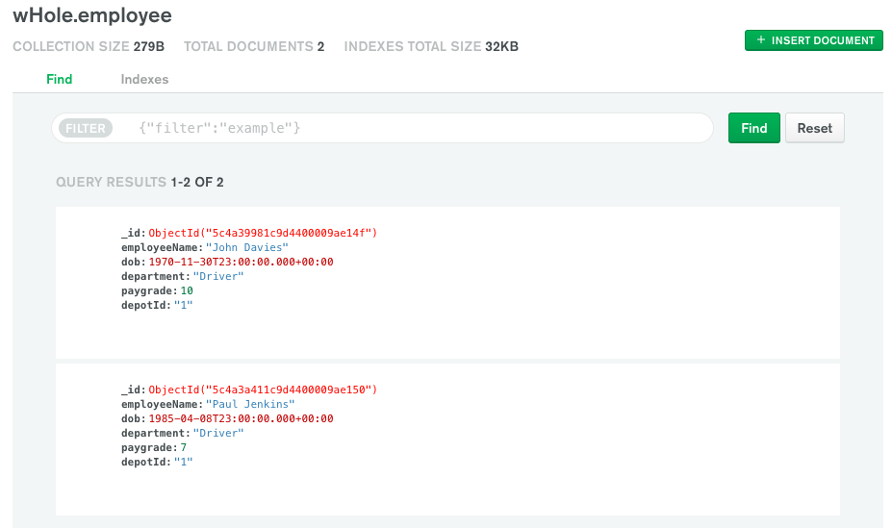

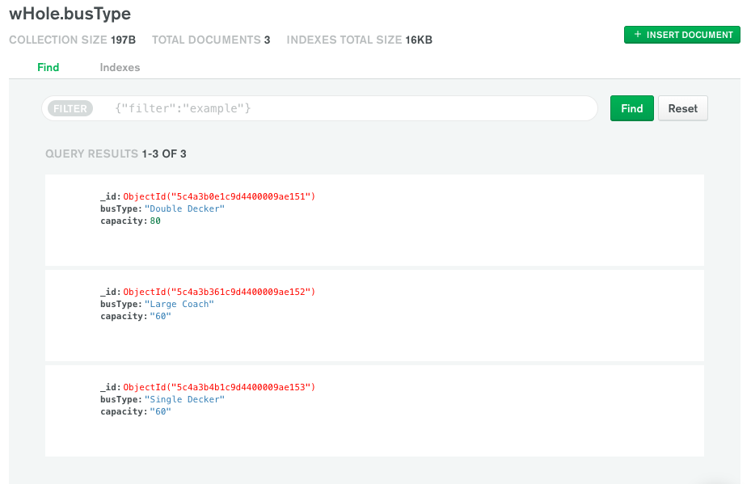

Critical Reflection
During this assignment I have encountered difficulties during the implementation of the database scenario into an ER diagram, in particular, when joining relations that hold a many to many relationships. These relations that lay between were often difficult to implement whilst ensuring the proper use of primary and foreign keys. Furthermore, I also came across complications when trying to create triggers that enforced business rules. These triggers have been demonstrated to the best of my ability within the assignment however, I found it challenging to reference two different relations, through an inner join, to restrict certain values from being entered within these relations. Having completed the assignment, I have discovered the differences between a relational database system that uses SQL and a document database that is MongoDB that is NoSQL. I have learned the advantages and disadvantages of both and where they may be best applicable. In addition to this, I have also learned the types of multi user database options and their importance. If I were to repeat the assignment I would look to further study into how I may be able to implement complex trigger functions to enforce business rules further. I might also want to study further the various other types of database options besides the ones looked at in this assignment.

Bibliography

[1] | C. Coronel and S. Morris, Database Systems Design, Implementation, and Management, CENGAGE Learning, 2016.
[2] | Y. Yang, L. Haibing and J. Weng, “Multi-user private keyword search for cloud computing,” in Cloud Computing Technology and Science (CloudCom), IEEE, 2011, pp. 264-271.
[3] | S. Vatika and M. Dave, “SQL and NoSQL Databases,” Internation Journal of Advanced Reserach in Computer Science and Software Engineering, vol. 2, no. 8, 2012.
[4] | Q. Zhang, C. Lu and R. Boutaba, “Cloud computing: state-of-the-art and reserach challenges,” Journal of internet services and applications, vol. 1, no. 1, pp. 7-18, 2010.
[5] | R. Elmasri and S. Navathe, Fundamentals of database systems, London: Pearson, 2016.
[6] | R. Batra, “A History of SQL and Relational Databases,” in SQL Primer, Berkeley, CA, Apress, 2018, pp. 183-187.
[7] | G. Singh and A. Solanki, “An algorithm to transform natural language into SQL queries for relational databases,” Selforganizology, vol. 3, no. 3, pp. 100-116, 2016.
[8] | TutorialsPoint, “Cohesion and Coupling,” 2018. [Online]. Available: https://www.tutorialspoint.com/software_engineering_basics/cohesion_and_coupling.asp?fbclid=IwAR0ez4T3NErr3KW7_Pu2SmJz4bN7bh62AJiZqrQV0M2aOfSqqSO40vYCbg. [Accessed 8 January 2019].
[9] | S. Chu and B. Murphy, “Axiomatic foundations and algorithms for deciding semantic equivalences of SQL queries,” Proceedings of the VLDB Endowment, vol. 11, no. 11, pp. 1482-1495, 2018.
[10] | S. Pore and S. Pawar, “Comparative Study of SQL & NoSQL Databases,” International Journal of Advanced Research in Computer Engineering & Technology (IJARCET), vol. 4, no. 5, 2015.
[11] | S. Binani, A. Gutti and S. Upadhyay, “SQL vs. NoSQL vs. NewSQL- A Comparative Study,” Communications on Applied Electronics (CAE), vol. 6, no. 1, 2016.
[12] | R. A. Rodrigues, L. A. L. Filho, G. S. Gonçalves, L. F. S. Mialaret, A. M. da Cunha and L. A. V. Dias, “Integrating NoSQL, Relational Database, and the Hadoop Ecosystem in an Interdisciplinary Project involving Big Data and Credit Card Transactions,” in Information Technology-New Generations, Cham, Springer, 2018, pp. 443-451.
[13] | D. Borkar, R. Mayuram, G. Sangudi and M. Carey, “Have your data and query it too: From key-value caching to big data management.,” in Proceedings of the 2016 International Conference on Management of Data, ACM, 2016, pp. 239-251.
[14] | Z. U. Haq, G. F. Khan and T. Hussain, “A Comprehensive analysis of XML and JSON web technologies,” New Developments in Circuits, Systems, Signal Processing, Communications and Computers, pp. 102-109, 2015.
[15] | K. S.-P. Chang and B. A. Myers, “Using and Exploring Hierarchical Data in Spreadsheets,” Proceedings of the 2016 CHI Conference on Human Factors in Computing Systems, pp. 2497-2507, 2016.
[16] | A. Angrish, B. Starly, Y.-S. Lee and H. Cohen, “A flexible data schema and system architecture for the virtualization of manufacturing machines (VMM),” Journal of Manufacturing Systems, vol. 45, pp. 236-247, 2017.
[17] | S. P. Phansalkar and A. Dani, “Selective Data Consistency Model in No-SQL Data Store,” in Privacy and Security Policies in Big Data, IGI Global, 2017, pp. 124-147.

