Natalie Jo Midwinter
1706975
University of Wales Trinity Saint David

Albeit past examinations have exhibited that countenances of one's own race are perceived more precisely than are appearances of different races, the hypothetical premise of this impact isn't obviously comprehended at display. The examination revealed in this paper tried the contact theory of the claim race predisposition in confront acknowledgment utilizing a culturally diverse plan. Four gatherings of subjects were tried for their acknowledgment of unmistakable and commonplace possess race and other-race faces: (1) dark Africans who had a high level of contact with white faces, (2) dark Africans who had practically zero contact with white faces, (3) white Africans who had a high level of contact with dark countenances, and (4) white Britons who had little contact with dark appearances. The outcomes demonstrated that in spite of the fact that overall subjects perceived claim race faces more precisely and more certainly than they perceived other-race faces, the possess race inclination in confront acknowledgment was essentially littler among the high-contact subjects than it was among the low-contact subjects. Likewise, albeit high-contact high contrast subjects indicated critical fundamental impacts of uniqueness in their acknowledgment of appearances of the two races, low-contact high contrast subjects demonstrated noteworthy primary impacts of peculiarity just in their acknowledgment of claim race faces. It is contended that these outcomes bolster the contact speculation of the claim race predisposition in confront acknowledgment and Valentine's multidimensional space (MDS) structure of face encoding.

Introduction
Humans are very good at recognising a face, even if it is a person we have only met once, face recognition is done fast and we process a face different to other things you may see, when looking at something eyes take in visual information through the retina then send it to optic cortex (Kelsey, 1997).
Own race bias (ORB) is studies taken place to compare if we have a better recognition of own race faces compared to other race faces. For example, white people would be more capable to recognise own white faces than black faces, and black people are better at recognising black faces compares to white faces. This is important within everyday life and there are many reports and studies done for this particular subject of ORB, and facial recognition because due to racial attitudes and Cross, Cross and Daley (1971) found that within their study, one particular theory is white children / youngsters from an isolated area demonstrates a more prominent race bias to a white children / youngster, in comparison to children in a mixed racial neighbourhood, (Bringam & Barkowitz, 1978, cited in Chiroio and valentine 1995) which wasn’t the case when argued that they did not discover comparable contrasts among black children announced a feeble yet critical relationship be tween’s subjects self-revealed level of cross facial experience and their acknowledgment of other race faces.
Own race bias is supported by literature Devine and Malpass (1985) which suggests the face recognition is the process of encoding and happens on two levels superficial and inferential.
This present study was conducted to produce findings to support the hypothesis of own bias face recognition meaning an individual will be able to recall own races faces more successfully than other race face.
Method
Participants
The study that was taken place was participated by twenty nine people all of white ethnicity including seven male and twenty two females. The age of those who took part where ranging from eighteen too sixty
The Mean (M=27.31) to the standard deviation (SD= 10.81).
Design
The test utilized was a combined example t-test. It was an inside subject think about. The autonomous variable (IV) was estimating the acknowledgment of ethnicity, the two conditions were white race and black race. The dependant variable (DV) was estimating the quantity of appearances effectively reviewed

Materials
The investigation utilized Power Point to make an introduction of twelve faces that where appeared for section one of the examination. They were appeared for two seconds of different genders and age and race, Every twelve faces six white six dark, the second piece of the investigation contained on six pages a sum of thirty six faces, each page of six faces where shown for twelve seconds and a review sheet with a space for statistic information, alongside a space to record the members reaction. Reports to see what it was that was remembered.
Procedure
The members that were participating in this study were altogether sat inside a room containing table and Chairs alongside various screens /televisions, All members participating where all at various distances from the screens, they were handed and asked to complete a concert form for this study (Appendix C) and told to watch the screen, which the power point introduction would be shown upon. Extra directions where verbally given for the participants to stay silent, further direction was listed on the screens (power point) The introduction started a commencement succession to start the initial segment of the examination and the underlying twelve faces were shown each one in turn as a vast picture on the screen, that where required for recall once area one had finished, a diversion undertaking in a type of address presenting data this was improved the situation one moment. The members were then taught to watch the screens for the second piece of the investigation and were demonstrated a sum of six photographs where appeared for twelve seconds total sum of thirty-six pictures where appeared on the power point, while the slides where playing members participating were requested to record on a reaction sheet (Appendix A) the 12 faces they appeared to some degree one. A question was then exhibited on the screen as this was a gathering setting (Appendix B).

Results
A paired sample t test was taken place to decide if members participating could review and recall more adequately white faces than a black face following several diversions. The outcome demonstrates that the members participating review essentially more black appearances
(M=3.34, SD= 2.42) than white faces (M= 2.67, SD= 1.97); t (29) = 3.12, p <.05. (appendix D.)
The original hypothesis for this study that participants would recall significantly more white faces must be rejected

Discussion
Limitation; One ethnic Group, this was a limitation as you could not compare between ethnic groups, as all participants where one race. Small number of participants which means that the results cant be generalised
The trail and test taken places has estimated the two rates of acknowledgment, initially the acknowledgment of white faces along side the acknowledgement of the black faces anyway it additionally estimated the level of review of the white and black countenances. This analysis gives confirmation that the acknowledgment of claim race faces is actually lower than black race faces or different race faces. The out come of conflicting to the proof given in (Brigham & Malpass, 1985, Bingham, & Brigham, 1989.

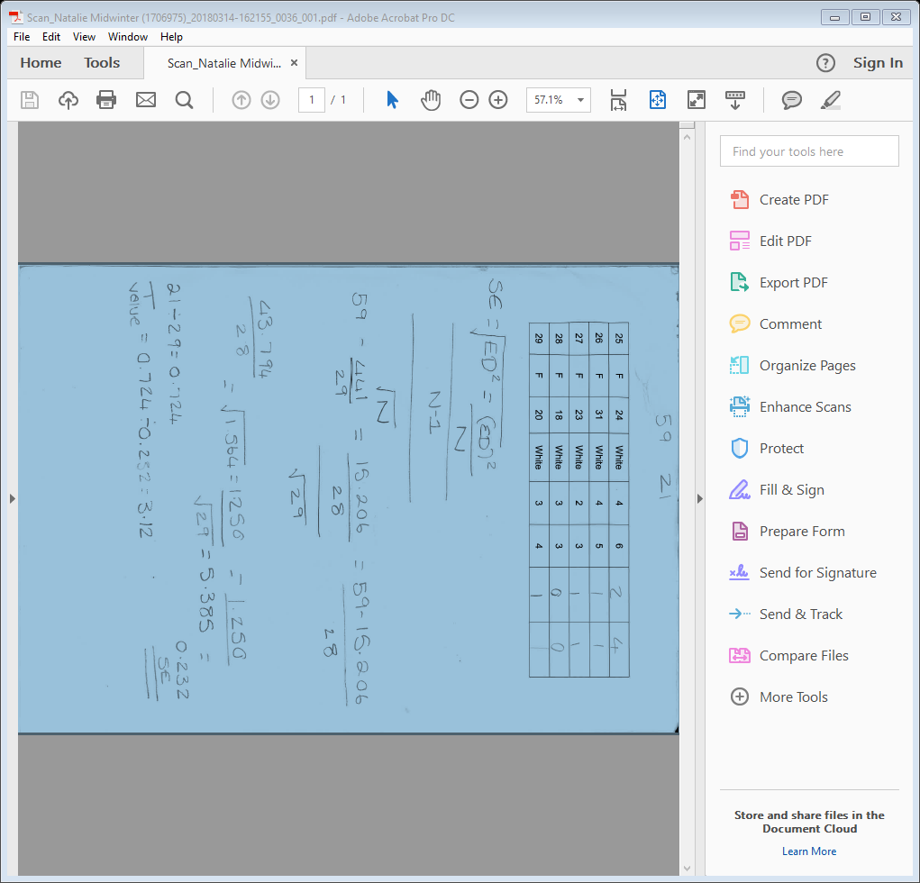
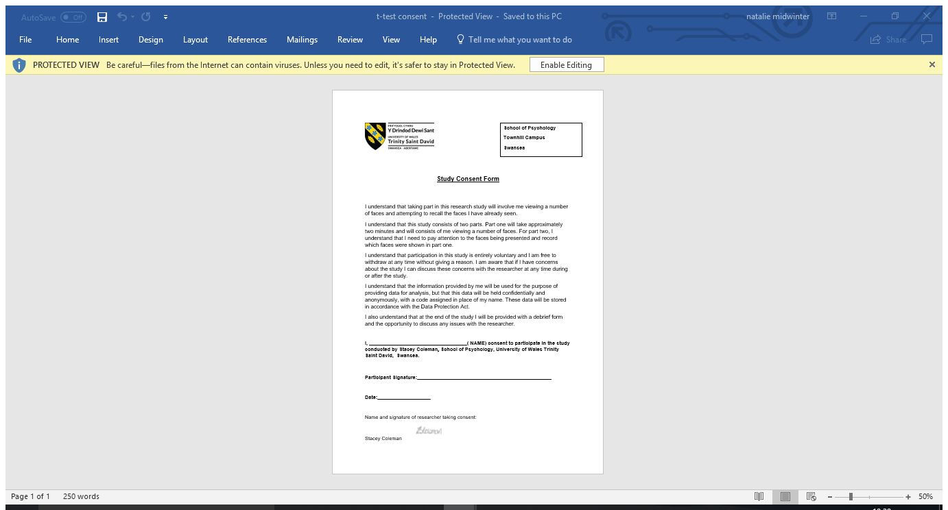
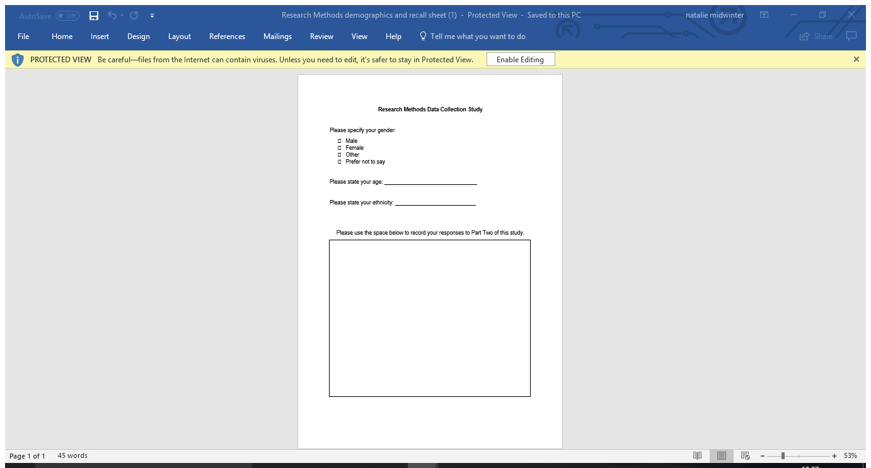

References
Kelsey, C.A. (1997). Detection of visual information. In W. R. Hendee & P. N. T. Wells (Eds.), The perception of visual information (2nd ed.). New York, NY: Springer Verlag.
McKone, E., Kanwisher, N., & Duchaine, B. C. (2007). Can generic expertise explain special processing for faces? Trends in Cognitive Sciences, 11, 8–15;
Bruce & vikki. (1986). understanding face recognition. british journal of psychology, 77.3 p305-328.
Valentine, P. C. (1995). An Investigation of the Contact Hypothesis of Own-race bias of face recognition. The quarterly journal of experimental psychology , 48A (4), 879-894.
Valentine, T. (1991). A Unified Account of the Effects of Distinctiveness, Inversion, and Race in Face. The quarterly journal of experimental psychology, 43A (2) 161-204

