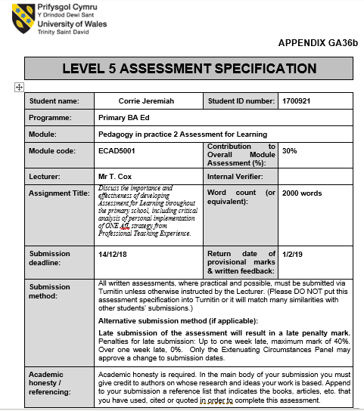

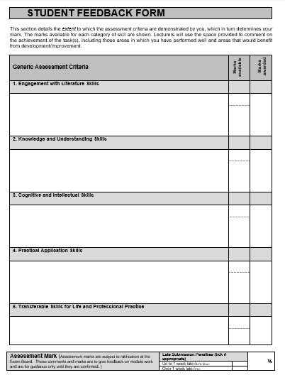
Discuss the importance and effectiveness of developing Assessment for Learning throughout the primary school, including critical analysis of personal implementation of ONE AfL strategy from Professional Teaching Experience.
Assessment which is the action of evaluating (assessing) someone or something, is used as a way of supporting individual learning. In education, assessment is carried out by educators in order to identify what children and young people know, understand and are able to do. However, assessment is often misinterpreted and ‘equated’ with traditional and standardised testing when in fact the term assessment refers to the wide variety of methods and tools that educators use to ‘evaluate, measure and document the learning progress, academic readiness and educational needs of each individual learner’ (Great Schools Partnership, 2015). Assessment is a fundamental component of both the ‘teaching’ and the ‘learning cycle’ (NSW Syllabus, 2012) as it helps to aid educators when tracking pupil’s progress, planning the next steps, as well as reporting to and involving parents, children and young people in the learning which is taking place.
There are a variety of different forms of assessment, however, assessment is generally divided into three approaches within a standard educational classroom: assessment for learning, assessment of learning and assessment as learning. These approaches enable educators to gather evidence and make judgements about student achievement. For this assignment, the focus will be solely on the ‘Assessment for Learning’ approach. Assessment for Learning (AfL) is a process where information gathered by educators is then used to help improve each individual learners’ performance. The aim of the approach is to create pupil feedback which is then logged and used by the educator in order to make the relevant adjustments and changes to their teaching strategies which will in theory improve students’ overall performance. According to Dr Cheryl Jones, the individuality of feedback should have the facility to support the weaker learners whilst also providing a challenge for the more able learners (2005). Feedback is believed to be one of the top ten influences on student achievement. Researcher in education, Professor John Hattie ranked the strategy of feedback tenth when examining the one hundred fifty factors that he believes brings about significant improvements in learner outcomes. A statement that John Hattie made in his book ‘Visible Learning for Teachers: Maximizing Impact on Learning’ in relation to the strategy of feedback can be found below:
“The greater the challenge, the higher the probability that one seeks and needs feedback, but the more important it is that there is a teacher to provide feedback and to ensure that the learner is on the right path to successfully meet the challenges.”
― John A.C. Hattie, 2008.

This statement outlines the potential positive effect that relevant and useful feedback could have on learner achievement. Assessment for Learning aims to help learners understand what is expected of them whilst also showing them what an exceptional piece of work looks like and how they can develop their own work to reach that level. Assessment for Learning also helps in making understanding and knowledge ‘more visible’ for learners, educators and parents (Hattie, 2008). Furthermore, Assessment for Learning is of importance as it informs the learners of their progress and empowers them to take the necessary course of action needed to improve their overall performance.
Assessment for Learning is classed as being a type of formative assessment which is the use of day-to day assessments that is often informal; for example, pupils displaying a ‘thumbs up’ or ‘thumbs down’, as a way of indicating their understanding of the task and/or lesson. Formative assessments allow educators to check the pupils’ level of understanding during the lesson instead of waiting until the completion of the lesson when it is too late to address any difficulties or misconceptions that the pupils may have. The leading experts in Assessment for Learning, Paul Black and Dylan Wiliam argue that should educators use formative assessments as part of their teaching strategies then students are given the opportunity to learn at approximately double the rate. Professor John Hattie's research also shows that using formative assessment in the classroom brings about positive effects in overall learner achievement. He discovered that teachers are far more likely to have a larger and more positive impact should they monitor their impact on students’ learning and adjust their approaches accordingly. Moreover, it is clear to see that assessment for learning is a fundamental process which is required to promote learning and ultimately achievement within education.
Whilst there are many Assessment for Learning strategies in existence, the one which will be solely featured in this assignment is the strategy developed by Professor Frank Lyman, Think-Pair-Share (1981). The Think-Pair-Share strategy is used for processing information. It is a three-step paired cooperative procedure. Think-Pair-Share gets its name from the three stages of actions that the learners undertake which emphasise what the learners are doing at each of those individual stages. During the first step, each pupil is required to think about the question posed by the teacher independently and silently. For the second step, the pupils are paired, and they are instructed to exchange and discuss their individual responses to teacher’s question. For the third and final step, the pupils’ may share their response or their partner’s response with the teacher and the entire class. Educators can discover the level and depth of a pupil’s knowledge and understanding of a specific topic in a variety of ways, whether by observation and discussion in the classroom or the reading of pupilsʹ written work. With the Think-Pair-Share strategy educators are given the opportunity to circulate through the class and listen to ideas as the learners are paired in discussion or as they are presenting their answers to the rest of the class. This ensure that any lack of subject matter understanding will be identified at the earliest opportunity.
One of the main issues which educators often encounter in the classroom and see frequently throughout their career is the lack of pupil participation shown towards whole classroom questions. Often when teachers pose a question to the class as a whole, more often than not they are usually met with a limited number of pupils volunteering to answer and on occasion they may be met with no volunteers at all. Therefore, the use of Assessment for Learning strategies needs to be adapted by educators in order to overcome this common difficulty and frequent problem. However, whilst there are a variety of strategies which could be implemented to solve this problem (e.g. use of lollipop sticks), the Think-Pair-Share strategy would be more beneficial to introduce and implement both to the pupils as it is a strategy that carries more advantages than disadvantages.
Think-Pair-Share is a discussion strategy, and class discussion is pedagogical tool that is as old as the profession of teaching itself. However, despite the historical role that discussion has played within the classroom there are some educators who are rather cautious and wary of prompting it during their lessons due to some fears and reservations that they hold. Think-Pair-Share like every other strategy does have its disadvantages, the main one being that there is a chance that the discussion may become too controversial, get out of hand or off topic. Whilst the teacher may be able to circulate the classroom and listen to a handful of pupil discussion, it would be difficult to prevent individuals or small groups from wondering off task, and this isn’t the only disadvantage that has been identified. Another disadvantage is that the strategy can be rather time consuming in the beginning whilst implementing it as the pupils need to become familiar with what the strategy is, how it works and how they will be paired (whether it will be assigned partners or the person sitting next to you). The noise level within the classroom may also rise as the pupil’s exchange ideas, viewpoints and generally converse with one another. However, despite the misgivings that have been vocalised in relation to the Think-Pair-Share strategy, it has been categorised as being a ‘low-risk’ strategy, meaning that it can be successfully used in a class of any size. It is also a highly collaborative strategy which is highly inclusive for all those who take part in it and is successful in generating a lot of ideas within a short span of time. The strategy of Think-Pair-Share also provides the pupils with thinking time in which they will be given the opportunity to form their own ideas and discuss and listen to any ideas formed with their partner. It is vital within education that the pupils are given enough time to formulate their answers as it has been proven that a wait of at least three seconds of individual thinking time can improve both the quantity and the quality of the answers the pupils give. Furthermore, the disadvantages highlighted in relation to the Think-Pair-Share strategy appear minimal when compared to the possible advantages; therefore, there are clearly more benefits to be had from implementing the Think-Pair-Share strategy as it seems that discussion fosters motivation for further learning amongst pupils within a classroom.
There are many individuals who support the use of Think-Pair-Share strategy, individuals such as: educational psychologist Michael Pressley (1992), who believes that pupils need many opportunities to speak in a ‘linguistically rich environment’ and to ‘elaborate’ on their ideas through the use of speech which is the purpose of the strategy; and David Pimm (1987) a man with expertise in teacher education, curriculum theory and in teaching methods, who believes that this specific strategy increases the kinds of ‘personal communications’ that the pupils require in order for them to successfully are internally process, organise, and retain ideas. These statements reinforce the idea that the Think-Pair-Share strategy is a strategy worth implementing within any and every educational classroom as there are many well-known advantages associated with it.
From experience, the Think-Pair-Share strategy is extremely easy to implicate, and it does not require in depth planning. It is a cooperative learning technique that encourages individual participation, and which is applicable across all year groups, learning levels and class sizes; meaning that it can be introduced to pupils from an early age and which can be maintained as the they progress throughout their school years (Foundation Phase and KS2). This strategy can be used in a variety of contexts but is most effective when the pupils are asked to consider a topic, question or issue, and since the pupils should be following a prescribed process it should minimise the chances of off task thinking and behaviour. Through the strategy of Think-Pair-Share pupils are given the chance to work with and learn from their peers. John Hattie stated in his book ‘Visible Learning for Teachers: Maximizing Impact on Learning’, that “if you want to increase student academic achievement, give each student a friend.” This statement has merit as pupils seem more comfortable, confident and eager to converse and share their ideas with a friend before sharing them with the teacher. This strategy has the ability to not only help pupils develop their communication skills but to also help them build up their confidence and self-esteem.
To conclude, Assessment for Learning serves a purpose within the education system as not only does it encourage learning, but it also promotes motivation by emphasising the importance of individual progress which in a way it helps the pupils take ownership and responsibility for their own learning. This idea links to the constructivist school of thought within education as each individual learner is expected to participate and start constructing their own learning. Constructivists aim to teach for understanding which relates to the Think-Pair-Share strategy as pupils are expected to take ownership of their leaning and negotiate meanings when sharing their ideas whether to their partner, the teacher or the rest of the class rather than rely solely on the teacher's authority (Cobb et al. 1991).

Total word count: 1954

References:
Black, P and Wiliam, D. (1998). Inside the Black Box: Raising Standards Through Classroom Assessment. Available at: https://www.rdc.udel.edu/wp-content/uploads/2015/04/InsideBlackBox.pdf. (Accessed on 10th December 2018).
Board of Studies NSW. (2012). Assessment for, as and of Learning. Available at: https://syllabus.nesa.nsw.edu.au/support-materials/assessment-for-as-and-of-learning/. (Accessed on 7th December 2018).
Education Scotland. (2018). What is assessment, and when and how does it take place? Available at: https://education.gov.scot/parentzone/learning-in-scotland/assessment-and-achievement/What%20is%20assessment,%20and%20when%20and%20how%20does%20it%20take%20place? (Accessed on 7th December 2018).
Goodreads Inc. (2018). John A.C. Hattie quotes. Available at: https://www.goodreads.com/author/quotes/7316324.John_A_C_Hattie. (Accessed on 9th December 2018).
Great Schools Partnership. (2015). The Glossary of Education Reform: Assessment. Available at: https://www.edglossary.org/assessment/. (Accessed on 7th December 2018).
Jones, C. (2005). Vocational Learning Support Programme: 16–19, Assessment for Learning. Available at: https://dera.ioe.ac.uk/7800/1/AssessmentforLearning.pdf. (Accessed on 7th December 2018).
Ledlow, S. (2001). Center for Learning and Teaching Excellence: Using Think-Pair-Share in the College Classroom. Available at: https://kaneb.nd.edu/assets/137953/think_pair_share_tips.pdf. (Accessed on 7th December 2018).
Minchin, M. (2016). Strategies for Successful Teaching: For faculty, adjuncts and teaching assistants who want to be effective teachers. Available at: https://successfulteaching.wordpress.com/2016/05/17/class-discussion-teaching-tactics/. (Accessed on 13th December 2018).
Raba, A. A. A. (2017). The Influence of Think-Pair-Share (TPS) on Improving Students’ Oral Communication Skills in EFL Classrooms. Creative Education, 8 ,12-23. Available at: http://dx.doi.org/10.4236/ce.2017.81002. (Accessed on 12th December 2018).
Sandbox Networks, Inc. (2000-2018). Teacher Vision: Think, Pair, Share Cooperative Learning Strategy. Available at: https://www.teachervision.com/group-work/think-pair-share-cooperative-learning-strategy. (Accessed on 12th December 2018).
Solomon, R. (2009). Think-Pair-Share (Lyman, 1981): An Equity Pedagogical Best Practice to Increase and Vary Student Participation in the Classroom. Available at: https://www.classroom20.com/profiles/blogs/thinkpairshare-lyman-1981-an. (Accessed on 7th December 2018).
Spanella, T. (Unknown). Study.com: The Importance of Assessment in Education. Available at: https://study.com/academy/lesson/the-importance-of-assessment-in-education.html. (Accessed on 7th December 2018).
The Australian Society for Evidence Based Teaching. (2013-18). Hattie & His High Impact Strategies for Teachers. Available at: http://www.evidencebasedteaching.org.au/hattie-his-high-impact-strategies/. (Accessed 9th December 2018).
Waack, S. (2018). Visible Learning: Feedback in schools by John Hattie. Available at: https://visible-learning.org/2013/10/john-hattie-article-about-feedback-in-schools/. (Accessed 9th December 2018).

