Inputs  A B |  | Output  Y
0 | 0 | 0
0 | 1 | 0
1 | 0 | 0
1 | 1 | 1

Question #01

- And gate

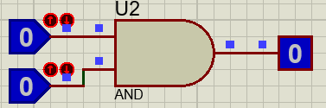when A=0, B=0
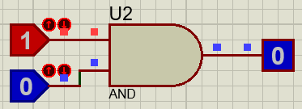when A=1, B=0
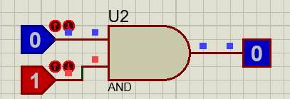when A=0, B=1
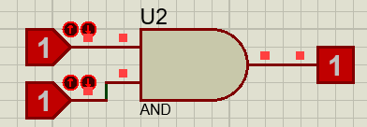when A=1, B=1

b) OR gate
when A=0, B=0 when A=0, B=1
Inputs  A B |  | Output  Y
0 | 0 | 0
0 | 1 | 1
1 | 0 | 1
1 | 1 | 1
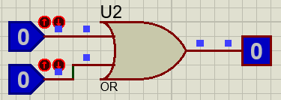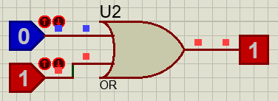
when A=01 B=0 when A=1, B=1
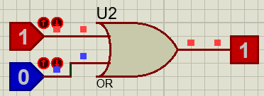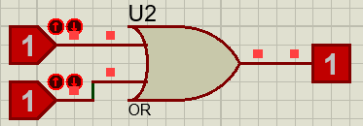

c) XOR gate
when A=0, B=0 when A=0, B=1
Inputs  A B |  | Output  Y=A+B
0 | 0 | 0
0 | 1 | 1
1 | 0 | 1
1 | 1 | 0
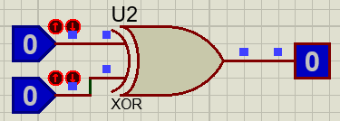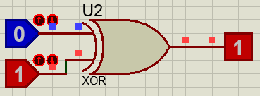
when A=1, B=0 when A=10, B=1
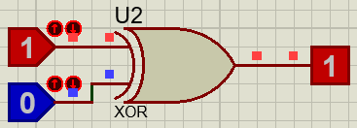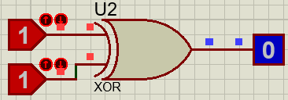

d) Nand gate

Inputs  A B |  | Output  Y
0 | 0 | 1
0 | 1 | 1
1 | 0 | 1
1 | 1 | 0
when A=0, B=0 when A=0, B=1
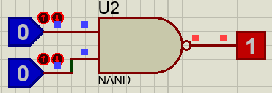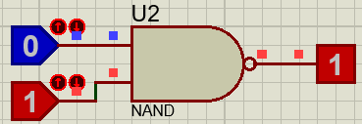
when A=1, B=0 when A=1, B=1
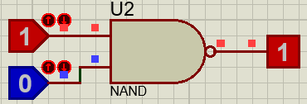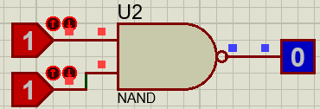

e) Nor gate

Inputs  A B |  | Output  Y
0 | 0 | 1
0 | 1 | 0
1 | 0 | 0
1 | 1 | 0

when A=0, B=0 when A=0, B=1
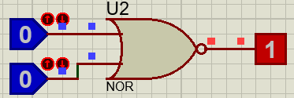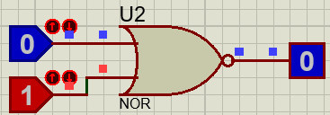

when A=1, B=0 when A=1, B=1
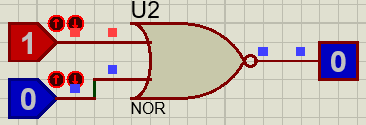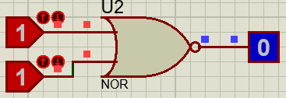

Question # 02

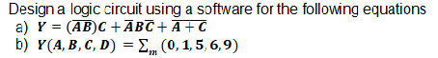

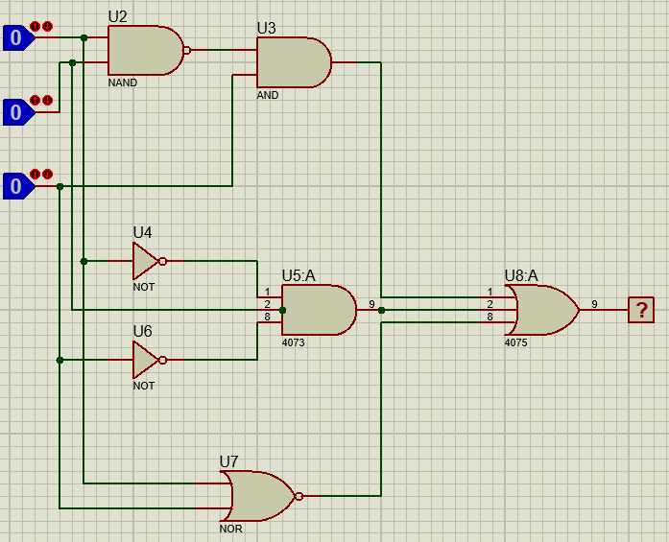

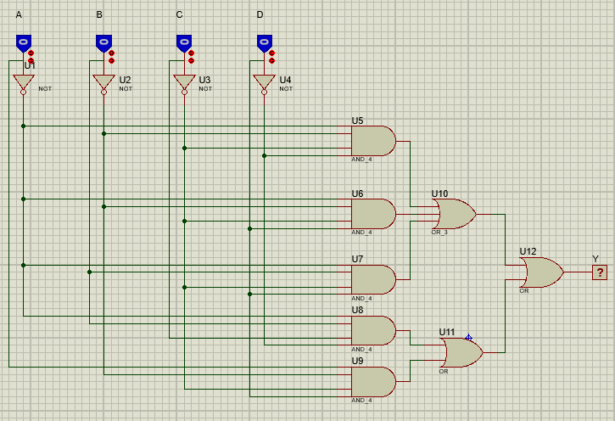

___________________________________________________________________________________

Question # 03

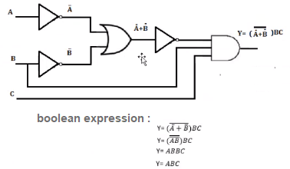

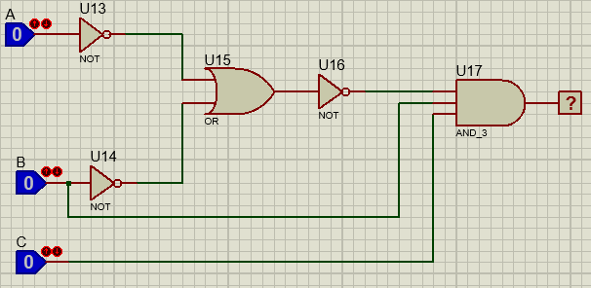

truth table

inputs |  |  | outputs
A | B | C | Y=ABC
0 | 0 | 0 | 0
0 | 0 | 1 | 0
0 | 1 | 0 | 0
0 | 1 | 1 | 0
1 | 0 | 0 | 0
1 | 0 | 1 | 0
1 | 1 | 0 | 0
1 | 1 | 1 | 1

_________________________________________

Question # 4

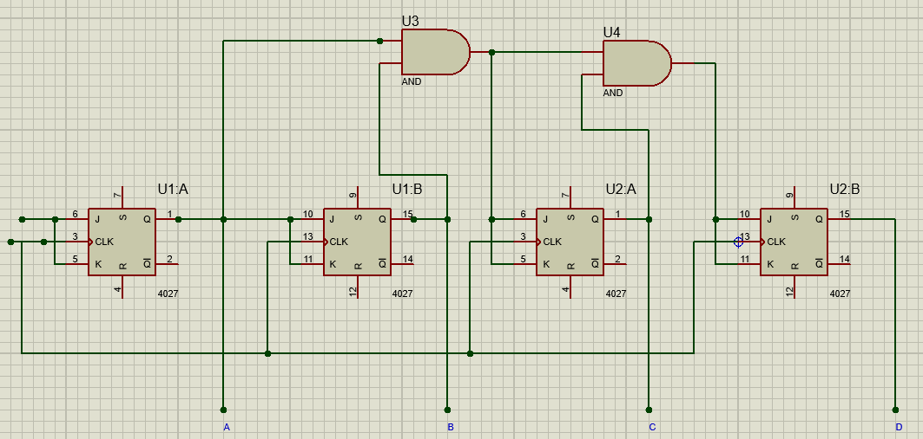
Truth table
input |  |  | output
clock | JK | state | D | C | B | A
1 | 1 | 0 | 0 | 0 | 0 | 0
2 | 1 | 1 | 0 | 0 | 0 | 1
3 | 1 | 2 | 0 | 0 | 1 | 0
4 | 1 | 3 | 0 | 0 | 1 | 1
5 | 1 | 4 | 0 | 1 | 0 | 0
6 | 1 | 5 | 0 | 1 | 0 | 1
7 | 1 | 6 | 0 | 1 | 1 | 0
8 | 1 | 7 | 0 | 1 | 1 | 1
9 | 1 | 8 | 1 | 0 | 0 | 0
10 | 1 | 9 | 1 | 0 | 0 | 1
11 | 1 | 10 | 1 | 0 | 1 | 0
12 | 1 | 11 | 1 | 0 | 1 | 1
13 | 1 | 12 | 1 | 1 | 0 | 0
14 | 1 | 13 | 1 | 1 | 0 | 1
15 | 1 | 14 | 1 | 1 | 1 | 0
16 | 1 | 15 | 1 | 1 | 1 | 1
17 | 1 | 0 | 0 | 0 | 0 | 0

Question #5

What is a Sequential Circuit?
A sequential circuit is the assimilation of a combinational logic circuit and a storage element. With the applied inputs to the combinational logic, the circuit outputs are derived. These sequential circuits deliver the output based on both the current and previously stored input variables. The derived output is passed on to the next clock cycle. Sequential circuits consist of memory devices to store binary data. This binary information describes the current state of the sequential circuit. As sequential circuits work along with the combinational circuit, there are two types of combinational logic inputs which are:
- External inputs where these are not monitored by the circuit
- Internal inputs are the function of previous state output
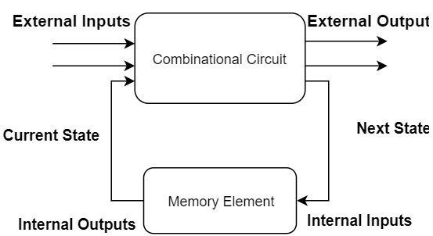basic sequential circuit

As every digital and memory circuit is built based on the finite state machines, sequential circuits are implemented for the construction of these machines. So, these circuits hold more prominence in digital and electronics technology.

Types of Sequential Circuits
1. Synchronous Sequential Circuits
2. Asynchronous Sequential Circuits

1). Synchronous Sequential Circuits
Synchronous sequential circuits uses level inputs and clock signals as the circuit inputs having limitations on the circuit propagation time and pulse width to generate the output. The duration of the output pulse is like the clock pulse of the clocked circuit. The level output modified its state at the beginning of an input pulse and continues in that order until the next clock pulse arrives. Until the arrival of the next pulse, these circuits perform no activity and so the operation is a bit slower than that of asynchronous circuits.
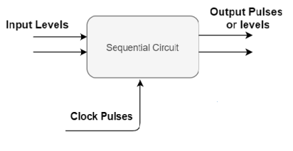
synchronous sequential circuit

Again, synchronous circuits are of two types clocked and unlocked.

a). Clocked Sequential Circuit
Clocked circuits use flip-flops and gated latches as the memory elements. The operation of the circuit is operated by the periodic clock pulses where these are connected to the clock inputs to synchronize all the internal modifications of the state.
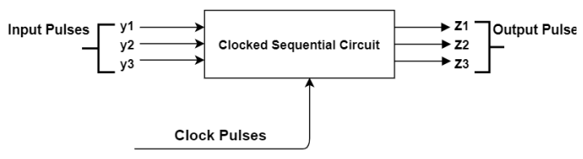
clocked sequential circuit

b). Unclocked Sequential Circuit
These circuits do not require any clock. The internal changes of the state are based on the pulse transitions between 0-pulse or 1 -pulse. This is designed to act in response to the pulses of specific time; the periodic signals in between the null and spacer signals.
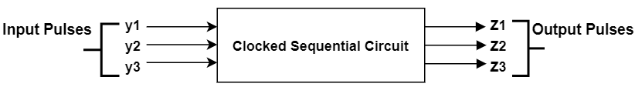
Unclocked sequential circuit
Applications
Synchronous sequential circuits are implemented in the design of flip-flops, counters and to develop MOORE-MEALY state-controlled machines.

2). Asynchronous Sequential Circuits
Asynchronous sequential circuits performs their operation without depending on the clock signal but uses the input pulses and generates the output. As there is no clock pulse dependency, these circuits can switch to the next state quickly when the input signal is changed, So that there is a faster operation with asynchronous sequential circuits.
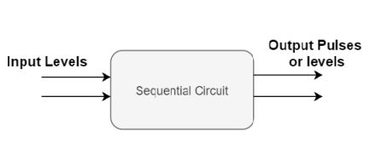
Asynchronous sequential circuit

Applications
Asynchronous sequential circuits are cost-effective to be used in small independent systems that need only a few elements. The communication between two elements, each hold its own independent clock, and this will be achieved by these circuits.

