Qualification: CIPD Diploma in Applied Human Resources

Module Name: Contributing to Change Management

Portfolio of evidence

Word Count:2768

Student Name: Tara Jeffreys
Student Number: 2005782
CIPD Membership Number: 80931290

By signing below, I confirm that the work/evidence presented is my own, unaided work. I understand the regulations pertaining to candidate malpractice and the action that may be taken as a result.

Signed: Tara Jeffreys
Date: 01/12/21

Contents

- Title Page

- Contents Page

- Evidence Matrix

- Personal Statement LO1

- Reference List

- Personal Statement LO2

- Reference List

- Personal Statement LO3

- Reference List

- Evidence

Evidence Matrix

Candidate Name:  Tara Jeffreys |  |  |  | CIPD Membership Number:  80931290
Qualification Title:  CIPD Diploma in Applied Human Resources |  |  |  | Unique Learner number (ULN):  2005784
Unit Code | Unit Title | Assessment Criteria | Evidence Description | Evidence Reference Number | Assessor Initials | I/V initials if sampled
5AMOC | Contributing to Change Management | 1.1 | SWOT analysis | EV 1
5AMOC | Contributing to Change Management | 1.1 | Meeting agenda for MD’s | EV2
5AMOC | Contributing to Change Management | 1:2 | Stakeholder Map | EV3
5AMOC | Contributing to Change Management | 1.2 | Copy of staff development plan | EV4
5AMOC | Contributing to Change Management | 1:2 | Poster for surgery | EV5
5AMOC | Contributing to Change Management | 1:3 | Budget for change | EV6
5AMOC | Contributing to Change Management | 1.4 | Change plan | EV7
5AMOC | Contributing to Change Management | 1.4 | Minutes from meeting to review change plan | EV8
5AMOC | Contributing to Change Management | 1.5 | Communication Plan | EV9
5AMOC | Contributing to Change Management | 2.1 | Objectives and targets | EV10
5AMOC | Contributing to Change Management | 2.2 | Copy of customer communication | EV11
5AMOC | Contributing to Change Management | 2.2 | Screenshot of website | EV12
5AMOC | Contributing to Change Management | 2.2 | Force field diagram | EV13
5AMOC | Contributing to Change Management | 2.2 | Colleague questionnaire | EV14
5AMOC | Contributing to Change Management | 2.3 | FAQ | EV15
5AMOC | Contributing to Change Management | 2.4 | Customer feedback | EV16
5AMOC | Contributing to Change Management | 2.5 | Witness testimony | EV17
5AMOC | Contributing to Change Management | 3.2 | Benefit communication | EV18

Candidate Declaration:
I confirm that the work/evidence presented for assessment is my own unaided work.
I have read the assessment regulations and understand that if I am found to have ‘copied’ from published work without acknowledgement, or from other candidate’s work, this may be regarded as plagiarism which is an offence against the assessment regulations and leads to failure in the relevant unit and formal disciplinary action.
I agree to this work being subjected to scrutiny by textual analysis software if required.
I understand that my work may be used for future academic/quality assurance purposes in accordance with the provisions of the Data Protection Act 1998.
I understand that the work/evidence submitted for assessment may not be returned to me and that I have retained a copy for my records.
I understand that until such time as the assessment grade has been ratified through internal and external quality assurance processes it is not final.
Signature: | Tara Jeffreys | Date: | 02/21/21

Personal Statement

LO1 Be able to plan for the implementation of change processes within an organisation

Skyline roofs limited is a SME who manufacture and provide elevating roofs for camper van conversions focussing on the Volkswagen market, the company has been trading since 2014, the company asked me to support them on a consultancy basis to help them implement a change to their accounting and invoicing process.

  - Establish need, objectives, and benefits in relation to a specific change requirement

With some research showing 70% of changes fail, its’s essential that organisations who want to effectively land a change initiative use a structured approach to manage the change, although HR are seen as the “hidden hand” of change, it is imperative that HR and line managers work in partnership (CIPD,2021)
The definition of change “the application of a structured process and a set of tools for leading the people side of change to achieve a desired outcome” (Prosci, 2021)

When supporting the organisation with the change, we reviewed the drivers of change ensuring the team understood the difference between internal and external drivers, I undertook a SWOT analysis on the company (EV1) this was shared with the managing directors of the company via a face-to-face meeting. (EV2)
When we discovered the factors that were driving the required change, we then looked at the factors that can hinder or have a positive effect on change.

The pandemic has forced changes for many organisations “every organisation needs to be agile and resilient in order to thrive and survive” (Sage Group PLC, 2020) Within Skyline as a result of the pandemic the need to change arose as many of the small businesses that they dealt with had faced operational and financial difficulties. The company decided to change its system of invoicing with the introduction of a SAGE system to include a proforma payment system and remove the previous 90 days credit system of payment. The changes would ensure that all customers were up to date with payments and deliveries and did not result in the build-up of large outstanding invoices. This would help skyline to reduce the time spent on chasing outstanding invoices and meant the customers would be in control of payments and deliveries and breaking their cost down into manageable chunks.

  - Analyse who will be affected by the change and their potential information and support needs
To clearly understand who would be affected by the change a stakeholder map was composed to ensure all key stakeholders would be involved at the correct level (EV3) establishing key stakeholders can be the difference between change success or failure(mindtools)
When each of the key stakeholders had been identified we then, reviewed current and future capability and devised a development plan (EV4) for the team to support the transition to the new system.
To support each team member through the change I created a surgery for the team to be able to pop in and discuss any concerns and additional support they may need. (EV5)

  - Identify the resources required for the change process and how these will be made available
When looking at the resources needed the first resource, we looked at was have the right people in the right role with the required capability levels, ensuring that the resources were not just focussed on who was available but who would be the best fit to ensure the change happened successfully. (McKinsey, 2017)
We then looked at the money that would be available to introduce the new Sage system and to support the training that would be needed. (EV6) the leadership team agreed the budget for the change, and this was confirmed prior to implementing the change.

  - Devise a plan including objectives, actions and timescales for implementing the required change

When taking a structured approach to implementing change a change plan (EV7) was written following the 3 stages, Design. Enact and sustain and followed the documented best practices (SHRM,2015)
When the change plan was written this was reviewed with the senior leadership team to ensure everyone understood the reasons why the change was needed and that everyone was bought in and clear on the need for change. (EV8)

  - Communicate the change plan and gain agreement for t’s implementation from decision makers
To ensure the change was communicated effectively I drew up a communication plan (EV9)
The change plan was communicated to the senior leaders via a face-to-face meeting to allow any questions or adjustments to be made.

References

CIPD, 2014, Landing Transformational Change, Chartered Institute of Personnel and Development,

McKinsey, 2017, Secrets of successful change implementation

Mindtools.com/ stakeholder analysis, (accessed 14.11.21)

Prosci, 2021, Definition of change management

Sage Group PLC, 2020

SHRM, 2015

LO2 Be able to implement a change plan

2.1 Follow the agreed plan to implement change process

Implementing change is often very difficult to get right, with 3 common themes being identified as the root cause of implementation failure
- Organisation wide ownership and commitment to change
- Regular and effective prioritisation
- Deployment of right resources and capabilities (McKinsey, 2017)

When implementing the plan each key stakeholder was given clear accountabilities and objectives, to ensure investment in delivering key targets and a clear reward system for delivery of the change (EV10)

The change plan was reviewed regularly to assess any adaptations that needed to be made and to ensure that the change was happening within the required timescales and the company objectives were being met.

2.2 Provide information and support to stakeholders in line with their identified requirements

The change plan was communicated to the staff in the company via email and a follow up one to one session was planned to address any concerns or development needs.
The customers were communicated regarding the change via email (EV11) and the use of social media and company website price list was updated (EV12)
Stakeholders are frequently only reviewed at the design stage of the change management process however, to successfully embed change stakeholders should be reviewed during the enact and sustain stages. (Rittenhouse, 2015)
To capture the views and level of buy in from stakeholders, I arranged a brainstorming session utilising the force field diagram (EV13). The information from this session I then used “the support for change instrument” to assess the company on it’s readiness for change (EV14) (Maurer, 1996) in the form of a colleague questionnaire.

2.3 Apply techniques for maintaining positive working relationships throughout the change process,

To maintain positive working relationships with key stakeholders through the change process I used the 6 methods to manage resistance (Kotter & Schlesinger, 1979)

Education and Communication – Following the communication plan to ensure each key stakeholder was communicated to at the right level

Participation and involvement – From the beginning each member of staff was involved in the process allowing them to provide ongoing feedback, to ensure they were bought in

Facilitation and support – each staff member were given a development plan to support them with their learning, they also had the opportunity to attend surgeries for additional support e.g. emotional support

Negotiation and Agreement – the use of incentives for the effective implementation of change, pay award, social events

Manipulation – this step was not utilised, and no information was limited to key stakeholders, this step is seen as a last resort

Explicit and implicit coercion – again seen as a last resort this step was not utilised as there was not a need to issue threats or use negative consequences to manage resistance.

To ensure key stakeholders communication was maintained I compiled a list of frequently asked questions and distributed this to the team (EV15)

2.4 Monitor the effectiveness of the implementation and making justified adaptations where required

Measuring the effectiveness of change is becoming an expectation, previously seen as a difficult to measure, research now shows there is a way to craft a well-rounded measurement strategy, this can be done in the form of 3 categories

1./ Organisational Performance – a review of KPI’s to include sales and cashflow also looked at customer feedback to measure the success (EV16)

2./ Individual performance – to measure this we looked at the compliance to the change, gained colleague feedback and conducted observations on the team

3./ Change management performance – for this measure we looked at the training attendance data and the progress and adherence to the change plan (Prosci)

2.5 Maintain records of the change process in line with organisational requirements

It is widely stated that change management is about attitudes, behaviours, and feelings, therefore it cannot be measured. Change management being ‘soft’ does not necessarily mean it cannot be measured. (thechange compass)
” if you can’t measure it, you can’t improve it” (Peter Drucker)
Many HR academics state because something is not black and white and harder to measure does not mean it should not be measured.
When measuring the impact of change data can be collated through Quantitative and Qualitative data

To record the effectiveness of the change we looked and 2 sets of data, Quantitative and Qualitative
Quantitative Data
- Sales Performance
- Absence levels
- Cashflow

Qualitative Data
- Customer Feedback
- Staff Feedback
- Colleague observations

The company was happy that the change process met their requirements (EV17) and they had seen a significant increase in staff productivity and company cashflow.

References

Kotter,J, Schlesinger, L, (1979) Choosing strategies for change, Harvard Business Review

Maurer,R, (1996) Beyond the walls of resistance, Bard Books

McKinsey, (2017) Secrets of successful change implementation

www.Prosci.com/ measuring change management effectiveness with metrics (accessed 19/11/21)

Rittenhouse,J, (2015) Improving stakeholder management using stakeholder tools, Prjoect Management Institute

www.thechangecompass.com/the-ultimate-guide-to-measuring-change

LO3 Be able to assess the impact of change processes within organisation

3.1 Measure the effectiveness of the change process in meeting the required objectives

Research indicates a growing need to report on the effectiveness of change management projects “measuring change management used to be considered elusive and complicated” however research had highlighted emerging fundamentals when measuring success and can be broken down into 3 measures
1./ Measuring organisational performance
- Measuring Individual performance
- Measuring change management performance

Organisational performance
The company objectives to increase sales and cash flow and reduce wasted effort on chasing outstanding invoices were met as a result of the new SAGE system and proforma payments.

Individual Performance
The transition was smooth for the company and the majority of the colleagues were bought in to the new system as they felt they had been communicated to and given the correct training. The staff delivered the objectives in their personal development plans

Change Management Performance
The original change plan was reviewed to measure the effectiveness of the process

3.2 Identify further work required to embed changes and / or further developments required

Change management only becomes effective when the change to process and outcomes become part of the day-to-day operation of an organisation and all the staff and managers are bought in to the changes. (Change factory)

Although the change was enacted well the company must ensure that they build a comprehensive training plan for any new to the business colleagues. A driver for sustaining and embedding change is the opportunity for career progression, the company needs to develop a succession plan and a clear direction for staff who wish to progress their careers, without this the company may be at risk of losing expertise.

In addition to clearly establishing objectives there needs to be a zero tolerance for underperformance. The company needs to adopt a robust performance management process to address any capability issues they may have and to manage the resistors.

Customer feedback must be reviewed to ensure the sustainability of the change and that post pandemic the system is still fit for purpose.

3.3 Communicate the key outcome and impact of changes to stakeholders

Communication is key to effective change management, it is considered important in building a change ready culture and gaining commitment to the change (Armenakis et al, 1993)

With the completion of the new system, key stakeholders were given communication updating them on the improvements the new systems had made (EV18)

A driver for embedding change is reward and recognition, as a means of thanking all the staff involved the company rewarded them all with an evening out and as a result of the increased sales and cashflow each of the colleagues were rewarded with a pay increase.

Following feedback from the staff they stated they found the new system made their roles far easier as they could focus on customer service and not chasing outstanding debts, (which they state was the part of the job they hated the most.)

3.4 Evaluate the effectiveness of own performance in contributing to the management of change
When reviewing my own performance in change management I used the CIPD 2013 profession map, this lists change as a core knowledge for HR professionals. It’s about having the understanding of how to effectively enable change; it’s about taking a structured approach to change and understanding the impact change has on people and how to support them through the change process. It’s having the awareness of tools and techniques and utilising them for effective change management, ensuring projects are managed effectively and risks are minimised/ mitigated.

I assessed my performance and understanding against the associate level and met the following criteria

- Understand how to do a SWOT and PESTLE analysis and use the data to create a case for change
- Understand different change management approaches and their advantages and disadvantages
- Understand how to explain why change is happening and basic models for how people experience change
- Understand how to conduct skills or capability audits and gap analyses n your area of work
(CIPD,2013)

References

Armenakis, A A, Harris, SG, et al, 1993, Creating readiness for organisational change, Sage Publications

CIPD, 2013, Profession Map, Chartered Institute of Personnel and Development

Prosci.com / measuring change management effectiveness with metrics

www.changefactory.com/embedding-change

EV1
Strengths | Weaknesses
- Quality products with a large market share  - Excellent customer service  - Leading brand in industry  - Locally produced  - European presence  - Part ownership of suppliers  - Sufficient workforce | - Technology not fit for purpose  - Current capability of workforce not at required level  - Payment delays due to 90 days credit  - Lack of productivity time wasted chasing outstanding invoices  - Intense competition from start ups
Opportunities | Threats
- Increased market share in Europe  - Increase cash flow  - Global expansion  - Material source outside UK | - Economic recession  - Brexit  - Competitors replicating business model  - Difficulty maintaining customer service with changes
SWOT Analysis on Skyline Roofs Ltd

Strengths | Weaknesses
- Quality products with a large market share  - Excellent customer service  - Leading brand in industry  - Locally produced  - European presence  - Part ownership of suppliers  - Sufficient workforce | - Technology not fit for purpose  - Current capability of workforce not at required level  - Payment delays due to 90 days credit  - Lack of productivity time wasted chasing outstanding invoices  - Intense competition from start ups
Opportunities | Threats
- Increased market share in Europe  - Increase cash flow  - Global expansion  - Material source outside UK | - Economic recession  - Brexit  - Competitors replicating business model  - Difficulty maintaining customer service with changes

EV2
Agenda for meeting with MD’s

- Welcome
- Purpose of meeting
- Results of SWOT
- Questions and answers
- Next Steps

EV3
Stakeholder map Skyline roofs

Stakeholder Mapping Worksheet

Stakeholder Influence/Interest Matrix
For each key stakeholder, characterize them using the following stakeholder influence grid.

Influence | High | Keep Satisfied | Key Players
Influence | Low | Minimal Effort | Keep Informed
 |  | Low | High
 |  | Level of Interest

Stakeholder Grouping
Using the Stakeholder Influence/Interest Matrix, complete the table below. This will help determine stakeholder’s grouping for change communications.

Stakeholder Name | Influence Level | Level of Interest | Stakeholder Grouping
Managing Directors | High | High | Key Players
General Manager | High | High | Key player
Office Staff | Low | High | Keep Informed
Workshop staff | Low | Low | Minimal Effort
Suppliers | Low | Low | Minimal Effort
Customers | Low | High | Keep Informed
Trade customer | Low | High | Keep informed

EV4
Staff Development Plan Skyline

Current
Situation

Career
Goal

Skills
Gap

Actions

Evaluation

Name_________________________________. Date__________________

EV5
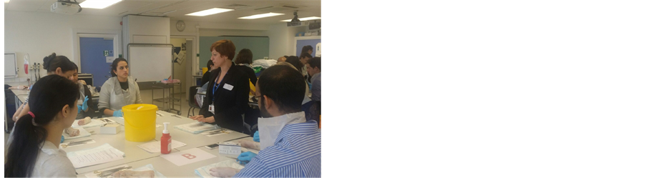

Support Surgery

Should you have any questions or concerns regarding the upcoming changes I will be here at the following times to answer any question or just have a chat, pop in and see me in the main office.

Monday 22 November 10..00 – 13.00

Wednesday 23 November 10.00 – 13.00

Thanks
Tara

EV6

EV7
Change Plan Skyline Roofs

Example Change Plan
Created by | Tara Jeffreys
Date | 20 November 2021
Version | 1

Vision and Objectives
Raising the standard of Pop Top Roof specialists
Objectives
Bring invoicing in line with competitors
Train all staff to ensure they are confident with new system
Update technology to support changes

Activities to achieve objectives
Source and price new sage system
Complete SWOT analysis
Complete stakeholder map
Complete Communication plan
Allocate budget
Complete development plans
Complete training
Conduct support surgeries

Business case (evidence-based - include data, benefits of change, gap analysis – difference between current and future states, issues and risks)
Currently the company operates a 90 day credit finance package for all customers, this is out of sync to competitors and causes issues with outstanding invoices, the current invoice system is not compatible to the order system therefore potentially causing mis communication. As a result of the pandemic some trade customers have become insolvent leaving a deficit with payments

The new sage system will link invoicing and ordering to ensure the orders are charged correctly.
The credit system will be replaced with a proforma system ensuring all payments are received prior to delivery.

Improved staff morale with the removal of the task of chasing outstanding invoices
Improved customer service as the staff can spend more time helping customers
People affected (stakeholders – employees, particular employees, customers, shareholders)
Directors
Managers
Office staff
Workshop Staff
Customers
Trade customers
Scope of change (eg one site, one product group)
The change will affect the UK and European operations

Roles (project manager, sponsor, team members)
Project Manager – Adrian Braham
Sponsor – Paul Winter and Glen Davies
Team Members - all office and workshop staff

Communication strategy (attach communication plan, list of change champions)
Ensure all key stakeholders are communicated effectively

Support to be offered (advice, counselling, coaching, mentoring, representation, training - attach, for example, a training plan)
Provide training and support to team

Resources required, including cost (equipment, time, people, materials, guidance)
Cost for new system
Cost of training
Time to train properly
Monitoring activities
Review change plan, ensure continuous review of staff and customer feedback

Success Measures
Implementation of new system in line with budget
All colleagues complete training
Positive customer feedback
Fully engaged colleagues
Increased cash flow
Zero outstanding invoices

EV8
Minutes from meeting Review of change plan Skyline

Date of meeting
Time
Attendees Tara Jeffreys
Adrian Braham
Paul Winter
Glen Davies

- TJ reviewed plan with team discussing each point
- AB confirmed all was currently going to plan
- Review current colleague training
- Review any further support needed
- Review of customer feedback
- Review of colleague feedback
- Next Steps
- Celebrate success

EV9
Communication Plan Skyline Roofs

Communications Plan Template
© | Information
Document Id | SKY001
Document Owner | Tara Jeffreys
Issue Date | 20/11/21
Last Saved Date | 20/11/21
File Name | Skyline comms

Document History
Version | Issue Date | Changes
1.0 | 20/11/21

Document Approvals
Role | Name© | Signature | Date
Project Sponsor | Paul Winter
Project Review Group | Na
Project Manager | Adrian Braham
Quality Manager  (if applicable) | n/a
Procurement Manager  (if applicable) | n/a
Communications Manager  (if applicable) | Tara Jeffreys
Project Office Manager  (if applicable) | n/a

Communication Vehicles Analysis

Communication Vehicle Description | Target Audience | Advantages | Disadvantages | Frequency | Owner (Contact) | Feedback Mechanism
Current
Email | All staff and customers | Efficient, detailed | Not individual personal | Weekly \ daily | Adrian | Reply email
Social Media | All customers public | Far reaching | Open to misinterpretation | As required | Glen | Post on message
Face to face | Staff / managers | Personal 2 way communication | n/a | weekly | Tara | Face to face
Notices / posters | All staff and managers | Consistent fast message | One way communication  Not personal | As required | Tara / Adrian | None
Proposed
Email | All staff and customers | Efficient, detailed | Not individual personal | Weekly \ daily | Adrian | Reply email
Social Media | All customers public | Far reaching | Open to misinterpretation | As required | Glen | Post on message
Face to face | Staff / managers | Personal 2 way communication | n/a | weekly | Tara | Face to face
Notices / posters | All staff and managers | Consistent fast message | One way communication  Not personal | As required | Tara / Adrian | None

Communication Activities & Topics (What) | Target Audience (Who) | Timing / Frequency (When) | Developer | Reviewer | Approver | Deliverer | Vehicle (How) | Goal
Current Month
Meeting to review SWOT | MD’s | 22/11/21 | Tara | Adrian / Paul | Adrian / Paul | Tara | Meeting
Team launch meeting | all | 23/11/21 | Tara |  | all | Tara | meeting
Email | Customers | 25/11/21 | Glen | Adrain / Paul | Adrain / Paul | Glen | email
Next Month
Training | all | w/c 29/11/21 | Tara | Adrian / Paul |  | Tara | Face to face

ID | Event | Description© | Purpose | Frequency | Date(s)
3 | Project MD Meeting | Meeting involving MD’s, to discuss the SWOT | To review the business need for change. | Start of project | 22/11/21
4 | Project Team Meeting | Formal meetings held with Team to discuss propsed changes | Communicate update all staff | Start of project | 23/11/21

EV10
Objectives Skyline

Objective | Who | When
Attend SWOT meeting | MD’s | 20/11/21
Attend meeting to understand the need for change | All staff | 22/11/21
Communicate to customers regarding the change to ways of working | Glen | 23/11/21
Attend training session on new SAGE system | All Office staff | 27/11/21
Ensure all orders are ordered and invoiced prior to delivery | All office staff | ongoing

EV11

EV12

EV13

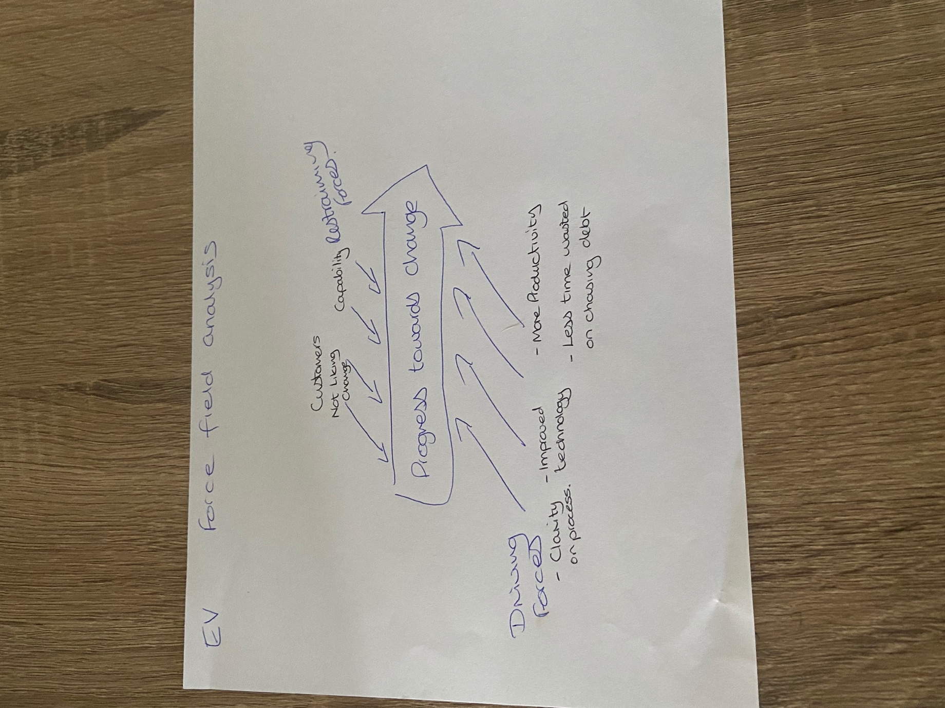

EV14
Staff Questionnaire Skyline

Please can you answer the following questions using the scale provided 1 being low and 7 being high

- Do you share the company vision for change?
1 2. 3. 4. 5. 6. 7

- Does the company have a good track record of managing change?
  - 2. 3. 4. 5. 6. 7
- Do you think levels of trust are high?
  - 2. 3. 4. 5. 6. 7
- Does the culture in the company support risk taking?
  - 2. 3. 4. 5. 6. 7
- Can people handle the change?
  - 2. 3. 4. 5. 6. 7
- Will the change be beneficial?
  - 2. 3. 4. 5. 6. 7
- Will people be able to maintain dignity and self respect?
  - 2. 3. 4. 5. 6. 7
- Will the change be mild?
  - 2. 3. 4. 5. 6. 7

EV15
Frequently asked questions Skyline

- Why do we need to change?
As described in the launch meeting, we need to change to bring us in line with competitors, to speed up and simplify the processes in the business and to remove the task of chasing outstanding invoices

- What training will I receive?
You will receive training from a sage expert and Adrain and Glan will be available for any further follow up training

- What Happens if I can’t understand the new system?
Should you need any further help please do not worry we will have surgeries and ongoing support from Adrian and Glen

- What happens if customers complain?
If a customer is not happy with the changes please politely explain the need for change and if they are still unhappy apologise and pass them over to Adrian or Paul

- What will the change mean for me?
This does not mean any change to your role and job security, it will only simplify the processes to allow us to grow the business in Europe and globally

- When will this take effect?
The new system will be effective in December

- What happens to any old outstanding invoices?
In the short term all outstanding invoices will be dealt with by Adrian until all customers are up to date and on the new system

EV16
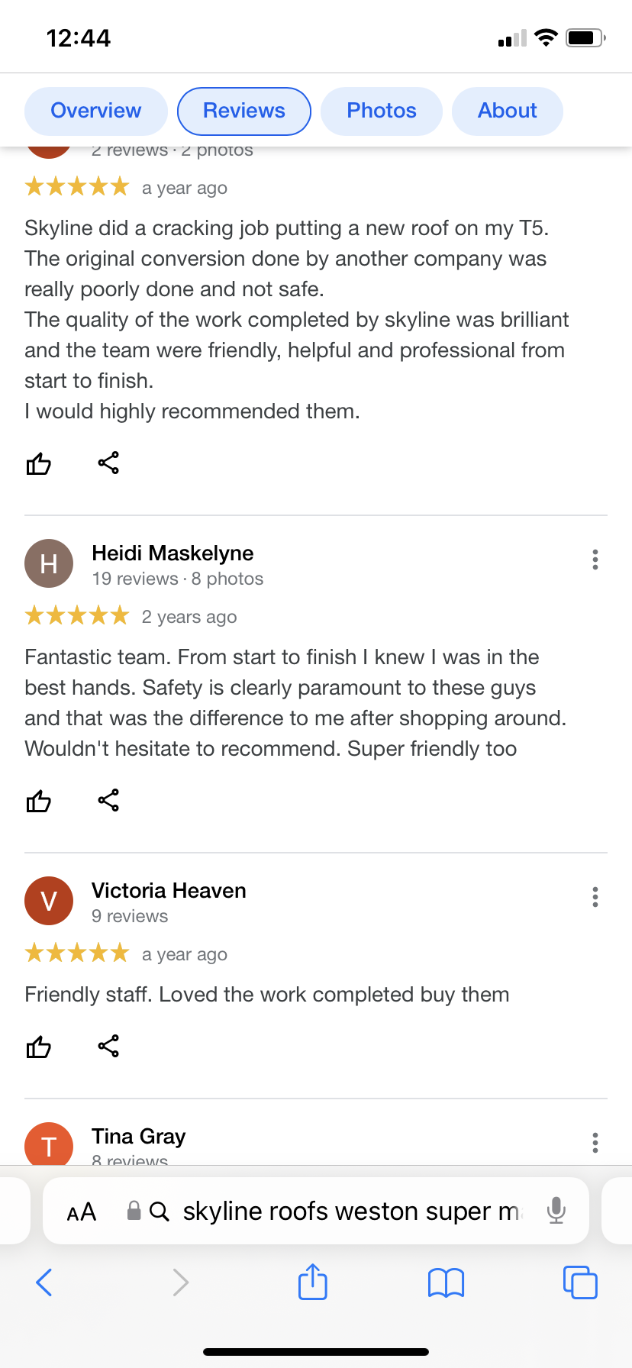
EV17
Yahoo/Inbox

Adrian Braham <adrian.braham@gmail.com>
To:tarajeffreys@yahoo.co.uk
Thu, 2 Dec at 10:46
Witness testimony for Change Management Support from Tara Jeffreys

I enlisted the services of Tara to support my company through a large change in relation to invoicing and payment systems
Tara helped with establishing a firm business case for the change and supported by ensuring a structured approach was taken to manage the change. Throughout the whole process Tara has made sure she has communicated effectively and supported the team emotionally through the change. The change has been successful and the customers and staff have given positive feedback. Tara has offered a great professional service and would not hesitate to enlist her services again in the future.

Adrian Braham
Managing Director
Skyline Roofs LTD

EV18
Celebration


The new system has delivered the following benefits
- Reduction in outstanding invoices and payments
- Improved productivity with integrated order and invoice system
- Increased company cash flow
- 100% attendance to training
- Excellent customer feedback

