

BA Business Management

Data Handling and Business Intelligence- LCBB5000

Report

Submission deadline: 23/02/2023

Student: Veronica Cusciac- 2123297
Lecturer: Khaza Ahmed

Contents
1. Introduction 3
2. Discussion 3
2.1 Definitions 3
2.2 Architecture and importance of DW and BI 3
2.3 Current Business Intelligence Tools 4
2.4 Impact of DW and BI on modern businesses 4
3. Conclusion 5
4. References 5

1. Introduction

Since the advent of the internet, significant changes have taken place all over the world. The internet has become the driving force behind everything in today's world. Internet now drives every aspect of modern life. What matters most is how it is put to use. Today's businesses rely on the internet to gather massive amounts of data for use in strategic planning and long-term forecasting. The primary themes that are having a positive and swift effect on today's businesses are data storage and business intelligence, both of which will be explored in this study, along with examples of BI tools, and benefits of the Data warehouse on modern businesses. Based on personal working experience the conclusion will highlight the key point of this report.

2. Discussion

2.1 Definitions
In order to facilitate data interpretation, information retrieval, artificial intelligence (AI), and computer vision, it is common practice to store this information in a centralized location called a "data warehouse’’(DW). When compared to a traditional database, a data warehouse platform allows for far more robust analytics to be performed on massive amounts of historical data (Inmon, W.H.,2010). Although DW platforms have been an element of BI through over 30 years, they have lately changed to accommodate new data kinds and data hosting technologies. The term of Business Intelligence is described as a collection of structures, techniques, systems, analytics, programs, and processes that facilitates the progression from raw data to valuable information (and learning), which can then be used to make choices and act (Module UWTSD ac.uk. week 1).

2.2 Architecture and importance of DW and BI
Data warehouses serve as the primary storing and retrieval mechanisms for all relevant information, in most BI setups. The major components of the DW are shown in the bellow framework.
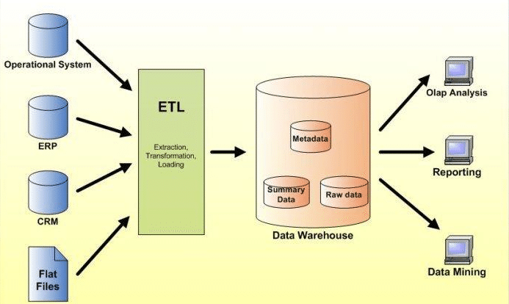
Enterprise Resource Planning (ERP) software, customer relationship management (CRM) software, accounting software, spread sheets, and operational systems are all examples of data suppliers. Extract, Transform, and Load (ETL) processes are carried out on data from multiple sources at the staging area. The ETL process involves bringing data from several sources into a centralized staging location. For ETL to begin, data must be extracted from its original source. Data is then prepared for analysis by the end users by being cleaned and transformed according to their specifications, before being loaded into data warehouses. Metadata is the primary content of data warehouses. When data has been changed and processed, it is called summary data. Finally, at the application level, users may execute OLAP operations using the information they have extracted from the data storage in order to conduct data mining, monitoring, and analysis. To decipher the meaning of unprocessed transaction data, analytical operations are performed on it. Informed business decisions can be made with access to and analysis of relevant data (Pedamkar, 2022). As data volumes increase, it becomes increasingly challenging to isolate and convey only the data that is directly applicable to solving the challenges at hand. That’s the whole point of business intelligence. Users of BI tools can access a broad spectrum of information types, which are not restricted to organized (such as accounting transactions), unorganized (such as posts on social networks), quasi (such as tags and comments), and based on past. Insights regarding the health of the company can be gleaned from an examination of this data. Such information may be used for a broad range of purposes, including but not limited to advertising, promotional offers, future construction needs, and so on. (English, V. 2018).

2.3 Current Business Intelligence Tools
Investing time and energy into researching and vetting potential BI technologies is crucial. The greatest business intelligence tools will aid in accomplishing the predetermined objectives in a variety of ways, from research methodology to quality control. To provide the best possible business intelligence, the best tools currently used include: Zoho- has everything a business intelligence tool requires, from producing visuals capable of being shared to unearthing hidden insights using data modeling; Hadoop handles massive data over internet systems and devices; using SAP Business Intelligence's visualization, investigation, and reporting tools, improve your company's decision-making; MicroStrategy is a corporate BI application that gives users a bird's-eye perspective of their organisation and entry to all of the company's digital assets; Power BI represents the data visualisation and analysis service available on the web. In addition to these standard features, it also includes artificial intelligence technologies, Excel support, and the ability to create your own data interfaces (Enfroy, 2022). The rapid development of BI made previously inaccessible sophisticated programs available to SMEs, but it has also given rise to a whole new set of confusing acronyms.

2.4 Impact of DW and BI on modern businesses
The primary goal of business intelligence (BI) is to simplify access to data (and concepts) so that company owners can do analytics. Operating system designed for BI collects relevant information and displays it in digestible formats including reports, displays, diagrams, and graphs (IBM, n.d.). Bigger companies have realized the value of the information stored in their data stores and warehouses and have turned it into useful procedures for studying their industries, clients, and goods. Such as hospitality sector which collects huge volumes of data in a wide range of formats. Accor, the biggest hospitality company in Europe and on the sixth place worldwide, collects lots of data and use it in their favor. The corporate world is expecting major changes as a result of technological advancements and database management. Several studies have demonstrated that businesses may increase their competitiveness through the use of data-driven strategic planning, BI, and analysis.

3. Conclusion
Through a holistic view of all of the enterprise's complicated large data, business intelligence (BI) technologies enable enterprises to gather, monitor, analyze, and anticipate future business circumstances. In simple words, more information company knows about its consumer, more performance the business has. Hence, the success of a company may be measured by its growth and profitability relative to its long-term goals. The goal of big data analytics is to boost business efficiency. Applying new tactics, marketing strategies, and more information openness are just some of the ways in which big data analytics may boost the efficiency of internal operations and competitive offers. One of the many IT solutions, business intelligence (BI) is put to use in the four operational pillars of any successful business: revenue, promotion, resources, and help. Big data will undoubtedly play a larger role in the evolution of most strong firms' business intelligence (BI) strategy. Businesses who use data manipulation and harvesting constructively have a competitive advantage. In order to facilitate reporting and choice-making, many businesses are adopting insights and BI systems (Tong-On, P., et al., 2021).

4. References
Efroy, A. (2022). 11+ Best Business Intelligence Tools of 2023 (Ultimate Guide). Available at: https://www.adamenfroy.com/business-intelligence-bi-tools. Accessed on 20/02/2023.
English, V. (2018). Business intelligence as a source of competitive advantage in SMEs: A systematic review. Available at: https://esource.dbs.ie/bitstream/handle/10788/3607/article_english_v_hoffman_m_2018.pdf?sequence=1&isAllowed=y. Accessed on 20/02/2023.
IBM (n.d.). What is business intelligence. Available at: https://www.ibm.com/topics/business-intelligence. Accessed on 18/02/2023.
Inmon, W.H., Strauss, D. and Neushloss, G. (2010). DW 2.0: The architecture for the next generation of data warehousing. Elsevier.
Module UWTSD ac.uk. (2023). An Overview of Business Intelligence, Analytics, and Decision Support. Available at: https://moodle.uwtsd.ac.uk/course/view.php?id=9724. Accessed on 18/02/2023.
Pedamkar (2022). Data warehouse architecture. Available at: https://www.educba.com/data-warehouse-architecture/. Accessed on 19/02/2023.
Tong-On, P., Siripipatthanakul, S. and Phayaphrom, B. (2021). The implementation of business intelligence using data analytics and its effects towards on performance in the hotel industry in Thailand. International Journal of Behavioral Analytics, 1(2). Available on: https://moodle.uwtsd.ac.uk/pluginfile.php/684134/mod_resource/content/1/The%20implementation%20of%20business%20intelligence%20using.pdf?redirect=1. Accessed on 22/02/2023

