Management Performance (LCMB7013)

Shirina Begum
Student ID 1709360
MBA- Masters of Business Administration
Performance Management
University of Wales Trinity Saint David

Table of Contents
ABSTRACT 4
1.0 INTRODUCTION 4
1.1 Management of Performance 5
1.2 Performance management's critical role 6
2.0 LITERATURE REVIEW & MAIN BODY 8
2.1 Performance management 8
2.2 Performance management system 10
2.3 Modern Techniques of Performance Management 12
2.3.1 Management by Goal (MBO) 12
2.3.2 360-Degree Feedback Method 13
2.3.3 Behaviourally Anchored Rating Scale Method 13
2.3.4 Critical Incident Method 13
2.4 Leadership Styles 14
2.5 Modern management styles 15
2.5.1 Visionary leadership 15
2.5.2 Laissez-faire 15
2.5.3 Transactional leadership 15
2.5.4 Pacesetting 16
2.5.5 Transformational leadership 16
2.6 What is the modern method? 16
2.7 Modern management theories 17
2.7.1 Quantitative approach 17
2.7.2 Contingency approach 18
2.7.3 Systems approach 18
2.8 Performance Management Model 18
2.9 SWOT & PESTEL analysis 20
2.9.1 SWOT 20
2.9.2 PESTEL 21
3.0 CONCLUSION 24
4.0 RECOMMENDATION 23

ABSTRACT
When assessing a company's efficiency, profitability, marketing effectiveness, productivity, customer satisfaction, and employee morale must be considered. The viewpoint holds that employee performance is directly tied to organizational effectiveness. High energy levels and efficiency in employee productivity will positively influence corporate performance. SainCo companies should reconsider how they hire, reward, and train their workers if they are to structure themselves successfully; as a result, people could be motivated to be aggressive. Without question, human interaction plays a significant role in the success of enterprises. Investing in people is one of the essential management tactics firms employ. Organizations are looking for ways to develop, motivate, and raise employee performance in various human resource disciplines, including management and leadership development. As a result, performance management should be a key element in an organization's performance management system since it affects employee performance, which drives its performance.

1.0 INTRODUCTION
SainCo's business relies heavily on performance management systems to improve productivity and efficiency. Performance appraisal systems have been hailed as a boon, but 70% of installations have failed. SainCo needs to determine which aspects of the performance management process are more critical to achieving effective and efficient results to place these structures in place. An essential goal of this research was to find characteristics of the management system that could correctly assess employee satisfaction and satisfaction with the system as a whole (Armstrong, 2021).

1.1 Management of Performance
As part of employee engagement, performance appraisal is just one of the various procedures. Skill management involves identifying key positions, building a talented group of high-performing established parties to fill those roles, and designing a different human resource to make it easier to fill those roles with the advantage of installing and ensuring their success. Recruitment, training, selection, and performance evaluation are all part of typical human resources processes and activities that make up performance management. As part of intellectual capital, performance measurement has been characterized as measuring and managing organizational and employee performance to improve organizational efficiency. SainCo managers need to collaborate with their employees to set performance expectations and evaluate and reward performance as part of the company's performance management process. Performance management includes the following components: assessing the efficacy of existing performance management and designing new ones, establishing goals for the organization, departments, teams, and individual employees, and executing performance evaluations (Aning, 2022).
According to Gandolfi and Stone (2018), it is possible to establish a performance management system using interconnected and independent process improvement elements that impact each other to improve employee performance and productivity and eventually boost the organization's effectiveness. It is possible to have all aspects present and still be labeled performance management. Several performance management factors work together to achieve the shared aim of increasing the performance of an organization. Performance assessments, key performance metrics, and managerial dashboards are examples of performance management systems or technologies. For the most part, organizations implement performance management strategies to boost productivity and stay one step ahead of the pack.

The significance of performance evaluation is emphasized here. Performance appraisal, which improves human resource efficiency, is critical to thriving in a highly competitive business environment, where efficiency in all sectors rises, and only those most productive firms can thrive. Today, in innovative and modern firms, the essential component influencing the performance of companies is human capital and performance. Companies can plan their future actions systematically by using performance appraisal and reaping the rewards of the results: Determining and defining the preferred performance requirements of institutions and describing them to staff; identifying an effective structure for interaction between management and employees; aligning the objectives and aims of the company with current employers; create a good chance for consistent appraisal of employees and directing and encouragement of staff Approach to performance evaluation in which the objectives and aims of the company are taken into account to define the performance evaluation criteria, and this is then applied to performance evaluations. Using suitable quantitative and qualitative tools to assess a company's efficiency is a critical component of our work.

1.2 Performance management's critical role
Because of the tremendous influence performance measurement systems can have on firms, it is crucial to analyse the system. Employee and organizational benefits have been discovered to result from performance management systems, which add to the overall effectiveness of organizations. In other words, performance management methods encourage high-performance levels, assist the growth of employees, aid in the management of human resources, and contribute to the overall corporate plan.
According to Helmold and Samara (2019), financial and productivity outcomes are better for firms that monitor their workers' productivity than organizations that do not manage their workers' effectiveness. The ability of an organization's performance management process to accurately anticipate the organization's efficiency is critical if these desired goals are to be realized. The success of a performance management system can be defined as its ability to improve individual employee outcomes, such as performance, motivation, teamwork, consciousness, working conditions, and ease in carrying out job responsibilities. According to some experts, performance management systems are effective when they result in positive outcomes for a company. Successful performance management systems lead to achieving corporate objectives, more excellent employee morale, improved customer satisfaction, better employee retention, and increased ease of organizational development adaptation. It is what we mean by improving performance. The efficiency of the performance management process has also been investigated in terms of perceived effectiveness by researchers.
People's perception of how effective their performance management system achieves desired corporate and individual objectives is perceived effectiveness. It is critical to measure the system's quality and energy to gauge its success in meeting its primary goals of increasing organizational success and improving employee performance and productivity. According to research, employees' perceptions are anticipated to moderate the relationship between quality management organizational performance and organizational culture, leading to an increase in the quality and effectiveness of an organization's system, which leads to an increased level of organizational performance. There is a lot of data on how performance management systems are regarded as practical based on their purpose, evaluations, activities, and structural parts (Pieket & Spruit 2018).
2.0 LITERATURE REVIEW & MAIN BODY
Participation of workers and awards are all part of the performance management process. In today's global market, companies want CEOs that inspire their employees. Specialists can exhibit an autocratic style when leadership controls organization systems and processes. As a specialist, SainCo leaders need to be familiar with the benefits and drawbacks of authoritarian leadership. Since SainCo uses an autocratic management style, the management makes decisions. Authoritarian leadership is defined as concentrating decision-making and direction power in one dominant leader. SainCo 's autocratic leadership style creates a hierarchy between management and subordinates and inside teams, with the leader dictating policies and procedures.

2.1 Performance management
Within the field of HRM, the study of performance evaluation has become a popular topic. I aim to define performance as the deployment and management of the causal model components that lead to the timely attainment of stated objectives within restrictions particular to the company and the situation. As a general rule, I believe that a successful company is achieving its goals; in other words, it is successfully adopting a suitable plan. Performance is dependent on the ability, motivation, and opportunity to participate of employees in the organization's activities. An organization can benefit significantly if the process is organized in such a way as to allow for extra-role behaviours from non-managerial employees, which could be accomplished by giving them autonomy to make the decision, offering decent interaction, and having employees join self-directed and off-line teams. It could be achieved. Employees' efforts will be more fruitful if they possess the necessary expertise and knowledge (A). The best way for a firm to get workers who already have this knowledge is to hire them or provide formal and informal training. This personnel needs to be encouraged to put their best effort forward for the organization (M). such issues are taken into account as part of general performance management.
Performance management is an approach to establishing an organization's purpose and goals, helping each employee understand and recognize their role within them, and thus managing and enhancing the overall performance of both the individual employee and the organization. Employees are held accountable for their work efforts through a process known as performance management, which is also a management tool.
(a) Setting expectations for employee performance,
(b) keeping an open line of communication between supervisor and employee, and
(c) comparing the actual results with the expectations.
Performance management is a strategy for improving the entire organization's performance by analysing and managing the performance of specified goals, standards, and competencies. Motivational techniques, interventions, and motivations are at the heart of performance management, aiming to turn people resources' raw potential into actual performance. Potential exists in every human being in one or more functional areas. There are several reasons why this potential isn't fully utilized and turned into actual performances; by removing intermediate hurdles and motivating the human resource, performance management functions as an agent in converting the prospect into performance. Performance management is a continuous communication process undertaken in partnership between an employee and their immediate supervisor to establish clear expectations and understanding of how each person's work contributes toward organizational goals and what it means in terms of doing their job well. Goal-setting, planning, evaluation, feedback, and incentive activities are comparable in general performance management and HR-related performance management (Stone et al., 2020).
As a result, HR-related performance management concentrates on the management and motivation of employees or managers. General performance management also has a broader definition than HR-related performance management. Goal definition and goal attainment (not just financial but also achieving all stakeholder desires) are examined. The goal of HR-performance management is to help employees maximize their full potential. The company's long-term policies must be reflected in the performance management system. The purpose of performance management is to coordinate employees' efforts in light of their actual performance. Determine what good performance is and how it may be measured to build an effective process for managing performance. The effectiveness of performance management rises when continuous feedback, behaviour-based measurements are used, and pre-established targets and skilled raters are employed.

2.2 Performance management system
Various models of performance management have been discussed in multiple academic literature sources. Each model serves a specific function in managing organizational performance, employee performance, and the integration of these functions. Various degrees of analysis goes into performance management, tied to strategic HRM and performance evaluation. Many other terms describe organizational efforts to improve performance management, such as results budgeting, performance pay, and management by objectives. Hr functions are progressively integrated with the organization's business objectives through a performance management system. Management and HR operations are engaging together to impact collective and individual conduct that supports the company's strategy. In addition, he emphasized that the method of performance management must be compatible with the firm's culture. An integrated and finished performance management cycle can be found in a performance management system (PMS). Performance management systems focus on improving the organization's overall performance, which is achieved by enhancing each person's performance. Motivating performance and helping individuals grow their talents are common aims such as developing a performance culture, identifying who should be promoted, eliminating low performers, and implementing business plans. The primary goal of a company's performance management system is to make sure that:
1. Employees' work contributes to the company's goals;
2. Employees are aware of the quality and quantity of work expected of them;
3. Employees are given regular feedback on their performance concerning expectations;
4. Employees receive incentives based on their performance; and
The primary goal of a company's performance management system is to make sure that: The establishment of a method for tracking employee performance is critical for any company. Developing a performance management system is divided into a development, planning, managing, and reviewing stage. Individual performance goals are set to meet the team's needs and the organization as a whole. Then employees are regularly evaluated against these goals, with the results being used to identify areas for improvement or admixture in their performance management framework published in 2000. main essential elements of a performance management approach include: constructing the group's aims and goals; enhancing communication in the organization so that staff members are not only aware of the plans and the business model but can make a contribution to their composition; identifying and assessing personal skill; and implement effective reward systems (Schleicher et al., 2018).

2.3 Modern Techniques of Performance Management
The corporation respects anyone; it does not keep it hidden, and the companies show their support in what we call productivity appraisals or performance evaluations. SainCo company, therefore, needs to utilize performance assessments to evaluate a worker's contributions to the company's growth. As a result, performance appraisals assess an employee's performance and personality based on the organization's requirements, such as adaptability and collaboration (Stone et al., 2020). Companies like SainCo are expected to develop performance assessment techniques to make employees content with the business rules and inspired to work more. It has its benefits and drawbacks. No organization has established a universal or worldwide appraisal approach. However, Sayles and Strauss a categorization of appraisal systems are broadly acknowledged. Strauss and Sayles classify traditional and current appraisal system approaches. The fundamental difference between conventional and contemporary performance appraisal is that old techniques focus on work-related goals and ignore other qualities. In contrast, modern methods focus on personality traits like creativity and leadership (Gupta et al., 2019).

2.3.1 Management by Goal (MBO)
MBO is faster because it does not require a response. Instead, management by objectives relies on the role of self, as employees are well informed of the criteria used to evaluate productivity. Both the employer and the employees know their aims and deliveries to the firm. Therefore, management by goal is one of the fairways of performance review. Because the employees generally know the objectives, there is little need for frequent input. This strategy will save the company time and helps the employees progress and thrive.

2.3.2 360-Degree Feedback Method
The performance appraisal method is excellent for start-up companies because it involves getting input from everyone who communicates with the employees. These people could be customers, colleagues, or superiors. Acquiring opinions and statistics provides good insight into an individual's character and personal attitudes. This process is time-consuming, but it gives the worker's overall quality score, allowing management to plan career advancement accordingly. The continual assessment would assist both the person and the company in genuinely understand the worker and his process and encourage them to improve. This strategy is an expense and provides a clear image of organizational efficiency (Al-Malki & Juan 2018).

2.3.3 Behaviourally Anchored Rating Scale Method
This technique has been regarded as the most suitable evaluation method and offers the most accurate result. The mixture of essay assessment and rating scale technique makes it a slightly pricey performance assessment approach; nevertheless, it promises the best outcomes. This performance review technique evaluates the worker as an excellent, medium, or terrible worker based on the overall productivity and conduct assessment. The human resource management is also engaged in this strategy, and they are updated on the worker behavior and productivity concurrently.

2.3.4 Critical Incident Method
This style of performance evaluation is extensive and effort-intensive yet very successful. Based on these documented instances, the employee's performance is rated after a conversation with the worker. Supervisors are intended to maintain track of minor and significant occurrences and implement choices fairly. Companies must choose intelligently so that both employees and the organization benefit. Future technologies will determine how beneficial these performance assessment approaches are for both workers and the corporation. Workers are a company's most precious asset; therefore, making policies employee-friendly is critical to keeping them engaged and happy.

2.4 Leadership Styles
Unsupportive Accountability has high accountability but poor cooperativeness. This leader expects excellent results but does not supply the required tools, equipment, or psychological support. Responsibility may produce a severe, threatening, and unsympathetic workplace. Managers that impose non - supportive burdens create a stressful work atmosphere. They often push staff to perform well, but at great expense to both parties.
High levels of care and low responsibility rates define a helpful lack of oversight. Insecure leaders stress very much about becoming loved and making the employees comfortable. They struggle to hold themselves and the staff responsible for achieving corporate goals. However, they strive to help staff live up to expectations. Surprisingly, supporting a lack of oversight does not increase employee engagement or organizational justice(Franco‐Santos & Otley 2018).
Total Avoidance lacks both accountability and support. These leaders abdicate their responsibilities to manage, educate, motivate, and make themselves or their staff responsible for achievements. Managers who avoid addressing problems allow things to grow into more significant difficulties that demand further involvement. Leaders who eschew performance appraisals do not “manage” productivity.
The best performance style of management is supportive accountability. It incorporates high levels of both assistance and responsibility. Nobody knows how much help and commitment are required. Great managers adapt their service and responsibility to the circumstances. When productivity isn't up to the mark, they investigate the underlying causes and provide the necessary help. They consider how they might better lead, encourage, and ensure transparency. Excellent performance comes from a healthy, fully supported based on mutual trust, care, and respect (Nanjundeswaraswamy & Swamy 2014).

2.5 Modern management styles

2.5.1 Visionary leadership
To achieve challenging but gratifying goals, visionary leader influences and empower people. These experts inspire others in their industry by openly stating their goals and how to attain them. This leader inspires individuals to work together towards a common objective, ensuring everyone's achievement. This managerial approach can be tough to master. To earn this respect as a leader, you must listen to your colleagues.

2.5.2 Laissez-faire
In this method, the leadership delegated all responsibility. In well-run laissez-faire, the employer only emerges at the start and finish.
This style of leadership promotes staff personality to foster innovation and creativity.
In the beginning, the entrepreneur trusts his workers while overseeing the rest of the business. And it works well in organizations with qualified workers that demand flexibility and innovation.
However, this is not a model for organizations that cannot self-manage. Letting a team address challenge leads to low productivity and member engagement.

2.5.3 Transactional leadership
This leadership style is based on motivating employees to do better. As a transactional boss, you reward your employees for completing tasks. You award them with extras if they go above and beyond. Essential information must be communicated to workers on what their efforts are worth when they have clear duties. As simple as this leadership style is, it works best for smaller projects. External rewards aren't as efficient as internal rewards for long-term work. This style isn't conducive to generating more intelligent and innovative workers (Grossi et al., 2019).

2.5.4 Pacesetting
This form of management requires people to work hard for a demanding but gratifying goal. You're in the lead; as a leader, you inspire your colleagues to work more. You push your employees to achieve more by challenging them. People in particular areas, like sales, thrive when their successes are recognized. A competent boss can mix high performance with healthy competition. The Harvard Business Review showed that while pacesetting CEOs should avoid using stretch goals, complacent teams gain from them. If you have a good but complacent team, you can use pacesetting to motivate them.

2.5.5 Transformational leadership
This type of leadership entails ongoing change based on the people's goals. Your organization has essential responsibilities, but as boss, you constantly push them to attain more challenging goals. Companies that are focused on growth should utilize this management approach. As a leader, you regularly change your employees' plans to inspire them to develop. But communication is crucial to not losing sight of your employees' personal growth and lowering their morale.

2.6 What is the modern method?
Modern management theory provides direction on effectively leading personnel and processes inside an organization. This theory offers numerous techniques for understanding your company's operations. These methodologies can detect and work with various internal and external business variables. Organizations use several ideas, including management theories. In this idea, information is both a source and a remedy for today's enterprises' dramatic change and complications. Managers use technologies and statistics to evaluate their employees and make choices. This approach opposes standard management theory, which assumes employees only labour for money. Employees strive to accomplish various goals, including fulfilment, joy, and preferred lifestyles. Managers need to use this approach to understand their employees' requirements and build their skills over time.
According to Crilly (2020), modernization theory combines quantitative and statistical methods to evaluate a company's efficiency. It helps managers analyse employees' performance and design solutions that optimize their workforce's capabilities. For instance, they may develop processes to improve employee efficiency or provide training to improve skills. Modern management theories often provide managers with insights into the aspects they need to evaluate their business or department. Knowing what to look for can help managers discover issues and potential remedies. Mathematical tools aid their decision-making (Schleicher et al., 2018).
Modern management theory investigates workers' incentives for labour beyond financial benefit. Using this approach, supervisors can develop and execute processes or procedures that meet employees' diverse needs. Employees that are happy at work are more likely to stay with the company and contribute to its success.

2.7 Modern management theories

2.7.1 Quantitative approach
Quantitative management employs data and arithmetic to address complicated challenges. Management may utilize computational models or data modelling to assess performance. This study allows them to understand the business and develop solutions to solve or enhance the challenges they find. Management can use these tools to evaluate the risks and advantages of various proposals. Managers might use this technique instead of personal beliefs or sentiments to achieve decisions based on the data and facts.

2.7.2 Contingency approach
According to the contingencies management strategy, no single management style fits all organizations. Using this approach, leaders must recognize and deploy distinct management styles for diverse scenarios. As a result, these leaders get new talents and skills that help them govern effectively. Using various techniques can assist these managers in being more flexible and open. Three variables determine an organization's culture: population, technologies, and leadership styles. A good manager recognizes these influences on productivity. A young company may have greater flexibility and minor division between functions than a large corporation. Smaller firms' managers have more control over procedures and can easily change them.

2.7.3 Systems approach
A company is a complicated grouping of numerous elements that work together to attain a shared purpose. A corporation has many components, such as bureaus. Instead of evaluating each member separately, executives employing this paradigm look at how they connect. They must also assess the external influences influencing or affecting these processes. System thinking divides an institution into parts.

2.8 Performance Management Model
The goal of the PCER is to establish a continuous conversation between the employees and supervisors to improve performance. The PCER model, developed by the Institute of Human Resource Management Practices and Organizational Effectiveness, is recognized for facilitating the performance management process. Appropriate procedures are employed throughout this process to establish a presentation plan, guide staff to ensure that the plan is accomplished, and achieve the yearly presentation evaluation (Hameed & Waheed 2011).
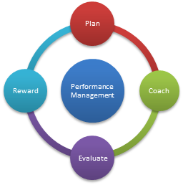

Fig: 1 Performance Management Model (PCER) Source: employees.tamu.edu

Plan: It is the manager's responsibility to review the worker's placement constraints, start communicating skills and knowledge, develop objectives, and discuss the purposes and objectives with the employee.
Coach: Over the year, the leader gives feedback and coaching to their staff members to assist them in achieving their objectives. After the Plan phase is completed, the objectives and other supporting documents generated during that sequence become a working document that can be mentioned and adjusted throughout the performance evaluation period. Both the employer and the employees can make notes about each other's effectiveness at any moment, and these observations are stored outside of the Weekday scheme.
Evaluate: During the assessment process, the manager may rely on different resource bases, including the individual's self, achievement records generated all year, recognitions, and feedback from customers, to evaluate the worker's performance to determine whether or not to promote the employee. The superintendent scheduled a meeting with the staff to discuss the performance assessment, describe the evaluations and provide comments on the worker's areas of improvement. After that, the supervisor accomplishes the assessment during Working hours and sends it to the worker for evaluation and acknowledgment before officially closing the summary in Workday on the computer.
Reward: The superintendent recognizes and rewards the meritorious overall performance of the year and throughout the year.

2.9 SWOT & PESTEL analysis

2.9.1 SWOT
SWOT, when broken down, means analysing the following:
Strengths – benefits you have over the competitors concerning this project are simple to understand.
Weaknesses – When compared to your competition, the limitations you have inside are significant.
Opportunities – External tendencies are currently in effect and ready to be exploited.
Threats – Exterior activities that may cause a problem and have a detrimental impact on your company's operations are listed here.
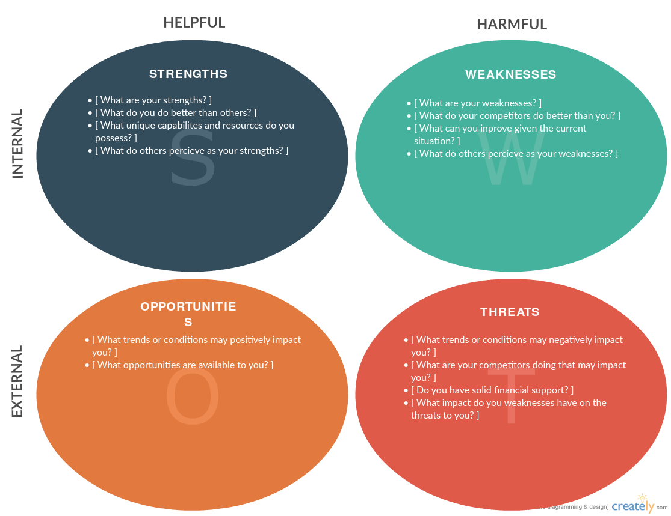

Fig 2: SWOT Analysis and PEST Analysis Source: creately.com

Knowing the SWOT analysis will help you create a project prepared to work around specific obstacles effectively and prevent failure. The SWOT Assessment should be carried out with the company group throughout the project preparation's early stages. It is a great idea and a great habit to do so. Incorporating all of the essential internal and external aspects of each study component through imagination is a beautiful method to get things started.

2.9.2 PESTEL
PESTEL refers to examining external elements that are advantageous when conducting research before starting a new project or market analysis. These factors are:
Political – laws, worldwide concerns, restrictions, and other regulations and rules impact a business directly or in the foreseeable future.
Economic – Taxation, bond yields, hyperinflation, the equity markets, and consumer sentiment are all factors that must be considered while determining a budget.
Social – The media, significant events, morality, marketing, PR issues, and shifts in purchasing and living habits are all aspects to consider.
Technological – Innovation, usage of technology, licenses and copyrights, production, academic financing, and worldwide communication are some of the issues that need to be addressed.
Environmental – Environmental challenges, whether regional or worldwide in scope, as well as the political and social elements that influence them
Legal – Policy that has been suggested and may become law, as well as any legislation that has been approved
Unlike SWOT, PESTEL when it comes to the outer macro-environment that may impact your company's stance, the explanations for growth over time in the industry, and identifying different avenues for the company overall. The tactic is more explicitly aimed at the variables directly impacting your company. Create offers some outstanding PESTEL analysis frameworks that will allow you to start immediately.
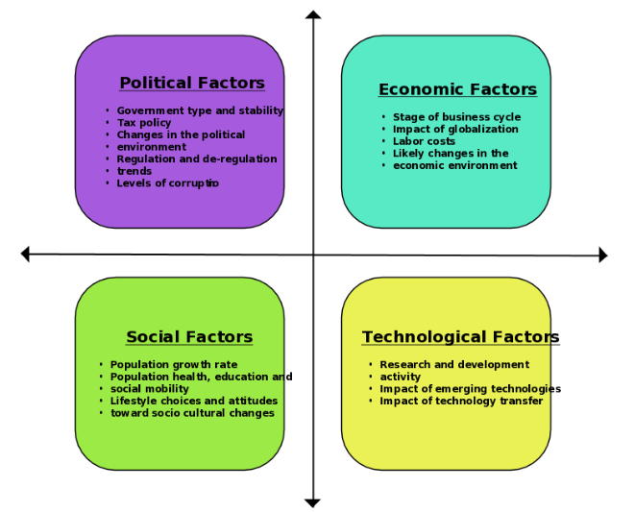

Fig 3: PESTEL Analysis

4.0 CONCLUSION
As the administration has become more prominent in recent years, human resource management (HRM) has become a significant part of managing a company. Performance measurement systems have been increasingly evident as a field of study. It is critical for a business to organize, monitor, and promote its employees' productivity. Consequently, the firm's efficiency would improve, and its profit would rise due to overseeing the entire performance management system, including setting objectives, receiving feedback, and evaluating performance. The resources and assets of a company, on the other hand, are the people who work for them. SainCo needs to devise techniques to discover and support employees' work performance and monitor, evaluate, develop, and recognize their efforts. As a result, more excellent employee performance may impact the organization's overall success. The goal is to conduct a review of relevant books on management systems and employee performance and the connection between the two.

3.0 RECOMMENDATION
It is anticipated that future attempts regarding the performance management structure would remain focused on leadership up-skilling and facilitation, notably on efficiently utilizing the system and concentrating on management styles. Any sound system can be ineffective if talented individuals do not lead it. The variables in a stable state (i.e., evaluations, the method, instruments, and technologies) are managed. I concentrate on improving the quality and efficacy of usage rather than increasing the quantity. I used a typical project management approach to accomplish results outside the norm. I was capable of achieving this by establishing the system's foundation on scientifically proved concepts and a clear mindset, connecting it with our company goal, and incorporating cultural characteristics into our process. It is recommended that SainCo needs to concentrate on the following phases to obtain a suitable formulation and construction:
- Create guiding personnel concepts upfront, actively engaging and approval from the highest levels of corporate management. Then adhere to the core rules.
- Create the system so that those principles are hardwired into your people's processes and habits.
- Complete the task successfully. Continue on your current path. Keep up with the current trends and other businesses' "practice guidelines," but resist the temptation to follow them. Your project management program (PMP) should be tailored to your organization's culture, experience, and requirements (Mone & London, 2018).

References

Al-Malki, M., & Juan, W. (2018). Leadership styles and job performance: A literature review. Journal of International Business Research and Marketing, 3(3), 40-49.
Armstrong, M. (2021). Performance management.
Aning, P. (2022). Modern Business Practices for Performance Excellence: A Study of Roubmap Company Limited (RCL) Business in Ejura–Sekyedumasi. ADRRI Journal (Multidisciplinary), 31(1 (8), January 2022-March), 153-180.
Crilly, B. C. (2020). Ambidextrous project management: The influences of leadership styles, project management practices, and team characteristics on creativity and innovation (Doctoral dissertation, Hood College). According to Crilly (2020)
Franco‐Santos, M., & Otley, D. (2018). Reviewing and theorizing the unintended consequences of performance management systems. International Journal of Management Reviews, 20(3), 696-730.
Gandolfi, F., & Stone, S. (2018). Leadership, leadership styles, and servant leadership. Journal of Management Research, 18(4), 261-269.
Grossi, G., Kallio, K. M., Sargiacomo, M., & Skoog, M. (2019). Performance management systems and accountability changes in knowledge-intensive public organizations: a literature review and research agenda. Accounting, Auditing & Accountability Journal.
Gupta, A., Gupta, N., & Gupta, M. (2019). British Airways-A SWOT and PESTLE Analysis-The impact of Europe 2020 policy. NOLEGEIN-Journal of Corporate & Business Laws, 1(1), 1-11.
Hameed, A., & Waheed, A. (2011). Employee development and its affect on employee performance a conceptual framework. International journal of business and social science, 2(13).
Helmold, M., & Samara, W. (2019). Progress in performance management: Industry insights and case studies on principles, application tools, and practice. Springer.
Mone, E. M., & London, M. (2018). Employee engagement through effective performance management: A practical guide for managers. Routledge.
Nanjundeswaraswamy, T. S., & Swamy, D. R. (2014). Leadership styles. Advances in management, 7(2), 57.
Pieket Weeserik, B., & Spruit, M. (2018). They are improving operational risk management using business performance management technologies: sustainability, 10(3), 640.
Schleicher, D. J., Baumann, H. M., Sullivan, D. W., Levy, P. E., Hargrove, D. C., & Barros-Rivera, B. A. (2018). Putting the system into performance management systems: A review and agenda for performance management research. Journal of Management, 44(6), 2209-2245.
Stone, R. J., Cox, A., & Gavin, M. (2020). Human resource management. John Wiley & Sons.

