Student name: | Raducu – Viorel Ciolpan | Student ID number: | 2221478
Programme: | BA International Hotel Management
Module: | Food & Beverage Operations
Module code: | BMIH4002 | Contribution to  Overall Module Assessment (%): | 25%
Lecturer: | Jaliya De Silva | Internal Verifier: | Charlotte Joyner
Assignment Title: | Assignment 2 Menu Engineering (Practical Task) | Word count (or equivalent): | Throughout practical placement work

Table of Contents
Part 1: Restaurant Concept 1
Part 2: Menu Design 3
References 4

Part 1: Restaurant Concept
The "Romantic Delights" restaurant concept offers a sophisticated and exclusive dining experience that caters to couples in search of a unique and affectionate evening. The restaurant, situated in the renowned Trinity Hotel Chain, endeavours to establish a delightful atmosphere through the use of subdued lighting, sophisticated furnishings, and conscientious hospitality. Our menu has been thoughtfully curated to blend exceptional flavours, premium ingredients, and flawless presentation, resulting in an indelible dining encounter.
Our target audience comprises of couples that are eager to commemorate special events, with a particular emphasis on the impending Valentine's Night celebrations. We aim to attract a customer that is discriminating in nature. Our goal is to entice couples of any age who have an appreciation for great meals and are looking for a romantic atmosphere to make their evening more enjoyable (Filimonau and Krivcova, 2019).
Lobster bisque with crème fraîche begins a delicious feast. A tasty vegetarian alternative is roasted cauliflower soup with crunchy chickpeas. Grilled asparagus with lemon vinaigrette compliments appetizers. Meat aficionados might choose grilled ribeye steak for the main meal. Pan-seared salmon with a mild sauce is also delicious. The vegetarian wild mushroom risotto highlights mushrooms' earthy tastes. Finally, butternut squash and sage ravioli are sweet and delicious.
When designing our dessert menu, our aim was to provide a diverse range of decadent choices. The dessert comprising of chocolate lava cake and raspberry is a luxurious and amorous conclusion, characterized by its viscous centre and tart raspberry embellishments. The dessert option of classic crème brûlée accompanied by fresh berries is a sophisticated and enduring choice (Halim et al., 2019). Finally, the vegan chocolate mousse accommodates the dietary preferences of health-conscious patrons while upholding its palatability and aesthetic appeal.
In addition to the menu offerings, Romantic Delights places emphasis on crafting a noteworthy guest experience. The staff is highly attentive and offers personalized service to ensure that couples feel valued and well taken care of during the course of their evening. The Valentine's Night experience is designed to create an enduring impression on guests through a combination of intimate and romantic atmosphere and a carefully curated menu.
To conclude, Romantic Delights offers a distinctive and amorous dining concept that caters to couples in search of an extraordinary experience. The restaurant's intimate atmosphere is complemented by a thoughtfully crafted menu consisting of three courses and a variety of beverage options (Horng et al., 2021). Our objective is to provide a remarkable Valentine's Night experience for our discerning customers, featuring delectable tastes, exceptional customer service, and a captivating ambiance.

Part 2: Menu Design
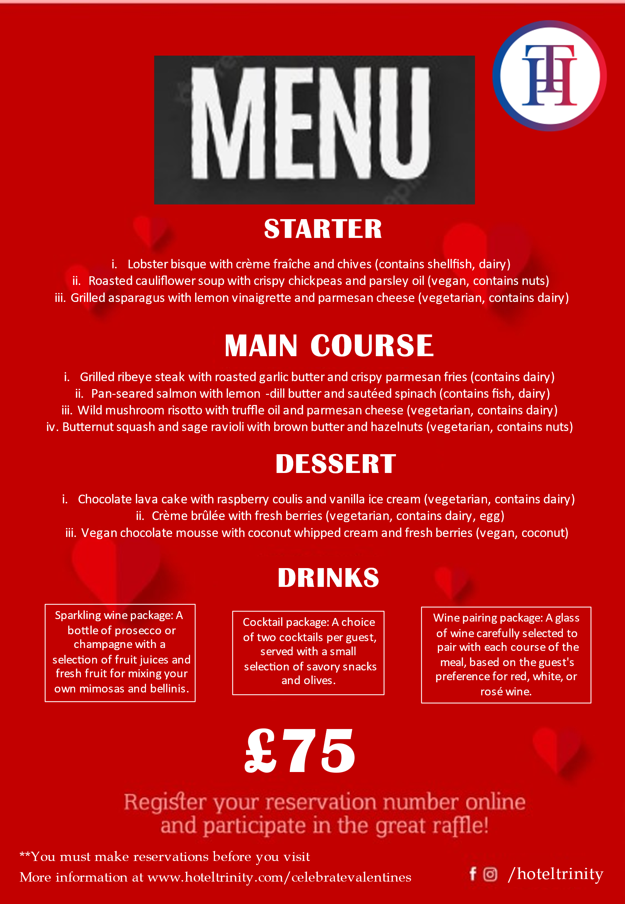

References


