



Understanding and Engaging in the Customer Experience
BMSK5003

Student Name: Suraya Begum
Student ID number: 1712135
Tutor: Vajira Balasuriya
Table of Contents
List of Figures/ Diagrams 3
Introduction 4
Investigating the ‘customer experience’ based on the following policies - Ethical and Sustainability 5
Critical discussion of a variety of quality models and theories that may assist in an organisation improving its customer relationship management 9
Concluding the impact of ethical and sustainability policies on the quality of the CRM in ASDA 13
Recommendations 16
Conclusion 17
References 18

List of Figures/ Diagrams
Figure 1………………………………………………………………………………………………6
Figure 2………………………………………………………………………………………………9
Figure 3………………………………………………………………………………………………12

Introduction
This particular report has focussed on critically discussing the influence of ethics, sustainability, CRM and quality policies as well as operations on customer experience. ASDA has been referred to here as the organization of interest. Besides ASDA other supermarkets operating across UK have also been considered for better evaluation and assessment.

Investigating the ‘customer experience’ based on the following policies - Ethical and Sustainability

Working directly with customers involves large number of responsibilities in order to ensure the success of the relationship build with the customers. Customer experience can be associated with the perceptions carried by the customers regarding the services and products offered by the companies (Crane et al., 2019). When an organization is working in a direct relationship with the customers then the former plays the role of brand ambassador and has the utmost responsibility of managing the particular relationship. In the current global business environment with technical enhancements it has become extremely difficult to maintain suitable customer relationships. Customer experience has become a matter of concern for all businesses since these days it is significantly easy to share views and experiences on social media platforms (Buil et al., 2016). It takes only some time for a bad experience to get circulated across the global media which is capable of developing a negative reputation for a company. In the context of this fact businesses have started realizing that customer experiences do play a crucial role in ensuring sustenance of the organization within the market (Signori et al., 2019). Taking into consideration the changing scenario of the business environment it can be inferred that customer perceptions get greatly impacted by the sustainable and ethical policies formulated and applied by the organizations.
Devising and implementing appropriate ethical policies is about ensuring the fact that complete transparency is given importance by the organization while dealing with customers. There are some ethical considerations which must be taken into account by the businesses while making policies. They are,
Avoiding any kind of misrepresentation: Misrepresentation of a business, service or product is not only against standard business ethic but also to be considered as illegal. This is regarded by the customers as a category of false advertising. This kind of wrongdoing can take place in any form. Like the features of any product can be lied about or false promises or offers can be made regarding a service. The process of accumulating experiences on the part of the customers is a continuous process (Charter et al., 2017). Suppose a customer buys a product from an ASDA store and is extremely satisfied with the results. Thus, the customer accumulated a positive experience about the product and the information provided about the product. This is the start of the process. If in case of the next purchase another product or service from the same store fails to meet the advertised information, then the same customer will develop a negative experience.
Follow the promises made: The promises made needs to be followed in order to contribute towards positive experience building in case of customers. For example, the representatives of ASDA dealing with customer queries and complaints provide great focus on the ultimate resolving of the issue (Crane et al., 2019). If the issue is not dealt with and forgotten, then it will lead to dissatisfaction creating a negative experience with the retailer's service provision.
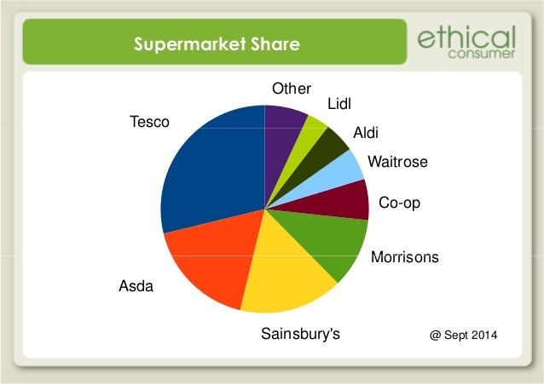
Make sure that customers are well off: It is important to set up strategies and approaches to deal with the customers till the end. Providing the customers with products, services and solution cannot be regarded as the end. In order to retain customers, it is mandatory to become a part of the entire customer experience accumulation process.

(Figure 1: Ethical Consumer)
ASDA greatly focuses on maintaining and managing ethical and sustainable aspects as their main aim is to make the world a better and safe place for their customers. Under its ethical and sustainable policies ASDA gives priority to three elements - people, price and planet. With respect to ethical policies ASDA concentrated on carrying out ethical trade (Naidoo and Gasparatos, 2018). To maintain a transparent representation in the market the supermarket has become a member of ETI (Ethical Trading Initiative) and is also a supporter of Fair-Trade Foundation. Proper trade policies ensure the quality of the products provided to the customers (Perks, 2015). The higher the standard of products higher is the level of positive experience on the part of the customers. Food safety is one of the primary concerns which influence customer experience. ASDA through implementation of its ethical and sustainable policies make sure that all of its suppliers are audited from time-to-time and products received have sustainability certificates. From 2007 onwards the retailer has doubled up acceptance and marketing organic products and has completely stopped accepting genetically modified derivatives or ingredients (Lewis and Phillipov, 2016). ASDA has focused on removing unnecessary plastic consumption from their business. By 2021, they are planning to reduce plastic packaging by 15% (Asda.com - Online Food Shopping, George, & more, 2020).
This kind of policy is likely to create a positive impact on customer perceptions as people are becoming significantly concerned about growing plastic and food waste. The retailer has removed plastic packaging in case of more than 180 products. Also, it has included in its sustainability policy to become 100% recyclable by the end of 2025 (Asda.com - Online Food Shopping, George, & more, 2020). Regarding food waste generation and control also ASDA stayed transparent in front of customers and other stakeholders. It revealed about the generation of 32,000 tonnes food waste in 2018 and stated 26% of extra food has been donated to charities in the same year (Hart, 2019). By 2025 the supermarket has decided to reduce food waste generation by 20%. All these plans, revelations, ethical and sustainable policies have been leading towards creation of a positive influence on the perceptions of the customers (Hart, 2019).
Besides ASDA there are also other supermarkets across UK who are members of ETI and ensures implementation of suitable human right policies. This is being done to establish a positive brand image in the market. More is the positivity of the brand image higher is the value of the brand among the customers (Jones and Comfort, 2018). For example, by 2018 Tesco has been able to attain higher ratings with respect to effective maintenance of its ethical policies through their revelations and declarations like 'Modern Slavery Statement 2018/19', 'Our Approach to Human Rights 2019' and 'Supplier Code of Conduct'. However, certain deficiency on the part of supermarkets like ASDA, Tesco, Sainsbury, Waitrose, M&S, etc. was noticed in 2018 (Tench and Topić, 2017). All these supermarkets gave explanation that they were completely ignorant about the fact they had employed individuals who had been kept and supplied as slaves to workplaces. This particular ignorance of the supermarkets did lead to breaching modern slavery statements and policies. Questions also raised on the brand ethics and reliability when in 2019 it came to the picture that Tesco had no strict policies regarding doing business with brands who in a way support testing on animals (Shaw and Shaw, 2019). This kind of revelation had resulted in mass abhorrence on the part of the customers. Poor ethical policy compliance can be seen from the discussions have great negative impact on the perceptions of the customers regarding the branding and practices of the organizations. However, in the context of sustainability supermarkets like ASDA and Tesco have taken suitable steps towards reducing the negative impacts on the environment. Tesco has decided to fight against the consumption of single-use plastics by banning brands which are inclined towards using excessive packaging materials (Jolly, 2019).

A great example of customer experience based on ethical and sustainable policies is the 'Horse meat scandal' which took place in 2013 across UK. Many of the supermarkets got entangled with the scandal. When periodic testing of frozen foods was done by FSAI (Food Standards Agency Ireland) in 2012 they identified unknown DNA in the food samples. Later it got revealed that major portion of the frozen meat contained horse meat (Jones and Comfort, 2018). This is highly unethical and resulted in the creation of negative experiences on the part of the customers. Not only the customers were cheated as they paid for beef but received horse meat instead but also it affected their health. Also, horses are given drugs which are not for human consumption and this piece of information is significantly disturbing for the consumers. Many customers after this breakout experienced disgust and trauma and consumers lost their trust on the meat products sold by the supermarkets. It was observed that 30% of the consumers started avoiding buying meat products and 24% converted their preferences towards vegetarian alternatives (Perks, 2015). This kind of ethical blow caused supermarkets like Tesco, Aldi, etc. to tighten their supply chain management policies further. Effective trading ethics, supply chain management policies, workforce policies, sustainability policies to reduce impacts on nature and encourage CSR activities, etc. are some of the organizational policies which are necessary in carrying out direct dealing with the customers. Breaching or violation of such policies and plans as seen in the case of 'Horse meat scandal' can lead to negative customer experiences which in turn will result in reduction in sales, reputation damage, poor brand value and obliteration from the global business environment.

Critical discussion of a variety of quality models and theories that may assist in an organisation improving its customer relationship management
Customer Relationship Management is regarded as a foundational strategy which is used by companies to develop and implement customer centred culture within the working environment. This helps in optimizing and managing present as well as future relationship with clients or customers. Such a strategy helps businesses to understand customer interactions which further contribute towards improvement of the values provided to the customers (Nyadzayo and Khajehzadeh, 2016). CRM in a way assists in increasing profit generation and customer retention possibilities of the organization. Modern Theory of CRM is in support of 'integration of customer' strategy. This way of looking into the business includes integrating customers in all elements of business that is from managing of suppliers to dealing with enhancement of business processes. In this way it becomes easy to develop a deeper bond with the customers (Soltani and Navimipour, 2016).
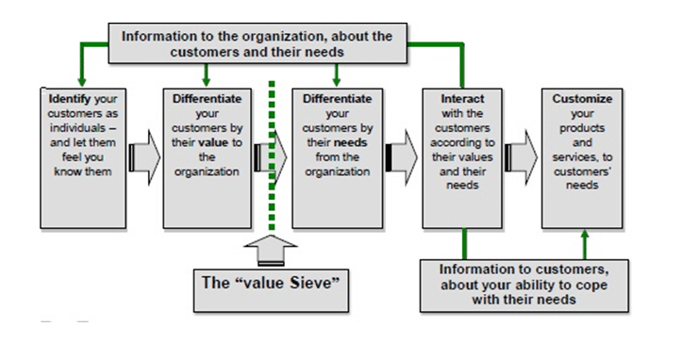
(Figure 2: IDIC Model of CRM) Source: (Buttle and Maklan, 2019)
The IDIC model of CRM has been proposed by Pepper and Rogers. As per this model companies are required to take into consideration four actions for developing, maintaining and retaining long-term relationships with the customers. The four actions are - identify, differentiate, interaction and customization. The first step of this model is about identifying the customers in an effective manner. Information like address, name, age, contact details, purchase history, etc. are to be obtained by the companies (Buttle and Maklan, 2019).

The primary goal is to collect as much data and information as possible about the customers in order to develop a strong knowledge about their wants, demands, needs and purchasing pattern and behaviours (Lee, 2018). For example, ASDA gives great importance to customer data obtained across the business at various points of transaction. This data is used by the retailer to improve the shopping journey and experience of the customers. The retailer collects information from the reviews of the customers both on online and offline platforms. The purchasing history of the customers is also used to understand the nature of purchase. In this manner several ways are implemented by ASDA to collect information about their customers (Naidoo and Gasparatos, 2018).
The second step of the model is about carrying out appropriate differentiation and segmentation of the customers on the basis of the information obtained. The customers are categorised by considering their projected and current lifetime value. Every customer retains a different value to the business of an organization. By analysing the value given to the business, companies can prioritize the customers and will be able to enhance their interaction with the customers (Marolt et al., 2020). ASDA generally focuses on demographic and behavioural segmentation of customers in order to serve the customers in an effective manner. Demographic information like age, gender, lifestyle, spending behaviour, address, contact details, preferences and so on are used by the retailer to segregate the customers into different age groups, societal classes, etc. Behavioural segmentation carried out by the retailer basically focuses on the purchase pattern and decision-making process of the customers (Marolt et al., 2020). This kind of information is obtained from purchase history, reviews collected from online and offline platform, feedbacks and interactions with the customers. With such information ASDA is able to find out which products are on demand, whether the prices of the products needed to be altered, at what time of the year customers prefer sales and discounts, which group of customers prefer quality over quantity and vice versa, etc.
The third stage of IDIC model is associated with the process of interaction. Depending on the information collected and the segmentation carried out an effective CRM plan is created by an organization. In the third stage of the model the CRM plan is implemented to interact with the customers. After appropriate analysis and categorization of customers it becomes easy to continue with interaction with the customers (Sachdeva, 2020). Like individuals who have been identified as valued customers can be offered loyalty points, special discounts or rewards in order to ensure long-term retention. ASDA has significantly followed the trend of UK supermarkets and has launched their own loyalty card point programme. Through this loyalty scheme customers are able to earn points on every purchase of clothes and homeware. The scheme is only viable for online purchases and not for offline purchases.
The retailer has provided its valued customers with 'Money Cashback Credit Card' which the customers can use for earning points, saving money and utilising the points or money saved in future. If customers on a regular basis shop from ASDA, then they are at profit and will get rewarded for their loyalty towards the brand. The retailer also targets the emotional quotient of the customers through effective use of social media campaigns for emotionally attaching the customers with the brand. In this way ASDA is fighting hard to retain its customers and maintain its level of sales throughout the years.
The fourth and last step of the model is to customize the services. After interacting with the customers, implementing the CRM plan and engaging customers in the buying process, it is important to ensure to be a part of the continuous customer experience development process. Accumulation of experience on the part of the consumers is a continuous process. It does not end with the purchasing of the products or services from an organization (Soltani and Navimipour, 2016). Depending on this experience repetitive purchase and staying loyal to the brand takes place. Customizing is all about analysing the customers further depending on the interaction process and improves customer engagement more. ASDA through their interaction processes are able to understand the ways in which their services and products can be enhanced more. The documentation of the interactions helps in highlighting the gaps which can be addressed for further development of the business processes and achievement of the business goals.

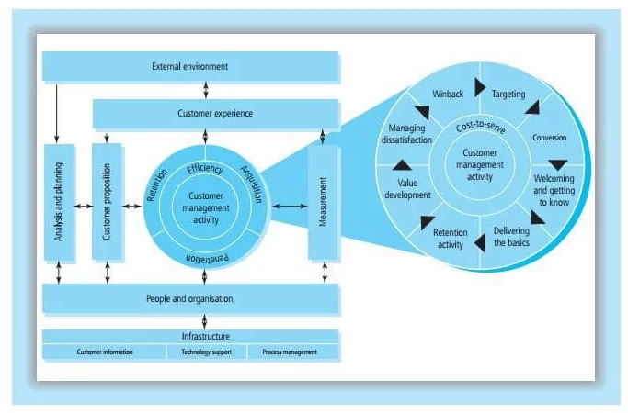
(Figure 3: QCI or Quality Competitive Index Model of CRM) Source: (Buttle and Maklan, 2019).
The Quality Competitive Index model generally emphasizes on three aspects, they are acquisition, retention and penetration. The model firstly focuses on analysing the external environment of the customers where it considers their concerns, the business goals, and several other factors which will influence their decision of buying the product or services or interact with the sales team. All these elements highly influence the experience of the customers. The customer experience accumulated then leads to affecting customer proposition as well as customer management processes and activities. It can be seen from the above model that several activities are required for retaining and acquiring the customers (Buttle and Maklan, 2019). The QCI model includes series of activities and processes which are associated with technology, organization, employees and people. As per the model relationship gets highly influenced by the external environment. When customers decide to interact with an organization then the external environment directly influence the experience of the customers as well as the planning process of that organization (Charter et al., 2017). The gained experience directly influences three particular future activities which are measurement, customer proposition and customer management activity. Customer proposition is associated with what has been promised to be offered to the customers by the company.
Customer management activity starts from capturing the attention of the customer till retention of the customers. Measurement is related with analysing the success of the activities which also impacts customer experience.
From this model it can be inferred that ASDA needs to be aware of the external environmental factors which can impact the decisions of the customers. Besides understanding the needs and wants of the customers as per the QCI model the retailer also need to focus on the external environment factors directly affecting the decision-making process of the customers and the CRM planning of the organization. The three general factors which directly impact customer experiences or perceptions are culture, social class and reference groups. ASDA by collecting information about the customers through their business will be able to develop an idea about the social class and culture of the latter. Regarding reference groups the retailer consider the reviews provided on various online and offline platforms. In this manner it becomes easy to assess the extent up to which the external environment is impacting customer experience and thereby customer relationship management. From the above theory of CRM and models it is clear that organizations need to assess customers as well as external environment factors in order to support long-term development of relationship with their customers.

Concluding the impact of ethical and sustainability policies on the quality of the CRM in ASDA
As being one of the largest supermarket chains in the United Kingdom with almost 15.8% of the total market share in the retail sector, both ASDA and its owner Walmart had been persistent in the headlines for multiple news exposures ranging from slavery in the Walmart prawn supply chain to accusations of discriminatory activities by the ASDA employees (Sharpe and Barling, 2019). Hence, many researchers as well as retail market analysts had interrogated whether or not the low price of ASDA deliverables are way too costly from the consumer relationship management.
The research so far had highlighted that several ethical issues pertained with respect to both ASDA and its parent company Walmart. This is the reason the former had been demarcated with a considerably low ranking in the overall country-specific rating system with respect to categories. These categories had comprised of environmental reporting, climatic changes, and rights to workers, supply chain management system, animal rights, irresponsible marketing, anti-social finance, political activities and use of controversial technologies.

The market analysts had also reported that the new Democratic Consumerism project had successfully proven to be a raft of customer empowerment initiatives with respect to ASDA’s ethical and sustainable policies in the UK platform. The company has been heard of involving customers in almost every aspect of its business in order to showcase their way of doing business. Through this, the company has also intended to assist its customers make the most appropriate decisions that might have an impact on the selling protocols of ASDA. With respect to the ethical and sustainable policies which have been improvised upon the company, it can be suggested so far that its recruited panel of 18,000 shoppers shall have a wide-scale influence on the purchasing decisions (Tench and Topić, 2017). The company has announced to reward those customers who shall come up with the most fruitful idea to save the business finance. This strategy has also been implemented in order to establish a transparent store in Wales where shoppers shall be able to see the back-office activities which most often remain unseen to outsiders.
The customer relationship management (CRM) usually improvises the affectivity through the Consumer Focus group and in association with ASDA has attempted to gain trust of their loyal and targeted customer group. The accreditation of the Democratic Consumerism has eventually allowed the company to focus more on to the decision-making stances of the customers as a result of which, the company had been successful in modifying its inputs in accordance. ASDA’s corporate affairs director Paul Kelly had significantly mentioned that the company had been trying to uplift its market position and improve customer trust within the background of mistrust in business. Such mistrust had eventually led the company fall short to credit crunches with the collapse of the conventional banking system. Hence, the inclusive approach had been found to be highly benevolent from the company’s initiatives wherein the approach and the policy implementations have been innovative.
Moreover, the company’s spokesperson had also stated to The Guardian that the CRM profile of ASDA does not only intend to reflect social responsibility through pricing strategy and zero-compromise on product quality, but also on the surrounding environment. ASDA had been working hard since many years to improve the livelihoods of the workers associated with the supply chain management for the reduction of the environmental impact on their products. ASDA had effectively collaborated with several partners in order to mitigate such issues such as the Ethical Trading Initiative’s Program for the improvement of the working conditions of workers in developing countries like India and Turkey (Gardetti and Torres, 2017). ASDA had the focus on their grocery aisles and in order to comply more proficiently with the ethical and sustainable policies, it has become one of the first retailers to publish fish sourcing data through Open Disclosure Project.
Such transparent implementation has been found to be highly crucial both for the outsourcing events as well as its positive impact on the CRM for a prolonged lifespan.
ASDA had recently improvised George sustainability strategy with stretching targets as well as commitments for the overall reduction of both social and environmental impact on the company’s products. This is basically because of the fact that currently consumers are also becoming environment conscious and companies associated with low carbon emission Performa are more likely to be on the long run (Tidy et al, 2016).
The ASDA spokesperson has also stated recently to The Guardian that by the end of 2025, there is the commitment of improvising fully recyclable plastic for the polyester fibers which are usually used in George Fashion or George Home products (Davies and Gutsche, 2016). This means that the drink bottles sold by ASDA would not end up in the landfills or ocean but can be reused and made into clothes and other fabric products.

Recommendations
There are certain toiletry products sold by ASDA which are difficult to recycle such as toothpaste, sun cream and other squeezable tubes since they combine many different forms of products. The recommendation is that the company should open up its own packaging unit where minimal components shall be collated for the making of packaging materials so that they become recyclable too. The management strategies and the pricing of the products at ASDA stores may be compromised to a certain extent so that downstream processing can be funded properly and this needs to be relayed forward effectively with the customer segment. The company may also instigate zero-tolerance policy towards incineration and domination of garments that cannot be sold to charitable organizations for reuse (Young et al, 2017). The company may also open up clothing banks in its stores/outlets for the customers to donate used clothes which they no longer intend to use so that least amount of decelerated effect gets imparted upon the environment.

Conclusion
On a concluding note, it can be stated that ASDA has got its platforms strengthened with respect to ethical and sustainable policy enforcements because of which customer relationship management had gained foothold in the current marketing content. Besides the scandals that the company had faced so far in the past, the current policies and modifications in the marketing and management strategies had been found to be compliant with regulatory affairs of the demography under context and thereby positively impacting the conscious attitude of the customers.



References
Asda.com. 2020. Asda.Com - Online Food Shopping, George, & More. [online] Available at: <https://www.asda.com/creating-change-for-better/better-planet/packaging-and-plastic> [Accessed 12 March 2020].
Buil, M., Aznar, J.P., Galiana, J. and Rocafort-Marco, A., 2016. An explanatory study of MBA students with regards to sustainability and ethics commitment. Sustainability, 8(3), p.280.
Buttle, F. and Maklan, S., 2019. Customer relationship management: concepts and technologies. Routledge.
Charter, M., Gray, C., Clark, T. and Woolman, T., 2017. The role of business in realising sustainable consumption and production. In System Innovation for Sustainability 1 (pp. 56-79). Routledge.
Crane, A., Matten, D., Glozer, S. and Spence, L., 2019. Business ethics: Managing corporate citizenship and sustainability in the age of globalization. Oxford University Press, USA.
Davies, I.A. and Gutsche, S., (2016). Consumer motivations for mainstream “ethical” consumption. European Journal of Marketing.
Gardetti, M.A. and Torres, A.L., (2017). Sustainability in fashion and textiles: values, design, production and consumption. Routledge.
Hart, C., 2019. 32,000 Tonnes Of Food Waste At Asda. [online] Supply Management. Available at: <https://www.cips.org/en-SG/supply-management/news/2019/september/32000-tonnes-of-food-waste-at-asda/> [Accessed 12 March 2020].
Jolly, J., 2019. Tesco Promises To Ban Brands That Use Excessive Packaging. [online] the Guardian. Available at: <https://www.theguardian.com/business/2019/aug/22/tesco-promises-to-ban-brands-that-use-excessive-packaging> [Accessed 12 March 2020].
Jones, P. and Comfort, D., 2018. Storytelling and Corporate Social Responsibility Reporting: A Case Study of Leading UK Retailers. European Journal of Sustainable Development Research, 2(4), pp.1-11.
Lee, I. ed., 2018. Diverse Methods in Customer Relationship Marketing and Management. IGI Global.
Lewis, T. and Phillipov, M., 2016. A pinch of ethics and a soupçon of home cooking: Soft-selling supermarkets on food television. In Food, Media and Contemporary Culture (pp. 105-124). Palgrave Macmillan, London.
Marolt, M., Zimmermann, H.D., Žnidaršič, A. and Pucihar, A., 2020. Exploring Social Customer Relationship Management Adoption in Micro, Small and Medium-Sized Enterprises. Journal of theoretical and applied electronic commerce research, 15(2), pp.38-58.
Naidoo, M. and Gasparatos, A., 2018. Corporate Environmental Sustainability in the retail sector: Drivers, strategies and performance measurement. Journal of Cleaner Production, 203, pp.125-142.
Nyadzayo, M.W. and Khajehzadeh, S., 2016. The antecedents of customer loyalty: A moderated mediation model of customer relationship management quality and brand image. Journal of Retailing and Consumer Services, 30, pp.262-270.
Perks, K.J., 2015. The influence of interactive, non-interactive, implicit and explicit CSR communication on young adults’ perception of UK supermarkets’ corporate brand image and reputation. Corporate Communications: An International Journal, 20(2), pp.178-195.
Sachdeva, G., 2020. Tools and Techniques Used for Customer Relationship Management: Review and Case Studies. In Strategies and Tools for Managing Connected Consumers (pp. 232-251). IGI Global.
Sharpe, R. and Barling, D., (2019). ‘The right thing to do’: ethical motives in the interpretation of social sustainability in the UK’s conventional food supply. Agriculture and human values, 36(2), pp.329-340.
Shaw, H.J. and Shaw, J.J., 2019. Corporate Social Responsibility, Social Justice and the Global Food Supply Chain: Towards an Ethical Food Policy for Sustainable Supermarkets. Routledge.
Signori, P., Gozzo, I., Flint, D.J., Milfeld, T. and Nichols, B.S., 2019. Sustainable Customer Experience: Bridging Theory and Practice. In The Synergy of Business Theory and Practice (pp. 131-174). Palgrave Macmillan, Cham.
Soltani, Z. and Navimipour, N.J., 2016. Customer relationship management mechanisms: A systematic review of the state of the art literature and recommendations for future research. Computers in Human Behavior, 61, pp.667-688.
Tench, R. and Topić, M., (2017). Evaluating CSR, Sustainability, and Sourcing within the UK Supermarket Industry. In CSR, Sustainability, and Leadership (Vol. 100, No. 123, pp. 100-123). ROUTLEDGE in association with GSE Research.
Tench, R. and Topić, M., 2017. Evaluating CSR, Sustainability, and Sourcing within the UK Supermarket Industry. In CSR, Sustainability, and Leadership (Vol. 100, No. 123, pp. 100-123). ROUTLEDGE in association with GSE Research.
Tidy, M., Wang, X. and Hall, M., (2016). The role of Supplier Relationship Management in reducing Greenhouse Gas emissions from food supply chains: supplier engagement in the UK supermarket sector. Journal of Cleaner Production, 112, pp.3294-3305.
Young, W., Russell, S.V., Robinson, C.A. and Barkemeyer, R., (2017). Can social media be a tool for reducing consumers’ food waste? A behaviour change experiment by a UK retailer. Resources, Conservation and Recycling, 117, pp.195-203.

