Student name: Ainur Seit
Student ID number: 2512056
Programme: Cert HE Business Skills for the Workplace
Module: Employability and Career Development
Module code: LCLM4005
Lecturer name: Dr. Inderjit Grewal
Assignment title: Portfolio of written tasks.

Analysis of Selected Job Advertisements

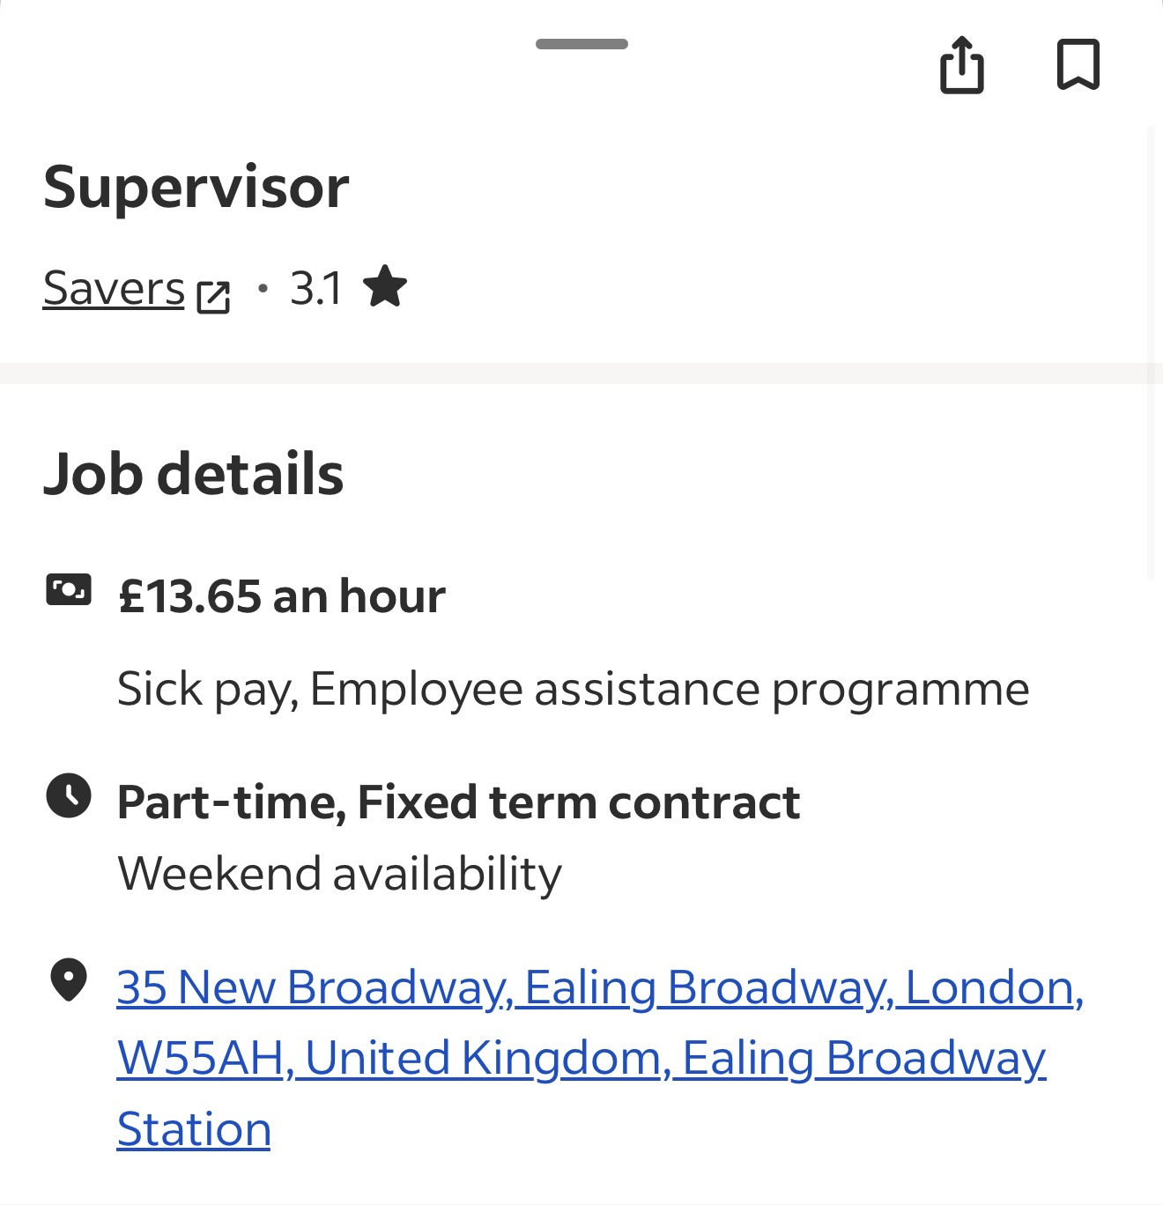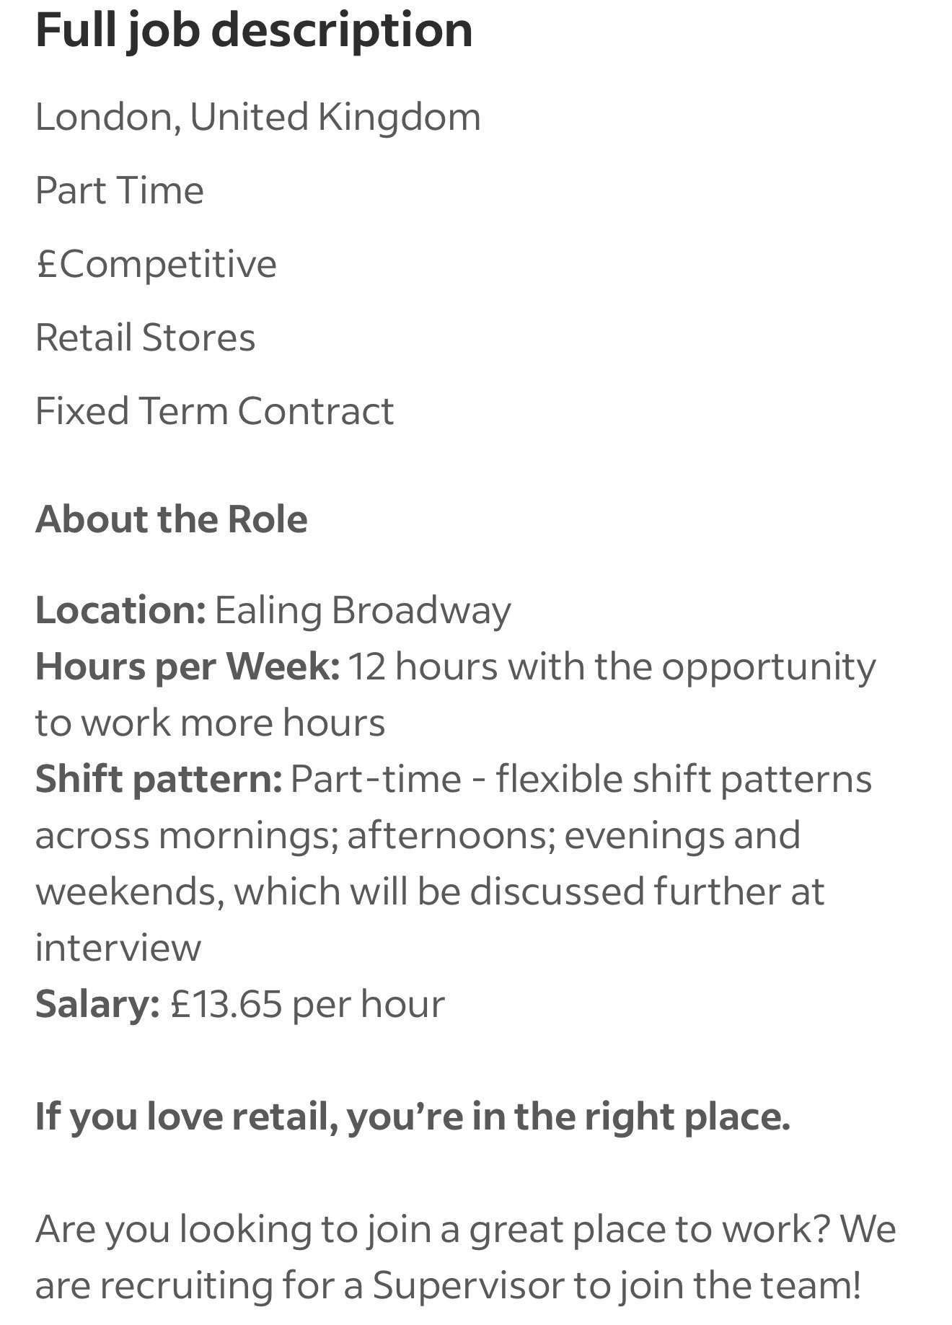
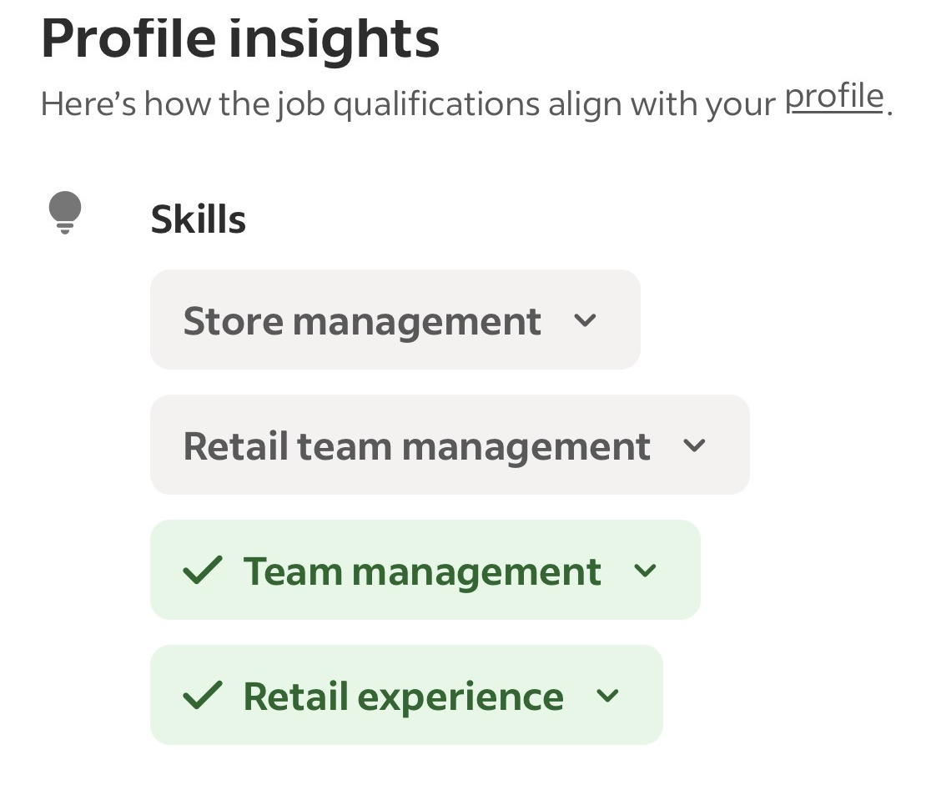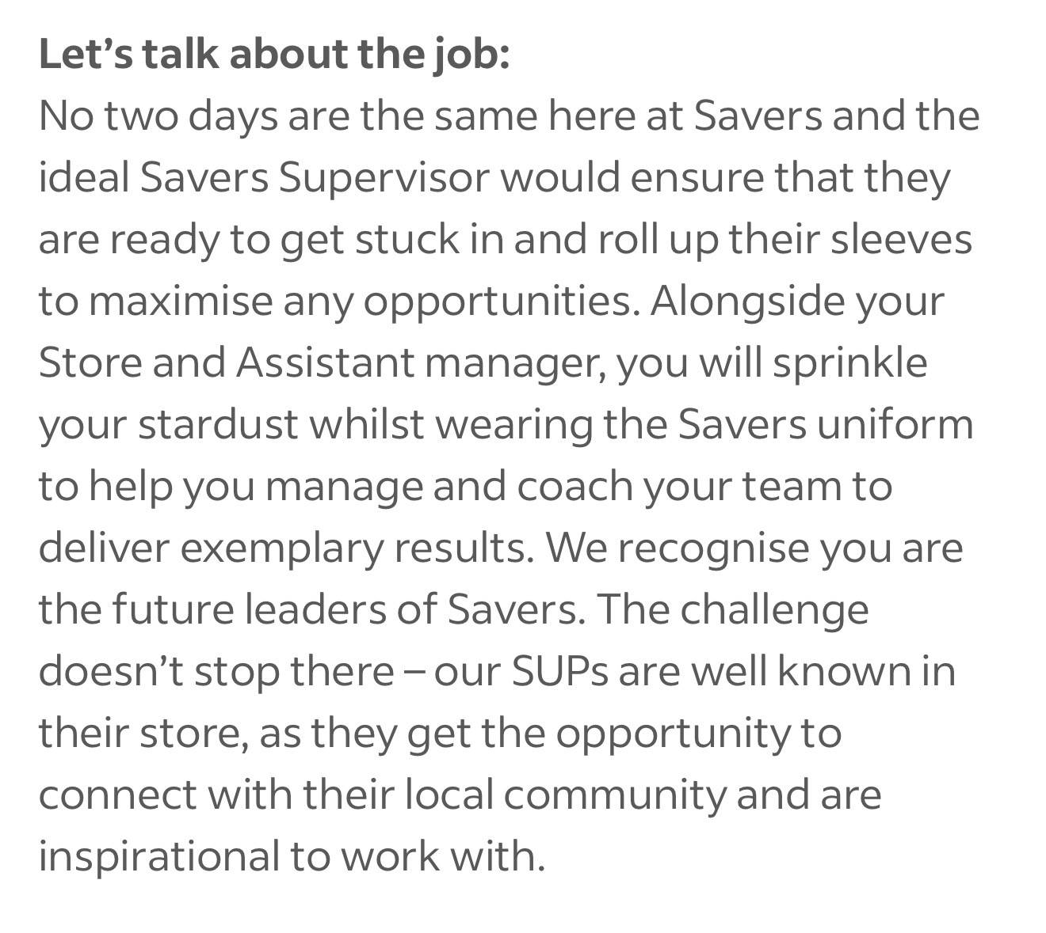
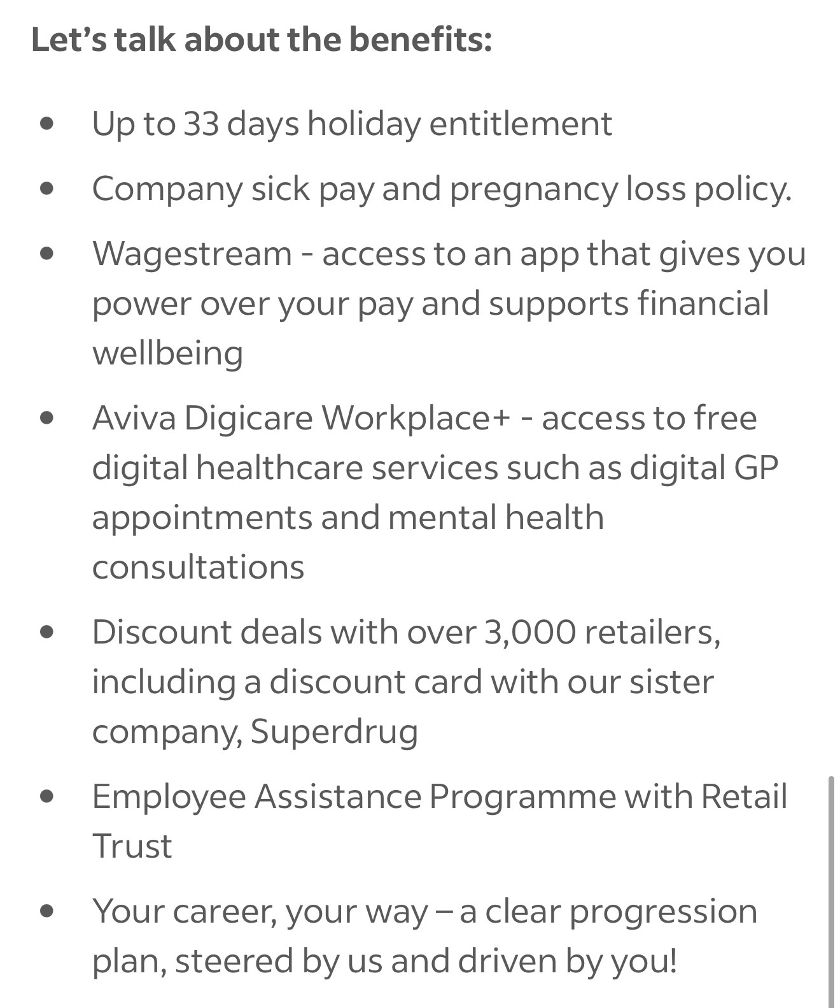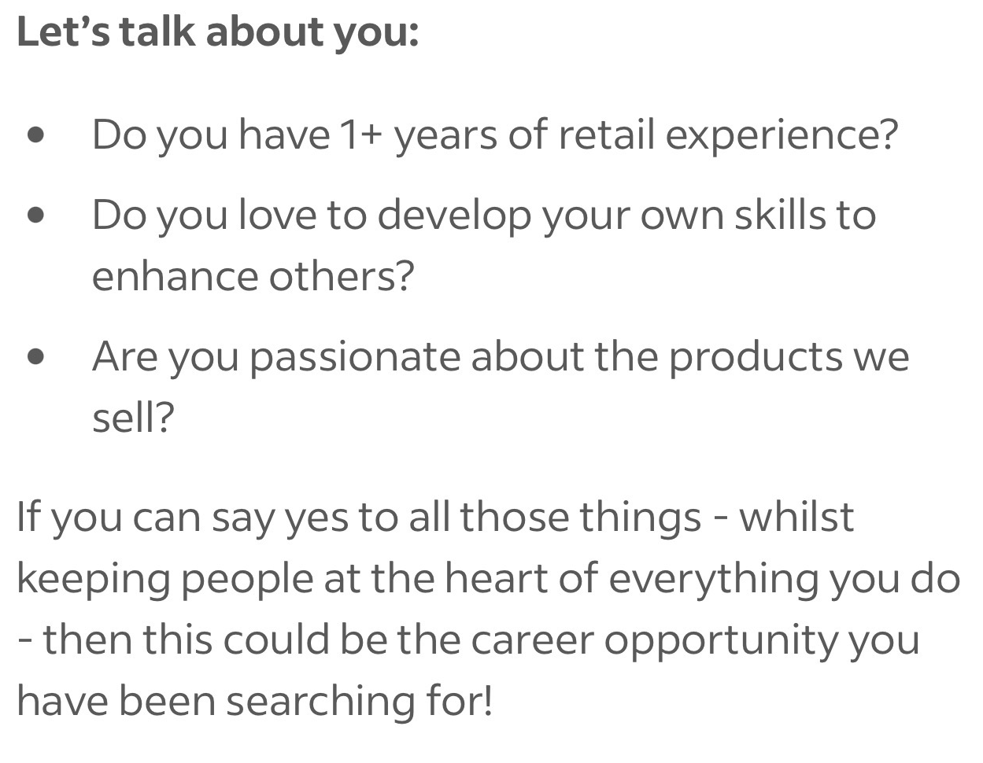
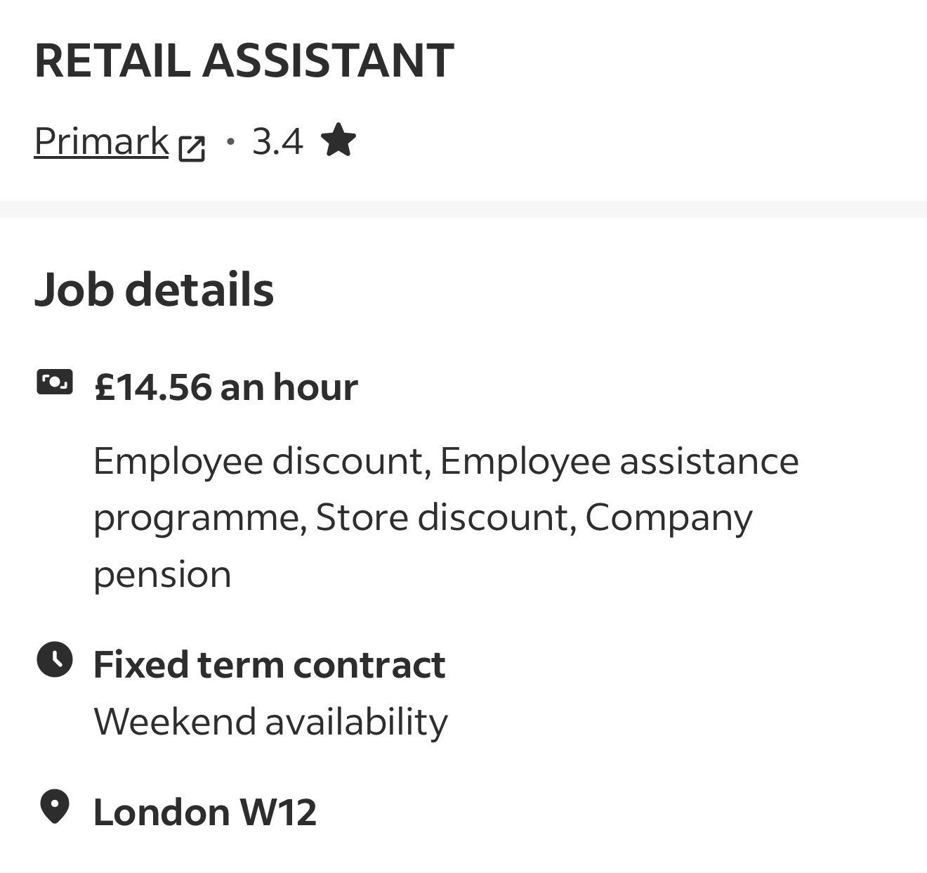
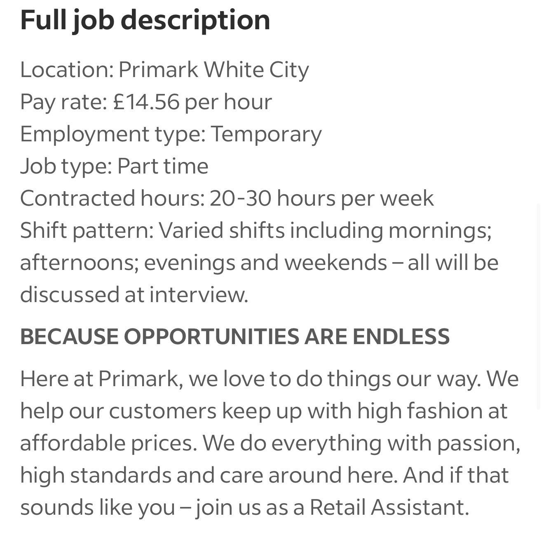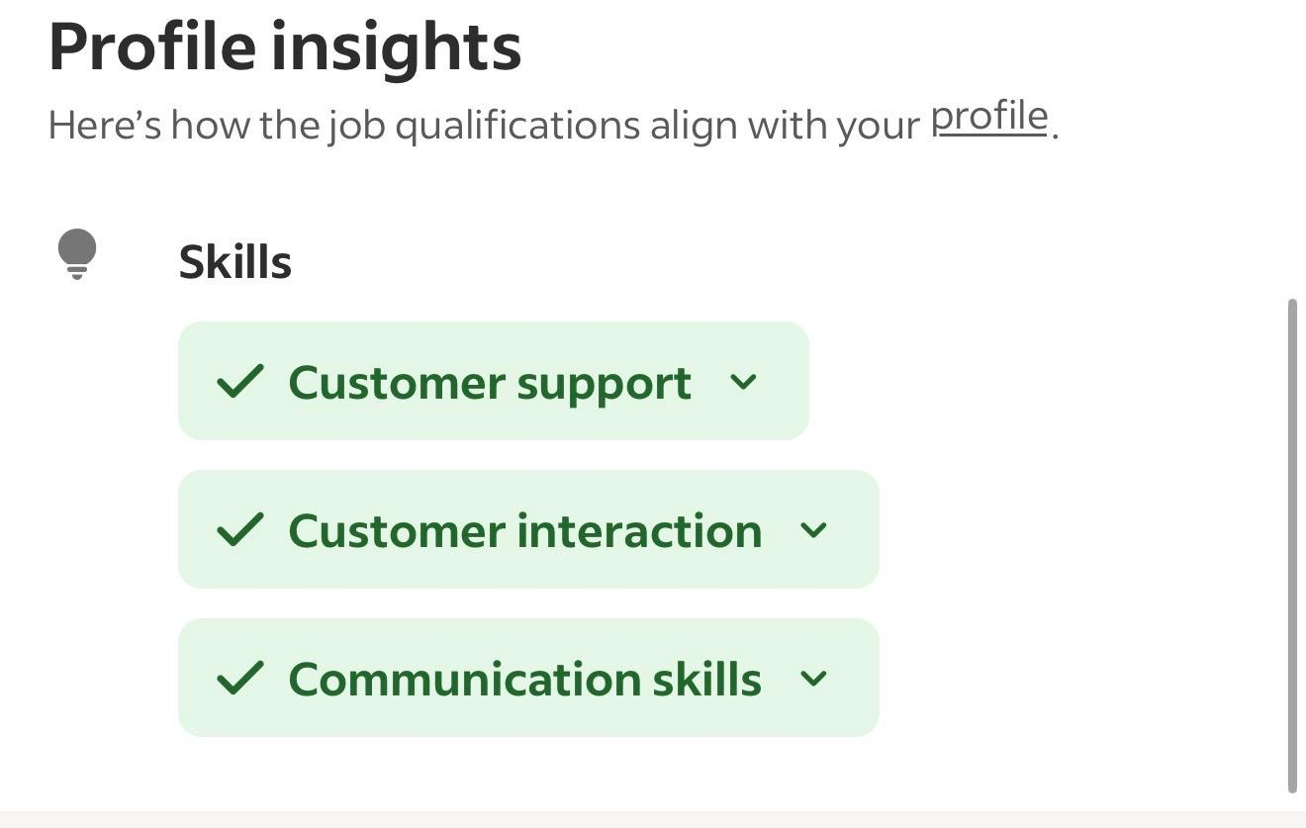
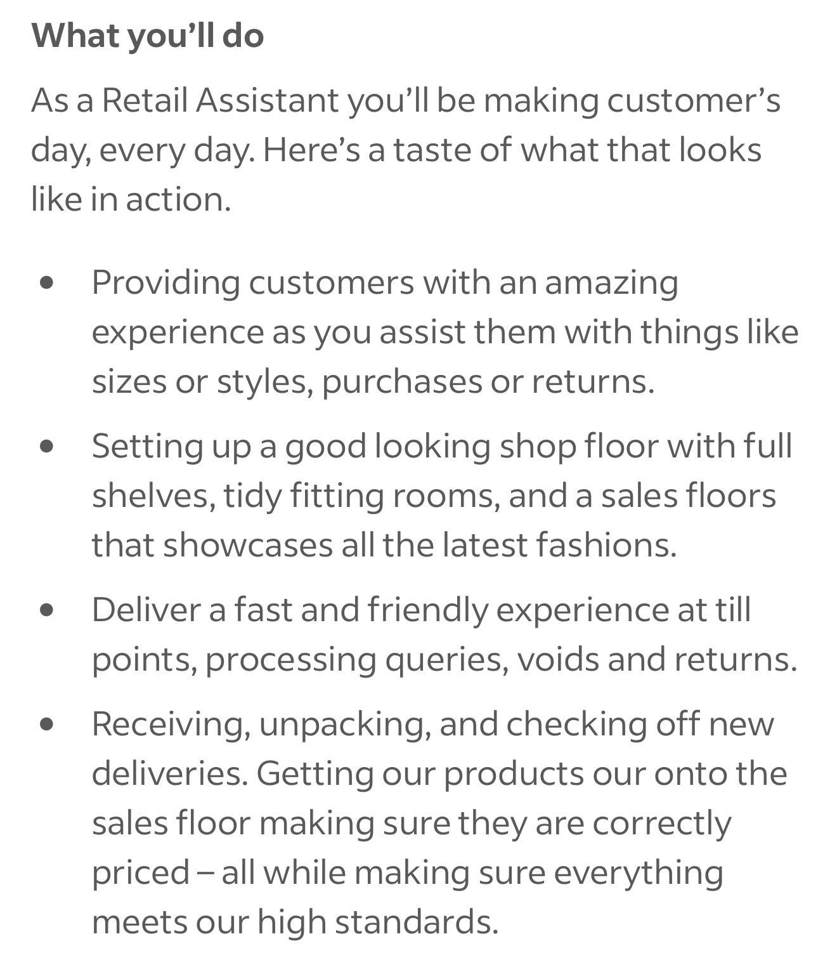

Task 1 – Job Advert Comparison and Key Skills
For my chosen profession, I have selected retail management. I chose this career area because I have previous experience working in customer-facing roles, including restaurants and JD Sports. I am also currently studying Business, and I would like to use both my practical experience and academic knowledge to progress into a position with greater responsibility.
To investigate the skills required in retail, I selected two job advertisements: Supervisor at Savers in Ealing Broadway and Retail Assistant at Primark in White City. The two positions are at different levels, which makes them useful for understanding how skills can develop when progressing from a retail assistant role towards management.
Comparison of Job Advertisements
Area | Savers – Supervisor | Primark – Retail Assistant
Customer service | Required when supporting customers | A major part of the role
Communication | Needed with customers and employees | Needed for customer interaction
Teamwork | Working with and supporting the store team | Working alongside colleagues
Retail knowledge | Previous retail experience required | Understanding customers and the retail environment
Leadership | Important part of the role | Not a main requirement
Team management | Managing and coaching employees | Not required at the same level
Flexibility | Needed within the retail environment | Different shifts, including evenings and weekends
The comparison shows that communication, customer service and teamwork are important in both positions. Primark places greater emphasis on direct customer interaction. A Retail Assistant needs to understand customers' needs, communicate clearly and provide a positive shopping experience. Flexibility is also important because employees may work at different times and on weekends. The Savers position requires these customer-service skills but adds another level of responsibility. A Supervisor works with the Store Manager and Assistant Manager and helps manage and coach the team. Therefore, leadership, staff development and team management become particularly important. This demonstrates a possible career progression within retail: customer-service experience provides a foundation, while leadership and management skills are required for more senior positions.
One skill that I would particularly use in my future career is communication. My previous experience at JD Sports and in restaurants has already given me opportunities to communicate with customers and colleagues. However, communication in management would involve additional responsibilities. For example, I may need to explain tasks to employees, listen to staff concerns, handle customer complaints and communicate expectations clearly. Developing this skill further would help me build positive working relationships and become more effective when leading a team.

Task 2 – Self-Assessment
Understanding my current abilities is important when planning my career because work experience alone does not automatically mean that I am ready for management. I need to consider what I can already offer an employer, what I still need to develop and what factors may support or affect my progression. I have used a SWOT analysis to evaluate my current position.
SWOT Analysis
Strengths | Weaknesses
• Experience working at JD Sports  • Previous restaurant experience  • Customer-service experience  • Communication skills  • Ability to work as part of a team  • Experience of busy working environments  • Currently studying Business | • Limited formal supervisory experience  • Limited experience managing employees  • Need to develop leadership confidence  • Need more experience making management decisions  • Management knowledge is still developing
Opportunities | Threats
• Developing knowledge through my business studies  • Applying for Team Leader/Supervisor positions  • Taking management or leadership training  • Learning from experienced managers  • Building on my previous retail experience | • Competition for supervisory and management positions  • Other applicants may have more leadership experience  • Some management vacancies require previous experience  • Balancing work and study  • Changes within the retail job market

Reflection on My Strengths and Weaknesses
One of my strongest areas is customer-facing experience. Working in restaurants introduced me to an environment where customer expectations can be high and employees need to work efficiently. It helped me understand that good service depends on communication and teamwork. During busy periods, employees need to support one another rather than concentrate only on their individual responsibilities. This experience helped me develop the ability to work with different people and remain focused in a busy environment. My experience at JD Sports gave me a different type of customer-service experience because it was directly within retail. I gained an understanding of how employees interact with customers in a store environment and how teamwork contributes to the overall customer experience. This is particularly relevant to the Primark advertisement, where customer support and interaction are central to the role.
These experiences also helped me recognise the difference between being a good team member and being a good team leader. I have experience working within teams, but I have less experience being responsible for managing them. This is currently one of my main weaknesses when considering a career in retail management.
For example, the Savers Supervisor position involves coaching and supporting employees. A supervisor may also need to make decisions, delegate responsibilities and respond to problems within the team. These are areas in which I need further practical experience. I therefore see leadership development as an important next step rather than assuming that my customer-service experience alone is enough for management.
Opportunities for Development
My current Business studies provide an important opportunity to develop further. Studying Business allows me to look at organisations from a different perspective. Instead of only understanding what happens from an employee's point of view, I can develop a broader understanding of how businesses operate and how decisions are made.
My studies also give me opportunities to develop transferable skills such as organisation, problem-solving, communication and teamwork. These skills are relevant beyond the classroom and can be applied to future employment.
Another opportunity is the experience I already have. My time at JD Sports means that I am not starting my career development without knowledge of retail. I can use this experience as a foundation and gradually seek positions with more responsibility. A Team Leader or Supervisor position would be a realistic next step because it would allow me to develop leadership experience before attempting to move directly into store management.
However, there are also potential threats to my progression. Retail management positions can be competitive, and some candidates may already have several years of supervisory experience.
Employers may prefer these applicants, particularly for management roles. To respond to this challenge, I need to demonstrate that I am actively developing rather than relying only on my previous experience.
Balancing study and employment may also be challenging. Developing a career while completing my education requires organisation and realistic planning. For this reason, I need to set achievable goals rather than trying to progress too quickly.
Evidence of Readiness for Employability and Personal Advancement
There are several areas of my experience that demonstrate my readiness for future employment. Firstly, I have already experienced the expectations of a professional workplace through my restaurant and retail roles. I understand the importance of arriving prepared, completing responsibilities, communicating professionally and contributing to a team.
Secondly, my work at JD Sports provides evidence that I already have experience in the industry in which I would like to progress. Customer interaction, teamwork and communication are skills identified in the two advertisements, and these are skills that I have had opportunities to use in practice.
My restaurant experience provides additional evidence because it exposed me to a different type of customer-service environment. Working with customers in different settings has helped me understand that people have different expectations and that employees need to adapt their communication accordingly.
Finally, studying Business demonstrates my commitment to further development. I am not only depending on the skills I gained through employment; I am continuing to build my knowledge through education. My aim is to combine academic knowledge with practical experience.
Overall, my self-assessment shows that I already have a useful foundation for a career in retail. At the same time, I can clearly identify a gap in my experience: I have worked as part of a team, but my next stage is learning how to lead and support a team. Recognising this gap gives me a clear direction for my personal development.
Task 3 – Employment Goals and Personal Development Plan
My SWOT analysis has helped me identify that my main development need is leadership and supervisory experience. Therefore, my goals focus on moving gradually from my current level of experience towards management.
My short-term goal, within the next six to twelve months, is to improve my leadership and decision-making skills and become ready to apply for a Team Leader or Supervisor position. I do not expect to become a manager immediately. Instead, I want to gain experience taking responsibility for tasks, supporting colleagues and making decisions. This will help me understand the responsibilities that come with leading other employees.
My long-term goal, within approximately two to three years, is to progress towards a Retail Manager or Store Manager role. This goal connects my previous retail experience with my current Business studies. By that stage, I aim to have developed both theoretical knowledge and practical leadership experience.
These goals are important to me because I want to progress beyond customer-facing positions and take greater responsibility within a business. However, progression needs to be realistic and measurable. For this reason, I have created the following Personal Development Plan.
Personal Development Plan (PDP
What I need to improve | What I will do | Resources needed | When | How I will know I improved
Leadership skills | Take more responsibility in group work and learn how to lead a team | Business course materials; group-work opportunities; feedback from tutors and peers | 3–6 months | I will feel more confident leading others and use feedback to identify improvement
Management experience | Apply for a Team Leader or Supervisor role | Primark and Savers careers websites; CV; job-search websites; guidance from experienced managers | 6–12 months | I will gain interviews or practical experience in a supervisory role
Management knowledge | Continue my business studies and learn more about management | University learning materials; lectures; library resources; workplace examples | Ongoing | I will complete my course and apply what I learn in the workplace
Career progression | Gain experience and work towards becoming a Retail Manager | Supervisory experience; mentoring or feedback from managers; leadership training | 2–3 years | I will progress into a management position or be ready to apply for suitable management roles

The plan gives me clear stages rather than one general career ambition. I can review my progress regularly and change my actions if necessary. Completing my business studies while gaining practical leadership experience should help me become better prepared for future management opportunities.

References

Indeed (2026a) Savers Health and Beauty: Supervisor jobs, including Supervisor – Ealing Broadway Station. Available at: https://uk.indeed.com/cmp/Savers-Health-and-Beauty/jobs/q-Supervisor (Accessed: 16 August 2026).

Indeed (2026b) Primark: Retail Assistant jobs in White City. Available at: https://uk.indeed.com/cmp/Primark/jobs/l-White-City (Accessed: 16 August 2026).

National Careers Service (n.d.) Discover your skills and careers. Available at: https://nationalcareers.service.gov.uk/discover-your-skills-and-careers/ (Accessed: 16 August 2026).

Prospects (2026) What skills do employers want? Available at: https://www.prospects.ac.uk/careers-advice/applying-for-jobs/what-skills-do-employers-want/ (Accessed: 16 August 2026).

The Open University (n.d.-a) Move forward with career plans: Developing your career. Available at: https://help.open.ac.uk/developing-your-career/move-forward-with-career-plans (Accessed: 16 August 2026).

The Open University (n.d.-b) Personal development plan (PDP): Developing your career. Available at: https://help.open.ac.uk/index.php/developing-your-career/personal-development-plan (Accessed: 16 August 2026).

The Open University (n.d.-c) Career self-assessment. Available at: https://help.open.ac.uk/career-self-assessment (Accessed: 16 August 2026).

