University of Wales Trinity Saint David.
School of Engineering.

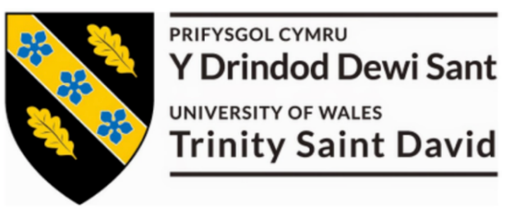
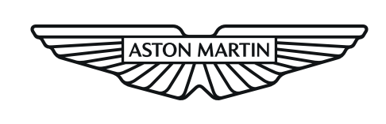

Matthew Dewhurst
2113040
22/02/25

ACMA6007 Plant & Asset Engineering

Evaluating the Effectiveness of Chosen Maintenance Strategies for Dedicated Equipment

BEng Manufacturing Systems

Table of Contents
1 Introduction to Aston Martin Lagonda 4
1.0 Background of Chosen Manufacturing Equipment 4
1.1 Ensuring Maintenance Compliance with Regulatory Standards 6
2 Current Maintenance Practises 7
2.0 Current State of Maintenance 7
2.1 Reasoning for Current Maintenance 9
2.2 Disadvantages of Current Maintenance 10
3 Evaluation of Maintenance Improvements 11
3.0 Potential Maintenance Improvements 11
3.1 Implementation of Maintenance Improvements 13
4 Cost of Maintenance Improvements 14
4.0 Cost of Maintenance Improvement Implementation 14
4.1 Identification of Future Improvements 15
5 Conclusion of Report 16
6 References 17

Table of Figures
Figure 1 – Image of primary production line at Aston Martin’s Gaydon facility 4
Figure 2 – Image of hydraulic lifter for Valhalla powertrain assembly 5
Figure 3 – Diagrams of hydraulic lifter system components 6
Figure 4 – Current maintenance plan which is outlined by manufacturers manual 8
Figure 5 – Bathtub curve graph of failure rates of equipment during lifecycle 10
Figure 6 – Improved planned preventative maintenance plan for hydraulic lifters 12
Figure 7 – Diagram to demonstrate the 8 pillars of TPM 13
Figure 8 – Image of Tan Delta oil conditioning sensor utilised in OCM methods 15

1 Introduction to Aston Martin Lagonda
Aston Martin is a British luxury car manufacturer known for producing high-performance sports cars and grand tourers. Founded in 1913 by Lionel Martin and Robert Bamford, the company has built a reputation for combing elegant design, cutting edge technology and handcrafted quality. The company’s Gaydon facility is located in Gaydon, Warwickshire, which serves as the global headquarters and primary manufacturing plant. Opened in 2003, this site plays a crucial role in production of the brands core sports car models, such as the Vantage, Vanquish, DB12 and the newly introduced Valhalla. To allow manufacture of the new Valhalla model, one of the two production lines within the Gaydon facility has been refurbished with new equipment to aid the assembly of the brands first hybrid hyper car.

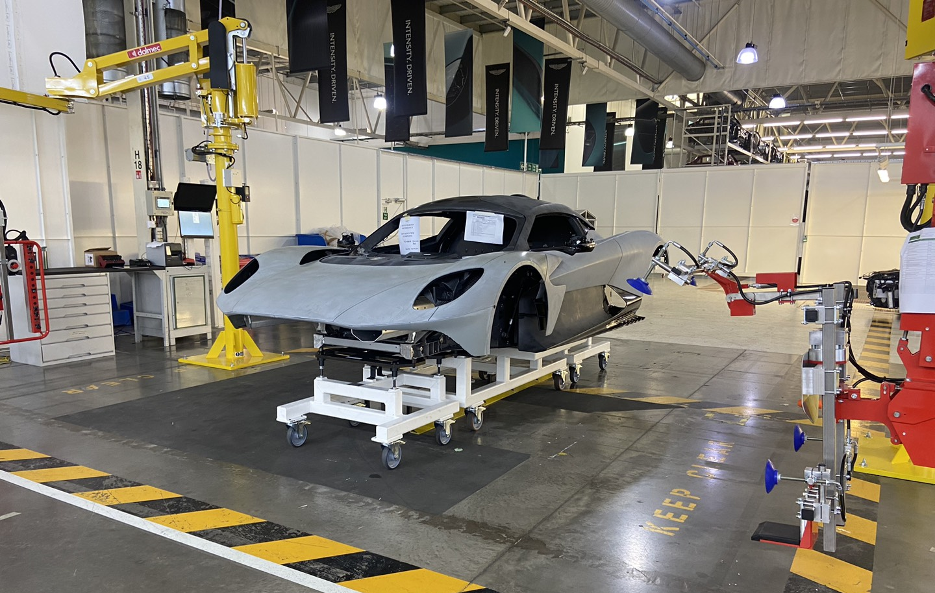
Figure 1 - Image of Valhalla production line at Aston Martin’s Gaydon facility.

1.0 Background of Chosen Manufacturing Equipment
For the assembly of the Valhalla powertrain, hydraulic lifters are utilised to raise and lower each build to ergonomic heights. The hydraulic lifters are an off the shelf solution which has been tailored to the production of the Valhalla powertrain assembly, by allowing the build trolley to be pushed onto the lifter and raised to a suitable height that creates effective build of the powertrain. Without the ability to raise the powertrain assembly with each lifter, it may result in an increased risk of workplace injuries and increased error rates as poor ergonomics can make tasks harder to perform effectively and accurately. Therefore, the hydraulic lifters play a vital role in the production of Valhalla, to ensure safe working and optimum quality.

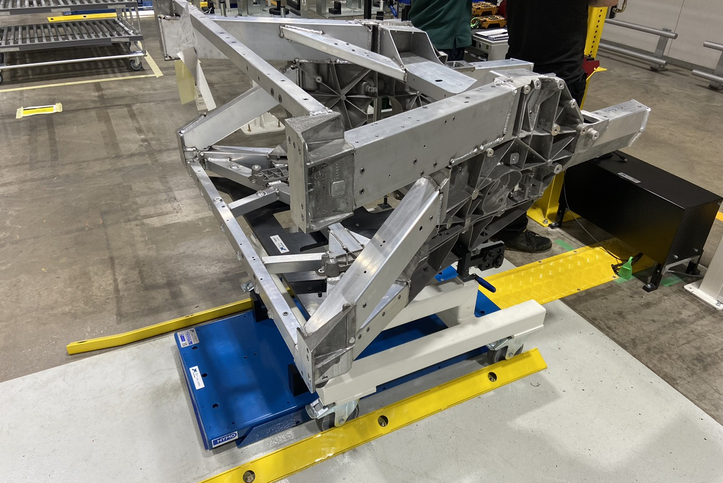
Figure 2 - Image of hydraulic lifter for Valhalla powertrain assembly.

The lifting table operates using a hydraulic system, where pressurised oil moves through cylinders to extend or retract the platform. The hydraulic system is a single acting system which consists of a motor, oil tank, pump, check valve and adjustable flow control valve. When lifting, the pump moves hydraulic oil into the cylinders, while a bypass valve prevents overloads by re-directing oil back into the tank. During lowering, the platform descends under its own weight and returns oil into the tank through the flow control valve. The table is controlled via an ‘UP’ and ‘DOWN’ button located on the control box attached, allowing users to position loads at the desired height. The diagrams to demonstrate the components of the system are shown by Figure 3.
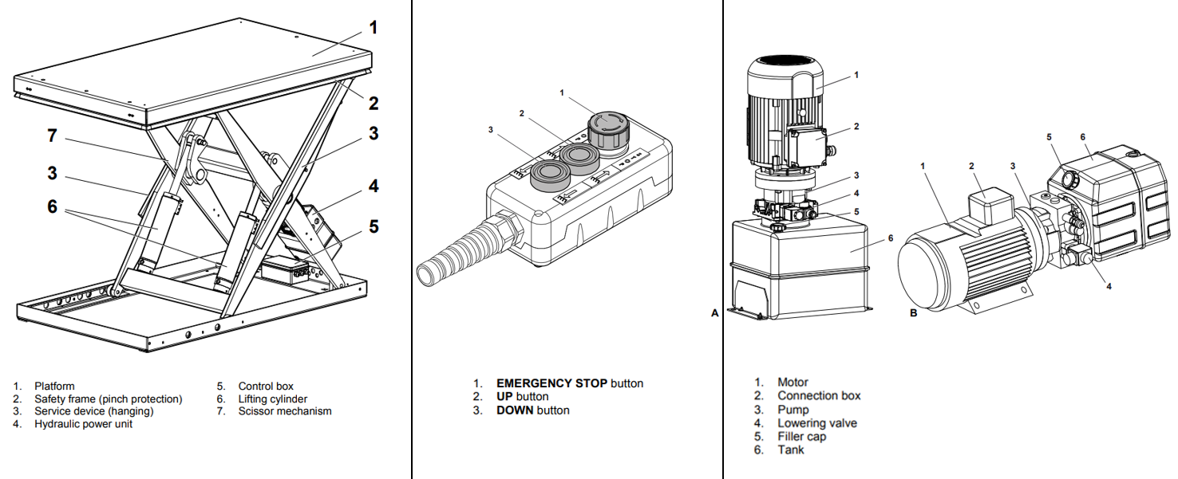
Figure 3 – Diagrams of hydraulic lifter system components. (Hymo. 2022)

1.1 Ensuring Maintenance Compliance with Regulatory Standards
Ensuring maintenance compliance with regulatory standards is essential for maintaining safety, efficiency and legal adherence within an organisation. The main regulation that Aston Martin must consider is the Health and Safety at Work Act of 1974, which requires employers to ensure a safe working environment by primarily maintaining equipment. Under ‘Section 2’ of this act, employers must provide and maintain safe systems of work, equipment and a safe working environment. Other examples of regulations that Aston Martin must consider when assessing maintenance activities is the provision and use of work equipment regulations of 1998, or ‘PUWER’. Regulation 5 of PUWER regulations states that, “Every employer shall ensure that work equipment is maintained in an efficient state, in efficient working order and in good repair.” (Health And Safety Executive, 2014). Another regulation that must be considered is the lifting operations and lifting equipment regulations of 1998, or ‘LOLER’. Regulation 9 of LOLER states that, “ You should either have the lifting equipment thoroughly examined at intervals no longer than those specified in the regulation or shorter intervals if the competent person considers this appropriate, or in accordance with the intervals specified in the examination scheme for the equipment.” (Health And Safety Commission, 1998).
These regulations highlight the importance of adequately maintaining equipment such as the hydraulic lifters, to ensure compliance and create a safe working environment for Aston Martin technicians. Non-compliance with both of these regulations can result in significant legal and financial consequences, including legal actions and operational shutdowns.

2 Current Maintenance Practises
To maintain the hydraulic lifters effectively and allow efficient build of Valhalla powertrain assemblies, there are various maintenance activities which are carried out by maintenance technicians on a regular basis.

2.0 Current State of Maintenance
The current maintenance plan outlined through the manufacturer’s manual, states regular servicing requirements to ensure the safe and efficient operation of the lifting table. Planned preventative maintenance, or ‘PPM’, of the lifting tables should be performed at least once a month, though operating conditions may require more frequent intervals. Figure 4 demonstrates the maintenance guidance within the manufacturer’s manual, this was received by Aston Martin upon the installation of each lifting table and conveyed to the maintenance department for guidance of ‘PPM’ requirements.
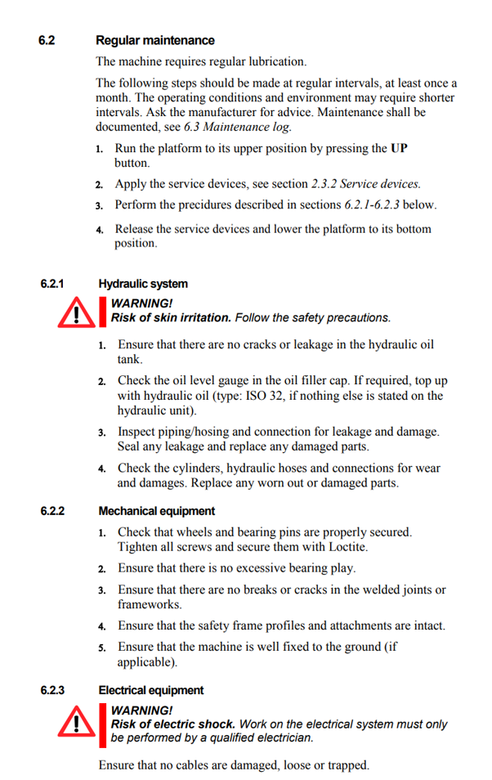
Figure 4 – Current maintenance plan which is outlined by manufacturers manual. (Hymo. 2022)

2.1 Reasoning for Current Maintenance
The reasoning for undertaking this maintenance is to ensure the lifting tables operate safely, efficiently and reliably, while minimising the risk of accidents and failures that can cause downtime. The current maintenance plan is based upon the recommendations of the manufacturer, carrying out all suggested activities as per the user manual. This is a preventative maintenance plan which helps identify and fix potential issues before they lead to unexpected breakdowns or safety concerns. The recommended maintenance intervals are stated within the manual as, “at least once a month” (Hymo, 2022), therefore the maintenance technicians carry out the suggested activities on a monthly basis, as per the expected rate.
Regular equipment maintenance is crucial for compliance with LOLER and PUWER, ensuring workplace safety and reliability. LOLER requires lifting equipment such as the hydraulic lifters to be inspected and maintained to prevent failures and accidents. PUWER mandates that all work equipment remains safe, as poor maintenance can lead to malfunctions, hazards and legal consequences. Failure to maintain equipment, as per the lifter manual requirements can result in serious legal, financial and safety repercussions.
Most actions of the preventative maintenance scheme in place are visual inspections of the lifting tables are their importance is highlighted by a textbook source. “Routine visual inspection of all critical plant systems will augment the other techniques and ensure that potential problems are detected before serious damage can occur.” (R Keith Mobley (2014)). Preventative maintenance can have a significant impact on the ‘bathtub curve’, which is a reliability model used to describe the failure rates of equipment over its lifecycle and demonstrated by Figure 5. Preventative maintenance schemes can particularly impact the infant mortality and the wear-out phase, as it helps identify design flaws through regular inspections and prolong the equipment life cycle by regularly replacing worn parts.
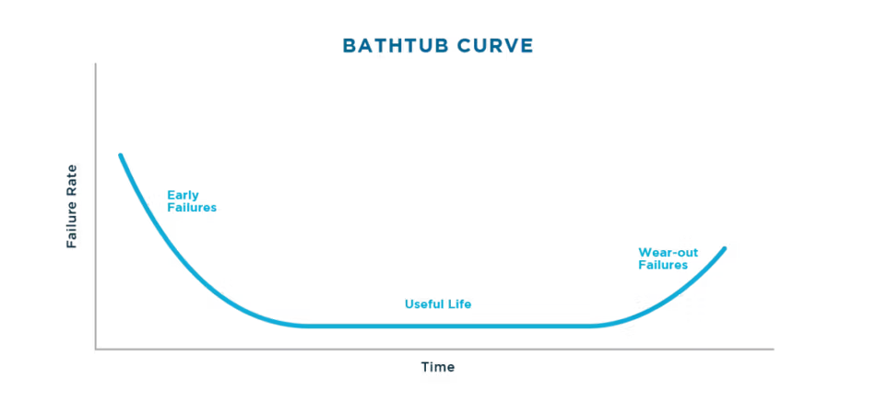
Figure 5 – Bathtub curve graph of failure rates of equipment during lifecycle. (Peters, C. 2022)

2.2 Disadvantages of Current Maintenance
As the lifters are newly installed equipment within the Aston Martin facility, the maintenance scheme is only based upon the advice within the supplier manual. Therefore, there are potential unknown failures and maintenance requirements that may not be known to the supplier or a result of the environment within the Aston Martin facility. The current maintenance only covers basic tasks such as checks and lubrication of certain components, but there are many components of the lifters that are not checked and could be areas of concern. As a result, the use of the current maintenance plan could lead to an increased risk of sudden breakdowns or component failures. This risk could have a negative impact on the Valhalla production, through unplanned downtime to rectify failed components, as well as decreased efficiency due to worn and degraded parts in the system.
Another disadvantage of the current maintenance plan is that preventative maintenance can lead to unnecessary waste, as some tasks such as lubrication and replacement of parts may not be required in the current monthly intervals. Many components of the system can withstand greater wear and cycle times than the maintenance plan states, so lubricant and replacement parts could be wasted if utilised every month as the current plan states. The time taken to carry out the current maintenance plan could also be considered as a waste, as a trained technician will have to take time to perform potentially unnecessary maintenance. This could be considered a waste as the skilled maintenance technicians can be better utilised in other areas of the plant, attending to more complex breakdowns or maintenance activities.

3 Evaluation of Maintenance Improvements
It is evident that the manufacturer’s maintenance plan for the hydraulic lifters has been proven inadequate, leading to unnecessary costs, wasted time and inefficiencies. By refining the current planned preventative maintenance strategy, a more efficient and cost-effective approach can be implemented.

3.0 Potential Maintenance Improvements
A key issue with the manufacturer’s maintenance plan is the inclusion of unnecessary checks and inspections that contribute little to the overall reliability of the equipment. Tasks such as verifying the absence of cracks or leaks in the hydraulic oil tank and ensuring the machine is securely fixed to the ground do not require frequent inspection under normal operating conditions. Eliminating these activities from the maintenance plan allows for a more streamlined approach, enabling skilled technicians to focus on critical tasks that directly impact equipment performance and site operations.
Additionally, a reduction in consumable requirements such as lubricants and sealants will help to minimise waste, lower costs and improve efficiency by preventing excessive use a regular basis. Over lubrication not only increases material expenses but can also attract dirt and debris, leading to unnecessary wear on components. Optimising lubrication use in the preventative maintenance plan based on actual operational needs ensures effective equipment performance while reducing environmental impact and waste disposal challenges.
The necessary revision of the PPM plan, demonstrated by Figure 6, highlights the inadequacy of the manufacturer’s original guidelines and creates a more practical and resource efficient maintenance strategy.
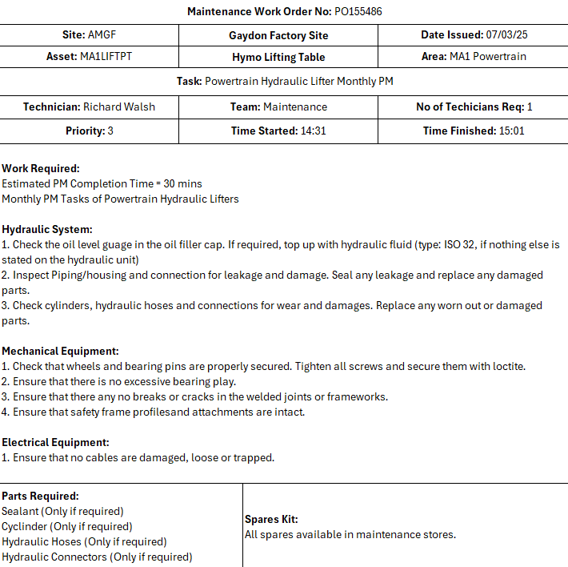
Figure 6 – Improved planned preventative maintenance plan for hydraulic lifters. (AML standard PM document. 2025)

Although some basic inspections have been removed from the planned preventative maintenance scheme, they could still be carried out by production operators due to their simplicity. Therefore, these simple inspections can be carried out by the operators who use them, on a daily basis. This new responsibility of the operators is considered to be autonomous maintenance, which is a key pillar of the Total Productive Maintenance model or ‘TPM’. This empowers operators to take responsibility for routine maintenance tasks, rather than relying solely on maintenance technicians. Initially, this may require a level of training so that operators are able to effectively inspect and maintain the equipment. However, once adequately trained, the company should see an 80 percent reduction in equipment failures or an ‘OEE’ or overall equipment effectiveness rate of over 80 percent (Nakajima, S, 1988).

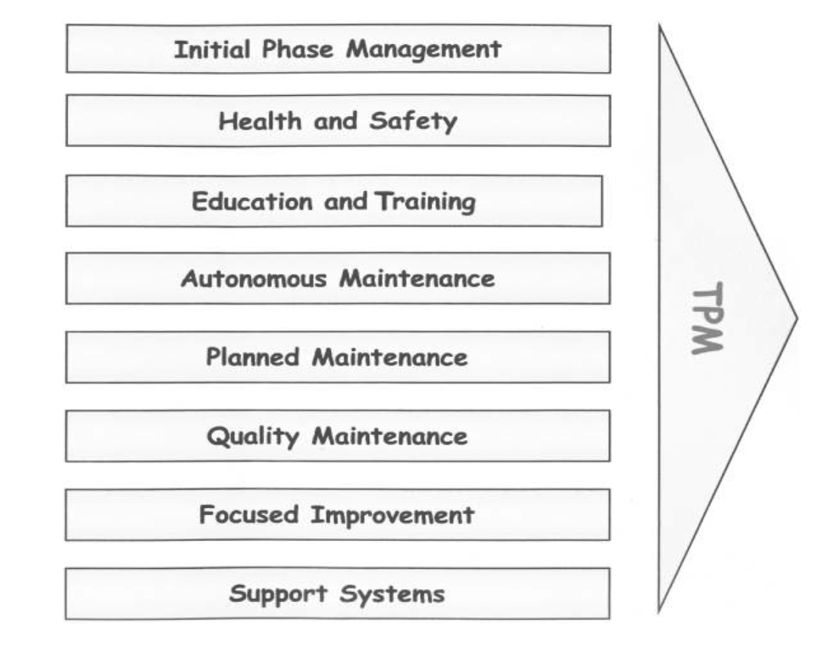
Figure 7 – Diagram to demonstrate the 8 pillars of TPM. (Borris, S. 2011)

3.1 Implementation of Maintenance Improvements
Due to the new responsibility held by production operators to carry out autonomous maintenance, there could be resultant resistance to the changes. The resistance to change must be addressed to ensure successful implementation of the maintenance improvements. This can be best achieved through the use of Lewin’s change management model, which is a three stage framework that guides organisations through change (Crosby, G. 2020). The first stage, unfreeze, involves preparing for change by breaking down old behaviours and increasing awareness, which could include the learning of the lifter components. The change stage introduces new processes, requiring effective communication, support and training such as the maintenance activities that operators are expected to carry out on a daily basis. Finally, the refreeze stage reinforces and stabilises the change, embedding new practises into the organisations culture, ensuring the adoption of the maintenance practises by each technician on the hydraulic lifters.

4 Cost of Maintenance Improvements
Assessing the costs and resources required for the proposed maintenance improvements is essential to determine their feasibility and justify the changes being made to the maintenance plan for each lifting table. While proposed adjustments to the plan are largely cost-free and will lead to significant annual savings, there is an initial investment associated with implementing total productive maintenance measures, such as autonomous maintenance.

4.0 Cost of Maintenance Improvement Implementation
One of the primary cost benefits of the revised PM plan is the reduction in routine maintenance activities, which decreases the need for consumables and maintenance technician labour. This will lead to substantial long term savings, potentially amounting to thousands annually, while also allowing skilled maintenance technicians to focus on higher-priority breakdowns and productivity enhancing tasks. However, implementing autonomous within the TPM framework requires additional resources, particularly in terms of training costs. Training operators to perform daily maintenance tasks and inspections typically ranges from £500 to £1500 per employee (Palmer, D. 2019), depending on the complexity of the equipment and depth of training required.
Beyond the financial investment, the time required for operator training presents another resource challenge. Training sessions will temporarily remove employees from production activities, potentially impacting productivity and output in the short term. Additionally, supervisors and maintenance personnel will need to allocate time to oversee training, monitor implementation and ensure operators are correctly performing maintenance tasks. Despite these initial resource demands, the long term benefits of integrating PM with autonomous maintenance include a reduction in maintenance costs by up to 30% and an increase of production rates by 17% (Nakajima, S, 1988). By creating a balance between preventative maintenance and operator-led autonomous maintenance, Aston Martin can achieve a more cost efficient and effective maintenance strategy that optimises productivity and resource allocation.

4.1 Identification of Future Improvements
To further improve the maintenance methods of the hydraulic lifters, the use of predictive maintenance or ‘PdM’ could be introduced. One effective predictive maintenance method that is suitable for the lifters is Oil Condition Monitoring or ‘OCM’. This technique analyses hydraulic fluid properties such as viscosity, temperature and contamination to detect signs of degradation and wear (R. David Whitby, 2021). Inline oil condition sensors provide real-time data, identifying oil degradation, metal particles and contaminants. Using artificial intelligence algorithms, the system predicts potential failures and alerts maintenance teams, enabling targeted actions like oil replacement or component repairs. OCM and other predictive maintenance techniques can help with early failure detection, extends component lifespan and can reduce maintenance costs by more than 15 percent (R Keith Mobley, 2014).

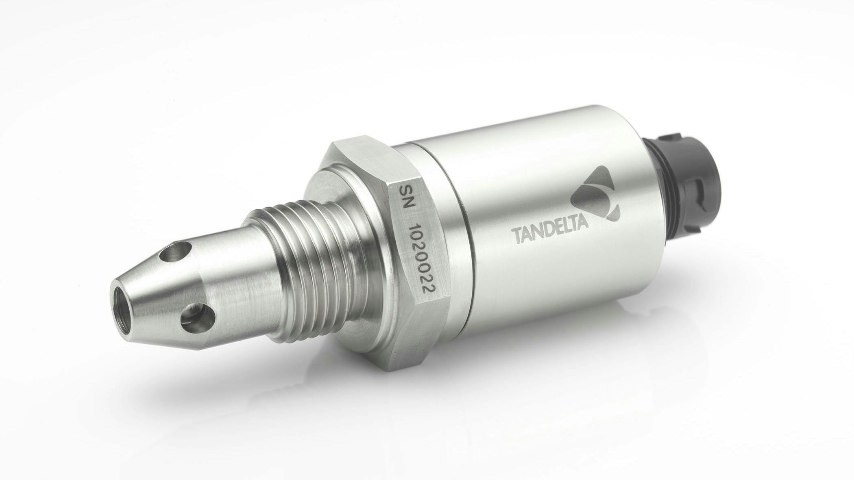
Figure 8 – Image of Tan Delta oil conditioning sensor utilised in OCM methods. (Jensen, S. 2024)

5 Conclusion of Report
In conclusion, optimising maintenance strategies for the hydraulic lifter systems involves a phased approach that adapts to immediate, mid-term and long-term needs. In the short term, the focus should be on making timely adjustments to the preventative maintenance plan so that wasted time and resources can be reduced. This will ultimately help reduce preventative maintenance costs and allow skilled maintenance technicians to focus on other important equipment on site. To aid this reduction, the introduction of autonomous maintenance will cover daily inspections to identify early signs of wear or potential problems. Although it may require an initial investment, Aston Martin will experience significant improvements in equipment reliability and lifespan, to reduce maintenance costs further over the long-term.
The mid-term focus of hydraulic lifter maintenance should allow further improvements to the current preventative maintenance plan. This could be with the use of Reliability-Centred Maintenance or ‘RCM’ which is a systematic approach to maintaining equipment and ensuing reliability by focusing on critical components and identifying failure modes (Moubray, J. 2001). Over the short-term, through autonomous and preventative maintenance, identification of new requirements and failed components will generate new areas of focus to improve the maintenance plan further. This may be a result of components that fail due to not currently being inspected or are not within the scope of the supplier’s recommendations.
In the long-term, Aston Martin should look to invest in predictive maintenance techniques such as OCM. Although the initial investment of a method such as OCM could cost Aston Martin between £5,000 and £25,000, they could benefit from reduced downtime and extended equipment lifespan any identifying potential failures within the lifter hydraulic system before they occur (R Keith Mobley, 2014). Despite the high investment cost, Aston Martin could create a cost saving by preventing production downtime of the Valhalla powertrain assembly area. As Aston Martin has suffered recent financial troubles, making 1000 fewer cars within 2024 (Silva, J. da. 2024), it highlights the importance of sufficient investment in maintenance schemes to provide efficient production in the year 2025.

6 References
Borris, S. (2011). Total productive maintenance. New York Mcgraw Hill Professional.
Crosby, G. (2020). Planned Change Why Kurt Lewin’s Social Science Is Still Best Practice for Business Results, Change Management, and Human Progress. Milton: Productivity Press.

Great Britain. Health And Safety Commission (1998). Safe use of lifting equipment : approved code of practice and guidance. London: H.M.S.O.

Health And Safety Executive (2014). Safe use of work equipment : provision and use of work equipment regulations 1998. Approved code of practice and guidance. Sudbury, Suffolk: Health and Safety Executive, Hse Books.

Hymo. (2022). Manual - Lifting table MX10-8/6. Hymo, a SIGI brand.

Jensen, S. (2024). Sensors Improve Monitoring of Hydraulic Oil Conditions. [online] Powermotiontech.com. Available at: https://www.powermotiontech.com/sensors-software/article/21280705/sensors-improve-monitoring-of-hydraulic-oil-conditions

Moubray, J. (2001). Reliability-centered maintenance. New York: Industrial Press.

Nakajima, S. (1988). Introduction to TPM.

Palmer, D. (2019). Maintenance Planning and Scheduling Handbook, Fourth Edition /. New York, N.Y.: Mcgraw-Hill Education.

Peters, C. (2022). Equipment Longevity & Performance: Why the Bathtub Curve Is Inaccurate. [online] Datacenterfrontier.com. Available at: https://www.datacenterfrontier.com/sponsored/article/11427153/service-express-equipment-longevity-performance-why-the-bathtub-curve-is-inaccurate.

R. David Whitby (2021). Lubricant Analysis and Condition Monitoring. CRC Press.

R Keith Mobley (2014). Maintenance engineering handbook. New York: Mcgraw-Hill Education.

Silva, J. da (2024). Aston Martin issues second profit warning in two months. BBC News. [online] 27 Nov. Available at: https://www.bbc.co.uk/news/articles/c98dze04eyyo#comments.

