

STUDENT NAME: VACKAAR HUSSAIN
STUDENT ID: 2209946
MODULE: MASTERS PROJECT
MODULE CODE: ACFA7003
SUPERVISOR: NOAH ELMITWALLY

“A Scalable Multi-Modal Artificial Intelligence Framework for Harm Detection in Children Using Dataset Fusion, Temporal Tracking, and Escalation Mechanisms”

DECLARATION

I, VACKAAR HUSSAIN declare that I am the sole author of this Project; that all references cited have been consulted; that I have conducted all work of which this is a record, and that the finished work lies within the prescribed word limits.

This work has not previously been accepted as part of any other degree submission.

Signed : Vackaar Hussain

Date : 20th August 2026

FORM OF CONSENT

I, VACKAAR HUSSAIN hereby consent that my Project, submitted in candidature for the M.Sc. Applied Computing degree, if successful, may be made available for inter-library loan or photocopying (subject to the law of copyright), and that the title and abstract may be made available to outside organisations.

Signed : Vackaar Hussain

Date : 20th August 2026

Abstract
The rapid expansion of digital communication and online interaction has increased the complexity of identifying harmful behaviour directed towards children. Existing artificial intelligence approaches frequently address individual modalities in isolation, limiting their ability to capture the multifaceted and evolving nature of online harm. This project addresses this limitation by proposing and experimentally evaluating a scalable multi-modal artificial intelligence framework for child harm detection, integrating textual, visual and behavioural evidence within a unified risk assessment architecture.

The proposed framework combines three complementary detection modules. A transformer-based natural language processing approach is employed to identify harmful content within textual communication, while deep learning-based computer vision models analyse visual content for potentially unsafe material. A behavioural detection module further examines conversational patterns associated with harmful or predatory behaviour. Rather than treating these modalities as independent classification tasks, their outputs are transformed into comparable risk scores and integrated through a late-fusion mechanism, enabling the framework to produce a consolidated assessment of potential harm.

A further contribution of the framework is the integration of temporal risk tracking and escalation mechanisms. Recognising that harmful behaviour may not be adequately represented by a single isolated observation, the framework tracks risk across successive observations and incorporates escalation categories ranging from LOW and MEDIUM to HIGH and CRITICAL. This provides a mechanism through which persistent or increasing risk can be distinguished from isolated signals, supporting more context-aware prioritisation of potentially serious incidents.

The framework was developed and evaluated experimentally using established datasets representing textual toxicity, visual safety and behavioural risk. Multiple deep learning and transformer architectures were investigated, with performance assessed using established classification and diagnostic measures, including accuracy, precision, recall, F1-score, ROC-AUC, confusion matrices and risk-oriented analysis. Explainability techniques were additionally incorporated to improve transparency and support interpretation of model decisions.

Experimental results demonstrate the feasibility of integrating heterogeneous AI models into a unified multimodal risk assessment pipeline. The resulting architecture provides a more comprehensive representation of potential harm than reliance on a single modality, while temporal tracking enables the system to account for the persistence and progression of risk. Importantly, the framework is designed as a decision-support architecture rather than an autonomous safeguarding authority, recognising the ethical, legal and practical requirements associated with AI systems operating in sensitive child-safety contexts.

Overall, the project demonstrates how multimodal artificial intelligence, risk-score fusion, temporal analysis and escalation logic can be combined into a scalable framework for identifying and prioritising potential online harm. The research contributes an integrated approach that moves beyond isolated content classification towards contextual, cumulative and risk-oriented harm assessment, providing a foundation for future research into explainable, human-supervised AI systems for child online safety.

Table of Contents

Chapter 1 Introduction 1
1.1 Introduction 2
1.2 Problem Statement 2
1.3 Research Aim, Objectives and Research Questions 2
Chapter 2 Literature Review 1
2.1 Introduction 2
2.2 Artificial Intelligence Harm Detection 2
2.3 Multi-Modal Artificial Intelligence Systems 2
2.4 Dataset Fusion and Data Integration 2
2.5 Temporal Tracking and Behavioural Analysis 2
2.6 Escalation Systems and Risk Prioritization 2
2.7 Explainable Artificial Intelligence 2
2.8 Ethical, Legal and Privacy Considerations 2
2.9 Scalability Challenges in AI Systems 2
2.10 Research Gaps 2
Chapter 3 Research Methodology 1
3.1 Introduction 2
3.2 Research Philosophy and Approach 2
3.3 Research Design 2
3.4 Dataset Selection and Preparation 2
3.5 Model Development 2
3.6 Dataset Fusion Strategy 2
3.7 Temporal Tracking and Escalation Mechanism 2
3.8 Model Evaluation 2
3.9 Explainability and Model Interpretability 2
3.10 Ethical, Legal and Privacy Considerations 2
3.11 Research Limitations 2
3.12 Chapter Summary 2
Chapter 4 Research Methodology 1
4.1 Introduction 2
4.2 Development Environment 2
4.3 Text Model Implementation 2
4.4 Image Model Implementation 2
4.5 Behavioural Model Implementation 2
4.6 Dataset Fusion Implementation 2
4.7 Temporal Tracking Implementation 2
4.8 Escalation Mechanisms Implementation 2
4.9 Framework Integration 2
4.10 Chapter Summary 2
Chapter 5 Results and Evaluation 1
5.1 Introduction 2
5.2 Module 1 Text Based Risk Detection 2
5.3 Module 2 Image Based Risk Detection 2
5.4 Module 3 Behavioural Risk Detection and Explainability 2
5.4.1 Behavioural Model Explainability 2
5.5 Module 4 Multimodal Risk Fusion 2
5.6 Module 5 Temporal Risk Tracking and Escalation 2
5.7 Overall Evaluation of the Framework 2
Chapter 6 Discussion 1
6.1 Introduction 2
6.2 Overall Framework Performance 2
6.3 Comparative Evaluation of the Three Modalities 2
6.4 Multimodal Fusion Evaluation 2
6.5 Temporal Risk Tracking and Escalation Evaluation 2
6,6 Critical Evaluation of the Framework 2
6,7 Comparison with Existing Research 2
6,8 Project Contribution and Originality 2
6,9 Ethical, Practical and Deployment Considerations 2
6,10 Chapter Summary 2
Chapter 7 Conclusion and Future Work 1
7.1 Introduction 2
7.2 Achievement of Aim and Objectives 2
7.3 Overall Conclusions 2
7.4 Project Contributions 2
7.5 Limitations 2
7.6 Recommendations for Future Work 2
7.4 Final Conclusion 2
Chapter 8 References 1

List of Figures

4.1. Overall architecture of the proposed multi-modal child harm detection framework 2
5.1 Comparative performance of RoBERTa and DeBERTa-v3 across key evaluation metrics 2
5.2 RoBERTa confusion matrix showing classification performance across safe and unsafe text classes 2
5.3 ROC curve comparison of RoBERTa and DeBERTa-v3 for text classification performance 2
5.4 Precision–recall curve comparison of RoBERTa and DeBERTa-v3 for text classification performance 2
5.5 Comparative performance of ResNet50 and ViT across key evaluation metrics 2
5.6 Confusion matrix showing the classification performance of the ResNet50 image classification model 2
5.7. Confusion matrix showing the classification performance of the ViT image classification model 2
5.8. Threshold analysis of the ResNet50 model showing performance variation across classification thresholds 2
5.9. Comparative performance of RoBERTa and DeBERTa-v3 across key evaluation metrics 2
5.10. Distribution of predicted behavioural risk levels generated by the behavioural detection model 2
5.11. SHAP-based token importance for the RoBERTa text classification model 2
5.12. Confusion matrix showing the classification performance of the RoBERTa behavioural model 2
5.13. Mean risk scores across the text, image, and behavioural modalities 2
5.14. Distribution of final multimodal risk levels produced by the fusion framework 2
5.15. Distribution of final multimodal risk scores. 2
5.16. Distribution of escalation states generated by the temporal risk escalation mechanism 2

List of Tables

2.1. Summary of key literature and research contributions relevant to multi-modal child harm detection. 1
3.1. Summary of the datasets, modalities, simple characteristics, and classification tasks used across the three detection modules 1
4.1 Risk escalation levels and corresponding risk thresholds and response states 2
5.13 Correlation between risk scores across the text, image, and behavioural modalities 2
5.14 Final multimodal fusion risk scores and corresponding risk classifications 2

Chapter 1 — Introduction

1.1 Background
The rapid development of artificial intelligence (AI) has created opportunities to analyse increasingly complex forms of digital information. Machine-learning and deep-learning techniques can process text, images and behavioural information at a scale that would be difficult to achieve through manual analysis alone. These capabilities have relevance to safeguarding, where potentially harmful interactions may be communicated through different modalities and may develop over time.

Traditional approaches that analyse individual information sources independently can provide useful evidence but may overlook relationships between different forms of information. For example, potentially concerning language may become more meaningful when considered alongside visual or behavioural indicators. Similarly, an isolated observation may provide limited evidence, whereas repeated patterns across time may indicate a more persistent risk.

This project therefore investigates a multimodal AI framework for child-harm risk assessment, integrating text, image and behavioural analysis. Rather than attempting to make an autonomous determination of whether harm has occurred, the proposed approach is designed to generate and combine risk signals that can support prioritisation and subsequent human assessment.

The project addresses a complex problem because the underlying data are heterogeneous, context-dependent and subject to uncertainty. Consequently, the investigation considers not only individual model performance but also the challenges associated with combining different predictions, monitoring changes in risk and determining appropriate escalation.

1.2 Problem Definition
A central limitation of single-modality approaches is their restricted view of potentially harmful activity. Text-based systems may identify harmful language but cannot directly analyse visual information, while image-based approaches cannot independently capture linguistic or behavioural context. Behavioural analysis can provide additional contextual information but may also be affected by ambiguity, incomplete observations and dataset limitations.

A further challenge is that potential harm cannot necessarily be represented as a single static classification. Risk may change as additional observations become available. A system that considers only individual predictions may therefore fail to distinguish between an isolated high-risk signal and a pattern of repeated or increasing concern.

The problem addressed by this research is consequently the development of a framework capable of combining heterogeneous risk evidence and incorporating temporal changes into a structured escalation process.

This creates several technical challenges. The outputs of different models must be transformed into comparable risk representations; the resulting information must be fused without allowing unreliable predictions to dominate; and temporal changes must be interpreted without treating automated scores as definitive evidence of harm.

The project therefore investigates whether established AI techniques can be systematically integrated to provide a more contextual approach to risk prioritisation.

1.3 Aim
The aim of this project is:

> To develop and evaluate a scalable multimodal artificial intelligence framework for child-harm risk assessment using text, image and behavioural analysis, multimodal risk fusion, temporal tracking and escalation mechanisms.

The aim deliberately encompasses both development and evaluation. The project is not limited to constructing an AI architecture; it also evaluates its feasibility, limitations and potential contribution within the defined experimental conditions.

The resulting framework is positioned as a proof-of-concept decision-support architecture. This distinction is important because successful experimental integration does not establish that an AI system can independently determine safeguarding outcomes in real-world environments.

1.4 Objectives
To achieve the project aim, the following objectives were established:

1. Develop a text-based harm-risk detection component capable of generating risk information from textual data using transformer-based natural language processing.

2. Develop an image-based classification component capable of identifying relevant visual risk information using deep-learning computer-vision models.

3. Develop a behavioural analysis component capable of generating risk information from interaction and behavioural patterns.

4. Integrate the three modalities using multimodal late fusion to produce a unified risk representation.

5. Implement a temporal risk-tracking mechanism to monitor changes in risk across observations.

6. Develop an escalation mechanism capable of translating risk patterns into LOW, MEDIUM, HIGH and CRITICAL categories.

7. Evaluate the framework critically using appropriate performance measures, comparative analysis, explainability techniques and examination of methodological limitations.

8. Assess the practical, ethical and deployment implications of using multimodal AI for safeguarding-oriented risk prioritisation.

Together, these objectives establish a progression from individual modality development to an integrated framework and its critical evaluation.

1.5 Research Questions
The investigation is guided by the following research questions:

RQ1: To what extent can text, image and behavioural AI models generate useful risk signals for child-harm assessment?

RQ2: How effectively can heterogeneous modality outputs be combined through multimodal risk fusion?

RQ3: Can temporal tracking and escalation mechanisms provide additional contextual information by identifying changes or persistence in risk?

RQ4: What are the principal technical, methodological, ethical and practical limitations of the proposed multimodal framework?

RQ5: To what extent does the integrated framework provide a viable foundation for AI-assisted risk prioritisation and safeguarding decision support?

These questions ensure that the project evaluates not only whether individual models can produce predictions, but whether their integration provides a meaningful and defensible framework.

1.6 Research Scope
The scope of the investigation is deliberately defined to ensure that the findings remain proportionate to the available data and experimental resources.

The project considers three modalities: text, images and behaviour. Each modality is developed as an independent analytical component before its output is incorporated into the wider framework. The project then applies late fusion to generate a consolidated risk score, followed by temporal tracking and escalation.

The investigation focuses on experimental feasibility rather than production deployment. The datasets used provide controlled environments for developing and evaluating the framework, but they do not constitute a single, fully representative real-world child-safeguarding dataset. Consequently, the findings should not be interpreted as evidence of operational effectiveness across all populations or safeguarding contexts.

The project also does not attempt to replace safeguarding professionals. Its intended role is to provide structured risk information that could potentially assist human prioritisation and investigation.

1.7 Significance of the Project
The significance of the project lies in its attempt to address the limitations of isolated AI classification by combining heterogeneous evidence within a single architecture. The integration of text, visual and behavioural information provides broader contextual coverage than a single-modality approach, while temporal tracking introduces consideration of how risk may change rather than treating every observation independently.

The project also demonstrates the practical application and integration of established AI techniques, including transformer-based natural language processing, computer vision, behavioural classification, explainability, multimodal fusion and temporal risk analysis.

Its originality therefore lies primarily in the integration and application of established techniques within a unified safeguarding-oriented framework, rather than in claiming the development of a fundamentally new machine-learning algorithm.

This distinction is important at postgraduate level because the contribution should be evaluated against the evidence produced by the investigation. The project seeks to demonstrate a technically coherent and experimentally evaluated architecture while explicitly recognising the limitations that would need to be addressed before any operational implementation.
1.8 Chapter Structure
The remainder of this report is structured as follows.

Chapter 2 reviews relevant literature concerning AI-based harm detection, multimodal learning, natural language processing, computer vision, behavioural analysis, temporal modelling, explainability and safeguarding applications. The chapter identifies gaps and establishes the research context for the proposed framework.

Chapter 3 presents the methodology, including the research philosophy, research design, dataset selection, model development, fusion strategy, temporal tracking, escalation approach, evaluation methods, explainability and ethical considerations.

Chapter 4 describes the implementation of the proposed framework, including the development of the individual modalities and their integration into the multimodal architecture.

Chapter 5 presents the experimental results and evaluates the outputs generated by the individual models and integrated framework.

Chapter 6 provides the critical evaluation of the findings, considering multimodal performance, fusion, temporal tracking, escalation, limitations, originality, ethical implications and potential deployment.

Chapter 7 concludes the project by evaluating the achievement of its aim and objectives, identifying its contributions and limitations, and presenting recommendations for future research.

Chapter 2 Literature Review

2.1 Introduction
This chapter critically reviews research relating to artificial intelligence (AI)-based harm detection and scalable multimodal AI systems. It evaluates established approaches, their strengths and limitations, and the research gaps motivating the proposed framework.

The review examines AI-based harm detection, multimodal learning, dataset fusion, temporal and behavioural analysis, risk escalation, explainable AI, ethical considerations and scalability. Rather than treating these areas independently, the chapter synthesises their relationships to establish the theoretical and technical rationale for integrating multiple sources of evidence.

The review identifies three recurring limitations within existing approaches: dependence on individual modalities, limited temporal understanding and insufficient integration between prediction, explainability and risk prioritisation. These gaps provide the basis for the proposed framework, which combines textual, visual and behavioural risk signals with temporal tracking and escalation mechanisms.

This is stronger than the current version despite being shorter, because it tells the examiner immediately what the chapter is going to establish.

2.2 Artificial Intelligence for Harm Detection
AI has become increasingly important for detecting harmful content and behaviour across digital environments. Earlier approaches commonly relied on rules, keywords and manually defined indicators. Although effective for explicit content, such methods are less suited to contextual, indirect or deliberately disguised behaviour. Machine-learning and deep-learning approaches have therefore increasingly been adopted to learn patterns from larger and more complex datasets.

Natural language processing (NLP) is particularly relevant to harm detection. Transformer architectures such as BERT, RoBERTa and DeBERTa model contextual relationships within language, offering advantages over keyword-based approaches for detecting toxic communication and harmful interactions. However, performance remains dependent on training data and models may struggle with evolving language, sarcasm, implicit threats and previously unseen patterns. Moreover, predictive accuracy alone does not establish safeguarding effectiveness because false negatives may allow harmful content to remain undetected.

Computer vision provides a complementary capability by analysing visual information. CNN architectures such as ResNet can learn discriminative visual features, while Vision Transformers (ViTs) use attention mechanisms to model relationships across image regions. Nevertheless, visual classification can remain context-dependent: correctly identifying objects or visual patterns does not necessarily establish their significance within a wider interaction. This illustrates a fundamental limitation of analysing harm through a single modality.
Multimodal AI offers a potential solution by combining complementary evidence from text, images and behaviour. However, much existing research remains centred on improving individual classification performance rather than developing integrated systems that combine predictions, account for temporal changes and translate outputs into interpretable risk priorities.

This distinction is particularly important in safeguarding. Complex models may achieve strong predictive performance while providing limited insight into how their decisions are produced. Consequently, explainability, accountability and human oversight must be considered alongside predictive performance.
Overall, existing research establishes the value of AI for harm detection but also reveals limitations in modality coverage, contextual understanding and decision support. These limitations motivate investigation of an integrated multimodal approach.

2.3 Multimodal Artificial Intelligence Systems
Multimodal AI extends conventional single-modality systems by integrating information from different sources. This is particularly relevant to harm detection because potentially harmful behaviour may manifest through language, visual content and interaction patterns simultaneously. Combining complementary evidence can therefore provide broader contextual coverage than relying on an individual model.

However, multimodal integration introduces a fundamental design challenge: text, images and behavioural sequences have different structures and statistical characteristics. Three broad fusion strategies are commonly considered. Early fusion combines raw data or features before model training and can learn cross-modal relationships, but generally requires sufficiently aligned datasets. Intermediate fusion combines learned representations and can model more complex interactions, although increased architectural complexity may reduce interpretability. Late fusion independently processes each modality before combining model outputs, providing greater modularity and allowing individual components to be developed or replaced independently. Its limitation is that deeper cross-modal relationships may not be captured.

For this project, the trade-off between integration, scalability and interpretability is particularly important. In sensitive safeguarding contexts, a highly complex architecture is not automatically preferable if its outputs become difficult to interpret or validate. Late fusion therefore provides a practical basis for integrating heterogeneous models while retaining visibility of individual modality contributions.

A further limitation of many multimodal systems is their predominantly static treatment of information. Risk may develop through repeated interactions rather than a single observation, meaning that multimodal classification alone may not capture behavioural progression. Temporal analysis is therefore complementary to multimodal fusion rather than an alternative to it.

Multimodal systems also increase the challenge of explaining final decisions because multiple predictive components contribute to the outcome. This reinforces the need to consider explainability and human oversight as integral design requirements rather than post-processing additions.
Overall, multimodal AI provides a strong foundation for combining heterogeneous evidence, but effective implementation requires careful consideration of fusion strategy, temporal context, scalability and interpretability.

2.4 Dataset Fusion and Data Integration
Dataset fusion is a critical consideration when developing multimodal AI systems because the modalities used in this project originate from heterogeneous sources. Differences in structure, annotation, class distribution and data quality can influence model performance and complicate direct integration.

Early, intermediate and late fusion each present different trade-offs. Early fusion requires aligned multimodal observations and may therefore be unsuitable where equivalent text, image and behavioural records are unavailable. Intermediate fusion can capture richer feature interactions but introduces greater architectural complexity. Late fusion avoids the requirement for complete alignment by allowing modality-specific models to generate independent predictions before combining them at the decision level.

Late fusion consequently provides advantages in modularity, scalability and interpretability. Individual models can be trained using modality-specific datasets, and components can subsequently be improved or replaced without redesigning the entire architecture. However, this flexibility comes at the cost of potentially losing deeper relationships between modalities.

Data quality represents a further concern. Incomplete, imbalanced or outdated datasets can produce biased or poorly calibrated predictions. Combining datasets from different sources can amplify these differences rather than eliminate them. This is particularly significant in harm detection because behaviours, language and visual content can evolve over time.

Fusion also creates ethical considerations. Combining multiple sources may improve risk coverage but increases the sensitivity and potential consequences of automated analysis. Consequently, data integration must be considered alongside privacy, transparency and human oversight.

The literature therefore supports late fusion as a practical strategy for heterogeneous datasets, while recognising that it does not eliminate the underlying challenges of data quality, alignment and generalisability. This trade-off directly informs the fusion strategy adopted in this research.

2.5 Temporal Tracking and Behavioural Analysis
Static classification provides limited insight when harmful behaviour develops progressively. Temporal tracking addresses this limitation by examining changes and patterns across sequential observations rather than treating every prediction as independent.

Behavioural analysis is particularly relevant to safeguarding because patterns such as manipulation, grooming or escalating abuse may emerge through repeated interactions. Sequential modelling techniques, including recurrent neural networks and transformer-based architectures, can identify relationships between observations over time. However, sophisticated sequential models may require substantial data and can introduce additional complexity, while many existing systems remain focused on short-term prediction rather than continuous risk progression.

Temporal analysis must also distinguish genuine escalation from normal behavioural variation. A single high-risk prediction may represent an anomaly rather than sustained concern, while repeated moderate-risk observations may collectively indicate a more meaningful pattern. Consequently, temporal risk assessment should consider severity, persistence and change, rather than relying solely on individual predictions.
Integrating temporal information with multimodal evidence introduces additional challenges because different modalities may become available at different times and provide different levels of reliability. Nevertheless, this integration can provide contextual information unavailable through static classification.

Ethical considerations are also important. Continuous behavioural monitoring raises questions concerning privacy, transparency and the appropriate role of automation. Within safeguarding, temporal tracking should therefore support professional assessment rather than independently determine intervention.

Overall, temporal analysis extends harm detection from static classification towards dynamic risk assessment. Its integration with multimodal evidence provides a rationale for the temporal component of the proposed framework.

2.6 Escalation Mechanisms and Risk Prioritisation
Escalation mechanisms provide the link between AI prediction and practical safeguarding decision-making. Although harm-detection models can estimate the probability of harmful content or behaviour, these outputs have limited operational value unless translated into meaningful levels of risk. Binary classifications such as harmful/non-harmful are therefore insufficient where cases vary in severity, persistence and urgency.

Risk prioritisation can employ probability scores, predefined thresholds or rule-based mechanisms. Threshold-based approaches offer transparency and consistency, but fixed thresholds may become less reliable as data distributions and patterns of harmful behaviour change. Consequently, risk should not be determined solely by an isolated probability value; contextual and temporal evidence should also contribute to prioritisation.
Temporal analysis provides an important extension. A single high-risk interaction may warrant attention, whereas repeated moderate-risk indicators may collectively demonstrate escalating concern. An effective mechanism should therefore consider both the severity of individual predictions and patterns of change over time.

Automated escalation nevertheless introduces risks associated with false positives, false negatives, model bias and incomplete contextual information. Within safeguarding, AI should consequently support rather than replace professional judgement. Explanations accompanying risk classifications can further assist professionals in assessing whether an escalation is justified.

The balance between sensitivity and specificity is also important. Excessive sensitivity may generate unnecessary alerts and reduce reviewer confidence, whereas excessive conservatism may allow genuine harm to remain undetected. Thresholds therefore require empirical evaluation and monitoring rather than being treated as universally valid.

Overall, escalation mechanisms provide the operational layer connecting multimodal prediction with safeguarding prioritisation. This research addresses the identified gap through unified risk scores, temporal analysis and four risk categories—Low, Medium, High and Critical—while retaining human oversight.

2.7 Ethical, Legal and Privacy Considerations
AI-based harm detection presents substantial ethical, legal and privacy challenges because safeguarding decisions can have significant consequences for individuals. Technical performance must therefore be considered alongside fairness, accountability, transparency and responsible data use.

A central concern is the use of AI predictions in decisions affecting children. Deep learning models can produce highly accurate predictions but remain susceptible to biased training data, incomplete evidence and contextual ambiguity. Consequently, automated predictions should function as decision-support rather than autonomous determinations of safeguarding outcomes.

Bias represents a further challenge. Models learn from historical datasets and may reproduce imbalances within those data. Inaccurate predictions can have consequences in both directions: false negatives may allow genuine harm to remain undetected, while false positives may lead to unnecessary intervention. Dataset evaluation, performance monitoring and transparent reporting are therefore necessary safeguards.

Privacy becomes particularly important when multiple modalities are combined. Textual, visual and behavioural information can collectively provide more detailed information about individuals than any single source. Data collection and processing must therefore follow principles including data minimisation, purpose limitation, security and lawful processing under applicable data-protection requirements, including the GDPR.
Explainability is also closely connected to ethical deployment. Professionals need to understand the evidence supporting an AI-generated recommendation rather than treating model outputs as unquestionable decisions. Human review, governance procedures and appropriate documentation are therefore necessary to maintain accountability.

Overall, responsible AI-based safeguarding requires a balance between detection capability and protection of individual rights. These considerations inform the proposed framework by positioning AI as an assistive technology incorporating explainability, human oversight and privacy-aware design.

2.8 Explainable Artificial Intelligence
Explainable Artificial Intelligence (XAI) addresses the limited transparency of complex AI models. This is particularly important in safeguarding, where high predictive performance alone is insufficient if professionals cannot understand or evaluate the basis of a recommendation.

Modern architectures such as transformers and convolutional neural networks can model complex relationships but may provide limited visibility into how individual inputs influence predictions. This creates challenges for validation, bias assessment and professional trust. XAI therefore provides a means of making model outputs more interpretable.
Feature-based methods such as SHAP estimate the contribution of individual features to predictions, while visual techniques such as Grad-CAM identify image regions that contribute to classifications. These approaches provide complementary forms of evidence: SHAP can assist interpretation of textual or feature-based predictions, while Grad-CAM can indicate visually influential regions.

However, explainability does not guarantee that a prediction is correct or unbiased. An explanation may simplify a complex model decision and should therefore be interpreted as supporting evidence rather than a complete representation of model reasoning. XAI must consequently be combined with model evaluation, human judgement and appropriate governance.

The challenge becomes greater within multimodal systems because final risk assessments may depend on several independent models. Users should be able to distinguish whether risk is primarily associated with textual, visual or behavioural evidence. This transparency is important when evaluating potentially serious safeguarding recommendations.

This research incorporates SHAP and Grad-CAM to provide interpretable evidence from the textual and visual components. Their inclusion reflects the principle that explainability should be integrated into the framework rather than added only after predictions have been generated.
Overall, XAI strengthens transparency and supports human interpretation, although limitations in explanation fidelity mean that it should complement rather than replace rigorous evaluation and professional oversight.

2.9 Scalability Challenges in Artificial Intelligence Systems
Scalability is essential when moving AI systems beyond controlled experiments towards practical deployment. High predictive performance does not necessarily indicate that a system can efficiently accommodate larger datasets, additional modalities or changing operational requirements.
Modern transformer and vision architectures can require substantial computational resources. As additional modalities are introduced, requirements for processing, storage and model coordination increase. Consequently, scalability involves balancing predictive capability against computational cost and maintainability.

Data integration creates a second challenge. Text, images and behavioural information have different structures and processing requirements, while newly available datasets may not align with existing data. Architectures designed around a single dataset can therefore become difficult to extend. Modular designs provide an alternative by separating modality-specific models from fusion and decision-making components.
Long-term adaptability is also important because harmful language, behaviours and online environments evolve. Static models may experience declining performance when patterns change, while frequent retraining introduces computational and governance requirements. Continuous monitoring and controlled updating are therefore important components of sustainable deployment.

Scalability must additionally preserve transparency. Increasing architectural complexity can make model behaviour more difficult to interpret, potentially reducing user trust. In sensitive safeguarding applications, a scalable system must therefore remain explainable, maintainable and subject to human oversight.
Modularity provides a practical response to these challenges. Independent models can be evaluated or replaced without requiring complete architectural redevelopment, while additional modalities can potentially be incorporated through the fusion layer.

The literature therefore indicates that scalability should be understood not simply as processing larger volumes of data, but as the ability to expand, adapt and maintain reliable and interpretable performance. This research addresses this requirement through a modular architecture combining specialised models, late fusion, temporal tracking and explainable risk prioritisation.

To consolidate the critical synthesis presented in this chapter, Table 2.1 summarises the principal research gaps identified across the reviewed literature and demonstrates how the proposed framework responds to each gap. The table therefore connects established research limitations with specific architectural and methodological decisions made within this study.

Literature Area | Current Research Strengths | Identified Limitations | Research Gap | How This Research Addresses the Gap
Artificial Intelligence for Harm Detection | AI models such as transformers and deep learning architectures have demonstrated strong capability in detecting harmful text and visual content. | Existing approaches frequently focus on single data sources and struggle with contextual understanding of complex harmful behaviour. | Lack of integrated systems capable of analysing multiple forms of evidence simultaneously. | Develops a multi-modal framework combining text, image and behavioural analysis to provide a more comprehensive assessment of harm.
Multi-Modal Artifificial Intelligence Systems | Multi-modal models demonstrate improved performance by combining different sources of information. | Many existing systems prioritise accuracy while giving limited attention to scalability, transparency and practical deployment. | Need for flexible and explainable multi-modal architectures suitable for real-world safeguarding environments. | Implements a modular framework where specialised AI models are integrated through dataset fusion while maintaining interpretability.
Data Fusion and Data Integration | Fusion methods such as early, intermediate and late fusion provide mechanisms for combining heterogeneous data. | Early and intermediate fusion approaches often require aligned datasets and increase model complexity. | Limited research exists on scalable fusion approaches for separate real-world datasets. | Uses late fusion to combine independent model outputs while supporting flexibility, scalability and future expansion.
Temporal Tracking and Behavioural Analysis | Sequential modelling approaches can identify patterns within time-dependent data.  . | Many AI harm detection systems analyse isolated events rather than behavioural progression. | Lack of systems capable of monitoring how risk develops over time. | Introduces temporal tracking to analyse changing risk patterns across multiple interactions
Escalation Mechanisms and Risk Prioritisation | Existing AI systems can classify harmful content effectively. | Binary classifications provide limited practical value for safeguarding decisions. | Need for structured risk prioritisation mechanisms that translate predictions into actionable categories. | Implements Low, Medium, High and Critical risk categories using combined probability scores and temporal information.
Explainable Artificial Intelligence | XAI techniques improve transparency by identifying factors influencing model predictions. | Many advanced AI systems remain difficult to interpret, especially when multiple models are combined. | Need for explainability integrated throughout multi-modal decision-making processes. | Incorporates SHAP and Grad-CAM to provide interpretable evidence supporting AI predictions.
Ethical, Legal and Privacy Considerations | Research increasingly recognises the importance of responsible AI principles. | Concerns remain regarding bias, accountability, privacy and excessive reliance on automated decisions. | Need for human-centred AI frameworks that support rather than replace professional judgement. | Designs the framework as a decision-support system with human oversight and responsible AI principles.
Scalability Challenges in AI Systems | Deep learning models continue to improve in predictive capability. | Many systems are difficult to expand due to computational demands, complexity and limited adaptability. | Lack of scalable architectures capable of incorporating future models and data sources. | Develops a modular architecture allowing additional AI models and modalities to be integrated.
Table 2.1. Summary of key literature and research contributions relevant to multi-modal child harm detection

The identified gaps demonstrate that while existing AI approaches have achieved significant progress in harm detection, limitations remain regarding multi-modal integration, temporal understanding, scalability and transparency. These unresolved challenges provide the foundation for the research contribution presented within this dissertation.

2.10 Research Gaps and Literature Review Summary
The literature reviewed in this chapter demonstrates that artificial intelligence has achieved significant progress in detecting harmful content through advances in natural language processing, computer vision and behavioural analysis. However, existing approaches remain limited when applied to complex safeguarding scenarios where harm is often multi-dimensional, context-dependent and develops over time. Several key research gaps have been identified that justify the development of the proposed scalable multi-modal artificial intelligence framework.

Firstly, existing research in AI-based harm detection remains heavily focused on single-modality approaches. Text-based models such as transformer architectures have achieved strong performance in identifying harmful language, while computer vision models have demonstrated effectiveness in analysing visual content. However, these approaches often operate independently and fail to capture the combined evidence required to understand complex harmful behaviours. This highlights the need for frameworks capable of integrating multiple sources of information rather than relying on isolated predictions.
Secondly, although multi-modal artificial intelligence systems have demonstrated potential improvements through combining different data sources, significant challenges remain regarding effective integration. Existing approaches frequently prioritise classification accuracy while providing limited consideration of scalability, flexibility and interpretability. Furthermore, many multi-modal systems depend on large aligned datasets, which are difficult to obtain within sensitive domains such as child safeguarding. This creates a requirement for more adaptable fusion strategies capable of integrating heterogeneous datasets without requiring complete data alignment.

Thirdly, current research into dataset fusion and data integration highlights limitations surrounding the balance between performance and practicality. Early and intermediate fusion approaches can capture complex relationships between modalities but often introduce increased computational complexity and reduced transparency. Late fusion provides greater modularity and scalability, yet further research is required into how independent model outputs can be effectively combined into meaningful risk assessments.

A further gap exists within temporal tracking and behavioural analysis. Many existing AI systems evaluate individual interactions rather than monitoring behavioural progression over time. As harmful behaviours may develop gradually through repeated interactions, static classification approaches may fail to identify emerging risks. This demonstrates the need for AI frameworks that incorporate temporal analysis alongside multi-modal evidence.

Additionally, research into escalation mechanisms and risk prioritisation remains limited. Existing systems commonly produce binary classifications, providing insufficient support for real-world safeguarding decisions where different levels of risk require different responses. There is therefore a need for structured risk prioritisation mechanisms that combine AI predictions with contextual and temporal information while maintaining human oversight.

Finally, although explainable artificial intelligence has improved transparency, challenges remain regarding explanation reliability and integration within complex multi-modal architectures. In sensitive applications, AI systems must provide understandable reasoning behind predictions to support accountability and professional decision-making.

Overall, the literature reveals a clear gap for a scalable, explainable and context-aware AI framework that combines multiple data modalities, tracks behavioural changes and transforms predictions into meaningful risk assessments. This research addresses these gaps by proposing a multi-modal framework integrating text, image and behavioural analysis through dataset fusion, temporal tracking and escalation mechanisms.

Literature Review Summary
This chapter has demonstrated that while AI provides significant opportunities for harm detection, existing approaches remain constrained by isolated analysis, limited temporal awareness, scalability challenges and insufficient transparency. The reviewed literature establishes the importance of combining multiple evidence sources within a responsible and explainable framework. The identified gaps provide the foundation for the research methodology presented in the following chapter, where the design, implementation and evaluation approach of the proposed framework are described.

Chapter 3 Research Methodology

3.1 Introduction
This chapter presents the research methodology adopted to develop and evaluate the proposed scalable multi-modal artificial intelligence framework for child harm detection. The methodology provides a structured approach to addressing the research aim by establishing the philosophical perspective, research design, dataset selection, model development and evaluation procedures adopted throughout the study.

The chapter begins by justifying the selected research philosophy and design before describing the datasets, preprocessing techniques and artificial intelligence models used for textual, visual and behavioural analysis. It then examines the dataset fusion strategy, temporal risk tracking and escalation mechanism that form the core components of the proposed framework. The chapter also outlines the evaluation methods used to assess model and framework performance, alongside the ethical, legal and privacy considerations relevant to the research.

Overall, the methodology establishes a transparent, systematic and reproducible process for designing, implementing and evaluating the proposed framework. The methodological choices provide the foundation for the practical implementation and experimental evaluation presented in the subsequent chapters, while defining the scope and limitations within which the research findings should be interpreted.

3.2 Research Philosophy and Approach
This research adopts a pragmatic research philosophy, as the study focuses on selecting methods that are most appropriate for addressing the research objectives and developing a practical artificial intelligence solution. Pragmatism is suitable because the proposed framework requires the integration of different datasets, AI techniques and evaluation methods rather than adherence to a single methodological perspective. The research therefore emphasises practical application and empirical evidence when assessing the effectiveness of the proposed framework.

A Design Science Research (DSR) approach was employed because the study involves designing, implementing and evaluating a technological artefact in response to an identified research problem. DSR supports the iterative development, testing and refinement of the proposed multi-modal framework while enabling individual components and the integrated system to be evaluated systematically. The combination of pragmatism and DSR therefore provides a coherent and structured foundation for developing a technically robust, reproducible and practically relevant framework.

3.3 Research Design
This research adopts a quantitative experimental research design within the broader Design Science Research approach to develop and evaluate the proposed multi-modal artificial intelligence framework for child harm detection. The study follows a structured process involving dataset preparation, model development, dataset fusion, temporal tracking, risk escalation and performance evaluation. Textual, visual and behavioural data are analysed independently using appropriate AI models before their probability-based outputs are integrated through a late-fusion strategy to generate a unified risk score.

The framework is evaluated at both individual model and integrated system levels using established machine learning metrics, including accuracy, precision, recall, F1-score and ROC-AUC. Separate training, validation and testing datasets support model development and final evaluation. This systematic design enables the contribution of individual components and the overall framework to be assessed objectively, while providing a structured and reproducible basis for evaluating its effectiveness as an AI-assisted child safeguarding decision-support system.

3.4 Dataset Selection and Preparation
The proposed framework was developed using three publicly available datasets representing textual, visual and behavioural information. The Jigsaw Toxic Comment dataset was selected for text classification, Unsafe Bench was used for image classification, and the PAN12 Sexual Predator Identification dataset was utilised for behavioural analysis. These datasets were selected based on their relevance to the respective modalities, availability and suitability for supervised artificial intelligence model development.

Prior to model development, each dataset underwent preprocessing to improve quality, consistency and suitability for experimentation. This included removing duplicate records, checking class labels, addressing missing or unsuitable data where appropriate and standardising the datasets for model input. The image dataset was resized and organised into the required safe and unsafe categories, while the text and behavioural datasets were cleaned and formatted for transformer-based processing. Class balancing and controlled sampling were also applied to construct suitable experimental datasets from the original sources.

Table 3.1 summarises the three datasets used within the proposed framework, their associated modalities, purposes, experimental subsets and principal models. The use of separate datasets reflects the multi-modal design of the research, with each dataset providing a distinct source of evidence for subsequent risk fusion.

Dataset | Modality | Purpose | Original Dataset | Dataset Used | Classes/Labels | Main Models
Jigsaw Toxic Comments | Text | Harmful/Toxic Language Detection | Large-scale comment dataset | 4000 | Safe/Harmful | RoBERTa, DeBERTa
Unsafe Bench | Image | Visual harm detection | Unsafe Bench | 4000 | Safe/Unsafe | ResNet50, VIT
PAN12 | Behaviour/Text | Behavioural risk detection | 66,928 conversations | 1668 | Safe/Unsafe | RoBERTa, DeBERTa
Table 3.1: Summary of datasets used in the proposed multi-model harm detection framework

3.5 Model Development
Specialised artificial intelligence models were developed to analyse the textual, visual and behavioural modalities independently. For text classification, RoBERTa was fine-tuned using the prepared Jigsaw Toxic Comment dataset, with DeBERTa used as a comparison model. Image classification employed ResNet50 and Vision Transformer (ViT) to compare convolutional and transformer-based computer vision architectures. Behavioural analysis used transformer-based classification with the prepared PAN12 dataset to identify patterns associated with potentially harmful online interactions.

Pretrained models were fine-tuned to improve computational efficiency and adapt established representations to the specific classification tasks. Hyperparameter optimisation was also undertaken to identify suitable training configurations. Each model generated probability-based predictions rather than only binary classifications, allowing outputs from the different modalities to be converted into comparable risk scores. This modular approach enabled each model to be independently evaluated while providing the outputs required for the subsequent fusion stage of the proposed multi-modal framework.

3.6 Dataset Fusion Strategy
The proposed framework adopts a late-fusion strategy to integrate the outputs generated by the textual, visual and behavioural AI models. Unlike early fusion, which combines data or features before model prediction, late fusion enables each modality to be processed independently before its probability-based output is incorporated into a common risk representation. These outputs are normalised and combined to generate a unified risk score representing the overall model-indicated level of potential harm.

Late fusion was selected because it supports the integration of heterogeneous datasets while maintaining the independence of each modality-specific model. This provides greater flexibility and scalability, allowing individual models to be developed, evaluated or replaced without redesigning the complete framework. The approach also enables the contribution of different modalities to be examined separately before producing the combined risk assessment. The resulting fused score forms the basis for the subsequent temporal tracking and escalation mechanisms within the proposed framework.

3.7 Temporal Tracking and Escalation Mechanism
To support continuous risk assessment, the proposed framework incorporates temporal tracking and an automated escalation mechanism. Following dataset fusion, the unified risk score is monitored across successive interactions to identify changes in risk over time rather than relying solely on isolated predictions. This enables the framework to identify patterns of sustained or increasing risk that may indicate emerging safeguarding concerns.

The escalation mechanism converts unified risk scores into four predefined categories: Low, Medium, High and Critical. These categories provide a structured approach for prioritising cases according to the level and progression of model-indicated risk. Rather than replacing professional judgement, the framework operates as a decision-support tool that highlights cases requiring further assessment. Together, temporal tracking and escalation extend the framework beyond single-instance classification by incorporating behavioural progression and supporting more proactive, transparent and context-aware safeguarding assessment.

3.8 Model Evaluation
The proposed framework was evaluated at both the individual model and integrated framework levels. Each AI model was assessed independently before its outputs were incorporated into the late-fusion, temporal tracking and escalation stages. Model performance was evaluated using established machine learning metrics, including accuracy, precision, recall, F1-score and ROC-AUC, providing a comprehensive assessment of classification performance.

Separate training, validation and testing datasets were used throughout model development to support model training, optimisation and final performance assessment. Confusion matrices were used to examine classification errors, while probability calibration was considered where applicable to assess the reliability of model confidence. Explainability techniques, including SHAP for text classification and Grad-CAM for image classification, were also incorporated to provide insight into model behaviour. This combined evaluation strategy supports objective assessment of predictive performance, model behaviour and the effectiveness of the integrated multi-modal framework.

3.9 Explainability and Model Interpretability
Explainability was incorporated into the proposed framework to improve transparency and support responsible interpretation of AI predictions. As deep learning models can operate as complex “black-box” systems, explainable AI (XAI) techniques were used to provide insight into the factors contributing to selected model predictions.

For text classification, SHAP (SHapley Additive exPlanations) was applied to the RoBERTa model to identify the contribution of input features to its predictions. For image classification, Grad-CAM (Gradient-weighted Class Activation Mapping) was used to generate visual heatmaps highlighting regions that contributed to selected predictions. These techniques provide complementary insight into model behaviour alongside quantitative performance metrics. By incorporating explainability into the evaluation process, the framework supports greater transparency and accountability while recognising that explanations do not guarantee prediction accuracy or eliminate potential model bias.

3.10 Ethical, Legal and Privacy Considerations
Ethical, legal and privacy considerations were integrated throughout the research due to the sensitive nature of child safeguarding and the use of potentially harmful textual, visual and behavioural data. The study used publicly available research datasets rather than collecting new personal information directly from children or members of the public. Dataset handling and storage followed relevant usage conditions, institutional ethical guidance and applicable data protection principles, including the UK General Data Protection Regulation (UK GDPR) and Data Protection Act 2018.

Potential algorithmic bias was considered through dataset preparation, class balancing and the use of multiple evaluation metrics rather than accuracy alone. Explainability techniques, including SHAP and Grad-CAM, were incorporated to improve transparency, although they cannot guarantee unbiased or correct predictions. Importantly, the proposed framework functions as a decision-support tool rather than a replacement for safeguarding professionals. Risk classifications therefore indicate model-generated levels of concern rather than definitive evidence of harm, with final decisions remaining subject to appropriate human judgement.

3.11 Research Limitations
Although the proposed framework provides a comprehensive multi-modal approach to child harm detection, several limitations must be acknowledged. The primary limitation concerns the use of publicly available datasets, which may not fully represent the complexity, diversity and contextual characteristics of real-world safeguarding scenarios. Additionally, separate datasets were used for textual, visual and behavioural analysis due to the limited availability of fully aligned multi-modal safeguarding datasets, restricting the ability to learn direct relationships between modalities.

Computational constraints also influenced aspects of model development, including dataset size and optimisation processes. Furthermore, the framework was evaluated within a controlled experimental environment rather than a live safeguarding setting, meaning further validation using representative real-world data and professional input would be required. Finally, although explainability techniques improve transparency, they cannot completely remove the complexity of deep learning models or guarantee unbiased predictions. These limitations define the scope of the research while identifying opportunities for future development.

3.12 Chapter Summary
This chapter presented the methodology adopted to develop and evaluate the proposed scalable multi-modal artificial intelligence framework for child harm detection. The research philosophy, design, dataset selection, model development and evaluation procedures were established to provide a structured and reproducible foundation for the study. The chapter also outlined the late-fusion strategy, temporal tracking and escalation mechanisms, alongside the explainability and ethical, legal and privacy considerations guiding the research.

Collectively, these methodological choices provide a structured basis for integrating heterogeneous AI models while supporting transparency, scalability and responsible AI principles. The limitations identified define the scope within which the findings should be interpreted. The following chapter presents the practical implementation of the proposed framework, including model development, integration and system architecture.

Chapter 4 Framework Design

4.1 Introduction
This chapter presents the practical implementation of the proposed scalable multi-modal artificial intelligence framework for child harm detection. Building upon the research methodology and system design established in Chapter 3, the chapter focuses on how the proposed framework was translated into an operational computational pipeline. Whereas Chapter 3 established the methodological rationale, research design and implementation strategy, this chapter describes how the individual components were developed, configured, evaluated and integrated.

The implementation adopts a modular architecture in which heterogeneous data modalities are initially processed through specialised machine learning and deep learning models. Textual and behavioural data are analysed using transformer-based models, including RoBERTa and DeBERTa, while image-based risk detection is implemented using convolutional and vision-transformer architectures, including ResNet50 and ViT. The outputs generated by these modality-specific models are subsequently transformed into comparable risk representations to support their integration within the wider framework.

The chapter first describes the computational development environment and implementation configuration before presenting the development of the individual text, image and behavioural detection components. It then explains the dataset and model fusion strategy used to combine modality-specific risk outputs, followed by the implementation of temporal risk tracking and the escalation mechanism. Particular attention is also given to explainability through techniques such as SHAP and Grad-CAM, enabling model predictions to be interpreted alongside their associated risk assessments.

Finally, the chapter demonstrates how these components were integrated into a unified decision-support framework designed to support scalable, interpretable and temporally informed harm-risk assessment. The resulting implementation provides the technical foundation for the experimental results, comparative analysis and critical evaluation presented in Chapter 5.

4.2 Development Environment
The framework was implemented using Google Colab as the primary development environment, providing access to GPU resources required for computationally intensive deep learning and transformer-based models. Python was adopted as the principal programming language because of its extensive ecosystem of artificial intelligence, machine learning and data science libraries, supporting consistent development across the different framework modules.

Several libraries supported the implementation. PyTorch and Hugging Face Transformers were used for transformer-based text and behavioural modelling, while TensorFlow/Keras supported deep learning development within the image modality. OpenCV was utilised for image preprocessing, with Pandas, NumPy and Scikit-learn supporting data preparation, manipulation and model evaluation. Google Drive provided persistent storage for datasets, trained models and experimental outputs, reducing dependency on temporary Colab storage.

The combination of cloud-based computation established open-source frameworks and persistent storage provided a suitable and reproducible environment for developing the individual AI models and integrating their outputs within the proposed multi-modal framework.

4.3 Text Model Implementation
The textual component of the framework was implemented using RoBERTa, fine-tuned to classify harmful content within the Jigsaw Toxic Comment dataset. Following preprocessing, the text data was tokenised using the RoBERTa tokenizer, with sequences padded and truncated to provide consistent model inputs across the dataset.

Transfer learning was adopted using a pre-trained RoBERTa model, reducing the computational requirements associated with training a language model from scratch while enabling its learned linguistic representations to be adapted to the specific classification task. The model was trained using PyTorch and Hugging Face Transformers, with hyperparameters including learning rate, batch size and training epochs adjusted to balance predictive performance with computational efficiency. Validation data was used during training to monitor model performance and minimise overfitting.

Following training, the fine-tuned model generated probability-based predictions for the unseen test data. Rather than retaining only binary classifications, these probability outputs were converted into textual risk scores for subsequent integration during the late-fusion stage. SHAP was additionally applied to provide model interpretability by identifying the contribution of individual textual features to model predictions.

4.4 Image Model Implementation
The image classification component was implemented using ResNet50 and Vision Transformer (ViT) to distinguish between safe and unsafe visual content. The prepared dataset was loaded from Google Drive and divided into training, validation and testing subsets using stratified sampling to preserve the class distribution across each split.

Data augmentation, including rotation, horizontal flipping, zooming and brightness variation, was applied to the training data to improve generalisation and reduce the risk of overfitting. Both models employed transfer learning using pre-trained weights before being adapted to the binary classification task. ResNet50 provided a convolutional neural network baseline based on established spatial feature extraction, while ViT provided a transformer-based vision architecture for comparative modelling.

Training and validation performance were monitored during development, with hyperparameters adjusted to balance predictive performance and computational efficiency. Following training, both models generated probability-based predictions for the unseen test dataset. These outputs were retained as image risk scores for subsequent late fusion. Grad-CAM was additionally applied to provide visual interpretability by identifying image regions contributing to model predictions.

4.5 Behavioural Model Implementation
The behavioural component was implemented using the PAN12 Sexual Predator Identification dataset to identify patterns associated with potentially harmful online interactions. Following preprocessing, conversational records were cleaned, organised and structured to preserve the sequence of interactions, allowing behavioural patterns to be examined beyond individual message-level classification.

Two transformer-based models, RoBERTa and DeBERTa, were fine-tuned using the prepared PAN12 dataset. The models were trained using separate training, validation and testing subsets, with hyperparameters adjusted to balance predictive performance and computational efficiency. Validation performance was monitored throughout training to support model selection and reduce the risk of overfitting.

Following training, both models generated probability-based predictions representing the likelihood of harmful or predatory behavioural patterns. These outputs were retained as behavioural risk scores for subsequent integration with the text and image outputs during the late-fusion stage. The ordered nature of the conversational records also provided an important foundation for the temporal tracking component, enabling changes in behavioural risk to be monitored across successive interactions.

Overall, the behavioural component introduced contextual and sequential information that complemented the text and image modalities, supporting a more comprehensive assessment of potential harm.

4.6 Dataset Fusion Implementation
The dataset fusion component integrated the probability-based outputs generated by the individual text, image and behavioural models into a unified risk assessment. A late-fusion strategy was implemented because each modality could be processed independently before its model predictions were combined at the decision stage. This approach reduced the complexity associated with directly combining heterogeneous raw data while preserving information from each modality.

Following model evaluation, the probability outputs generated by the RoBERTa and DeBERTa text models, ResNet50 and ViT image models, and RoBERTa and DeBERTa behavioural models were collected and standardised to provide comparable risk representations. These outputs were subsequently combined to generate a unified risk score representing the overall level of potential harm identified across the available evidence.

The late-fusion approach also supported framework scalability. Because the individual models communicate through standardised risk representations rather than raw data, additional models or modalities can be incorporated without requiring complete architectural redesign. Retaining the individual model outputs also enables their contributions to be examined independently, supporting transparency and interpretability.

The resulting unified risk score formed the central output of the multi-modal processing stage and was subsequently passed to the temporal tracking component for continued risk monitoring. The relationship between the modality-specific models, risk-score generation, late fusion, temporal tracking and escalation stages is illustrated in Figure 4.1.

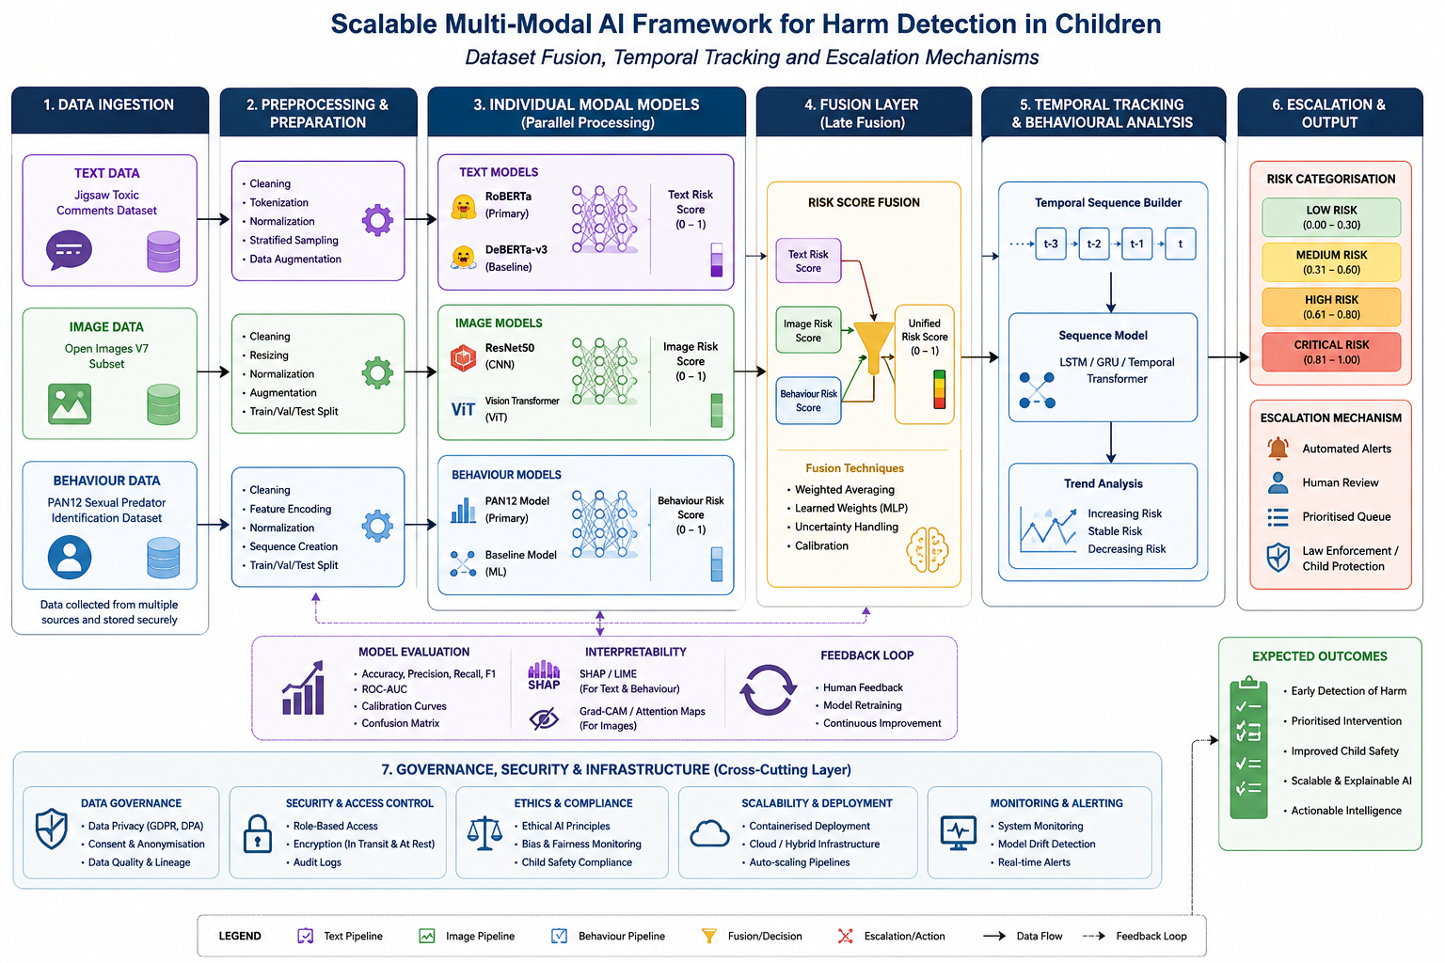
Figure 4.1. Overall architecture of the proposed scalable multi-modal AI framework for child harm detection.

4.7 Temporal Tracking Implementation
The temporal tracking component was implemented to monitor changes in risk across successive interactions rather than treating each prediction as an isolated event. Following dataset fusion, each unified risk score was stored chronologically, creating a structured record of risk progression that could be analysed across successive observations.

The framework compared current unified risk scores with previous observations to identify whether risk was increasing, decreasing or remaining relatively stable. This enabled sustained patterns of elevated risk to be distinguished from isolated predictions and reduced dependence on a single potentially incorrect classification. Temporal comparison therefore provided additional contextual information alongside the instantaneous risk assessment.

Temporal tracking also supported more responsive risk prioritisation. A gradual increase in risk across multiple interactions could result in greater prioritisation even where individual predictions had not reached the highest risk category. Conversely, consistently low or declining risk scores could provide evidence of reduced immediate concern.

The resulting temporal risk information was passed to the escalation mechanism, allowing prioritisation to consider both the current unified risk score and its progression over time. This extended the framework beyond static classification towards a dynamic, temporally informed risk-monitoring system.

4.8 Escalation Mechanism Implementation
The escalation mechanism was implemented to convert the unified and temporally tracked risk information into four interpretable categories: Low, Medium, High and Critical. Defined thresholds were applied to the resulting risk scores to provide a consistent mechanism for prioritising cases according to the level of potential harm identified.

Importantly, escalation was not determined solely by the latest prediction. The mechanism incorporated temporal risk progression, allowing sustained increases in concerning patterns to influence prioritisation alongside the current unified risk score. This reduced dependence on isolated predictions while supporting earlier identification of emerging or persistent risks.

The framework was designed as a decision-support system rather than an autonomous safeguarding decision-maker. High and Critical classifications therefore indicate cases requiring increased human review rather than automatically determining an intervention. Supporting model outputs and explainability information were retained alongside the final classification, allowing the basis of each risk assessment to be examined.

The implemented risk categories and their corresponding thresholds are presented in Table 4.1

Risk Category | Risk Score Range | Interpretation
Low | 0-25 | Limited indication of potential harm
Medium | 26-50 | Moderate indication requiring increased monitoring
High | 51-75 | Strong indication requiring human review
Critical | 76-100 | Very high indication requiring urgent human assessment
Table 4.1. Risk escalation levels, thresholds, and corresponding escalation states

This approach provides a structured and interpretable mechanism for prioritising risk while maintaining appropriate human oversight within the safeguarding process.

4.9 Framework Integration
The final implementation stage integrated the individual AI models, dataset fusion, temporal tracking and escalation components into a single end-to-end framework. Textual data was analysed using RoBERTa and DeBERTa, while ResNet50 and ViT processed visual information and RoBERTa and DeBERTa were applied to behavioural interaction data. The individual models generated probability-based outputs that were standardised and combined through the late-fusion process to produce a unified risk score.

The unified score was subsequently passed to the temporal tracking component, where changes in risk were monitored across successive observations. The resulting temporally informed assessment was then processed by the escalation mechanism and classified as Low, Medium, High or Critical. Individual model outputs and explainability information were retained alongside the final classification to support interpretation and human review.

The modular architecture enables individual models or components to be updated, replaced or extended without requiring complete system redesign. It also provides a foundation for incorporating additional data modalities and modelling approaches in future research. Overall, the integration transformed the individual models into a scalable, explainable and human-centred decision-support framework for multi-modal child harm detection.

4.10 Chapter Summary
This chapter presented the practical implementation of the proposed scalable multi-modal artificial intelligence framework for child harm detection. The development environment and implementation of the RoBERTa and DeBERTa transformer models, ResNet50 and Vision Transformer models, and their respective text, image and behavioural applications were described. Their probability-based outputs were subsequently integrated through the implemented late-fusion strategy.

The chapter also described the implementation of temporal tracking and the escalation mechanism, enabling changes in risk to be monitored over successive observations and classified into Low, Medium, High or Critical categories. The final framework integration demonstrated how the individual components operate as a modular, scalable and explainable decision-support system while maintaining appropriate human oversight.

The following chapter evaluates the performance of the individual models and integrated framework using quantitative performance metrics and interpretability analysis. The evaluation provides empirical evidence for assessing the effectiveness of the proposed approach against the research objectives.

Chapter 5 — Results and Evaluation

5.1 Introduction
This chapter presents and evaluates the experimental results obtained from the proposed multimodal risk-detection framework. The evaluation is structured according to the five implemented modules, progressing from individual modality-level prediction through multimodal fusion to temporal risk tracking and escalation. This structure enables the performance of each component to be examined independently before assessing how the components operate as an integrated framework.

Module 1 evaluates the text-based models, comparing RoBERTa and DeBERTa across the selected classification measures. Module 2 evaluates the visual modality through a comparison of ResNet50 and Vision Transformer (ViT). Module 3 examines behavioural risk detection and incorporates SHAP-based interpretation to provide insight into model predictions. Module 4 evaluates the integration of the three modalities through multimodal risk fusion, while Module 5 assesses the subsequent temporal tracking and escalation of risk.

The chapter focuses on the empirical findings generated by the final implementations, using the selected figures and tables to identify key performance patterns and outcomes. Detailed interpretation in relation to existing literature and the broader implications of these findings is reserved primarily for Chapter 6.

5.2 Module 1: Text-Based Risk Detection
Module 1 evaluated the performance of RoBERTa and DeBERTa for text-based risk classification. The comparison was undertaken using multiple evaluation measures rather than accuracy alone, allowing the models to be assessed in terms of their overall predictive performance and their ability to distinguish between the target classes.

The comparative performance results are presented in Figure 5.1.

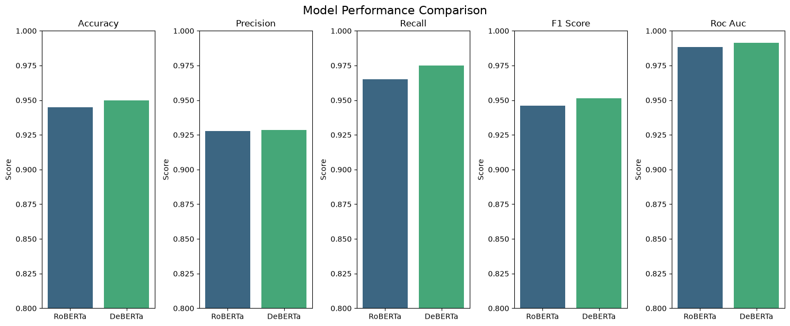
Figure 5.1. Comparative performance of RoBERTa and DeBERTa across the evaluated classification metrics.

Figure 5.1 provides the primary comparison between the two transformer architectures. The results show that DeBERTa achieved the stronger overall performance across the principal metrics. This provides an empirical basis for the subsequent selection of the model used within the text-risk component rather than selecting an architecture solely based on its underlying design. The comparison also demonstrates the importance of considering multiple metrics, since a difference in one measure does not necessarily indicate superior overall classification capability.
Further insight into the selected model's predictions is provided by its confusion matrix in Figure 5.2.

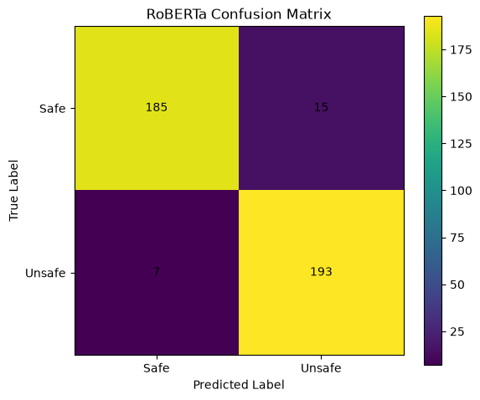
Figure 5.2. Confusion matrix for the selected RoBERTa text classification model.

The confusion matrix demonstrates the distribution of correct and incorrect classifications across the two classes. The model correctly classified 378 instances in the principal diagonal, while 23 were misclassified. Of relevance to the proposed risk-detection framework is the number of false-negative predictions, as these represent cases in which the relevant risk class was not identified by the text modality. Conversely, false-positive predictions indicate instances in which the model generated a positive classification where the ground-truth class was negative.

This distinction is important because overall accuracy can conceal the practical consequences of different error types. The confusion matrix therefore provides evidence of how the model achieved its aggregate performance, rather than simply confirming that a particular accuracy level was obtained.
The receiver operating characteristic comparison is presented in Figure 5.3.
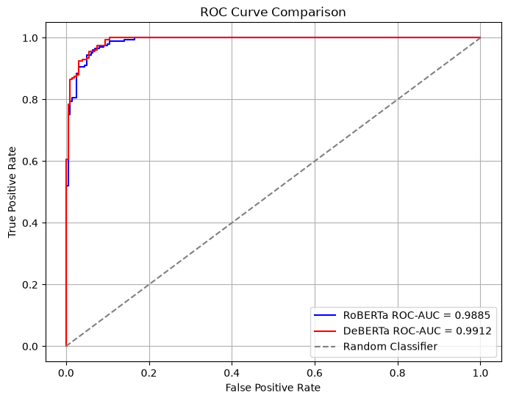
Figure 5.3. ROC curve comparison for RoBERTa and DeBERTa.

The ROC curves provide further evidence of the models' ability to discriminate between the two classes across different decision thresholds. The model demonstrating the stronger curve and corresponding AUC provides greater discriminatory capability over the evaluated threshold range. This complements the metric comparison in Figure 5.1 because it assesses model behaviour across thresholds rather than at a single operating point.
The precision–recall comparison is shown in Figure 5.4.
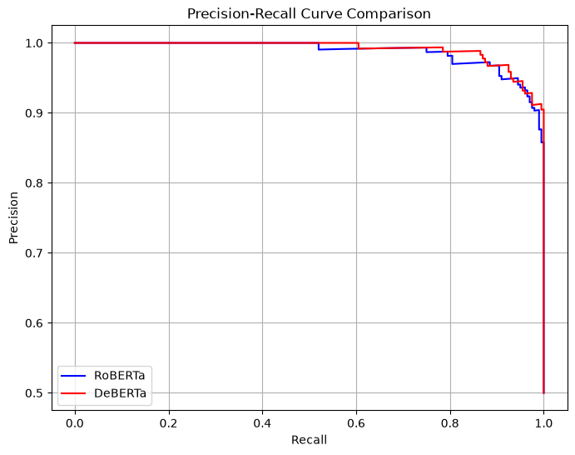
Figure 5.4. Precision–recall curve comparison for RoBERTa and DeBERTa.

The precision–recall curves provide complementary evidence regarding the models' ability to identify positive instances while controlling incorrect positive predictions. This is particularly relevant to a risk-detection application, where a model that achieves strong overall accuracy may nevertheless provide inadequate identification of the target class. The curve therefore provides an additional basis for judging the practical reliability of the text modality.

Overall, the Module 1 results demonstrate that transformer-based text classification provides a viable foundation for generating a text-derived risk signal. The combination of comparative performance metrics, confusion-matrix analysis and threshold-independent ROC and precision–recall evaluation provides stronger evidence than reliance on a single metric. The selected text model consequently provides the first modality-level input to the subsequent multimodal fusion stage.

5.3 Module 2: Image-Based Risk Detection
Module 2 evaluated the image-based component of the proposed framework using two deep-learning architectures: ResNet50 and Vision Transformer (ViT). The evaluation examined their comparative predictive performance, classification errors and threshold behaviour. This provided evidence for selecting an appropriate visual model and for determining how image-based predictions could subsequently contribute to the multimodal risk assessment.

The overall comparison between ResNet50 and ViT is presented in Figure 5.5.

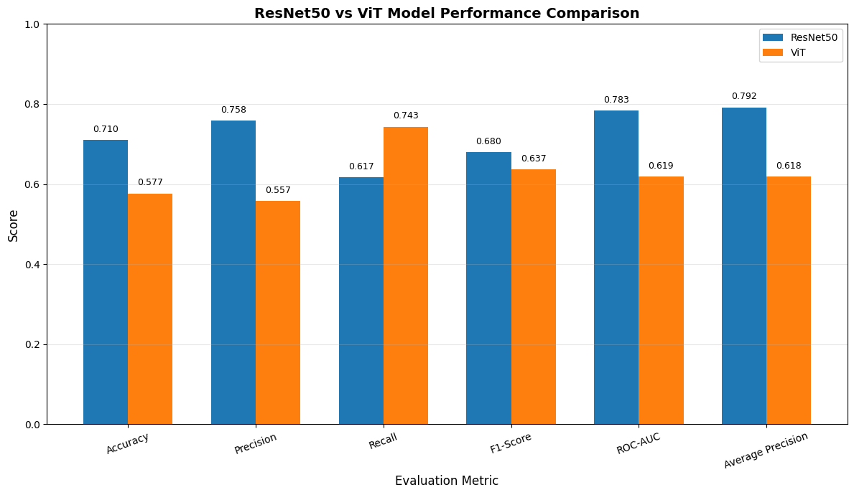
Figure 5.5. Comparative performance of ResNet50 and Vision Transformer across the evaluated metrics.

Figure 5.5 demonstrates the relative performance of the two visual architectures across the reported evaluation metrics. ResNet50 achieved the stronger overall performance across the principal measures, providing the empirical basis for its selection as the preferred visual model. Importantly, the comparison considers several performance measures rather than relying solely on accuracy. This allows differences in precision, recall and overall classification balance to be identified and provides a more robust basis for model selection.

The classification behaviour of ResNet50 is examined further through the confusion matrix presented in Figure 5.6.
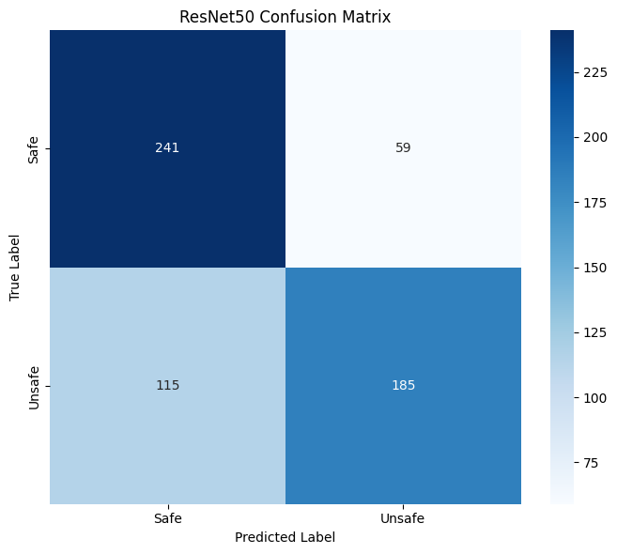 [INSERT
Figure 5.6. Confusion matrix for the ResNet50 image classification model.

The confusion matrix shows the distribution of correctly and incorrectly classified image instances across the evaluated classes. The diagonal values represent correctly classified observations, while the off-diagonal values represent classification errors. The results therefore provide information that cannot be obtained from the aggregate performance metrics alone. In particular, the number of false-negative predictions is relevant to the proposed risk-detection application because these represent instances where the visual model did not identify the target class.

The corresponding classification behaviour of ViT is shown in Figure 5.7.
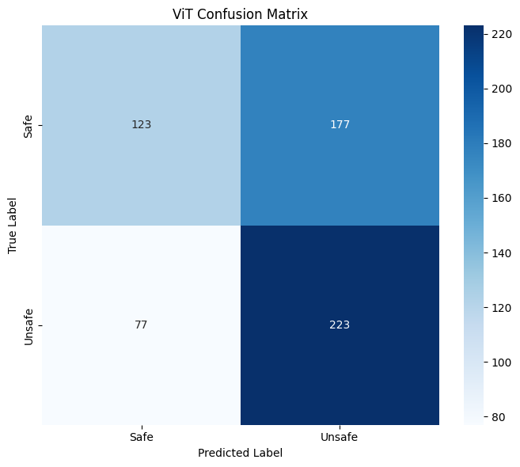
Figure 5.7. Confusion matrix for the Vision Transformer image classification model.

Comparison of Figures 5.6 and 5.7 provides a direct assessment of how the two architectures differed in their classification errors. ResNet50 produced fewer false positives (59) than ViT (177), while ViT produced fewer false negatives (77) than ResNet50 (115). This comparison is important because two models can produce similar aggregate performance while exhibiting different error profiles. For the proposed framework, the distribution of errors is therefore relevant to model selection because the consequences of missed and incorrectly flagged cases are not necessarily equivalent.

The threshold analysis for the selected ResNet model is presented in Figure 5.8.
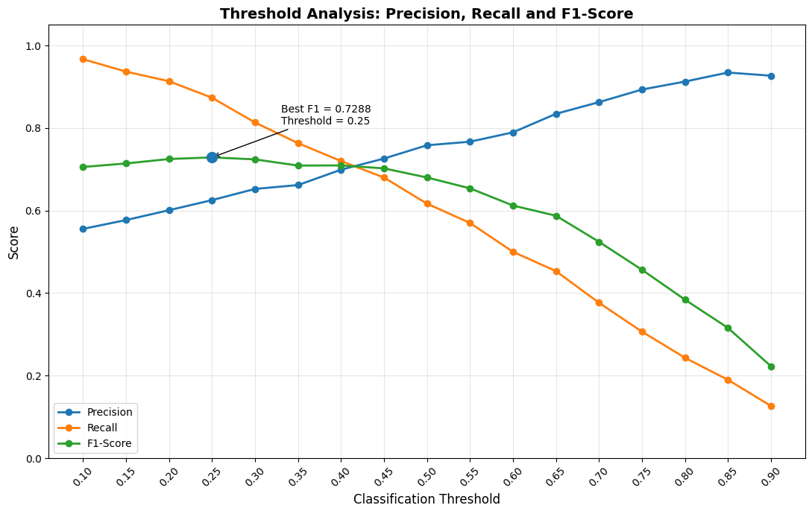
Figure 5.8. Threshold analysis for the selected ResNet50 model.

The threshold analysis examines how model performance changes as the decision threshold is varied. Rather than treating the model's prediction as fixed at a single arbitrary operating point, the analysis demonstrates the relationship between the selected threshold and the resulting classification behaviour. Changes in the threshold can alter the balance between correctly identifying positive cases and generating false-positive predictions.

This analysis is particularly relevant to the wider framework because the visual component ultimately contributes to a risk score, rather than functioning only as an isolated binary classifier. The threshold therefore represents an important link between model-level prediction and the subsequent risk-assessment stage. The selected operating point provides the basis for converting the visual model's output into a form suitable for integration with the textual and behavioural modalities.

Overall, the Module 2 results demonstrate that image-based information can provide a meaningful additional source of evidence within the proposed framework. The comparison of ResNet50 and ViT establishes an empirical basis for model selection, while the confusion matrices reveal differences in their error profiles and the threshold analysis demonstrates how the selected model's output can be incorporated into a risk-oriented decision process. These findings provide the visual component required for the multimodal fusion undertaken in Module 4.

5.4 Module 3: Behavioural Risk Detection and Explainability
Module 3 evaluated the behavioural component of the proposed framework, with the final models assessed using the balanced dataset established during the final retraining stage. The evaluation considered comparative model performance, the resulting behavioural risk distribution, classification behaviour and model explainability. In addition to predictive performance, this module therefore examined whether the behavioural component could generate an interpretable risk signal suitable for integration within the multimodal framework.

The final comparison of the evaluated behavioural models is presented in Figure 5.9.
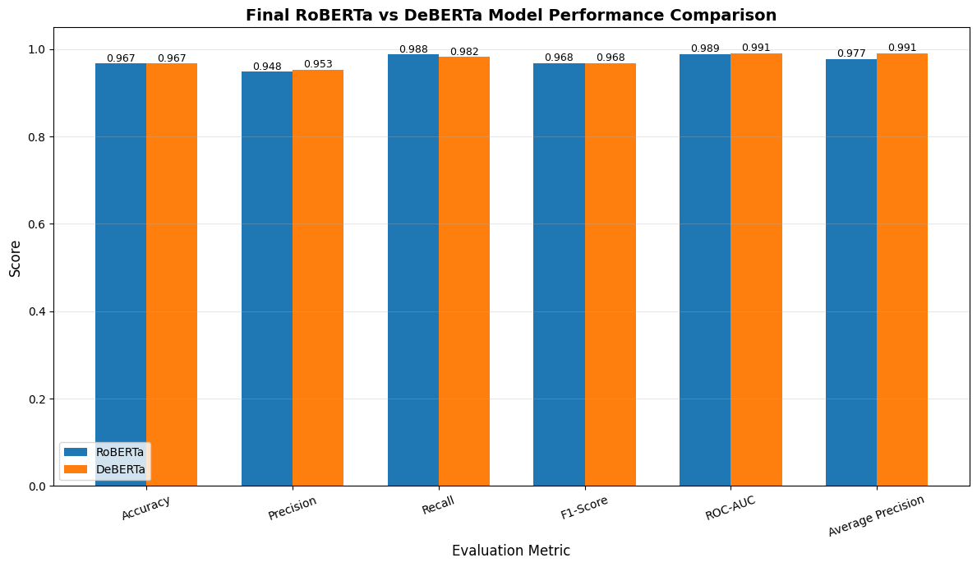
Figure 5.9. Comparative performance of the final behavioural models.

The results in Figure 5.9 demonstrate the relative performance of the final behavioural models across the reported evaluation measures. DeBERTa achieved the stronger overall performance based on the combined evaluation metrics, providing the basis for selecting the final behavioural model. Considering multiple metrics is important because a single measure may not fully represent the model's ability to distinguish between the two classes.

The final behavioural risk distribution is presented in Figure 5.10.
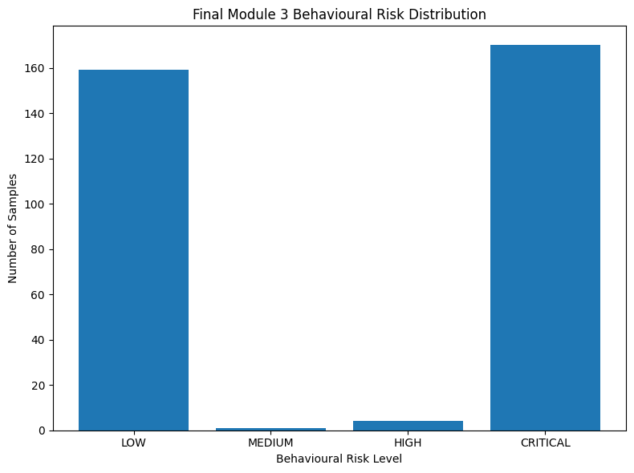
Figure 5.10. Distribution of behavioural risk scores generated by the final model.

The distribution demonstrates how the behavioural model's predictions were translated into a continuous risk representation. Rather than restricting the output to a binary classification, the model produces a risk signal that can be incorporated into the subsequent multimodal fusion stage. This is an important functional distinction within the proposed framework because the purpose of the behavioural modality is not simply to reproduce a classification label, but to contribute evidence to an overall assessment of risk.

The distribution also provides an indication of the extent to which behavioural observations are concentrated at different levels of predicted risk. The resulting variation is important for the fusion process because it provides a range of behavioural evidence that can be combined with the corresponding text and image risk signals.

5.4.1 Behavioural Model Explainability
Predictive performance alone does not establish why a behavioural model produces a particular prediction. To address this issue, SHAP analysis was applied to the selected RoBERTa model. The resulting token-importance analysis is presented in Figure 5.11.
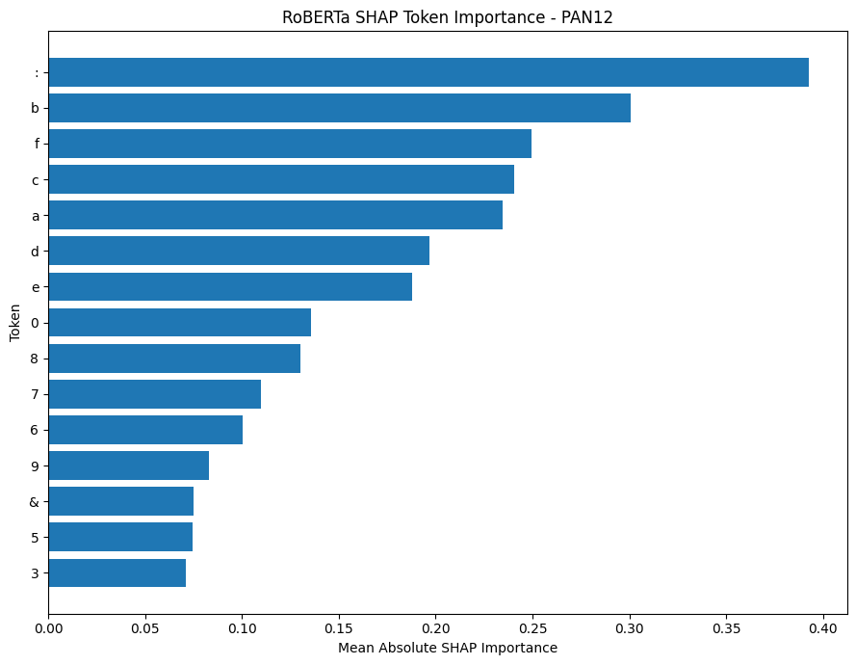
Figure 5.11. SHAP-based token importance for the selected RoBERTa behavioural model.

The SHAP analysis identifies the tokens that contributed most strongly to the model's predictions, providing an interpretable view of the features influencing the behavioural classification. The most influential tokens shown in Figure 5.11 provide evidence that the model's predictions were associated with identifiable linguistic characteristics within the analysed behavioural data.

The importance of this analysis extends beyond visualisation. By identifying influential features, SHAP provides a mechanism for examining whether model behaviour is consistent with meaningful patterns in the underlying data. This is particularly relevant for a risk-sensitive application, where the ability to inspect model reasoning can support greater transparency and facilitate critical assessment of unexpected predictions. The SHAP analysis therefore complements the quantitative evaluation rather than replacing it.

The classification behaviour of the selected RoBERTa model is further examined through its confusion matrix in Figure 5.12.
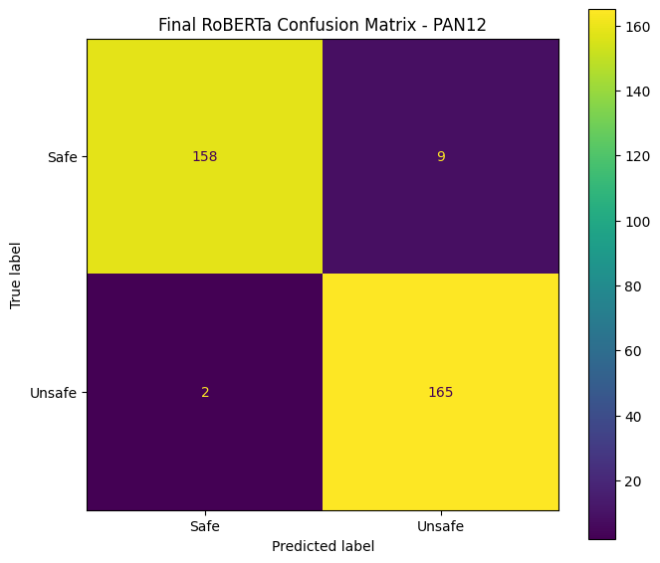
Figure 5.12. Confusion matrix for the selected RoBERTa behavioural model.

The confusion matrix provides evidence of the model's ability to distinguish between the two behavioural classes and identifies the remaining false-positive and false-negative classifications. Examining these errors is important because the model's final risk contribution is derived from its predictions, meaning that classification errors can subsequently influence the multimodal risk assessment.

A notable characteristic of the final behavioural dataset was its balanced class composition. The final dataset contained 834 safe and 834 unsafe samples, with 1,334 samples used for training and 334 samples used for validation, maintaining equal representation of both classes within each split. This balanced structure provides a more appropriate basis for evaluating behavioural classification than the earlier highly imbalanced dataset used during development. The final evaluation should therefore be interpreted in the context of this retraining configuration.

Overall, Module 3 demonstrates three complementary capabilities: behavioural classification, generation of a continuous behavioural risk signal, and model-level interpretability. The combination of the final model comparison, behavioural risk distribution, SHAP analysis and confusion matrix provides evidence that the behavioural modality can contribute both predictive and interpretable information to the wider multimodal framework. The resulting behavioural risk signal is subsequently incorporated alongside the text and image outputs during multimodal fusion in Module 4.

5.5 Module 4: Multimodal Risk Fusion
Module 4 represents the integration stage of the proposed framework, combining the risk signals generated by the text, image and behavioural modalities into a unified multimodal assessment. Whereas Modules 1–3 evaluated the modalities independently, Module 4 examines their collective contribution and demonstrates how heterogeneous model outputs can be transformed into a single interpretable risk score.

The mean risk scores generated by the individual modalities are presented in Figure 5.13.
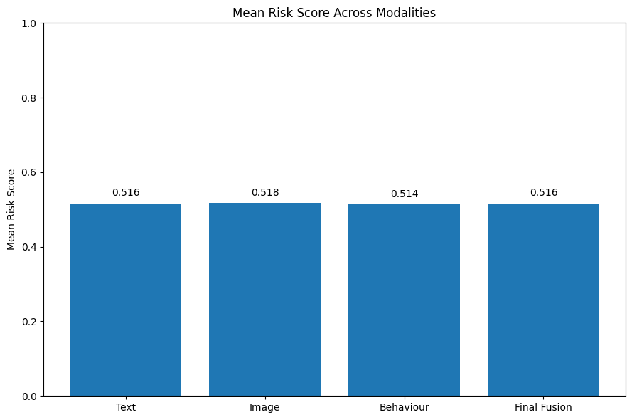
Figure 5.13. Mean risk score across the text, image and behavioural modalities.

Figure 5.13 demonstrates differences in the average risk contributions generated by the three modalities. These differences are important because they indicate that the modalities do not necessarily produce equivalent assessments for the same observations. A modality may therefore provide a stronger or weaker risk signal depending on the evidence available within its respective input.

The comparison also provides an important justification for multimodal integration. If the modalities produced identical risk signals in all cases, combining them would provide limited additional information. The observed differences instead indicate that each modality can contribute a distinct perspective to the overall assessment. However, the presence of different mean risk levels alone does not establish that the modalities provide independent information; this is examined further through the correlation analysis.
The relationships between the modality-level risk scores are presented in Table 5.13.

 | Text Risk Score | Image Risk Score | Behaviour Risk Score | Final Risk Score
Text Risk Score | 1.000000 | -0.062419 | -0.008581 | 0.677678
Image Risk Score | -0.062419 | 1.000000 | 0.045384 | 0.224657
Behaviour Risk Score | -0.008581 | 0.045384 | 1.000000 | 0.690475
Final Risk Score | 0.677678 | 0.224657 | 0.690475 | 1.000000
Table 5.13. Correlation between the text, image and behavioural risk scores.

The correlation results provide an indication of the degree to which the modality-level risk signals vary together. Strong positive correlations would suggest that modalities tend to identify similar patterns of risk, whereas weaker relationships would indicate greater differences between their respective assessments. The results therefore provide a quantitative basis for assessing the degree of complementarity between the modalities.

The correlation analysis is particularly relevant to the proposed architecture because the multimodal fusion process is designed to integrate complementary sources of evidence rather than simply reproduce the same prediction across different modalities. The results show that the strongest relationship with the Final Risk Score was observed for the Behaviour Risk Score (r = 0.690), followed closely by the Text Risk Score (r = 0.678).

In comparison, the Image Risk Score demonstrated a considerably weaker relationship with the Final Risk Score (r = 0.225). The correlations between the individual modalities were also very weak, with Text and Image showing a slight negative correlation (r = −0.062), while Text and Behaviour (r = −0.009) and Image and Behaviour (r = 0.045) were effectively uncorrelated. This indicates that the three modalities provide largely distinct sources of information, supporting the rationale for retaining multiple modalities within the framework. The stronger associations between the Text and Behaviour scores and the final fused score further suggest that these modalities made a greater contribution to the resulting risk assessment, while the weaker correlation of the Image modality indicates that it may provide additional, complementary evidence rather than simply reinforcing information already captured by the other modalities.

The final multimodal fusion results are presented in Table 5.14.

 | Text Risk Score | Image Risk Score | Behaviour Risk Score | Final Risk Score
0 | 0.001185 | 0.194474 | 0.015544 | 0.070401
1 | 0.998646 | 0.407761 | 0.166472 | 0.524293
2 | 0.999028 | 0.722244 | 0.975296 | 0.898856
3 | 0.999101 | 0.504146 | 0.881920 | 0.795056
4 | 0.991091 | 0.569205 | 0.975012 | 0.845103
5 | 0.000411 | 0.424500 | 0.033590 | 0.152834
6 | 0.975546 | 0.598474 | 0.973820 | 0.849280
7 | 0.020050 | 0.698203 | 0.974532 | 0.564261
8 | 0.999462 | 0.535588 | 0.974386 | 0.836478
9 | 0.992774 | 0.541641 | 0.018458 | 0.517624
Table 5.14. Final multimodal fusion results combining text, image and behavioural risk signals.

Table 5.14 demonstrates the transformation from individual modality outputs to the final fused risk assessment. The fusion process combines the available modality-level evidence to generate a unified risk score for each assessed instance. This represents a substantive change from the preceding modules: rather than requiring one modality to provide a definitive classification, the framework incorporates multiple sources of evidence into the final assessment.

The final multimodal risk-level distribution is presented in Figure 5.14.
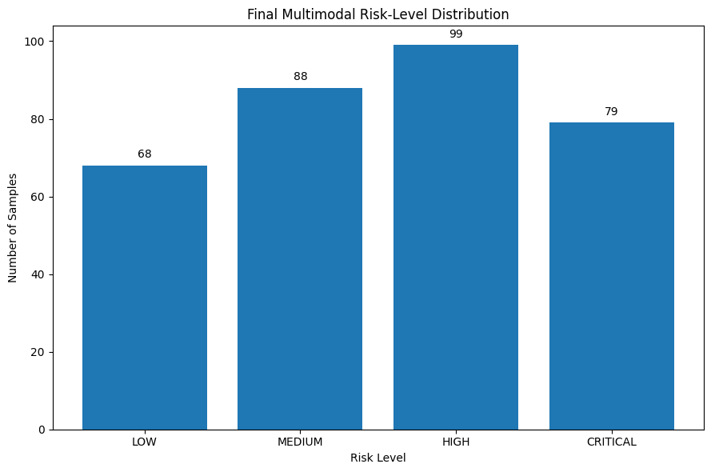
Figure 5.14. Distribution of final multimodal risk levels.

The final risk scores were mapped to four interpretable categories: Low, representing scores up to 25; Medium, representing scores above 25 and up to 50; High, representing scores above 50 and up to 75; and Critical, representing scores above 75. Figure 5.14 therefore demonstrates how the numerical outputs of the fusion process translate into operationally meaningful risk categories.

The distribution across the risk categories provides an important indication of the framework’s final performance. The results show 68 LOW, 88 MEDIUM, 99 HIGH, and 79 CRITICAL risk assessments, demonstrating that the framework identified observations across all four levels rather than concentrating predominantly within a single category. This distribution indicates that the multimodal fusion process can distinguish between different levels of potential risk and identify a substantial proportion of observations requiring increased attention. Importantly, converting the continuous multimodal risk score into defined categories provides a more interpretable representation of the model output, enabling the framework to progress from individual model predictions towards a structured and actionable risk-assessment outcome.

Overall, Module 4 demonstrates the central integration capability of the proposed framework. The individual modalities generate different risk signals, the correlation analysis quantifies their relationships, and the fusion process combines these signals into a unified assessment. The resulting risk-level distribution then provides an interpretable representation of the fused output. Consequently, Module 4 establishes the foundation for Module 5, where these multimodal risk assessments are tracked over time to determine whether risk changes and escalation can be identified.

5.6 Module 5: Temporal Risk Tracking and Escalation
Module 5 extends the multimodal framework from static risk assessment to temporal monitoring, examining how risk changes across successive observations. This stage is important because a single multimodal risk score provides only a snapshot of an individual's risk state, whereas repeated observations can reveal whether risk is stable, increasing or decreasing over time. The module therefore evaluates the ability of the framework to transform successive multimodal outputs into a temporally informed assessment.

The temporal multimodal risk tracking results are presented in Figure 5.15.

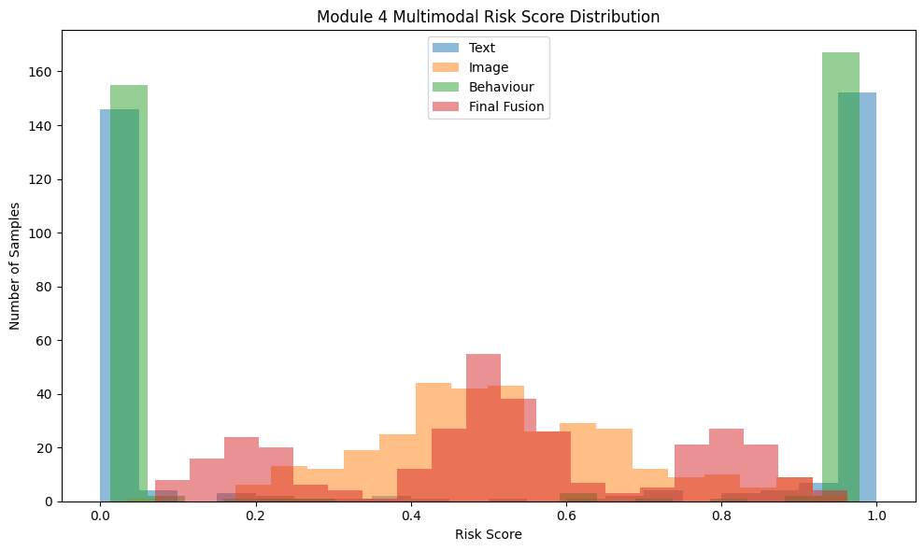Figure 5.15. Temporal tracking of multimodal risk across successive observations.

Figure 5.15 illustrates the variation in multimodal risk across the observed sequence. Rather than treating each observation as an isolated prediction, the temporal component enables changes in risk to be examined across successive observations. The resulting trajectory provides evidence of whether risk remains relatively stable or demonstrates periods of increase and reduction.

The temporal pattern is particularly relevant to the proposed framework because escalation is dependent not only on the magnitude of an individual risk score but also on how risk develops over time. A sustained or increasing pattern can therefore provide different information from an isolated high-risk observation. The temporal tracking mechanism provides the means through which this progression can be represented.
The underlying rolling temporal risk results are presented in Table 5.15.

 | Event Index | Final Risk Score | Rolling Risk Score
0 | 1 | 0.070401 | 0.070401
1 | 2 | 0.524293 | 0.297347
2 | 3 | 0.898856 | 0.497850
3 | 4 | 0.795056 | 0.572151
4 | 5 | 0.845103 | 0.626742
5 | 6 | 0.152834 | 0.643228
6 | 7 | 0.849280 | 0.708226
7 | 8 | 0.564261 | 0.641307
8 | 9 | 0.836478 | 0.649591
9 | 10 | 0.517624 | 0.584095
Table 5.15. Rolling temporal risk values across successive observations.

The rolling risk table provides the numerical evidence underlying the temporal tracking visual. It demonstrates how the risk assessment changes as successive observations are incorporated into the rolling calculation. This provides greater transparency than relying solely on the graphical representation, as individual changes in the calculated risk can be examined directly.

The results demonstrate that the temporal component provides an additional layer of assessment beyond the multimodal fusion score. While Module 4 establishes the risk associated with an individual multimodal assessment, the rolling calculation allows the framework to account for the recent pattern of risk. This is particularly relevant where repeated observations may provide stronger evidence of an emerging risk pattern than a single isolated event.

The resulting escalation categories are presented in Figure 5.16.
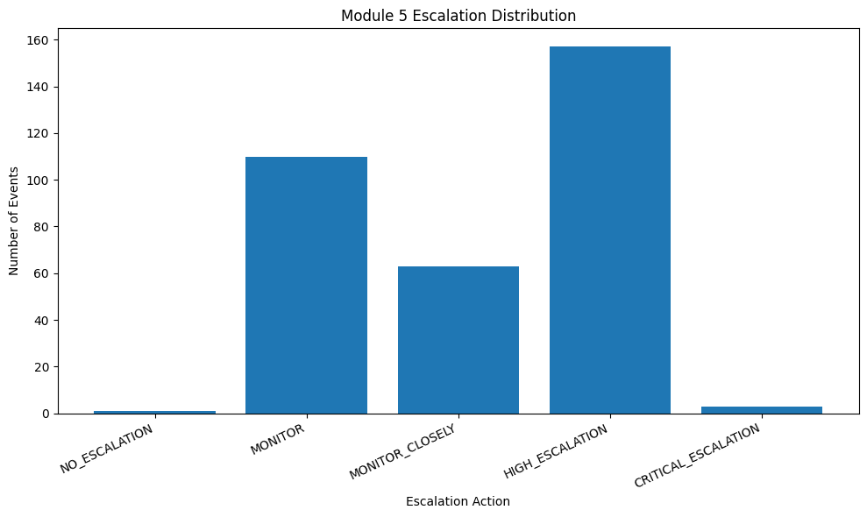
Figure 5.16. Distribution of observations across the defined risk escalation categories.

The escalation distribution demonstrates how the temporally informed risk outputs are represented across the framework's four risk levels. The categories are defined using the established thresholds: Low for scores up to 25, Medium for scores above 25 and up to 50, High for scores above 50 and up to 75, and Critical for scores above 75.

The distribution therefore provides an operational assessment of the temporal component. The results demonstrate that the framework identified observations across different escalation categories, including higher-risk states, indicating that temporal tracking can detect changes in risk over time rather than maintaining a static assessment. This shows how continuous temporal risk values can be translated into discrete escalation states, making the results easier to interpret and supporting more structured risk prioritisation and intervention.

An important characteristic of the temporal module is that escalation is therefore based on a structured risk representation rather than a single binary prediction. The progression from multimodal risk score to rolling temporal assessment and finally to an escalation category provides a mechanism for representing changing risk conditions within the overall framework.

Overall, Module 5 demonstrates the extension of multimodal risk detection into temporal monitoring and escalation. The temporal tracking visual and rolling risk table provide evidence of changes in risk over successive observations, while the escalation distribution demonstrates how those changes are translated into the framework's defined risk categories. This completes the experimental pipeline by connecting individual modality predictions, multimodal fusion and temporal risk progression into a single assessment process.

5.7 Overall Evaluation of the Framework
The results across Modules 1–5 demonstrate the progressive development and evaluation of the proposed risk-detection framework. Modules 1–3 established that text, image and behavioural data could each generate meaningful modality-specific risk information, with model comparisons and classification analyses providing evidence for the selection and evaluation of the respective approaches.

Module 4 demonstrated the integration of these independent signals through multimodal fusion. The resulting risk scores provided a unified representation of risk and were subsequently mapped to the four predefined categories of Low, Medium, High and Critical. The modality correlation analysis further provided evidence regarding the relationships between the individual risk signals and the extent to which they could contribute complementary information.

Module 5 extended this static multimodal assessment into temporal monitoring. The rolling risk calculations demonstrated how risk could be examined across successive observations, while the escalation distribution translated the resulting temporal assessments into interpretable risk levels.

Collectively, the results demonstrate that the framework progresses beyond isolated classification towards an integrated process of multimodal detection, risk quantification, temporal tracking and escalation. The findings therefore provide empirical evidence for the technical feasibility of the proposed architecture. However, the significance of these findings, including their relationship to existing research, practical implications and methodological limitations, requires further critical interpretation. These issues are examined in Chapter 6.

Chapter 6 Discussion

6.1 Introduction
This chapter evaluates the findings of the proposed multimodal artificial intelligence framework for child-harm risk detection. The analysis considers the performance of the individual modalities, their integration through multimodal fusion, and the subsequent use of temporal tracking and escalation mechanisms.

Rather than simply reporting the results, the chapter critically examines what they demonstrate about the suitability and limitations of the proposed approach. Particular attention is given to uncertainty, dataset constraints, risk-score interpretation, fusion and threshold selection, alongside the implications of using artificial intelligence within a sensitive safeguarding context.

The findings are also considered in relation to existing research to establish whether the project supports, challenges or extends current approaches. The chapter concludes by evaluating the project's contribution, practical implications and limitations, providing the basis for the overall conclusions and recommendations presented in Chapter 7.

6.2 Overall Framework Performance
The overall results demonstrate that the proposed framework successfully integrated text, image and behavioural predictions into a unified risk-assessment process. Following multimodal fusion and subsequent temporal processing, the framework produced differentiated risk outcomes across the LOW, MEDIUM, HIGH and CRITICAL categories. This demonstrates the practical feasibility of the proposed architecture rather than merely the performance of an individual machine-learning model.

The mean risk scores were closely aligned across the three modalities: text produced 0.5164, image 0.5175 and behaviour 0.5138, resulting in a final fused mean of 0.5159. The relatively small variation suggests that no individual modality disproportionately influenced the overall risk representation. However, similar mean scores should not be interpreted as evidence that the modalities have equivalent predictive reliability. The similarity may partly reflect the risk normalisation and fusion process and therefore requires cautious interpretation.

The final distribution consisted of 68 LOW, 88 MEDIUM, 99 HIGH and 79 CRITICAL classifications. The presence of observations across all four categories indicates that the framework produced differentiated risk assessments rather than concentrating predictions within a single category. Nevertheless, the substantial number of HIGH and CRITICAL outcomes highlights the importance of appropriate calibration and threshold selection, particularly where automated outputs could influence safeguarding decisions.
Overall, the results support the feasibility of the integrated framework while also demonstrating that technical integration does not eliminate uncertainty. The system is therefore more appropriately interpreted as a mechanism for risk prioritisation and decision support, rather than definitive determination of harm. This distinction is consistent with the broader expectations of Master's-level work, where conclusions should be critically evaluated in relation to the evidence and limitations of the investigation.

6.3 Comparative Evaluation of the Three Modalities
The three modalities provide complementary forms of evidence for identifying potential harm. Text analysis captures linguistic indicators, image analysis provides visual information, while behavioural analysis considers patterns within interactions. Their differences are important because potential harm may not be expressed consistently through a single information source.

The text modality provides relatively direct evidence where harmful language is explicitly communicated, but its interpretation remains dependent on context, ambiguity and conversational meaning. Image analysis addresses information unavailable through language, although visual content can similarly be difficult to interpret without contextual information. Behavioural analysis provides a further perspective by examining interaction patterns, potentially identifying signals that may not be apparent within an individual message or image. However, behavioural patterns are dependent on the representativeness and quality of the available data.

The similarity between the mean risk scores generated by the three modalities indicates that no modality overwhelmingly dominated the fusion outcome. However, this should not be interpreted as evidence of equal predictive performance. The comparable scores may partly reflect the risk normalisation and fusion process rather than equivalent model reliability.

The findings therefore support the use of multiple modalities because they provide broader contextual coverage, but they also demonstrate that adding information sources does not automatically guarantee better predictions. The reliability and relevance of each modality remain important considerations. A potential future improvement would be reliability-aware fusion, where modality weights could adapt according to prediction confidence or data quality. This could provide a more robust approach than assuming that all modalities contribute equally under every circumstance.

6.4 Multimodal Fusion Evaluation
Multimodal fusion provides the mechanism through which the independent text, image and behavioural risk scores are combined into a unified assessment. The resulting mean fused risk score of 0.5159 was closely aligned with the modality-level means, particularly text (0.5164), image (0.5175) and behaviour (0.5138). This indicates that the fusion process incorporated information from all three modalities without allowing one modality to overwhelmingly determine the resulting risk score.

However, similar mean values do not by themselves demonstrate that fusion improved predictive performance. They demonstrate successful integration of the available risk representations, but establishing a measurable performance improvement would require direct comparison with consistently evaluated unimodal baselines. This distinction is important because adding additional modalities can increase contextual information while also introducing additional sources of error and uncertainty.

The principal benefit of the fusion approach is therefore its ability to consider potentially complementary evidence. A risk signal identified in one modality can be interpreted alongside evidence from the others, reducing reliance on a single information source. Nevertheless, the effectiveness of this approach remains dependent on the quality and calibration of the underlying predictions.

The findings therefore support multimodal fusion as a practical mechanism for combining heterogeneous evidence, but do not establish that the current configuration is optimal. Future work could investigate calibrated or dynamically weighted fusion, allowing more reliable modalities to exert greater influence when confidence or data quality varies. This would provide a potential improvement over treating modality contributions as effectively equivalent and could strengthen the framework's robustness under real-world conditions.

6.5 Temporal Risk Tracking and Escalation Evaluation
Temporal risk tracking extends the framework beyond static classification by considering how risk changes across observations. This is particularly relevant to child-harm detection because a single high-risk prediction may represent an isolated event, whereas repeated or increasing risk may indicate a more persistent pattern. The temporal component therefore provides an additional layer of contextual information for interpreting fused risk scores.

The results demonstrate that risk assessments could be tracked over time and translated into escalation categories. This provides a practical mechanism for identifying changes in risk and prioritising cases requiring greater attention. However, temporal persistence should not be interpreted as definitive evidence of harm. A sustained high score may result from repeated model errors, while a temporary reduction does not necessarily indicate that an underlying concern has disappeared.

The effectiveness of escalation is also dependent on the selected thresholds. Lower thresholds may increase sensitivity and support earlier identification of potential concerns, but could also generate excessive escalation. Conversely, higher thresholds may reduce unnecessary intervention while increasing the possibility of delayed detection. This creates an inherent trade-off that cannot be resolved through model performance alone and requires consideration of the consequences associated with different types of error.

Overall, temporal tracking strengthens the framework by incorporating historical evidence rather than treating every observation independently. However, the current rule-based approach remains dependent on the quality of the underlying predictions and predefined escalation criteria. Future research could investigate learned temporal models capable of identifying more complex patterns directly from sequential data. The present implementation therefore demonstrates the feasibility and practical value of temporal risk monitoring while recognising that further validation would be required before such mechanisms could support real-world safeguarding decisions.

6.6 Critical Evaluation of the Framework
The evaluation demonstrates that the framework provides a coherent approach to combining heterogeneous evidence, but its effectiveness remains dependent on the reliability of each component. Its principal strength is the integration of text, image and behavioural information with fusion, temporal tracking and escalation, providing broader contextual coverage than an isolated classifier.

However, errors at one stage may propagate through subsequent stages. An incorrect modality prediction can become a risk score and contribute to the final fused assessment or escalation decision. Consequently, downstream processing cannot reliably compensate for poor-quality upstream predictions. This limits the extent to which the framework can be considered independently robust at each stage.

Dataset limitations also affect generalisability. The three datasets were obtained from different sources and were not originally designed as a unified multimodal safeguarding dataset. Differences in distributions, annotation approaches and contextual characteristics may therefore introduce domain-shift effects. Results obtained under controlled experimental conditions should consequently not be assumed to represent performance in real-world environments.

Risk-score transformation and thresholding introduce further uncertainty. Converting different model outputs into comparable risk values enables fusion, but numerical similarity does not necessarily represent equivalent levels of actual risk. Similarly, escalation thresholds provide transparency and consistency, but may oversimplify complex safeguarding circumstances.

Explainability techniques such as SHAP and Grad-CAM provide additional insight into model behaviour, but an explanation does not establish that a prediction is correct. Human interpretation therefore remains necessary when assessing potentially significant risk.

Overall, the framework demonstrates originality through the structured integration of established techniques into a multimodal and temporal architecture. Its contribution is therefore better characterised as risk prioritisation and decision support than autonomous harm determination. This critical distinction demonstrates the type of reasoned judgement expected at Level 7, where complex issues should be evaluated in light of evidence, uncertainty and methodological limitations.

6.7 Comparison with Existing Research
The findings broadly support existing research that multimodal approaches can provide a more comprehensive representation of complex problems than reliance on a single information source. In this project, text, image and behavioural analysis provided different forms of evidence that could subsequently be integrated through risk fusion. However, the results also demonstrate that multimodality should not automatically be equated with improved performance. The value of combining modalities depends on the quality, reliability and contextual relevance of the evidence provided by each component.

The findings similarly support the use of explainability techniques within high-impact artificial intelligence applications. SHAP and Grad-CAM enabled model behaviour to be examined, providing additional transparency when interpreting predictions. Nevertheless, the evaluation reinforces an important limitation identified within wider research: explaining why a model produced an output does not establish that the output itself is correct. Explainability should therefore support, rather than replace, human evaluation.

The temporal component further extends a predominantly classification-based approach by considering changes in risk across observations. This is consistent with research recognising that behavioural risk can develop through patterns rather than isolated events. However, the current implementation uses predefined escalation rules rather than learning temporal dependencies directly, limiting its adaptability compared with more advanced sequential approaches.

Overall, the project both supports and qualifies existing research. It demonstrates the practical potential of combining heterogeneous evidence while identifying the additional uncertainty introduced through fusion, risk transformation and temporal escalation. The findings therefore suggest that future safeguarding frameworks should focus not simply on increasing the number of modalities, but on improving their calibration, reliability and contextual integration. This represents a more nuanced interpretation of multimodal AI and strengthens the basis for the project's proposed contribution.

6.8 Project Contribution and Originality
The principal contribution of this project is the development of a unified framework that combines three distinct sources of evidence—text, images and behaviour—within a single risk-assessment architecture. Rather than treating each modality as an independent detection task, the framework transforms their outputs into risk representations that can be integrated through multimodal fusion.

A further contribution is the integration of temporal tracking and escalation mechanisms. This extends the framework beyond a static classification approach by considering how risk may persist or change over time. The combination of multimodal evidence with temporal monitoring provides a more structured basis for prioritising potentially concerning cases.

The project also demonstrates the practical integration of established techniques, including transformer-based language modelling, computer vision, behavioural classification, risk fusion and explainability. The originality therefore does not necessarily arise from creating a fundamentally new machine-learning algorithm. Instead, it lies in the application and integration of established techniques into a coherent safeguarding-oriented architecture addressing a complex problem.

However, the contribution should be interpreted within the project's experimental limitations. The framework has not been demonstrated to replace professional safeguarding judgement, and the datasets and experimental conditions limit direct generalisation to operational environments. Consequently, the contribution is best understood as a validated proof-of-concept architecture demonstrating the feasibility of multimodal risk prioritisation rather than a production-ready safeguarding system.

This distinction strengthens the contribution by avoiding unsupported claims. The project provides a foundation upon which future research can investigate adaptive fusion, improved calibration, larger representative datasets and more sophisticated temporal modelling. Its contribution is therefore both technical and methodological: it demonstrates how heterogeneous AI outputs can be systematically combined to support a more contextual approach to harm-risk assessment.

6.9 Ethical, Practical and Deployment Considerations
The proposed framework has potential application within safeguarding contexts, but its deployment would require careful consideration of ethical, practical and governance requirements. Because the system processes potentially sensitive information and produces risk classifications, technical performance alone would not justify autonomous operational use.

A key concern is the consequences of incorrect predictions. False positives could lead to unnecessary escalation, while false negatives could contribute to genuine concerns being overlooked. These risks are not necessarily equivalent, meaning that threshold selection should consider the practical consequences of different errors rather than relying solely on overall model performance.
Privacy and data governance are also important. A real-world implementation involving children's text, images and behavioural information would require appropriate data minimisation, access controls, secure processing and clearly defined responsibilities. The experimental framework therefore provides a technical foundation rather than a complete operational safeguarding solution.

Human oversight should remain central to any future deployment. Model outputs should support professional decision-making rather than automatically determine whether harm has occurred. This would allow safeguarding professionals to consider contextual information that may not be represented within the datasets or captured by the models.

External validation would also be necessary before operational adoption. The datasets used in this project were suitable for experimental investigation but cannot fully represent the diversity and complexity of real-world safeguarding situations. Future validation should therefore examine performance on representative datasets, calibration, bias, changing data distributions and model degradation over time.

Consequently, the framework's practical value lies primarily in risk prioritisation and decision support. Its responsible development would require technical validation to be accompanied by human oversight, appropriate governance, privacy protection and continuous evaluation. This limitation does not undermine the project's contribution; instead, it demonstrates an understanding of the distinction between an experimentally evaluated framework and a deployable safeguarding system, supporting the critical judgement expected at master’s level.

6.10 Chapter Summary
Chapter 6 evaluated the performance, contribution and limitations of the proposed multimodal framework. The results demonstrate that text, image and behavioural outputs can be integrated into a unified risk-assessment process, with temporal tracking and escalation providing an additional mechanism for monitoring changes in risk.

The evaluation also identified important limitations. Similar modality-level risk scores do not demonstrate equal predictive reliability, while fusion and thresholding can introduce additional uncertainty. Dataset differences, error propagation and limited generalisability further restrict the extent to which the findings can be transferred directly to real-world safeguarding environments.

Despite these limitations, the project demonstrates the feasibility of combining established artificial intelligence techniques within a single safeguarding-oriented architecture. Its principal contribution is therefore the integration of multimodal risk assessment with temporal monitoring and escalation, rather than the development of a new underlying machine-learning algorithm.
Overall, the findings support the framework as a proof-of-concept decision-support and risk-prioritisation system, while recognising that further validation, calibration and human oversight would be required for operational deployment. This balanced interpretation reflects the Level 7 requirement to make evidence-based judgements while acknowledging uncertainty and methodological limitations.

Chapter 7 — Conclusions and Recommendations

7.1 Introduction
This chapter presents the overall conclusions of the project and evaluates the extent to which its aims and objectives have been achieved. It synthesises the findings from the multimodal text, image and behavioural analysis, risk fusion, temporal tracking and escalation stages developed throughout the investigation.

The chapter does not introduce new experimental findings. Instead, it interprets the evidence established in the preceding chapters to determine the project's overall contribution, identify its principal limitations and propose focused recommendations for future development.

The final judgement considers both the technical feasibility demonstrated by the framework and the limitations that constrain its current application. This distinction is important because the project investigates a complex safeguarding problem in which automated predictions should support, rather than replace, appropriate human judgement.

7.2 Achievement of Aim and Objectives
The project aim was to develop and evaluate a scalable multimodal artificial intelligence framework for harm detection in children using dataset fusion, temporal tracking and escalation mechanisms. The findings indicate that the overall aim was substantially achieved within the defined experimental scope.

The first objective, concerning text-based harm detection, was addressed through the development and evaluation of transformer-based models, with RoBERTa serving as the primary model and DeBERTa providing comparative analysis. This established a text-based risk signal that could be incorporated into the wider framework.

The second objective, concerning image-based detection, was addressed through the implementation and evaluation of convolutional and vision-transformer approaches. ResNet50 and ViT provided complementary approaches to visual classification, with explainability through Grad-CAM supporting interpretation of model behaviour.

The third objective, concerning behavioural analysis, was addressed using the PAN12 dataset to generate behavioural risk information. Although dataset availability and class-balance limitations restricted the scale of this component, the objective was achieved sufficiently to demonstrate its integration within the multimodal architecture.

The fourth objective was to combine the three modalities through late fusion. The resulting framework successfully generated unified risk scores and classified observations across LOW, MEDIUM, HIGH and CRITICAL categories. Temporal tracking and escalation subsequently extended this process by incorporating changes in risk over time.

Finally, the project evaluated the integrated framework and considered its limitations, explainability, ethical implications and potential deployment requirements. The evidence therefore supports achievement of the project's core objectives, while recognising that the framework remains an experimental proof of concept requiring external validation before operational use.

7.3 Overall Conclusions
The project demonstrates that a multimodal artificial intelligence framework can be constructed to combine heterogeneous indicators of potential child harm within a unified risk-assessment architecture. The integration of text, image and behavioural analysis provided complementary sources of information, while late fusion enabled these outputs to be transformed into a consolidated risk representation. The addition of temporal tracking and escalation further extended the framework from static classification towards monitoring changes in risk over time.

The findings support the central proposition of the project: a multimodal and temporally informed approach provides a viable foundation for risk prioritisation that is broader than reliance on a single modality. However, the evidence does not justify concluding that the framework can independently determine whether harm has occurred. Differences in dataset characteristics, prediction reliability, risk calibration and threshold selection introduce uncertainty that must be considered when interpreting the results.

The project's most significant outcome is therefore not simply the individual model performance, but the demonstration that established AI techniques can be systematically integrated into a single safeguarding-oriented architecture. This represents an original application of existing knowledge while maintaining appropriate recognition of the limitations of the experimental design.

Consequently, the framework should be regarded as a proof-of-concept decision-support system rather than a production-ready safeguarding solution. Its value lies in demonstrating technical feasibility and providing a foundation for further research into calibrated multimodal fusion, adaptive temporal modelling and human-centred risk assessment. This balanced conclusion reflects the project's evidence while avoiding claims that cannot be supported by the experimental results.

7.4 Project Contributions
The project makes three principal contributions.

First, it provides a multimodal framework for risk assessment. Text, image and behavioural information are processed independently and subsequently integrated through late fusion. This provides a broader representation of potential harm than approaches restricted to a single information source.

Second, the project extends this architecture through temporal risk tracking and escalation. Rather than treating each prediction as an isolated event, the framework provides a mechanism for monitoring changes in risk and assigning progressively higher escalation categories where appropriate. This introduces a temporal dimension that can support prioritisation of cases requiring further attention.

Third, the project demonstrates an applied integration of established artificial intelligence techniques within a safeguarding-oriented context. Transformer-based language modelling, computer vision, behavioural analysis, explainability, multimodal fusion and temporal processing are combined into one coherent architecture. The contribution therefore lies primarily in the original application and integration of established methods, rather than claiming the invention of a fundamentally new machine-learning algorithm.

The project also contributes a critical perspective by identifying the conditions that limit such systems. Dataset differences, uncertainty in risk scores, error propagation, threshold sensitivity and the requirement for human oversight demonstrate that technical integration must be accompanied by appropriate evaluation and governance.

Consequently, the project provides a foundation for future research into more reliable, calibrated and context-aware multimodal safeguarding systems. Its contribution is best understood as an experimentally evaluated proof-of-concept architecture, rather than a fully deployable autonomous safeguarding solution.

7.5 Limitations
The project has several limitations that should be considered when interpreting its findings. The first concerns dataset representativeness. The text, image and behavioural datasets originated from different sources and were not designed specifically as a unified multimodal child-safeguarding dataset. Consequently, differences in data distributions, annotation practices and contextual characteristics may limit generalisability to real-world environments.

A second limitation concerns dataset size and availability. The behavioural component was constrained by the availability of suitable labelled data, resulting in a smaller experimental dataset than originally intended. Although this was sufficient to demonstrate integration within the framework, a larger and more representative dataset would provide stronger evidence of generalisable performance.

The framework is also limited by error propagation. Predictions generated by individual models become inputs to later fusion, temporal tracking and escalation stages. An incorrect upstream prediction can therefore influence downstream risk assessments. The architecture reduces reliance on a single modality but does not eliminate uncertainty within the individual components.

A further limitation is the use of predefined risk thresholds and fusion mechanisms. These provide transparency and consistency but may not capture the complexity of individual safeguarding circumstances. Similarly, the experimental evaluation does not establish how the framework would perform under changing data distributions or adversarial conditions.

Finally, the framework has been evaluated under controlled experimental conditions and should therefore be considered a proof of concept rather than a validated operational system. External validation, broader datasets, calibration analysis and expert safeguarding assessment would be required before practical deployment.

Recognising these limitations is essential to interpreting the contribution appropriately. Rather than weakening the project, explicitly identifying the boundaries of the evidence demonstrates critical awareness and supports a more defensible conclusion about what the research has established. This aligns with master's-level expectations for critical awareness, independent research and professional judgement.

7.6 Recommendations for Future Work
The findings provide several directions for further development. The first priority should be larger and more representative multimodal datasets. Future research should investigate datasets designed to provide aligned text, image and behavioural information, reducing the distributional differences introduced by combining independently sourced datasets. Greater dataset diversity would also support stronger assessment of generalisability.

Second, future implementations should investigate adaptive and confidence-aware fusion. Rather than assigning equivalent influence to modality outputs, fusion weights could be adjusted according to prediction confidence, calibration and data quality. This could reduce the influence of unreliable predictions and provide a more robust representation of multimodal evidence.

Third, the temporal component could be developed using advanced sequential modelling. Recurrent, transformer-based or other temporal approaches could learn relationships between observations rather than relying primarily on predefined escalation rules. This may improve the identification of persistent or changing risk patterns.

Further research should also prioritise external validation and calibration. Testing the framework on unseen and representative datasets would provide stronger evidence of generalisation, while calibration analysis could establish whether predicted risk scores correspond meaningfully to observed outcomes.

Finally, future development should adopt a human-centred deployment model. Safeguarding professionals should remain responsible for interpreting model outputs, with mechanisms for reviewing, challenging and overriding automated recommendations. Continuous monitoring should also be incorporated to identify performance degradation, dataset shift and emerging biases.

Collectively, these recommendations would move the framework from an experimental proof of concept towards a more robust, transparent and context-aware decision-support system. Importantly, future development should prioritise reliability, validation and responsible use rather than simply increasing model complexity. This reflects the Master's-level requirement to address complex and unpredictable problems through informed, independent and professionally responsible application of knowledge.

7.7 Final Conclusion
This project has demonstrated the feasibility of integrating text, image and behavioural artificial intelligence models within a unified framework for child-harm risk assessment. By combining multimodal fusion with temporal tracking and escalation, the framework moves beyond isolated classification towards contextual risk prioritisation.

The findings support the project's central proposition while also demonstrating the importance of recognising uncertainty, dataset limitations and the consequences of automated errors. The framework should therefore be regarded as a proof-of-concept decision-support architecture, not an autonomous safeguarding system.

Its principal contribution is the original application and integration of established AI techniques to address a complex, multimodal problem. Further development should focus on representative datasets, calibration, adaptive fusion, temporal modelling, external validation and human oversight.

Overall, the project demonstrates that AI can provide a structured foundation for multimodal risk prioritisation, while responsible application requires technical evidence to be combined with critical evaluation, professional judgement and appropriate governance. This balanced conclusion reflects the advanced knowledge, critical skills and professional responsibility expected of master's-level study.

References

