Therapy Assistant Practitioner:
Demonstrating Practice Logbook



This logbook was completed by:

Mentor’s name: Anna Mostyn Mentor’s signature: 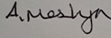 Date: 18/02/2026

Learner’s name: Emma Convery-Evans Learners’ signature: E.Convery-Evans Date: 18/02/2026

The content page includes a list of evidence to be collected as part of your portfolio:

- Log of supporting documents: | Details to include (including criteria): | Date of completion: | Mentors signature: | Appendix / page
- An observation of your practice | A supporting document from your mentor of your compliance with person centred practice (1.2 & 4.3). | 18/02/2026 |  | Appendix 1 / Page 3
- Evidence of reading and learning related to role | A minimum of 2 examples of your engagement with researching and learning on topics related to your role (8.4). | 18/02/2026 |  | Appendix 2 / Page 5
- Log of a wide range of assessments. | A minimum of three anonymised assessments completed by you, demonstrating a range of skills and tools (1.2). | 18/02/2026 |  | Appendix 3 / Page 6, 7, 8, 9
- Copy of a recent Personal Development Appraisal Review (PDAR). | A copy of the most recent PDAR document completed with supervisor / mentor (8.1 & 8.3). | 18/02/2026 |  | Appendix 4 / Page 10, 11
- Copies of your recent supervision records. | A minimum of two supervision records, demonstrating attendance and contribution to supervision and agreement to actions (4.2). | 18/02/2026 |  | Appendix 5 / Page 12,13
- A copy of a risk assessments you have undertaken | A formal or informal risk assessment that you have completed. This can be a case note entry, DATIX, incident report or an assessment completed due to risks (such as a falls risk assessment) (4.3) | 18/02/2026 |  | Appendix 6 / Page 14
- Examples of any training you have participated in or delivered | A minimum of five examples of evidence that you attended or delivered training within the last 12 months (8.4). | 18/02/2026 |  | Appendix 7 / Page 15, 16
- Evidence of your compliance with mandatory training | A minimum of 5 examples of your mandatory training compliance over the past 12 month (4.1). | 18/02/2026 |  | Appendix 8 / Page 17
***The following pages are where you can start to include your evidence:
Appendix 1 (to be completed by your mentor) - Supporting document:
Give a brief description of your relationship with the learner and a typical activity that you have overseen the learner complete:
I am Emma’s clinical lead OT and provide supervisions with her. I have overseen Emma undertake equipment reviews and joint functional clinics, whereby she has taken the lead in providing the intervention.

Does the learner demonstrate the following performance in their day to day practice: | - Yes | - No | - N/A | Signature
- Person-Centred Practice
- Actively listens to patients/carers to understand goals and concerns | √
- Adapts communication style to meet patient needs (such as cognitive, language, sensory) | √
- Respects patient dignity, respect, and personal preferences | √
- Involves patients in decision making and provides clear explanations | √
2. Professionalism & Accountability
- Arrives prepared, punctual, and appropriately presented for the clinical task. | √
- Follows organisational policies, procedures, and scope of practice | √
- Accurately reports and escalates clinical concerns to qualified therapists | √
- Accepts responsibility for actions and learns from feedback | √
- Maintains appropriate boundaries and therapeutic relationships | √
3. Safe & Competent Clinical Practice
- Delivers treatment sessions as prescribed by supervising clinicians | √
- Demonstrates safe handling, mobility, and equipment use | √
- Uses standardized assessments correctly and ethically | √
- Identifies and reports risks (falls, safeguarding, deterioration, environmental hazards) | √
- Documents interventions and outcomes accurately and timely | √

Appendix 2 - Evidence of reading and learning related to role

‘National Occupational Standards describe the skills, knowledge and understanding needed to undertake a particular task or job to a nationally recognised level of competence. They focus on what the person needs to be able to do, as well as what they must know and understand to work effectively’ (Skills for health, 2025).

‘You must only practise in the areas where you have the appropriate knowledge, skills and experience to meet the needs of a service user safely and effectively’ (Health Care Professional Council, 2024).

References
Skills for Health, (2025), National Occupational Standards Overview, Available at https://www.skillsforhealth.org.uk/resources/national-occupational-standards-overview/#:~:text=NOS%20describe%20the%20skills%2C%20knowledge%20and%20understanding%20needed,they%20must%20know%20and%20understand%20to%20work%20effectively., (Accessed: 25th October 2025)
HCPC (2024). Standards of conduct performance and ethics. Available at: https://www.hcpc-uk.org/globalassets/standards/standard-of-conduct-performance-and-ethics/revised-standards-2023/revised-standards-of-conduct-performance-and-ethics.pdf. (Accessed: 25th October 2025)
I have attached the two pieces of evidence above as they are related to my role as a Children’s Occupational Therapy Support Worker.

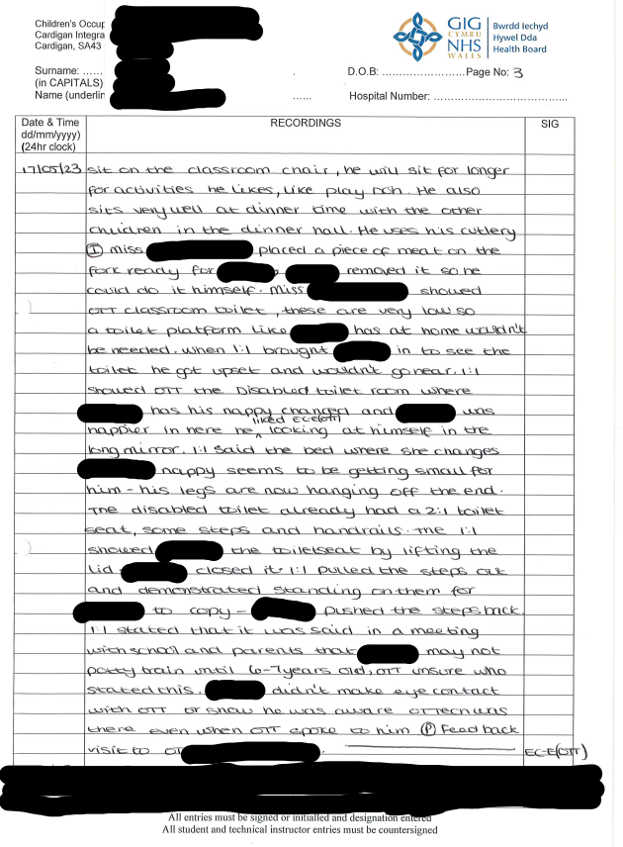
Appendix 3 -Log of a wide range of assessments.

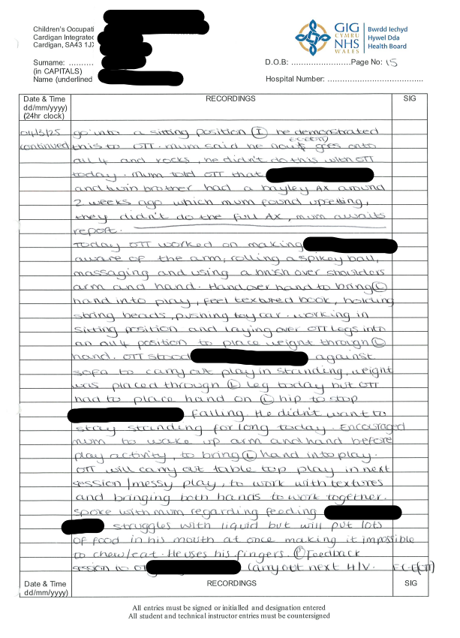
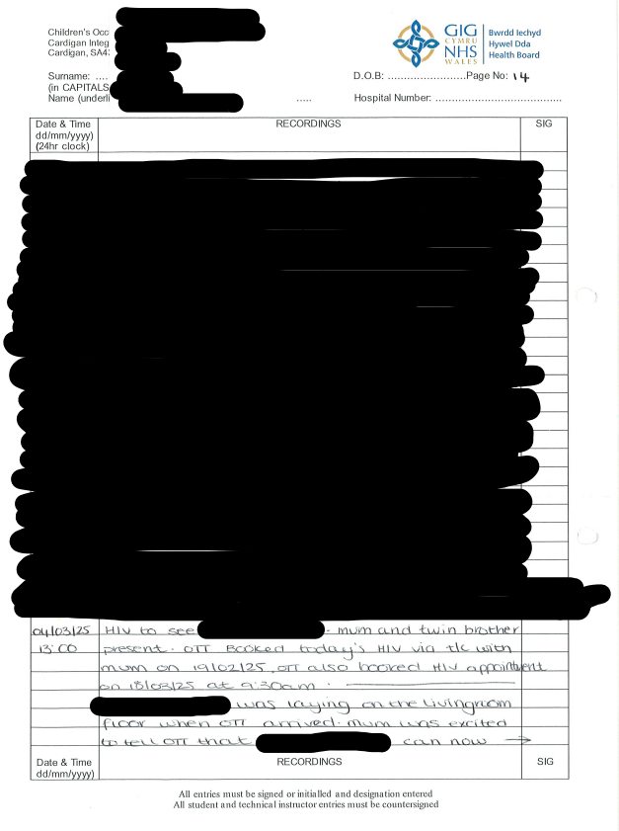

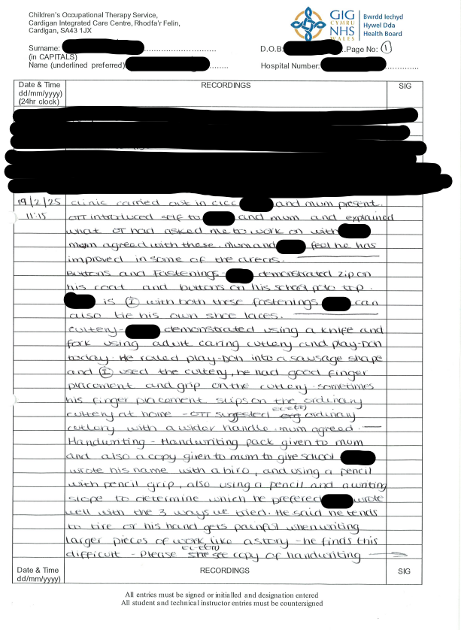
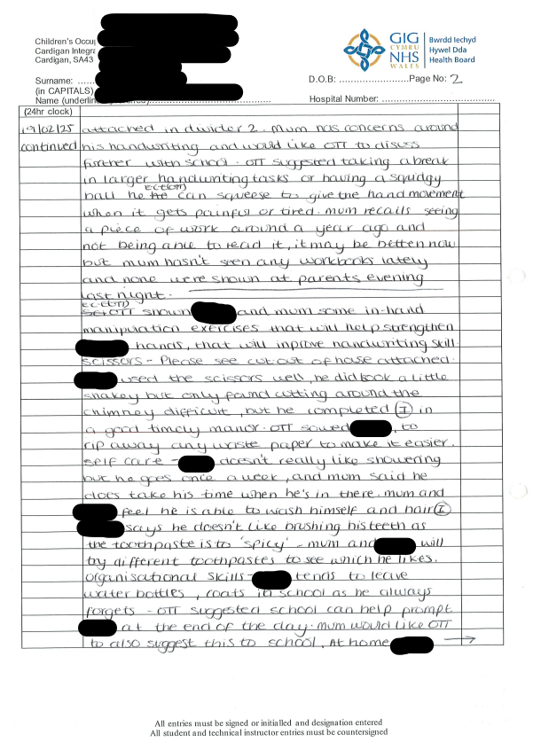

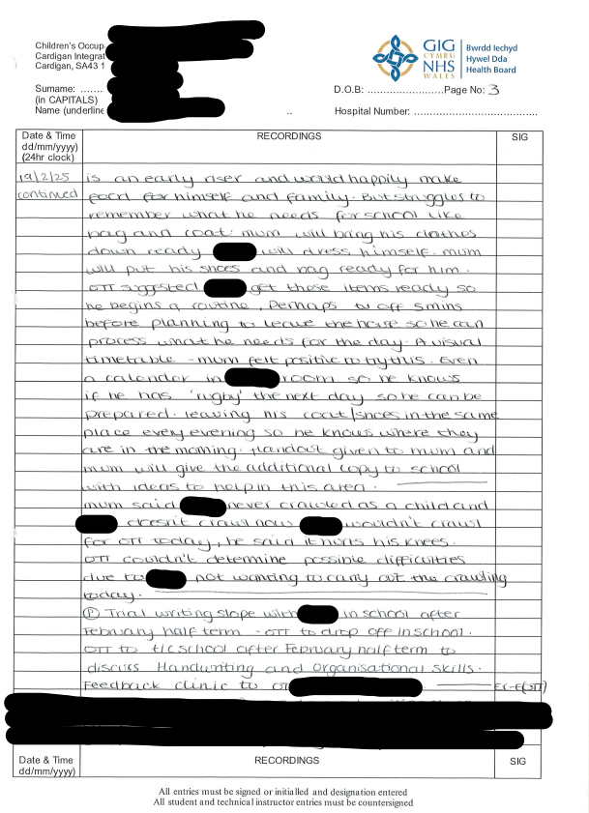
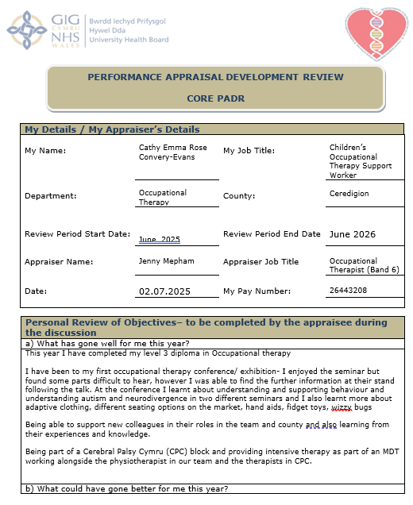
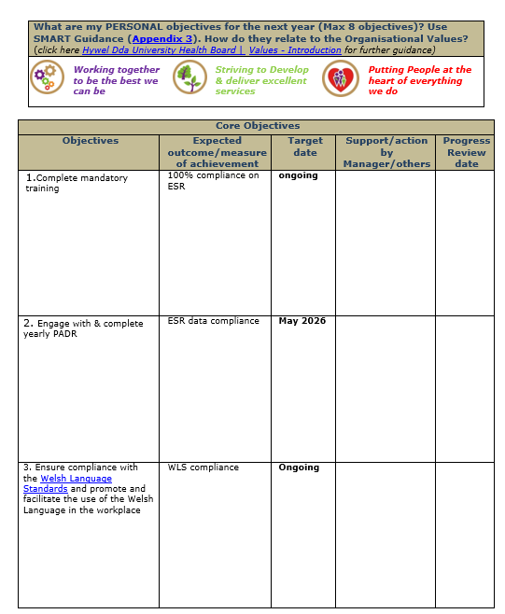
Appendix 4 - Copy of a recent Personal Development Appraisal Review (PDAR).

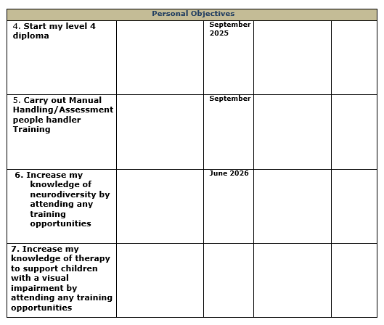
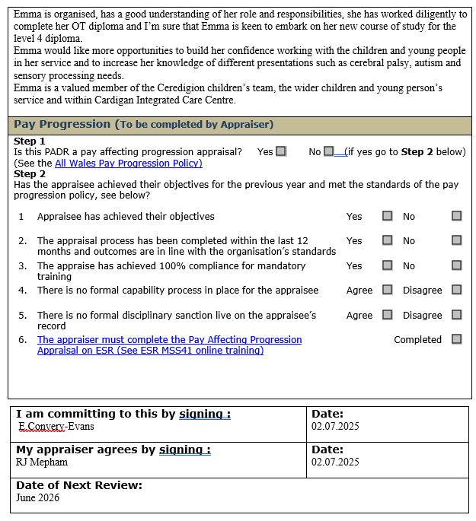

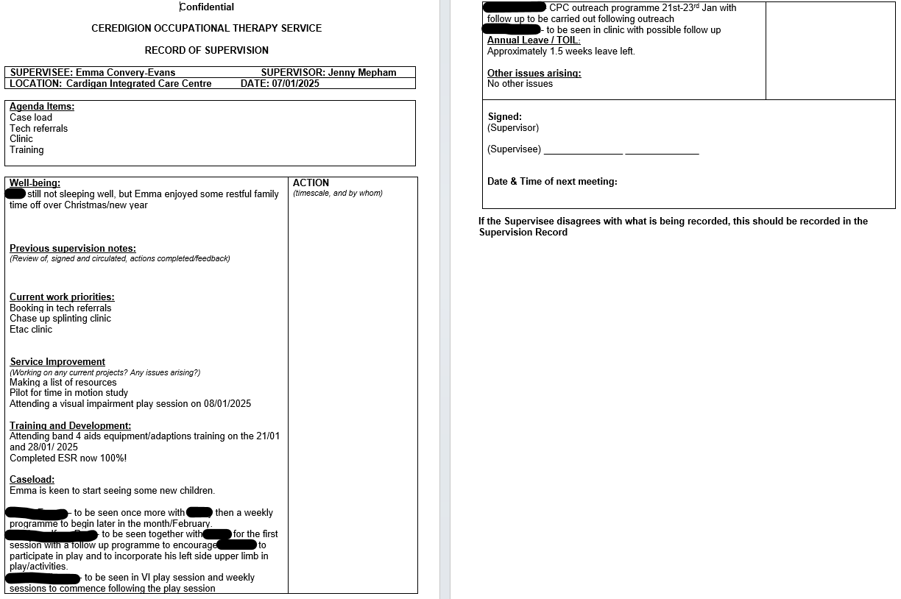
Appendix 5 - Copies of your recent supervision records.

Emma Convery-Evans

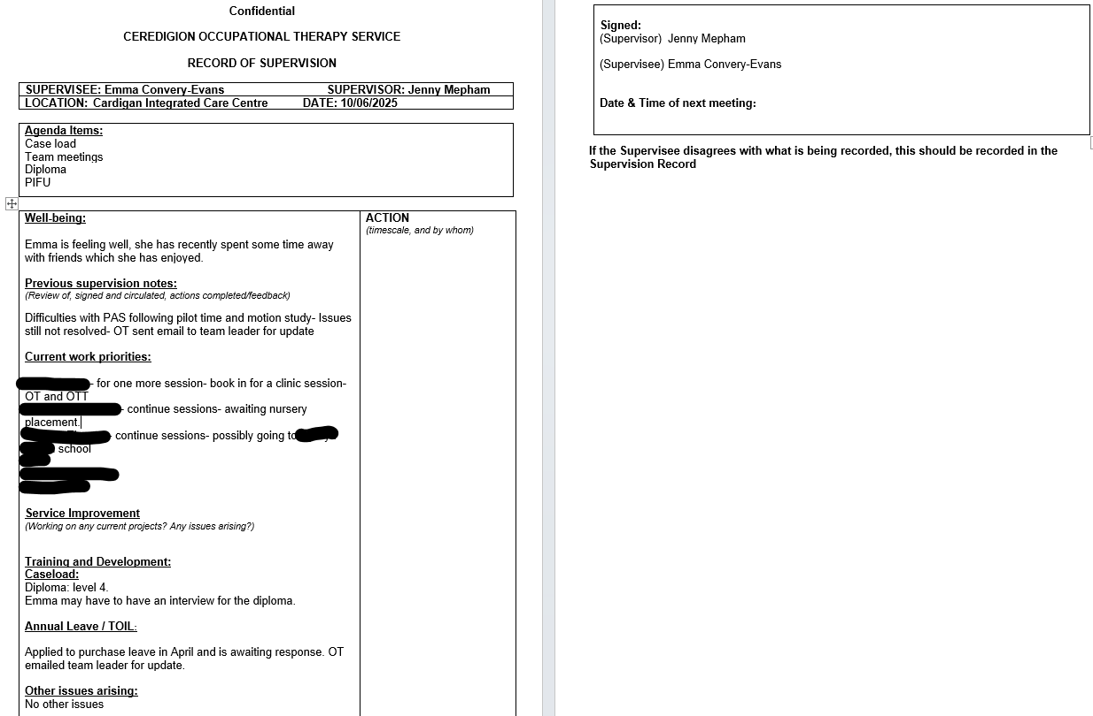

Appendix 6 - A copy of a risk assessments you have undertaken
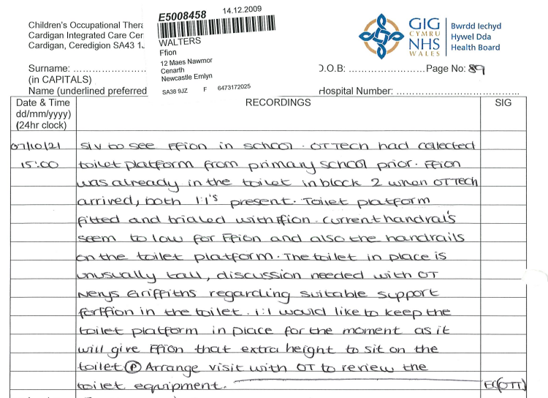

Appendix 7 - Examples of any training you have participated in or delivered

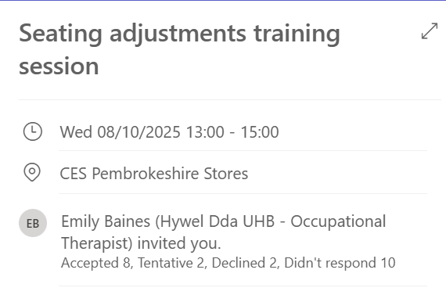
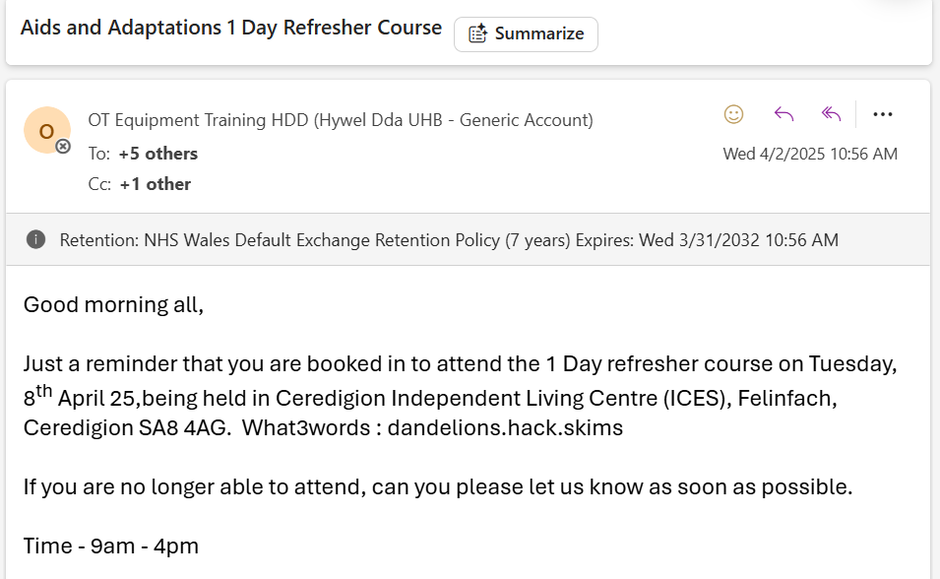

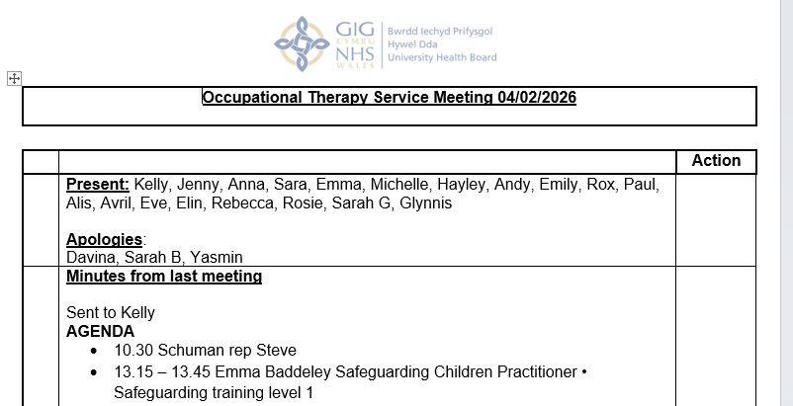
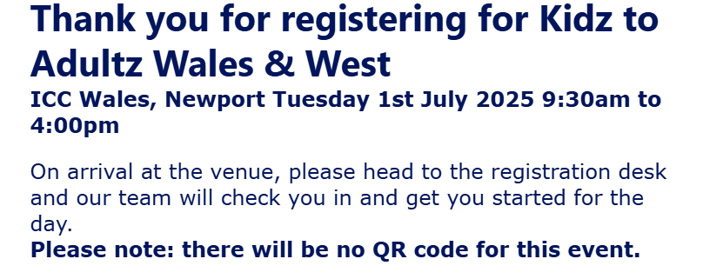

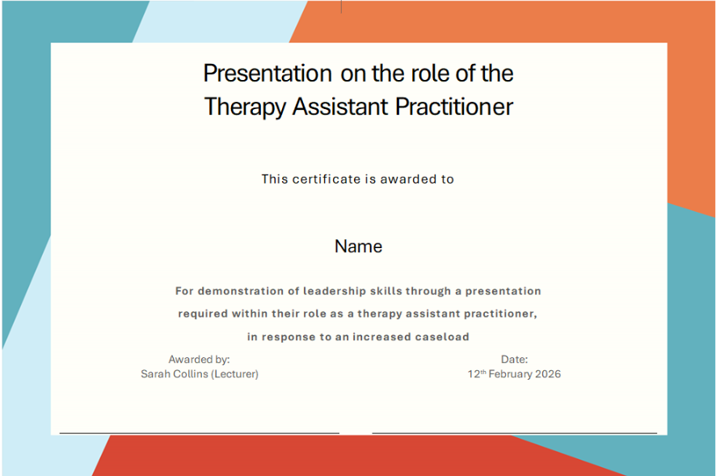
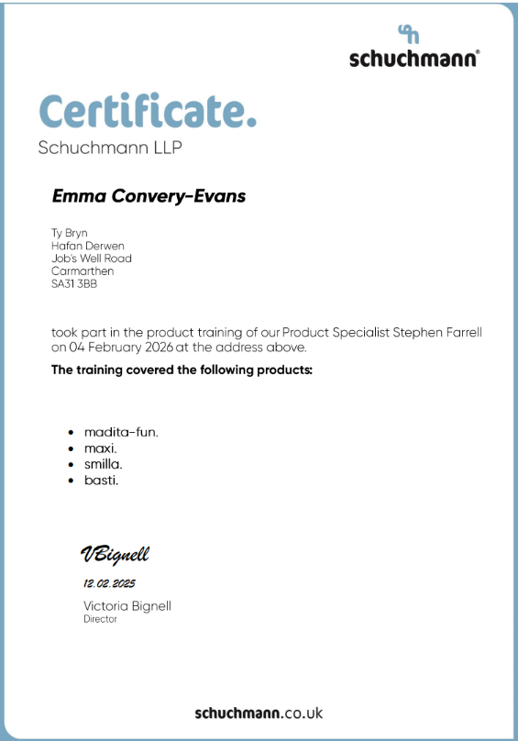

Emma Convery-Evans

20th November 2025

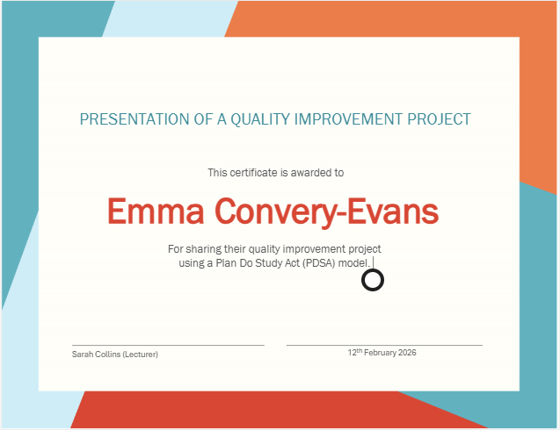

Appendix 8 - Evidence of your compliance with mandatory training


