DS 1 Marekris Racoma Ledda

My Screenshots/Photos
- Please add 4–6 screenshots or photos of your digital life.
- You can use your phone or laptop.
- For each screenshot, write one or two sentences explaining what it shows.

Screenshot/Photo 1
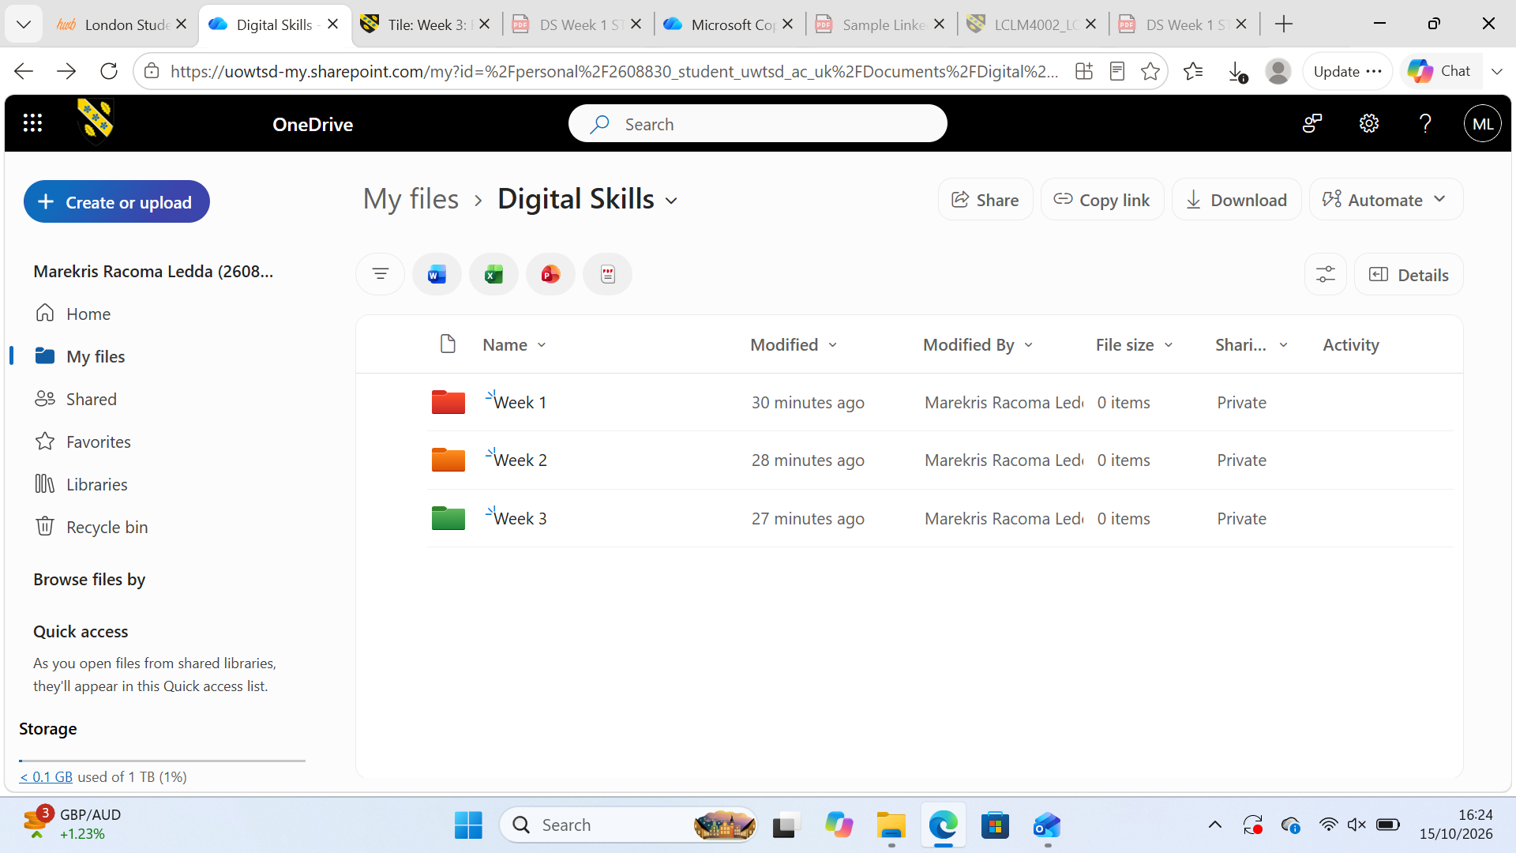
I use Onedrive to create folder for my weekly lessons, such as screencaptures, images and my notes. Using Onedrive makes me organise my homework and my worksheets. This makes my work easy to find what I need and revise my previous lessons and evidence.

Screenshot/Photo 29/60
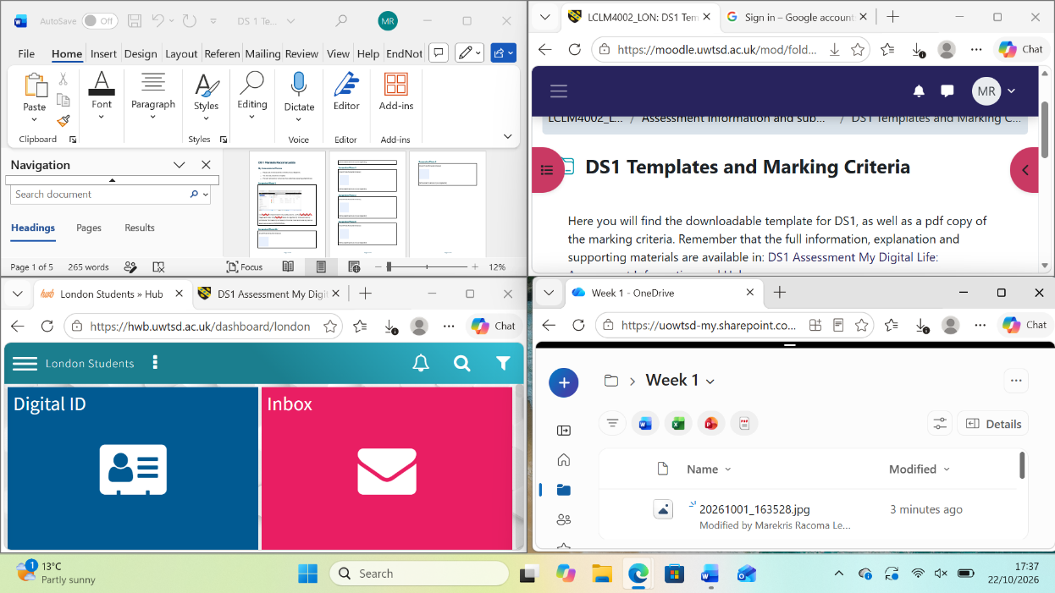
I use my laptop to manage my lessons,such as reading, watching videos and listening to my lessons recording. It helps me get tract and get use to manage all my needs and support my learning. Check my emails and accessing the library online.

Screenshot/Photo 3
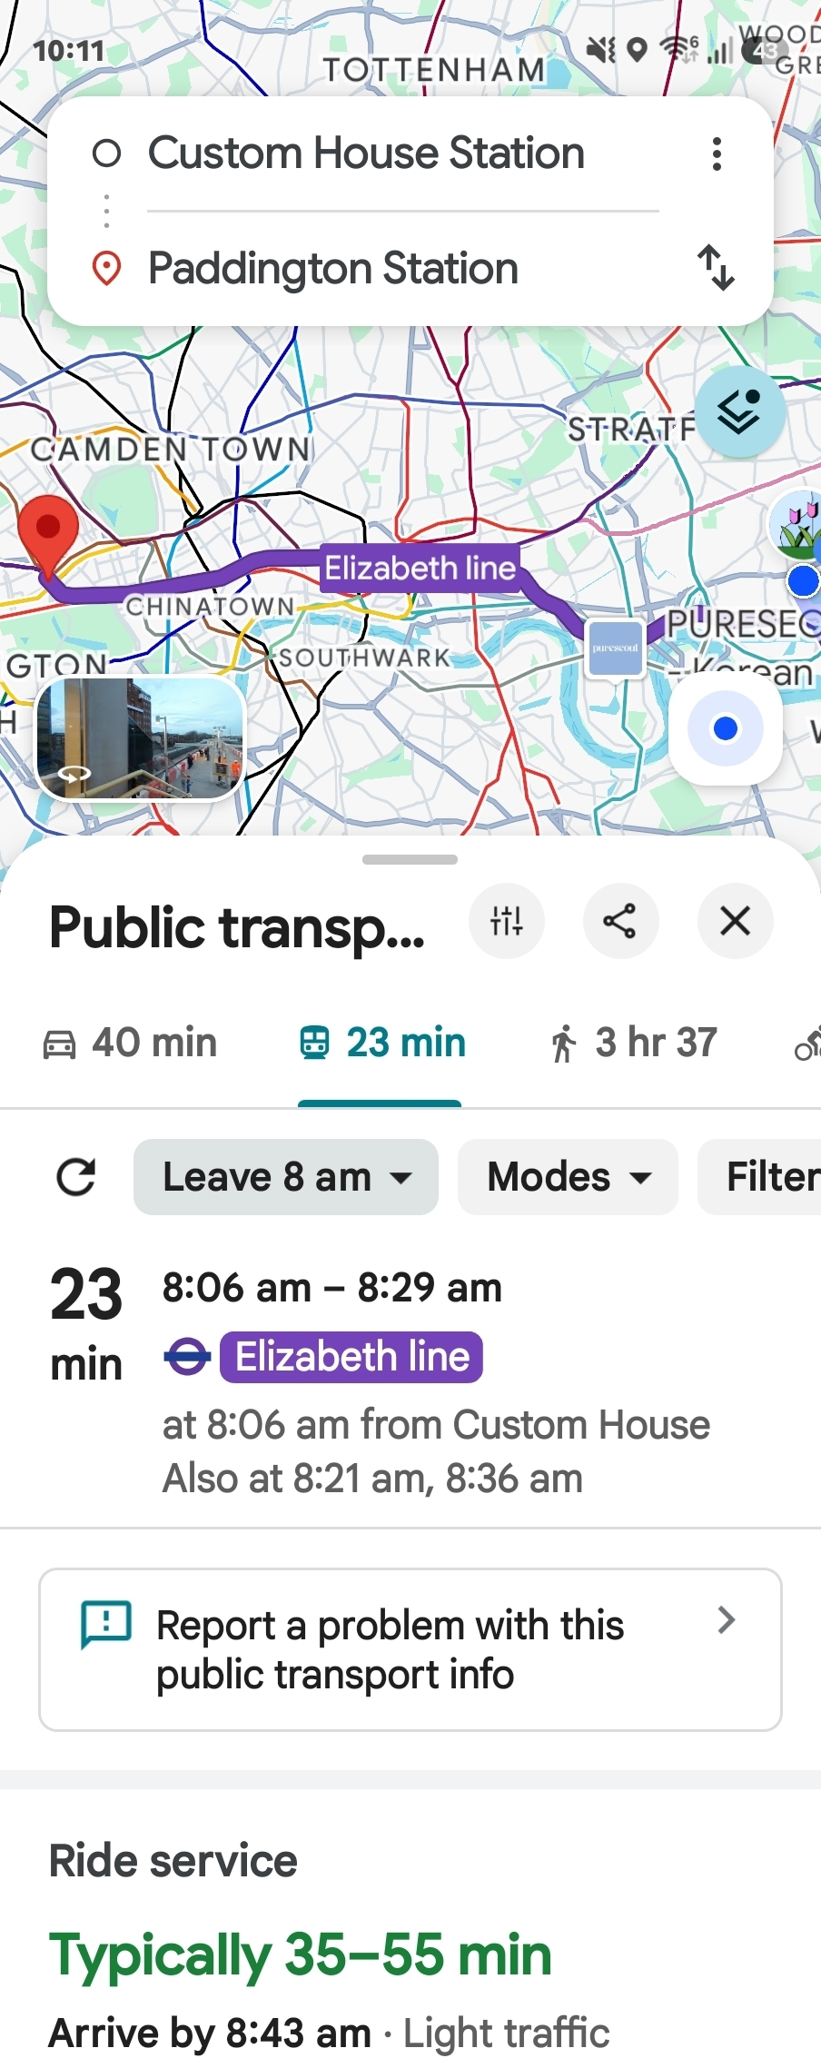
I use Googlemap on my everyday living. Checking the bus times and to calculate my time of arrival and check if there is any disruption on my journey. Its very essential for me to find my location of work I will go, it gives me options to take bus,train or just walk. It saves my time wondering around and asking random people.

Screenshot/Photo 4
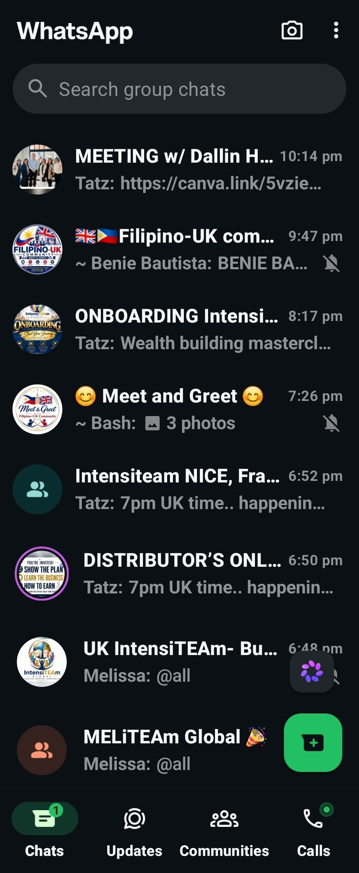
This is WhatsApp, I use this to communicate with my family,friends and business partners. I like using this app as I can make a community group. I can make a separate group in any transactions I make. I could get a live update whether they received my message or not. I use this to make calls and video calls.

Screenshot/Photo 5
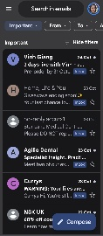
This is googlemail that I used to received important emails, send emails. I use this to get updateds on my childrens and myself appointments such as GP, Dental, school agendas and meetings. I use this to communicate through business such as my partners, suppliers and so on.

Screenshot/Photo 6
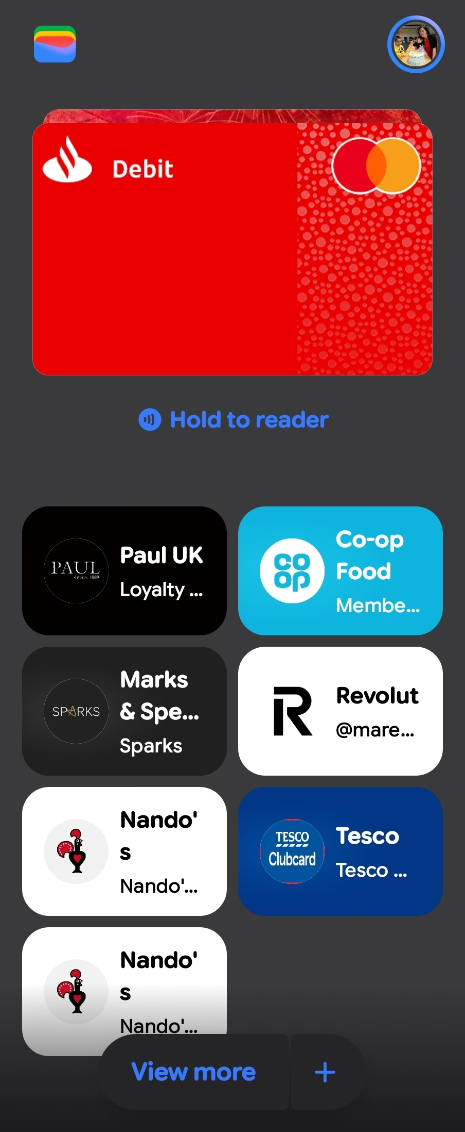
This is Google wallet. My cards is installed to my wallet including all my other cards that gives me points. I have made all my cards accessible for me not to carry dozens or cards with me anymore. I am able to store my tickets on the apps as well. Easier for me to find it and more accessible in a lot of ways.

6My Short Reflection
- Write 5–8 simple sentences about your digital life.
- You can use the sentence starters below if helpful.
My digital life is very useful to my everyday life.
Makes my life easier and accessible.
It gives my more convenient.
It gives me time management.
Gives me freedom to access my digital platforms.
Gives me the opportunity to communicate to people around the world.

Sentence starters
- I use digital tools to …
- I feel confident when I …
- I want to improve …
- I often use these tools: …
- I sometimes feel nervous about …
- I hope this module will help me …
- Digital skills are important for me because …
You can write more if you want.

Submission Checklist
Before you submit, please check:
​​​ ☐ I added 4–6 screenshots
☐ I wrote short sentences for each screenshot
☐ I wrote my short reflection
☐ My work is my own
☐ My file opens correctly
​​☐ My file opens correctly

