

LOCATION: Swansea | LLEOLIAD: abertawe
LEVEL 5 | LEFEL 5
EXAMINATION PERIOD | CYFNOD ARHOLIADAU
may 2019 | mai 2019

MODULE CODE: ACCA5014
DATABASE MANAGEMENT SYSTEMS
TIME: 2 HOURS
answer all of section A

answer TWO QUESTIONS out of THREE in section B

Equipment or materials required – None
Adnoddau neu ddefnyddiau sydd eu hangen - Dim

SECTION A

ANSWER ALL QUESTIONS IN THIS SECTION

Question 1
- Using the Personal Tutors case study, write out SQL data definition language (DDL) statements for the following queries:
  - Create the TutorBooking table without the primary key and foreign key(s), but adding in all columns and column constraints including at least one check and one default constraint.
(7 marks)
Answer
Notes:
- Alternative suitable data types and check constraints may be used
- Constraints do not have to be named – any of the following or other suitable options are valid

CREATE TABLE TutorBooking (
BookingRef INT IDENTITY(1, 1),
BookingDate DATETIME NOT NULL DEFAULT GETDATE(),
TutorNo INT NOT NULL,
StudentNo INT NOT NULL,
SubjectId INT NOT NULL,
SubjectLevel VARCHAR(10),
HourlyRate DECIMAL(6,2) CHECK (HourlyRate >= 7.38)
);

  - Add the primary key to the TutorBooking table.
(1 mark)
Answer
Notes:
- Constraints do not have to be named
ALTER TABLE TutorBooking
ADD CONSTRAINT [PK_TutorBooking] PRIMARY KEY(BookingRef)

  - Add the foreign key(s) to the TutorBooking table.
(3 marks)
Answer
Notes:
- Constraints do not have to be named
- Foreign keys can be added as separate ALTER statements
ALTER TABLE TutorBooking
ADD FOREIGN KEY (TutorNo) REFERENCES Tutor(TutorNo),
FOREIGN KEY (StudentNo) REFERENCES Student(StudentNo),
CONSTRAINT [FK_TutorBooking_Subject] FOREIGN KEY (SubjectId) REFERENCES Subject(SubjectId)

  - Create the TutorSubject table with the primary key and foreign key(s), as well as any column constraints including at least one check constraint.
(8 marks)
Answer
Notes:
- Alternative suitable data types and check constraints may be used
- Constraints do not have to be named – any of the following or other suitable options are valid
- Students should recognise PK is composite and needs to be created after the columns have been defined

CREATE TABLE TutorSubject (
TutorNo INT NOT NULL FOREIGN KEY REFERENCES Tutor (TutorNo),
SubjectId INT NOT NULL FOREIGN KEY REFERENCES Subject (SubjectId),
KSLevel BIT,
ALevel BIT,
HELevel BIT,
MinHourlyRate DECIMAL(6,2) NOT NULL CHECK (MinHourlyRate >= 7.38),
MaxHourlyRate DECIMAL(6,2) NOT NULL CHECK (MaxHourlyRate >= 7.38),
CONSTRAINT [PK_TutorSubject] PRIMARY KEY (TutorNo, SubjectId)
)

- Write out the SQL statements to execute the following queries on the Personal Tutors database.
  - Get a list of all tutors whose DBS Certificate is due to expire in June 2019 and sort the list by expiry date. Include the TutorNo, Name and Contact details in the query results returned.
(2 marks)
Answer
Notes:
- Alternative appropriate WHERE clause syntax may be used
SELECT TutorNo, FirstName, Surname, Email, PhoneNo FROM Tutor
WHERE DBSExpiryDate BETWEEN '01-Jun-2019' AND '30-Jun-2019'

  - For any tutor whose DBS Certificate has expired, update their status to “Pending DBS Check”.
(2 marks)
Answer
Notes:
- Alternative appropriate WHERE clause syntax may be used
UPDATE Tutor
SET [Status] = 'Pending DBS Check' WHERE DBSExpiryDate <= GETDATE()

  - What is the minimum, maximum and average hourly rate charged by tutors for all bookings made this year?
(2 marks)
Answer
Notes:
- Aliases for columns is optional, though helpful
SELECT MIN(HourlyRate) MinHourlyRate, MAX(HourlyRate) MaxHourlyRate, AVG(HourlyRate) AvgHourlyRate FROM TutorBooking;

(Total 25 marks)
SECTION B
ANSWER TWO QUESTIONS FROM THIS SECTION
Question 2
- The overall description of a database is made up three types of schema: external, internal and conceptual schemas. Distinguish between these three types of schemas.
(6 marks)
Answer
- External schemas are many and describe the various different views of data.
- Conceptual schema, describes all the entities, attributes and relationships, as well as any integrity constraints. There is only once conceptual schema per database.
- Internal schema is a complete description of the internal model, i.e. definitions of the physical storage, organisation structures and methods of representation e.g. indexes and storage structures used. There is only one internal schema per database.

- A common internal schema change is the addition or modification of indexes.
  - Describe the purpose of an index in a database.
(2 marks)
Answer
- An index is a structure that provides accelerated access to the rows of a table based on the values of one or more columns in the table. The presence of an index can significantly improve the performance of a query.

  - Why is it important to analyse transactions before implementing indexes in the database and what type of criteria would you be looking at to help you decide on the indexes to implement in the database?
(6 marks)
Answer
- To carry out physical database design effectively, e.g. choose appropriate indexes, it is necessary to have knowledge of the transactions or queries that will run on the database.
- The transactions that run frequently and will have a significant impact on performance;
- The transactions that are critical to the operation of the business;
- The times during the day/week when there will be a high demand made on the database (called the peak load).

  - By default most DBMSs will automatically index the primary key column(s) as the Clustering Index, the column(s) used to order the rows in a table. Sometimes it may, however, be more beneficial to use non-primary key column(s) as the Clustering index.
    - In the Tutor table, identify an alternative appropriate Clustering index for this table giving reasons for your choice
    - Write out the SQL code to create this index.
(2 marks)
Answer
- A common query will be to find tutor by city, so it may make sense to order the tutors by city and their tutor no.
- Other appropriate responses may be considered
CREATE CLUSTERED INDEX idx_TutorByCity ON Tutor (City, TutorNo);

  - Secondary indexes provide a mechanism for specifying an additional index key for a table that can be used to retrieve data more efficiently.
    - Choose one appropriate column to index as a secondary index in the Tutor table and indicate why you have chosen to index this column.
(2 marks)
Answer
- Any appropriate column

  - Write out the SQL statements to:
    - Make a new booking (Booking Ref: 500)
      - Student: Martin Thomas (ID: 25)
      - Subject: Programming (ID: 100)
      - Tutor: John Davies (No: 66)
    - The booking should include two individual 2-hour (120 mins) lessons
      - Booked for 30-May-2019 and 31-May-2019 at 10:00 am
      - Use the minimum set of required fields to book the lessons.
(6 marks)
Answer
Notes:
- Column names may be omitted in first INSERT but order of values is important.
- If omitted in second, then values for all columns should be specified and order of values is important
INSERT INTO TutorBooking (BookingRef, BookingDate, TutorNo, StudentNo, SubjectId, SubjectLevel, HourlyRate)
VALUES (500, GETDATE(), 66, 25, 100, 'HE', 25.00)

INSERT INTO BookedLesson (BookingRef, LessonDateTime, DurationMins, Location)
VALUES (500, '30-May-2019 10:00', 120, 'Costa Swansea')

INSERT INTO BookedLesson (BookingRef, LessonDateTime, DurationMins, Location)
VALUES (500, '31-May-2019 10:00', 120, 'Costa Swansea')

(Total 25 marks)

Question 3
Security is of paramount concern when using multi-user systems and is an important function of a Database Management System.
- A database is an essential corporate resource that should be properly secured using appropriate controls. What are four examples of database security threats and identify the risks they pose to the organisation?
(8 marks)
Answer – any four points from the following
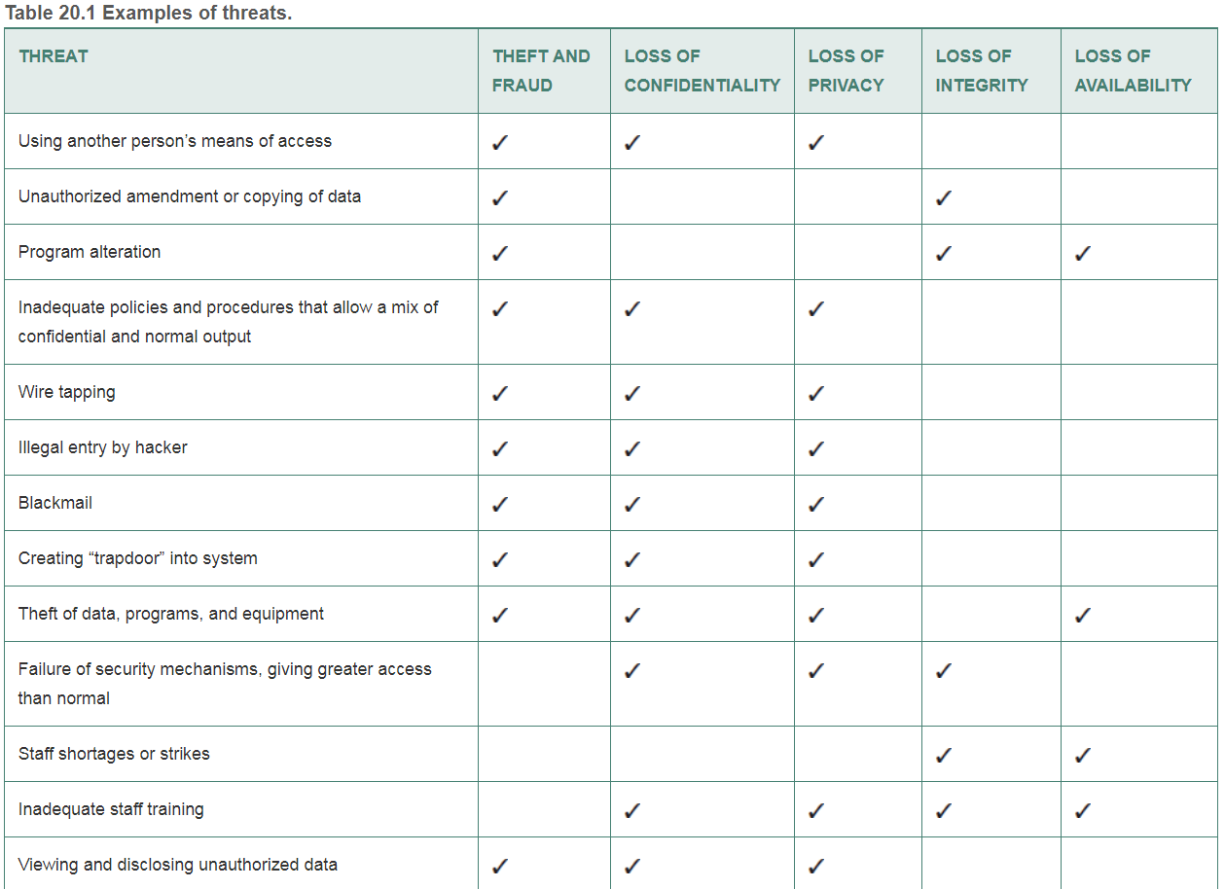
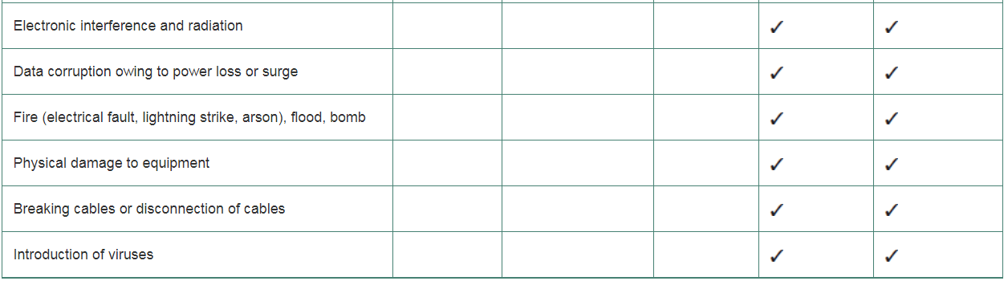

- The Database Administrator is suspicious about the activities being performed by some users. Explain how the DBA may use the following in terms of providing security controls:
  - Authentication
  - Access controls and user privileges
  - Views
(9 marks)
Answer
- Authentication: a mechanism that determines whether a user is who he/she claims to be. It is a process of verifying the identity of a user.
  - User accounts, identifiers and password authentication are the most common methods of verifying the identity of a user.
  - Authentication can be done at the operating system level, but it is also desirable to require it again at the database level.
  - Use of accountability – capture and maintain security logs that can be used for traceability when security incidents occur.
- Access controls and user privileges: making sure that data or other database resources are accessed in only authorised ways.
  - The typical way of doing this is based on granting and revoking privileges.
  - In SQL, the use of authorisation controls, i.e. granting of rights or privileges to users on database objects and what the user may do with the object can also be used. (Note: The use of privileges spans across the three terms: authentication, access controls and views)
  - Privileges are granted to users to accomplish the tasks required for their jobs. They define whether a user is allowed to read, create or modify some database object or to run certain DBMS operations/utilities.
- Views: a widely used mechanism for implementing access control in a database.
  - It provides a powerful and flexible security mechanism by hiding certain parts of the database from certain users. It hides the structures and data that the user should not see.
  - A view can be defined over several relations, with a user being given access privileges to the view but not the base relations.
  - WHERE clauses can also be added to specify restrictions on the selected view data.

- Using the Personal Tutors database create a view containing a list of all “Active” tutors and the subjects they teach. The query results should:
  - Include the name, email and city location of the tutors
  - Include the names of the subjects, the levels taught and the minimum and maximum hourly rates the tutors charge.
  - Sort the results by subject and city
(8 marks)
Answer
- Students should not use SELECT *
- Students should recognise the JOINS required
- WHERE and ORDER BY clauses are required
- The order of WHERE and ORDER BY is important
CREATE VIEW TutorSubjects
AS
SELECT t.TutorNo, FirstName, Surname, Email, City, [Subject], KSLevel, ALevel,
HELevel, MinHourlyRate, MaxHourlyRate
FROM Tutor t
JOIN TutorSubject ts ON t.TutorNo = ts.TutorNo
JOIN Subject s ON s.SubjectId = ts.SubjectId
WHERE [Status] = 'Active'

(Total 25 marks)

Question 4
Transaction Support, Concurrency Control and Recovery Control are three closely related functions of the DBMSs used to ensure that the database is reliable and in a consistent state.
- The ACIDity properties of transactions are used to provide database consistency and reliability. Identify and define each of these properties.
(6 marks)
Answer
- A: Atomicity; all-or-nothing property i.e. a transaction is an indivisible unit performed in its entirety or not at all;
- C: Consistency (correctness); a transaction must transform the database from one consistent database state to another;
- I: Isolation; transactions execute independently of each other; i.e. partial effects of incomplete transactions should not be visible to other transactions;
- D: Durability; ensures that once a transaction commits, its results are permanent and cannot be erased from the database;

- What role does concurrency control play in ensuring that the database is reliable and remains in a consistent state?
(3 marks)
Answer – anything similar to
- Concurrency control is the process of managing simultaneous operations on the database without them interfering with one another.
- Prevents interference when two or more users are accessing the database simultaneously and at least one of them is updating data.

- Lack of concurrency control can lead to three potential problems when multiple transactions are scheduled to execute concurrently: lost updates, uncommitted dependency and inconsistent analysis
  - Define each of these problems.
(6 marks)
Answer
- Lost Update: An apparently successfully completed update transaction by one user is overridden by another user.
- Uncommitted Dependency: Occurs when one transaction is allowed to see the intermediate results of another transaction before it has committed.
- Inconsistent Analysis: occurs when a transaction reads several values from the database but a second transaction updates some of them during the execution of the first.

  - Transactions T₁ and T₂ are operating on an account balance, bal_{X} (initial value £500) as follows:
• Transaction T₁ is withdrawing £50 from the account.
• Transaction T₂ is depositing £100 into the account.

Complete the following table (see attached sheet) to illustrate how the lost update problem can occur with the following transactions. Explain how the lost update problem has occurred and how it can be prevented.

Answers in table shown in blue. Explanation:
- T₁ (transaction time t6) overwrites the previous update made by T₁ thereby “losing” the £100 previously added to bal_{X} by T₂.
- The loss of T₂’s update is avoided by preventing T₁ from reading the values of bal_{X} until after T₁’s update has been completed, i.e. committed.

Time | T₁ | T₂ | bal_{X} (£500)
t1 |  | BEGIN TRANS | 500
t2 | BEGIN TRANS | Read bal_{X} | 500
t3 | Read bal_{X} | bal_{X} = bal_{X} + 100 | 500
t4 | bal_{X} = bal_{X} - 50 | Write bal_{X} | 600
t5 | … | COMMIT | 600
t6 | Write bal_{X} |  | 450
t7 | COMMIT |  | 450

(7 marks)

- The Recovery Control function of the DBMS is responsible for restoring the database to a correct state in the event of a failure.

The following figure illustrates a timeline for a number of transactions, T1 … T4, executing concurrently in the Personal Tutors database. The timeline shows each transaction’s starting and ending time along the DBMS timeline. A start and a commit are indicated by a large dot, while an abort is indicated by an X. The DBMS starts at time t₀, but fails at time t_{f}, while at time t_{c}, a checkpoint occurs.

t0 tc tf
T₁
T₂
T₃
T₄
X
Assuming the DBMS is using an immediate update recovery technique:
  - Which transactions, if any, need to be redone and why?
  - Which transactions, if any, need to be undone and why?
  - Which transactions, if any, are not affected by the crash and why?
(4 marks)
Answer
- redo T₃. Although the transaction has committed, it is not clear if the committed changes have been stored to permanent storage as the commit happened after the last checkpoint.
- undo T₄. This transaction had not been committed at the time of the crash.
- T₁ and T₂ are unaffected as they had both completed and committed/aborted prior to the crash.

(Total 25 marks)
Diwedd/End

Student Number: ………………………………………………………………………

Time | T₁ | T₂ | bal_{X} (£500)
t1 |  | BEGIN TRANS | 500
t2 | BEGIN TRANS | Read bal_{X}
t3 | Read bal_{X} | bal_{X} = bal_{X} + 100
t4 | bal_{X} = bal_{X} - 50 | Write bal_{X}
t5 | … | COMMIT
t6 | Write bal_{X}
t7 | COMMIT
Table 1: Table for Question 4c.ii.

DATABASE MANAGEMENT SYSTEMS (ACCA5014) EXAM MAY 2019
Personal Tutors Case Study
Personal Tutors is an online service designed to help registered members find tutors, communicate with them and book and pay for lessons. Tutors are selected carefully and all registered tutors must have a valid, up-to-date DBS certificate. Members can book lessons with a preferred tutor at an agreed rate. Booked lessons can be cancelled within 24 hours of the booked lesson time. All payments are handled through the platform service. Payment is taken once the lesson has taken place and payments are made to tutors at the same time.

A subset of the current database schema for the Personal Tutors platform is shown below. Please note that the database schema does not truly reflect a real world scenario as it has been simplified for examination purposes.

Table | Columns
Subject | SubjectId, Subject
Tutor | TutorNo, Title, FirstName, Surname, DOB, Email, City, Postcode, PhoneNo, DBSExpiryDate, Status
TutorSubject | TutorNo, SubjectId, KSLevel, ALevel, HELevel, MinHourlyRate, MaxHourlyRate
Student | StudentNo, Title, FirstName, Surname, ContactEmail, ContactAddress, City, Postcode, PhoneNo, CardNo, CardCVV, CardExpiry, Status
TutorBooking | BookingRef, BookingDate, TutorNo, StudentNo, SubjectId, SubjectLevel, HourlyRate
BookedLesson | BookingRef, LessonDateTime, DurationMins, Location, CancellationDateTime, PaymentDetails, TutorFee
Table 1: Current database schema for Personal Tutors database (Note: primary key fields for each table have been underlined)

Where:
Table | Description
Subject | Contains a list of different subjects available.
Tutor | Contains details of tutors registered with Personal Tutors.
TutorSubject | Contains a list of subjects taught by a tutor.
Student | Contains details of student members registered with Personal Tutors.
TutorBooking | Contains details of a tutor booked by a student for a particular subject. It includes the hourly rate agreed with the tutor.
BookedLesson | Contains details of the individual lesson dates and times the student has booked as part of a set of tutoring sessions.

