

Thomas Lumsden

Reflection on Study Skills

UWTSD
Study Skills - ACDB4010

Academic Year: 2024/2025

© UWTSD 2025. All rights reserved. No part of this publication may be reproduced without the written permission of the copyright owner.

Table of Contents
1 | Presentation | 3
1.1 | Brief overview as per class presentation exercise | 3
1.2 | Screengrabs from initial PowerPoint presentation | 3
1.3 | Key points learnt when trying to produce and deliver a successful PowerPoint presentation | 4
1.4 | Aspects for improvement to enhance future presentations | 4
2 | Skills Evaluation | 5
2.1 | Required skills identified for successful learning in a Higher Education environment | 5
 | 2.1.1 Self-Motivation | 5
 | 2.2.2 Effective Notetaking | 5
 | 2.2.3 Critical Thinking | 6
2.2 | Generic, transferrable skills employers look for in prospective candidates | 6
 | 2.2.1 Communication | 6
 | 2.2.2 Problem Solving | 6
2.3 | Self-Evaluation exercise on strengths and weaknesses | 7
 | 2.3.1 Kinesthetic Learner test | 7
 | 2.3.2 Strengths and weaknesses test | 7
2.4 | Main short term and long term goals | 8
 | 2.4.1 Academic | 9
 | 2.4.2 Personal | 9
3 | Application | 10
3.1 | Looking after your data – backup strategy that obeys the ‘in 3 difference places rule’ | 10
3.2 | Time management and self-organisation | 11
 | 3.2.1 Steps to enhance productivity, improve organisation and/or reduce stress levels | 11
 | 3.2.2 Screenshots as evident of completed e-Portfolio/PDP implementation | 12
3.3 | Independent Study – ability to gather and present new information | 12
4 | Conclusion and Evaluation | 13
Appendix 1 |  | 14
Appendix 2 |  | 15
References |  | 16
- Presentation

  - Brief overview as per class presentation exercise
My name is Thomas Lumsden. I am a 17-year-old boy living in a small village in the west of Scotland called Clydebank. Recently left secondary school to pursue an apprenticeship. I tend to live a quiet life, living with my mother and two younger siblings, who I showed to be quite close with. I portrayed myself as a man of many hobbies and was able to show different sides of what I do during my free time, ranging from being a person who is big into gaming, who has played a variety of popular games over the course of some years, even showing my gaming setup in my room. I also gave people an idea of my creative side, showing pictures of different drawings, I have done for various YouTube video thumbnails on my drawing tablet. I took pride in also being able to show some pictures I have taken of nature and wilderness which displayed that I am a person who likes the outdoors and the wonders of nature. Overall, I painted the picture that I am a very hobby centred person who likes a range of different activities, from nature, to drawing, music, racing and a family-oriented person.
  - Screengrabs from initial PowerPoint presentation

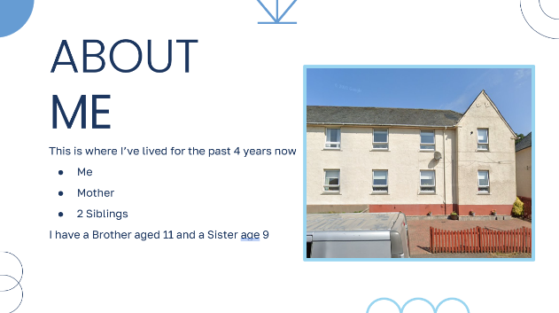
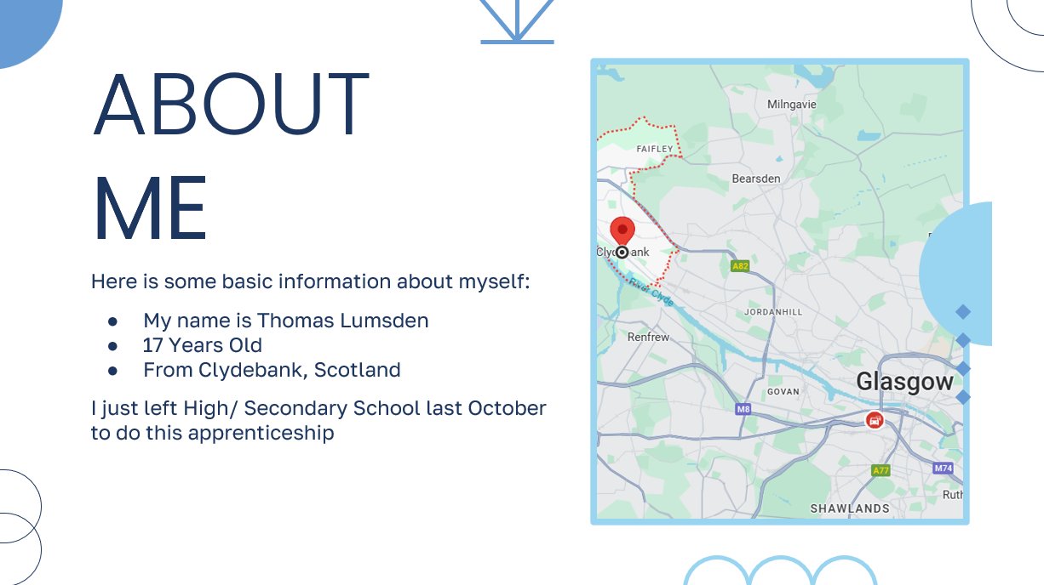
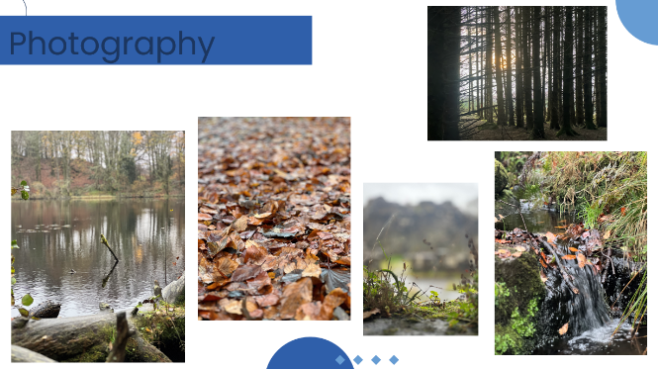
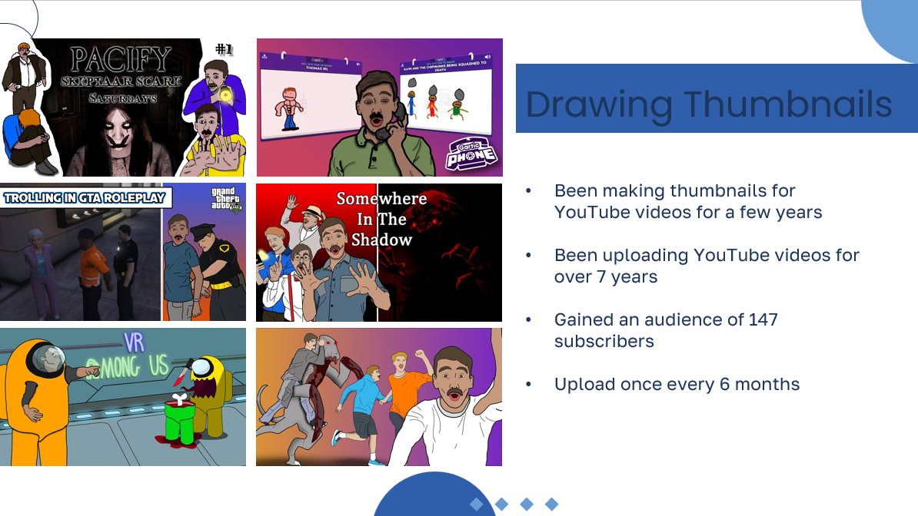

  - Key points learnt when trying to produce and deliver a successful PowerPoint presentation
Through doing this presentation, I have so far learned many valuable skills I will be able to apply in the future.
Not reading off the slides is a key aspect to producing a successful presentation, as when you are reading off the screen, you never seem to be engaged with your audience. I was able to maintain eye contact and faced the audience which showed I have aspects of confidence and was speaking directly to them. In doing this also showed I knew what I was talking about and can speak from knowledge and able to elaborate if someone has a question or does not understand something. Feedback from audience reinforced that what I had learned had a positive output in my presenting skills “Remained calm and presented himself in a positive and approachable fashion, was able to answer question and keep the audience engaged.”
Time management helps in producing a high quality and well put together presentation. When leaving the development of a presentation to the last minute, many problems can arise including an untidy and rushed layout of a presentation. This can make it seems to the audience that you have rushed it, as they can clearly see that the level of professionalism is not there. In making my presentation I was able to produce a high quality and successful presentation due to making sure I made good time and was not stressed about not having it finished in time. I made sure my presentation was flowing at a natural pace, and I was not rushing or dragging any parts, which made it look like to the audience that I had prepared well and am able to plan well for things like this. I made sure this would be the case as while practicing, timing myself while giving the presentation to myself helped give a good idea how long I should spend on each slide to ensure that I was able to keep within the set time.
  - Aspects for improvement to enhance future presentations
I have also identified areas I should work on in relation to my presenting skills for future situations to ensure a successful presenting experience.
Layout of presentation. When producing my presentation, I included many images across my slides as I was showing different pictures I had taken/ made. Looking back now, I think it would be a clever idea to contain less images in my presentation as it makes it difficult for the audience to stay engaged with what I am saying while also trying to look at all the images. I was given feedback from my audience in that I “Do not overwhelm slide with images as this could distract audience from what you are saying.”
Confidence when giving the presentation. I was quite nervous in the buildup to giving the presentation, as giving presentations and public speaking is something out of my comfort zone and that I am not a fan of doing. When giving my presentation due to being nervous was quiet, this is enforced as in getting feedback I was told to “Project voice more when public speaking”. This would help people understand and better and hear everything I have to say while also showing I am confident in speaking in front of an audience.
- Skills Evaluation

  - Required skills identified for successful learning in a Higher Education environment
I have performed my own research to identify what skills I think are necessary for a successful learning experience in a higher learning environment.
2.1.1 Self-Motivation
Being responsible for managing your own learning in a higher learning environment I found is very important. Self-research and home learning is stressed more than ever. There are many things that you need to do to make sure you have a successful learning experience and having that drive to make sure you do everything that is required to achieve that is key. Staying committed to studies and setting goals are just some of the things you can do to fulfil the purpose you have at this level of learning. This sense of purpose continues to motivate them throughout their careers and personal lives [1]. Staying motivated to learn, putting that effort in to ensure the best results, keeping engaged with lessons and being eager to be taught are all key parts to guaranteeing a successful learning experience. Without putting in effort, you cannot learn.
2.1.2 Effective Notetaking
I have identified that having effective note-taking skills when learning in a higher learning environment is crucial to ensure the best possible knowledge coming out of a lecture. Taking notes is key when attending a lecture, this is the material you can look back on and further research on. Taking notes requires understanding on the topic you are being lectured on, without understanding on the topic, you are just writing the words you hear down, which can further clutter your material and halt your progress while learning from home. To ensure that you are taking notes in the most beneficial way you may want to only take notes of key points and focus on remembering what is being said rather than becoming distracted from what the lecturer is saying since you are trying to scribble down everything you hear. This will help you identify the key aspects of the material being covered and will result in more in depth and accurate notes of the most relevant information. This makes studying easier as you have much more reliable information to base your studies off and to refer to.
2.1.3 Critical Thinking
Having in depth critical thinking skills can massively benefit oneself by being able to see the bigger picture and able to see things from all angles. In a higher learning environment, there will be situations where you will be expected to deal with issues and questions which do not have a single answer [2]. Being able to attack a problem from multiple angles is an example of positive critical thinking, being able to choose the most beneficial path to an issue after considering multiple viewpoints can result in your own unique viewpoint. In a higher learning environment, having this skill can objectively translate to other skills including, better decision making, self-reflection and the being able to identify misinformation.
2.2 Generic, transferrable skills employers look for in prospective candidates
Similarly, I have performed my own research to identify what skills I think employers look for in prospective job candidates.
2.2.1 Communication
Communication is a must have skill when it comes to employment, this is the basis of all teamwork. In ICT or other occupations for graduates in 2018, cognitive skills, communication, critical thinking, and problem-solving are demanded most widely [3]. Employers are looking for people who can effectively talk to their team to work to the most optimal standard and in the most efficient way possible. This results in things like deadlines being met faster, improved client relations, increased engagement, and stronger team morales. Being open in communication within a team gives the possibility to share innovative ideas and perspectives, which can lead to new solutions and innovation. Employers strive for someone with effective communication skills and being able to show that to them heavily increases the chances of being a successful candidate in applying for a position.
2.2.2 Problem Solving
Employers are keen to have an employee with good problem-solving skills as people who have this tend to benefit the employer greatly. To name a few positive impacts that comes with having complex problem-solving skills includes, efficiency within the workplace, adaptability, creativity and ability to make better decisions overall. If an employee has effective problem-solving skills, this can result in being able to identify issues and efficiently but also accurately deliver a solution that is beneficial to all parties. Problem solvers are also equipped to better identify things that may have gone wrong and are able to adapt to this, and still able to deliver a positive outcome. This benefits the employer as problem solvers are less likely to need assistance with a task and also able to come up with a solution to a problem without the manager needing to step in. That is why in most managers, problem solving is a crucial skill needed for managing within a team.

2.3 Self-Evaluation exercise on strengths and weaknesses
2.3.1 Kinesthetic Learner test
When doing an online quiz, I learned that I am a Kinesthetic-ISTJ learner [see Appendix 1]. Which stands for:
I – Introverted
S – Sensing
T – Thinking
J – Judging
ISTJ learners tend to thrive in situations where the material relates to real-life situations and where order is maintained during the learning process. These types of learners also benefit where there is repetition of material with practical examples and where positive affirmation is provided. The ISTJ learners also show signs of weakness where there are theoretical situations or examples. There is also a tendency to struggle when trying to grasp where some material will be used in real life situations. These results seem accurate to me and depict well what I would have predicted it to display, I have always depicted myself as someone who is quite introverted when it comes to learning and also someone who likes to keep to themselves when learning rather than learning in a group, this test reinforces that idea.
Kinesthetic learners are the type to work well when hands on work/ demonstrations are taking place, and when they tend to see things being done, they are able to replicate what they see easier than other learners. I see this in myself as I am also able to work well after I see something done. Practical lessons are where I really understand what is being taught as I am able to see the process behind something, this is also another example of learn by doing.
2.3.2 Strengths and Weaknesses test
When doing a strengths and weaknesses test [see Appendix 2], I found that my top five strengths are:
- Integrity
- Self-Motivation
- Focus
- Innovation
- Visionary

I somewhat expected these results, as Integrity, Self-Motivation and Innovation are some of the words I could refer to myself using, as I am a person who sticks to what they like to do and thrive where they are most comfortable. I would also consider myself to be someone who likes making meaningful decisions for themselves and needs space while doing so. My strength tends to show when I am in control of a situation and need feedback to develop my instincts. I was somewhat surprised when focus was one of my strengths, as I would describe myself as someone who can get easily distracted when doing something I am not particularly interested in. But when set on a certain task with clear instructions, while also being something I enjoy, I can be extremely focused.
And my weakness was:
- Leadership
This result was expected for me. I am open when it comes to being a shy introverted person, and this weakness was not shocking for me. When it comes to working in a team, I would usually prefer to work alone, and having leadership within a workplace or education environment is not something with which I would associate. In doing this assignment, I have bettered my understanding of the importance of having leadership and what it can bring to the table and benefit oneself. I acknowledge that this is something I would like to work on in the future to better myself if I am tasked to work in a team or even manage staff.
I have now compared the data I have been given from these tests and compared the results to find that there is a clear relation between both tests. They both enforce ideas that I am a person who likes to work by themselves and not a super sociable person when it comes to the workplace or learning environments. I could improve on my sociability to positively structure myself for working in team-based exercises and be more open to speaking out when in a group. These are all things I have identified and will try to work on in the future.
2.4 Main short term and long term goals
Here I have used SMART goals to plan out some professional/personal goals I have for the future but first, why are SMART goals used? SMART goals provide a clear sense of direction for what is trying to be achieved, it lays out the requirements and helps you stay engaged the whole way through. Each letter is asking a different question to ensure you have the resources to attain every aspect and eventually achieve the goal at hand. I have chosen two personal and two academic goals.

2.4.1 Academic:
Pass my Maths exam.
S – I will be able to effectively study to pass both paper 1 and 2 of my upcoming maths exam with a good mark
M – It is measurable by the mark I receive
A – By putting in constant effort to study, yes, I should be able to pass the maths exam with good marks
R – 1st grade would be the optimal grade for me, but a 2.1 is still plausible
T – Paper 1 maths exam is only a week away, and paper 2 is a month away. So, 1 week of paper 1 study should be required, and 2-3 weeks of paper 2 study will be required.
Learn Chemistry and pass the exam.
S – I will be able to learn the chemistry course well, and put in the study effort to attend the exam and get good enough marks to pass the module
M – This is measurable by the grade achieved during the exam
A – Yes, this goal is possible if I work extremely hard, and use lots of time to try and understand the course in my free time
R – This module is a must pass, so at a 2.1 grade would leave me happy, but since it is my first time doing chemistry, a 2.2 would be the minimum that would be acceptable
2.4.2 Personal
Gain 1kg every month.
S – I would like to aim to gain 1kg of weight every month for the next 6 months
M – I will track my weight consistently in order to make reasonable adjustments to my diet
A – Yes, as I have the money to buy lots of food, and consistent effort will need to be made to eat extra meals when I can
R – Slightly less than 1kg would be sufficient. Just as long as I am gaining weight over time.
T – It is just the start of the month currently, so I have more than enough time to start eating extra meals, in order to gain it by the end of the month
Hit Champion rank in Tom Clancy’s Rainbow Six Siege
S – I am aiming to hit Champion rank in Tom Clancy’s Rainbow Six Siege by the time the season ends
M – I will be measuring my rp (ranked points) gain / loss at the end of a day to make sure it is positive
A – With consistent playing time and commitment to improving, yes, this goal is achievable.
R – Hitting Champion would be preferred, but even just cutting it short and being in high Diamond at the end of the season would still be my highest rank ever and put me in an advantageous position for next season.
T – This current season ends on the 4th of March, so I have about 1 month to get there. But being at university takes away 2 weeks of that time. So realistically I have about 2 weeks in total.
- Application

3.1 Looking after your data – backup strategy that obeys the ‘in 3 different places rule’
The backup strategy I have created focuses on ensuring my university work is kept secure and is not able to be lost. I have made this backup strategy around the “in 3 different places rule”. But first, why is backing up data important? Backing up one’s data is key to making sure important files/ work can be safely stored without the possibility of being lost. This can be detrimental to one self’s occupation as data can be the basis for many organisations function, or similarly to a student’s work can result in failing a class.
My backup strategies backbone is based on being stored in multiple drives and being backed up to the cloud. All my university work is stored in a single drive on my university laptop, which is carried about everywhere I go during university. So, what I have done to combat the loss of data is also have this folder stored on a reliable external USB drive, and all my work after subject to change is replaced on the drive. I also have a system set up through my use of the cloud with this folder. I use the cloud to transfer files back and forth from my PC in my house, which is remote to university, this is just another place that data can be stored in the case of an extenuating circumstance.
My strategy also follows the 3-2-1 backup rule which stores three copies of the data, keeps two copies stored at two separate locations (university laptop, USB drive) and one copy off site (PC at home).
I make sure that all my data is backed up at the start and end of every week, but that is only for my laptop and USB drive, as all my files are automatically set to back up whenever a change is made.
This method ensures that all my work is safely stored and maintained to be up to date on every storage point.
3.2 Time management and self-organisation
3.2.1 Steps to enhance productivity, improve organisation and / or reduce stress levels
These are the steps I take / intend to take to further increase my time-management and organisation while being a student and employee.
I regularly go to the gym to increase my physical function throughout the week. This is the only time I get much exercise done as work and university tends to take up most of my days. This benefits me as it can clear my mind of stress temporarily and makes me feel fresher going into the approaching days.
I also understand the importance of staying fit, and sometimes you forget to move around when you have a big workload and can easily get caught up in just sitting on a chair for hours on end. This is why I also have an electronic calendar where I can effectively manage my time and plan out tasks in advance. This helps me efficiently identify tasks that need to be completed, keeps me informed about deadlines and assists managing an overload of work. This also keeps me mentally clear, since I am kept informed about what needs to be done and overall increases my productivity.
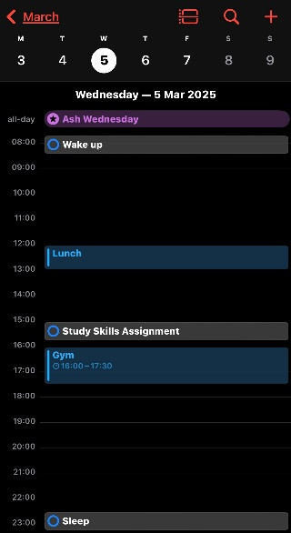

3.2.2 Screenshots as evidence of completed e-Portfolio/PDP implementation
Here I have provided screengrabs from my e-Portfolio on my computer. This portfolio contains all my files needed while at university. This is a simple and clean layout I have followed which is easy to remember and contains all my documents about my academic achievements, goals, personal descriptions. It also contains my university work / assignments. This folder helps me easily navigate through all my important files that I may need when at university.

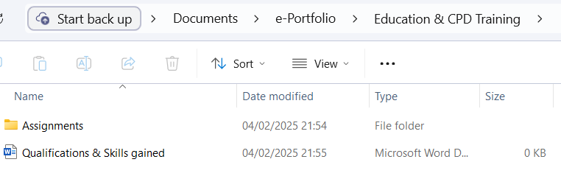
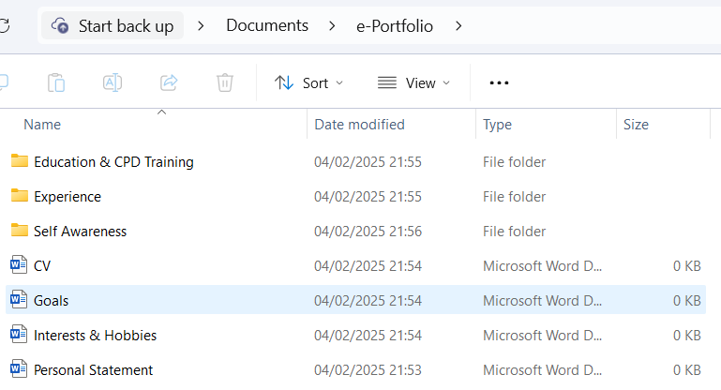
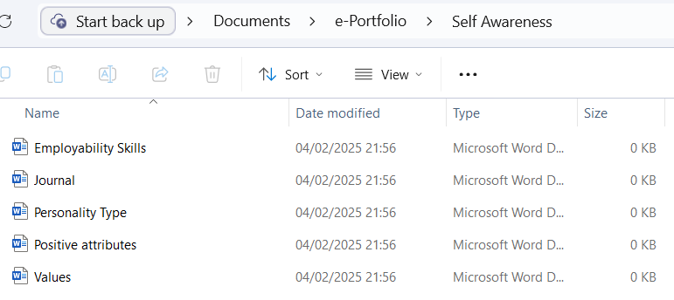
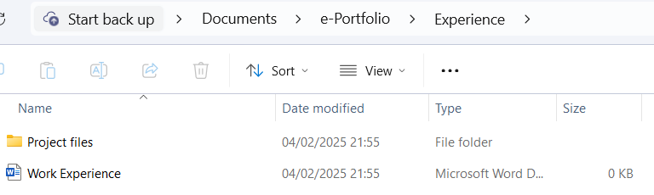

3.3 Independent Study – ability to gather and present new information
Here I have completed a concise literary review of “Torpex – a powerful underwater explosive”.
First, what is torpex? “Torpex” is the name given to this Torpedo Explosive. Torpex is an explosive that is made up of mostly RDX (Royal demolition explosive), TNT (Trinitrotoluene) and also, but less so powdered aluminium.
Torpex’s significance in WW2 was huge, being used from 1942 onwards and being created in Britain. Torpex is not only in torpedoes, but also in navy mines and depth charges. But nowadays, Torpex is considered to be out of date and is almost not used at all anymore, except for cases like that of the Sting Ray, which is a lightweight torpedo with homing guidance, which as of today, is still in service by the royal navy. Torpex is also recently used by multiple foreign militaries.
Where exactly was torpex used? Torpex came in handy when faced with seeking more effective weapons against German U-Boats. As previously mentioned, torpex was also used in depth charges, which are bombs that detonate underwater when an enemy is detected nearby, specifically Mark IX depth charges. Torpex also had great significance during the Pacific War, American Mark 14 torpedoes carrying 1,100-pound Torpex warheads devastated Japanese shipping. These warheads delivered an explosive force 150% greater than TNT alone [4].
In conclusion, I think torpex was a highly effective explosive in the sense that it fulfilled its purpose and played a massive role in many conflicts, although nowadays it is considered obsolete. I believe it represents a significant chapter in the history of military explosives, it shows how much of an impact chemical engineering can have on the military space, and on the world as a whole.
4 Conclusion and Evaluation
To conclude this module, in summary I found this assignment to be an especially useful task to be able to evaluate my different skills and personality type. I now have a much clearer idea on how I should function in a workplace / learning environment, based on the different tests I took. In doing this I also learned new steps to enhance my schedule when it comes to university work, which will now help me be able to manage my time better. Due to the use of SMART goals during this assignment, I have now implemented that into the way I will grow during my time in university and as a person in general. Since this is my first ever university assignment, it gave me a good idea of what is expected of me when doing more papers like this in the future and how things like literature reviews are carried out, and the shear amount of research that goes into them. I have a few areas of interest to research about further, for example, I was quite interested when doing my research about torpex and feel it is something I may want to investigate more at some point in the future. The same goes with my strengths and weaknesses, I would also like to look more in depth at some weaknesses I have so I can work on them further. In summary, I have benefited greatly from doing this assignment due to how it has improved how I will go about my days at university.

Appendix 1

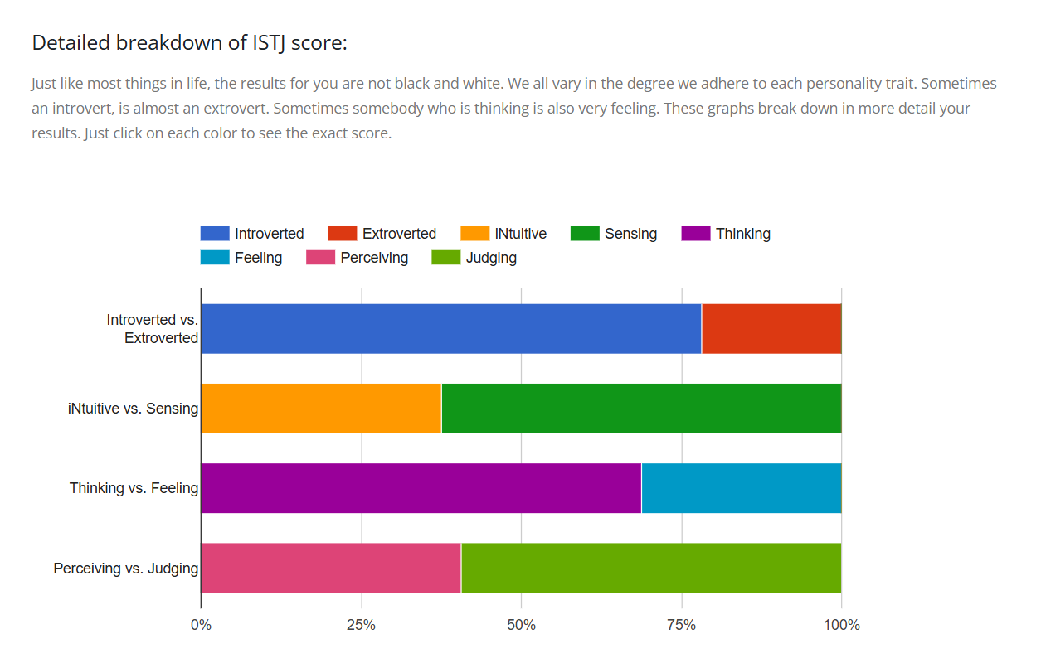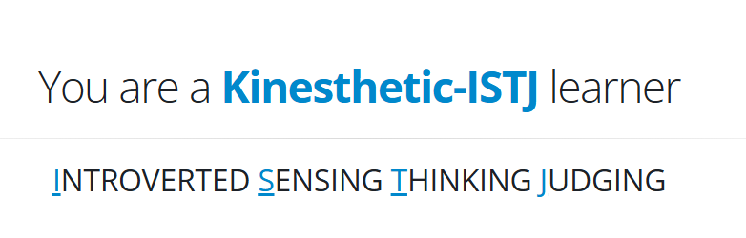

Appendix 2
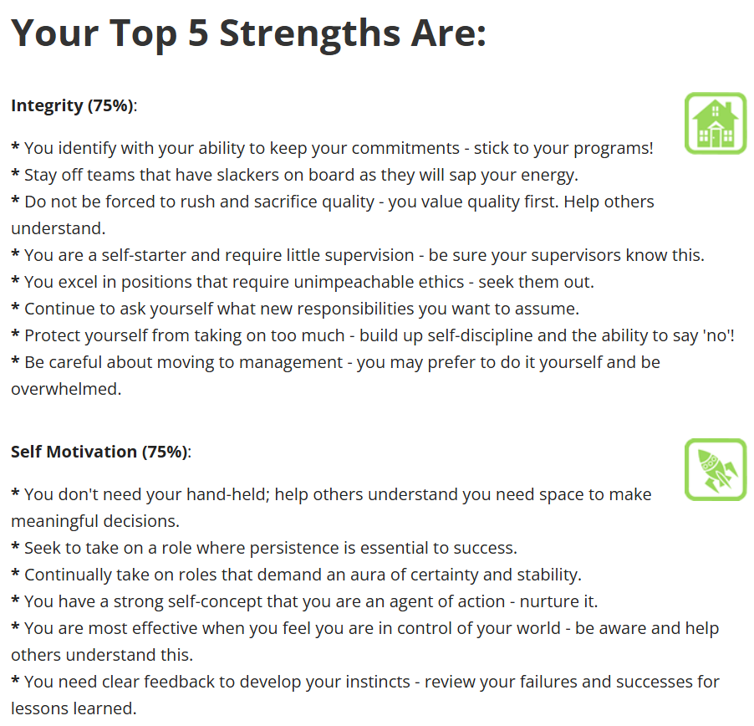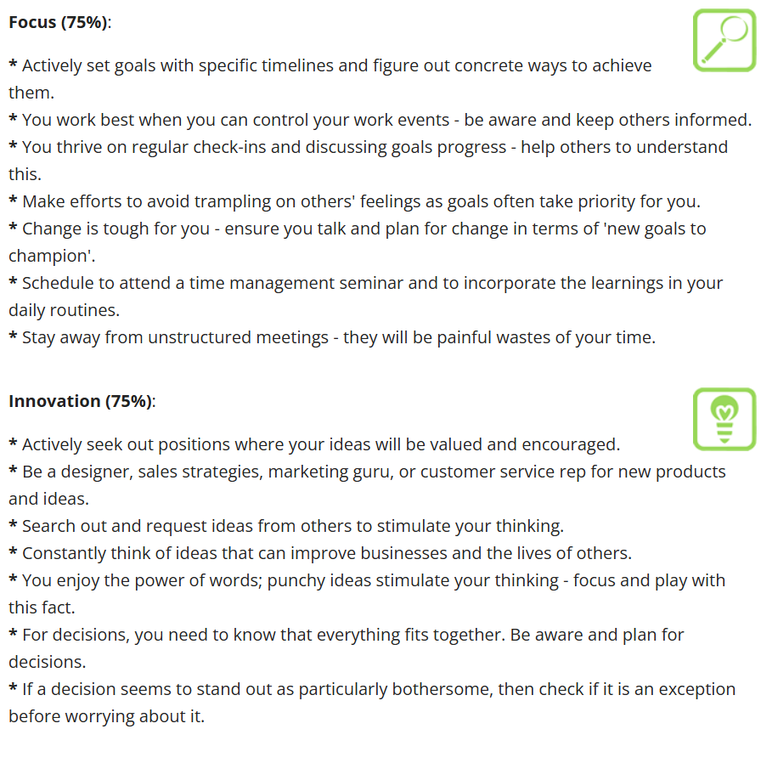
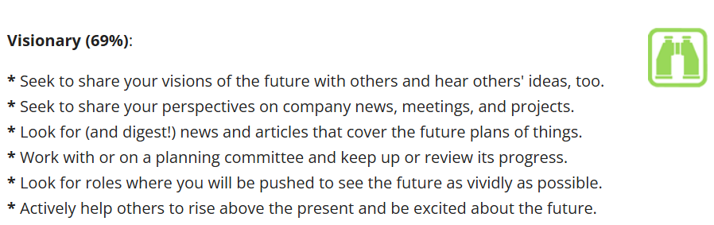

References

[1] (2024, Oct. 31.) “10 Essential Skills Every Student Should Develop in Higher Education”. Available at https://publish.illinois.edu/newedublog/10-essential-skills-every-student-should-develop-in-higher-education/

[2] (n.d) “10 Tips for Effective Learning and Adjustment to Higher Education” Available at https://www.thei.edu.hk/student-services/learning-advising/study-tips/10-tips-for-effective-learning-and-adjustment-to-higher-education

[3] N. Brüning, P. Mangeol, “What skills do employers seek in graduates?: Using online job posting data to support policy and practice in higher education”, OECD Education Working Papers, No. 231, pp. 39, Oct 2020

[4] C. F .Baxter, “The Secret History of RDX: The Super-Explosive that Helped Win World War”, Journal of Advanced Military Studies, Volume 12, pp. 243, Apr 2018

