

Student name: | Vaibhavi Hardik Barot | Student ID number: | 2539619
Programme: | MSc Public Health and Social Care in Practice
Module: | Social Epidemiology and Public Health Development
Module code: | LCHS7000 | Contribution to Overall Module Assessment (%): | 50%
Lecturer: | Itse Olaoye | Internal Verifier: | Dr Hamdi Hussain
Assignment Title: | Component 2 Analytical Report | Word count (or equivalent): | 2500 words

Table of Contents
Task 1: Social Epidemiological Analysis 3
Introduction 3
Section 1: Contextual background and underlying factors 4
3 Disease/Illness Issues 4
3 Social Issues (social determinants of health) 5
Section 2: National Response to reduce health inequalities 7
NHS Learning Disability Annual Health Check 7
Learning from Lives and Deaths (LeDeR) Programme 7
Section 2: Organisations that support chosen group 7
Scope 7
Disability Rights UK 7
Conclusion 8
Task 2 9
Introduction 9
Public Health Measures (3Ps) 9
Prevention 9
Protection 10
Promotion 10
Determinants and Risk Factors 10
Epidemiological Studies and Health Needs Assessment 11
Monitoring and Surveillance System 11
Enhanced TB Surveillance (ETS) 11
Active Case Finding and Contact Tracing 11
Laboratory and Community Monitoring 12
Public Health Impact 12
Intervention Design and Evaluation 14
Strengths and Weaknesses 14
Conclusion 14
Reference List 15
Task A 15
Task B 16

Task 1: Social Epidemiological Analysis

Introduction
In England, health inequalities remain a significant public health problem, with wide differences in health status across groups. The selected target group for this report is working-age adults aged 18–64 years with moderate to severe learning disabilities in England, United Kingdom. A learning disability is a lifelong condition that impacts intellectual functioning and daily living. It makes learning, communication, problem-solving, and independent living harder. Approximately 1.3 million people with a learning disability live in England, including approximately 950,000 adults (Mencap, 2024).
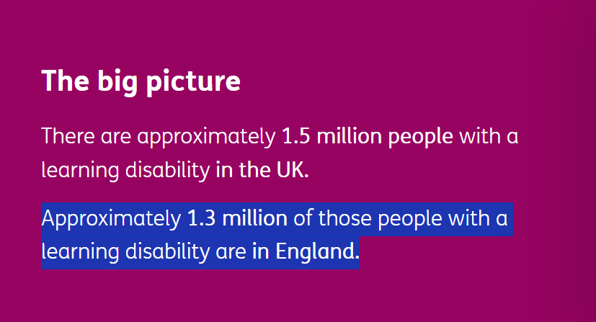
Fig 1: 1.3 million people with learning disability in UK
(Source: Mencap, 2024)
Moderate to severe learning disability adults experience health inequalities due to access to health services, deprivation, unemployment, discrimination and social exclusion.

Section 1: Contextual background and underlying factors

3 Disease/Illness Issues

(a) Higher Rates of Mental Health Disorders
Moderate to severe learning-disabled working-age adults (18-64 age group) are more likely to suffer from depression and anxiety than the general population. NHS England estimates that around 40% of adults with learning disabilities have a mental health condition (PHE, 2025).

(b) Higher Rates of Chronic Physical Health Conditions
This age group is prone to long-term chronic physical health conditions. Official data in Fig 2 revealed that 16.5% of deaths were due to respiratory diseases and 13.5% due to diseases of the nervous system, primarily epilepsy (kcl.ac.uk, 2024).
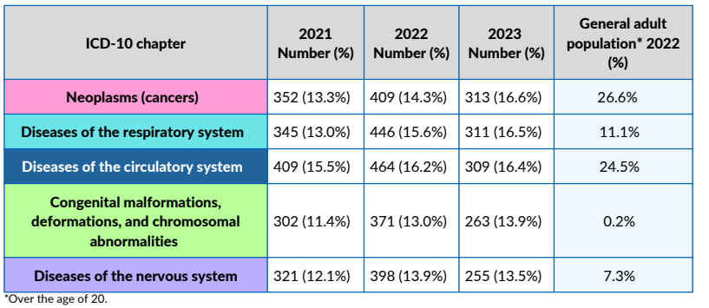
Fig 2: Deaths for adults with a learning disability
(Source: kcl.ac.uk, 2024)
These poor health outcomes are the result of delayed diagnosis and limited preventive interventions.

(c) Higher Rates of Premature and Preventable Mortality
The life expectancy of adults with learning disabilities is much shorter than that of people without learning disabilities. The LeDeR Programme reported that they die at an average of 19.5 years earlier than the general population. These inequalities are caused by access problems to healthcare and postponed treatment.

Explanation of Health Inequalities
There are health inequalities among adults with moderate to severe learning disabilities due to poor access to health care, poor communication and delayed diagnosis. LeDeR said 39% of deaths were preventable, while the non-LeDeR population had 21% preventable deaths (Mencap, 2025).
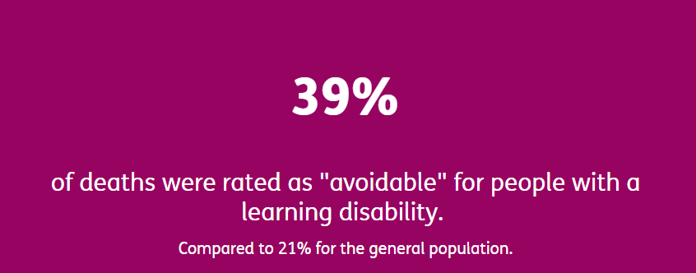
Fig 3: Percentage of deaths rated as "avoidable" in learning disability
(Source: Mencap, 2025)
These inequalities can be reduced through reasonable adjustments, early treatment and regular NHS Annual Health Checks, as well as staff training.

3 Social Issues (social determinants of health)

(a) Poor Access to Healthcare Services
Adults suffering from severe learning disabilities in the age group of 18-64 face a lack of access to healthcare services. Only 79.88% of all adults who were eligible for an Annual Health Check received one (England, 2025).

(b) Poverty and Unemployment
The employment rate of disabled individuals in the UK was 52.8% compared to 82.5% for non-disabled people (GOV.UK, 2025). Lack of employment limits independence, creates higher rates of poverty and fewer opportunities for a healthy lifestyle.
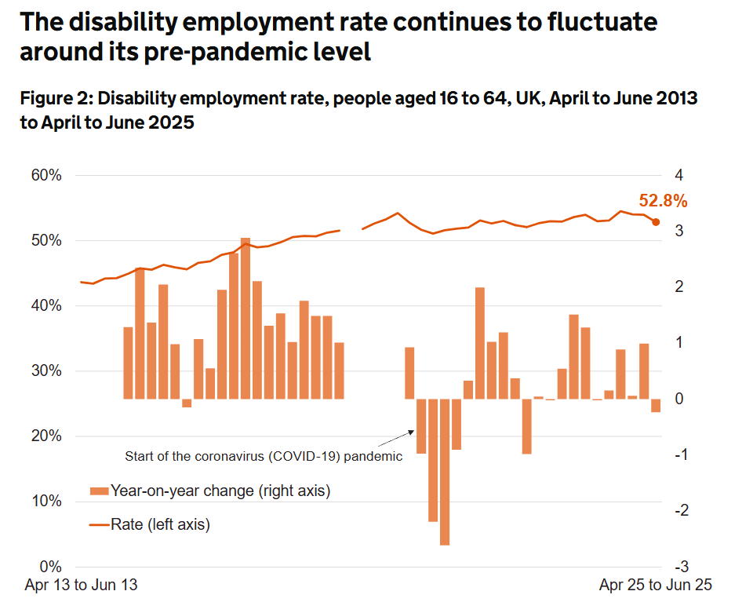
Fig 4: 52.8% employment rate of people with learning disabilities (16-64)
(Source: GOV.UK, 2025)

(c) Social Isolation and Discrimination
Social isolation becomes a common issue for many adults with learning disabilities due to stigma and reduced community participation. According to official data, 49% of learning-disabled people feel lonely most of the time.

Explanation of Health Inequalities
Social inequalities exist for adults with learning disabilities due to poverty, unemployment, social exclusion and access to health services. Only 79.88% were offered an NHS Annual Health Check, and employment was 52.8% compared to 82.5% for non-disabled people (England, 2025). These inequalities can be mitigated through enhanced access to healthcare, inclusive employment and community support.

Section 2: National Response to reduce health inequalities

NHS Learning Disability Annual Health Check
The Annual Health Check is an NHS procedure for people with learning disabilities, aimed at detecting health issues early and enhancing access to health services (Tanner et al. 2022). It is offered for those 14 years and over who are registered on the GP Learning Disability Register. According to official data, more than 79.88% of adults participated in the Annual Health Check. This programme is supported by the Equality Act 2010.

Learning from Lives and Deaths (LeDeR) Programme
NHS England's LeDeR Programme is an investigation into the causes of death of people with learning disabilities to find out what is avoidable and how services can be better. The programme determined that 39% of deaths were avoidable, while this figure was 22% in the general population (Mencap, 2025). Its recommendations have had a positive impact on staff training, reasonable adjustments and patient safety. The LeDeR Programme is supported by the Health and Care Act 2022.

Section 2: Organisations that support chosen group

Scope
(a) Role in Supporting People with Learning Disabilities
Scope is the UK's largest disability charity. It can help adults with learning disabilities with advice on healthcare, employment, benefits and independent living. The charity also works to end discrimination and enhance access to public services. In Scope's Disability Price Tag 2025 report, it has been revealed that disabled households require an additional £1,095 per month to be able to live on the same level as non-disabled households (Scope, 2025).
(b) Goal
Scope's vision is to create an equal society where disabled people are equal to everyone else. It carries out research, lobbies for disabled people's access to services, financial support, equal rights and better government policy in the UK.

Disability Rights UK
(a) Role in Supporting People with Learning Disabilities
Disability Rights UK (DR UK) is a national charity run by disabled people. It offers advocacy, legal information and guidance to assist disabled people understand and exercise their rights (Evans, 2022). The charity supports the NHS, local authorities and the UK Government to enhance access to health care and to tackle discrimination.
(b) Goal
Disability Rights UK aims to achieve equal rights and full participation for disabled people in society. It aims to advance health, education, work and community participation by conducting research, policy advocacy, public campaigns and collaborating with national organisations.

Conclusion
There are still large health inequalities for adults aged 18-64 years with moderate to severe learning disabilities in England. Are at increased risk of mental and physical illness, early death, poor health care, poverty and social isolation. There has been an increase in awareness and support through national initiatives and charities, but more can be done. The NHS needs to expand Annual Health Check coverage, improve staff training, enhance reasonable adjustments, and encourage inclusive employment and community participation, to help reduce inequalities and to have positive long-term health outcomes.

Task 2

Introduction
The public health problem chosen for this report is tuberculosis (TB). The epidemiological analysis is based on the population of the London Borough of Newham, England, which has the highest notification rate of TB in the country. TB is a contagious disease that's caused by Mycobacterium tuberculosis. It primarily infects the lungs and is spread through the air when someone who is infected coughs or sneezes (Swalehe and Obeagu, 2024). If left untreated, TB may lead to severe health complications such as disability, chronic lung damage and death. It also presents social and cultural issues like stigma and discrimination, loss of income, especially within migrant and disadvantaged communities. In 2024, it is estimated that 10.7 million people globally had TB and 1.23 million people died from TB (WHO, 2025). There were 5,480 cases of TB in England in 2024, with Newham having the highest notification rate of 43.8 per 100,000 population, especially people aged 16-35, who have migrated from TB-prone countries in the UK in the last 5 years (UKHSA, 2025).
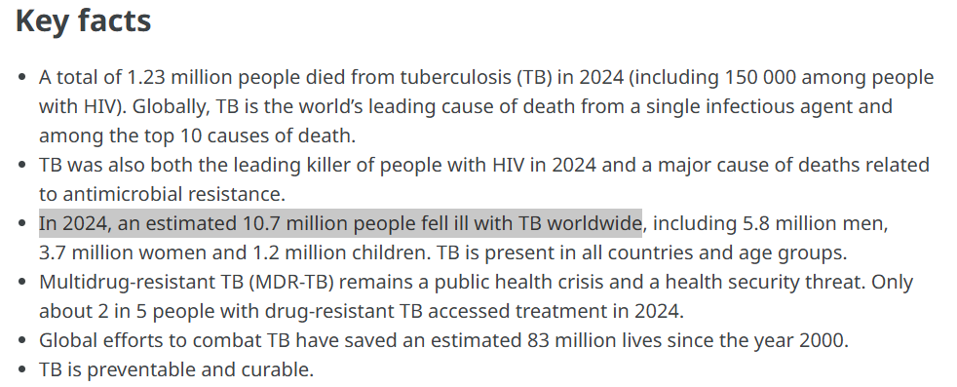
Fig 5: worldwide victims of TB
(Source: WHO, 2025)

Public Health Measures (3Ps)

Prevention
The focus of public health prevention in Newham is on people aged 16-35 who are recent migrants from a high TB-incidence country who have arrived in the UK in the last 5 years and are registered with a GP. The population is at increased risk of having active TB. Newham has had a GP-led Latent Tuberculosis Infection (LTBI) programme since 2014, which provides migrants with the choice of having a blood test, a chest X-ray if necessary and preventive treatment before TB becomes active (Burman et al. 2024). This local model was incorporated into England's national TB strategy.

Protection
The measures of protection are directed at limiting the spread of TB within the identified population by the following: mandatory notification, laboratory diagnosis, specialist TB services, and contact tracing. In 2023, Newham had the highest rate of TB cases in London (38.9 per 100,000 population) (UKHSA, 2025). As a result, Barts Health TB Services has collaborated with UKHSA to diagnose TB quickly, visit patients, screen contacts, and offer treatment assistance to reduce community transmission.

Promotion
Newham's health promotion efforts target recent migrants aged between 16 and 35 years of age, from high TB incidence countries (UK, 2026). Multilingual education and free testing and treatment are offered by Well Newham, Newham Council, GP practices and Barts Health TB Services. They also hereby promote early GP registration, minimise stigma, and enhance treatment completion via community outreach and local awareness campaigns.

Determinants and Risk Factors
Determinant / Risk Factor | Evidence and Impact on the Defined Population
Recent migration from high TB-incidence countries | The defined population comprises recent migrants aged 16–35 years from high TB-incidence countries registered with GPs in Newham (UK, 2026). The borough's LTBI programme specifically targets this group because latent TB is more common among recent migrants and may later develop into active TB.
High deprivation | TB is closely linked to deprivation. The Newham JSNA states that disadvantaged groups have a greater risk of TB. In England, TB rates in the most deprived communities are more than five times higher than in the least deprived communities (Berrocal-Almanza et al. 2023).
Overcrowded housing | Newham has high levels of overcrowded housing, increasing prolonged exposure to infectious individuals and facilitating airborne TB transmission.
Social vulnerability and poor healthcare access | In Newham, the most common social risk factors are alcohol misuse, mental health problems, and also homelessness.
Table 1: Determinants and Risk Factors
Source: (Self)

Epidemiological Studies and Health Needs Assessment
Epidemiological studies and the Newham Joint Strategic Needs Assessment (JSNA) indicate that the population most affected by tuberculosis (TB) in Newham are recent migrants (from high TB-incidence countries) aged 16-35 years who are registered with GP practices in Newham. Newham has one of the highest TB burdens in England, with 436 TB cases reported between 2020 and 2022 in the JSNA. The retrospective cohort study carried out in 59 GP practices in Newham revealed that 5,591 eligible migrants were invited to be screened for latent TB (Loutet et al. 2018).
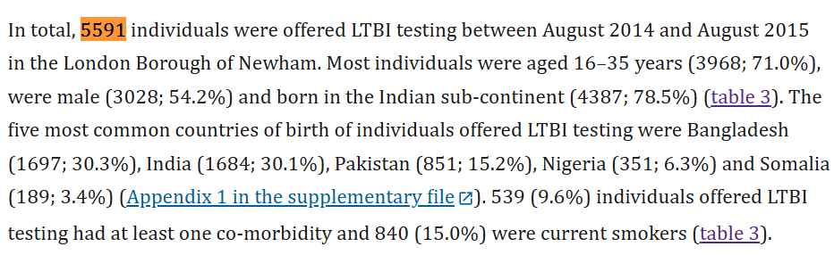
Fig 6: 5591 individuals were offered LTBI testing between August 2014 and August 2015
(Source: Loutet et al. 2018)
Of these, 71% were between 16 and 35 years old, and the majority had come from Bangladesh, India and Pakistan. In view of these findings, the Health Needs Assessment suggested screening for latent TB, early diagnosis and preventive treatment for this target group, to be delivered in the GP setting.

Monitoring and Surveillance System

Enhanced TB Surveillance (ETS)
The Enhanced TB Surveillance (ETS) system is run by the UK Health Security Agency (UKHSA) to keep an eye on TB cases among recent migrants aged 16-35 from high TB incidence countries registered with GP practices in Newham (Morgan et al. 2026). ETS captures patient information, lab results, treatment history, and results. This information can be used to recognise patterns of disease and high-risk populations.

Active Case Finding and Contact Tracing
Newham's TB programme is based on latent TB screening and contact tracing by GP-led screening to identify new TB cases early. When migrants register with a GP, they are provided with blood tests for latent TB if eligible. If someone is diagnosed with TB, Barts Health TB Services will conduct screening of close contacts, workplaces and households to stop further spread.

Laboratory and Community Monitoring
The diagnosis of TB is done by blood tests, sputum tests, chest X-rays and laboratory tests. Barts Health TB Services also do home visits, check treatment adherence and work with Newham GPs and the local Health Protection Team (O’Brien et al. 2026). Community monitoring, multilingual education and immediate care are effective in the identification of new cases at an early stage in the defined population.

Public Health Impact
Epidemiology is used to assess the impact of TB disease in recent migrants aged 16-35 years who are registered with GP practices in Newham, London Borough. Public health teams regularly monitor TB incidence, notification rates, latent TB screening results, treatment outcomes, and contact tracing data. These are useful for detecting trends in disease, high-risk groups and the effectiveness of local TB control programmes.
TB in the short term is a very sickening disease and poses a risk of transmission to family members and close contacts. Newham had the highest number of TB cases reported in 2023 (141) and the highest TB notification rate in London, 38.9 cases per 100,000 population (UK, 2026). It demonstrates the importance of early diagnosis and prompt treatment to prevent further transmission.
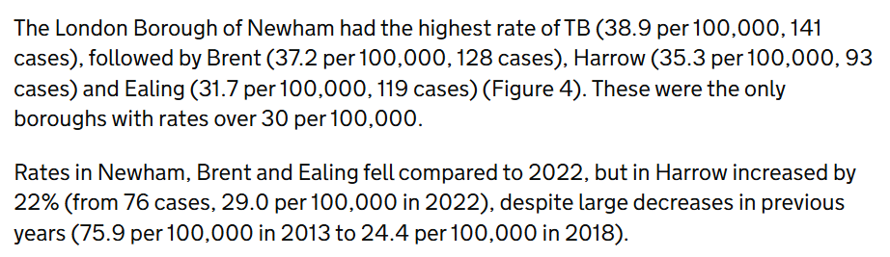
Fig 7: Newham TB cases
(Source: UK, 2026)
Untreated TB can lead to permanent lung damage, drug resistance, and early death in the long term. In Newham, 41.4% of migrant children screened were positive for latent TB infection, with a high risk of active TB in the future without preventive treatment (UK, 2025b).
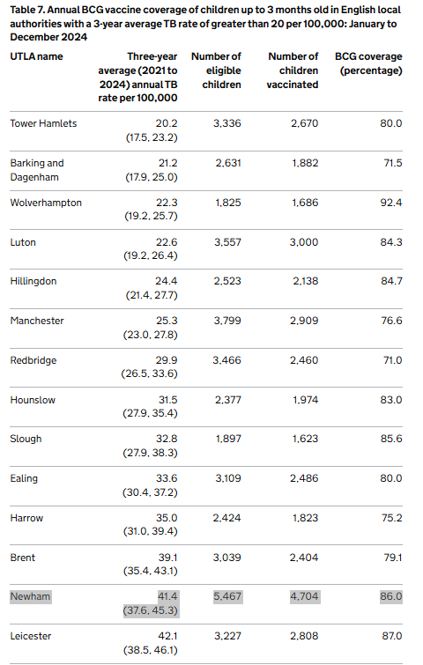
Fig 8: Percentage of migrant children got TB vaccination in Newham
(Source: UK, 2025b)
Epidemiological surveillance supports Newham health authorities to focus on high-risk groups, enhance treatment completion, reduce transmission and better utilise NHS resources.

Intervention Design and Evaluation
The Newham GP-led Latent Tuberculosis Infection (LTBI) Programme should be extended to recent migrants aged 16-35 years from high TB incidence countries. The programme should maintain latent TB screening, treatment and follow-up in GP practice. It is also to be provided, in a multilingual way, health education and support by community TB workers. In the period 2014-2016, over 6,000 people were screened. Approximately 1,200 individuals were diagnosed with LTB, and 14 cases of ATB were detected early. The rate of TB in Newham later dropped by over 30%. This programme may also help to further decrease TB transmission and enhance health outcomes. Expanding the programme could strengthen early identification and management of latent TB among high-risk migrant populations. Thereby reducing progression to active disease. Continued investment in GP-based care and community TB worker support is likely to improve treatment adherence, patient engagement, and overall public health outcomes in Newham.

Strengths and Weaknesses
Aspect | Strengths | Weaknesses
Data Sources | Uses UKHSA Enhanced TB Surveillance (ETS), Newham JSNA, and published cohort studies | Some TB cases are not reported because latent TB has no symptoms. This may underestimate the true disease burden.
Target Population | Focuses on recent migrants aged 16–35 years from high TB-incidence countries. | The findings may not represent all Newham residents because the analysis focuses on one high-risk population.
Public Health Planning | Epidemiological evidence supports early screening, contact tracing, and treatment. | Language barriers, delayed GP registration, and incomplete patient records.
Table 2: Strengths and Weaknesses
Source: (Self)

Conclusion
TB continues to be a significant public health problem in Newham, particularly in young age groups (16-35 years) of recent migrants from high TB incidence countries. Epidemiological evidence can be used to identify high-risk groups, track disease trends and to inform effective interventions. Improving early diagnosis, decreasing TB transmission, and achieving better long-term health outcomes for the targeted population can be achieved through strengthening GP-led screening, surveillance and community awareness.

Reference List

Task A
Mencap (2024). How common is learning disability? [online] Mencap. Available at: https://www.mencap.org.uk/learning-disability-explained/research-and-statistics/how-common-learning-disability [Accessed 4 Aug. 2026].
PHE (2025). Health inequalities: Mental health problems. [online] Available at: https://fingertips.phe.org.uk/documents/Health%20Inequalities_Mental%20health%20problems.pdf [Accessed 2 Aug. 2026].
kcl.ac.uk, (2024), LeDeR Annual Report Learning from Lives and Deaths: People with a Learning Disability and Autistic People, [online] Available at: https://www.kcl.ac.uk/ioppn/assets/pdfs/leder/leder-annual-report-2023.pdf [Accessed 3 Aug. 2026].
Mencap (2025). Mencap. [online] Mencap. Available at: https://www.mencap.org.uk/get-involved/campaigns-and-activism/leder-report [Accessed 6 Aug. 2026].
England, N. (2025). NHS England » Performance report. [online] England.nhs.uk. Available at: https://www.england.nhs.uk/long-read/performance-report-24-25/ [Accessed 6 Aug. 2026].
GOV.UK, (2025). The employment of disabled people 2025. [online] GOV.UK. Available at: https://www.gov.uk/government/statistics/the-employment-of-disabled-people-2025/the-employment-of-disabled-people-2025 [Accessed 4 Aug. 2026].
Tanner, L., Kenny, R.P.W., Still, M., Ling, J., Pearson, F., Thompson, K. and Bhardwaj-Gosling, R., (2022). NHS Health Check programme: a rapid review update. BMJ open, 12(2), p.e052832.
Scope. (2025). Disability Price Tag 2025 | Disability charity Scope UK. [online] Available at: https://www.scope.org.uk/campaigns/disability-price-tag [Accessed 3 Aug. 2026].
Evans, E., (2022). Political intersectionality and disability activism: Approaching and understanding difference and unity. The Sociological Review, 70(5), pp.986-1004.
Swalehe, H.M. and Obeagu, E.I., (2024). Tuberculosis: Current diagnosis and management. Elite Journal of Public Health, 2(1), pp.23-33.

Task B
WHO, (2025). Tuberculosis. [online] World Health Organization. Available at: https://www.who.int/news-room/fact-sheets/detail/tuberculosis [Accessed 6 Aug. 2026].
UKHSA (2025). National quarterly report of tuberculosis in England: quarter 4, 2024, provisional data. [online] GOV.UK. Available at: https://www.gov.uk/government/statistics/tuberculosis-in-england-national-quarterly-reports/national-quarterly-report-of-tuberculosis-in-england-quarter-4-2024-provisional-data [Accessed 5 Aug. 2026].
Burman, M., Zenner, D., Copas, A.J., Goscé, L., Haghparast-Bidgoli, H., White, P.J., Hickson, V., Greyson, O., Trathen, D., Ashcroft, R. and Martineau, A.R., (2024). Treatment of latent tuberculosis infection in migrants in primary care versus secondary care. European Respiratory Journal, 64(5), p.2301733.
UK (2026). London: tuberculosis in 2024. [online] GOV.UK. Available at: https://www.gov.uk/government/publications/tuberculosis-tb-regional-reports-2024/london-tuberculosis-in-2024 [Accessed 4 Aug. 2026].
Berrocal-Almanza, L.C., Lima, M., Piotrowski, H., Botticello, J., Badhan, A., Karnani, N., Kaur, H., Pareek, M., Haldar, P., Dedicoat, M. and Kon, O.M., (2023). Vulnerability and tuberculosis treatment outcomes in urban settings in England: A mixed-methods study. Plos one, 18(8), p.e0281918.
Loutet, M.G., Burman, M., Jayasekera, N., Trathen, D., Dart, S., Kunst, H. and Zenner, D. (2018). National roll-out of latent tuberculosis testing and treatment for new migrants in England: a retrospective evaluation in a high-incidence area. European Respiratory Journal, 51(1), p.1701226.
Morgan, E., Cleary, P. and Wingfield, T., (2026). Social and health factors associated with postmortem diagnosis of tuberculosis in England: a national, retrospective cohort study. thorax.
O’Brien, K., Ikram, S., Burman, M., Rahman, A., Patel, P., Dart, S., Trathen, D., Zenner, D., Malhotra, A.M. and Kunst, H., (2026). Barriers and enablers of TB infection screening and treatment programme for recent migrants in East London. Public Health Action, 16(1), pp.8-14.
UK (2025b). 2. Tuberculosis prevention, England, 2024. [online] GOV.UK. Available at: https://www.gov.uk/government/publications/tuberculosis-in-england-2025-report/2-tuberculosis-prevention-england-2024 [Accessed 5 Aug. 2026].

