PERSONAL DEVELOPMENT PLAN

Student Name: Marios Soulka ID: 1907844 Group: 5 Module : Academic & Employability Skills BMSW4001 Peter Allen
Teacher Name:

LONG TERM

DEVELOPMENTAL
OBJECTIVES
GOALS

- Carrier development

- Software development
And Computer programing

- Kids - Family

ACTIONS

University, Curses Gain Experience Improve my English

University, Online curses Home practice
Hard studying
Good and stable Work Being Ripening
Passion and love for Kids

RESOURCES

Time Management Focus on my Targets
Passion for Development

Time Management Money
Will Power
Love Affection Time

TIME FRAME

By 2021

By 2023

By 2024

MEDIUM TERM

DEVELOPMENTAL OBJECTIVES
GOALS

- Language and communication skills

- Team Work Skills
ACTIONS

Studying, reading books
Talk more with British people Watch British Movies and Radio
University, Group assessments Friendship, Practice

RESOURCES
Time Managing Will Power

Time Management Team, Friends Will Power

TIME FRAME

By August 2020

By September 2020

What is S.W.O.T Analysis ??
The S.W.O.T Analysis even though it has been over 40 years since it was developed, is still considered an important "tool" in business decision making today. The Maker of S.W.O.T Analysis is Albert Humphrey, a professor in the 60s and 70s at Stanford University.
S.W.O.T Analysis examines a company's Strengths and Weaknesses, Opportunities and Threats from the environment it operates. Its used by many businesses to evaluate the situation they are in today in order to make decisions and thus shape their future strategy.
S.W.O.T analysis is divided into two main parts. In analyzing the internal environment of the business which is Strengths and Weaknesses, and in analyzing the external environment of the business which are Opportunities and Threats.
IN CLASS EXERCISE PERSONAL S.W.O.T ANALYSIS
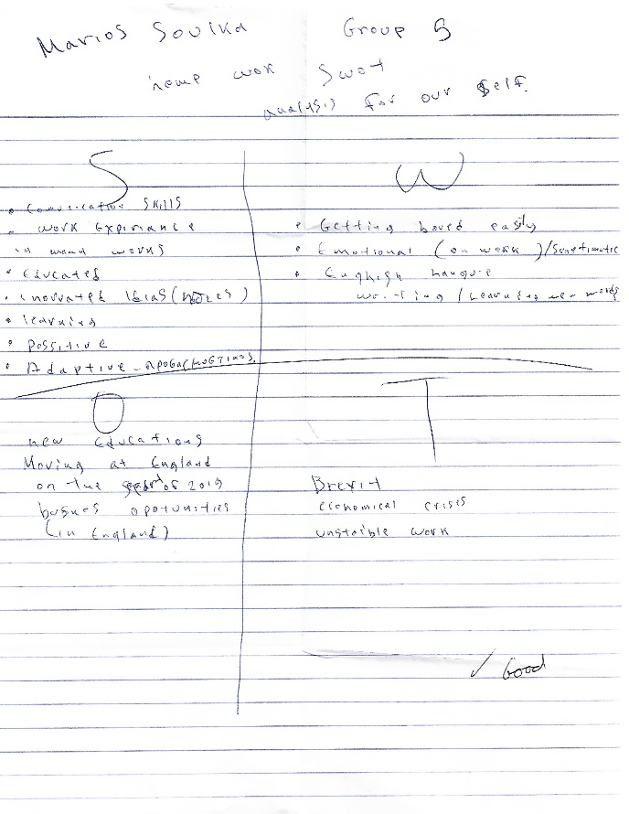

PARAPHRASING

What is paraphrasing?
Paraphrasing - presenting the ideas and information you have read in your own words - is an important academic skill. By translating content from your research into your own words, you demonstrate to your reader that you've understood and are able to convey this content.
It is important to be very thorough when you paraphrase. Paraphrasing is not simply taking what someone has written and changing a few words to make it your own. It is about translating another person's ideas into your own words and in reduced form. You must change the words a lot so they are no longer similar to the original. Even if you use an in-text reference to show where the idea came from, a lecturer may decide that what you have written is plagiarism if your wording is still too close to its source.
For example, look at the extract below that talks about film adaptations of books:
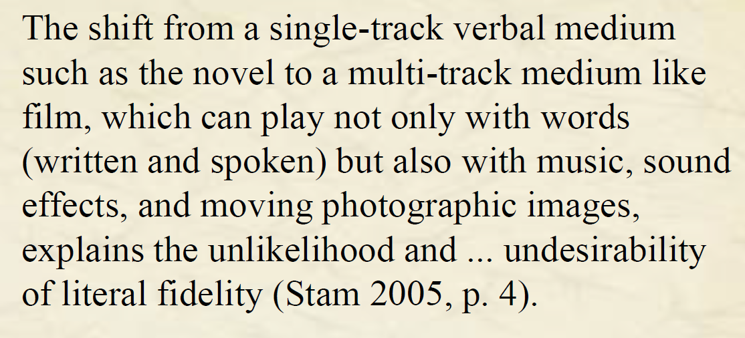
Now look at this paraphrase of the above passage:
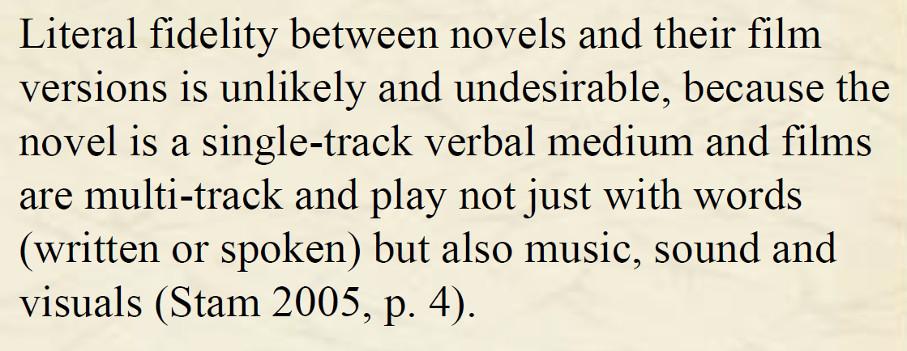
This paraphrase would be considered too close to the original, and would be deemed plagiarism despite the correct referencing. This is because it's not enough to simply change a few words and/or turn sentences around, as the author does here, because you will still be copying the way the original author expressed their ideas.
The paraphrase below, however, is much better:
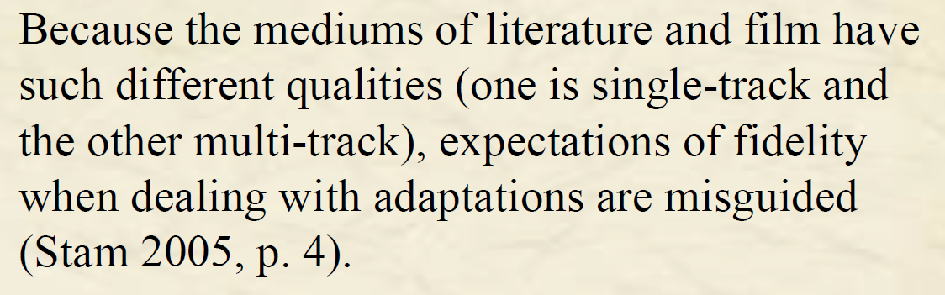

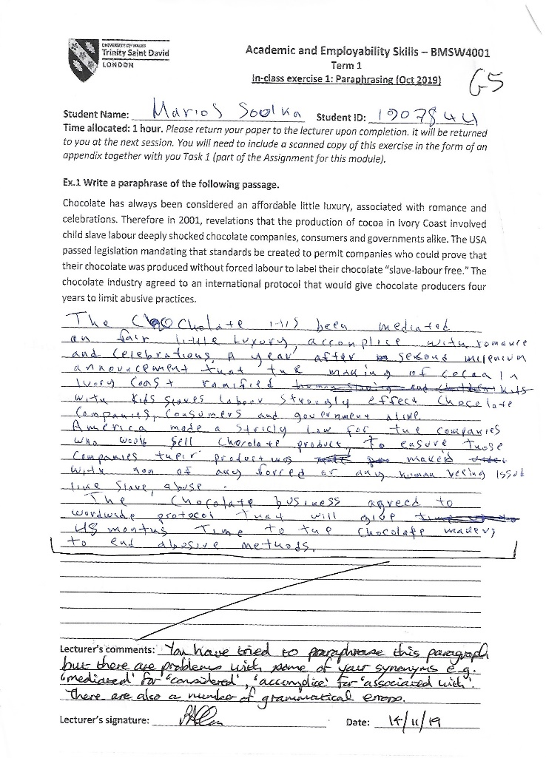
IN CLASS EXERCISE PARAPHRASING



