Ana Carden-Coyne, David Morris and Tim Wilcox, eds., The Sensory War, 1914–2014(Manchester Art Gallery: Manchester, 2014)
Images from section entitled ‘Chemical War and the Toxic Imaginary’
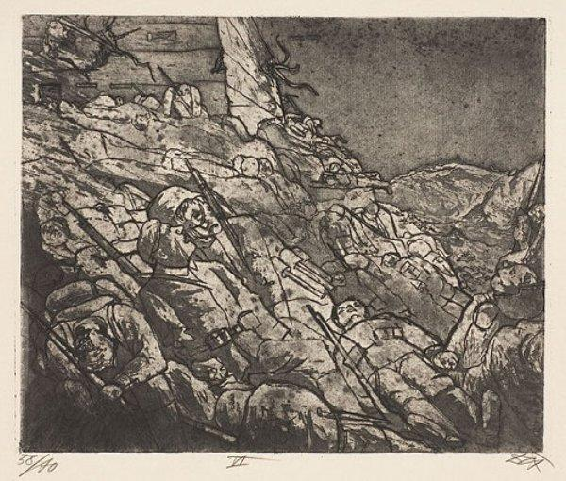
Otto Dix, War 46: The Sleepers of Fort Vaux (Gas Victims), 1924

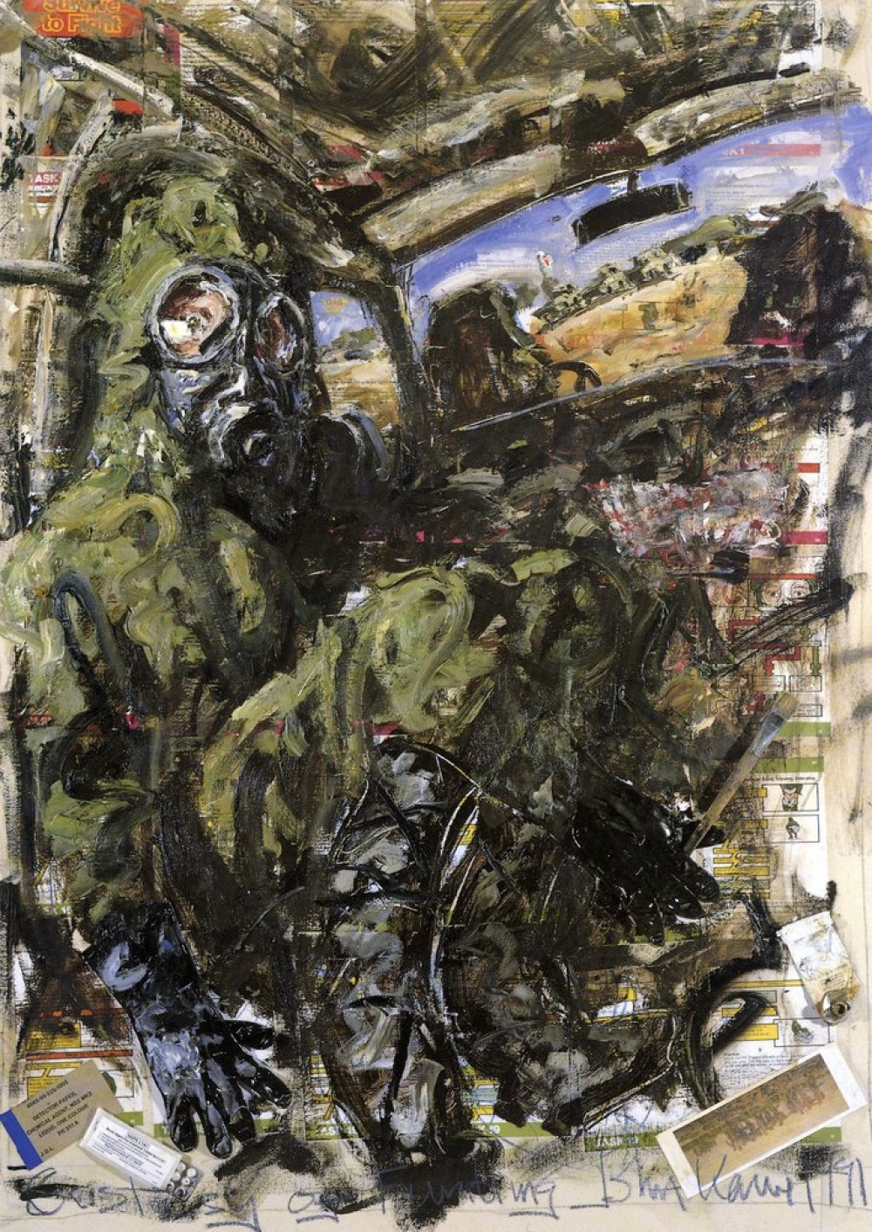
John Keane, An Ecstasy of Fumbling (Portrait of the Artist in a Gas Alert, 1991

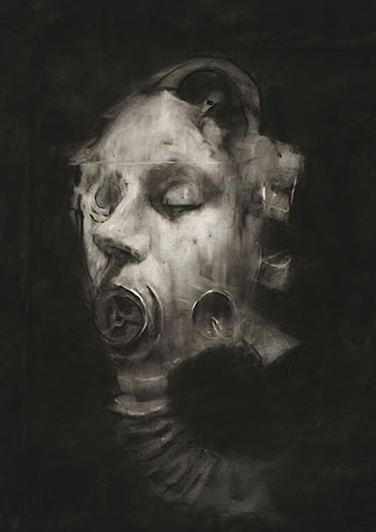
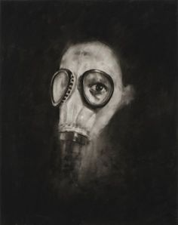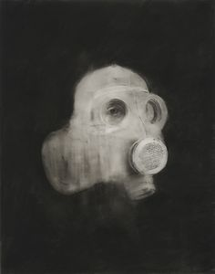
Sophie Jodoin, Gas Mask series,2008
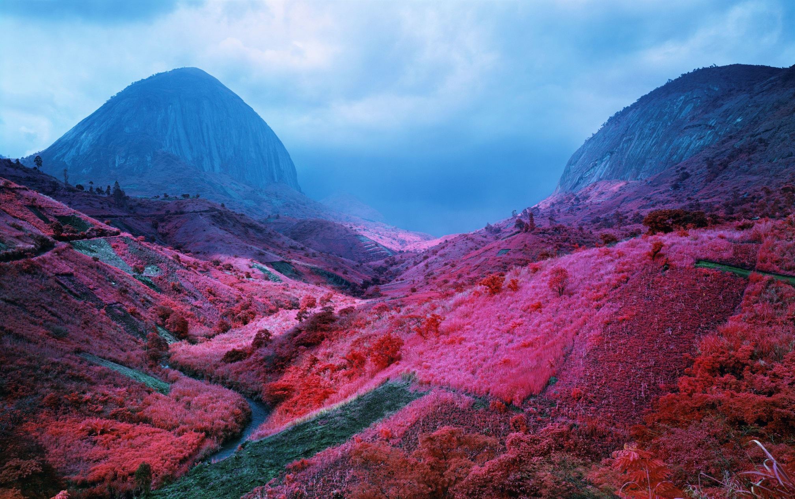
Richard Mosse, Poison Glen, 2012

