Blwyddyn:  Year:  Reception | Maes Dysgu a Phrofiad:  Area of Learning and Experience:  Welsh | Amcan y wers:  Aims of the lesson:  To develop welsh skills for ‘diod’s’ and recap on previous learning.
Gwybodaeth flaenorol:  Previous knowledge:  The children have prior experience with the types of questions used in WordWall, which we regularly use to recap key vocabulary and concepts in a fun, interactive way. These questions are revisited randomly in each session to reinforce learning and ensure retention through repetition. In addition, we have recently been focusing on the topic of drinks, so the children already have a foundational understanding of related vocabulary and phrases. This existing knowledge will be built upon and extended in each lesson. | Geirfa allweddol / Ffocws iaith:  Key vocabulary / Language focus:  Word wall- ‘sut wyt ti’  - Cyffrous  - Nerfus  - Trist  - Hapus  - Diflas  - Wedi Synnu  - Crac  - Ofnus  Splat- ‘diod’  - Llaeth  - Dwr  - Sgwash  - Sudd afal  - Sudd oren  Incidental Welsh-  - Da Iawn  - Diolch  - Barod  - Dwylo I fyny | Gweithgareddau Addysgu a Dysgu:  Teaching and Learning Activities:  To recap previous questions from Word-wall, we used a range of interactive and engaging strategies. We began with repetition-based activities such as “My turn, your turn”, which supported accurate pronunciation and built confidence through modelling. Pupils then practiced asking and answering the questions with a partner, encouraging peer interaction and speaking and listening skills.  To revisit vocabulary around the topic of drinks, we used flashcards to support visual recognition and recall. Finally, we played a game of ‘Splat’, where pupils worked in pairs to quickly identify and ‘splat’ the correct answer. This promoted active engagement, collaborative learning, and quick recall, all while reinforcing key vocabulary in a fun and physical way.
Adnoddau:
Resources:
The white board was used for ‘word wall’ to spin questions the children have previously learned, to recap this existing knowledge.
Flash cards are used as an effective way of reinforcing memory through active recall and spaced repetition.
Splat boards were used to combine engagement, movement, and quick thinking.
Cynllun Gwers Lesson Plan

Welsh Lesson
https://uowtsd-my.sharepoint.com/:v:/g/personal/2107710_student_uwtsd_ac_uk/ETSfYdBM2EBHteMSEUG6aKcBO8-yD4opnrrp2QfpwFf7pw?e=4xdb6L

Lesson resources
During the Helpwr Heddiw session, a variety of interactive resources were used to support pupil engagement and reinforce prior learning. The interactive whiteboard was used to display a ‘Wordwall’ wheel, which featured familiar Welsh questions. Once the wheel had been spun, pupils practiced responding to the selected question using sentence structures and strategies previously taught.
Flashcards displaying emotions were used to support vocabulary recall. Pupils repeated the emotion words after the teacher, accompanied by corresponding actions to aid memory through movement and repetition.
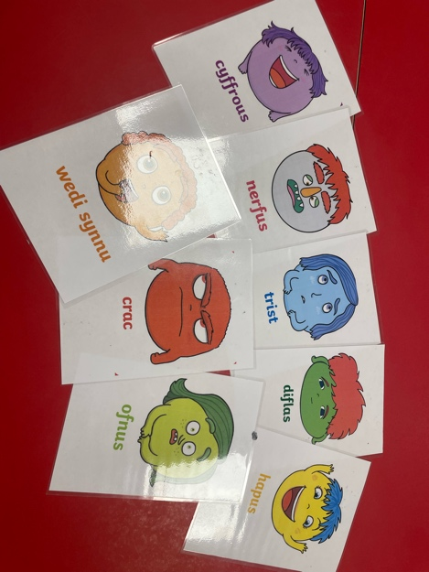
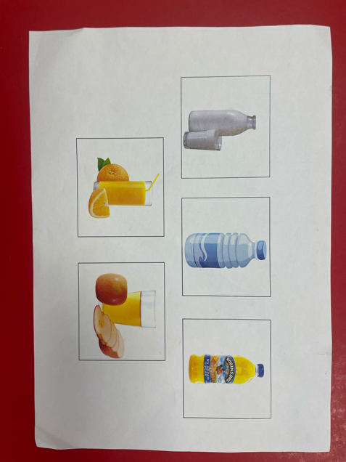
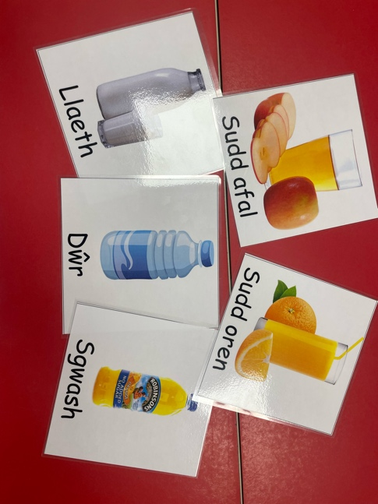
In addition, a ‘Splat board’ featuring pictures related to ‘diods’ (drinks) was used as a fun, competitive way to consolidate understanding of familiar terms. These resources were familiar to the pupils and helped create a supportive environment for language practice.

Lesson Evaluation
The focus of this Helpwr Heddiw session was to consolidate pupils’ understanding and recall of familiar Welsh questions and vocabulary, particularly “Sut wyt ti?” and related emotion and drink vocabulary. A range of interactive and multimodal resources were used to support engagement, reinforce prior learning, and assess pupils’ progress in a meaningful and enjoyable way.
The session began with a Wordwall activity, displayed on the interactive whiteboard. This digital tool featured a virtual spinning wheel containing a selection of familiar Welsh questions that pupils had encountered previously. The use of Wordwall helped to create an element of anticipation and excitement. When the wheel landed on “Sut wyt ti?”, pupils immediately recognised the question, which was a positive indicator of their familiarity with the topic. Using the “my turn, your turn” method, I modelled the pronunciation and intonation of the phrase, and the pupils echoed the phrase back to me. This call-and-response technique was repeated several times to ensure accuracy and fluency. It also allowed for immediate feedback and correction if needed. I monitored pupils’ participation closely to ensure everyone was joining in confidently. Once the phrase was practised, I asked pupils to explain its meaning in English, which they were able to do with minimal prompting. This helped to confirm that the pupils not only recognised the phrase but also understood its meaning.
Next, we transitioned into a vocabulary recall activity using emotion flashcards. These cards included common Welsh words for emotions such as “hapus” (happy), “trist” (sad), “cyffrous” (excited), and “crac” (angry), each illustrated with a visual representation. Alongside each flashcard, pupils were encouraged to perform an associated action that matched the emotion—for example, smiling for “hapus” or crossing arms and frowning for “crac.” This multi-sensory approach supported pupils in retaining vocabulary by linking it to physical movement and visual stimuli. According to research on memory and learning, kinaesthetic learning helps reinforce language acquisition, especially in early learners. Pupils responded enthusiastically to this method, engaging with the actions and repeating the vocabulary with growing confidence.
To assess pupils’ grasp of the question “Sut wyt ti?” and their ability to respond using appropriate vocabulary, I introduced a game of Lotto Lolly. This involved drawing names at random from a lolly stick pot, and inviting those pupils to respond to the question in Welsh. This served as an informal assessment for learning (AfL) strategy. It allowed me to quickly gauge which pupils could respond independently and correctly, and which pupils required further support or modelling. The random nature of the game kept pupils attentive, as they were unsure when they would be called on. This encouraged all children to stay prepared and engaged. The pupils responded correctly and confidently, which demonstrated that the initial rehearsal and vocabulary recall had been effective.
After this, pupils were given the opportunity to practise asking and answering the question with a partner. I modelled a short dialogue first to demonstrate the structure: one pupil asking “Sut wyt ti?” and the other responding using one of the emotion words. Pupils then moved into pairs and took turns role-playing this exchange. This activity supported peer learning and helped pupils develop confidence in using the target language in a communicative context. I observed several pairs and noted that most pupils were able to take turns appropriately and support each other if they forgot a word. The paired interaction also encouraged active listening, which is a key component of effective language learning.
The second half of the session revisited vocabulary from a previous lesson on ‘diods’ (drinks). Again, I used flashcards featuring drinks such as “sudd afal” (apple juice), “dŵr” (water), “sudd oren” (orange juice). As with the emotion vocabulary, pupils repeated the words using the “my turn, your turn” strategy, and we incorporated gestures—for example, miming drinking from a glass. Pupils responded positively to these familiar routines and appeared to enjoy revisiting the words, often racing to remember them before I even said them aloud. This familiarity reinforced their sense of achievement and showed evidence of learning retention.
The session concluded with a splat board game, which was played in pairs. Each pair had a board featuring pictures of drinks, and I called out a Welsh word. Pupils had to ‘splat’ (tap) the correct picture as quickly as possible. This added a competitive, kinaesthetic element that energised the group and helped maintain focus toward the end of the lesson. The game format allowed pupils to demonstrate quick recall in a low-stakes, fun environment. Many pupils were visibly excited and engaged, and the collaborative aspect encouraged turn-taking and team skills.
Overall, I believe the lesson was highly successful. The learning intention was clearly met, as pupils were able to ask and answer “Sut wyt ti?” with growing independence and recall relevant vocabulary from previous sessions. The use of a variety of resources (Wordwall, flashcards, Lotto Lolly, splat boards) catered to different learning styles and kept pupils motivated throughout. Pupil engagement was consistently high, and they responded enthusiastically to all activities. The progression from teacher-led practice to peer interaction was effective in developing oral language skills, and informal assessment strategies gave me a clear picture of their current understanding.
If I were to teach this lesson again, I would make a few adjustments to improve its impact further. Firstly, I would allocate more time for paired discussions, as pupils were just beginning to deepen their exchanges when the activity ended. Allowing longer for dialogue would give them more opportunities to practise forming full sentences and applying vocabulary independently.
Secondly, to avoid potential disengagement during carpet-based activities, I would incorporate a ‘mix-up’ strategy where pupils move around the room to find new partners for discussion. This would help keep the energy levels high and give pupils the chance to interact with a wider range of classmates, which supports both social and language development.
Finally, I recognised that before asking pupils to answer “Sut wyt ti?” in front of the class, it would have been more effective to first model sample answers using the ‘popcorn’ method. This involves pupils spontaneously shouting out answers as a group when prompted, making the activity fast-paced and pressure-free. This technique would have helped scaffold pupil responses and encouraged more active participation, particularly from those less confident in speaking aloud.
To conclude, this Helpwr Heddiw session successfully reinforced key elements of Welsh language learning through engaging and varied activities. The combination of repetition, visual prompts, kinaesthetic actions, and interactive games created a dynamic learning environment that supported both recall and language production. With minor adjustments to timing and group structure, this session could be made even more effective in future lessons.

