The Star Castle Hotel

Table of Contents
EXECUTIVE SUMMARY: 2
INTRODUCTION: 4
History Reimagined: 4
Luxurious Accommodations: 4
Culinary Excellence: 4
Unparalleled Amenities: 5
Unmatched Hospitality: 5
Discover the Magic of Star Castle Hotel: 5
ANALYSIS: 6
Introduction: 6
Kotler's 8-Step Structure: 6
Lewin's 3-Stage Model: 8
Conclusion: 10
RECOMMENDATIONS AND CHANGE MANAGEMENT: 10
Recommendations 10
Change Management Process: 12
ACTION PLAN: 15
CONCLUSION: 16
REFERNCES: 17

STAR CASTLE HOTEL:

EXECUTIVE SUMMARY:
The Star Castle Hotel is widely recognised as being among the best hotels in the world, and it is often considered to be one of the most prestigious and sophisticated hotels in the whole hospitality business. Additionally, this hotel is often considered to be among the most forward-thinking hotels operating anywhere on the globe. Due to the fact that the hotel is well-known for its exceptional reputation, this is the reason for this development. This is as a result of the hotel's location, which is in an area with exceptionally high-quality nature. This is the reason why situations are the way they are. This can be attributed, in large part, to the fact that the hotel is situated on the shores of a beautiful island, which is a particular locale that happens to be extremely magnificent despite its location. In comparison to other institutions, the hotel provides a one-of-a-kind combination of traditional elegance and modern grandeur that is completely unique and cannot be found anywhere else. Something like this is not available anywhere else in the world of commerce.
Regarding the field of international commerce, there is no other location where one might possibly come across something else that is comparable to this. This is the only place where such a possibility exists. In addition to this, it is well-known for its rich and well-known history that dates back centuries, and it also provides stunning views of the region in which it is located that is immediately adjacent to it. Both of these things contribute to its widespread popularity. The presence of both of these criteria contributes to the significance of this phenomenon, which is already significant. Both of these characteristics are significant because, in addition to making a contribution to the strengthening of the organisation's existing reputation, they are also vital. The fact that this is the differentiating characteristic that sets it apart from other websites is of the utmost importance, and it is essential to be aware of the fact that it is the defining characteristic. Individuals who are staying at the Star Castle Hotel are given the opportunity to take part in an experience that is truly one of a kind and unrivalled in terms of the width and depth of the encounter that it gives. This opportunity is made available to them. Visitors are presented with the option to take advantage of this special opportunity as soon as they arrive at the hotel. Visitors will have the opportunity to take advantage of this opportunity, which will be made available to them while they are staying at the hotel. The fulfilment of this conclusion is the consequence of a range of variables, some of which include the distinctive star-shaped architecture of the hotel, the amenities that have been built in an appropriate manner, and the wonderful service that is offered.
The hotel is a great example of a commitment to excellence in every facet of its infrastructure, and it is a testament to this devotion. From the opulent suites to the world-class dining selections that make use of foods that are grown in the general neighbourhood of the hotel, this commitment can be observed in every aspect of the establishment. In summary, the hotel acts as a monument to this devotion because it is a magnificent illustration of the commitment that has already been established. Especially in this particular instance, the hotel serves as a fantastic illustration of the kind of dedication that is being introduced throughout the establishment. The Star Castle Hotel is able to accommodate all of the needs and desires of its guests, regardless of whether they are looking to relax by the poolside, embark on an exciting excursion to discover the natural beauties of the island, or take pleasure in the revitalising treatments that are offered at the spa. In view of the fact that the hotel is able to satisfy each and every one of these qualifications and objectives, this accomplishment has been achieved. This particular rationale has been the driving force behind the accomplishment of this success. As a result of the fact that it is a hotel that is well-known for its reputation as a symbol of elegance and sophistication, the Star Castle Hotel has the potential to become an exceptional getaway. It is a hotel, which is the reason for this particular circumstance.
In particular, this is due to the fact that the hotel has the potential to develop into an exceptional refuge for discerning tourists who are looking for the most unforgettable experience they can have while they are away from their own country. This is the reason why situations are the way they are. In the course of its existence, it has earned the distinction of being a model of refinement and elegance within the hospitality industry. This reputation has been earned over the course of its existence. The establishment has established itself as the recipient of this honour. This is because it provides hospitality that is unparalleled and boasts an attraction that endures for an unlimited amount of time. This is the reason why it is so popular. This is due to the fact that there is no other place that can compete with the warmth and welcome that it provides. This is the reason why this is the case. It is because of this that the situation is as it is.
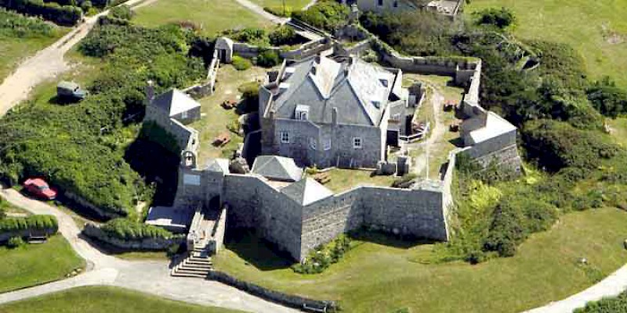
Fig 01: Castle hotel, England, U.K.

INTRODUCTION:
One of the most well-known architectural landmarks in the world, the Star Castle Hotel is a superb example of both elegance and legacy (Horvath 2012). This magnificent stronghold, which has been transformed into a hotel, dates back to the 16th century and offers visitors an unparalleled combination of history, elegance, and hospitality that cannot be found anywhere else.

History Reimagined:
Since its construction in 1593 by Sir Francis Godolphin as a defensive fortress, Star Castle has been privy to a wealth of history that spans several centuries. This history has been passed down from generation to generation. Throughout the course of history, the island's formidable architecture and strategic location have both acted as a testament to the island's capacity to withstand the test of time (Nagy 2012). In spite of the fact that it has been methodically repaired and transformed into a sanctuary of splendour, the castle has been able to maintain its historic attractiveness.

Luxurious Accommodations:
We will ensure that you are transported to a realm of splendour by providing you with magnificent accommodations. Each room and suite has been painstakingly crafted to deliver the greatest possible degree of luxury and refinement. In addition to offering breathtaking views of the surrounding surroundings or the calm courtyard garden, each room and suite has been designed to offer a unique and unforgettable experience (Addo 2011). Our accommodations are designed to accommodate all of your wants and preferences, so whether you are searching for a romantic getaway or a holiday with your family, you can be assured that we have you covered.

Culinary Excellence:
You will be able to experience the most exquisite flavours that the region has to offer at our well-known restaurant, where our chefs have won awards for their ability to create delectable dishes utilising the freshest ingredients that are available locally (Denby 2002). Each and every meal is a gastronomic excursion that satisfies the delights of the senses, and it includes everything from exquisite seafood specialties to mouthwatering traditional fare.

Unparalleled Amenities:
In the midst of the tranquil ambiance of our spa, where we offer a wide range of excellent treatments and therapies, you will have the opportunity to relax and refresh yourself. For customers who are looking for an exciting experience, our concierge service is able to plan a wide choice of outdoor activities for them to participate in (Davis 2021). Kayaking across canals that are completely transparent and experiencing the beautiful scenery of the Isles of Scilly are two of the activities that are included in this assortment.

Unmatched Hospitality:
At the Star Castle Hotel, our commitment to delivering exceptional service is evident in each and every facet of our business operations. As soon as you arrive, our devoted personnel will make certain that all of your wants are satisfied with a kind and professional demeanour, thereby ensuring that you will have an experience that you will never forget.
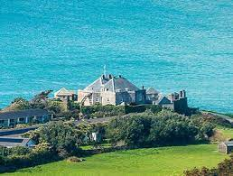

Fig 02: sea view star castel

Discover the Magic of Star Castle Hotel:
The Star Castle Hotel cordially invites you to discover the magic of the Isles of Scilly in a way that you have never done before. This offer is extended to you regardless of whether you are seeking a romantic break, a family vacation, or an opportunity to have a destination wedding (Repieva). We encourage you to create memories that will last a lifetime in the midst of the beauty that has stood the test of time and the magnificent amenities that are available at our mediaeval stronghold that has been converted into a hotel.
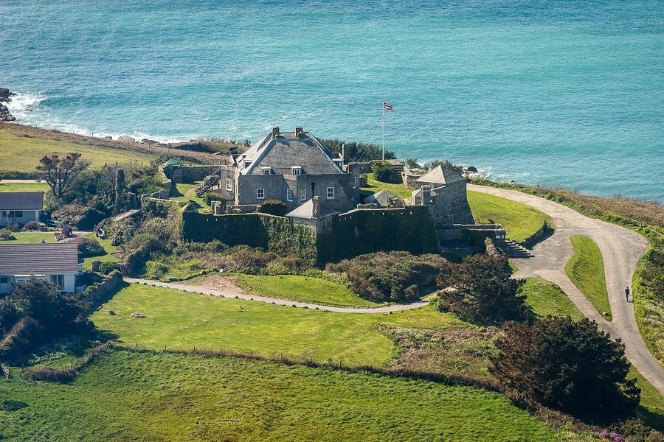
Fig 03: STAR CASTLE (updated 2021 Tipadvisor)

ANALYSIS:

Introduction:
It is possible to get insights into the strategy and operations of the Star Castle Hotel by conducting an analysis of the hotel through the lens of marketing and organisational change models with the intention of gaining a better understanding of the hotel. This analysis may be done in order to gain new insights into the hotel (Zhukov). It is clear that the Star Castle Hotel is an establishment that stands out as being particularly remarkable when examined from the perspective of the hospitality business. This research will make use of both Kotler's 8-Step Structure and Lewin's 3-Stage Model in order to provide a comprehensive image of the hotel's approach to marketing and managing change, with the goal of providing a comprehensive picture. Lewin carried out the development of each of these models. The satisfactory completion of this assignment will be accomplished by the utilisation of both models.

Kotler's 8-Step Structure:
Understanding the Market and Customer Needs:
Star Castle Hotel has conducted extensive market research and developed techniques for collecting feedback from customers in order to demonstrate a full awareness of both its target market and the preferences of its consumers. This is done in order to demonstrate that the hotel is aware of both of these aspects. To demonstrate that the hotel is dedicated to providing outstanding service, this is done in order to convey that commitment (Péterfi 2020). The hotel guarantees that its services will continue to be in compliance with the expectations of its clients on a consistent basis by acknowledging the changing patterns and preferences that are common within the hospitality industry. Bringing about this effect is accomplished by identifying evolving preferences and tendencies as the means by which it is carried out.
Creating a Marketing Strategy:
The hotel develops an all-encompassing marketing plan that encompasses a wide range of different types of media, including digital platforms, traditional advertising, and strategic relationships, among others. Customers are encouraged to make reservations at the institution through the use of this method. Using personalised marketing campaigns and promotions, the Star Castle Hotel is able to effectively communicate its one-of-a-kind value offer and differentiate itself from other hotels operating within the industry (Péterfi 2019). This allows the hotel to stand out from the competition. This makes it possible for the hotel to differentiate itself from its rivals.
Developing the Marketing Mix:
The Star Castle Hotel is putting forth a lot of effort as it develops its marketing mix, which consists of elements like product, pricing, venue, and promotion. To present its customers with an offering that is appealing, this is done in order to fulfil their needs (Schmitz 1979). When the hotel is operating in a market climate that is becoming increasingly competitive, it makes use of its offers, which include anything from outstanding dining experiences to luxurious suites, in order to attract and retain customers. These offers include a wide range of amenities.
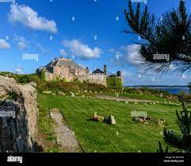
Fig 04 : star castel sky seen
Implementing and Managing the Marketing Efforts:
In addition to ensuring that its marketing initiatives are carried out in a manner that is very effective, the hotel also makes use of sophisticated analytics and performance indicators in order to keep track of the extent to which the campaigns are successful. By continuously evaluating and improving its marketing strategies, the Star Castle Hotel assures that it will continue to increase its market share and achieve the maximum possible return on investment (Sargent 1979). This is accomplished by ensuring that it stays at the forefront of the industry. As a result, the hotel is able to achieve the highest possible return on investment. In order to accomplish this objective, the marketing activities of the organisation are optimised to attain the highest possible level of effectiveness.

Monitoring and Evaluating Performance:
The Star Castle Hotel is in a position to analyse the effectiveness of its marketing activities and to make adjustments based on the information that is obtained as necessary since it conducts performance reviews on a consistent basis. This allows the hotel to make adjustments as necessary. Using key performance indicators and metrics that monitor client input, the hotel is able to maintain its agility in responding to shifting market conditions and developing possibilities. This allows the hotel to preserve its ability to adapt quickly to new opportunities (Slack 1979). The hotel is able to preserve its lead over its competitors as a result of this.
Managing Relationships:
When it comes to its stakeholders, the Star Castle Hotel places a substantial amount of importance on establishing and sustaining connections with its customers, suppliers, and other organisations that are usually referred to as members of the stakeholder community (Penner 2013). The hotel promotes the cultivation of client loyalty and advocacy by providing individualised service and implementing proactive engagement initiatives. This allows the hotel to ensure that customers are satisfied with their experience. This results in an enhancement of the hotel's reputation as well as the equity of its brand, which in turn leads to an increase in the hotel's potential for future success.

Lewin's 3-Stage Model:
Freezing:
In order to achieve the goal of ensuring that any significant change management operations are carried out, it is necessary to do an analysis of the existing organisational structure, methods, and culture of the Star Castle Hotel. The reason for this is to ensure that any change management operations are carried out, which is the intention of this action (Adams 2013). In order to guarantee that any change management activities are carried out, it is essential to carry out this evaluation, which is the reason why it is of such great significance. The building of a baseline awareness of the current state of affairs enables the establishment to develop a platform for change preparedness, which in turn lessens resistance to future adjustments. This is made possible as a result of the establishment's ability to develop a platform for change readiness. This goal can be accomplished by the establishment of baseline awareness, which is the means by which it is accomplished. Increasing one's awareness of the current circumstances is not only the means by which this objective can be accomplished, but it is also the means by which it can be accomplished.
Changing:
The first thing that needs to be done in order to get the Star Castle Hotel to start the process of transformation is to implement new approaches, methods, and projects. This will take place in order to initiate the process that is going to take place (Choi 2009). It is with the purpose of boosting the hotel's operational efficiency as well as its competitive edge over other hotels in the industry that these activities are being done. The process begins with this subsequent step, which comes after the formulation of a distinct vision and the setting of strategic objectives. This stage marks the beginning of the process. It entails the formulation of strategic goals and objectives, respectively. After these two phases have been finished, the process will proceed to the next steps, which will begin immediately after that. It is likely that the hotel will be able to make the transition as easy as possible and prevent as many disruptions as possible to the day-to-day operations if it integrates personnel at all levels and provides them with the necessary training and assistance. This is a possibility that can be considered very likely. One can accomplish achievement in this area if they are determined enough (Dickson 2009). Because of this, it is possible to ensure that the transfer is properly completed in a timely manner and without any complications developing. In addition to this, it eliminates the possibility that any problems will arise in the future.
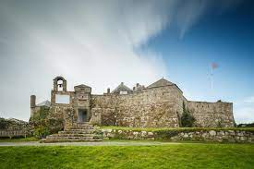
Fig 05: rock castel
Unfreezing:
The Star Castle Hotel places a significant amount of importance on the establishment of new routines and standards, which are subsequently strengthened as the change becomes more firmly ingrained within the corporate culture of the organisation. The alteration is carried out in this manner in order to guarantee that it will be successful in achieving its intended objective. Immediately after the completion of the transformation, this stage is carried out in order to ensure that the hotel will continue to be successful in its journey towards change throughout the course of the long term (Castle 2017). The hotel is able to successfully construct an atmosphere that is not only flexible but also committed to the pursuit of continuous development across its operations on a consistent basis. This target can be accomplished by the establishment of open communication channels, the development of feedback systems, and the execution of recognition programmes. These are the mechanisms by which this objective can be realised. Consequently, as a consequence of this, the hotel is in a position to successfully position itself for future expansion and innovation (Levy 2017). It is because of this that the hotel is able to successfully position itself in the market.

Conclusion:
Within the context of the marketing strategies and organisational transformation operations that are currently being carried out by Star Castle Hotel, this report provides a substantial amount of information that is appropriate to the scenario that is being taken into consideration. The 8-Step Structure that was developed by Kotler and the 3-Stage Model that was generated by Lewin are both examples of models that can be utilised in order to effectively communicate these one-of-a-kind concepts (Pratten 2003). By taking a customer-centric approach to marketing and managing change in a proactive manner, the hotel is able to maintain its agility, resilience, and competitiveness in the constantly shifting landscape of the hospitality industry. The hotel's proactive management of change makes this possible. Because of this, the hotel is able to keep all of these characteristics without giving up any of them. Additionally, as a result of this, the hotel is able to maintain its competitors in the market.

RECOMMENDATIONS AND CHANGE MANAGEMENT:

Recommendations
Customer Experience Enhancement:
Surveys should be conducted, and feedback should be gathered from guests in order to identify areas that could be improved through the implementation of change within the business. It is highly suggested that these activities be carried out. This approach will make it feasible to effectively identify areas that could be improved, which is something that would not have been achievable otherwise (Bled 1999). When it comes to ensuring that customers receive outstanding service, the most efficient method is to make investments in the training of staff members. This is the most effective method among all of them. For the purpose of achieving this objective, it is possible to provide these individuals with the opportunity to take part in training programmes. The usage of technological solutions, such as a mobile application, is something that needs to be taken into consideration in order to succeed in accomplishing the objectives of simplifying the process of reserving accommodations and making it simpler to contact guests(Mottershead 2000).
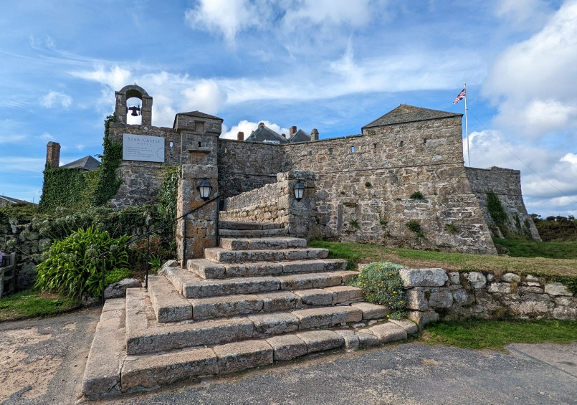
Fig 06: isles of scilly
Renovation and Upgrade:
Before anything else, it is of the utmost importance to carry out a comprehensive assessment of the property in order to determine whether or not any modifications or repairs are necessary for the rooms, amenities, and facilities. Such a thing is unquestionably essential (FORK 1969). The procedure begins with this step, which is the most important of all the phases. Inside the establishment, the locations that have a direct influence on the level of comfort and enjoyment that guests experience should receive a greater degree of attention than other places inside the business. In contrast to the context that would ordinarily be taken into consideration, the situation that is currently taking place is distinct from the context that is currently in existence. Some examples of activities that are beneficial to the environment and should be taken into consideration with regard to the protection of the environment include the use of energy-efficient machinery and the utilisation of materials that are sustainable. Both of these activities are examples of activities that are beneficial to the environment (VALLEY 1969). Two instances of activities that are good for the environment are being described here, and both of these activities are examples of activities that are being addressed.
Marketing and Branding:
In order to guarantee that the logo of the hotel accurately reflects the distinguishing features of the establishment as well as the fundamental principles that serve as the foundation for its operations, it is recommended that the logo be altered. As a result, the logo will appropriately represent both of these categories (Tang 2015). The process has a number of components, one of the most significant of which is the formulation of marketing plans that are precisely focused on recruiting new consumers and preserving the customers that you now have. In this regard, this is one of the most important features. This particular part of the process is considered to be among the most significant aspects of the process. Increasing the quantity of connection you have with your audience as well as the amount of exposure you have may be accomplished through the utilisation of a broad variety of different strategies (Adamska 2021). One of the strategies that may be employed is to work together with influential people, and another is to make use of the many different social media platforms that are currently available.
Diversification of Services:
If you are interested in boosting the amount of money that you make, you might want to consider the possibility of organising events, providing spa services, or building links with local businesses in order to provide tours and activities. These are all options that you could consider (Schultz 2011). At all times, it is essential that you keep all of these considerations in mind from beginning to end. If you choose to choose any one of the many various pathways that are available to you, you have the opportunity to potentially raise the amount of money that you bring in.
Offering packages and promotions that are specifically designed to appeal to the interests and preferences of a number of different market groups is one of the most essential approaches that can be utilised in order to cater to a wide variety of market segments. When it comes to catering to a wide range of different market sectors, this is one of the most important strategies involved. This is one of the most essential strategies that can be utilised in order to accomplish the objective of catering to a wide variety of market sectors, and it is one of the approaches that can be obtained (Golden 2007).

Change Management Process:
Stakeholder Engagement:
You need to make sure that the vision for the change is communicated to all of the stakeholders, which includes the staff, the management, the owners, and the customers themselves. Of all the things that need to be done, this is the most important factor. Within the confines of this conversation, the customers themselves are not excluded from consideration (Enz 2012). This action is being conducted with the objective of ensuring that it will be accepted, which is the idea behind this activity. This action is being taken in order to ensure that the change will be authorised. In order to accomplish the goal of resolving any concerns or resistance to change that may be present, it is crucial to first allow open discourse and then promptly address any issues that may be present.
This is especially important in order to achieve the goal of achieving the objective. On the other side, there is a possibility that this will make it simple to locate answers to any problems that may happen to be widespread. It is of the utmost importance to involve critical stakeholders in the decision-making process in order to achieve the aim of developing a sense of ownership and commitment in the individuals who are participating in the activity (Radford 2013). This is because the goal is to achieve the goal of attaining the goal. This must be done in order to accomplish what has to be done. Because of this, it will be feasible to achieve the goal that has been set. It is necessary to proceed in this manner in order to accomplish the tasks that need to be done in order to fulfil the requirements.
Training and Development:
Access to training and development programmes should be made available to employees in order to enable them to acquire the information and skills necessary to adapt to changes that occur in the workplace. It is essential to provide employees with this opportunity. It is imperative that individuals who are currently involved in the labour force be given the opportunity to participate in these activities (Magers 2013). This is due to the fact that these opportunities ought to be made available to a workforce, which is the basis for this observation. Individuals who are currently employed ought to be given the opportunity to participate in the supply of job opportunities. One of the most essential things that may be done is to make certain that these chances are accessible to each and every individual.
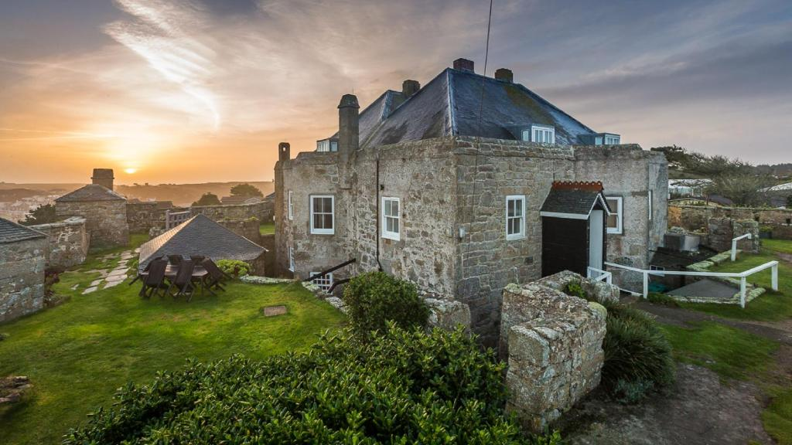
Fig 07: sunset in star castel
By actively participating in the labour force, it is possible to achieve this goal. One of the most crucial things that can be done or may be done is to find a way to guarantee that these opportunities are accessible to every individual. Participating actively in the labour force is a viable option for achieving this purpose, which can be accomplished. Because the provision of assistance and resources is of the utmost importance and ought to be given to those individuals who are participating in the activity, it is imperative that these individuals be assured of the provision of these things (Mensah 1994). This step is conducted with the intention of ensuring that the implementation is successful while also ensuring that the learning process is kept straightforward and easy to comprehend.
Clear Communication:
It is of the utmost importance to build communication channels within the organisation that are not only open but also transparent in order to guarantee that information concerning changes is successfully communicated to the right personnel. This is required in order to guarantee that the information is successfully shared. This is a criteria that must be met in order to guarantee that the information is communicated in a manner that is accurate (Mensah 2016). Due to the fact that it is essential, it is something that must be done in order to completely satisfy this requirement. Ensure that all of the stakeholders are kept informed about the progress that has been achieved, the milestones that have been accomplished, and any new changes that have been made to the plan. Two of the most important components of this attempt are the rapid resolution of any complaints or misunderstandings in a timely manner, as well as the encouragement of participation in the endeavour. The entirety of this should be carried out while simultaneously ensuring that transparency is preserved. One of the most important aspects is the encouragement of involvement, which is also one of the most important components. Many people are of the opinion that both of these qualities are among the most important that can be found in the world. The reason for this is that both of these characteristics are quite significant (Channouf 2016). In addition to being highly substantial in their own right, both of these aspects are also quite significant when paired with one another.
Continuous Evaluation and Improvement:
When the changes that are being implemented are being adopted, it is of the utmost importance to keep a watchful eye on how the modifications that are being made will affect the performance requirements before those changes are implemented. This is because meeting the performance criteria is a requirement that must be met. The reason for this is specifically related to the fact that it has an impact on the essential performance requirements (Al-Zaidi 2016). This includes the quantity of money that can be generated, the level of happiness that guests are able to experience, and the efficiency with which activities are carried out. These are just some of the many variables that are taken into consideration. Both of these facets are taken into consideration throughout the process. It is of the utmost importance to collect feedback from both the employees and the customers in order to determine the areas in which there is room for development and to make it possible to implement any changes that may be necessary. This input must be gathered as quickly as possible; it is of the utmost importance. In order to identify the areas in which there is room for improvement, it is possible to make use of this information, and it is also possible to do so (Bartmanski 2021). While it is of the utmost necessity to recognise and respect the efforts that have been made by both individuals and teams, it is also of the utmost necessity to take delight in the moments of triumph. Both of these things are of the utmost importance. The combination of these two things means that they are of the utmost importance and worth. As a result of the fact that it is essential to keep momentum and motivation throughout the process, this is the reason why this situation has arisen.
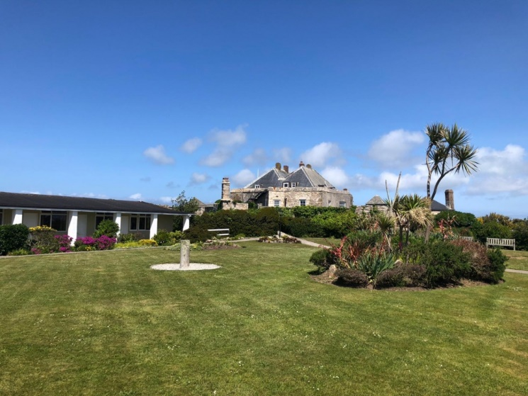
Fig 08: gallery star castel

ACTION PLAN:
The Star Castle Hotel is a well-known establishment in the hospitality industry, and it has recently made public its comprehensive action plan. It is the intention of this plan to not only satisfy the standards for operational efficiency and sustainability but also to improve the overall experience that guests have while they are staying at the hotel (Bartmanski 2021). Recently, the concept was brought to the attention of the general public. An emphasis is placed on the happiness of visitors through the provision of individualised services, an increase in the number of amenities, and experience offers that are tailored to specific interests. This all-encompassing strategy takes into account a wide variety of different aspects, beginning with an emphasis on the happiness of visitors. Additionally, the strategy places a large emphasis on the training and development of staff workers, which is a crucial factor. When this is done, it is done with the purpose of ensuring that the workforce as a whole is not only trained but also motivated and that it is able to offer products and services that are of exceptional quality. A key area of concentration is operational efficiency, which encompasses the implementation of initiatives that aim to streamline operations, maximise the utilisation of resources, and make use of technology to boost productivity. This is one of the basic areas of concentration. It is important to pay attention to this particular aspect. Specifically, this particular facet is one of the primary areas of concentration. Additionally, the Star Castle Hotel is committed to environmental stewardship, and it has developed a variety of programmes with the objectives of reducing the amount of waste produced, reducing carbon footprints, and promoting environmentally responsible practices within the hospitality industry. These goals are all aimed at reducing the amount of waste produced (Thierstein 2021). The implementation of these projects was done with the intention of accomplishing these objectives. It is the intention of the Star Castle Hotel to put this action plan into action in order to boost its reputation as a premium site for travellers who are selecting their accommodations. This action is taken with the intention of attracting a greater number of guests. During this period, the hotel is working towards the goal of cultivating a culture within the firm that is defined by quality and sustainability. This is happening at the same time that this is taking place.
Table for Action Plain
Aspect | Action | Timeline | Resources Required | KPIs
Customer Happiness | - Provide individualized services | Ongoing | Staff training, feedback mechanisms | Guest satisfaction surveys
 | - Increase number of amenities | Yearly review | Budget for amenities, market research | Amenities utilization rates
 | - Offer tailored experience packages | Quarterly | Marketing budget, customer data analysis | Package bookings, satisfaction
Staff Training | - Develop training programs | Annually | Training materials, trainers | Staff performance evaluations
 | - Motivate workforce | Ongoing | Recognition programs, team-building events | Staff retention rates
Operational Efficiency | - Streamline operations | Quarterly | Process analysis, technology investments | Time/cost savings
 | - Maximize resource utilization | Ongoing | Resource management systems, staff training | Resource utilization rates
Environmental Stewardship | - Reduce waste production | Ongoing | Waste management systems, staff training | Waste reduction rates
 | - Decrease carbon footprint | Ongoing | Energy-efficient technologies, recycling | Carbon footprint reduction
 | - Promote environmentally responsible practices | Ongoing | Educational campaigns, partnerships | Adoption of sustainable practices
Reputation Building | - Implement action plan | Immediate | Cross-departmental collaboration | Guest reviews, bookings
 | - Cultivate quality & sustainability culture | Ongoing | Leadership commitment, staff training | Employee engagement, retention
Explanation:
The action plan, its timeframe, the resources that are required, and the key performance indicators (KPIs) that will be used to monitor progress and success are all spelled out in this table. The table also includes those resources that are necessary.
CONCLUSION:
A remarkable facility that exemplifies elegance, attractiveness, and tranquilly on the rocky shore, the Star Castle Hotel is a place of distinction. When everything is taken into consideration, the hotel is an incredible establishment. With regard to each and every one of these three characteristics, it is an outstanding illustration. No other option even comes close. There is not a shred of doubt in my mind that it is an investment beyond compare. The opportunity to experience something that they will never forget in their entire lives will be provided to each and every visitor who attends the event (Silva 2015). The reason for this is that the hotel has a long and distinguished history, gorgeous architecture, and service that is unmatched by any other establishment. Something like this is going to make an impression on me that will last a lifetime. This is something that will occur on an individual level, and it is something that will leave an indelible mark on one's memory that will last forever. There is something that this historic jewel has to offer that is really wonderful, and it doesn't matter if you are seeking a getaway with your significant other, an adventure with your family, or just a change of pace from the stresses of everyday life. It makes no difference what it is that you are looking for; it has something to provide that is truly fantastic (Chittiprolu 2021). It is certain that your stay at the Star Castle Hotel will not only be one that exceeds your expectations, but it will also give you an experience that will remain engraved in your memory for the rest of your life. You have every reason to believe that this will be the case. It is possible that you are looking forward to this happening with a great deal of energy. Whether it be the gorgeous views of the ocean, the sumptuous dining alternatives, or the great attention to detail that is provided, the fact that this is the case is true irrespective of any of these aspects. As a result of this well-known location's constant commitment to exceeding the expectations of its clients, in addition to meeting or exceeding those expectations, it continues to become a popular destination for tourists. It is not only that this site continues to bring in customers, but it also continues to further solidify its position as one of the most well-known hotels in the vicinity of the general area (Dalton 2008).

REFERNCES:
Nakai, A., 2023. Sustainable Initiatives of Forbes Five-star hotels in Tokyo: Balancing Sustainability and Average Customer Spending under COVID-19.
Dorignon, L. and Wiesel, I., 2022. Five-Star homes: Hotel imaginaries and class distinction in Australia’s elite vertical urbanism. Annals of the American Association of Geographers, 112(7), pp.2111-2129.
Stankova, M. and Kaleychev, S., 2023. Digital Transformation in the Hotel Industry: Shaping the Challenges and Opportunities by the Case of Five-Star Hotels in Bulgaria. Digital Transformation of the Hotel Industry: Theories, Practices, and Global Challenges, pp.205-232.
Vũ, T.L.A. and Dương, Q.B., 2022. A business plan for the Villa Song Saigon in 2023: The feasible solutions with the purpose of attracting more potential customers throughout guest’s service experience (Doctoral dissertation, FPTU HCM).
APPIAH, P.A., ADONGO, R. and Abdul-Rafiw, S.A.F.O., 2023. Sustainable Energy Systems and Green Hotel Practices in Hotels in Tamale Metropolis, Ghana. Journal of Environmental Management and Tourism, 14(7), pp.2915-2934.
Windegger, F., Scuttari, A., Walder, M., Erschbamer, G., de Rachewiltz, M., Corradini, P., Weisel, Z.K., Habicher, D., Ghirardello, L., Wallnöfer, V. and Garzon, G., 2023. The Sustainable Tourism Observatory of South Tyrol (STOST): annual progress report-2022 edition.
Péterfi, J., 2019. A Co-operative Settlement for the Utilization of the Hertelendy Castle. Turisztikai és Vidékfejlesztési Tanulmányok, 4(különszám).
Schmitz, T., Sargent, M.L., Slack, C., Wagner, T., Hacker, J.F. and Pollard, R., 1979. Prospectus, November 28, 1979.
Penner, R.H., Adams, L. and Rutes, W., 2013. Hotel design, planning and development. Routledge.
Choi, Y. and Dickson, D.R., 2009. A case study into the benefits of management training programs: Impacts on hotel employee turnover and satisfaction level. Journal of Human Resources in Hospitality & Tourism, 9(1), pp.103-116.
Castle, I., 2017. The History of.
Levy, S., 2020. The Castle on Sunset: Life, Death, Love, Art, and Scandal at Hollywood's Chateau Marmont. Anchor.
Pratten, J.D., 2003. What makes a great chef?. British Food Journal, 105(7), pp.454-459.
Bled, L., 1999. Slovenia.
Anastasiadou, P., Sarantakou, E., Maniati, E. and Tsilika, E., 2022, April. Exploring stakeholders’ perspectives on hotel design. In Transcending Borders in Tourism Through Innovation and Cultural Heritage: 8th International Conference, IACuDiT, Hydra, Greece, 2021 (pp. 239-255). Cham: Springer International Publishing.
Amriddinova, R. and Islomov, S., 2022. The role of guest houses in the organization of rural tourism. Builders of the future, 2(2), pp.116-122.
Tang, T., 2015. Senior housing development in China (Doctoral dissertation, Massachusetts Institute of Technology).
Adamska, A., 2021. Tourist accommodation of castles and palaces located within the Lower Silesian Voivodeship. Teka Komisji Architektury, Urbanistyki i Studiów Krajobrazowych, 17(4), pp.7-18.
Schultz, P., 2011. 1,000 Places to See Before You Die: Revised Second Edition. Workman Publishing Company.
Golden, E., 2007. Vernon and Irene Castle's Ragtime Revolution. University Press of Kentucky.
Enz, C.A., 2012. Competing successfully with other hotels: The role of strategy. The Cornell School of Hotel Administration on hospitality: Cutting edge thinking and practice, pp.207-226.
Radford, D. and Magers, D., 2013. New Castle: Darrel Radford and Doug Magers. Arcadia Publishing.
Radford, D. and Magers, D., 2013. New Castle: Darrel Radford and Doug Magers. Arcadia Publishing.
Mensah, I., 1994. Environmental management practices in US hotels.
Oukil, A., Channouf, N. and Al-Zaidi, A., 2016. Performance evaluation of the hotel industry in an emerging tourism destination: The case of Oman. Journal of Hospitality and Tourism Management, 29, pp.60-68.
Alaily-Mattar, N., Bartmanski, D., Dreher, J., Koch, M., Löw, M., Pape, T. and Thierstein, A., 2021. Situating architectural performance:‘star architecture’and its roles in repositioning the cities of Graz, Lucerne and Wolfsburg. In Dislocation: Awkward Spatial Transitions (pp. 174-200). Routledge.
Silva, R., 2015. Multimarket contact, differentiation, and prices of chain hotels. Tourism Management, 48, pp.305-315.
Chittiprolu, V., Samala, N. and Bellamkonda, R.S., 2021. Heritage hotels and customer experience: a text mining analysis of online reviews. International Journal of Culture, Tourism and Hospitality Research, 15(2), pp.131-156.
Dalton, N. and Stone, D., 2008. Frommer'sTM Wales With Your Family: From Cliff-top Castles to Sandy Coves (Vol. 48). John Wiley & Sons.
Rogerson, J.M., 2018. The early development of hotels in Johannesburg ca 1928-1963. African Journal of Hospitality, Tourism and Leisure, 7(4), pp.1-16.
Cosma, S., Negrusa, A. and Pop, C., 2008. Romania as a tourist destination and the Romanian hotel industry. Cambridge Scholars Publishing.
Marino, B., 2021. Conscious maintenance as a tool for built heritage valorization. Theory applied to the Sammezzano castle.
CASTLES, C.H., 1794. north wales.
Hansmann, J., 2018. Castle Rock: An Architectural & Historical Walking Tour. Xlibris Corporation.
Iomaire, M.M.C., 2015. Haute cuisine restaurants in nineteenth and twentieth century Ireland. Proceedings of the Royal Irish Academy: Archaeology, Culture, History, Literature, 115(1), pp.371-403.
PORT, W. and TERRACE, C., DESIGN BRIEF REPORT.
Ivanova, M. and Ivanov, S., 2015. Affiliation to hotel chains: Hotels' perspective. Tourism Management Perspectives, 16, pp.148-162.
Carson, C., 2019. The star factory. Bloomsbury Publishing.
Ivanova, M. and Ivanov, S., 2015. Affiliation to hotel chains: Hotels' perspective. Tourism Management Perspectives, 16, pp.148-162.
Akhtar, N., Zubair, N., Kumar, A. and Ahmad, T., 2017. Aspect based sentiment oriented summarization of hotel reviews. Procedia computer science, 115, pp.563-571.
Honma, S. and Hu, J.L., 2012. Analyzing Japanese hotel efficiency. Tourism and Hospitality Research, 12(3), pp.155-167.
Tran, Q., 2023. Hotel’s resilience against major changes in demand-case Da Lat palace hotel.
Hindley, C., Legrand, W. and Zaslavskaya, A., 2023. Biophilic Design in the Hospitality Industry: A Window Into Back of House Workspaces. In Advances in Hospitality and Leisure (Vol. 18, pp. 1-15). Emerald Publishing Limited.
Clara, I., Paiva, T. and Morais, E.P., 2022. Digital Marketing and user-generated content: a case study of Vidago Palace Hotel. In Marketing and Smart Technologies: Proceedings of ICMarkTech 2021, Volume 1 (pp. 451-461). Singapore: Springer Nature Singapore.
Alhassan, T., Kidido, J.K. and Tannor, O., 2023. Assessment of facilities management sourcing approaches in hotels in Ghana: a study of selected hotels in Wa. Property Management.

Miller, W.H., 2013. Union Castle Liners: From Great Britain to Africa 1946-1977. Amberley Publishing Limited.
Ludy, R.B., 1927. Historic Hotels of the World, Past and Present: By Robert B. Ludy. David McKay.
Chaplin, S., 2007. Japanese love hotels: A cultural history (Vol. 10). Routledge.
DeVivo, A., 2006. New Castle and Mahoningtown. Arcadia Publishing.
Musiaka, Ł., 2013. The tourism function of the castles of the Knights of the Teutonic Order in Poland. Turyzm, 23(2), pp.49-57.
Zolfani, S.H., Mosharafiandehkordi, S. and Kutut, V., 2019. A pre-planning for hotel locating according to the sustainability perspective based on BWM-WASPAS approach. International Journal of Strategic Property Management, 23(6), pp.405-419.
Ofori, D. and Appiah-Nimo, C., 2022. Relationship management, competitive advantage and performance of hotels: a resource-based view. Journal of African Business, 23(3), pp.712-730.
Rianthong, N., Dumrongsiri, A. and Kohda, Y., 2016. Optimizing customer searching experience of online hotel booking by sequencing hotel choices and selecting online reviews: A mathematical model approach. Tourism management perspectives, 20, pp.55-65.
Łukasz, M., 2014. The Tourism Function of the Castles of the Knights of the Teutonic Order in Poland. Turyzm, (Turyzm 2013, 23/2).
Addo, E., 2011. European heritage and cultural diversity: the bricks and mortar of Ghana's tourism industry. Journal of Contemporary African Studies, 29(4), pp.405-425.
Walls, J., 2017. The glass castle: A memoir. Simon and Schuster.
Albee, J., 1885. New Castle, historice and picturesque. Cupples, Upham.
Adam, I. and Amuquandoh, F.E., 2014. Hotel characteristics and location decisions in Kumasi Metropolis, Ghana. Tourism Geographies, 16(4), pp.653-668.
Qian, X., 2015. Planning Senior Living Homes for the Satisfaction of Active Elderly (Doctoral dissertation, Columbia University).
Gerster, J., Monthly Archives: November 2021.
Larasanti, N.M. and Nasution, D.A.D., 2022. Royal Victoria Hotel Industrial Strategies and Efforts Towards the Impact of The Covid-19 Pandemic. Basic and Applied Accounting Research Journal, 2(1), pp.1-7.
Kapoor, R., Singh, A. and Manchanda, G., 2023. Hospitality internships and green leaders: analysing the engagement of interns with hotel sustainable development practices. Worldwide Hospitality and Tourism Themes, 15(3), pp.295-307.

