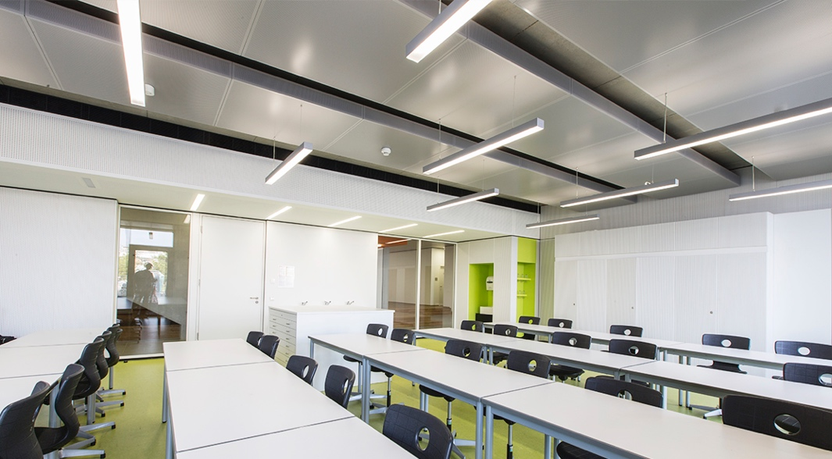

Lighting layout and Sound Index calculations

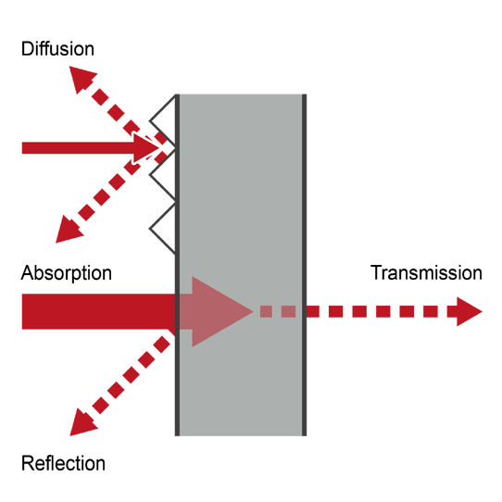

By Steffan Pryce-Griffiths (1902720)

Content page

- Introduction (page 3)
TASK A
- Question 1: calculate
- Room index. (page 3)
- The utilisation factor. (page 4)
- The number of lamps required. (page 5)
- A suitable layout for the light fittings. (page 6)
Plan layout of the factory floor (page 7)

TASK B
- the overall sound reduction index for the entire wall. (page 8)
- The implications of frequency and wavelength in internal sound management, partition wall construction technique and insulation choice. (page 9)
- Examples of construction techniques to soundproofing partition walls (page 9/10
- Frequencies and wavelengths and why some sound is harder to combat than others? (page 10)
- Soundproof smarter? (page 9)
- Resilience (page 11)
- Picture examples of how sound waves react when hitting solids and insulation materials (page 11)
- Conclusion (page 11)
- Bibliography (page 11)
- Figures (page 11)

Introduction

Mr Pryce-Griffiths in this presentation will be calculating two questions between lighting layout and sound reduction index calculation. The calculation will work out the lighting plan and layout needed for a production area in a factory for work benches, takes into consideration with the areas reflectance’s of the ceiling and walls. The sound reduction index calculation will measure the level of sound insulation provided by a structure such as a wall and window in our case. Last of all I will discuss the implications of frequency and wavelength in internal sound management with partition walls and the construction techniques and insulation choice to try to minimise this.

TASK A.

A production area in a factory measures 60 metres x 24 metres x 8 metres in height. The factory’s work benches are set at a height of 1m above the floor level. The area’s reflectance’s are 0.3 for the ceiling and 0.5 for the walls. The lighting design specifies fluorescent lamps in recessed louvre with DLOR of 50%.
A lighting design Lumen (LDL) output of 18,000 lumens is required.

The illumination required for the factory area us 200 lux at the working plane.
Light Loss Factor = 0.75

Question 1: Calculate:
- The Room Index. RI= $\left(LxW\right)÷\left(Hm\left(L+W\right)\right)$
Where:
L = Length of the room
W = Width of the room
H_{m} = Height of the luminaire measured from the working plane
(such as top surface of a desk)

Nearest figure is used for the room index from the utilisation factor sheet but the figure must be greater not lower to determine the utilisation factor. Room index value must be taken from the suitably light fitting. (which has been shown with a blue circle on the utilisation factor table sheet)

Answer for Room index = $\left(60 x 24\right)÷\left(7m\left(60+24\right)\right)=2.448$

The utilisation Factor (from table) - The utilisation Factor collects all of the variables above (reflectance of both the walls and ceiling, the room index, and the type of luminaire) into a single value.

follow the correct column, which in our case is Reflectance’s figure of 0.5 / 0.3
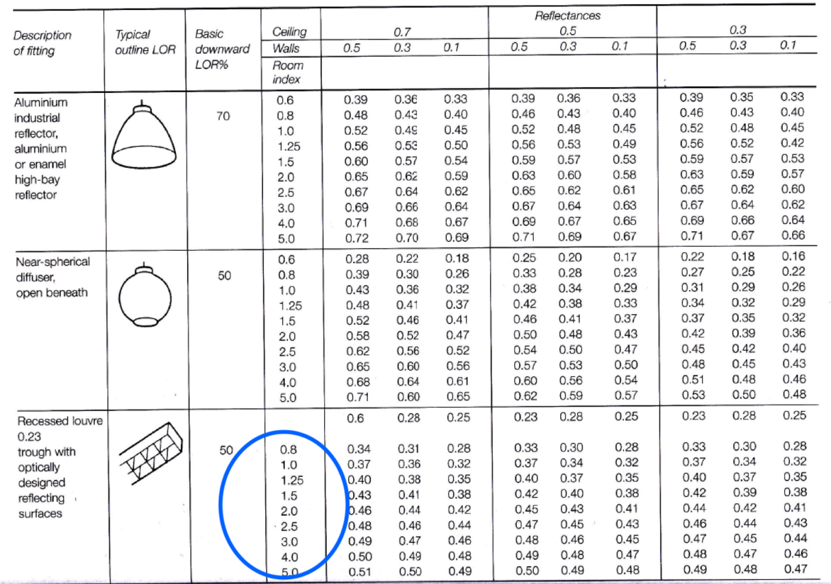

The utilisation factor figure is shown by the two green lines conveying the pathway to the figure of 0.45. (from the table)

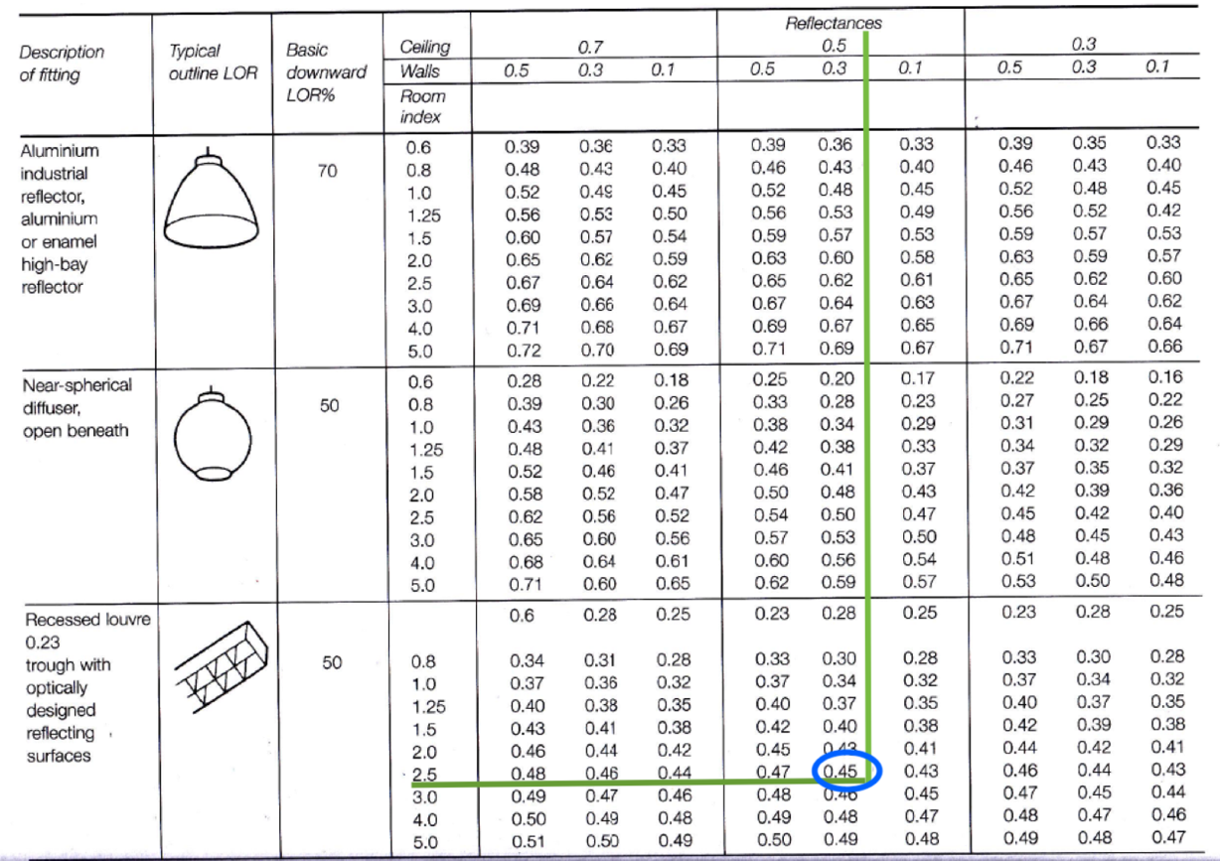

The number of lamps required N= $\frac{E x A}{F x UF x LLF}$

(THE FIGURE IS ROUNDED UP TO THE NEAREST EVEN NUMBER)

WHERE:

N = Number of lamps required

E = illuminance level required (lux)

A = Area at working plane height (m²)

F = Average luminous flux from each lamp (1m)

UF = Utilisation factor, an allowance for the light distribution of the luminaire and the room surface

LLF = Light loss factor, an allowance for a reduction in light output caused by lamp deterioration and dirt.

Lux level given in the question E= 200lux

Area A = 60 x 24 = 1440

Output of lumens is required F = 18000 lumens

Utilisation factor from the table UF = 0.45

Lighting loss factor given in the question LLF = 0.75

Equation
N= $\frac{200 x 1440}{18000 x 0.45 x 0.75}=47.407$

Answer = Number of lamps required is 48.

A suitable (layout of S) for the lamp fittings

Equation

S_{max} = 1.5 x H_{m,} The mounting height (H_{m}) = 7metres.

S_{max} = 1.5 x 7 = 10.5 metres apart

Maximum spacing between each light

The layout is correct if the maximum distance between lamps
is less than 10.5m.

- rows of 12 I believe to be best suitable layout to achieve the required lighting needed for the work benches in the factory.

Below is the layout Steff has produced through AutoCAD. The lights around the outside have come in 200mm from wall to prevent too much light glaring on the walls. 6800mm distance between each light width’s ways and 5090mm distance between each light length’s way. This is show on the image on page 7. This is acceptable as its lower than the maximum distance of 10.5m.

Plan layout of the factory floor (best fit design for the luminaire installation)

TASK B.
A brick wall of area 20m² contains a window of area 4².
The values of sound reduction indexes are:
50dB for the brickwork and 10dB for the window.

- Calculate the overall sound reduction index for the entire wall

The equation used to calculate the sound reduction index T₀ = $\frac{\left( T1 x A1\right)+(T2 x A2)}{A1+A2}$

Where T0 = overall (averaged) transmission coefficient
T1 = transmission coefficient of one component
A1 = area of that component

For the brickwork: T1 = ?, A1 = 20-4=16m ² SRI = 50dB
For the window: T2 = ?, A2 = 4m ² SRI = 10dB

Able to place the Area values as we know these figures but the Transmission Coefficient needs solving.
Using the formula: SRI = 10 x (log ₁₀ (1/T))

Brick Window
$SRI=10 x (log10\left(1÷T\right)$ $SRI=10 x(log{10 \left(1÷T\right)}$
$50=10 x (log10 (1 ÷T1$ $10=10 x (\log{10 ( 1 ÷T2)}$
$5=log10 x (1÷T1$) $1=\log{10 x ( 1 ÷T2)}$
$1÷T1=$ 10⁵ $1 ÷T2=10$¹
T1 = 10⁻⁵ T2 = 10⁻¹
= 0.000010 = 0.10
(Transmission coefficient for brick) (Transmission coefficient for window)

Sound reflectance index value

$$\frac{\left(16 {x 10}^{-5}\right)+({10}^{-1} x 4)}{16+4}=0.020008$$
Using SRI formula and substituting
SRI = 10 x (log 10 (1/T))
= 10 x (log 10 (1/0.020008))
= 10 x (log 10 (49.980007))
= 10 x 1.69
= 16.9

SRI for the Composite partition = 17 dB

Different construction techniques to deal with the implications of frequency and wavelength in internal sound management with partition walls and insulation choices.

The loudness of a noise will be separated between the frequency/pitch of a noise. The sound of the same volume with a low bass frequency will filter through far easier than the high frequencies but low-frequency sound will drop in energy when surpassing a solid object. This is can be down to two reasons; their longer wavelengths and low-frequency sounds form a vibration in walls and this aids propagate the passage of sound.

Three things outcomes can occur when sound hits an object: transmission (the sound save will travel through the object), reflection (the sound wave will bounce off the object, which can generate an echo) and absorption (the sound wave is confined in the object).
A general problem with standard brick walls that a vibration can occur at a specific frequency permitting penetration of specific frequencies (normally bass/low frequency). Acoustic wall treatment materials are incredibly important to confront this dilemma.

Examples of construction techniques to soundproofing partition walls

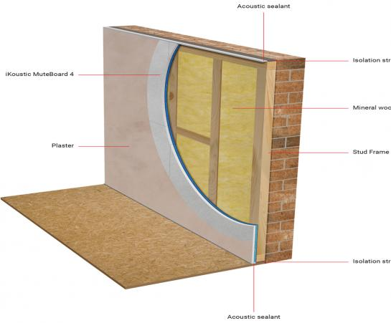

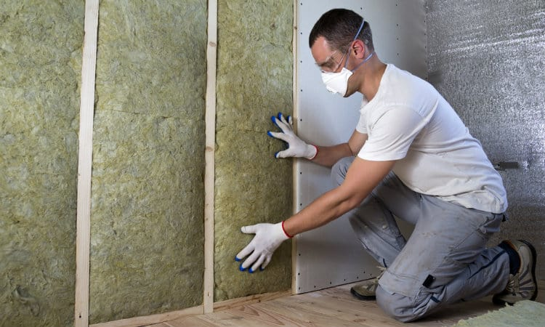

Frequencies and wavelengths and why some sound is harder to combat than others?
High-frequency waves will fall off or be absorbed but low-frequency sounds will go through the wall fairly easily. Increasing the thickness of the wall is one way we can improve soundproofing but it’s not the most effective as low-frequency sounds can have a wavelength of 5 metres or greater. This method is known as mass law which states that roughly 6dB improvement in sound reduction with doubling the weight of acoustic barriers. This displays that just putting a couple of layers of soundproofing plasterboard on the wall will not solve the problem.

Soundproof smarter?
By soundproofing smarter, it means using materials that will fulfil the requirements. The materials will need to combine; mass, resilience and absorption.
Attaching a specialist soundproofing material will interrupt the resonance in walls and will successfully absorb sounds as they pass through the wall. Best outcome would yes make your walls thicker but also intelligently soundproof.

The wall is now soundproofed, as the same sound hits the wall. The wall has been made thicker which blocks more of the waves. We encounter many difficulties with different types of mass and air gaps but the sound will be absorbed in the wall and a resonate cannot be formed in the wall. This is due to the applied materials being diverse to the original heavy brick making the frequency resonant.

Resilience
Making the material springy will make the sound wave vibrate and absorb creating passing energy. The methods used to this day are corrugated steel or rubber-mounted bars where plasterboard will be mounted on to which disintegrates vibrations. Tecsound acoustic membrane can act in the same way providing resilience to the solution.
Picture examples of how sound waves react when hitting solids and insulation materials.
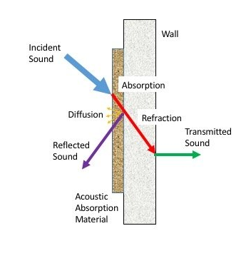

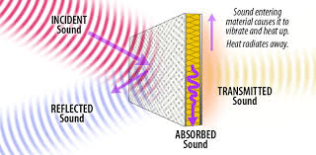

Conclusion

Multiples of products and systems can be used in different situations. Best way to maximise soundproofing to a good standard is to think how much space is allowed to be lost and the amount of the that’s willing to be spent.

Figure:

- https://www.google.com/url?sa=i&url=https%3A%2F%2Fglamox.com%2Fuk%2Fsolutions%2Ftest-small-class-room&psig=AOvVaw11zVkudY5hcnRDrhNGYGv7&ust=1582808480074000&source=images&cd=vfe&ved=0CAIQjRxqFwoTCICUyrWn7-cCFQAAAAAdAAAAABAD
- https://www.google.co.uk/url?sa=i&url=https%3A%2F%2Fwww.paroc.by%2Fknowhow%2Fsound%2Fgeneral-information-about-sound%3Fsc_lang%3Den&psig=AOvVaw2AmY3czsRDhZioG054UNjN&ust=1583512034625000&source=images&cd=vfe&ved=0CAIQjRxqFwoTCMiHmJfgg-gCFQAAAAAdAAAAABAD
- https://www.ikoustic.co.uk/systems/masonry-wall/muteboard-4-stud
- https://bettersoundproofing.com/soundproofing-walls/
- https://www.sonic-shield.com/acoustical-interactions/
- https://www.acousticsciences.com/solutions/absorption

Bibliography:
https://www.soundstop.co.uk/science-of-soundproofing
White Book - C02 - Technical performance - British Gypsum
file:///Users/steff/Downloads/White-Book-C02-Technical-performance.pdf

