Ways of perceiving
Nerys Thomas
Word count – 1413

In this essay I will be planning an exhibition based on the idea of body positivity and how everyday woman are critiqued on imperfections of their body which are usually completely normal, can’t be helped and in my mind, and the mind of body positive activists- beautiful. Body positivity is the idea that no matter what a person looks like, they should be celebrated and seen as normal. The idea arose because of the way the media pushes an ideal way a woman should look and many young girls grow up not knowing what’s normal and healthy and end up developing issues with the way they look which creates an unhealthy expectation of themselves and others. Since the rise of social media and websites such as Instagram,, a certain body type has been pushed into the public and photoshopping ones photos has become the norm which I disagree with . It’s hard to argue that social media hasn’t added to the rise of eating disorders and body issues in young woman but can also effect woman of every age but much less, which can be backed up by a recent study by NEDA (National Eating Disorder association) which says “women between the ages of 18 and 25 showed a link between Instagram and increased self-objectification and body image concerns, especially among those who frequently viewed fitspiration images” (fitspiration being fitness inspiration) that’s why i’m planning my exhibition on body positivity to introduce people into the idea of self love and normalising the way our bodies look instead of being obsessed with comparing themselves to others because even though I’ve been using the word “normal” there is in fact no normal as everyone is different and it should be celebrated by both men and woman of all ages.

The artists I want to exhibit in my Body Positive exhibition are; Beto França , Kelly Bastow, Clarity Haynes and then a collection of photographs from an online group of body positive enthusiasts called “Underneath-we-are-woman”.The first artist I have chosen to exhibit is Beto França. he is a 36 year old illustrator who does illustrations for books and teaches watercolour and drawing workshops. He is mostly influenced by the 50s and 60s style which is quite prominent in his work. He works mostly with watercolours to give a softer and prettier approach. The second artist is Kelly Bastow, an illustration who focuses on men and woman. She started making patterns of men and woman back in 2014 when she realised there wasn’t much representation for people in the media. Her work is very neauteral toned because it’s slightly raw and nude yet still very cartoon and fun to look at. Not only does she draw men and woman, but she also incorporates mythical beasts sometimes like mermaids to make it more colourful and appealing. The third artist is Clarity Haynes is an oil painter who strictly paints very raw nude torsos which can be confronting, of what she calls ‘real woman’. She started "The Breast Portrait Project” in the late 1990s, which she used self-portraiture to examine and heal the relationship with her body. Lastly I wanted to exhibit a group of woman called “Underneath-we-are-woman” because they photograph every woman who is willing to be shown. They show a huge range of bodies, scars and disabilities which helps give woman a voice and tell their story. I feel it is a really powerful and beautiful movement to include as it may show some people things they haven’t seen before and others, something to identify with.

As for the layout of my exhibition, I feel it would be best to use a eased approach as to not show everything and confront people right as the start with imperfections and things they may be insecure about. I also think it’s best to use the easing approach as it could feel like a crescendo to the final, naked truths of woman’s bodies. Ideally, my exhibition would be a long corridor with a big room at the end. The walls would be white as to not take away from the work placed upon them. First I want to showcase Beto França as his work is so cartoon, it eases people into the body positive experience and doesn’t yet shock them as they work is so pretty, dainty and light but I think they still have a strong message as I hope bigger woman would be able to see themselves in them and identify with it. Next would be some of Kelly Bastows work as all of her work is of nude people unlike França who sometimes does clothed. I feel removing the clothes would be the next step to battling body stigma in a gentle way. Kelly Bastows work I feel is a good next step because it’s less colourful and feels right being the next part of the crescendo as even though it’s still fun and cartoon, the pallet has gotten more neutral and feels like we’re stripping back layers to the final part of the exhibition which I call the confrontation. Third will be Clarity Haynes as she moves further away from cartoon and her work is more life like so her images are more stark. She covers a wide variety of bodies and issues woman may have which hopefully should open peoples eyes to realising that all bodies are good bodies and hopefully could pick out aspects of themselves in her art. Lastly I would have a room dedicated to Underneath- We-Are-Woman as there are so many photographs I love, I feel they should have their own space as they’re the finale of the exhibition, the confrontation of what many woman may fear, haven’t seen before or are disgusted by. They are the finale because we break away slowly from cartoon illustrations and ease into real life images of real woman who are proud to show off what they have. The group of photographs will cover every
Imperfection imaginable because I want my exhibition to be as inclusive as I can make it because to me, that’s another important part of body positivity.

As for the ideal outcome of my exhibition, I want it to shock, entice, and help people learn more not only about their bodies but the idea of accepting everyone as they are. Though I am not opposed to changing oneself to feel better, I don’t think people should do it to imitate what they see on social media. I am a strong believer that any change that is made should always be for yourself. Which leads into why I want to do it on ‘Bo-po’ (body positivity) As worries about body weight, shape, and ideas or attempts to diet, start at an early age for females, some people speculating as low as age 5. A study by Common Sense Media found out that by age 6, girls are aware of dieting and may even have tried it and that between 1990-2012, the hospitalisation of young children for eating disorders rose to 112% and although there are many factors into why someone has body issues, it’s hard to argue that exposure to social media at a young age doesn’t help as we are bombarded with images of skinny, tanned woman with big breasts and bums. The theory behind my exhibition is to break the stigma on the way bodies look and open the doors to woman of all ages as everyone is my intended audience because body positivity is so inclusive.

In conclusion, I want my exhibition to be about body positivity and breaking the stigma centred around the way woman’s bodies look apprised to how the media says they ‘should look’. The 4 people I want to include in the exhibition are Beto França , Kelly Bastow, Clarity Haynes and a photography collection by Underneath- we-are-woman’ and in that order to ease people into the idea of self love by taking a gentle approach to opening their minds through art. The exhibition will be a long corridor with a room that gradually pics up speaks of exposure to nudity by starting off with the most cartoon art and ending with real pictures of woman that have their own space at the end to confront fears. In this exhibition I hope that all woman can find at least one piece of art they Identify with and can feel represented by and feel validated in their existence as body positivity celebrates that all bodies are good bodies.

Images by the artists

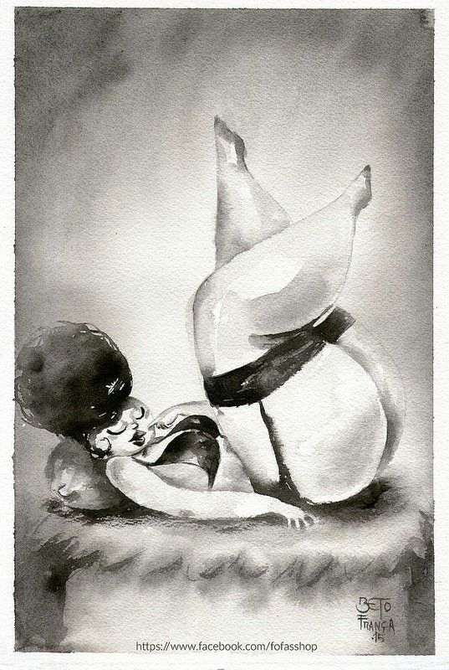
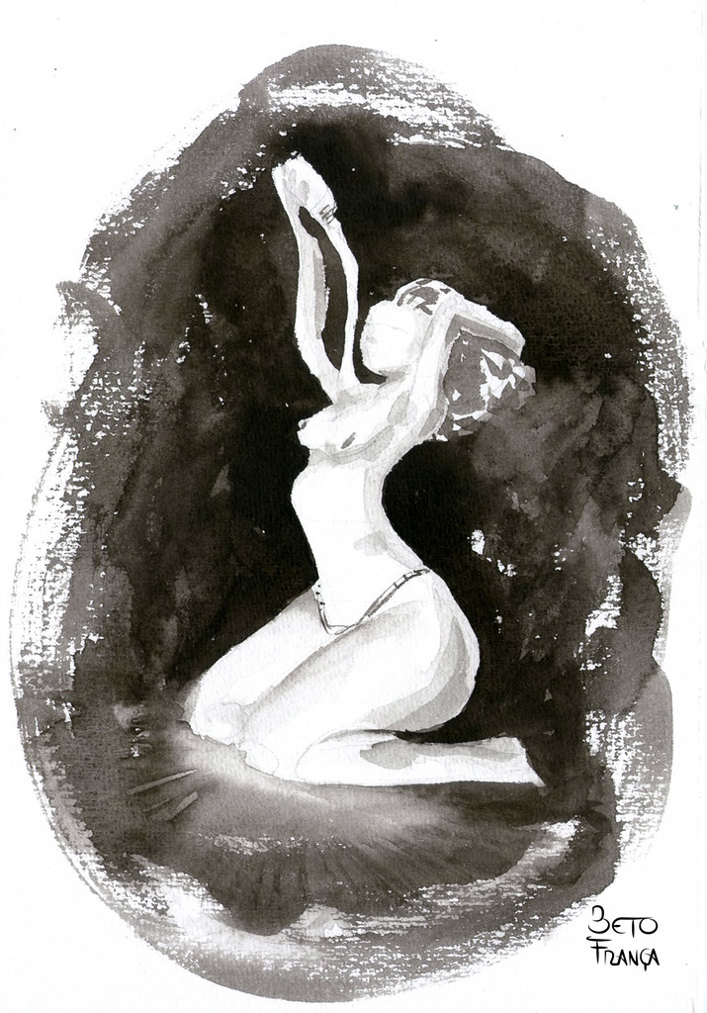
Beto França

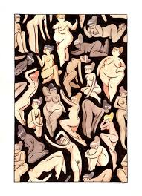
Kelly Bastow
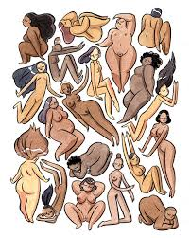
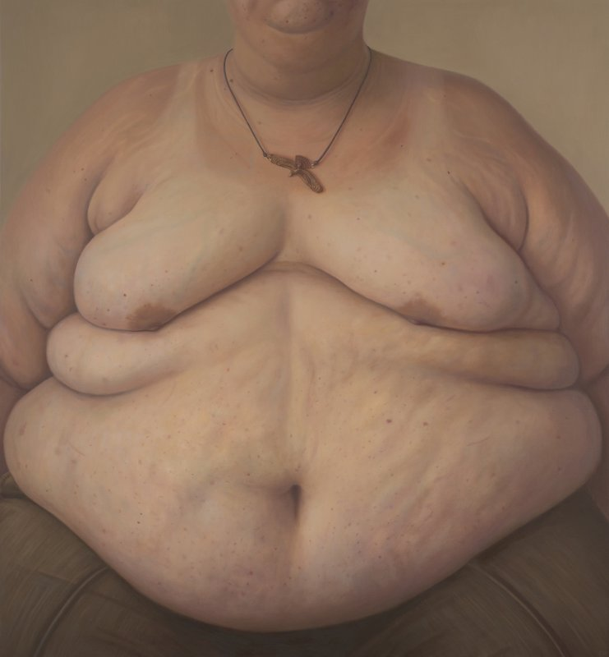
Charity Haynes
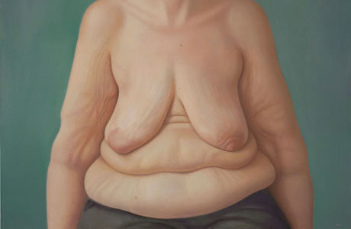
Underneath we are woman

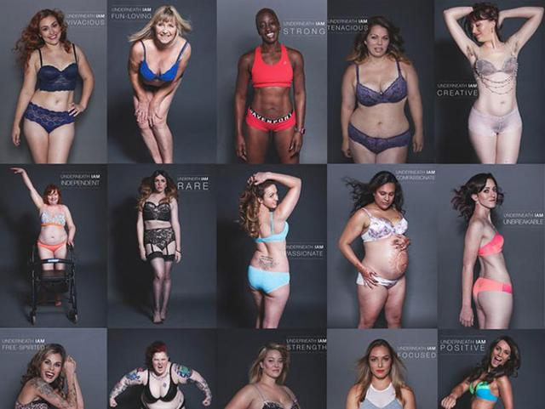

Reference links

https://shemightbe.co.uk/5-body-positive-artists/

https://www.google.co.uk/amp/s/www.magnolia-creek.com/eating-disorder-recovery-blog/social-media-and-eating-disorders/amp/

https://m.huffingtonpost.co.uk/2014/04/07/clarity-haynes_n_5084995.html?guccounter=1&guce_referrer=aHR0cHM6Ly9jb25zZW50LnlhaG9vLmNvbS9jb2xsZWN0Q29uc2VudD9zZXNzaW9uSWQ9M19jYy1zZXNzaW9uXzhiZDMxM2IzLTMwZDQtNDYwZC05Y2RmLWFkZjFjYzU0ZjhkMyZsYW5nPWVuLXVzJmlubGluZT1mYWxzZQ&guce_referrer_sig=AQAAAE3Su7hL31H2ezdSAYD79biW1ySi3oQhXlCBDP2kcj1PxEn5M0B3sKeiuMmYdksBHMvfPUnm6o1DplvDvIT8E38-vht4mKShOMubbEl26HuQy8j1soIGrjsGXDW6MPQa_YvyuMC5qUmXRdP841dHE4gwOcHGxf1Kus8WtQn-gdI-

https://www.commonsensemedia.org/media-and-body-image/at-what-age-does-media-begin-affecting-my-childs-body-image

https://www.refinery29.com/en-us/2016/04/107683/female-body-image-statistics-2016

