

Kinetic Energy Recovery

Tamzin Cooper
2300764
BEng Motorsport Engineering
01/12/2024
ACHA5010 Alternative Propulsion Systems
Mark Sandford

Word Count: 2668

Contents Page

Chapter 1 - Introduction 3
1.1 Justification of vehicle 3
Chapter 2 – Vehicle Characteristics 4
Frontal Area 4
Test Mass 4
Coefficient of Drag 4
Coefficient of rolling resistance 4
Chapter 3 – Worldwide Harmonised Light Vehicle Test Procedure (WLTP) 6
Chapter 4 – Analysis of results 8
4.1 Forces 8
4.2 Tractive Power 9
4.3 Cumulative Energy 9
Chapter 5 – KER System Selection 11
5.1 Flywheel Regenerative Braking KERS 12
Chapter 6 – System Efficiency 14
6.1 System Features 14
6.1.1 Energy In 14
6.1.2 Energy Out 14
6.2 Energy Recovered 15
6.3 Driver Implications 16
Chapter 7 – Conclusion 17
Reference List 18

Chapter 1 - Introduction

This report discusses the impact of the potential addition of a Kinetic Energy Recovery System (KERS) to a Nissan GTR R35 2018 vehicle. KERS are used to convert kinetic energy, which is lost through braking, for example, to electrical or mechanical energy, for future use in acceleration. (Science Direct, 2021). This system is derived to reduce fuel consumption by replacing engine power with the recovered energy. The report outlines the vehicles performance in the WLTP 3 test to determine an appropriate KER system which provides a sufficient energy storage and power output.

1.1 Justification of vehicle

Using a Nissan GTR R35 2018 to analyse the influence of introducing a KERS to reduce fuel consumption allows assessment on a high-performance vehicle that undergoes frequent and harsh braking. This generates a magnitude of braking energy which generates multiple energy recovery phases to benefit the vehicle and its acceleration. Due to being a high-performance vehicle and having a high braking potential, the Nissan GTR R35 can withstand a large amount of force from the brakes. Therefore, it can maximise the kinetic energy gained and subsequently stored in the KERS. When choosing a vehicle to complete the WLTP test on and assess the impact of a KERS, considerations into where the KERS could potentially be implemented must be considered. The Nissan GTR R35 allows space in the rear-mounted transaxle to incorporate the KERS into the vehicle, allowing potential opportunities with different sizes and powers of the system.
With the Nissan GTR R35 being a performance car, implementing a KERS would help motorsport reduce its carbon footprint and direct the sport onto a more sustainable path. This is due to the stored energy being redeployed to help aid acceleration, reducing the load on the internal combustion and reducing fuel consumption. This aligns with the future goals within motorsport and being more environmentally conscious, and so using the Nissan GTR R35 ensures the KERS integration has a clear impact on real world scenarios and is relevant to test.

Chapter 2 – Vehicle Characteristics

Frontal Area
According to Nissan (2018), the frontal area of a Nissan GTR is 2.25 m^2. This value is needed to calculate the aerodynamic drag force of the vehicle, which can be used to calculate the cumulative tractive energy to understand the losses incurred in the cycle.

Test Mass
The test mass of a vehicle is the full mass of the vehicle whereby all loads are incorporated. (ICCT, 2011) This includes the kerb weight of the vehicle, the accounted driver weight, fuel weight and any miscellaneous weight, such as cargo load.
Table 2.2.1 - A table showing the calculated test mass of a Nissan GTR. (Nissan, 2018)
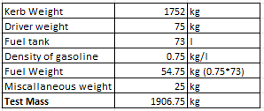

Coefficient of Drag
From Nissan (2018), it is seen that the coefficient of drag for the vehicle is 0.26. This value is needed to calculate the aerodynamic drag force of the vehicle from the WLTP-3 test. Therefore, allowing further calculations on the efficiency of the vehicle and additional kinetic energy system.

Coefficient of rolling resistance
There is no set value as it quantifies the resistance of the tyre design, pressure and road surface. The coefficient of rolling resistance can be estimated as 0.01 for a typical Nissan GTR R35 assuming the tyres used are a set of high-performance slick tyres and on a smooth road surface. (ChatGPT, 2022)

Chapter 3 – Worldwide Harmonised Light Vehicle Test Procedure (WLTP)

The WLTP is a global test “used to measure fuel consumption and CO2 emissions from passenger cars, as well as their pollutant emissions”. (WLTP Facts, 2017). It is used to provide a more realistic data set of a vehicle in standardised conditions.
The WLTP is split into three classes depending on the power (W) to kerb mass (kg) ratio of the vehicle. They are adapted to suit the maximum velocity required in their respective classes and in each phase. For example, the maximum velocity at the low phase of WLTP class 1 is 49.1 km/h, compared to 51.4 km/h for class 2 and 56.5 km/h for class 3. This shows the adjusted velocity compared to the power to weight ratio, highlighting the importance of identifying the correct test for a vehicle.
Kerb mass = 1752 kg
Power = 560 bp (Auto Express, 2021)
560bhp * 0.7457 = 417.592kW
Ratio of rated power against kerb mass = 417,592 W / 1752 kg = 238.3 W / kg.
This means the Nissan GTR R35 vehicle must be tested in class three of the WLTP due to the threshold being a ratio of 34 or above.
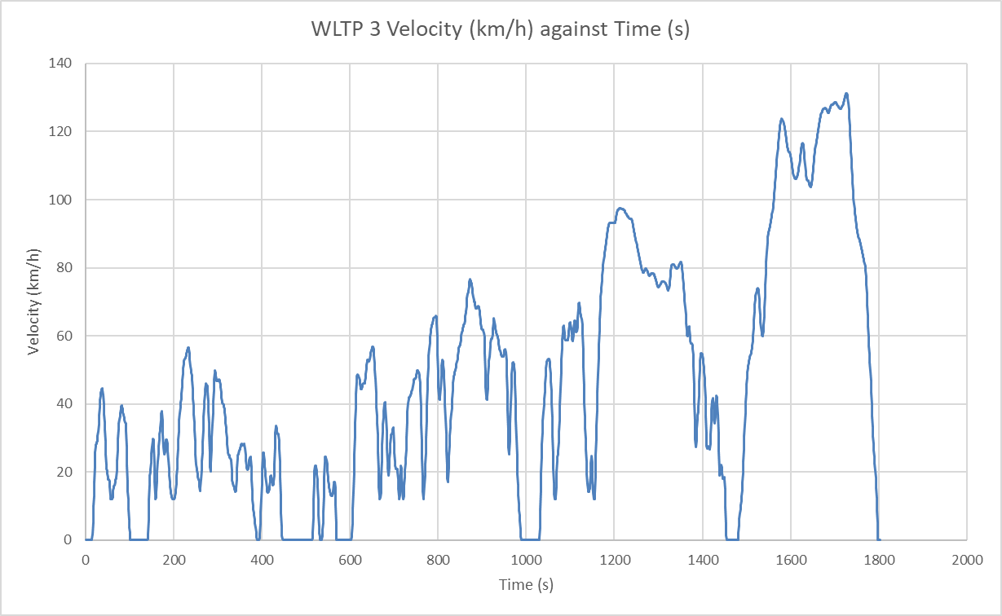
Figure 3.1 - A graph showing the velocity changes in km/h across the 1800s duration of the WLTP 3 test.
From the graph, it is clear to infer that the phases of deceleration from high velocity is where the most energy could potentially be recovered with the added KERS. This is because of the high braking required to slow down the vehicle and therefore more energy is being lost through heat, for example.

Chapter 4 – Analysis of results

4.1 Forces

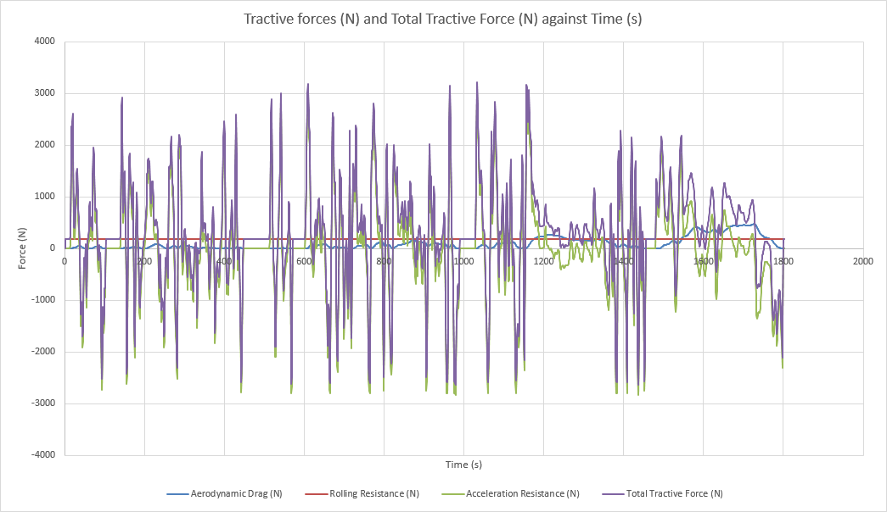
Figure 4.1.1 - A graph representing the tractive forces of the Nissan GTR R35.
The graph shows the forces combined to produce the total tractive forces. This represents the total force applied by the vehicle’s drivetrain to overcome all resistances which include aerodynamic drag, rolling resistance and acceleration resistance. The fluctuations in the total tractive forces depend on the throttle and braking of the driver. The negative tractive force represents where the vehicle is decelerating due to the resistive forces rather than the vehicle braking. Finding the tractive force of the vehicle during the WLTP 3 test is vital for understanding the total tractive energy required to move the vehicle.
From the graph, it is seen that the rolling resistance is a constant as it is the product of the test mass, coefficient of rolling resistance and gravitational acceleration, which remain the same throughout. The rolling resistance represents the resistive forces exerted on the vehicle between the tyre and road surface.
The aerodynamic drag shows a smoother progression compared to the other forces, this is due to the drag relying on the vehicles speed, which increases gradually, rather than the acceleration, which shows more spikes. The increases in aerodynamic drag occur at higher vehicle speeds, which aligns with Metcalf (2000), which explains that the reason for increased drag is due to the airflow around the vehicle becoming more turbulent.
The acceleration resistance highlighted on the graph represents the where the vehicle is accelerating and decelerating. Negative acceleration resistance outlines the potential opportunities for the addition of a KERS to recover the kinetic energy lost during deceleration as heat.

4.2 Tractive Power

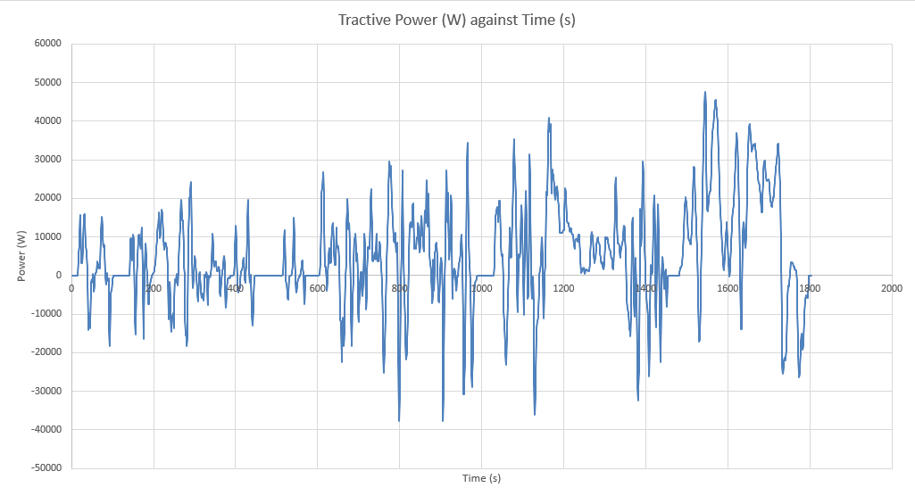
Figure 4.2.1 - Outlines the resultant tractive power of the vehicle against the time duration.
The graph illustrates the tractive power required to overcome a vehicle's tractive forces, calculated by multiplying these forces by velocity. Negative power areas indicate opportunities for kinetic energy recovery, aiding in selecting a suitable KERS system and component size for the Nissan GTR R35. Tractive power also helps determine the tractive energy consumed.

4.3 Cumulative Energy

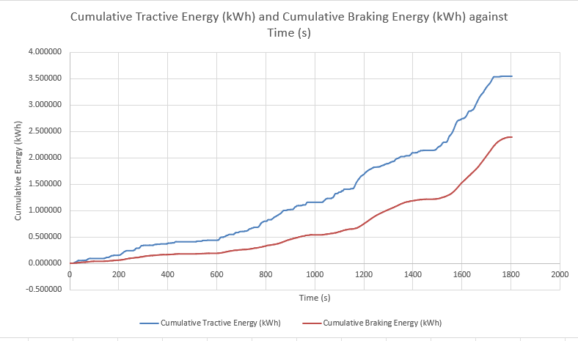
Figure 4.3.1 - The graph portrays both the cumulative tractive energy and cumulative braking energy of the vehicle.
From the graph, the trends of both lines increase steadily with time. The cumulative braking energy displays the energy dissipated in braking events during the cycle, whereas tractive energy is the energy required to move the vehicle forward. The final tractive energy is 3.55 kWh, compared to the final cumulative braking energy being 2.39 kWh. This is expected as braking energy was found by subtracting the tractive energy from the total kinetic energy. A low tractive energy indicates a better efficiency in the vehicle as less energy is required to overcome the resistive forces.

Chapter 5 – KER System Selection

To decide on an appropriate KERS for the Nissan GTR R35, the energy storage requirement of the KERS and maximum power input must be considered.
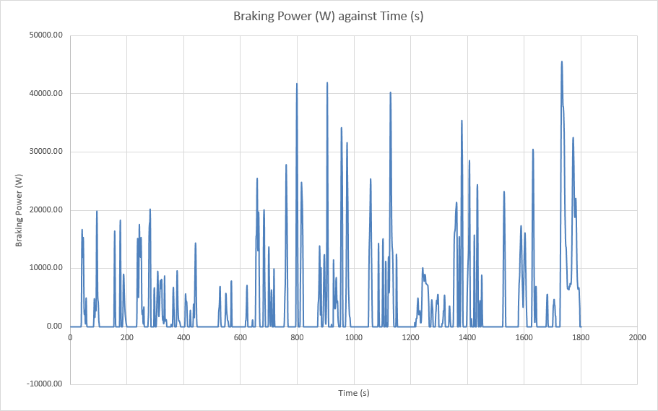
Figure 5.1 - A graph showing the braking power of the vehicle against time.
The graph depicts brake power exerted during deceleration. The graph shows frequent and harsh braking periods, where the peaks represent high kinetic energy dissipation, whist low power represents little to no braking and the vehicle is coasting. From figure 5.1 and the excel workbook, it is clear to see that the moment of maximum possible power input the KERS would have to deliver occurs at 1735 seconds, where the braking power is at its peak during the extra high phase of the test. This means the integrated KERS must be able to deliver a maximum of 45620.76 W of power at a given time, highlighting the significance of finding the braking power when choosing a KER system.
This deceleration period can be used to determine the maximum energy storage requirement. The vehicle begins decelerating at 1725 seconds, it uses a peak braking power of 45620.76 W from 0 W and takes 7 seconds to reach the peak.
Maximum energy storage requirement = ½ * (0-45620.76) * 7 = 159672.66 J
Therefore, the chosen KERS must be able to provide a maximum of 159672.66 J to the vehicle at one period.

5.1 Flywheel Regenerative Braking KERS

The KER system most appropriate for the Nissan GTR R35 is the use of a flywheel to complete regenerative braking. The flywheel absorbs energy dissipated during braking and releases the stored rotational energy to be used in acceleration to improve performance and reduce fuel consumption. This KERS is most suitable due to its ability to generate up to 60kW of power to the vehicle, which aligns with the theoretical maximum power output calculated using figure 5.1. (The Engineer, 2022) This ensures the KERS can withstand the braking power output that the vehicle will generate.
Furthermore, although the mechanical flywheel storage has a lower storage capacity, it can store up to 400kJ of energy which is sufficient for the maximum energy storage calculated for the Nissan GTR R35. So, even though the electrical battery storage has the higher capacity, for the specified Nissan vehicle, this is not an issue. Having a larger capacity comes with added weight and increased fuel consumption and so comparing the calculated maximum energy storage value with that of the KERS is important to ensure extra weight is not added for no gain. Tegler (2021) explains that the mechanical flywheels storage weighed “considerably lighter” than the battery alternative. Collins (2018) explains that it is possible for a flywheel made of carbon fibre to weigh as little as 18kg, whilst fulfilling the 45kW power and 160kJ energy storage required. This is vital as the GTR is used in performance and therefore must be as weight efficient as possible to ensure lap time is not compromised. It also ensures fuel efficiency is not affected as substantial weight increase can increase fuel consumption. Furthermore, the excellent handling of the Nissan GTR is a large selling point for the vehicle, and increasing weight with the KERS may hinder this characteristic and reduce its popularity. Therefore, using the flywheel with light carbon fibre components is a better option.
Another benefit of the flywheel system is the fuel consumption. According to Parveen and Kapoor (2013), the mechanical flywheel storage offers a higher fuel efficiency than using the battery storage. This is due to the electrical system having to convert the energy multiple times to store in the battery and then back to kinetic energy to release it. The more conversions, the more energy is lost in the process, therefore significantly reducing the efficiency. Motorsport is being pushed into becoming greener and therefore developing a fuel-efficient system is important.

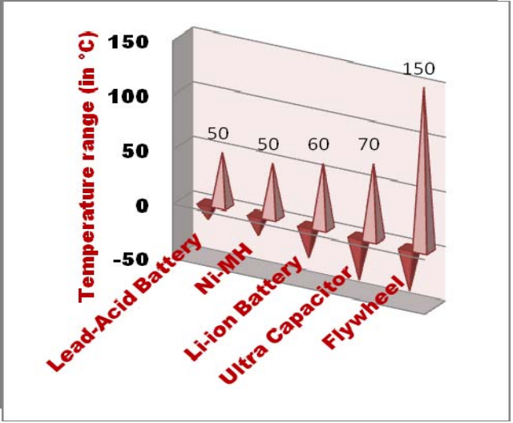
Figure 5.1.1 - A chart to show the different temperature ranges each KERS can withstand. (Parveen and Kapoor, 2013)
From figure 5.1.1, it is seen that the flywheel system has been proven to withstand the largest temperature ranges. This is due to the components of the flywheel storage being heat resistant, including the bearings and casing. Batteries rely on electromechanical processes to store energy and so can be affected by extreme temperatures. (Parveen and Kapoor, 2013) This is important for a Nissan GTR rR5 which is a performance-based vehicle and therefore relies on high speeds and intense braking which generates high temperatures.

Chapter 6 – System Efficiency

When implementing a KERS, the energy recovered must be calculated to understand the efficiency. For a flywheel KERS to be implemented, components must be incorporated to capture, convert and release the energy.

6.1 System Features

6.1.1 Energy In
The process starts at the braking system where it captures the kinetic energy lost during braking. The system converts kinetic energy into mechanical energy to be transferred to the motor generator unit. It’s located in the brake rotors of the vehicle and has an efficiency of 90%. The mechanical energy is passed into the motor generator unit which converts the energy into rotational energy to spin the flywheel. This component is mounted along the driveshaft tunnel for stability in the centre of the vehicle. It has a 95% efficiency. (Staff, 2008a) The energy is then transferred to the control unit which is an electrical system that directs the energy throughout the process for efficient recovery. This component has a high efficiency of 98% due to no conversion of energy. A clutch is used to connect and disconnect the flywheel storage to the drivetrain to manage the engagement during acceleration. The clutch has a 90% efficiency due to energy loss from friction. The energy is then absorbed by the flywheel. The flywheel is located at the rear of the vehicle to ensure weight distribution is not affected. It is important that the flywheel is located near the centre of gravity of the vehicle for minimal impact on the stability and balance. The flywheel has a 90% efficiency. (Chat GPT, 2022)

6.1.2 Energy Out
The regenerated rotational energy is released from the flywheel during acceleration to power the motor generator unit. The clutch is re engaged to control the transfer of rotational energy to the motor generator unit. The control unit manages when the energy is released and how much energy is released in alignment with the drivers input and driving conditions. The energy is then converted from rotational energy to mechanical energy to assist with acceleration in the drivetrain. The drivetrain with 90% efficiency delivers the energy to the wheels in the all-wheel drive system of the Nissan GTR R35. Each phase of delivering the energy out of the KERS also reduces the overall efficiency of the system.

6.2 Energy Recovered

In excel, calculations of the were done to find the overall efficiency of the system and how much energy it was possible to recover.
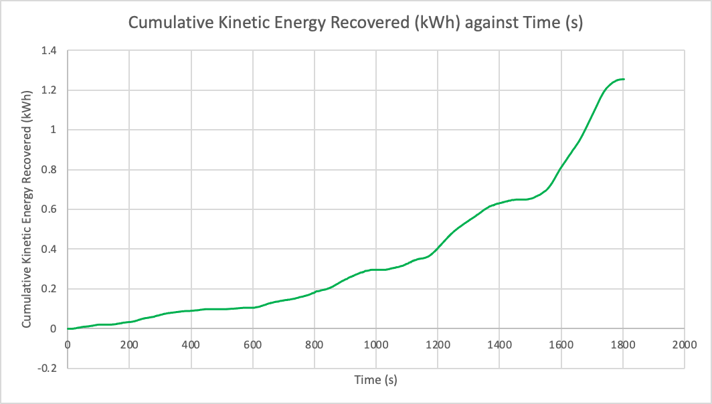Figure 6.2.1 - A graph to show the cumulative kinetic energy recovered after implementing the KERS.
The graph shows the cumulative kinetic energy available to be recovered after being inputted into the KERS. The graph highlights that a cumulative total of 1.25 kWh has been recovered which would’ve been lost though braking if not for the KERS. This shows how the vehicles fuel efficiency is improved due to less reliance on the internal combustion engine.
When comparing it to the cumulative braking energy line in figure 4.3.1, it is seen that the maximum cumulative braking energy used is 2.39 kWh, and out of this, the energy recovered is 1.25kWh. This shows the efficiency of the KERS is approximately 52%. Therefore, weighing up the added weight and expense of the KERS with the efficiency and fuel consumption must be done to see if there is an overall benefit.

6.3 Driver Implications

At low speeds, regenerative braking may not be sufficient due to low kinetic energy, and therefore friction brakes will begin to dominate. This switch in system during driving can affect the drivers feel. Regenerative braking is a much smoother process, and so reverting back to friction brakes can disrupt the driver. Ensuring the transition between the systems is seamless, is important.
The additional weight of the KERS can affect the handling feel of the car due to altered weight distribution and centre of gravity. Therefore, making the vehicle feel less agile and possibly slow down response.
Furthermore, the flywheel is a mechanical process, and the high-speed spinning can cause an increase in noise and vibrations in the vehicle. This can disrupt the feeling and concentration of the driver.

Chapter 7 – Conclusion

It is clear to see that the addition of a kinetic energy recovery system can improve the fuel consumption and performance of a Nissan GTR R35. As a performance vehicle, the mechanical flywheel KERS can be implemented into real world instances to enhance lap times and cornering speed. This is due to the release of stored energy during acceleration. Additionally, the Nissan GTR R35 can be used as a road car and therefore the introduction of a KERS would improve the efficiency of the car in stop and go traffic zones due to less reliance on the internal combustion engine. To conclude, although there are explicit benefits to the energy recovery and performance of a vehicle with a KERS, the weight and cost limitations must be considered.

Reference List
Auto Express (2021) Nissan GT-R Review, Auto Express. Available at: https://www.autoexpress.co.uk/nissan/gt-r/engines (Accessed: 29 November 2024).
Collins, S. (2018) Flywheel Hybrid Systems (KERS), Racecar Engineering. Available at: https://www.racecar-engineering.com/articles/f1/flywheel-hybrid-systems-kers/ (Accessed: 30 November 2024).
ChatGPT (2022) ChatGPT. Available at: https://chatgpt.com/ (Accessed: 30 November 2024).
ICCT (2011) Development of a worldwide harmonized light vehicles ..., theicct.org. Available at: https://theicct.org/wp-content/uploads/2021/06/WLTP4_2011.pdf (Accessed: 29 November 2024).
Metcalf, R. (2000) Successful race car driver. SAE International.
Nissan (2018) Nissan-GT-R-2018-UK.PDF, AutoCatalogArchive. Available at: https://autocatalogarchive.com/wp-content/uploads/2019/06/Nissan-GT-R-2018-UK.pdf (Accessed: 29 November 2024).
Parveen, C.M. and Kapoor, R. (2013) Comparative study on various KERS, iaeng.org. Available at: https://www.iaeng.org/publication/WCE2013/WCE2013_pp1969-1973.pdf (Accessed: 29 November 2024).
Science Direct (2021) Kinetic Energy Recovery System, Kinetic Energy Recovery System - an overview | ScienceDirect Topics. Available at: https://www.sciencedirect.com/topics/engineering/kinetic-energy-recovery-system#:~:text=A%20flywheel%20KERS%20stores%20the,41%2C97%2C98%5D. (Accessed: 28 November 2024).
Staff (2008a) Is the efficiency of a generator greater than that of a motor? why? Engineering.com. Available at: https://www.engineering.com/is-the-efficiency-of-a-generator-greater-than-that-of-a-motor-why/#:~:text=Generators%20have%20mechanical%20efficiencies%20up,are%20really%20the%20same%20device (Accessed: 29 November 2024).
Tegler, E. (2021) Why did the flywheel hybrid system never catch on for road cars? Ars Technica. Available at: https://arstechnica.com/cars/2021/02/whatever-happened-to-williams-f1s-flywheel-hybrid-idea/?utm_source=chatgpt.com (Accessed: 29 November 2024).
The Engineer (2022) Porsche has flywheel generator, The Engineer. Available at: https://www.theengineer.co.uk/content/news/porsche-has-flywheel-generator/ (Accessed: 29 November 2024).
WLTP Facts (2017) What is WLTP: The Worldwide Harmonised Light Vehicle Test procedure? WLTPfacts.eu. Available at: https://www.wltpfacts.eu/what-is-wltp-how-will-it-work/ (Accessed: 29 November 2024).

