Module code: LCMB7026
Module: International Marketing: Principles and Practices
Assignment Title: Assessment Component 1-Individual Report

Table of Contents
Section 1 4
Introduction 4
KFC and Selected Markets Overview 4
Comparative Analysis of KFC between the USA and India using PESTEL. 5
Political Factors 5
Economic Factors 6
Social and Cultural Factors 7
Technological Factors 7
Legal Factors 8
Environment Factors 8
A Comparative Analysis of STP between the USA and India KFC 8
Segmentation 8
Targeting 9
Positioning 10
Comparative International Marketing Mix (7Ps) of KFC between the USA and India 11
Product 11
Price 11
Place 12
Promotion 12
People 12
Process 13
Physical Evidence 13
Directional Development Strategy in India 14
Ethical Issues Evaluation 14
Recommendations 15
Conclusion 15
Section 2 17
Reflective Account using the Gibbs Reflective Cycle. 17
Description 17
Feelings 17
Evaluation 18
Analysis 18
Conclusion 19
Action Plan 19
References 20

List of Figures
Figure 1: Difference between the USA and India markets for KFC 5
Figure 2: Popularity of KFC in India 6
Figure 3: Segmentation in the USA and Indian market 9

Section 1

Introduction
The process of expansion to international markets demands that companies strike a balance between international and local responsiveness. This paper is a critical analysis of entry strategy and marketing mix of the KFC into international market, in the United States and India. KFC, being one of the largest quick-service restaurant brands in the world, conducts its operations in both developed and emerging markets and thus it is a suitable case to be compared in a comparative manner. The US is the mother country and the developed market of KFC, which is highly contested and saturated with fast-food consumption. Contrastingly, India is an emerging economy with a high growth rate, characterised by great differences in culture and religion as well as income, where the two play a significant role in shaping consumer behaviour and marketing mix (Saili et al., 2024). This report uses the main strategic models, such as PESTEL analysis to assess the macro-environmental variations, STP to assess the level of market focus, and the 7Ps marketing mix to assess the level of adaptation or standardisation. Also, the report evaluates the directional development strategy of KFC in India and assesses the ethical considerations in the two markets. The aim is to critically contrast the role of strategic approach of KFC in these two opposite environments and give recommendations to enhance the international marketing approach by KFC.

KFC and Selected Markets Overview
KFC was established in 1952 in the United States, in Kentucky, and it is one of the largest fast-food chains in the world that deals with serving fried chicken. The brand has an operation across over 150 countries and is known to possess its iconic recipe and a formidable bandwidth (Gore, 2025). KFC adheres to a mostly franchising-based expansion strategy, which allows attaining the internationalization in a very short period, though the brand management remains centralized. Its user positioning has been based on taste, convenience and affordability.
The US market is the home and the largest market of KFC. The level of competition in the American fast-food industry is quite stiff, with well-established fast-food companies like McDonalds and Burger King controlling the fast-food industry. The consumers are characterized by high purchasing power, adoption of digital and growing health consciousness, which affect menu innovation and promotional tactics (Alamuri and Aluvala, 2024). India, on the other hand, is an emerging market that is fast-growing and has a young population and an urban middle-class. Nonetheless, a great amount of cultural and religious diversity influences the preferences in food, especially towards vegetarianism and meat eating (Thin, 2024). The Indian quick-service restaurant business is booming, backed by urbanisation, an increase in disposable income, and the online food delivery systems. These differences in the nature of the market form significant differences in the strategic approach that KFC applies in both countries.

Comparative Analysis of KFC between the USA and India using PESTEL.
This part examines macro-environmental variations that affect the operations of KFC in the United States and India. The comparison shows that the strategic choices and the change in marketing in terms of both markets are influenced by political, economic, social, technological, legal and environmental factors.
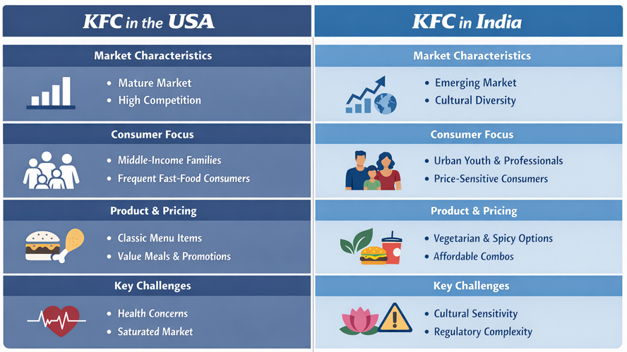
Figure 1: Difference between the USA and India markets for KFC
Source: (Kolhe, 2023)

Political Factors
The political condition in the United States is very stable and there are well-developed regulatory systems. Foreign investment barriers are minimal, as it is the home market of KFC. Nonetheless, the regulation of food industries, agricultural policies, and trade tariffs on imported raw materials may affect the cost structures. There is also a factor of the state-level differences in taxation and labour policies that influence decisions about operations (Deepa, 2025). The political environment is also relatively stable in India, but it is more complicated concerning multinational corporations. Business operations are affected by policies related to Foreign Direct Investment (FDI), support of food safety and local sourcing requirements. There is a possibility of bureaucracy and divergence in governance at the regional level influencing expansion rate. Though the Indian government actively helps to promote the development of the retail and food service industry, stimulating foreign brands (Perody and Sudhakara, 2024). All in all, there is low political risk in both countries, although the regulatory complexity and administrative practice in India are more difficult than in the USA.

Economic Factors
The United States has a powerful purchasing power, resulting in a high-income and a mature economy. The disposable incomes of the consumers are increased, and this means that they can afford a premium pricing strategy and frequent dining-out behaviour (Perody and Sudhakara, 2024). The market in the fast-food industry is very saturated and competitive, though this puts pressure on the profit margins. Consumer spending in discretionary goods can be affected by economic changes and inflation. India, on the other hand, is an emerging economy that is increasing at a high rate and has a lower GDP per capita. Despite a low level of disposable income when compared to the USA, the growing middle class and urbanisation in India offer good growth opportunities.
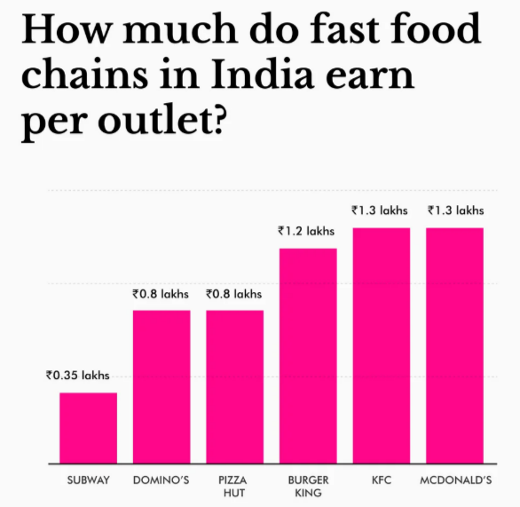
Figure 2: Popularity of KFC in India
Source: (Mogaji, 2025)
In India, the sensitivity of price is bigger, and KFC has to implement the value-based pricing policy and use affordable meal packages (Srivastava et al., 2022). Thus, the stability and high purchasing power of the USA are traded for long-term growth opportunities and price adjustments of India because of income differences.

Social and Cultural Factors
The main contrast between the two markets is brought about by social and cultural factors. Fast food in the United States is connected with everyday life. Customers are focused on convenience, speed and high portions. Nevertheless, the level of health awareness increases, the demand towards more health-aware menu items, the necessity to provide nutritional information and plant-based products, and transparency has been growing (Roffman, 2023). Menu innovation is also brought about by cultural diversity. Religion and tradition play a vital role in determining food consumption in India. A high percentage of the population conforms to the Hindu eating restrictions, which include not eating beef, and a major number are vegetarians. Consequently, KFC will no longer deal with beef products and offer vegetarian alternatives on the menu. Moreover, people usually go to restaurants or eat together as a family or group, and not as a daily habit. The Indian market is very young, and Western products conceptualized with modernity. The consumer behaviour varies in speed as well: American customers visit fast-foods more often, whereas Indian customers usually think of fast-food as a pleasant exception (Kolhe, 2023). These are differences in culture that play an important role in the adaptation of the products, pricing and promotion messages.

Technological Factors
The United States provides a high level of technological infrastructure with online ordering and self-service kiosks, mobile applications and delivery platforms. Digital marketing and personalisation based on background information are very advanced. India has undergone a fast digitalized change, especially with the smartphone users and digital payment systems. Swiggy and Zomato are food delivery apps that have made fast food available at an increased pace. The adoption of digital, however, is higher in urban locations as compared to rural ones. KFC relies on mobile interaction and mobile-based delivery of third-party services in its technological approach in India (Shukla et al., 2021). Although the two markets are equally developed in terms of technology, the USA is a mature digital ecosystem compared to India, which is fast and still growing unevenly in terms of technology.

Legal Factors
In the United States, fast-food businesses are controlled by stringent food safety laws, labour policies and consumer law protection. Advertising rules and the transparency on the issue of nutritional labelling. Employment laws, such as minimum wage legislation, are a direct influence on the operating expenses. Food safety in India is also governed at the national level, and the standards of compliance are also becoming stricter. The changes in labour laws take place, and franchise deals could be considered regarding some other regulatory requirements. Cultural sensitivities should also be well taken into consideration by the advertising rules (Chen, 2025). Both countries are very strict in legal compliance, but India may have a more difficult time in regulatory enforcement and procedural complexity.

Environment Factors
Sustainability of the environment has emerged as a major issue in both markets. In the United States, consumer and regulatory demands in sustainable packaging, carbon emissions and responsible sourcing are high. Brand reputation is determined by environmental activism. Environmental awareness is increasing in India, primarily in the urban regions. The recent campaigns by governments to cut down on plastic waste and achieve environmental sustainability are putting pressure on the fast-food chain outlets to use packaging materials that are eco-friendly (Malik, 2023). Even though sustainability expectations are found in both markets, consumer activism and environmental scrutiny are stronger in the United States.

A Comparative Analysis of STP between the USA and India KFC

Segmentation
KFC uses a multi-variable segmentation approach in the United States and in India, but the segments and emphasis are quite different because of the differences in the economic status, cultural difference and consumer maturity. Mature and very saturated fast-food markets in the United States also focus heavily on segmentation, being behaviour-driven (Schlegelmilch, 2022). The major segmentation among consumers is defined with the help of the demographic factors of age and family composition with the strong preference for young adults, working professionals, as well as families with children. Behavioural segmentation is especially significant when it comes to the situation in America, because a large number of consumers there are regular purchasers of fast food who focus on convenience, speed and value. The market segments are further characterized by lifestyle variables like the busy schedule and the choice of take-out or drive-through services (Kapoor, 2020). The purchasing power in the United States is comparatively high, and the affordability of meals in the United States is largely common; hence, income segmentation is less constraining.
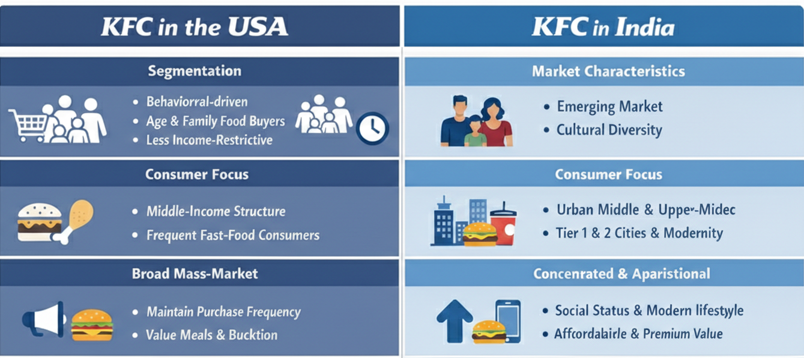
Figure 3: Segmentation in the USA and Indian market
Source: (Thin, 2024)
Segmentation in India, on the other hand, is geographically and socio-economically oriented. KFC mainly targets the rising urban middle and upper-middle classes due to the high levels of income variations. The geographic segmentation is an important factor because it is found that the presence of the brand is mainly at the Tier 1 and Tier 2 cities, where infrastructure, shopping malls and delivery stations are highly established. India has a huge young population with high potential demographically, which creates an important segment of the youth and young professionals (Singireddy, 2020). In India, psychographic factors are also stronger, and Western brands have been equated with modernity, aspirational and lifestyle upgrade. This means that segmentation in India is selective and city-based as opposed to larger behavioural segmentation employed in the United States.

Targeting
KFC utilises a differentiated targeting approach in the two markets, although the intensity and course of targeting transform depending on the maturity of the market and consumer expectations. KFC in the US has a mass-market market. The brand targets the middle-income families as well as young adults and frequent consumers of fast-food. Since fast-food consumption has become inseparable from American life, the targeting strategy is aiming at keeping the purchase frequency and loyalty (Parboteeah et al., 2024). The marketing of promotional campaigns, value meals, and family buckets promotional services are aimed at loyal customers to win customer interest instead of introducing the brand to a new consumer. It is therefore concentrated on competitive positioning and retention in a saturated industry.
The targeting strategy of KFC in India is, however, more focused and aspirational. The main target market is an urban younger generation, college students and young working employees who see Western brands of fast-food items as a sign of a status in society and a modern way of life. Considering that the price elasticity of its consumers is higher and the level of income is low in relation to the United States, KFC differentiates its products to allow affordability with a relatively upscale brand image (Mogaji, 2025). In contrast to the patterns of regular consumption typical of the United States, the fast-food meal consumption in India is usually viewed as a special treat or as a social event. As such, KFC targeting in India is aimed at building experiences and brand dreams as opposed to mere convenience-based consumption.

Positioning
KFC continues to have an internationally congruent core position of its fried chicken brand, but core positioning varies in the United States and in India based on cultural and competitive strategies. In the United States market, KFC is presented as a classic and genuine fried chicken brand that has a solid tradition. The fact that it has American roots and has been in existence for a long time influences a notion of familiarity and reliability. Its brand mostly competes on the basis of taste, value and convenience, with family dinners and the attractiveness of comfort food being a common theme (Souza et al., 2023). Positioning in a competitive environment is also dependent on the intensity of promotions and innovation in the menu to remain relevant.
Positioning in India has a more modern and aspirational aspect. Although the focus on flavour and quality is the same, KFC stands as a new Westernizing brand that is in line with the trend of urban lifestyle. The brand also positions itself to the local tastes and preferences by emphasizing on spicy flavours and vegetarian options, thus fitting into the cultural demands. Simultaneously, the presence of an international image helps the company to achieve a feeling of prestige. Because of this, KFC in India is no longer considered as an ordinary food but as a good dining experience, mostly among the young population (Amira and Fitriasari, 2021). On the whole, though the basic brand identity is the same in every part of the world, the STP strategy shown by KFC is more adjustable in India than in the United States due to financial development, consumer behaviour, and cultural values disparities.

Comparative International Marketing Mix (7Ps) of KFC between the USA and India

Product
The main product range of KFC, which is fried chicken according to its original recipe, is globally standardised, but there is a lot of accommodation between the United States and India. The product strategy in the United States aims at recovering the brand heritage, predictability in taste and menu innovation in a mature market. The menu consists of traditional fried chicken buckets, sandwiches, wraps and side foods like mashed potatoes and biscuits. Limited-time flavours and other collaborations are often used to introduce product extensions to spur demand in a highly competitive environment (Nilplengsang and Pankham, 2024). The growing health awareness has had a side effect in the introduction of grilled products as well as clear nutrition labelling. In India, product modification is widespread because of culture and religion. There is no beef, and a large part of the menu is given to vegetarian products, to suit the local culinary habits. The profiles of spicy flavours are stressed to conform to the Indian taste preferences (Szolgayová, 2022). Meal formats and portion sizes are also adjusted to reflect the local consumption patterns and expectations that are affordable. Though the brand identity is similar, the product strategy is based on high localisation in India rather than on a relatively homogeneous and uniform approach in the United States.

Price
Compared to the parent country, purchasing power and sensitivity to price vary significantly, which forms a major difference in pricing strategy. KFC competes in an environment that is highly competitive in terms of the fast-food industry in the United States, with customers enjoying relatively high disposable income. The value meals, offer and promotional discounts are pricing strategies aimed at competing with the already established competitors (Karadzhov and Patarchanova, 2025). Despite the significance of price competitiveness, affordability is not a structural restriction as it is in emerging markets. India, on the other hand, needs a more finely tuned pricing approach. Reduced average incomes and increased sensitivity to prices requires low end combo meals and low-end pricing choices. To keep accessibility and maintain perceived value, psychological pricing and smaller portion bundles are the typical way to go (Saili et al., 2024). Although KFC places itself as a global brand, Indian pricing needs to strike a balance between aspirational and economic factors. Hence, the price adjustments are stronger in India than in the US.

Place
The United States has a high market penetration and a sophisticated distribution system, which is in favour of KFC. The brand is conducted in independent stores, drive-through systems and franchisees in both urban and suburban regions. The place strategy is based on accessibility and convenience, with the help of highly developed logistics and incorporated computerized digital ordering platforms (Gore, 2025). However, reach is further increased by delivery services and mobile app integration. The place strategy in India is more urban-oriented. The KFC stores are mainly concentrated in shopping centre and, commercial centre and high-traffic urban areas in Tier 1 and Tier 2 cities. The growth in smaller towns is slow owing to the inadequate infrastructure and buying capacity. The collaboration with food delivery services is an important factor in increasing access to markets (Alamuri and Aluvala, 2024). As such, a situation of wide national penetration in the United States is different from that of others with narrow geographic concentration in India, which is based on economic feasibility.

Promotion
The promotional campaign in the United States focuses on heritage, values and a value-oriented approach. The campaigns aimed at advertising often emphasise taste, tradition and limited time. Electronic marketing, interaction of social media and the sports related promotions are also very important components of the communication strategy. Considering the saturation of the market, the intensity of the promotion is high to remain visible and special. Promotion in India is culturally modified. Advertisements tend to focus on the advertising culture of the youth, social events, and the dream life. It emphasises a lot on digital platforms and the goal of reaching younger consumers, which is often supported by the promotional message focused on spicy flavours and a price-friendly offer (Thin, 2024). Cultural sensitivity is also an important aspect of the communication and it must correspond with the local values and religious implications. In this way, promotional adaptation in India is much more widespread than the comparatively standardised thematic promotional approach in the United States.

People
The employee training in the United States is dedicated to the efficiency of the service, speed, and standardised customer experience. With tough labour laws and the increasing wage demands, the labour management plays a major role in operational costs. Quick service and consistency are the focus of customer interaction. In India, service delivery has added more focus to hospitality and customer involvement as it relates to customers and dining experiences (Deepa, 2025). The training of employees is also aimed at keeping the standards of global service and adapting to the local expectations. The difference in labour cost structures is another differentiating factor of operational strategies.

Process
The United States has very standardised and technology-driven operational processes. Efficiency and minimized waiting duration are achieved by the use of self-service kiosks, mobile ordering systems and simplified kitchen operations. It is focused on speed and convenience. In India, technology adoption is on the rise; however, the operation process should meet various consumer tastes and delivery relationships (Perody and Sudhakara, 2024). The role of the integration with the third-party delivery platforms is more central than in the United States. Though the standardisation of the processes is still a priority, it should be flexible enough to respond to the local working dilemmas.

Physical Evidence
Store design in the United States is symptomatic of contemporary fast-food design, which places comfort and convenience at the centre of the design, as well as the urgency of drive-through provision and coherence of branding. Outlet renovation is commonly done in order to remain relevant in the competitive world. The role of physical evidence as a part of brand perception is high in India. The design of outlets is usually focused on a modern and energetic ambience to appeal to younger customers and support aspiration appeals. Experience branding consists of maintaining uniform international branding with the use of a friendly atmosphere to create value.
On balance, the analysis of the 7Ps proves that, even though KFC has a core identity that is globally standardised, the level of the marketing mix adaptation is significantly higher in India, when compared to the situation in the United States (Srivastava et al., 2022). The economic status, cultural requirements and customer behaviour pattern require greater flexibility in the strategic changes in the Indian market, but the American approach is focused on competitiveness and efficiency in the operating environment, which is mature.

Directional Development Strategy in India
The market penetration and the market development are the main areas through which KFC can be analysed in its directional development strategy in India, facilitated by selective product development activities. In India, the brand is exposed to a high-growth emerging market as opposed to the United States, which is a saturated and very developed fast-food market with increasing urbanisation and the growth of disposable income (Roffman, 2023). Accordingly, KFC's strategic direction in India is anchored on intensifying its competitive position and growing market share in the existing urban segments and expanding geographically over time. The level of penetration is witnessed by intensive promotional efforts as well as meal packages that have the value element in an effort to make the urban youth and middle-income consumers buy in high numbers and also digital engagement initiatives. Food delivery systems are used to make the brand more convenient and easily accessible, which increases the likelihood of repetitive consumption, as do mobile-based ordering options (Kolhe, 2023). At the same time, KFC considers the market construction in the Tier 2 cities, in which an increase in income streams and a potential for Western brands are opening new prospects.

Ethical Issues Evaluation
KFC has dealt with ethical issues in the United States as well as India, yet the aspects of these issues vary depending on the socio-cultural as well as regulatory factors. Ethical issues in the United States are largely linked to the social health discussion, such as the obesity and high levels of sodium and the overall criticism of fast food (Shukla et al., 2021). The rise in health consciousness among American consumers has added to the criticism of nutritional transparency and responsible marketing, especially among families and younger age groups. Sourcing of poultry and waste disposal of packaging have also caused people to think in terms of animal welfare issues and sustainability. However, in India, ethical problems have a more cultural and socially based nature. Food practices involve a strong sensitivity that demands that dietary products that involve beef should be avoided, and there should be careful attention taken in marketing communication in order to honour religious feelings (Chen, 2025). Reputational risks can be caused by any drift between cultural norms. Moreover, with the regulation requirements and consumer consciousness, labour practices, supply chain transparency and environmental sustainability are also gaining more priority.

Recommendations
With the help of the comparative analysis, it is possible to offer the following strategic recommendations-
- KFC needs to keep on improving product innovation in India through offering more healthy and vegetarian food, owing to the rising health awareness among urban consumers (Malik, 2023). This would promote the sustainability of the brands in the long term and would counter ethical criticism.
- The increased focus on healthier menu diversification and open communication of nutritional information in the United States would respond to the unabated concerns on the health of the population and enhance corporate image. The use of more plant-based alternatives would make the brand match the new trends in diet.
- In both markets, the process of digital transformation should be further enhanced. The digital systems are advanced in the United States, but the customers can be more loyal by further personalising the data (Schlegelmilch, 2022). In India, penetrating the market in emerging cities can be encouraged by widening mobile-based interaction and enhancing interaction with delivery systems.
- Environmentally friendly packaging and fair sourcing efforts must be prominently displayed in the two nations (Kapoor, 2020). Enhancing environmental responsibility would boost brand equity and minimise the risk of ethical irresponsibility.

Conclusion
The comparative study of KFC in the USA and India shows that the international marketing strategy is a complex issue in the environment of opposite economic and cultural conditions. Although the United States is a mature, competitive and technologically advanced market, where efficiency and innovation are needed, India is a country with high growth potential, but it needs a lot of adjusted product, pricing and communication strategies. Social and cultural disparities have the greatest impact on the strategic decisions, especially with regard to eating habits as well as consumer aspirations (Singireddy, 2020). The balancing of standardisation and localisation keeps becoming important due to KFC's capabilities in ensuring that it has maintained a globally consistent brand identity and has adjusted its marketing mix to fit the local market environment. In the future, ethical responsiveness will be essential in achieving sustained growth, as well as automation of digital integration and the ongoing product innovation to meet the rapidly changing consumer expectations in the two markets.

Section 2

Reflective Account using the Gibbs Reflective Cycle.
This reflective paper assesses the procedure undertaken in investigating, examining and composing the preceding parts using the Reflective Cycle by Gibbs.

Description
The evaluation involved comparison of the operations of KFC in two countries through the strategic frameworks such as PESTEL, STP, as well as the 7Ps marketing mix, and analysis of directional strategy and ethical concerns. This was done by first of all identifying the requirements of the assignment and the allocation of words so that the depth of analysis is appropriate in each section. There was a strict outline that was planned before the research to support coherence and logical flow. The secondary data were extensively used and comprised the company reports, articles published in academic journals, industry publications and other reliable internet databases. Close emphasis was also placed on finding credible and modern data regarding consumer behaviour, cultural factors, and economic trends of fast-food industries in the United States as well as India. A simple description did not hold much importance, in that comparative analysis was given more priority because the evaluation focused on the juxtaposition of the two markets. The analysis was done once all the information was collected by organising it into the necessary structures. All sections were prepared in an organized manner, so that no discrepancy existed between macro-environmental factors and the marketing strategy adaptation.

Feelings
I was sure of my choice of KFC as the brand at first because it serves in both the developed and emerging markets and has great comparative potential. But I, too, felt confused on how to walk the fine line between standardisation and the argument of adaptation and not become too descriptive. It was feared that the academic tone would be lost trying to ensure that it was critically evaluated and not explained. I was also more confident during the research stage, where valid data started furnishing the comparative arguments. The presence of distinct cultural and economic differences between the United States and India helped me to enhance my faith in the direction of analysis. Nevertheless, it was difficult to construct huge amounts of information into a small and structured bit, especially where there were word constraints. When the section on the marketing mix and directional strategy was done, I was more optimistic about the practical implementation of theoretical frameworks. The experience made me more engaged in the study as it has helped me comprehend the way in which global brands suit different markets differently.

Evaluation
In general, the research and analytical process was very effective. One of the strongest points was that the structured framework was developed at an early stage and immediately ensured logical organisation and avoided meaningless repetition. Introduction of PESTEL before STP and 7ps were useful in instilling a solid context ground on strategic analysis. Such sequencing enhanced coherence in the report. The second good point was that there was a concern of comparison across the various sections, other than the complete division of countries. Critical analysis works were enhanced by integrating comparative insight in every sub-section. Besides, the focus on social and cultural aspects gave depth because these are key issues that impact food consumption behaviour. But there were certain limitations as well. Certain economic and industry statistics had to be interpreted very carefully, not to overgeneralise. Moreover, it was challenging to control the use of words in different parts. Occasionally, cultural differences were explicated too much, and it had to be refined to ensure that it would be in balance with other elements of the PESTEL.

Analysis
The effectiveness of the process is to be explained by the critical reflection, as well as the organised planning and theoretical implementation. Recurrent systems like PESTEL and STP helped in thinking in order and not discussing in bits. This is in line with the best academic practice in international marketing analysis, in which the strategic decisions should be informed logically by macro-environmental factors. The comparative factor involving the United States and India depicted the importance of market maturity in influencing the marketing mix adaptations. The analysis revealed that in a mature marketplace such as the United States, it is more feasible to use standardisation, but in new markets such as India, more localisation is required because of the diversity between cultures and economies. Such an awareness came about gradually during a research process and did not initially illustrate how analytical knowledge builds up across the interaction with evidence. The procedure further cemented the need to be critical in solutions to ethical problems. Instead of simply recognizing health or cultural issues, one had to evaluate their strategic effects on the brand reputation and capability to last long.

Conclusion
The research and preparation had been structured methodically and analyzed in a progressive order. The use of Gibbs Reflective Cycle shows that thoughtful planning, integration of framework and comparison that was persistent were some of the strengths. The experience made me more competent in applying the theory of international marketing to an actual context and differentiating between the standardisation and adaptation techniques in various economic settings. However, there is a necessity to enhance rigid balance on the analytical planes and improve brevity in discussing culturally pregnant situations. Through the reflective process, it has come out to appreciate the importance of academic planning and critical thinking in the development of coherent strategic writing.

Action Plan
In further evaluations, I would start with a more extensive research matrix to divide each source according to the framework component I aim to write about before drafting. This will enhance productivity and eliminate redundancy. I will then also set aside tentative word increases per subsection at an earlier stage to balance. I also wish to become more skilled in critical evaluation by asking analyzing questions. This will see to it that there is a deeper interpretation as opposed to descriptive reporting. Lastly, I will give myself more time to revise it to achieve clarity and conciseness, so the arguments can be focused and academic.

References
Alamuri, S. and Aluvala, R., 2024. Glocalization: an analysis into it’s conceptual and strategic underpinnings. Brazilian Journal of Development, 10(5), pp.e69567-e69567.
Amira, H. and Fitriasari, N., 2021. Are Segmenting, Targeting, and Positioning Necessary for Strategic Marketing?. Jurnal Kedokteran Brawijaya.
Chen, S., 2025. Balancing Global Standardization and Local Differentiation in Multinational Advertising—A Comparative Analysis of Global Advertising Strategies in the Restaurant Sector. Finance & Economics, 1(6).
Deepa, L., 2025. Globalisation and Localisation in the Culinary Industry (Doctoral dissertation, Dublin, National College of Ireland).
Gore, M., 2025. Why Western Strategy Frameworks Fail in India and Southeast Asia: A Critical Analysis and a Proposal for a Hybrid Consulting Model. Available at SSRN 5876342.
Kapoor, N., 2020. Strategic Analysis Of Fast Food Industry: Case Study Of India.
Karadzhov, V. and Patarchanova, E., 2025. How to create the best PESTEL analysis. International Journal of Digital Research, 1(3), pp.8-20.
Kolhe, A., 2023. Exploring the Factors Constraining the Adoption of Multi-domestic Strategy Among the Fast-Food Chains: A Case Study of Fast-Food Chains in Europe (Doctoral dissertation, Dublin, National College of Ireland).
Malik, R., 2023. Culture and its influence on elements of marketing mix. In Cultural Marketing and Metaverse for Consumer Engagement (pp. 123-130). IGI Global.
Mogaji, E., 2025. Market Segmentation, Targeting, and Positioning. In Strategic Marketing Management: Principles and Practice (pp. 103-133). Cham: Springer Nature Switzerland.
Nilplengsang, Y. and Pankham, S., 2024. Beyond STP Marketing Strategy for Online Service Businesses. Revista de Gestão Social e Ambiental, 18(6), pp.1-26.
Parboteeah, K.P., Cullen, J.B. and Kim, S., 2024. International Business: Perspectives from developed and emerging markets. Routledge.
Perody, S.H. and Sudhakara, A.M., 2024. Strategic Analysis of McDonald’s Global and Indian Market Performance. Asian Journal of Managerial Science, 13(2), pp.52-60.
Roffman, N., 2023. The cultural impact on international marketing: Understanding how different cultures influence advertising perception and strategies.
Saili, A.R., Fatah, F.A., Yusop, Z., Abd Aziz, A.S., Yusuf, S.M.W., Sapak, Z. and Ismail, S.A., 2024. Innovative Teaching Approach: Product Adaptation in International Agricultural Marketing. APS, p.266.
Schlegelmilch, B.B., 2022. Global marketing strategy. Springer International Publishing.
Shukla, M.A., Chauhan, S. and Uniyal, M.C., 2021. International Dining Outlets–A Tough Competitor Of Existing Indian Food Markets For Various Cuisines. Webology (ISSN: 1735-188X), 18(5).
Singireddy, M., 2020. Mcdonald's: Global Marketing. International Journal of Health & Economic Development, 6(2).
Souza, Y., Fonseca, M.J. and Cardim, S., 2023, April. Marketing Plan for an Online Business: A Case Study. In World Conference on Information Systems and Technologies (pp. 101-110). Cham: Springer Nature Switzerland.
Srivastava, R., Paul, M. and Bhanot, S., 2022. Perception study of customers of a global fast food restaurant in India and USA. International Journal of Indian Culture and Business Management, 26(3), pp.379-406.
Szolgayová, B., 2022. Adaption of Marketing Mix for Selected Country. In SHS Web of Conferences (Vol. 135, p. 01014). EDP Sciences.
Thin, M.K., 2024. The Effect of Marketing Mix on Consumer Purchase Decision Towards KFC Fast Food (Mya Kyu Thin, 2024) (Doctoral dissertation, MERAL Portal).

