LV6 Contemporary Themes
– Conference Learning Log

Student Name:  Riccardo Russo 1815101 | SERKD EVENT PLANNING COMPANY

Week 1 | 07/07/2020
Planning:
- Assign tasks to the Team (Decide Roles)
- Date/Type of meeting
- Define the purpose of the Meeting (team decided launch of a new product)
- Contracts, letters, invites
- Marketing (Social Media Pages)

Organising:

- Everyone to prepare a SWOT
- Company Name agreed as per our initials SERKD
- Following assessment of the Swot, Roles assigned based on the company scope, and tasks assigned (some tasks may not completely reflect the role, thus, voluntarily agreed to ensure a successful event):

Emoke Gego – Event Manager
  - Overview of the Event/Purpose
  - Audience engagement
  - Timeline – Budget
  - Safety Plan
  - Licences
Sandra Senenko – Marketing Manager
  - Create Social Media Pages
  - Promotions
  - Email set-up
  - Logo/Posts
  - Company Outline/Heading
Kissairy Valdez – Public Relation Manager
- Attendees
- Invitation
- Letter Template
- Thank you Email
Domenico Conte – Senior Project Manager – Quality Control
- Logo
- Flyers
- Survey
- Contract
Riccardo Russo – Operation Managers
- Contract – TBR
- Premises
- H&S – Confirm the current plan/make amendments or addendums

Managing:
In this first week various points have been defined for a great organization of the event; roles and different strategies have been established which will allow us to run a nice event on 21 September 2020.
The division of roles will be very useful in managing the workload better.
In addition, the division of roles allows us to create different deadlines for each member of the team that the latter must respect for the success of the event.
The date of the meeting has been defined, thanks also to a quick response from the company that will have to carry out the event.
September turns out to be an excellent month for launching a product for several reasons: people returns from holidays, search for new products for the winter by the structures that want to innovate their offer, proximity to Christmas and its holiday period which means more business for hospitality industry.

Marketing:
The Marketing strategy was almost totally defined during the first week thanks to an excellent job by our Marketing Manager: Sandra Senenko.
Her strategy appears to be in line with the ideas of team members and ready to be implemented.
Our marketing manager opts for an advertising strategy based on the growth of our social pages with an aggressive policy of 3 posts per day at certain times of the day, i.e. those times where more people are connected.

Technical:
Venue and technical arrangements where defined for the event. Standards, various alternatives and options as variants in case of any inconvenience and a procedure for printing contracts, invitations and letters have been defined.
It will be important to ensure the excellent functionality of the equipment and the wifi connection within the structure. Nothing should be taken for granted.

Problems/Resolution Action Plan:
First week of work was a bit confusing in manage various tasks but a strong team will know how to act and better define everything.
A weekly meeting with the whole team will be held to have, week by week, a good understanding of what is going on and how it will be run.
Well-defined appointments will help communication and ideas to have a quick approach to all the elements of the team concerned and it will be important to share every thought in order to improve the final offer.

Focus for the Week:
Event planning started; in the next brainstorming we will also define how to best perform the various services during the event.
Launch of the event and SERKD advertising.
Various and any new ideas come out during the work week.

Student Signature:

Riccardo Russo

Date:
07/07/2020

Week 2 |  | 14/07/2020
Planning:

- Design Structure (posters hangers)
- Event Preparation
  - Location for Guest Speakers and Presenters
  - Projectors, speakers, Wi-Fi, Streaming Techs
  - Flipcharts, Cameras with live broadcasting
  - Pre- Packaged food, Drinks, Consumables, Coffee, Tea
  - Display tables for samples
- Licences (Temporary)
- Budget
- Flyers
- Packages
  - Draw three offers
- Finance (Deposit, final payment, tickets)

Organising:
- Company description;
- Tasks review;
- Personal Swot to be shared with the team;
- Job performances analysis.
- Survey
- Contract with rental companies
- Thank you email
- Data protection policy
- Twitter to be included on the invitation

Managing:
A good presentation of the company has been drafted, analyzed and approved by the team.
SERKD strongly believes that it is very important to define a presentation of the team and the services offered in order to compete in an increasingly saturated market, where innovation makes the difference
The assigned tasks are also in line with the personal SWOT made by each team member.
All elements of the team created a personal SWOT which allowed all team members to have a clear idea of the strengths and weaknesses of the other members. The tasks and duties were therefore also defined based on the results of the SWOT.
The team is working well, the Senior Manager demonstrates excellent management and leadership skills.
The team seems to be in line with the decisions made by the Senior Manager and this strengthens the group that is rowing in one direction.
Everyone is aware of how they can best contribute to the realization of a great event.

Marketing:
The Senior Manager, Domenico Conte, was immediately seen by the team as the captain who must lead and support the team. In addition, he is in charge of solving all problems, with the help of the team, that may arise. Another very important task is to make sure that all deadlines are respected by the team.
The Marketing Manager has started an excellent advertising campaign for the team and the event on various social media.
Sandra is doing an excellent job with a careful advertising campaign that reflects the team's identity very well and perfectly shows the services offered.


serkd_besteventplanning


Serkd Besteventplanning
https://www.facebook.com/serkd.besteventplanning.7

Serkd Besteventplanning @SerkdB
https://twitter.com/SerkdB

Serkd.besteventplanner@gmail.com

Company Intro:
https://youtu.be/CqHNopLNMiI

Technical:
Our Marketing Manager has developed excellent pages on social networks and she is showing excellent technical skills in managing them.
The logo was defined by the team and is used on all web pages where we can be advertised.
The request for technological equipment came from the company that will hold the event, SERKD presents almost all the equipment it owns, few will be hired for the date of the event.

Problems/Resolution Action Plan :
The team works very well, each one carries out his role and his tasks. Excellent exchange of ideas during this week's meeting.
The next weekly meeting turns out to be richer and more intense.
Contracts and invitations to be reviewed
Rental company, we haven’t received a confirmation so far
Raising prices
Invites have been refined

Focus for the Week:
Review of the Company description
Event date Finalized
Licenses in process for the type of event described
Social Media Launched

Student Signature:

Riccardo Russo
__________________________________
Date:

14/07/2020
_________________________________

Week 3 | 21/07/2020
Planning:

- YouTube – Company Intro/ Everyone to present their role
- Reviews social media – 4/5 stars reviews – Articulated – Standard reply to be signed by Emoke as Event Manager - Standard (to be done by next meeting) –
  - 3 Reviews to be made and posted on a steady pattern / Emoke to focus on a standard Reply
- 2-3 posts by Monday with different Pictures – One post Tomorrow / one Friday – Couple of post per week for the Month
- Event to be advertised on a steady pattern once a week –
- Referral Promotion 10% off – August offer (Flier to Post – Dom)
- Rental companies and costs / Audited – Rent appliances (find out pricing)

Organising:
- Possible attendees
- Event Description Final for Communications
- Event Audience and USP
- Have current deadlines been met.
- Marketing team: Progress check, flyer/email list and slogan.
- Progress check
Managing:
Defining the participants and how to run the product launch conference.
The number of participants has been established and who will have to participate as well. With careful market research, SERKD has allowed LIMONCELLO CAPRI SPA to improve and expand the target of the event. Among the most famous structures in London, represented online by their managers, LIMONCELLO CAPRI SPA is preparing to present its product to an excellent slice of the hospitality market in London.
Consequent preparation of the event plan with definition of date, time, budget and a safety plan.
Date, time and various costs have been defined and some variables left pending.
It was not difficult to find an economic agreement for this event given our quite competitive prices.
Furthermore, LIMONCELLO CAPRI SPA has fully relied on us and our experience to carry out this event.
A safety plan was logically outlined and approved by both sides.
Marketing:
Definition of our target, where we would like to have an impact using social networks.
Creation of content for our online pages, management of posts and their publication time.
Through careful research, our advertising campaign continues great and seems to be able to attract the right slice of the market. This is evidenced by the various requests received in the last week at our headquarters, through social media and our online pages.

Technical:
Promotional videos were uploaded to various social networks and an event page was also created to attract additional customers.
A presentation of the SERKD is now also available on Youtube.
With a presentation video available online, we also have our own dynamic business card that we can show to future and potential SERKD customers.
The video, made by the Senior Manager with the collaboration of the team, highlights the services offered by us.

Problems/Resolution Action Plan:
More effective communication and deadlines were set for this week are met.
The team is very cohesive and compact to the realization of a well done event.

Focus for the Week:
- Data Protection Policy
- Credit card Information Handling
- Hire Company for Broadcasting instruments – to set up the room as well

Student Signature:

Riccardo Russo
__________________________________

Date:

21/07/2020
_________________________________

Week 4 |  | 28/07/2020
Planning:

- At this stage of the project almost everything should be going as planned previously, only that everyone should be able to meet the deadlines.
- General recap and updates.

Organising:

- Creating impactful flyers and advertisements, releasing discounts on future bookings.
- Everyone is working towards the deadlines.
Managing:
SERKD has worked hard on the event contract which is now ready and will soon be signed by Limoncello Capri SPA
The contract will be sent the same day to LIMONCELLO CAPRI SPA.
Within it, all aspects and procedures of the event, clauses and legal notes, required personnel, costs, any changes, deadlines and so on are highlighted.
Once signed, LIMONCELLO CAPRI SPA will also take action to send the deposit to confirm the event.
In addition, a credit card form was created and sent to the company to initiate a pre-authorization of a deposit for the event.

Marketing:
Intense work this week for the marketing manager, some beautiful flyers have been created and posted on the company's online pages.
We await some feedback next week.

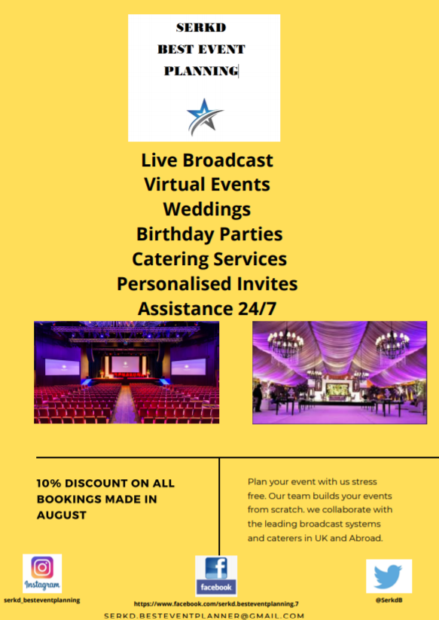

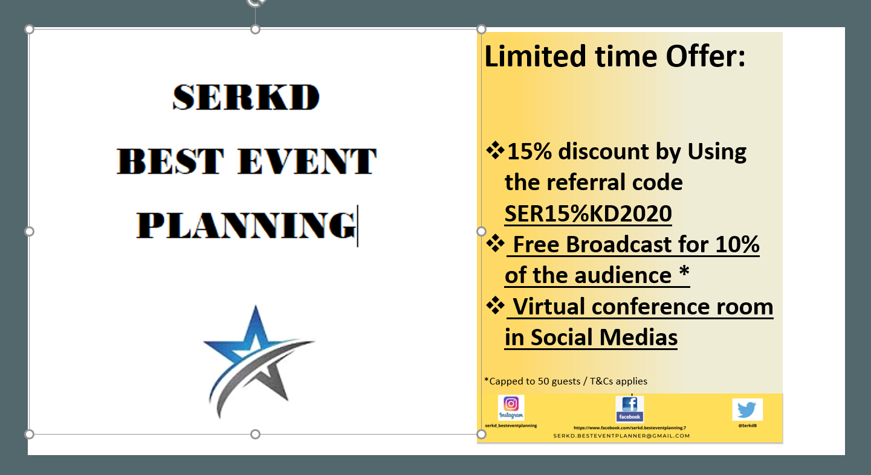

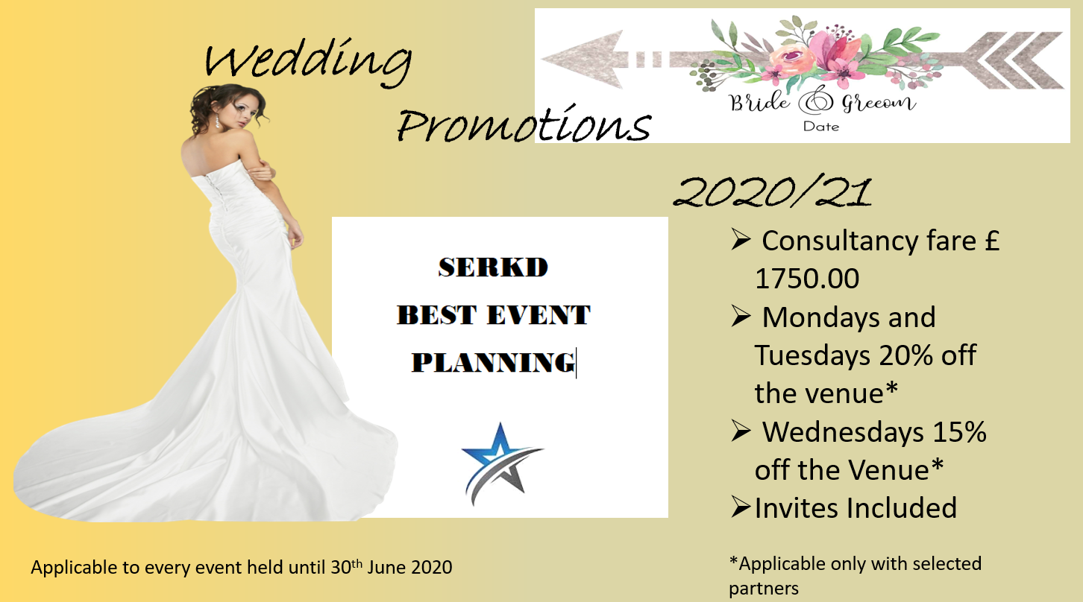

Technical:
Defined the technological services required.
The necessary technological equipment has been reviewed and confirmed today.
Next week they will be available for a first pre-event test.
Problems/Resolution Action Plan:
No issue

Focus for the Week:
sending invitations to participants
control of orders for the material needed for the event and their arrival date
ensure the presence of the required technologies and, if not, find who can rent them

Student Signature:

Riccardo Russo
__________________________________

Date:

28/07/2020
_________________________________

Week 5 |  | 04/08/2020
Planning:

- Invitation letter ready to be sent
- Follow up on the deposit and Credit Card Forms
- Contracts for food and beverage deliveries to be defined and choose company

Organising:

- Organizing meeting with marketing team to receive all the missing information and descriptions.

Managing:
The invitation letter is ready, and this allows us to start sending it to future participants.
In the invitation everything has been well described and any information can be found within it. Excellent work by the team who thought of every detail by specifying the event to all participants through the invitation quickly and concisely.
Various problems have been encountered by our senior manager; the team is taking steps to solve them.
However, it turns out that the planning is going very well thanks to the continuous organizational meetings held.

Marketing:
The video needs to be revised and improved.
Looking back to the video created and posted, the whole team decided to improve some aspects that can help a different impact in the eyes of the beholder.
Excellent final result
.
Technical:
Technological equipment required must be tested and its functioning must be ascertained.

Problems/Resolution Action Plan:
No issue

Focus for the Week:
Deposit to be received by the 7th September (at present not received yet, contract signed)
SERKD video to be improved
acknowledgment of acceptance of the invitation

Student Signature:

Riccardo Russo
__________________________________

Date:

04/08/20
_________________________________

Week 6 – Final Week | 18/08/2020
The job carried out in the previous weeks allowed us to arrive well prepared for the final week.
All deadlines have been met and the event just needs to be held.
The team did a great job planning all the work well in advance.
In the last week a general report has been made by the whole team.
The organization of the event was reviewed from start to finish so a clear vision of how it will be done is available to all team members.
The host facility will be sanitized the day before in order to be ready for the date of the event and free of any health problems.
The team is satisfied with the result achieved and LIMONCELLO CAPRI SPA is very happy with the delivered programming.

Student Signature:

Riccardo Russo
__________________________________

Date:

18/08/20
_________________________________

Conference Review | Planning; Organisation; Management; Marketing of the Event and Conference Delivery

The online conference project has allowed us to overcome the global problem of the Covid-19 pandemic. An important design work was carried out by the team to try to make the launch of this new limoncello by this great company in a foreign market as interesting as possible.
We are happy with the positive feedback received and we are sure that the event will be successful.

AGENDA
“LIMONCELLO DI CAPRI, THE TRUE ESSENCE OF CAPRI ISLAND”
- 9.00am: arrival of Limoncello Capri Spa members at our office;
- 9.30am: technical tests of the equipment and possibility of any logistical changes;
- 10.30am: break;
- 10.45am: access to the platform and welcome;
- 11.00am: conference start, 30 minutes of company presentation;
- 11.30am: 30 minutes of Limoncello presentation and the island which it comes from;
- 12.00pm: 15-minute break;
- 12.15pm: resumption of the conference and start of the tasting;
- 1.00pm: end of the tasting and release of contacts for possible and future collaboration;
- 1.15pm: thanks to all people who attended;
- 1.30pm: end of the conference presentation.



