
Assessment component: Financial performance and management of General Electronics
Programme Name: Master of Business Administration
Module Name: Financial Management
Module Code: LCMB7002
Topic: Strategic CFO Challenge - Saving a Failing Global Firm
Lecturer’s Name: Shengfeng Mei (London)
Student Name: Shubham Yadav
Student ID: 2504020
Word Count: 5033
Submission Date: 22 Dec. 25
Table of Contents
1. Introduction 5
2. Financial Health Check 5
I. Financial Statement Analysis 5
II. Ratio Analysis 8
III. Trends, Strengths and Threats 13
IV. Altman Z-Score for Default Risk 14
3. Working Capital Management Analysis 15
I. Cash Operating Cycle 15
II. Strategies to improve liquidity through working capital reforms 16
III. Short-Term vs Long-Term Financing Options 17
4. Strategic Financial Restructuring Plan 17
I. Financial Restructuring Options 18
II. Impact of Financial Restructuring Options 19
III. International and ethical considerations 20
5. Investment Appraisal and Capital Budgeting 21
I. Calculation of Investment Appraisal Techniques 21
II. Selection of Project 24
III. Recommendation via Capital Rationing 24
IV. Justification Based on Financial Performance and Project Risk 25
6. Conclusion 26
References 27
Appendices 32
Appendix 1: Ratios 32
Appendix 2: Altman Z-Score 33
Appendix 3: CCC 34
Appendix 4: Investment Appraisal Techniques 35

List of Figures
Figure 1: GE’s Income Statement 6
Figure 2: GE’s Balance Sheet 7
Figure 3: GE’s Cash Flow Statement 8
Figure 4: Profitability Ratios 9
Figure 5: Liquidity Ratios 9
Figure 6: Efficiency Ratios 10
Figure 7: Gearing Ratios 11
Figure 8: Investment Ratios 12
Figure 9: Cash Flows Ratios 12
Figure 10: Altman Z-Score for Default Risk 14
Figure 11: Cash Operating Cycle 15

List of Tables
Table 1: Trends, Strengths and Threats 13
Table 2: Payback Period for the 3 projects 21
Table 3: ARR for the 3 projects 22
Table 4: NPV for the 3 projects 23
Table 5: Profitability Index for the 3 projects 23
Table 6: IRR for the 3 projects 24

1. Introduction
Financial management is an important operation that companies need to perform to be able to manage resources for achievement of organisational goals. The report aims at performing financial evaluation, corporate restructuring, investment appraisal and working capital management. Financial health of General Electronics has been evaluated using ratio analysis. The cash operating cycle of the company has been evaluated to determine its management of working capital. A plan has been prepared for strategic financial restructuring. Calculation has been included for investment appraisal of three projects to select the most profitable option. Final recommendation has been made for investment assuming capital rationing.

2. Financial Health Check

I. Financial Statement Analysis
Analysis of financial statements is an important element of effective business decision-making as it offers valuable insights into financial performance and health of an organisation (Mishra, 2025). Analysis of three financial statements have been done below:
Income Statement
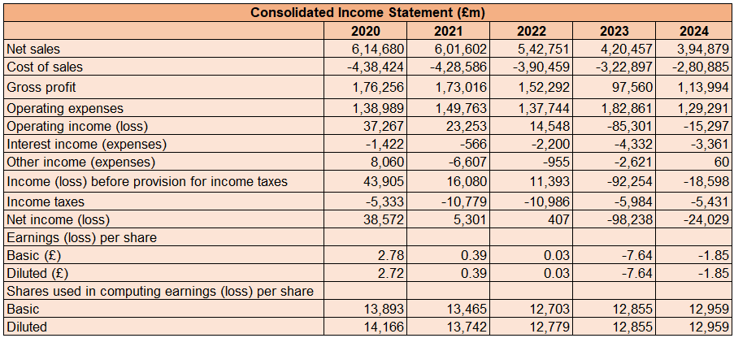

Figure 1: GE’s Income Statement
(Source: Assignment Briefings)
GE reported net sales of 394879 million in 2024 showing a decrease from the previous year as mentioned in Figure 1. Gross profit also decreased to 113994 million in 2024 indicating poor profitability. On one hand, expenses are increasing and on the other hand, incomes are decreasing leading to lower profit. Operating profit of the business was negative in both 2023 and 2024 which means operating expenses are greater than gross profit. In the same way, net profit of the business was negative in 2023 and 2024 which is not desirable for the business. Negative returns at the end of the year show that non-operating expenses are greater than operating income of the business. Also, this reduces its ability to pay dividends.
Balance Sheet
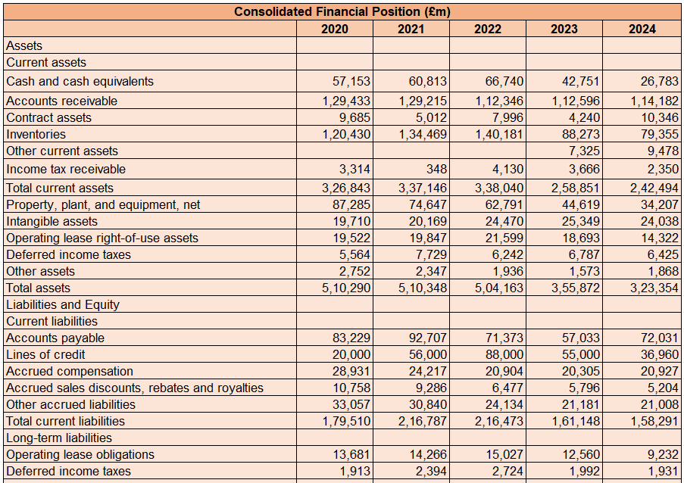
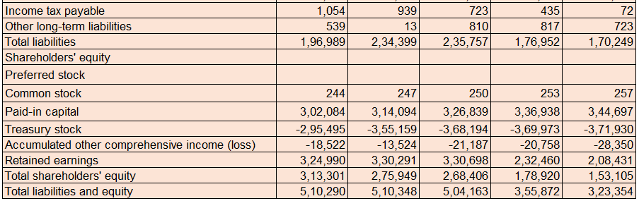

Figure 2: GE’s Balance Sheet
(Source: Assignment Briefings)
The Balance Sheet prepared in Figure 2 shows that GE's assets were 323354 million in 2024. This shows a decrease from previous years which is bad for the company’s financial position. Total liabilities of the company were 170249 million in 2024 which is also decreasing but less compared to assets. Equity of GE was 153105 million in 2024 showing a decreasing trend from the previous years. The above trend makes it evident that the company is operating with decreasing resources which is not desirable for its financial position.
Cash Flow Statement
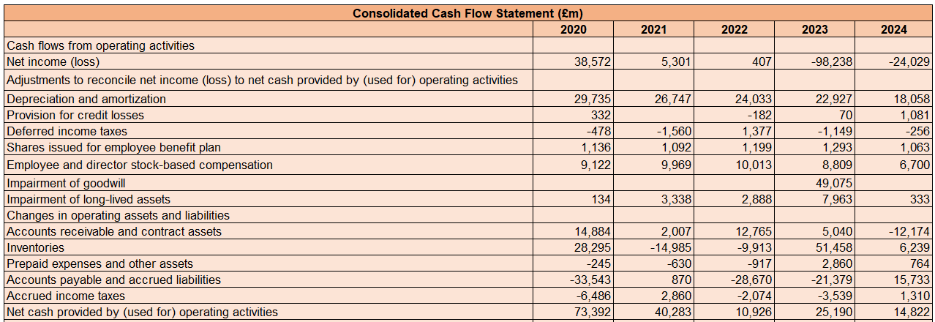
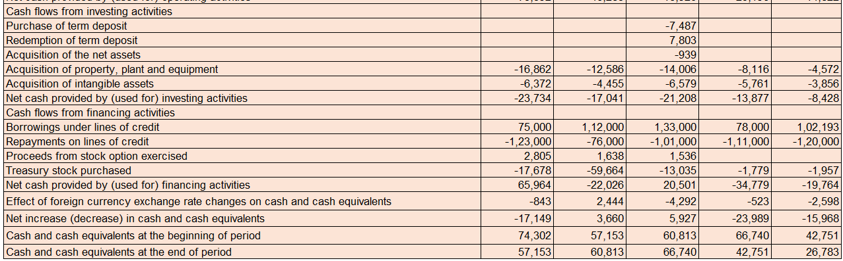

Figure 3: GE’s Cash Flow Statement
(Source: Assignment Briefings)
Operating cash of the business has decreased to 14822 million showing a significant decrease from that of 73392 million in 2020. This is because of a decrease in sales and other operating activities of the business. Investing cash of the business was negative in all the financial years but has decreased in 2024 showing less investment made by GE in the current year. Financing cash was also negative indicating that the company has repaid its debts. Cash balance at the end of the year also decreased significantly from 57153 million in 2020 to 26783 million in 2024. This decrease in balance of cash is not desirable for the company and its financial health.

II. Ratio Analysis
Profitability
Financial ratios have become important in explaining values in financial statements (Fadillah et al. 2024). Figure 4 shows profitability ratios for GE indicating decreasing trends in all. GPR is 29% which is quite good but NPR is -6% and OPR is -4%. The negative ratios are an indication that expenses of the business are greater than income. This makes it difficult for the business to sustain competition within the industry. The ability of the business to pay dividends to its shareholders has decreased which is bad for its profitability performance.

Figure 4: Profitability Ratios
(Source: Self-Created)
Liquidity

Figure 5: Liquidity Ratios
(Source: Self-Created)
Liquidity ratios of GE are quite good indicating good financial performance in Figure 5. Current ratio being greater than 1 shows current assets being greater than current liabilities. Also, the quick ratio is greater than 1 indicating that GE possesses sufficient liquid assets to pay off current obligations of the business. However, the cash ratio is very low which means the balance of cash is not sufficient to repay short-term obligations of the business. The company is keeping its investors satisfied with such a strong liquidity position within the industry by paying dues on time.
Efficiency

Figure 6: Efficiency Ratios
(Source: Self-Created)
The efficiency ratio of GE is decreasing and is very low compared to the idle ratio indicating poor performance in Figure 6. Stock turnover is 3.54 times which is indicating lesser sales made by the business. Inventories are not being converted into sales quickly which is leading to lower sales and also wastage of resources. Asset turnover is also very low at 1.22 times which shows that sufficient returns are not being earned through assets. Resources within the business show poor usage leading to low efficiency and wastage.
Gearing

Figure 7: Gearing Ratios
(Source: Self-Created)
Gearing ratio shows a poor financial position because the D/E ratio is very high as reflected in Figure 7. Debt capital is significantly high compared to equity showing a greater portion of assets being acquired through creditors which is not good. The company is subject to high leverage and risk. GE is enjoying greater tax shields but the risk of increasing cost of capital is very high. Also, interest coverage has decreased indicating a reduction in the ability of the business to pay interest expenses to the investors. Gearing performance requires attention so that the company achieves long-term sustainability.
Investment
EPS is an indicator of investment performance of a business because it shows returns that an organisation has earned over its outstanding shares. EPS was negative in 2023 and 2024 because of net loss earned by the company as reflected in Figure 8. The company is earning negative returns over its outstanding shares which is not good for its long-term sustainability. This is creating a negative impact on the shareholders of the company because it shows the inability of the business to earn returns.

Figure 8: Investment Ratios
(Source: Self-Created)
Cash Flow

Figure 9: Cash Flows Ratios
(Source: Self-Created)
Cash Flow ratios have decreased and are very low as reflected in Figure 9. This is because both operating cash and closing cash balance of the company have decreased in 2024 compared to the previous years. This is creating a shortage of cash within the business which affects the ability of the business to perform operations and pay obligations. Financial health of the business is being negatively affected because of shortage of cash which is not desirable. It would become difficult for the business to pay expenses out of the existing cash balance.

III. Trends, Strengths and Threats
Financial performance of a company is a critical indicator that is used for assessing financial health as well as operational efficiency of a commercial entity (Hasidi et al. 2024). Based on ratio analysis, the below-listed strengths, threats and trends have been identified.
Trends | Strengths | Threats
- Financial position and performance mostly reflect negative or decreasing trends.  - Sales, assets, liabilities, equity, profits and EPS have reported negative trends in all five years.  - Buy back of shares were done in 2924. | - Liquidity is very strong in all financial years.  - Working capital is positive indicating a proper balance between current liabilities and current assets.  - Operating cash balance is positive in all the years.  - Gross profit is positive in all the years | - The biggest threat for the business is increasing competition which makes sustainability difficult.  - Amid rising competition, sales are decreasing which is worsening its condition.  - EPS and net profit are negative.  - Debt capital is very high, increasing leverage and risk.  - A decreased cash balance is bad for the business in ensuring success.

Table 1: Trends, Strengths and Threats
(Source: Self-Created)

IV. Altman Z-Score for Default Risk
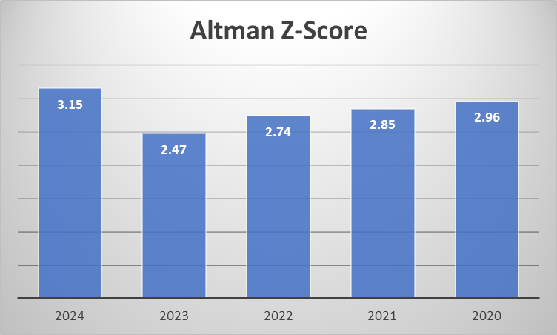

Figure 10: Altman Z-Score for Default Risk
(Source: Self-Created)
Altman's Z-Score has come up as a prominent analytical instrument used in evaluating financial soundness of companies and, eventually, their possibilities of survival. In the views of Chishti et al. (2024), Z-Score can be defined as a measure of predicting corporate distress as introduced by ‘Edward I. Altman’ in late 1960s. The score was 3.15 times in 2024, 2.47 times in 2023, 2.74 times in 2022, 2.85 times in 2021 and 2.96 times in 2020. Figure 7 shows a moderate bankruptcy risk during 2021 to 2023 as the score ranges between 1.81 and 2.99. Since then, the company has enhanced its performance achieving a score of 2.99 in 2024. Currently, the company is not subject to bankruptcy even after having poor financial performance. The company possesses sufficient resources for performing business operations successfully which is efficient in preventing liquidation and bankruptcy for General Electronics ensuring long-term sustainability. Currently, the business is operating in a safe zone.

3. Working Capital Management Analysis

I. Cash Operating Cycle

Figure 11: Cash Operating Cycle
(Source: Self-Created)
Working capital management or liquidity management is a critical choice in the short-term for any business. As commented by Karim et al. (2024), components of WCM such as CCC are the most significant variables to ensure liquidity, solvency as well as profitability of the business. The first element of CCC is inventory days which shows an increase in 2024 resulting in 103.12 days. This shows that the company requires 103.12 days to convert inventories into sales which is significantly high indicating poor performance. Also, inventory days are increasing in the last 5 years which is not desirable. The second element of CCC is receivable days which was 105.54 days in 2024. The ratio can be seen increasing which is not good for Working Capital Management. This indicates that the company is allowing customers with an extended period to clear off dues leading to shortage of cash within the business. This also increases the risk of the company to achieve bad debts. The last element of CCC involves payable days which was 93.60 days in 2024. The ratio is increasing indicating that the company is making late payments to the suppliers. CCC of GE was positive in all 5 years indicating poor management of working capital. In other words, the company is clearing payables sooner than receivables which leads to decrease in balance of cash. Therefore, it can be said that the Working Capital Management of the company is poor.

II. Strategies to improve liquidity through working capital reforms
Working capital is a lifeblood for a business which fuels regular operations and ensures fulfilment of financial obligations (JP Morgan, 2025). It helps in improving cash flow, increasing cash balance and achieving better position for the business. Working capital reforms that can be used for improving liquidity are:
- Accelerating accounts receivable is the best way of improving liquidity and enhancing working capital of the business. This involves making customers clear off their dues as soon as possible against their purchase. In order to encourage customers for early payments, GE is required to offer them with early payment discounts and implement digital invoicing systems.
- GE must tighten its accounts payable to optimize its working capital. This can be done by creating efficient payable processing through electronic workflows and negotiating favourable payment terms with the suppliers. Based on the views of Habib and Dalwai (2024), WCM includes management of payables, inventories, as well as receivables. Thus, the company must take advantage of early payment discounts.
- Reduction in operating expenses would help in increasing working capital. This would require optimisation of processes, outsourcing particular functions and renegotiating contracts.
- Controls and visibility must be improved by creating accurate forecasts of cash flow so that the company can plan for future cash requirements as well as use stock management tools for forecasting and tracking demand accurately.
- GE is required to manage and measure working capital by tracking receivable and payable turnover along with cash conversion cycle, quick ratio and current ratio. In the views of Cosima et al. (2025), cash flow is generally maximized by decreasing CCC and improving efficiency. Measuring performance through these ratios would help the organisation in determining issues in Working Capital Management.
- GE must consider financing options by decreasing dependence on external capital as well as improving prediction of actual requirements. Different financing and investment options must be considered such as term loans, lines of credit and invoice financing.

III. Short-Term vs Long-Term Financing Options
Short-Term Financing
Short-term financing of GE is being done through lines of credit. Lines of credit were 36960 pounds million in 2024, 55000 million pounds in 2023, 88000 million pounds in 2022, 56000 million pounds in 2021 and 20000 million pounds in 2020. A decrease in balance can be seen indicating less funds being collected. Accounts Payable is offering GE with some time period to clear off dues instead of spot payment.
Long-Term Financing
Long-term financing of the company is being done through debt and equity. Total shareholders' equity was 153105 million pounds in 2024, 178920 million pounds in 2023, 268406 million pounds in 2022, 275949 million pounds in 2021 and 313301 million pounds in 2020. The benefit of equity financing for the business involves no burden of repaying the principal value. Also, the business is earning loss due to which there is no obligation of paying dividends. On the contrary, total debt capital was 170249 million pounds in 2024, 176952 million pounds in 2023, 235757 million pounds in 2022, 234399 million pounds in 2021 and 196989 million pounds in 2020. The benefit of debt financing is reduction in tax that GE needs to pay to the shareholders. However, the capital structure of the business becomes risky.

4. Strategic Financial Restructuring Plan
Three options of strategic financial restructuring can be recommended to GE which includes divestiture, merger as well as equity injection.

I. Financial Restructuring Options
Divestiture: Divestiture is an option of financial restructuring which requires spinning off or selling business units as well as assets not aligning with core objectives of the organisation or with an aim of earning suboptimal returns. GE can consider this option for its poorly performing business units, especially those earning very low ROCE. With this strategy, the company would improve its working capital and liquidity due to the immediate inflow of cash. As commented by Colliard and Gromb (2025), ‘optimal capital structure’ creates a trade-off between cost of every instrument as well as its effect on restructuring delays. Along with this, the focus of management would shift towards activities of business generating higher profits. Operational complexity would decrease improving efficiency and cost control.
Merger: Merger is an option of financial restructuring which requires a company to collaborate with another operating in either similar industry or a different industry. In the views of Udeoji and Udeoji (2025), the incentive of restructuring mostly arises due to market value of a firm falling significantly below its intrinsic value or full potential. Merger would provide GE with the ability to access capital of the company it is merging with. With the help of this strategy, the company will be able to improve its profitability and acquire more resources. The company would also get access to knowledge and expertise present in the firm it is merging with, without any significant investment. An improvement in Goodwill of the business can also be seen post-merger.
Equity Injection: Equity Injection is an option of financial restructuring which requires rights issues to increase equity balance. GE can also look for strategic investors who can improve the capital base of the company without contributing to debt obligations. However, as argued by Shem and Mupa (2024), legal challenges, such as litigation, creditor disputes, and regulatory issues can complicate the process of restructuring. This option would be very suitable for the company because of strict credit situations and increasing interest rates in the market. In this way, the company would improve its creditworthiness and create a better balance between equity and debt. In addition, the ability of the firm to finance international expansion, digital transformation and innovation would improve.

II. Impact of Financial Restructuring Options
Shareholder Value: Divestiture would create value for shareholders via taking out capital from low-return assets as well as reallocating the same towards activities with opportunity of higher growth. As suggested by Akinsola and Kingsley Onu (2024), corporate spin-offs, and divestitures are important strategic initiatives to be used by companies in adapting to market demands, unlocking shareholder value and streamlining operations. Mergers would also create value for shareholders because of the increase in price of shares along with enhanced goodwill. Injection of equity might dilute current shareholdings for a short time period but the impact on long-term value would be positive significantly if the collected capital earns returns greater than cost of equity.
Debt Structure: Divestiture would generate proceeds which can be successfully used in retiring debt with high cost. This in-turn would decrease risk of interest coverage and leverage ratios. This option of financial restructuring is very beneficial when it comes to creating a balance between debt and equity as well as managing cost of capital. As per the views of Erl et al. (2025), divestiture is a main strategic tool for companies willing to streamline operations as well as enhance financial performance. Merger would help the company in combining both debt and equity of both companies. If the other company possesses a lower level of debt capital in its capital structure, then GE will be able to improve its debt structure. Equity injection would decrease financial leverage, burden of interest as well as bankruptcy risk. The company would not be subject to the pressure of repaying shareholders with the collected funds.
Operational Flexibility: Divestiture would ensure operational flexibility by creating a strong balance sheet as well as improving borrowing capacity in the future. Management of limited resources would also improve because of this financial restructuring option. As commented by Nguyen et al. (2025), restructuring is inevitable for driving sustainability of companies and economic landscape. Equity injection would provide better operational flexibility to GE by ensuring that the management focuses on strategic initiatives in place of breaching liquidity constraints or debt covenants. Merger improves operational flexibility by improving capital structure and resource base. The company will be able to acquire skilled workforce for performing business operations.

III. International and ethical considerations
Taxation: Equity injection and international divestiture has been found to trigger tax liabilities internationally which includes transfer pricing scrutiny, withholding tax and capital gain tax. GE would have to comply with the changing international regulations associated with taxation. Along with this, tax-efficient jurisdictions must be used to reduce regulatory and reputational risks ensuring achievement of the desired benefits.
Currency Risk: Companies with international operations are subject to currency risk if they decide to restructure their business financially. This is why GE is required to consider volatility of foreign exchange. Exchange losses or gains can be crystallized with foreign asset divestment. On the other hand, debt denominated in foreign currency makes the firm subject to risk of repayment. In this situation, GE must consider hedging strategies to be able to control the impact of fluctuating exchange rates.
Inflation: In the views of Adriana et al. (2024), market boundaries have been found to influence the decision of a firm to exit via divestiture spin-off. Interest and inflation rates increase cost of financing for a business along with decreasing returns. In this situation, equity financing becomes more attractive as the cost and risk remains lower compared to debt. GE must consider instruments that are inflation-indexed or fixed-rate so that the cash flows can be stabilized in the future.
CSR: It is important to consider the CSR aspects while taking the decision to perform financial restructuring. Strong ethical framework is required for maintaining sustainability and stakeholder trust in the long-term while performing financial restructuring. As analysed by Malapur (2024), CSR programs have been found to possess a huge impact on reputation as well as perception of a company, drawing in socially-conscious customers and investors while boosting brand loyalty. Equity investors have been found to prefer ESG performance which means GE must take initiatives to become a responsible citizen. Restructuring plans must incorporate practices which support value creation in the long-term, ethical governance and sustainable operations to be able to attract institutional investors as well as decrease cost of capital of the firm.

5. Investment Appraisal and Capital Budgeting

I. Calculation of Investment Appraisal Techniques
It is given that:
- Project A has initial investment of £40m along with Year 1 to Year 5 net cash inflows of £10m, £12m, £14m, £10m, and £8m.
- Project B has initial investment of £30m along with Year 1 to Year 5 net cash inflows of £6m.
- Project C has initial investment of £50m along with Year 1 to Year 5 net cash inflows of £5m, £10m, £20m, £25m, and £15m.
PBP:
Based on the views of Adriana et al. (2024), payback period offers the time it is required for projects to return invested capital. It has been computed using the equation: “Initial investment / average annual cashflow” for Project B as it had regular cash flows. For other two projects with irregular cash flows, the formula used is “Years prior-breakeven + Unrecovered Cost / Recovery Year Cash Flows”. It is a non-discounting technique of decision making because of which scholars do not consider payback as an effective technique of selecting projects. Thus, it is used as a complimentary tool for NPV indicating liquidity. A project with the shortest payback period is good for selection because it indicates that the investor will be able to re-earn the initial investment. Projects with longer payback periods must not be selected because their liquidity is low. Table 2 shows that project a has a payback of 3.4 years, project B has 5 years and projects C has 3.6 years. Project A has the highest liquidity whereas project B has the lowest liquidity making the former more feasible for investment.
 | Project A | Project B | Project C
Payback Period | 3.4 years | 5 years | 3.6 years

Table 2: Payback Period for the 3 projects
(Source: Self-Created)
ARR:
ARR offers yearly accounting profits that arise from an investment and is represented in the form of a percentage of total investment made (ACCA Global, 2025). It has been computed using the equation: “average annual accounting profits / investment) x 100%”. ARR is a non-discounting technique of investment appraisal just like payback because of which scholars do not consider it as an effective technique of selecting projects. Thus, it is used as a complimentary tool for NPV indicating accounting profit. ARR is an indication of accounting profit because of which the project with highest percentage must be selected whereas that with the lowest percentage should be rejected. ARR of project A is 14%, of project B is 0% and project C is 20%. On the basis of ARR, project C is the most profitable option whereas project B is the least profitable option.
 | Project A | Project B | Project C
ARR | 14% | 0% | 20%

Table 3: ARR for the 3 projects
(Source: Self-Created)
NPV:
NPV is a technique where PV of future gains and costs are compared to determine feasibility of projects. As per the ideas of Ridwan et al. (2025), NPV is computed using ‘estimated net cash flows’ and an ‘estimated cost of capital’. It has been computed using the equation: “-CF0 + CF1 x (1/1+r)^1 + CF2 x (1/1+r)^2 + CF3 x (1/1+r)^3 + CF4 x (1/1+r)^4 + CF5 x (1/1+r)^5”. NPV is one of the most important investment appraisal techniques because of its accuracy in determining feasibility of investment. It is a discounting technique of decision making considering ‘time value of money’ because of which scholars support NPV as an effective technique of selecting projects. Projects with negative NPV are rejected whereas those with positive NPV are selected. NPV of project A is 1.32 million pounds, project B is -7.26 million pounds and project C is 4.23 million pounds. Table 3 shows that based on NPV, project C is the most feasible option whereas project B is the least feasible option.
 | Project A | Project B | Project C
NPV | 1.32 million pounds | -7.26 million pounds | 4.23 million pounds

Table 4: NPV for the 3 projects
(Source: Self-Created)
PI:
Profitability Index is a measurement of a proposed project's benefits and costs by dividing ‘projected capital inflows’ by cost of investment. PI must be chosen if a possibility of decrease in future cash flow is there (Sokolov, 2024). It has been computed using the equation: “Projected Capital Inflows / Cost of Investment”. It is a discounting technique of decision making because of which scholars consider PI as an effective technique of selecting projects. It is used as a complimentary tool for NPV indicating profitability. PI indicates profitability because of which the projects with highest value must be selected and projects with the lowest value must be rejected. PI of project A is 1.03, project B is 0.76 and project C is 1.08. PI of project C is the highest whereas that of project B is the lowest.
 | Project A | Project B | Project C
PI | 1.03 | 0.76 | 1.08

Table 5: Profitability Index for the 3 projects
(Source: Self-Created)
IRR:
A discount rate reducing NPV of a project to 0 is IRR (Rugthaicharoencheep et al. 2024). It has been computed using the equation: “0 = CF₀ + CF₁ / (1+IRR)¹ + CF₂ / (1+IRR)² + CF₃ / (1+IRR)³ + CF₄ / (1+IRR)⁴ + CF₅ / (1+IRR)⁵”. It is a discounting technique of decision making because of which scholars consider IRR as an effective technique of selecting projects in support of NPV. Projects with greatest IRR are selected whereas projects with lowest IRR are rejected. It is important that IRR is greater than the cost of capital of the project. IRR of project A is 11%, project B is 0% and project C is 13%. As IRR of project C is greatest, the same must be selected.
 | Project A | Project B | Project C
IRR | 11% | 0% | 13%

Table 6: IRR for the 3 projects
(Source: Self-Created)

II. Selection of Project
Out of all the options, project 3 must be selected because of highest NPV, IRR PI and ARR. The above discussion shows that project 3 is profitable because cash inflows are greater than cash outflows as shown by NPV. Along with this, ARR is the greatest which means the company would generate the highest percentage of accounting profit even after deducting non-cash expenses like depreciation. IRR of project 3 is the highest indicating that the return rate is greater compared to the discounting rate. PI also supports that project 3 is the most profitable option for investment purposes. However, the payback period of this project is the highest. As NPV is the most reliable technique of decision making, project 3 must be selected.

III. Recommendation via Capital Rationing
Capital rationing is a process of allocating investment in different projects if investors have limited funds to invest. As per the views put forward by Sekhar (2025), companies facing capital rationing might favour Payback Period despite conceptual rigor of NPV. The company has 60 million pounds which can be invested in the three projects. Project A has initial investment of £40m, Project B has initial investment of £30m and Project C has initial investment of £50m. If Project A and Project B are combined then initial investment required would be £ 70 million which is greater than £ 60 million. Thus, this option is not feasible. Similarly, if Project A and Project C are combined then initial investment would be £ 90 million which is greater than £ 70 million making this option not feasible. In the same way, if Project B and Project C are combined then initial investment required would be £ 80 million which is greater than £ 70 million making it not feasible. This means the company can invest in only one project at a time and thus investment must be done in project C with the highest NPV.

IV. Justification Based on Financial Performance and Project Risk
Calculation of investment appraisal techniques help businesses in considering quantitative factors such as profitability. However, there are other factors that require equal importance at the time of decision making.
Profitability: One of the most important aims behind performing investment involves increasing profitability. In other words, profitability is one of the most attractive factors when it comes to investment. Profitability of GE currently is very low because of which the company is in the requirement of profitable investment options. Projects with greatest return earning potential would be suitable for the company to be able to improve with existing profitability. Based on this factor, project C is the best option for the business.
Liquidity: Liquidity of an investment is associated with the ability of the investors to earn back the investment. Liquidity of GE currently is good which means the company possesses sufficient liquid assets that can be invested in clearing dues. As the liquidity performance is already strong, GE is not required to consider investment options with greater liquidity. Based on this perspective, the company must proceed with project C.
Project risk characteristics - cash flow volatility: Volatility of cash flows is an important factor to be considered at the time of decision making. It is important that the company is investing funds in projects with lowest volatility of cash flows. Project B has the least amount of volatility in the cash flows which makes it suitable for the purpose of investment. However, cash flow volatility cannot become a sole decision maker when it comes to selecting investment projects. Project B does not satisfy other criteria of selection.

6. Conclusion
GE has reported very poor financial performance in terms of profitability, efficiency, gearing, cash flows, and investment. The company is earning losses and reduction in cash balance can be identified creating a negative impact on its sustainability. However, liquidity of the business is very strong leading to satisfied investors. Risk of bankruptcy is absent but working capital management requires improvement. Financial restructuring options must be considered by the company for improving its financial performance. Calculation of investment appraisal helps in concluding that project 3 must be chosen. Capital rationing concludes that the company can invest only in one project.

References
ACCA Global (2025). Accounting rate of return. Available at: https://www.accaglobal.com/in/en/student/exam-support-resources/foundation-level-study-resources/ffm/ffm-technical-articles/rate-return.html [Accessed on 15th December 2025]
Adriana, D., Hartoyo, H., Syarief, R. and Anggraeni, E., (2024). Revisiting Causes of Firm Exit for Divestiture Spin-Off in the Last Five Years: A Systematic Literature Review. Aptisi Transactions on Technopreneurship (ATT), 6(3), pp.458-467. Available at: https://att.aptisi.or.id/index.php/att/article/download/447/288 [Accessed on 15th December 2025]
Akinsola, O.K. and Kingsley Onu, D.Y.O., (2024), Legal Implications of Corporate Spin-Offs, Divestitures, and Corporate Restructuring: Key Considerations for Business Leaders and Legal Counsel. Available at: https://www.researchgate.net/profile/Beauden-John/publication/388659649_Legal_Implications_of_Corporate_Spin-Offs_Divestitures_and_Corporate_Restructuring_Key_Considerations_for_Business_Leaders_and_Legal_Counsel/links/67a19499645ef274a4664f72/Legal-Implications-of-Corporate-Spin-Offs-Divestitures-and-Corporate-Restructuring-Key-Considerations-for-Business-Leaders-and-Legal-Counsel.pdf [Accessed on 15th December 2025]
Chishti, M.F., Rao, M., Raffat, M.W. and Rafi, S., (2024). Estimating Corporate Risk and Corporate Value An Application Of Altman's Z-Score On The Kse-30 Index. International Journal of Contemporary Issues in Social Sciences, 3(2), pp.2833-2841. Available at: https://www.researchgate.net/profile/Mazhar-Farid-2/publication/382692938_ESTIMATING_CORPORATE_RISK_AND_CORPORATE_VALUE_AN_APPLICATION_OF_ALTMAN'S_Z-SCORE_ON_THE_KSE-30_INDEX_Corresponding_Author/links/66a9b545c6e41359a84d856e/ESTIMATING-CORPORATE-RISK-AND-CORPORATE-VALUE-AN-APPLICATION-OF-ALTMANS-Z-SCORE-ON-THE-KSE-30-INDEX-Corresponding-Author.pdf [Accessed on 15th December 2025]
Colliard, J.E. and Gromb, D., (2025). Financial restructuring and resolution of banks. HEC Paris Research Paper No. FIN-2018-1272. Available at: https://papers.ssrn.com/sol3/Delivery.cfm?abstractid=3183777 [Accessed on 15th December 2025]
Cosima, T., Ahmed, E.M. and Elfaki, K.E., (2025). Working capital management impact on Zimbabwe’s listed consumer services firms’ profitability and the influence of external factors via governance policy. Quality & Quantity, pp.1-24. Available at: https://link.springer.com/content/pdf/10.1007/s11135-025-02250-3.pdf [Accessed on 15th December 2025]
Erl, L., Kiesel, F. and Schiereck, D., (2025). The diversity of divestiture–stock market reactions around the announcements of divestiture programs. Review of Managerial Science, 19(9), pp.2729-2773. Available at: https://link.springer.com/content/pdf/10.1007/s11846-024-00830-5.pdf [Accessed on 15th December 2025]
Fadillah, I.R., Nadiyah, N., Rohmah, L., Haryadi, D. and Wahyudi, W., (2024). Profitability ratio analysis to assess the financial performance. International Journal of Applied Finance and Business Studies, 11(4), pp.964-969. Available at: https://ijafibs.pelnus.ac.id/index.php/ijafibs/article/download/243/190 [Accessed on 15th December 2025]
Habib, A.M. and Dalwai, T., (2024). Does the efficiency of a firm’s intellectual capital and working capital management affect its performance?. Journal of the Knowledge Economy, 15(1), pp.3202-3238. Available at: https://pmc.ncbi.nlm.nih.gov/articles/PMC10028330/pdf/13132_2023_Article_1138.pdf [Accessed on 15th December 2025]
Hasidi, M.H., Baheri, J. and Hajar, K.I., (2024). Financial performance evaluation using profitability and liquidity ratio analysis. Available at: https://jurnal.ibik.ac.id/index.php/jimkes/article/download/2742/1966 [Accessed on 15th December 2025]
JP Morgan (2025). 6 ways to improve working capital. Available at: https://www.jpmorgan.com/insights/treasury/treasury-management/6-ways-to-increase-working-capital [Accessed on 15th December 2025]
Karim, R., Mamun, M.A.A. and Kamruzzaman, A.S.M., (2024). Cash conversion cycle and financial performance: evidence from manufacturing firms of Bangladesh. Asian Journal of Economics and Banking, 8(1), pp.67-82. Available at: https://www.emerald.com/ajeb/article-pdf/8/1/67/9525823/ajeb-03-2022-0033.pdf [Accessed on 15th December 2025]
Malapur, S.K.S., (2024). Corporate Social Responsibility Integration In Corporate Restructuring: A Pathway To Sustainable Growth. Available at: https://d1wqtxts1xzle7.cloudfront.net/116962190/E2603083342-libre.pdf?1721655611=&response-content-disposition=inline%3B+filename%3DCorporate_Social_Responsibility_Integrat.pdf&Expires=1766059943&Signature=GVZ8qi7-yPq3-q3qHNA4DN~Tb5E-71R4FK38aFefD1JpyuDxcmQPiMMJAZ991aJX3KnsaB4d8v5t0i0HdxtKhJiN1NaI34mcRSgV1KNy0N8wDveyO4qBcJeozxba54STzH9b~IbN~cEuWyf53Aej1Ft8EfRukclRSL83LIID938ITkOZhVT4PwbD9U~FT0NMhEL9IliaGUltdUVADniJ03l2JiKCH-xBH-jen0OV93d8hd3dNVppPvWpPipsUP3lO6iIVgxjgv~8nsus~Eruf63GUBitN00EZgdHmvNTVbtHipFPYaXahjDWkGOAK8kMHtRr3779J5N~MG48y6~~ZQ__&Key-Pair-Id=APKAJLOHF5GGSLRBV4ZA [Accessed on 15th December 2025]
Mishra, R., (2025). FINANCIAL STATEMENT ANALYSIS AS A TOOL FOR BUSINESS DECISION-MAKING. Journal of Advanced Interdisciplinary Studies-p-ISSN 3050-8924 en e-ISSN 3050-8932, 1(7), pp.20-24. Available at: https://journals.eduacademic.co.in/index.php/jais/article/download/254/221 [Accessed on 15th December 2025]
Nguyen Thi, C., Anh, K.T. and Tran, K.B.N., (2025). Corporate distress and financial restructuring decisions in different stages of life cycle. Journal of Economics and Development, 27(3), pp.264-276. Available at: https://www.emerald.com/jed/article-pdf/27/3/264/10079017/jed-08-2024-0281en.pdf [Accessed on 15th December 2025]
Ridwan, S., Syah, T.Y.R., Kustiawan, U. and Nofierni, N., (2025). Financial planning and investment feasibility analysis based on five-year projections using ROI, NPV, IRR, and financial ratios. Journal La Bisecoman, 6(2), pp.489-506. Available at: https://mail.newinera.com/index.php/JournalLaBisecoman/article/download/1970/1958 [Accessed on 15th December 2025]
Rugthaicharoencheep, N., Ruangsap, N. and Nedphokaew, S., (2024). Shortening the payback period of greenhouse gas reduction benefits from photovoltaic rooftop systems. Energies, 17(23), p.6159. Available at: https://www.mdpi.com/1996-1073/17/23/6159 [Accessed on 15th December 2025]
Sekhar, S.C., (2025). Reassessing The Role Of Net Present Value In Capital Budgeting Decisions. International Journal of Research and Analytical Reviews. Available at: https://d1wqtxts1xzle7.cloudfront.net/124979573/28_2025_IJRAR-libre.pdf?1760351561=&response-content-disposition=inline%3B+filename%3DReassessing_The_Role_Of_Net_Present_Valu.pdf&Expires=1766063668&Signature=LYCZzvfeSwFWxhe~0QcZZ~3Ists4vH3nsvWzwW3ObKVMrGn4fRvPmWst3NWaH26mZ0PoH7O~CKak2uwdJN-iMcQqDGBzlMareOqWB0VKBERjvuuMkl8eeBZDo3yj8I0KRlqAS8OIarmScuHYOvwK2pV-muq98hLgWmq8scnlF~g0xq-7FF5QRcafp1igkoVSLn6qzh2Y7korYTb4h5QBBWKqh3GYi7m74o6wSlle~DCqkxln9qOpoIAx2L3IFF8UqeGElUaLeQdkuSlVposxUAnjq6I7ClyEWQ4mh2sCegJEyi8U~CDI0Dn1dVOgSqt2BK3q2sF0hsy5-sHejACVQw__&Key-Pair-Id=APKAJLOHF5GGSLRBV4ZA [Accessed on 15th December 2025]
Shem, A.M. and Mupa, M.N., (2024). Turnaround Financing: Legal and Financial Considerations for Distressed Companies [online] https://www.researchgate.net/profile/Munashe-Naphtali-Mupa/publication/384735379_Turnaround_Financing_Legal_and_Financial_Considerations_for_Distressed_Companies/links/6705d4e34cb01e6ec78177c2/Turnaround-Financing-Legal-and-Financial-Considerations-for-Distressed-Companies.pdf [Accessed on 15th December 2025]
Sokolov, M.V., (2024). NPV, IRR, PI, PP, and DPP: A unified view. Journal of Mathematical Economics, 114, p.102992. Available at: https://arxiv.org/pdf/2302.02875 [Accessed on 15th December 2025]
Udeoji, R.O. and Udeoji, N.N., (2025). A Comparative Analysis of Corporate Restructuring in Nigeria. Journal of Refugee Law and International Criminal Justice, 3(1). Available at: https://ezenwaohaetorc.org/journals/index.php/JORLAWICJ/article/download/3054/3184 [Accessed on 15th December 2025]

Appendices

Appendix 1: Ratios
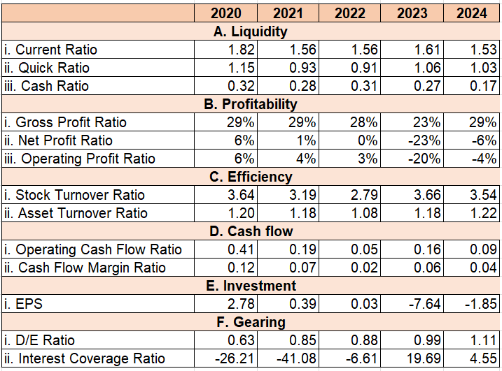
(Source: Self-Created)

Appendix 2: Altman Z-Score
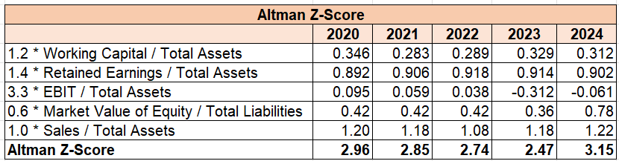
(Source: Self-Created)

Appendix 3: CCC
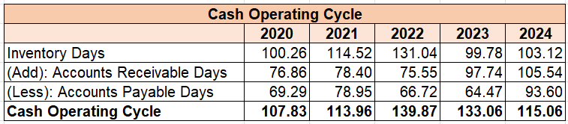
(Source: Self-Created)

Appendix 4: Investment Appraisal Techniques
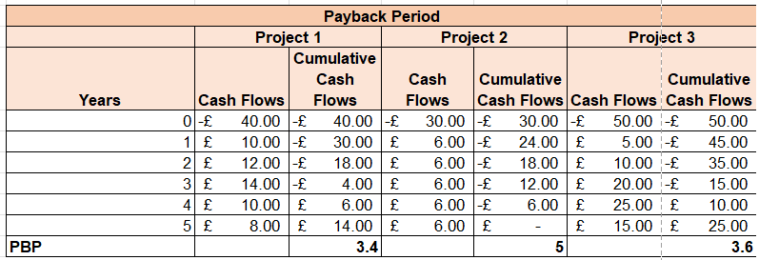
(Source: Self-Created)
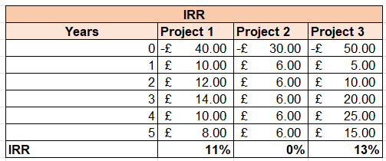
(Source: Self-Created)
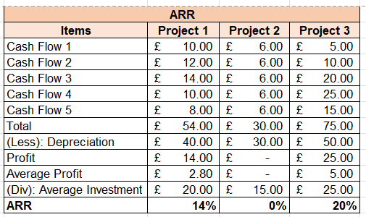
(Source: Self-Created)
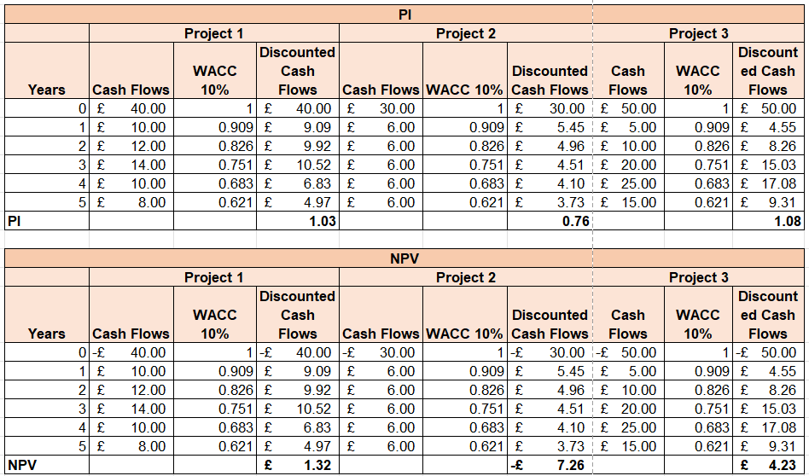
(Source: Self-Created)

