

  - Module: Application Development
  - Lecturer: Dr Kemi Ademoye
  - Program: BSc/HND Computing
  - Submission Deadline: 9th December 2019
  - Name: Ruzy Aktar
No. 1708215
Introduction
For this module, the author will be creating a responsive website, using Bootstrap, JavaScript, and CSS. The website should be adaptable to use on devices such as mobile phones, tablets, and a web browser when minimizing the screen. A responsive website should allow users to view all the content on the page when viewing on a mall screen or web browser if making the screen smaller.

Application Development Concepts
Application development is the process of designing, building, and implementing software applications. It can be done by massive organizations with large teams working on projects, or by a single freelance developer. Application development defines the process of how the application is made, and generally follows a standard methodology. [1]
Application development have a lot of elements, this means thoroughly thinking about what the size is for the programme. However, also what procedures needed.
An appealing website should be able to do numerous tasks, such as the images must be clear for their vision. Also, the colors that are used must be a good contrast to be able to read text as well as getting the viewers interest.
To make sure this application is put into action the author has explored all the requirements such as design fundamentals, which then must be implemented in the authors application.

Design Principles
Good web design always caters to the needs of the user. Each page of your website needs to have a clear purpose, and to fulfill a specific need for your website users in the most effective way possible [2].
When the student created the website , it was thought of thoroughly the student made sure the website was fit for individuals with visual impairments , however they made sure the layout and words were readable.

Mobile first
A “mobile-first” approach involves designing a desktop site starting with the mobile version, which is then adapted to larger screens (contrary to the traditional approach of starting with a desktop site and then adapting it to smaller screens) [3].
Mobile devices are now the primary means by which users are accessing Web sites, and the number of people using sites on mobile devices is projected to triple within the next year. Today, smartphone sales have surpassed personal computer sales [4].
Overall, creators who come up with website ideas must think about individuals who are always busy, meaning every website must be responsive to view on mobile phone devices and navigation must be tailored to fit on mobile phone screens.

Purpose
Initially all websites must have a purpose otherwise it will be hard to gain viewers attention as it will have no worth to them. If the contents of the website do not match then it will look unprofessional as well as leaving viewers confused. The website is about cakes so the student has made sure to include contents of the page to be about cakes to be relatable to the viewers. Thus, there are pictures and information regarding around cakes.

Colors
Colors on a web page need to be good quality contrast, this is important to viewers as they will be the ones loading the web page on their mobile phones or computers.
The student chose calm tone of colors, this is to make the website comfortable for users to view. The pastel colors are not effective on eyes and will not make their eyes hurt or affect them in anyway.
‘When it comes to designing a website, colour is just as important as usability and navigation’. [5]

Navigation
‘Menu navigation exists to help us find content and it should be simple and intuitive. When looking at a website, our expectation is to navigate with ease and have a great experience’[6]

Usability and User Experience
Usability experience initially means how the viewer interacts with the website. Such as, users should find it very simple when using a design interface. They should be able to accomplish their goal when visiting the website e.g. shopping, university research etc.

Requirements
The purpose of the student’s website is to advertise her home baking business. She will be using JavaScript, HTML, CSS. Target audience for the website will be individuals looking to purchase sweet treats for their own desires or venues that need dessert catering. The website will be called ‘Rosays’. The author thought of this when thinking of her own name and implementing it to a catchy phrase. All the continents on the website have a relation to the topic of the website. And have a useful interface adaptable on a mobile phone.
The pages on the website are called
- Home
- About
- Cakes
- Treats
- Events
- Contacts

Design
The design the author has opted for is mobile first. The author has made her website this so the website would bond with mobile devices. This then is good for in the future for individuals to view on bigger devices such as computers.

Colors
The individuals using the website will notice the background of the website is a light pink color. This is done for aesthetics; this is executed for visual pleasing. However, it is also done to give it a feminine feeling to the website allowing users to know it is a woman behind the baking.

Purpose
Purpose is to allow users to notice the author is a home baker, who has created 6 pages with all the required information, that allows her to advertise her business.

Navigation
The has used a simple navigation bar at the left-hand side of the page. This is done to allow users to see the bar as soon as they enter the page and it is easy to view.
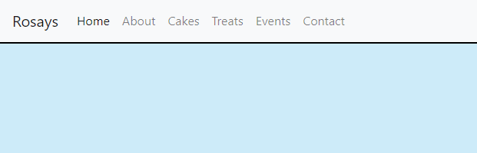

However, to make the navigation bar responsive the author has added a drop-down navigation bar for users who may wish to use this on their smaller screens.

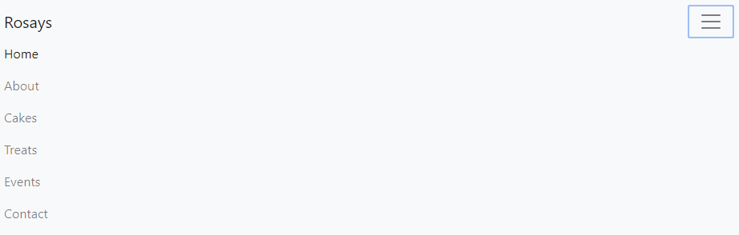
Code below has been used to implement this.

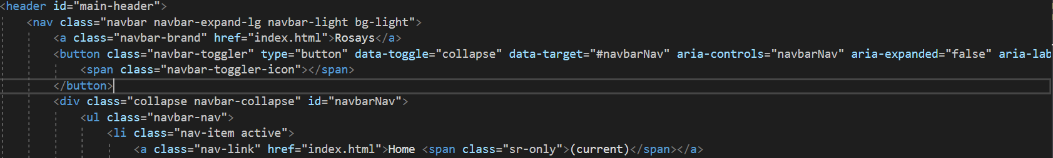

Implementation
The author has used JavaScript this is done on the second page called ‘Cakes’. The author has opted for this idea because the student has cakes on a grid in rows.
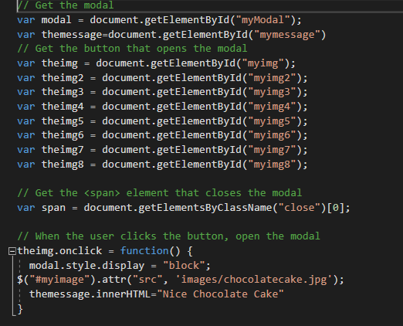
‘JavaScript is an interpreted programming language still it simplifies development of complex web applications by allowing the developers to simplify the application’s composition’ [8]
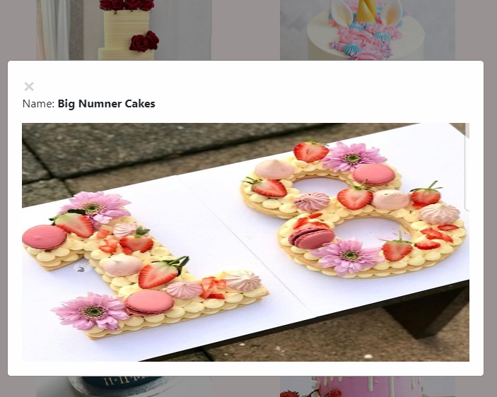

The student has highlighted the code that makes the function popup and visible. When selecting an image above is the expected result.
The top code is to select all the images and the below code is used to display those images. To implement this, she has used this code.
Over all for every one image there is 4 line of code , after function ( enter code for 1 image) so the above code is for selection for all the images , so that they are both combined.

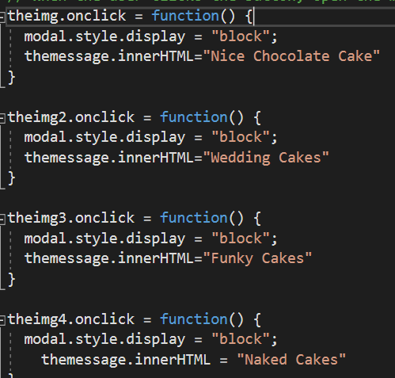
The Modal plugin is a dialog box/popup window that is displayed on top of the current page [7]. Some parts of the modal code have been researched and used but additional code has been implemented inside to make the whole task work. Such as, below you can see I have added a message to correspond with the HTML page which is the next picture.

Below the student has named each picture by a number so the computer knows which picture needs the onClick message. Each picture must have a different number otherwise the program will not know which one to focus on.
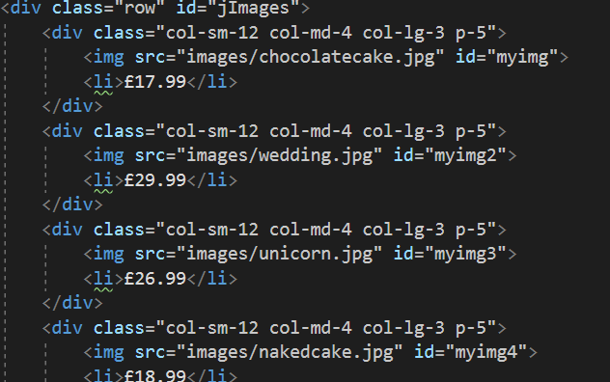

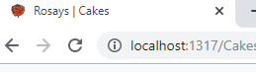
Another feature the student added is the Rose icon, the author has chosen a rose. Below is the code the student has used to insert the icon. This just shows where the icon comes from within the image file.

Footer
The student has added a footer where the information about the student e.g., who is the creator of the website. Below are pictures and the codes used to implement this.
This is an example of what all websites will look like with a header and footer.

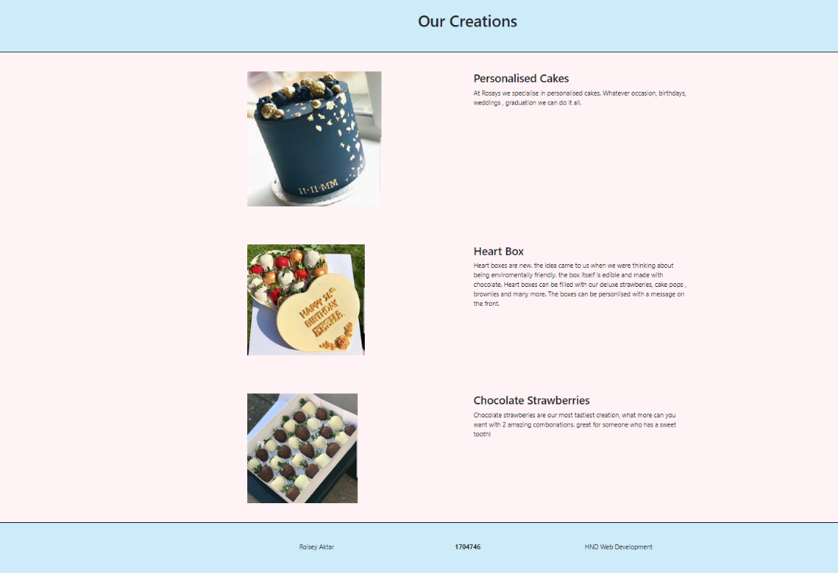

Footer
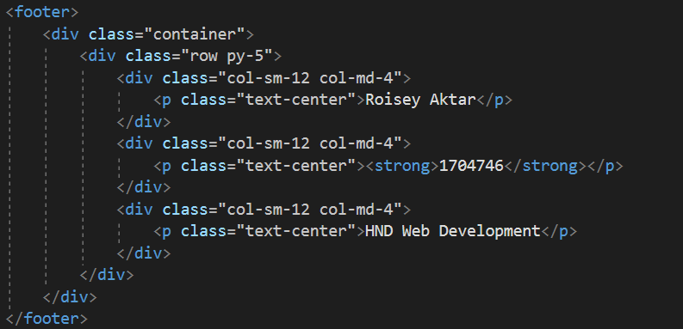
Coding for the footer the student has implemented.

Below is the code used to make the blue border. Which relates to the CSS file.
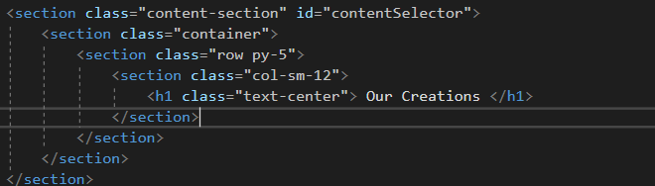

API/ Google Maps
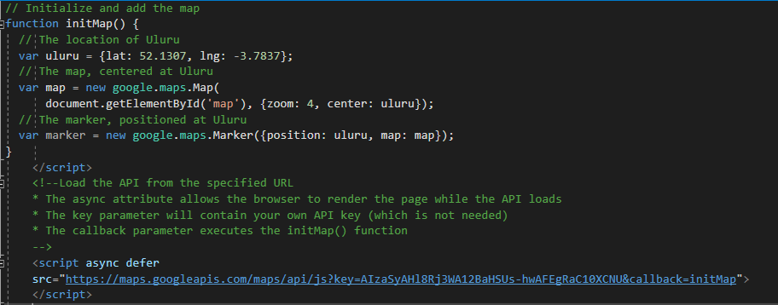

The ULRU is basically strong the longitude and latitude of the location the student wants to store. The next part is creating a new map, with the 2 parameters zoom and center. Zoom means how far the map would show. And the second one is to where to put the point on the map.
Center uses the values of the longitude and the latitude given by the student and shows how the student implemented the given location the student is at which is wales. ‘Initmap’ is a function used, the student used Google map API to implement this map. This is because they have the appropriate steps to get google maps to work. The API key was provided by Google platform to run the map.

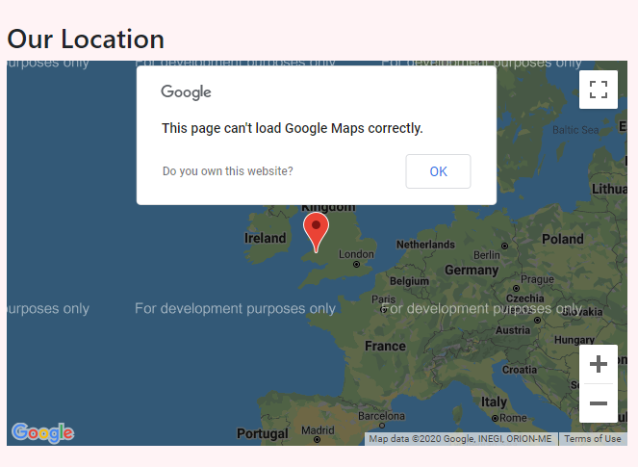

Conclusion
With thorough research the student has updated the report and has successfully implemented the required code for API and javascript. The website has been updated too with the correct coding to make website responsive and functional.

References

- https://kissflow.com/rad/types-of-application-development-methodologies/#
- https://shortiedesigns.com/blog/10-top-principles-effective-web-design/
- https://www.atinternet.com/en/glossary/mobile-first/
- https://www.uxmatters.com/mt/archives/2012/03/mobile-first-what-does-it-mean.php
- https://fabrikbrands.com/website-colour-schemes-colour-in-website-design/
- https://www.butterfly.com.au/blog/design/10-steps-for-better-website-navigation
- https://www.w3schools.com/bootstrap/bootstrap_modal.asp
- https://torquemag.io/2018/06/why-millions-of-developers-use-javascript-for-web-application-development/

