Hotel Placement - Hotel Administration & Leisure Club
Forest of Arden Marriott Hotel & Country Club
Department: Leisure Club
M4X01920_BIRM
Mubaraca Mombassa - 1905613

Week: 4
Work undertaken:
- Changing room checklist, (Female changing area & Male area)
- Daily Pool & Spa water testing sheet( how is done)
- Membership (number ,last name, first name, and client type)
- Daily Reception check list
- Photometer ( how is used and for what )
- Activities of Leisure club
- Visit all areas ( Fitness, Spa, swimming pool, jogging Room )
- Services, Treatments and Amenities

Self – Appraisal

Strengths:
When I meet the two members of staff at Leisure club I was in doubt about learn anything in Leisure club. First both of them are kindly and friendly with me . They answering all questions I have done to them and show me all areas of Leisure club such as swimming pool, fitness area, Spa tub area, Sauna and game room .I took the opportunity to write lots of notes, so I could easily explain to guest all the essential information, such as leisure time, family activities, swimming pool lessons , services, treatments and amenities. I also learn how to use a photometer, (A photometer is an instrument that measures the strength of electromagnetic radiation in the range from ultraviolet to infrared and including the visible spectrum. Most photometers convert light into an electric current using a photo resistor, photodiode, or photomultiplier.) I also learned that the pool test and spa are done from two and two hours.
Services, treatments and amenities leisure offers when you booking spa services such as
Services, treatments and amenities leisure offers when you booking spa services such as
- Body scrubs
- Eye treatment
- Manicures/pedicures
- Waxing
- Body wrap
- Facials
- Lip treatments
- Massages
- Couple’s massages
- Fitness classes
- Makeup services
Since I start my placement and meet with the two members of staff at Leisure club, my journey was amazing, confident and interacting with the staff of Leisure and I knew there was always a member of the Leisure team available to ask if I have any queries. Welcome to members and guests. I learned also how the Micro opera system of the Leisure club is managed, I checked and, I saw if the guest was a member or not Forest of Arden Marriott Hotel, I learn how to providing information and give them towels. Finally, I learned about the times and days of activities at the Leisure club.
Weaknesses:
My struggle in the leisure club was to understand how to do a pool test and Spa tub. But with the help of a member of staff, I learned how to fill the daily pool & Spa water testing sheet. I took a lot of notes and pictures so I can use in future .I struggled to deal with the photometer, the instrument that measures the strength of electromagnetic radiation in the range from ultraviolet to infrared and including the visible spectrum. My solution to this is just to try to book more hours with the manager of the Leisure club to understand and gain more experience.
Lost Opportunities
I cannot highlight any opportunities lost In those hours I had with them. They were true professionals, patience, helpful and when carrying out a task or any information, so I could understand and see how it was done and then look to do that task myself next time.
Plans for next week
- Meet with the manager of Housekeeping
- Find my rota and days of placement

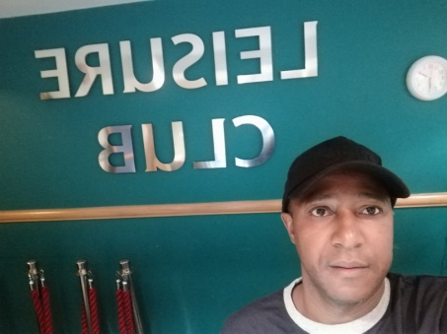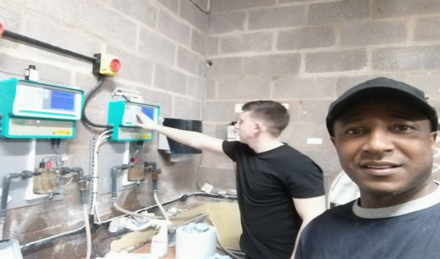

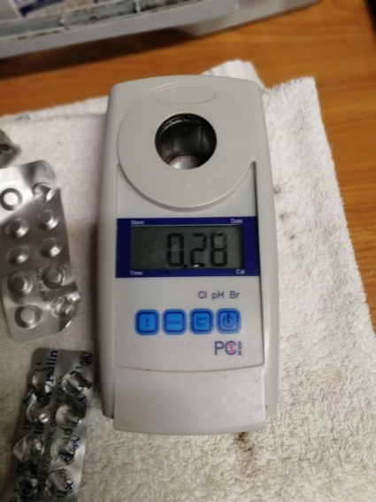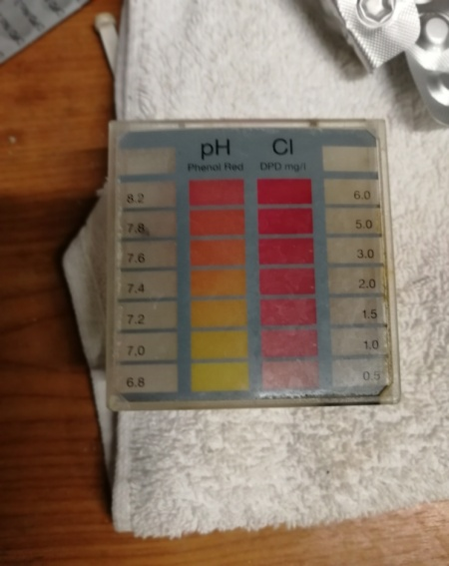

PHOTOMETER

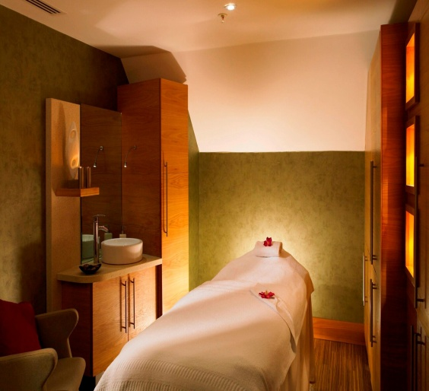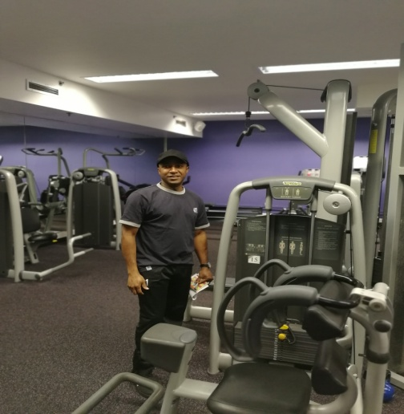
SPA Fitness....

