ASSESSMENT
Portfolio Report on Contemporary Software Applications for Business

4/11/2026

Module NaMe: Software solutions for business
Module Code: ACCA 4026
Lecturer: Kwame Assa Agyei
Student Name: Ozan YAKARYILDIRIM
Student Number: 2530090
Group :3

Trinity saint david University of Wales (London Campus)



Table of Contents
Introduction 1
Task 1. e-Commerce Website builders or software solutions 1
1.1 Shopify 1
1.2 Wix 2
Task 2. Mind-map of contemporary software applications 2
a. Mind mapping and explain the benefits of using mind mapping in business operations 2
b. Create a mind map of contemporary software applications 4
Task 3. Office Applications 4
a. Four office software solutions for business operations 4
Introduction 4
MS Word 5
MS PowerPoint 6
MS Excel 7
MS Access 9
b. Practical demonstration of Two Office Features 10
Mail Merge 10
If Statement 15
Task 4. Communication and Collaboration applications 16
a. One contemporary Communication and one Online Collaboration applications/tools 16
MS Outlook 16
MS Teams 16
b. One feature of a freely available Communication (1) and one feature of a Collaboration (1) application 17
MS Outlook 17
Ms Teams 19
Conclusion 20


Introduction
In today’s digital business environment, software applications play a key role in improving productivity, communication, and decision-making. Organisations rely on various digital tools to manage operations efficiently.
This report explores different software solutions used in modern businesses, including e-commerce platforms, mind mapping tools, office applications, and communication systems. It also includes practical demonstrations to show how these tools are applied in real-life scenarios.
The aim of this assignment is to analyse how these technologies improve workflow, collaboration, and organisational performance.

Task 1. e-Commerce Website builders or software solutions

1.1 Shopify

Shopify is a well-known platform that focuses mainly on online selling. It is used by millions of businesses around the world, from small shops to large companies [1]. The system is created to help users manage every part of their online store in one place.
With Shopify, store owners can upload products, control stock levels, follow customer orders, and handle payments easily. The platform supports many payment options, including cards and digital payment systems, which makes shopping safe and comfortable for customers [1]. It also provides tools for shipping and delivery management.
One strong advantage of Shopify is its large collection of apps and plugins. These extra tools help businesses improve marketing, customer communication, and store performance. Another useful feature is multi-channel selling, which allows companies to sell not only on their website but also on social media and other marketplaces [2]. This can increase visibility and sales. Moreover, Shopify is suitable for growing businesses because it can handle more products and customers over time.
On the other hand, Shopify can be more expensive compared to other website builders. Users must pay monthly fees, and some advanced tools cost extra money. Beginners might also need some time to understand all the features. Still, Shopify is considered a strong and professional choice for serious e-commerce businesses. Shopify is more suitable for businesses that aim for long-term growth.

1.2 Wix
Wix eCommerce

Wix is another popular solution that started as a general website builder and later added online selling features [3]. It is especially preferred by beginners and small business owners because it is very simple to use.
The biggest benefit of Wix is its drag-and-drop editor. Users can design their website visually by moving elements like text, images, and products without any coding knowledge [3]. There are many templates available, which helps users create modern and attractive websites quickly.
Wix offers important e-commerce functions such as adding products, managing inventory, receiving payments, and setting shipping options. It also includes basic marketing and search engine tools to help websites reach more customers online. In addition, Wix is usually more affordable and easier to set up than Shopify.
However, Wix may not be the best option for large businesses. It has fewer advanced features and less flexibility for complex stores. Therefore, it is more suitable for small or medium-sized shops.

Task 2. Mind-map of contemporary software applications

Mind mapping and explain the benefits of using mind mapping in business operations

Mind mapping is a visual technique used to organize ideas and information. A mind map begins with one central topic written in the middle of a page. From this central

idea, related points are connected with branches [4]. Each branch shows a sub-topic that is linked to the main subject.
Mind mapping is different from traditional note-taking. In normal notes, information is written in paragraphs or lists. In contrast, a mind map shows relationships between ideas in a visual and structured way [4]. Because of this, mind mapping is often used in education, project planning, brainstorming, and business management.
Today, many contemporary software applications allow users to create digital mind maps. Tools such as XMind, MindMeister, and Miro make it possible to design mind maps online [5]. These applications allow teams to work together in real time, even if they are in different places.
One important benefit of mind mapping in business operations is better organization. Managers can write the main project goal in the center and add tasks, deadlines, and responsibilities as branches. This makes complex projects easier to understand.
Another advantage is improved problem-solving. When a company faces a problem, the main issue can be placed in the center of the map. Possible causes and solutions can then be added as branches. This method encourages creative thinking and helps teams explore different ideas before making decisions [4]. I believe mind mapping is especially useful for planning and teamwork in modern organisations.

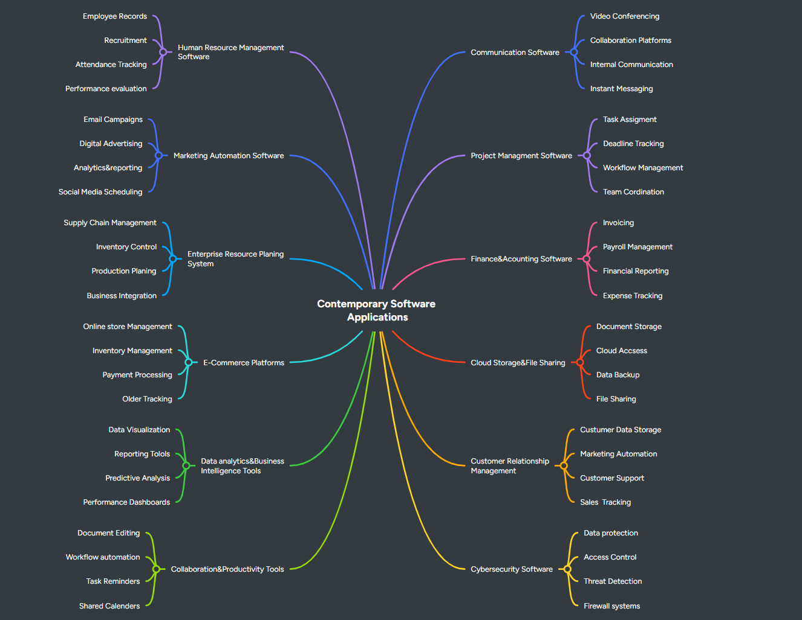
Create a mind map of contemporary software applications

Task 3. Office Applications

Four office software solutions for business operations

Introduction
In modern organisations, digital technologies play a central role in managing information and supporting business operations. Companies rely on office software to create documents, analyse data, store records and present ideas clearly. Office applications help businesses improve efficiency, communication and decision-making by allowing employees to manage information in a structured and organised way.
Among the most widely used office tools are Microsoft Word, Microsoft Excel, Microsoft PowerPoint and Microsoft Access. These applications are part of the Microsoft Office suite and are used in many organisations worldwide. Each program supports a different type of task. For example, Word is used for creating documents, Excel is used for analysing numerical data, PowerPoint is used for presenting information visually, and Access is used for managing databases [1].
Businesses depend on these applications to perform everyday tasks such as writing reports, analysing financial information, presenting project results and maintaining organisational records. Another important advantage of office software is that these tools can work together. For instance, data created in Excel can be inserted into Word reports or PowerPoint presentations. This integration improves productivity and allows organisations to manage information more efficiently [2].
This report discusses four important office applications used in business environments: Microsoft Word, Microsoft Excel, Microsoft PowerPoint and Microsoft Access. The essay explains the key features of each program, the benefits they provide to organisations and the limitations that businesses should consider when using them.


MS Word
Microsoft Word is one of the most widely used word-processing applications in the world. It allows users to create, edit and format text-based documents such as reports, letters, contracts and academic papers. Businesses use Word extensively because it enables employees to produce professional documents quickly and efficiently.

Microsoft Word interface and document formatting tools
Major Features
One of the most important features of Microsoft Word is its advanced text formatting capabilities. Users can change fonts, adjust paragraph spacing, apply headings and modify page layouts. These tools allow documents to appear more organised and professional.
Word also provides built-in templates that help users create documents quickly. Templates are available for reports, business letters, resumes and meeting agendas. This feature saves time because users do not need to design the document layout from the beginning.
Another useful feature is the spelling and grammar checking system. This tool automatically identifies mistakes and provides suggestions to improve writing quality. As a result, documents become clearer and more accurate.
Word also supports the insertion of visual elements such as tables, charts and images. These elements help present information more effectively and improve the overall readability of the document.
In addition, Microsoft Word includes collaboration features such as Track Changes and comments. These tools allow multiple users to edit and review the same document while keeping track of modifications. This function is especially useful when teams work together on reports or business proposals [3].
Benefits in Business
Microsoft Word provides several advantages for businesses. First, it enables organisations to produce professional documents quickly. Companies often use Word to prepare reports, letters, proposals and internal documentation.
Second, Word supports collaboration between employees. Documents can be shared through cloud platforms such as OneDrive or SharePoint, allowing team members to work on the same file simultaneously.
Another benefit is its ease of use. Most users can quickly learn the basic functions of Word, which reduces training time and improves productivity.
Limitations
Despite its advantages, Microsoft Word has some limitations. Advanced formatting tools may require practice for beginners to use effectively. In addition, documents containing large numbers of images or complex formatting may sometimes reduce software performance.
Another limitation is that organisations generally need a paid licence or subscription to access the full version of Microsoft Word [4]


MS PowerPoint
Microsoft PowerPoint is a presentation software used to create visual slideshows for meetings, training sessions and conferences. It helps presenters communicate ideas clearly by combining text, graphics and m ultimedia elements.
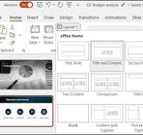
Microsoft PowerPoint presentation slides

Major Features
PowerPoint provides a wide range of design templates that help users create professional presentations quickly. These templates include predefined slide layouts, fonts and colour schemes.
Another important feature is multimedia integration. Users can add images, videos, audio files and charts to their slides. These elements make presentations more engaging and easier to understand.
PowerPoint also allows users to apply animations and slide transitions. These features control how information appears on the screen and can help emphasise important points.
The presenter view feature allows speakers to see their notes and upcoming slides while the audience only sees the current slide. This function helps presenters deliver information more effectively.
Benefits in Business
PowerPoint helps businesses communicate complex ideas more clearly. Visual elements such as diagrams and charts simplify complicated information and make it easier for audiences to understand.
Another advantage is improved audience engagement. Visual presentations are generally more interesting than text-based explanations. As a result, PowerPoint is commonly used for training sessions, marketing presentations and project reports.
Limitations
However, PowerPoint also has some disadvantages. Slides containing too much text or excessive animations may confuse the audience. Additionally, presentations often rely on the presenter’s explanation, meaning slides alone may not fully communicate the message

MS Excel
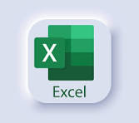
Microsoft Excel is a spreadsheet application used for organising, calculating and analysing data. It is widely used in business environments for financial analysis, budgeting, data tracking and reporting. Excel stores data in rows and columns, which allows users to organise large amounts of information efficiently.

Major Features

One of the most powerful features of Excel is its ability to perform calculations using formulas and functions. Users can apply functions such as SUM, AVERAGE and IF to analyse data automatically. This reduces manual calculations and improves accuracy.
Excel also allows users to create charts and graphs. These visual tools transform numerical data into visual representations such as bar charts, line graphs and pie charts. Visualising data makes it easier for managers to identify patterns and trends.
Another important feature is PivotTables. PivotTables allow users to summarise and analyse large datasets quickly. Businesses often use this feature to generate reports and analyse performance data.
Excel also includes sorting and filtering tools that allow users to organise data and locate specific information within large spreadsheets.
Benefits in Business
Microsoft Excel provides many advantages for organisations. One of the most important benefits is its ability to support data analysis and decision-making. Businesses use Excel to analyse sales data, monitor expenses and forecast financial performance.
Another advantage is flexibility. Excel can be used for many different purposes including project management, inventory tracking and payroll calculations.
Excel also helps organisations create visual dashboards and reports. These visual summaries allow managers to understand business performance more easily.
Limitations
However, Excel also has some limitations. Large spreadsheets may become difficult to manage if they contain very large datasets. Additionally, errors in formulas can lead to incorrect results if they are not carefully checked.
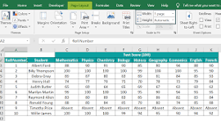
Excel is also not designed for managing complex relational databases or supporting many simultaneous users. In such situations, database systems such as Microsoft Access may be more appropriate [5].

Microsoft Excel spreadsheet and data analysis tools

MS Access

Microsoft Access is a database management system designed to store and manage structured information. Unlike spreadsheet software, Access is used to organise data in relational databases.
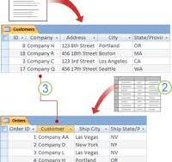
Microsoft access database tables and relationships

Major Features
One key feature of Microsoft Access is its relational database structure. Data is stored in tables that are connected through relationships. This helps maintain organised records and prevents unnecessary data duplication.
Access also provides query tools that allow users to retrieve specific information from the database. Queries help businesses analyse data and generate useful insights.
Another feature is the use of forms. Forms provide a user-friendly interface for entering and editing data. This makes database management easier for employees.
Access also includes reporting tools that allow organisations to generate structured reports based on stored data.
Benefits in Business
Microsoft Access is useful for managing large amounts of structured data. Businesses use it to store customer records, employee information, inventory data and sales records.
Another advantage is improved data organisation. The relational structure allows organisations to maintain accurate records and reduce errors.
Access also supports multi-user access, allowing several employees to update and retrieve information from the same database.
Limitations
Despite its usefulness, Access also has limitations. It is not as powerful as enterprise database systems such as SQL Server when handling extremely large datasets. In addition, designing databases and creating queries may require technical knowledge

Practical demonstration of Two Office Features

Mail Merge
Title | First Name | Last Name | Student Number | Class | Adress | Post Code
Mr | John | Malkovich | 546879 | A-1 | Kings road 147 | KM54HM
Miss | Elizabeth | Sason | 457722 | A-1 | Metro road 55 Flat1 | Me47SE
Mrs | Torera | Silva | 258411 | C-3 | Kaleken street 89 | SE45TE
Mr | Osimen | Cimbom | 571002 | B-1 | Ramspark 01 | TR90TR
Mr | Icardi | Cimbom | 000112 | B-2 | Ramspark 02 | TR90TR

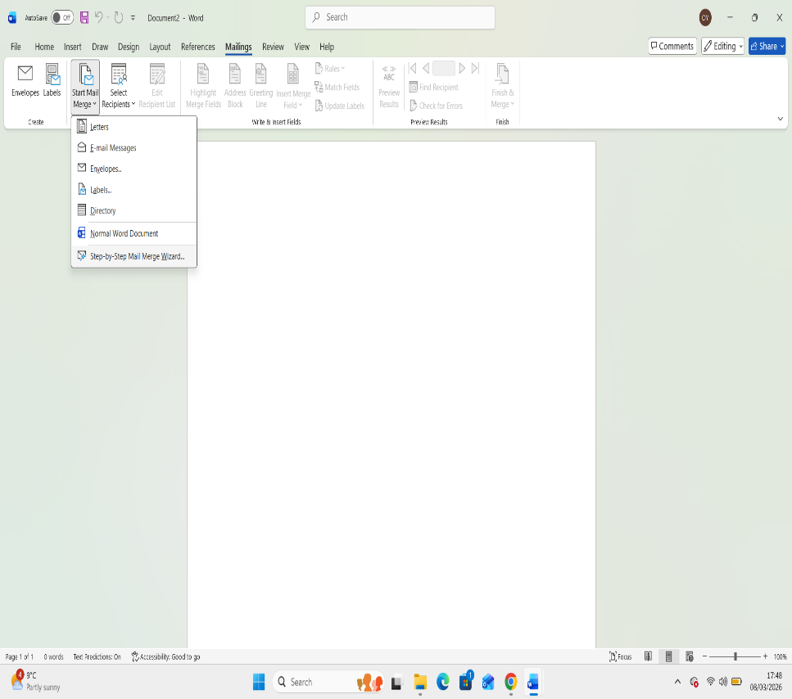
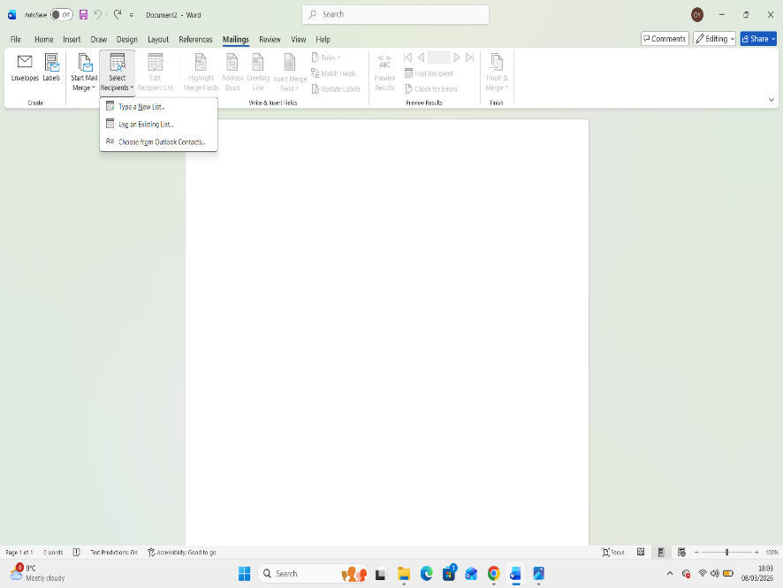

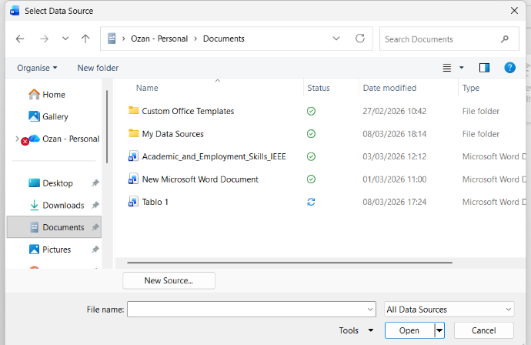

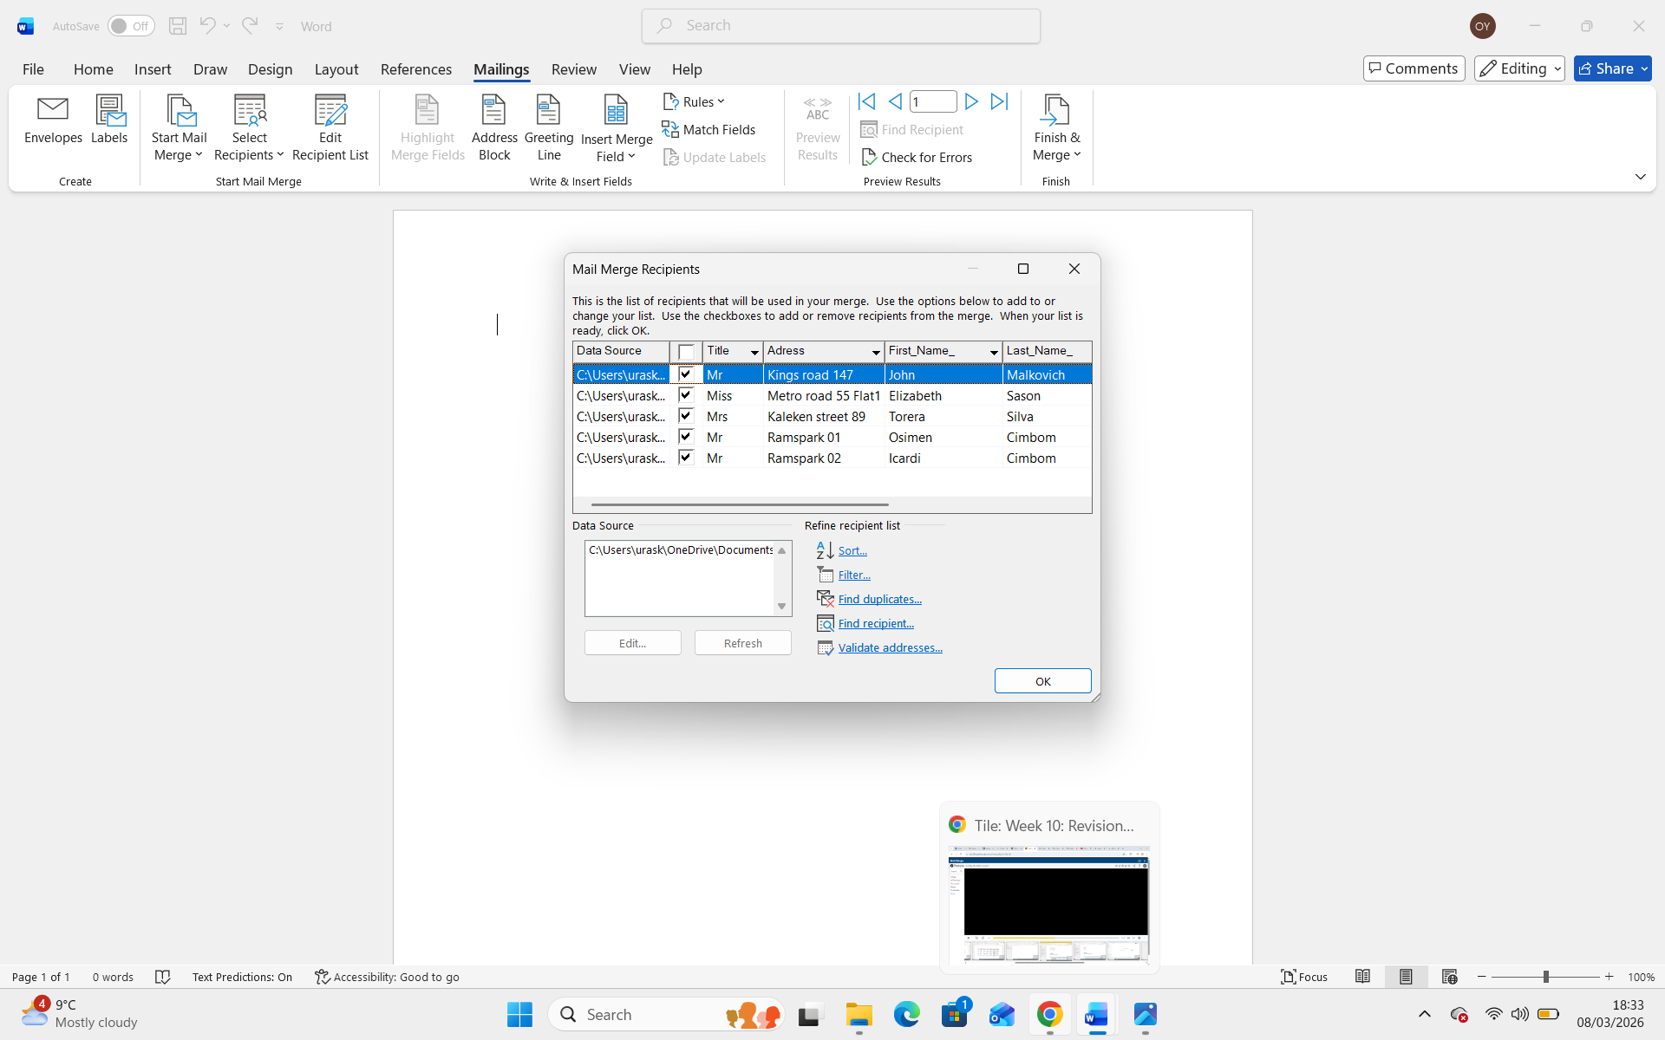

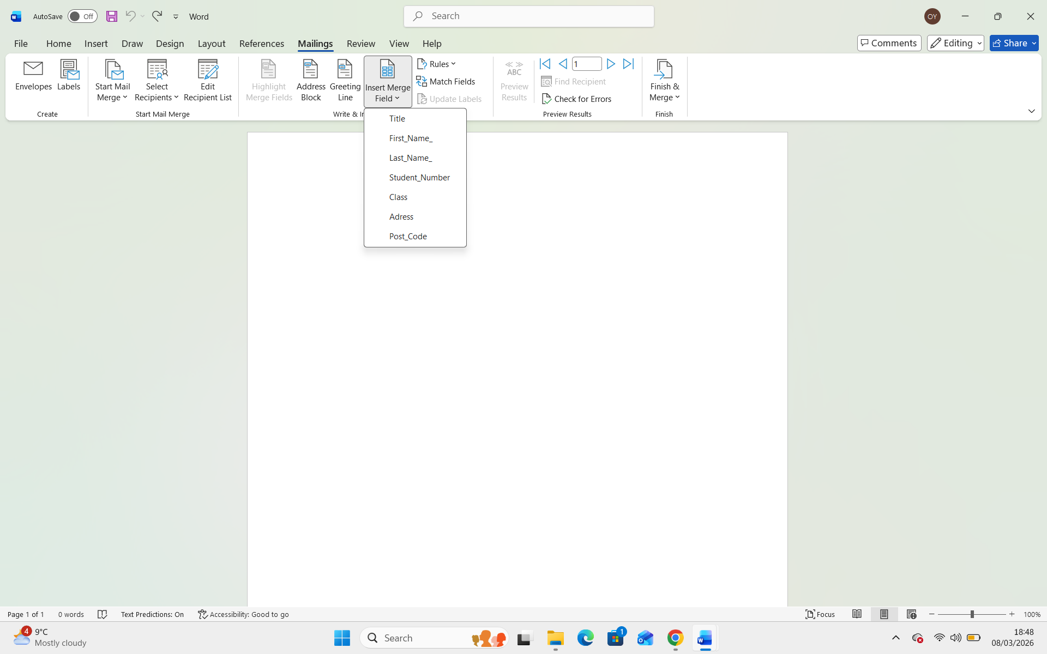

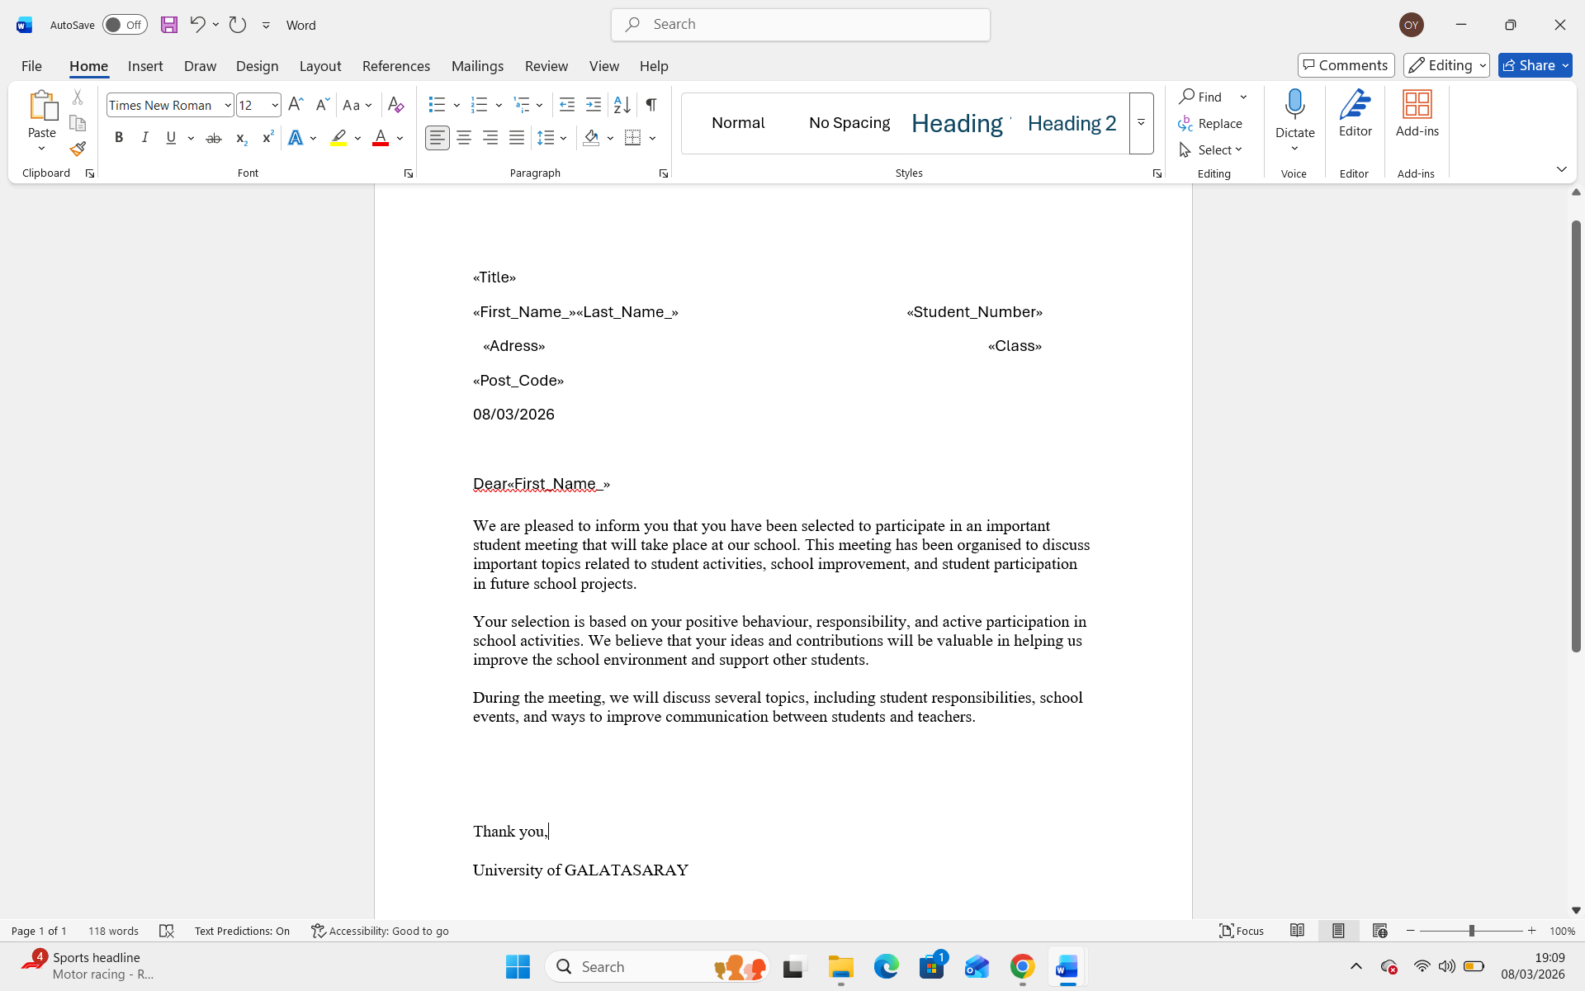

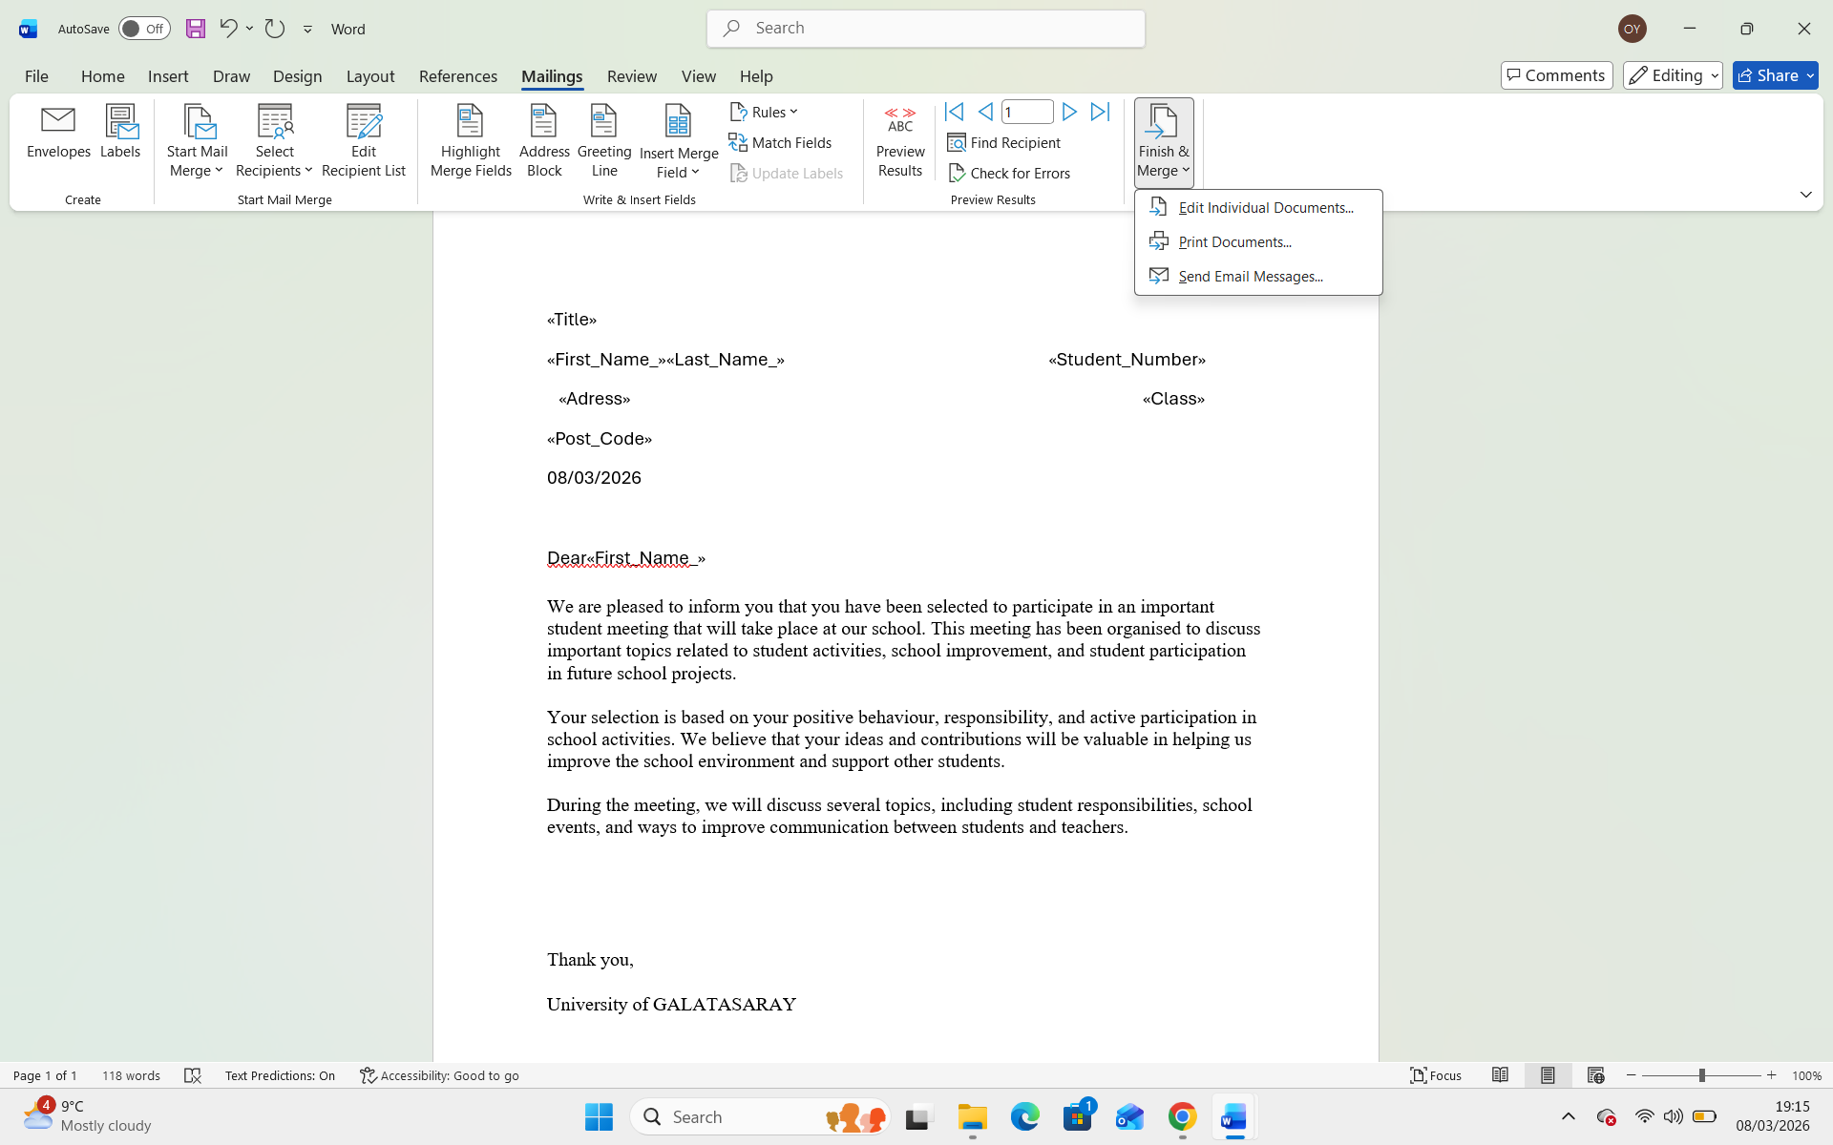

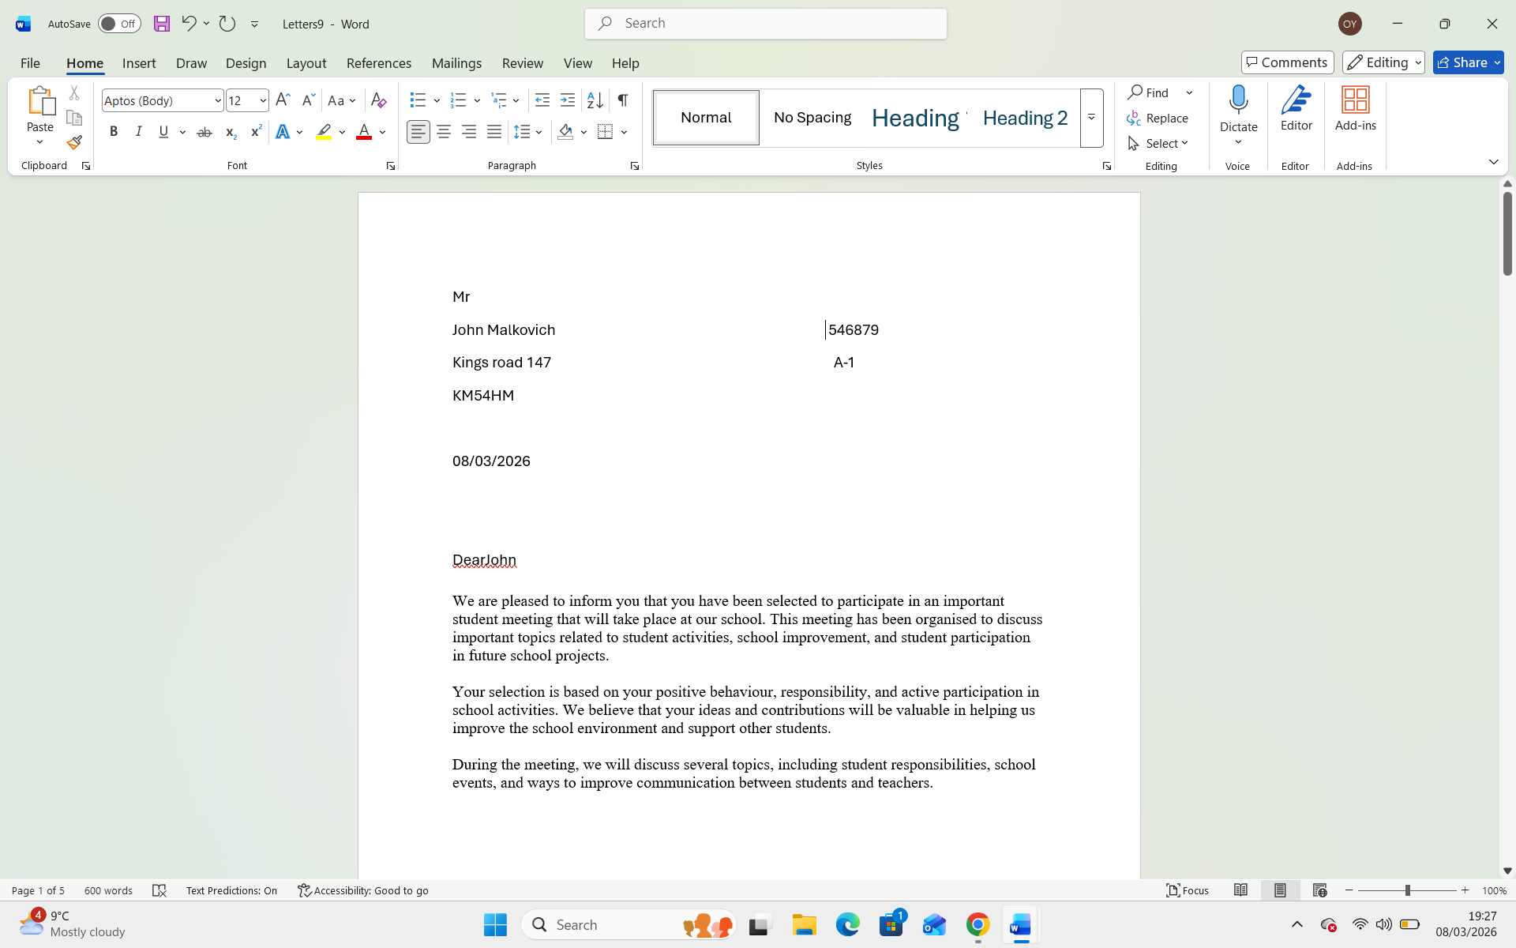

If Statement
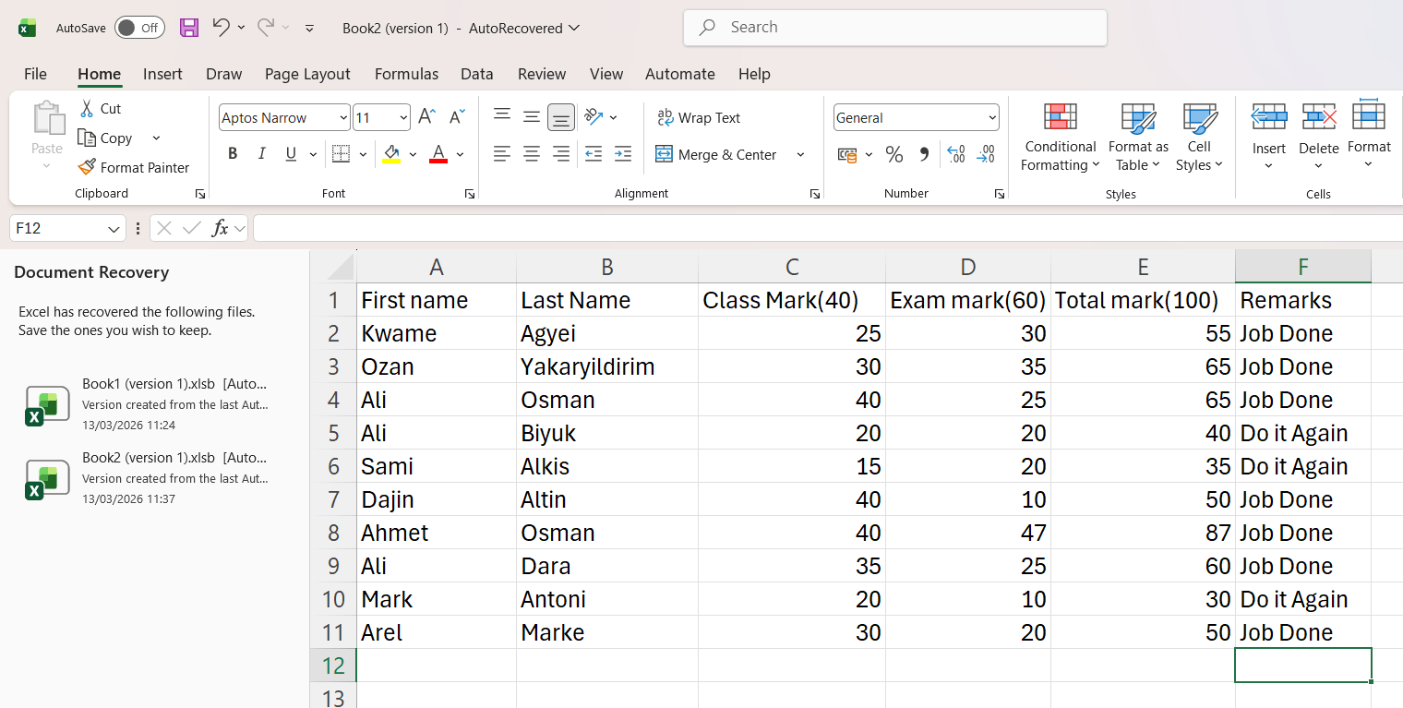
This screenshot shows a dataset created in Excel, including student names and their marks, which is used for data analysis.

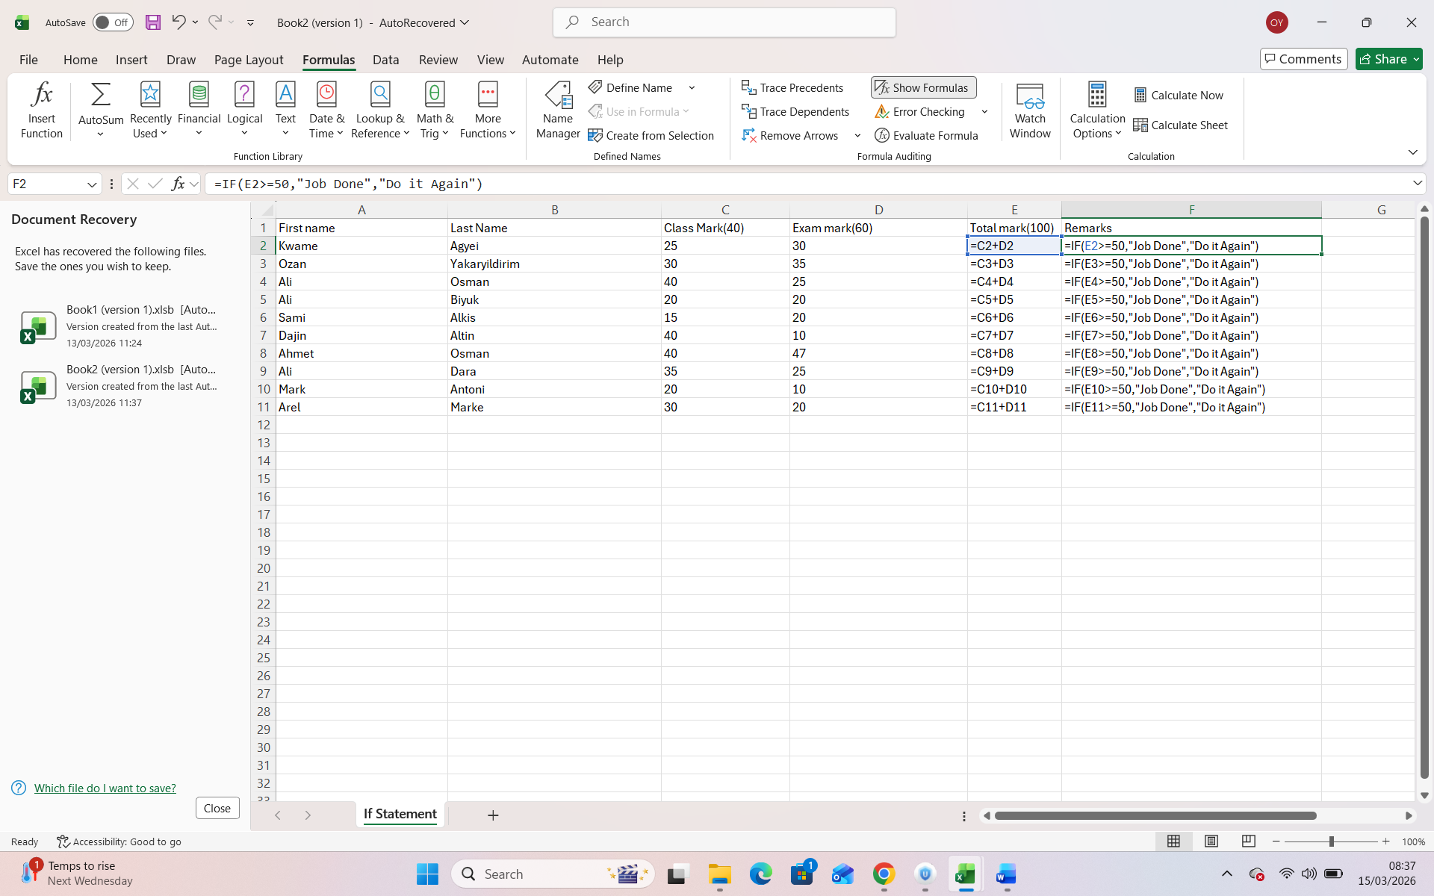
Applying IF function to generate remarks

Task 4. Communication and Collaboration applications

One contemporary Communication and one Online Collaboration applications/tools

MS Outlook
Microsoft Outlook, created by Microsoft, is one of the most commonly used tools for professional communication in modern organizations. Although it is mainly known as an email application, it also includes several additional features that support daily business activities, such as calendar management, task tracking, and contact organization.
One of the key strengths of Outlook is its ability to organize emails efficiently. Users can create folders, apply categories, and use filters to manage incoming messages. This is especially useful in busy work environments where a large number of emails are received daily. In addition, the search function makes it easy to find specific emails or documents within seconds, which improves productivity.
Another important feature is the built-in calendar. Outlook allows users to schedule meetings, set reminders, and manage their time more effectively. For example, meeting invitations can be sent directly through the system, which helps teams coordinate their availability. From my perspective as a computing student, this feature is very helpful for managing deadlines and group work.
Outlook also works well with other Microsoft tools such as Word and Excel. This makes it easier to share documents and collaborate with others in a more structured way. Furthermore, it includes security features like spam filtering and data protection, which are important in professional environments.
In terms of analysis, Outlook is highly suitable for formal communication because it keeps records of conversations and maintains a professional tone. However, it is not always the fastest option for quick discussions, especially when compared to instant messaging tools. Overall, Outlook remains a reliable and essential communication tool in modern business settings.

MS Teams
Microsoft Teams is a collaboration platform developed by Microsoft as part of the Microsoft 365 suite. It is designed to support teamwork by combining communication, file sharing, and collaborative tools in a single platform. It is widely used in businesses, educational institutions, and organizations worldwide.
One of the main features of Microsoft Teams is its real-time communication capability, which includes chat, voice calls, and video conferencing. This allows team members to communicate instantly, regardless of their location. Teams also supports large virtual meetings, making it suitable for remote work and online collaboration.
Another important feature is file collaboration. Users can upload, share, and edit documents directly within Teams using Microsoft Office applications. This enables multiple users to work on the same document simultaneously, improving efficiency and reducing the need for email exchanges.
Teams also provides channels and team spaces, where projects and discussions can be organized. This structure helps teams stay focused and ensures that information is easy to access. Additionally, Teams integrates with various applications, allowing users to manage tasks, track progress, and automate workflows.
From an analytical perspective, Microsoft Teams is highly effective for collaboration because it brings multiple tools together in one platform. It supports both communication and teamwork, making it a comprehensive solution for modern organizations. However, some users may find it complex due to the wide range of features available.
In conclusion, Microsoft Teams is a powerful collaboration tool that enhances teamwork and productivity. Its ability to combine communication, document sharing, and project management makes it an essential tool in the modern business environment.

One feature of a freely available Communication (1) and one feature of a Collaboration (1) application

MS Outlook

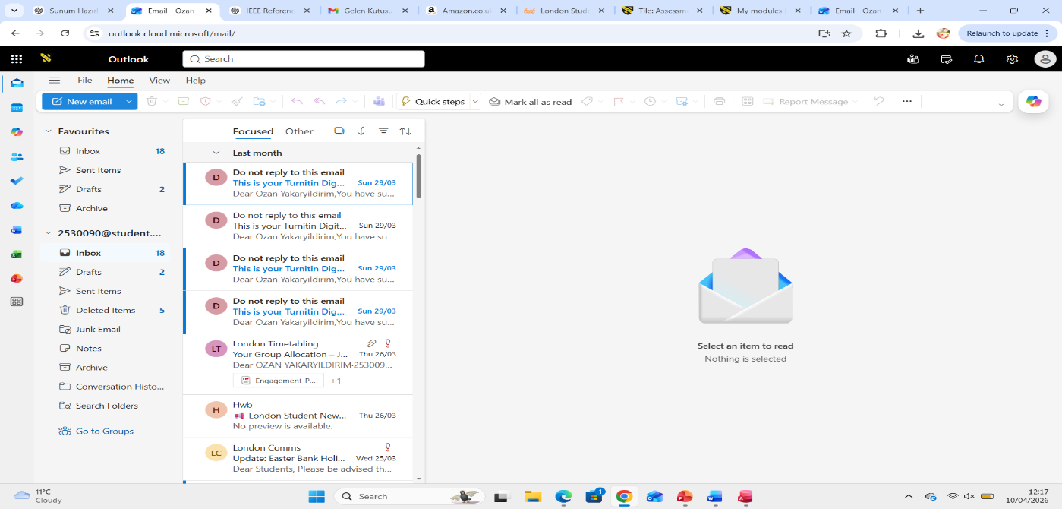

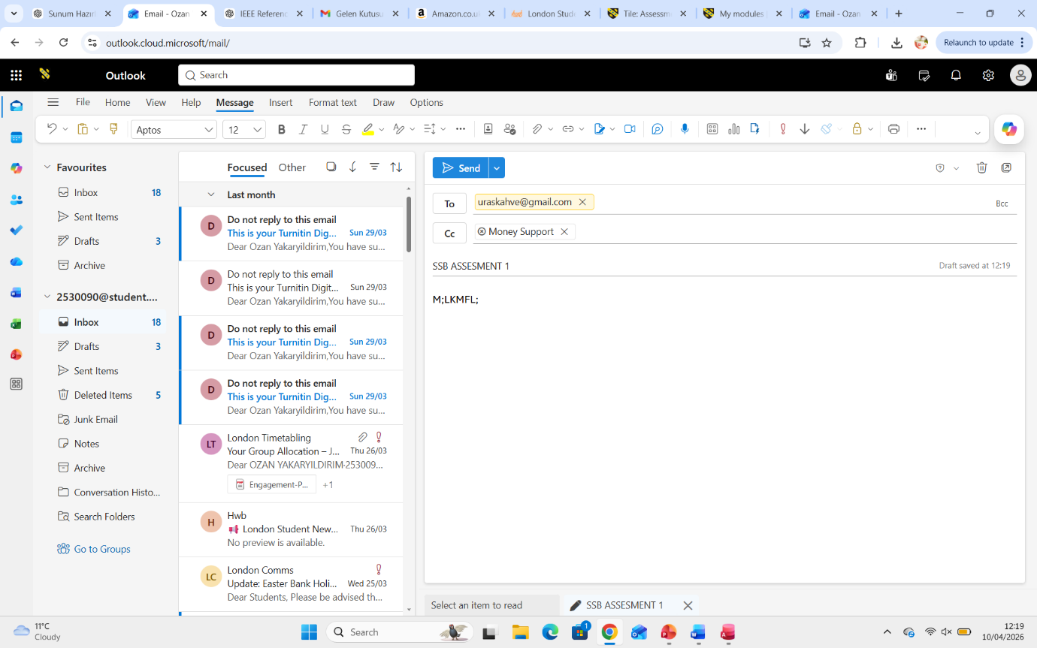
Sending an email in Outlook ;
To test a communication feature, I used Microsoft Outlook to send an email. First, I opened the Outlook application and selected the “New Email” option. Then, I entered the recipient’s email address, added a subject, and wrote a short message. After that, I clicked the “Send” button to deliver the email.
This feature demonstrates how Outlook supports professional communication by allowing users to send messages quickly and efficiently. It also shows that emails can be structured and formal, which is important in business environments

Ms Teams
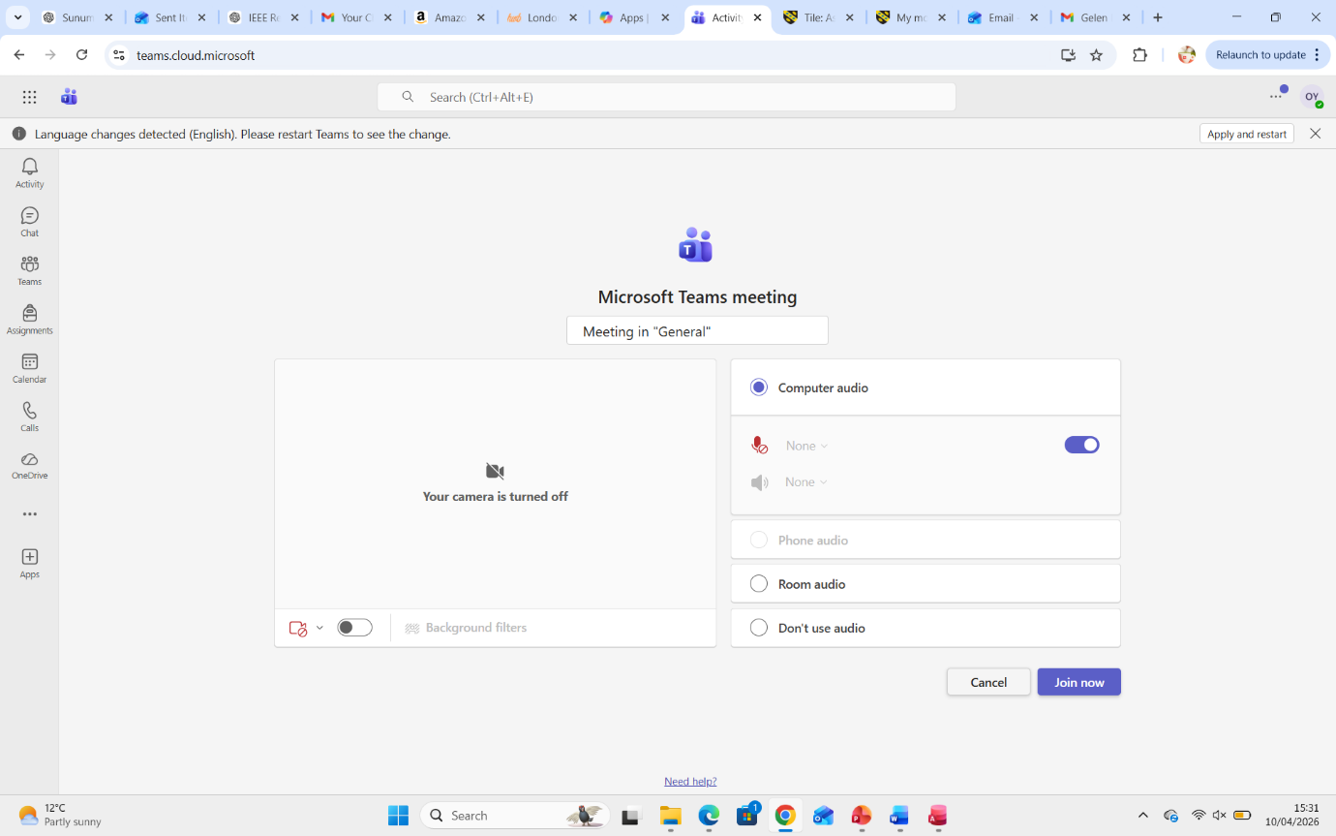This example illustrates the use of Microsoft Teams for virtual meetings, enabling effective communication between team members.

This screenshot shows the Microsoft Teams channel interface where users can start conversations and communicate with team members.

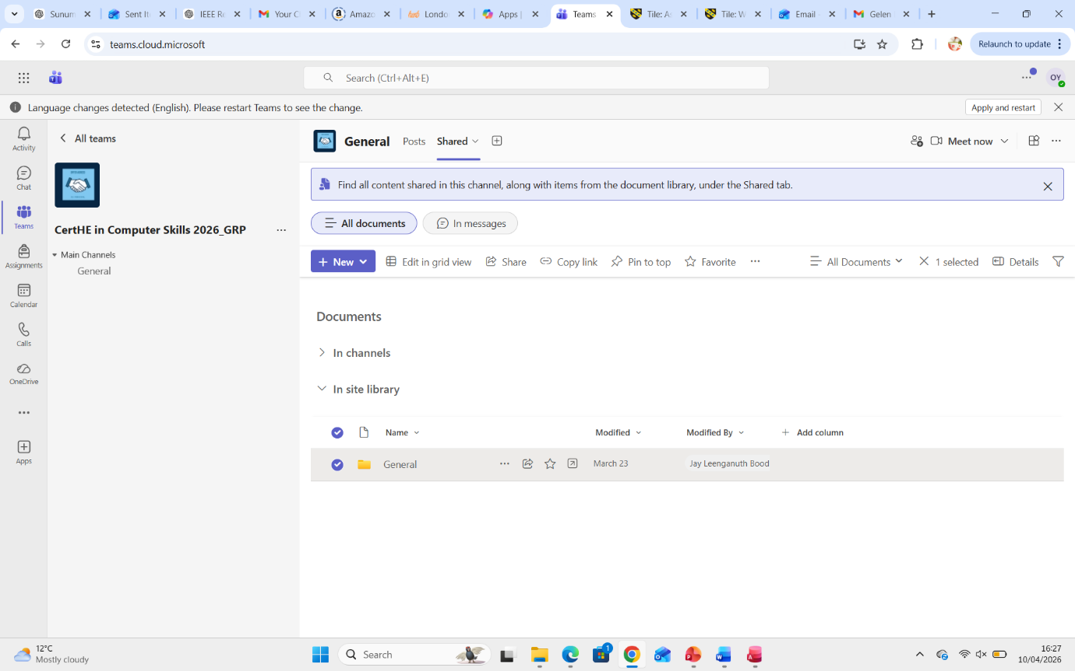
This screenshot shows the shared documents section in Microsoft Teams, where files are uploaded and accessed by team members for collaboration.

Conclusion
Office applications play a crucial role in supporting modern business operations. Microsoft Word, Excel, PowerPoint and Access each provide different functions that help organisations manage information effectively.
Word supports professional document creation, Excel enables data analysis and financial calculations, PowerPoint improves communication through visual presentations and Access provides structured database management. Together, these applications create a powerful system for creating, storing, analysing and presenting information in organisations.
Although each program has certain limitations, their combined use significantly improves productivity, collaboration and decision-making in the workplace. For this reason, office applications continue to be essential tools in modern organisations.

References
[1] Shopify Inc., "About Shopify," 2024. [Online]. Available: https://www.shopify.com
[2] Shopify Inc., "Sell Everywhere," 2024. [Online]. Available: https://www.shopify.com/sell
[3] Wix.com Ltd., "Wix eCommerce Overview," 2024. [Online]. Available: https://www.wix.com/ecommerce
[4] T. Buzan and B. Buzan, The Mind Map Book. London: BBC Active, 2006.
[5] MindMeister, "Online Mind Mapping Tool," 2024. [Online]. Available: https://www.mindmeister.com
[6] Microsoft, "Microsoft 365 Overview," 2024. [Online]. Available: https://www.microsoft.com
[7] Microsoft Support, "Office Applications and Collaboration Tools," 2024. [Online]. Available: https://support.microsoft.com
[8] The Knowledge Academy, "Features of Microsoft Word," 2023. [Online].
[9] Business.com, "Advantages and Limitations of Microsoft Word," 2023. [Online].
[10] Microsoft, "Microsoft Outlook and Teams Overview," 2025. [Online].
[11] Wikipedia, "Microsoft Outlook," 2025. [Online]. Available: https://en.wikipedia.org/wiki/Microsoft_Outlook
[12] Wikipedia, "Microsoft Teams," 2025. [Online]. Available: https://en.wikipedia.org/wiki/Microsoft_Teams

