Workshop and Practice-Coursework 1
Technical Report

Due: Sunday 3rd December 2023

Module: ACHA4011 Workshop and Practice

Name: Cody Surridge. Student Number:2304028

Lecturer: Kerry Tudor

Contents Page

- Introduction (Page 3)
- Chapter 1: Health and Safety with Risk Assessments (Page 4)
- Chapter 2: Engineers’ Role in Society (Page 5)
2.1-what is an engineer.
2.2-engineers’ responsibility to sustainability.
- Chapter 3: Problem Solving (Page 6)
- Chapter 4: Team Structure (Page 7)
- Chapter 5: Personal Development Plan (Page 8)
- Conclusion (Page 9)
- Reference List (Page 10)

INTRODUCTION
This report will be covering relevant Health and Safety Legislations which affect what Personal Protection Equipment (PPE) should be worn for an activity as well as determining the risk level of that activity. Additionally, the organisations that publish the code of conduct an engineer should follow and the responsibility and engineer will have to overcoming sustainability and environmental issues. This will also show how an engineer could overcome different problems during all stages of development. Then it will also be covering how a team structure may positively and negatively affect a team of engineers. And finally, a personal development plan.
Chapter 1: health & Safety

An activity that we have done is preforming a strip down and rebuild of an engine. This has involved working in a workshop environment and therefore having to wear suitable PPE. The suitable PPE “has to be assessed in the context of various "suitability" and "quality" criteria; for example, it must be capable of fitting the wearer correctly” (Co, M. &.,1993). The PPE that was required was wearing suitable Steel-capped footwear. This is due to the main risk/potential to harm yourself was by dropping heavy metal components on the floor and therefore your feet. In contrast, for an activity such as drilling holes in a material or sanding a material down you would be required to wear your steel-capped shoes, a pair of safety goggles and an overcoat/coverall as well as any suitable ventilation requirement or face masks.

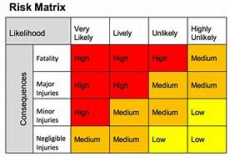

The activity above has a medium to low risk. This is because, if we are sensible and use the tools in their intended way there should be little to no risk involved during the full duration of the task. However, for the times where tools may not be used correctly the risk is increased as there is the constant threat of harm being delt to yourself and others due to the lack of control when using the tools. Another threat is when you get substances like oil on your hands which remove grip when using the tools and carrying objects which could be heavy and damage your feet if dropped upon. Despite this this can be mitigated by either washing your hands or wearing a suitable pair of gloves.
Chapter 2: engineers’ role in society.
2.1- What is an engineer?
An engineer is a person who builds, designs or maintains engines, machines or structures. However, an engineer is also a person who controls an engine such as on an aircraft or a ship. As a result of this, engineers are expected to work at a high level and therefore must ensure they follow a suitable code of conduct or ethics such as when “In 2005 the Royal Academy of Engineering and the Engineering Council (EC) jointly created a statement of ethical principles to guide engineering practice and behaviour” (EC,2005/2017). This the goes onto state that their fundamental principles are “honesty and integrity”, “Respect for life, law, the environment and public good.”, “accuracy and rigour” and “leadership and communication”. This shows that an engineer must first and foremost attempt to follow these guidelines when fulfilling any task. Additionally, this means an engineer must know how to protect the environment while simultaneously develop a world that will benefit humanity in a way that doesn’t cause any harm to people.

2.2- an engineer’s responsibility to sustainability
An engineer must be able to know how all their actions will positively and negatively affect the environment to gain the ability to help drive forward the development of human inventions through sustainable methods. This can be learnt and demonstrated in a variety of ways such as ensuring roads are built in areas where there is little to no plant or animal life, or a motorsport engineer developing alternative fuels for an engine to reduce overall CO2 emissions. Furthermore, a motorsport engineer must learn how to reuse and recycle different components and parts to reduce the quantity of wasted materials and therefore reducing the total volume of waste.

Chapter 3: problem solving.
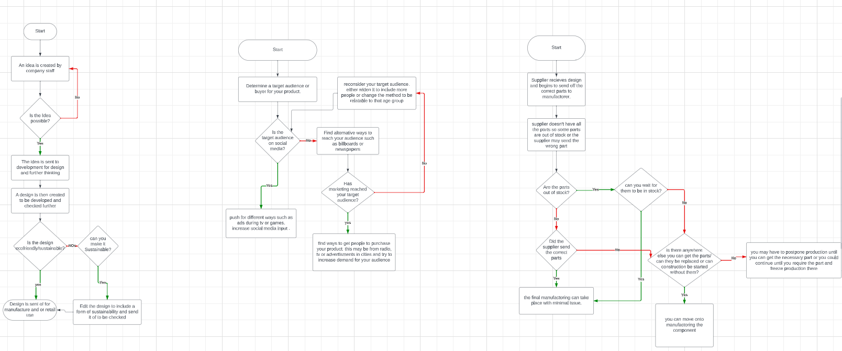
Flow diagram from to left to right of a sustainability issue during development, an issue during marketing and a supplier issue.

Issues during development can include a variety of things including measurements being incorrect meaning that the output of the design may have to be delayed correcting measurements and ensure that other errors are corrected. Another issue could be that the surrounding location may not be able to accommodate a product meaning that you would have to think about how to put it into a location like a city where you would have to think about plumbing, closing roads or how it fits on the road and the emissions that are produced and the environmental effect they may have.
Issues during marketing can occur when the marketing isn’t good enough. For example, if you are marketing for the older generation, they may not be on social media so you may want to target your marketing on things like radio, newspapers and billboards. Whereas, if you were to target the younger audience you would put a higher emphasise on social media and other ways such as TV adverts.
A supplier issue during production is if the supplier doesn’t have all the parts needed to complete construction. This can be resolved by deciding if you can wait by either delaying starting until you have the part available or continuing until you need the part and stopping there. This would then require “coordination and communication between the buyer and supplier, especially for problems that create a significant disruption to production or quality” (Clemons, R., Baddam, S. R., & Henry, R. M. (2021)) to avoid issues during the process Another way to resolve this would be to go to a different supplier if they have the required part, however you would have to consider if there is an increased cost or accommodating the delay getting the part.

Chapter 4: team structure
Time work in team:
For a Team to be successful it must have a clear structure. This means that all people within the team must have a clear understanding of a leader. This is so that they know who they can report to if there are any issues and so they have a person they can report to as well as pass on any requests such as days off. Another important area in a team structure is that everyone in the team gets along with one another. This will encourage productivity as well as increase efficiency as everyone knows each other and have the basic understanding of how to work with one another. However, “organizational structure is not just a question of optimization of organizational service production. Service teams’ decision-making configuration is also critical to developing innovation” ( Vendrell-Herrero, F., Bustinza, O. F., & Opazo-Basaez, M. , 2021).
Positives:
- Clear communication between each other
- Productivity is greater.

Negatives:
- Leader may become lazy or complacent.as may command people below them to do all work
- People may begin to take liberties if they are too relaxed with one another.
Images
Chapter 5: personal development plan

Name – Cody Surridge
Degree – motorsport engineering
Previous Qualifications – A-levels, GCSEs
Begin to have experience working in a professional motorsport setting.
Continue to enjoy motorsport and working with it

Short Term Goals (0 to 5 years)
Pass my degree.
Have a deep understanding of how and why different aspects of motorsport work.

Goal | Objective | Resources Required | Measurement | Target Date
Pass my degree. | Obtain a strong passing grade throughout my course. | Myself, and the ability to learn and use any info learned | I will have the degree | 3 years
Have a deep understanding of how different aspects of motorsport works. | To learn, understand and reuse what I learn during my course |  | I will be able to re-explain different areas to other people as well as begin to use what I learn in a real setting | 3-5 years
Have experience in a professional working motorsport setting. | To experience working in a professional team and help to develop and improve | Degree to prove proper qualifications and knowledge | I will have been working for a motorsport company for a few years to extend basic practical knowledge | Abou 6 or 7 years
To be able to enjoy motorsport while working in it | To continue to love motorsport and not lose the ability to follow it while working in it | The will to keep continue enjoying and working in motorsport | I will continue developing and understand motorsport while continuing to enjoy it. | 5+ years
Previous Experience –
Conclusion

To conclude, an engineer has many different roles in society nowadays including a responsibility to health and safety where an engineer must understand the risks involved while preforming any task from working in a workshop to managing an engine on a car where you must think about emissions wear and reusability. An engineer also has a responsibility to help protect the environment. This can occur by an engineer considering materials and their reusability and where they come from, as well as, understanding the emissions that are released during all stages of development.
Furthermore, an engineer must be able to confidently tackle and solve problems during all stages of development including, marketing where issues may occur because of not meeting the correct audience, initial design where measurements and surrounding location must be accounted for and production where suppliers may not have the required part.
And finally, an engineer must be able to work well in a team. This involves being able to follow commands from a leading person but also having the ability to share any issues they may have and work closely with one another.

Reference list:

- Clemons, R., Baddam, S. R., & Henry, R. M. (2021). Factors influencing swift and effective resolution of supplier problems. International Journal of Productivity and Performance
- Co, M. &. (1993). Health and Safety: 1993. Facilities (Bradford, West Yorkshire, England), 11(7), 11–17.
- Engineering Council, Statement of Ethical Principles. Available at: Engineering Council (engc.org.uk). Accessed 24th November 2023..
- Vendrell-Herrero, F., Bustinza, O. F., & Opazo-Basaez, M. (2021). Information technologies and product-service innovation: The moderating role of service R&D team structure. Journal of Business Research, 128, 673–687.

