

Obstacle detection software for the visually impaired

By: James Harrison Morgan

Supervisor: Dr. Michael Dacey

Submitted in Partial Fulfillment of the Requirements for the master’s degree in software engineering.

University of Wales Trinity Saint David

January 2020

DECLARATION

I, James Harrison Morgan declare that I am the sole author of this Project; that all references cited have been consulted; that I have conducted all work of which this is a record, and that the finished work lies within the prescribed word limits.

This has not previously been accepted as part of any other Masters' submission.


Signed :

Date: 31/02/2020

FORM OF CONSENT

I James Harrison Morgan hereby consent that my Project, submitted in candidature for the MSc Software Engineering (Web Development), if successful, may be made available for inter-library loan or photocopying (subject to the law of copyright), and that the title and abstract may be made available to outside organisations.

Signed

Date 31/02/2020

Abstract

Autonomous vehicles are a current popular discussion in the world of software engineering with the development of cars that can self-park, self-drive and navigate being the tip of the autonomous iceberg.

This project’s aim was to conduct an investigation to determine appropriate research and testing strategies, to develop a minimal viable product for a pair of assistive glasses which aid the blind.

To this end, the objectives span from background research into self-driving cars and target audiences, through to design, development, testing and summarising the products practicality.

In other words, the user would need a device which would allow them to move in a similar way that an autonomous car would park on the roads.

Prior to device construction full understanding of the target audience was needed. By following an experimental research strategy, which is a hybrid between waterfall and agile methodologies, the project dedicated time to understanding the user and the challenges their conditions presented.

Testing was a vital part of the report; as the device needs to be tested for real life capabilities, comparison against current methods and further improvements. The chosen approach to achieve this was moderated in-person testing.

The major findings were that the glasses could be used for obstacle detection at varying heights. In addition to this, the target audience and test subjects all concluded that the device could make their lives easier to live.

Deliverables included two glasses. One of which could sense obstacles at head height while the other could detect obstacles at waist or foot level.

Concluding on the project, the device can make a difference, the advantage of this association between the glasses and the autonomous vehicle field is the potential development in both areas. As self-driving vehicles become more advanced so do the use cases for future models of the glasses.

Acknowledgments

The report recognises and thanks the following people who have assisted or participated in the project:

- Dr. Michael Dacey (Final supervisor).
- RNIB for assistance is participant gathering.
- Wayne Morgan for mechanical and weighting advice.
- Victoria Morgan for aesthetic advice.
- Participants who took part in questionnaires, interviews and testing.

Contents
Acknowledgments iii
List of Tables ix
Chapter 1: Introduction 1
1.1 Introduction to the problem 1
1.2 Aim and objectives 2
1.3 Purpose of the study 3
1.4 Research questions 3
1.5 Rationale, relevance, and significance 4
1.6 Assumptions, limitations, and delimitations 5
Chapter 2: Literature review 7
2.1 Background information on blindness 7
2.2 Current Technology to aid the partially blind and fully blind in daily life 8
2.3 Subject background 9
2.4 Research into testing 12
2.5 Background information on animals and ultrasound 15
Chapter 3: Research methodology 18
3.1 Research methods available 18
3.11 Delphi method 18
3.12 Research onion 19
3.13 Chosen methodology 21
3.2 Target population and recruitment 23
3.3 Sampling 23
3.4 Focus groups 24
3.5 Questionnaires 24
3.6 Online interviews 25
3.7 Role-play 25
3.8 Testing 26
Chapter 4: Development methodologies and product design 27
4.1 Methodology explanation 27
4.2 Chosen methodology for project 30
Chapter 5: Requirements analysis 32
5.1 Description of the sample 32
5.2 Detailed analysis 32
Chapter 6: Design 36
6.1 Hardware design 36
6.2 Software design 41
Chapter 7: Implementation and testing of the prototypes 43
7.1 Implementation of prototype one 43
7.2 Testing and analysis of prototype one 43
7.3 Stage two implementation of prototype one 46
7.4 Stage two testing of prototype one 46
7.5 Implementation of prototype two 47
7.6 Testing and analysis of prototype two 47
7.7 Stage two implementation of prototype two 49
7.8 Stage two testing of prototype two 49
Chapter 8: Results of comparison 51
Chapter 9: Conclusion and discussion 54
9.1 Discussion of the results in relation to research questions 54
9.2 Discussion of the results in relation to the literature 55
9.3 Implication of results 55
9.4 Recommendations for further research 57
9.5 Summary of conclusion 58
References 59
Bibliography 69
Appendix A: Research methodology and definitions 70
A.1 Credibility 70
A.2 Transferability 71
A.3 Dependability 71
A.4 Confirmability 72
A.5 Ethical issues 72
A.6 Researcher's position statement 73
A.7 Conflict of interest assessment. 73
Appendix B: Analysis of questionnaires and online interviews continued 74
Appendix C: Additional research methodology (design thinking) 77
Appendix D: Hardware continuation 78
Appendix E: Recommendations for further research 80
Appendix F: Participant raw data collection 83
F.1 Subject A’s questionnaire raw data 83
F.2 Subject B’s questionnaire raw data: 86
F.3 Subject C’s questionnaire raw data: 89
F.4 Subject D’s questionnaire raw data: 91
F.5 Subject E’s questionnaire raw data 94
F.6 Online interview raw notes with subject A: 97
F.6 Online interview raw notes with subject B: 99
F.7 Online interview raw notes with subject C: 103
F.8 Online interview raw notes with subject D: 105
F.9 Online interview raw notes with subject E: 108
Appendix G: Code for the BATGLASSES M1 and M2 112
G.1 Code for basic sensor test using Arduino and pins. 112
G.2 Original code for M1. 113
G.3 Amended code for M1. 115
G.4 Original code for M2. 117
G.5 Amended code for M2. 119

Table of Figures

Figure 1: Figure of the UltraCane [49]. 8
Figure 2: Figure of the eSight glasses [50]. 9
Figure 3: Figure of autonomous technologies [23]. 10
Figure 4: Delphi process [87]. 19
Figure 5: Figure of the research onion [55]. 21
Figure 6: The twelve agile principles [58]. 27
Figure 7: Scrum process [59]. 28
Figure 8: Software development life cycle [63]. 29
Figure 9: Waterfall method which can be found from [8]. 30
Figure 10: Glasses used to make the BATGLASSES [17]. 36
Figure 11: Image of the seeeduino for the BATGLASSES [16]. 37
Figure 12: Image of an ultrasonic sensor [13]. 37
Figure 13: Sensors used to alert device owner [14]. 38
Figure 14: Sketch of the BATGLASSES M1. 39
Figure 15: Key displaying the labels for nose guard and seeeduino. 39
Figure 16: Sketch for BATGLASSES M1 Version 2. 40
Figure 17: Sketch for the BATGLASSES M2. 41
Figure 18: Photo of the BATGLASSES M1. 44
Figure 19: Photo showing flip up functionality. 44
Figure 20: Photo of the BATGLASSES M2 48
Figure 21: Scatter diagram showing the halting distance from the obstacle for different devices. 51
Figure 22: Figure of design thinking approach [69]. 77
Figure 23: Grove jumper cables [15]. 78
Figure 24: Base shield used to host grove components [18]. 79
Figure 25: Grove speaker used for alternative notification [19]. 79
Figure 26: Figure of lane control assisting a car around a corner taken form [33]. 81
Figure 27: Figure of lane control assisting a car into a narrower lane taken from [33]. 81
Figure 28: Figure of subject A's questionnaire response (page 1) 83
Figure 29: Figure of subject A's questionnaire response (page 2) 84
Figure 30: Figure of subject A's questionnaire response (page 3) 85
Figure 31: Figure of subject D's questionnaire response (page 1) 91
Figure 32: Figure of subject D's questionnaire response (page 2) 92
Figure 33: Figure of subject D's questionnaire response (page 3) 93
Figure 34: Figure of subject E's questionnaire response (page 1) 94
Figure 35: Figure of subject E's questionnaire response (page 2) 95
Figure 36: Figure of subject E's questionnaire response (page 3) 96
Figure 37: Figure of subject E's questionnaire response (page 4) 97
Figure 38: Authors notes of subject A's interview response (page 1) 97
Figure 39: Authors notes of subject A's interview response (page 2) 98
Figure 40: Authors notes of subject A's interview response (page 3) 99
Figure 41: Authors notes of subject B's interview response (page 1) 100
Figure 42: Authors notes of subject B's interview response (page 2) 101
Figure 43: Authors notes of subject B's interview response (page 3) 102
Figure 44: Authors notes of subject B's interview response (page 4) 103
Figure 45: Authors notes of subject C's interview response (page 1) 104
Figure 46: Authors notes of subject C's interview response (page 2) 105
Figure 47: Authors notes of subject D's interview response (page 1) 106
Figure 48: Authors notes of subject D's interview response (page 2) 107
Figure 49: Authors notes of subject D's interview response (page 3) 108
Figure 50: Authors notes of subject E's interview response (page 1) 109
Figure 51: Authors notes of subject E's interview response (page 2) 110
Figure 52: Authors notes of subject E's interview response (page 3) 111

List of Tables

Table 1: Table of test results. 51

Chapter 1: Introduction

1.1 Introduction to the problem
In the advancing software engineering and technological world, there are several assistive devices and methods which help the mobility and living challenges that are presented to those with physical ailments.
Examples of these include walking sticks for limps, wheelchairs for partial paralysis and stair lifts to aid transport between levels.
To the contrary, the visually impaired mainly rely on the traditional walking canes, guide dogs and guides for travel, movement and general day-to-day obstacles or activities [1].
The risk associated with these forms of travel assistive methods can be severe, as the user is exposed to the dangers of their surrounding environments without being able to visually pinpoint or track the risks.
Hence, it is not surprising that a member of the community who is unable to see has inherent risk of being knocked down, suffer from tripping or can injure themselves on pavement obstacles, in addition to variable environmental factors [2].
This issue currently posed to the blind community was noted by the author through the observation of a public member in their home, work and social settings pre-project conceptualisation.

Public members in question consisted of blind passer-by’s who found it difficult to navigate a new building to which they were unfamiliar, resulting in distress of the individual and intervention from surrounding public members.
The ideal finished minimal viable product of this project is to develop a set of glasses complemented with audio responses to detect obstacles in front of the user.
To narrow the understanding of what this means, the device will be able to use buzzer responses to notify users of dangers in the same manner that a self-driving car alerts a driver to an upcoming hazard when parking.
In addition to this safety aspect, the glasses will need to be practical in guiding participants through unfamiliar buildings.
The drive behind this is that users who enter familiar areas already understand their environment. However, when placed in a new or unfamiliar setting, a person can become disorientated with the lack of environmental understanding.

1.2 Aim and objectives

The overarching aim of this project is to develop a set of glasses that will assist travel by calculating distances in front of the user and notifying them of the risk. Thus, this will reduce consequential danger or misdirection.
The project’s aim can be followed by four objectives:
- Background research - Investigation into why the device is needed, concepts of self-driving vehicles, testing and approach methodologies.
- Collection of data from target community.
- Design, implementation and testing cycle for assistive devices.
- Analysis and conclusion on results of the devices.
To explain the above objectives in further detail, the report will need to develop an understanding of their target audience and the concepts involved with self-driving vehicles parking assistance.
This will enable the creator to cement the requirements, concepts and practicalities of the device.
Achieving the first two objectives will be possible through literature reviews, research from the industries and data collections methods.
Role-playing as a blind person, will equip the project will the correct physical, social and emotional requirements that the glasses will need.
The third stated objectives of the project relate to preparing the device construction, building the device to meet the minimal satisfactory model and ensuring the glasses are ready through field testing.
The final highlighted area of work is to conclude on the appropriateness of using the device. This ensures the project has value for current and future use.
As an additional elaboration, once the base device has been tested and assuming the MVP is reached i.e. the glasses can detect walls and notify users dynamically, the device will then be improved by providing detection of chairs, tables and litter while investigating alternative sound prompts.
Testing will need to satisfy several criteria. These would range from whether the device fulfils safety requirements, user requirement and provides a beneficial difference to the blind parties.
To understand the reasoning behind choosing glasses, the project wishes to highlight the familiarity associated between a blind person and glasses. The familiarity should encourage a smoother transition for the target audience.

The final item on the checklist is the conclusion. The device must be evaluated for benefits in real life situations, business value and evaluated for advantages or disadvantages when compared to current mobility methods employed by the users.

1.3 Purpose of the study
The motivation behind this, is to bring the traditional travel methods used by the visually impaired community into a more modern solution.
As an additional encourager the civil service who employ the author, clearly wish to ensure their workforce represents the disabled population [3].
This statement is further supported by the quote which states the civil service objectives to “support disabled staff networks across government and contribute to corporate activities” [3]. Similarly, this view is also shared by the local government association [4].
As it stands, there are no major current assistive methods for the blind incorporated into the government buildings [4].
From personal review, the author noticed the complex layout of the DVLA building would confuse a poor sighted person. Further, partial and no sighted employees found the area disorientation and daunting.
Issues like this will cause obstruction to smooth production flow in the workplace; therefore, another purpose of this study is to break down “the barriers facing people with disabilities and to suggest ways in which these and related concerns can be changed” [3].

1.4 Research questions

The research questions for this project are outlined as follows:

- How can glasses be made to assist the blind community?

- How can the glasses be tested?

- Can the assistive glasses provide a difference in stopping distances and general use for the visually impaired?

The initial question will address the objective to provide an understanding into what the user needs and how it can be constructed.

Repeated design and testing of the device will be a necessity to ensure the product is consistently developing and improving to suit the growing technology field and changing demands of the user.

Comparison between the product and current methods would need to be undertaken to ensure assistive methods can cooperate. This can be achieved through experiment and reviews.

If unfamiliar places provide difficulty for blind people to transverse, the third question is appropriate to provide concrete evidence that these glasses will in fact make a difference to stopping distances and reduce the anxiety of unfamiliar places.

To ensure the use case for the author’s employer is satisfied the glasses must be tested in the DVLA grounds, this will provide an employee with a more dependable form of navigating the large and complex layout of the main site Swansea office.

1.5 Rationale, relevance, and significance

The ethos behind this project is not for monetary or prestige gain. In other words, this is not a commercial product.

Additional reasoning behind this device is the social and practical impact it will have on the blind community. This idea was developed from a simple event witnessed by the author that evolved into a more compassionates desire to make a difference.

Further fuelling this focus was the data collection through role-play (see chapter three).

By experiencing a mock version of the small minority groups daily struggles really encouraged the need to fulfil this project and see its potential come to realisation in the technology community.

Rewording this philosophy, the objective is not to make a product just to satisfy the standards for a MSc, but to open educational doors and perspectives into the potential that this field of study has.

The relevance of this momentum cannot be overstated enough, as the proposal of this report discovered a severe lack of assistive aids to help the visually impaired especially in the technological world [8].

Hence, the significance that these glasses will make includes safety improvements, social extensions, project wide extensions and realisation of the need for change.

The nature of this study will involve some questionnaires, focus online groups and controlled experiments through role play and supervised walkabouts.

To be more concise, the first form or user requirement setting will be running a survey using charities as a source of participants.

Completed surveys and interviews will then be collected and the raw data will be used to specify the requirements and best course of action for the device MVP.

The controlled role play experiment will involve the author placing themselves in a similar situation the users face every day both inside the familiar home environment and in external unfamiliar grounds.

Experiments will provide valuable insight for further understanding the complexities behind the planning and designing of the glasses.

1.6 Assumptions, limitations, and delimitations

Project scope needs to be optimally refined for the product to be finished within the time scale available. For this reason, there are several assumptions that need to be stated, which are as follows:

- The project assumes that the glasses will be used solely for their intended purposes i.e. each device model will be used for their stated functions.

- The glasses will be used as an additional assistive method and will not replace traditional methods.

- The requirements received from sources feedback is unbiased and reliable.

Limitations will become apparent in this project; the difficulty of the disability means that improper testing on actual blind people would be unethical and risky.

However, this will have a knock-on consequence, the devices will not be tested by their intended target, meaning the project may never know if the objective is fully successful and all research questions are answered.

Considering these points, the author has decided to test the glasses on real life people who are not fully inhibited by blindness i.e. partially sighted users.

This is to ensure the project remains within the ethical boundaries of its scope while attaining useful and relevant feedback.

A second limitation is the power source for this device. Continuous running of a sensor and Arduino would be a large drain on the battery.

Due to the power concerns, it is wise for the MVP to have a larger battery which will be wired to the glasses and stored in a backpack or shoulder strap. This can then be attached to the device in later versions as part of an upgrade to the visual aid.

Chapter 2: Literature review

In this chapter, the report will cover background information on the blind target audience, self-driving vehicles, testing methodologies and investigation into ultrasound and experimentation with bats and whales.

2.1 Background information on blindness

According to [93], there is an estimates 285 million blind people in the world. Of this estimate there almost 2 million blind people who live in Britain [94].

As stated by [95], blindness does not just cover the patients who cannot see at all. Blindness refers to the “loss of vision that cannot be corrected with glasses or contact lenses” [95].

To narrow the scope of what blind is the report states that if someone’s sight, is below the value 20/200 they are classified as blind [95].

Referring to [95] sight loss can be categorised into three labels:

- Partial Blindness – blurry or incomplete sight.
- Total blindness – no light perception.
- Complete blindness – cannot see anything including light.

From reading [96] and from general knowledge, partial and complete blindness can be caused by a wide range of sources these include but are not limited to:

- Injury to the eye
- Diabetes
- Glaucoma
- Macular degeneration

Eye injury can come from a few causes these range from power tools to chemical damage. Damage to the skin, nerves or structure of the eye can cause blindness [99].

Low insulin levels are the prominent side effect of the disease called diabetes. The disease can cause diabetic retinopathy which in turn can cause eye deterioration [98].

Glaucoma is the condition associated with pressure build up in the eye [96]. Pressure build up inflicts damage to the nerve between the eye and the brain, this can develop slowly over several years and result in blurry vision [97].

Age is also a consideration in diagnosing blindness, age related macular degeneration is where the objects such as straight lines become blurred or wavy, colours become brighter and objects become smaller [100]. Eventually, if left untreated macular degeneration will cause a black hole to appear in the middle your vision [100].

2.2 Current Technology to aid the partially blind and fully blind in daily life

Aside from traditional methods like guide dogs and walking canes aside, there are some other services available to the blind community.

One such example of technology for fully blind users is the ‘UltraCane’ [49] seen in figure 1 below. The UltraCane, uses ultrasound to detect objects at head, waist and foot level [49]. UltraCane, will then give a response to the user using vibration [49].
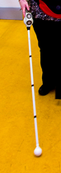
Figure 1: Figure of the UltraCane [49].
Meanwhile partially blind users have the option to use glasses called ‘eSight’ (shown in figure 2 below) [50] which provide a video feed of their surroundings and adapts the picture for objects close or far away [50].

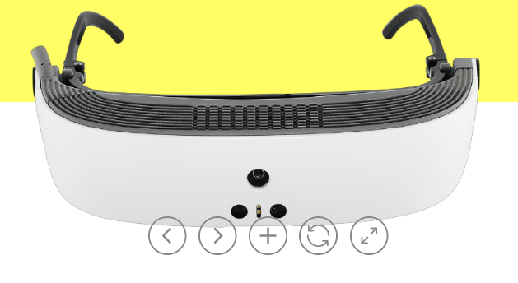
Figure 2: Figure of the eSight glasses [50].

In other words, the eSight glasses allow the user to see close and far objects on a video screen in front of their eyes using live feed cameras [50].

For text reading, the OrCam is a popular option, the device allows users who are blind to scan text. This text is fed back verbally [51].

In more detail, an extra feature is the glasses are also able to identify products and people’s faces using a camera [51].

2.3 Subject background

Autonomous and self-driving vehicles can be a misleading statement with no clear and agreed definition [44]; therefore, the project requires some clarity as to what constitutes towards autonomous vehicles and their features.

According to the UK government self-driving cars are already on British roads to some degree [22]. Examples of autonomous features can be seen in figure 3 below which include adaptive cruise control, emergency braking and park assistance [22].

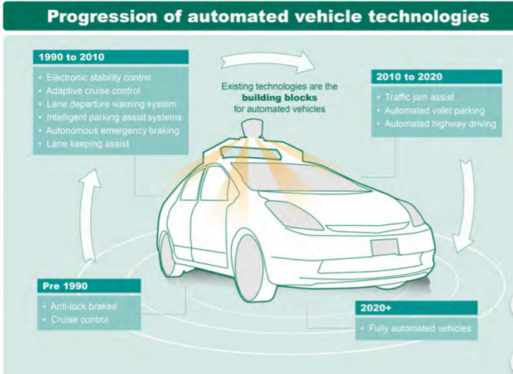
Figure 3: Figure of autonomous technologies [23].

To reduce the risk of confusion, the report states that vehicles with technologies shown in the above diagram defines different levels of autonomy with their predicted timelines [23].

To clarify further, according to [45], there are five levels of autonomous vehicle automation which are summarised below

- Level 0 (no Automation) – driver is in control of vehicle with no aids towards steering, accelerating or braking.
- Level 1 (Function-specific automation) – automation of control electronic stability.
- Level 2 (Combined Function Automation) – adaptive cruise control or lane assist are incorporated.
- Level 3 (Limited Self Driving Automation) – Vehicle can check surroundings and drive with minimal human involvement.
- Level 4 (Full Self-Driving Automation) – Vehicle self-drives and human has zero influence over driving capabilities.

Now self-driving vehicles have been defined within the scope of this project. There is a need to update the reader on the progress of the field.

As of 2019, level 3 has been attained with some achievement into level 4, while heavy research and development remains, this stage of automation is not yet on the road countrywide [39]. The developments of level three, include road mapping, parking sensors, machine learning and safety analysis [39].

Building on this, the most relevant development in autonomous vehicles to the device is parking sensors, which are mounted on the vehicle. These sensors emit ultrasonic pings, which alert the vehicle to distances from obstacles [40].

After extensive research, there has been some development in glasses for the blind.

The first case study the project will discuss is the device constructed in India [46]. This device is like the BATGLASSES idea in the sense that they use a single ultrasonic sensor and buzzer to beep at a user if an obstacle comes within 300cm [46].

Differences between this design and the BATGLASSES M1 and M2 counterparts will lie in the design blueprints and actual design use.

Specifically, the BATGLASSES will make use of sensors for side detections and the angled detection provides knee or foot level detection.

In addition to this, the glasses will provide an alternative response using speakers instead of buzzers.

Another case study example is the ‘Google glass’ [52]. Google glass is a device which can link to services like Aira and Siri [52].

Obvious advantages to this are the functionality where the device provides satellite navigation and voice search engine functionality [52].

Focusing on autonomous parking assistance, users may be familiar with the sensors and the applications involved. In other words, many cars have parking sensors fitted to them which integrate hazard detection or provide automatic parking [42].

Specifically, the closer to an object the car gets the faster and louder the notifications from the vehicle become. This is achieved by analysing and responding to the time of flight [38].

In self driving vehicles there is a combination of sensors used. These include ultrasonic, infrared, image-based and microwave sensors [41].

With more in depth reading, these sensors are not limited to distances between objects but assist in bounding boxes, obstacle direction, object acceleration and deceleration [41].

Hence, it is worthwhile to spend some time deliberating which sensor to use. Additionally, time needs to be set aside to decide what data the sensor needs to collect, along with a decision on how that data is then used.

Meanwhile, there is an extension to provide alternative feedback combined with foot and waist level obstacle detection.

Readers may note that the above extension is a common request from users during the online interviews (see appendix F).

Angled sensors will also be used, from reading [38] there were some considerations that need to be taken with regards to time delay.

This is especially prudent when disrupting factors exist from the height of user, angle of sensor and bad influence from head movements. Environment and user influence will need to be accounted for in the testing stage.

A requirement by multiple subjects is that the glasses should be able to navigate crowded areas e.g. shopping complexes. These environments prove to be difficult as people and moving objects i.e. carts are an inherent risk.

Through research, the report knows there is progress using sensors for robots to navigate and steer in cluttered environments. Therefore, the concept that the glasses can do the same is viable [43].

2.4 Research into testing

Devices emerging from this project will be assessed and tested using usability testing, this is where the test subjects directly involve themselves with the product [54].

Usability testing in this scenario, could apply through the users wearing the glasses and testing them against a different set of terrains. Feedback will be provided to aid device improvement.

The importance of simplistic and easy to complete testing is outlined by [109] who says users shouldn’t spend anytime wondering where to begin or how to proceed during the test.

For example, the first device could involve users walking towards walls while the second could involve chairs tables and litter. With each testing iteration, the code will be adjusted to better suit the needs and requirements of the users.

There are different types of usability testing. The literature review will discuss the following:

- Moderated testing
- Unmoderated testing
- Remote testing
- In-person testing
- Explorative tests
- Assessment tests
- Comparative tests

Moderated testing is essentially when the participants are supervised. The advantage of such an approach is the detail and quality of results that you can get from ensuring the tests go according to a pre-defined plan [73].

Meanwhile, the disadvantage of moderated testing is the organisation and implementation it requires. In more detail, it requires users to meet at a specific time and place which could incur expenses [73]. Risk of bias being introduced by the moderator is also an inherent risk.

Contrarily, unmoderated testing is the opposite to moderated testing. It is where users are unsupervised to carry out the experiment. The advantage is that the unmoderated tests can be done in a user’s location of choice and the process is cheaper [74].

However, the disadvantage of this usability testing approach is that the lack of guidance could give a poor return of results, potential miscommunication could be increased, and users are more difficult to contact for follow up questioning [74].

Remote testing is where the tests are completed using media such as phones or the internet to carry out the trials [74]. An advantage of this is that the tests can be carried out anywhere in the world avoiding the need for users to travel unnecessarily [76].

On the other hand, the drawback is the lack of communication and hands on assistance that can make the difference between a user understanding the task or misunderstanding what to do [75].

An alternative to the remote approach is in-person testing. In-person testing ensures users have influence from a human who can describe and assist using verbal, emotional and body language responses [76]. The obvious drawback to this is the risk of contaminating the results with unconscious bias [76].

Explorative tests are tests which involve open ended tasks. In other words, the tasks are less structured and require less guidance; experiments instead allow users to express opinions and investigate the product with minimal influence [77].

Assessment testing is an approach to determine user’s satisfaction with a service or device they are testing. The theory behind this type of testing is that the products desirability and functionality is assessed for market purposes [78].

Comparative research is the testing of two products against each other. For example, two types of drinks could be compared by users to assess which is more popular and worth advertising [78].

An example of usability testing with mobility aids for the blind is a project completed on the grounds of the University of Berlin. The application was designed to help users plan and carry out their journey using orientation and navigational assistance [91].

In this use case, users were testing the device as part of a moderated and in person test [91]. Discussing in more depth, the users were given able sighted partners to assist them to use the technology.

The results were that users were able to control the flow of information in order to travel around the campus [91]. Using usability testing meant the hands on and visual learning could be seen live and, in a setting, where questions could be asked immediately.

Another example of usability testing with the blind is a project where users used canes and RFID sensors to navigate and map out an area [92]. By using moderated and in person testing, the authors were able to carry out a series of obstacle courses for students to complete.

Investigating further into this testing approach, the advantage of using moderated testing is the benefits to the user from the perspective of safety. If a participant trips, they can be caught by the supervisor. The disadvantage of this approach is that the user could be guided by unconscious movements from the assistant.

Moderated testing could be applied to the project by running hands-on tests of the device with blind people. This would ensure the device is thoroughly reviewed while maintaining the safety of the users.

To align with moderated testing best practices, the tester must further understand the requirements and standards around it.

According to [73], best practices will initially fall under good preparation of the task and preparation of the user. With regards to the actual testing day, users need to be prompted based on their personality [73].

In other words, prompting would be increased for silent participants and decreased for expressive users respectively. Another raised point is the requirement around probing questions and providing encouragement [73].

Both elements will be necessary to a degree as users need some guidance and encouragement for effective results and motivation to carry out the task. Too much will affect results and too little will mean poor conclusions.

A case study of remote testing which involves testing with disability outside the range of visual impairment is mobility chairs for those with physical movement limitations [101].

In this case study electronic assistance chairs had a robotic arm attached to them which would assist users to move and pick up objects that would be otherwise out of reach [101].

In these testing scenarios, the users would be sat in the chair within an area away from supervisors [101]. The chair was then tested manually by the user or operated remotely by the moderator [101].

The advantage of this, lies in the fact that there was no physical pushing or pulling of the chair by supervisors; hence, results from the chair tests are reliable and give accurate reflections of the device.

In addition to this, it meant that the chair could be tested from locations outside of the lab without the need for travel from both the user and tester’s perspective.

How can these examples, testing perspectives and standards be applied to the project?

Looking at the first case study moderated, and supervised testing is a necessity [91]. This is a required since users could get hurt through remote individual testing.

Meanwhile, the second study using obstacles courses to test the canes [92] would ensure the glasses are tested in appropriate real-life simulations. This in turn will improve the credibility of the device.

Conversely, some of the testing approaches and the third case study is not appropriate for this project.

Firstly, remote testing could result in confusion for the user, combining this with the fact the glasses are difficult for the blind to assemble, the test may not even be able to start [73].

Additionally, the tasks to complete will be well structured and avoid explorative testing as this again increases risk. However, opinions will be expressed so aspects of explorative testing will be used.

2.5 Background information on animals and ultrasound

To further understand ultrasound and how it can be used in the project, further knowledge around the topic in nature and related projects needs to be covered.

An Ultrasound is a sound wave, above the spectrum of human hearing frequencies [102]. A perfect example of its use is through mammals that use ultrasound, in this case a bat.

In 2014, there are around one thousand bat species in the world, and many of those species nest in caves [103].

Caves commonly being absent of light means these winged creatures need another form of obstacle detection. Bats have naturally evolved ultrasound to act as radar towards other objects [104].

The science behind this involves a burst of alternating frequency sound waves emitted from the bat, these mechanical waves will reflect off surface. From this feedback, the bat can essentially create a mental picture of the environment in front of it while reacting to information and adjusting flight accordingly [104].

One such project investigating how this is achieved was completed by [105]. The aim was to deduce how bats used echolocation to explain the difference between daytime and night-time flying [105].

Using sensorimotor, the project would record flight paths of the bats in different lighting; specifically, the sensors detected how the bat moved in fine detail [105].

Researchers concluded from the model that the bats use the feedback from the echolocation to determine the angle in which their prey lies in real time [105].

This means that the bats can detect distance and angles using ultrasound in a similar way the glasses could.

Dolphins and whales also use underwater echolocation to detect their prey this is also known as sonar.

To prove this is viable from the project, there needs to be a study provided. In 1958, a researcher called Kellogg ran an investigation into dolphin sonar. Unmoderated tests consisted of poles set 2.4 meters apart which the dolphins swam around. The results showed that the dolphins were able to avoid the poles even in pitch black conditions [106].

Similarly, the same dark conditions were used to observe the dolphins hunting fish while emitting the clicks of sonar.

This links to the glasses as poles and small objects are a daily obstacle that people would face. Using ultrasonic bursts could be used to avoid such obstacles in the same way the dolphins hunted and avoided the poles.

Ultrasound could be used to detect obstacles in front of the user.

The advantages of this method are that it is a non-invasive sensor and it contains no moving parts [108]. The benefit of this is the reduced risk to users jamming hair or fingers in components.

Another advantage is the rapid real time response which is vital when detecting obstacles which users could trip over [108]. The thinking and stopping distances will be greatly affected if the device is slow to assess and respond to the situation at hand.

However, something to consider is the influence of other ultrasonic emitters. Reinforcing this issue is the case of stranded whales. Whales use sonar in a similar way that dolphins do.

When research and autopsy was conducted on stranded whales, biologists found damaged ears drums, indicating that boats and deep-sea earthquakes had them [107]. The background ultrasound from ships and environments cause the whales to swim to shore and become stranded [107].

Similarly, the user does not wish to suffer an injury as a result of ultrasonic environmental influences sending the wrong response to the glasses. In more depth, noise pollution is a very important factor to consider with the glasses.

If the glasses were to receive the same ultrasonic frequency from an external emitter, they would be triggered and provide false readings. Therefore, there could be an additional test criterion where the tests are be carried out using contamination devices to test the influence of external ultrasonic signals.

Chapter 3: Research methodology

To ensure the best research approach is utilised, the project will compare two data research methods and conclude what aspects will be used in the projects approach.

In addition to this, the data collection methods will also be outlined, combined with discussion around the benefits and drawbacks of using questionnaires.

3.1 Research methods available

To ensure the best product is designed for the user, the project will first compare two strategies called the delphi method and research onion. The report will then compare the two and extract the elements that best fit this project.

3.11 Delphi method

The delphi method is an approach which uses estimation and discussion. The flow of information will be passed from the experts to the users and back via a panel of members who filter the information. The result is that a group tackles the complex issue presented [85].

The four key characteristics which the report will discuss are:

- Anonymity
- Structure of information flow
- Feedback
- Role of facilitator

From the perceptive of the participant and facilitator, the user will remain anonymous throughout the research [88]. The drive behind this is the desire to prevent status and identity affecting the results of the data gathering [86].

The information flow is structured using questionnaires and feedback. To break this down further, the report notes that questions are asked by the experts who then hand them to a panel for review.

Reviewed questions are then passed on to the participants through open question interviews, results are reported, coding is completed and the process repeats [87]. The advantage of this is that users do not feel belittled by the experts who may ask the questions in ways that the participant may not understand [86]. See figure 4 for the process.

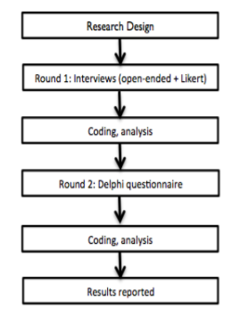
Figure 4: Delphi process [87].

Another advantage of this approach is the feedback. The Delphi method allows the continuous flow of feedback between the user and the panel, allocating room for changes in opinion and revisions of results [88].

Facilitators of the research will essentially lead the communication between user and panel members [86]. This repetition of information flow between the experts and the users via the panel ensure collected information is processed and used appropriately [88].

This could be applied to the project by means of a supervisor. The supervisor could be the facilitator watching over the questionnaire and interview information fed by the participants. This ensures the author and creator of the glasses does not directly influence the participants in a positive or negative way.

Similarly, the panel could consist of UWTSD staff members. The obvious drawback to this is that the lack of direct influence would mean the device creator cannot properly visualise the requirements or issues that would be presented by the participants.

Another major disadvantage is organising the process as staff would need to allocate a large amount of time and effort to the transfer, review and restructuring of the information.

3.12 Research onion

The research design could alternatively follow the research onion. More specifically, the research onion is the different layers of classification in which research follows (see figure 4) [55].

In this methodology, the core of the onion is the feedback and test results. Specifically, the data users will provide during the final testing and evaluation stage between the devices, when comparing them to the traditional cane method [55].

Providing a more in-depth analysis of this method, the report will investigate the individual layers which are as follows.

- Philosophies
- Approaches
- Strategies
- Choices
- Time horizons
- Techniques and procedures

Philosophy relates to the perspective or the research [89]. Meanwhile, phenomenology is the observation of experiences involving consciousness [20]. These can range from viewing the project as a social aspect to making decisions based on both sides of view [90].

The deductive or inductive approach is whether you start with a question to answer or create your own theory respectively [89]. In other words, it is how you start your projects investigation stance.

Research style defines the third layer of the research onion. Specifically, which method or methods will the research take to ensure data gathering becomes a reality [90].

This can range from known examples through case studies, solving an issue by adopting the form of action research or by using another of the multiple approaches [90].

The fourth layer of the onion defines the qualitative or quantitative data gathering perspective. This layer determines which ratios of each are applied [89].

Time horizons construct the penultimate layer of the research onion. Time horizons are based on the time to which the research is applicable [89]. Cross-sectional time horizons can be applied to a single point or period while longitudinal horizons can be for a longer or infinite window. [89].

The final layer of the onion (see figure 5) is the data collection and analysis where decisions around questionnaire content, open or closed questioning and how your interviews or collection methods are tailored to the participants [90].

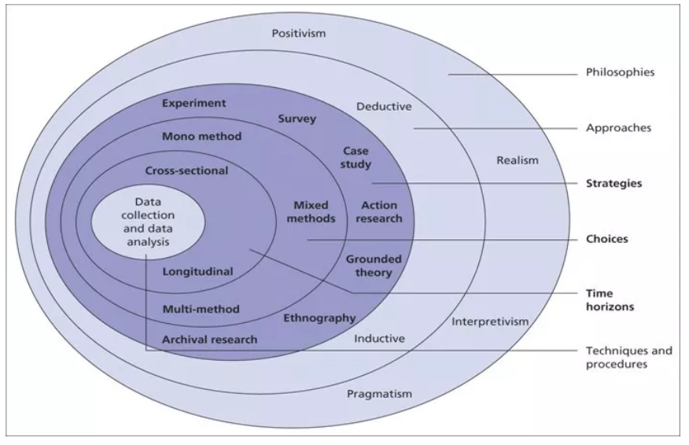
Figure 5: Figure of the research onion [55].

3.13 Chosen methodology

Comparing the two methods, there are several positive and negative aspects to evaluate.

The main advantage of the Delphi method is the reduction of bias and encouragement of open questions. The disadvantage is the organisational cost and effort.

Meanwhile, the research onion has a good structure but does involve a clinical approach.

Hence, it is beneficial that the project moves forward with neither method. Instead, this investigation will follow its own experimental approach which adopts aspects of both the of the research onion complemented with the open questioning and response principle of the Delphi method.

To be clearer, there will not be a panel between the project owner and participants but instead the author will adopt the ethos of the method.

Assessing the projects relationship to the first layer of the research onion, the author can see that the research is designed to address a question which can be evaluated and tested. This implies that the methodology lies in the positivism category [55].

Arguably, there is an element of how the blind interacts with their society and cultural life which would also indicate ‘interpretive’ [55] elements as well.

The research must now be debated to whether it identifies as qualitative or quantitative. In fact, looking at [26] and based on the definition of qualitative and quantitative, the research essentially falls into both categories [90].

This conclusion was arrived at from the following elements: the analysis and data obtained from both users and testing, could be measurable in numerical form e.g. stopping distances.

Meanwhile, the data could be immeasurable through human responses to their opinions on the device. Hence, the project could be classed in both respects.

The project will be incorporating deductive research. This is clear from the fact that data gathering methods will be used to answer the question presented at the start of the report.

Combined with the existing use cases and the conceptualised need for the glasses deductive research is the correct label.

Investigations rotate around visually impaired interactions needs, behaviour and participation through interviews, social interactions and reflection. Therefore, strategies align with surveys, case studies and action research [90].

Once requirements have been established, the research will gather evidence, run tests and then conclude on its findings to follow good practice and partially relate to the experimental category of the research onion [21].

The fact remains that there is also a comparison between different types of assistive methods which suggests the research design is comparative. Mixed methods are further implied by the combination of both qualitative and quantitative methods.

However, there is also an element of correlation during the testing by investigation the relationship between the glasses and the improved safety of travel.

Therefore, it is summarised that this research encompasses simple descriptive, comparative and correlative design.

Time horizons are a more difficult layer of the onion to conclude on. The author is observing users at single and multiple points of the experiment can go on endlessly.

However, as this project will come to an end by a specified submission date, the time horizon will be classes as cross-sectional

Meanwhile the only Delphi characteristic to be adopted is the anonymity. This will be applied as participants names will not be known by the author. This will ensure the users’ identity is protected and personal data isn’t stored.

3.2 Target population and recruitment

The target population is the blind community, hence, to help narrow the field of participants a few charities have been contacted to take part in the data collection methods.

After some consideration, the RNIB was used as the main information source.

The reasoning behind this selection is due to the quick responses, eagerness and all-round resources the charity puts into their public relations.

3.3 Sampling

The sampling method chosen for this research is not simple random sampling where users are chosen at random [84].

Elaborating on this, the sample will consist of volunteers. Classifying the sample under the term ‘convince sampling’ [84], this approach is useful for determining a trend in the field [84].

An additional reason behind this decision, is the RNIB have their own ‘connect group’ [9]. They are a social society who try to integrate voluntary blind members with the public and research projects [9].

Sample sizes must be appropriately set to ensure the right amount of data gathering and testing is conducted.

A sample size that is too large would indicate that data gathered is more accurate in representing the user requirements [81].

Large samples sizes are generally useful when projects need definitive, precise results and conclusions [82]. The advantage of a large sampling size is that you reduce the risk of sampling error. This will also ensure that outliers have less effect on results [81]. Conversely, the main disadvantage is the expense, excess planning and time taken to perform research on such large groups [83].

On the other hand, a sample size that is too small will increase the risk of incorrect data contaminating the decision-making process [81].

Small sample sizes are more suited to exploratory study. This is most useful when the results are to be more open ended [82]. The advantages of small samples are the ease in which data is gathered and research is managed [83]. Meanwhile, the disadvantage is that a sample size which is too small will not gather enough information to justify credibility of the results [82].

The sample size will therefore consist of 5 participants. This is to produce a reasonable range of data which in turn should provide clean, unbiased and reliable consensus.

The setting takes place in on-site locations, participants’ home environment or over video conferencing. The charities have their own facilities for the blind participants to provide their feedback.

Remote communication is used to avoid the inconvenience of travelling, hassle of setting up venues and insurance for the data collection.

For testing purposes, the glasses themselves will be tested against a 36-inch walking cane as a standard comparison for stopping distances.

3.4 Focus groups

An online focus group was an approach that has been removed from consideration. This setting would have been in a community hall of the authors choosing. Enabling control over location and setting while the users feel more relaxed to provide primary feedback [79].

However, the main drawback of this approach is the organisation, cost and risk of running the event. As attendees would be blind, they may require special facilities which would add more complexity to the situation.

Adding to the issue is the problem around time keeping. Organising an event which will allow users to participate may prove to be too difficult as you are catering for a large group [80].

3.5 Questionnaires

Obtaining information from a few sources is key to ensuring the glasses are designed and made to fit the purpose.

The questionnaire responses can be seen in appendix F. Queries were specifically designed to provide insight into the life of a blind person, with minimal influence from the semi-structured questions.

The project’s data gathering methods will lead with open and closed questions.

Open questions are questions that cannot give a static response. In other words, the user cannot answer with just ‘yes’ or ‘no [110].

A benefit to open questions, is encourages users to provide you with more detail in the answer. This ensures conclusions are drawn from larger amounts of debate [111].

The drawback of this approach is the difficulty around categorisation; specifically, how can the surveyor extract statistical analysis in the form of quantitative data from a lengthy answer [111]?

Meanwhile closed questions are questions which restrict answers to either a confirmation or declination response [110].

The main advantages of closed questions are that they provide quick responses meaning a more of questions can be covered [111]. In addition to this, the data can be more easily graphed and quantified [111].

Contrarily, disadvantages of closed questions are that they restrict the questionnaire and make it more clinical instead of a conversational flow. This can result in poor data return and therefore inaccurate conclusions [111].

Referring to this project, it needs to gain the best results and most thorough insights which would require open-ended questioning.

3.6 Online interviews

Online focus groups allow the data gathered to have a more personal involvement in the questioning.

However, as the data collection took place in the summer, it proved too difficult to arrange a convenient time for all the participants to meet.

Hence, the online focus group suggested in the proposal [8] was replaced with online one-to-one interviews.

Interviews were set up to allow an unstructured discussion to take place. The objective of the discussions was to ensure all the relevant information was gathered.

In other words, it gave the participants opportunity to add points they wish to raise which the questionnaire did not give them allocation to do.

3.7 Role-play

To obtain a true understanding of how being blind can have an impact on oneself, the author decided to do a controlled experiment. The author (test subject) would blindfold themselves and navigate their home while under supervision.

Upon reviewing the results (see chapter five for detailed analysis), it was decided the spectrum of research needed expansion.

The next option available was to run another controlled test in an unfamiliar town using a mobility cane (see chapter five).

Testing posed many more real-life experiences from the perspective of a visually impaired public member. This included trip hazards, crowds and background noise influence.

3.8 Testing

Usability testing will be the main approach adopted. The moderated, in person assessment and comparative testing will consist of multiple stages.

First review stages will test the device for practical, comfort and usability feedback. This will then be used to test and re-evaluate the device for improvements.

The moderated approach was decided to reduce tripping and bumps with obstacles; furthermore, the device requires fine tuning, combined with the fact that the user needs to be supported and guided indicates in person testing is the best approach.

Finally, the users will be comparing the devices to each other and to traditional cane methods. Hence, there will be an element of individual review and comparison between options.

To read more on the credibility, transferability and dependability of the results combined with the position statement please see appendix A.

Chapter 4: Development methodologies and product design

To assist the development of this project, this chapter will investigate different design methodologies selecting the appropriate elements to incorporate.

To choose the best design methodology, the following approaches will be investigated:

- Agile
- Waterfall
- Prototyping
- Design thinking (see appendix C)

4.1 Methodology explanation

Agile methods are software development processes which matches the changing needs of the client to the planning and implementation of the product [56]

The benefit of using agile approaches is the product can be adapted for improvement to the use case as the story develops [57].

From figure 6 shown below, the report can note that the main difference between agile and more traditional methods like waterfall, is that traditional methods deviate from the design plan once the project has commenced. Any changes or extra specifications would require a new waterfall planning and implementation. Meanwhile the agile approach will improve the design and implementation dynamically; the advantage of this is the project becomes more efficient to create but can slow development if changes are required [58].

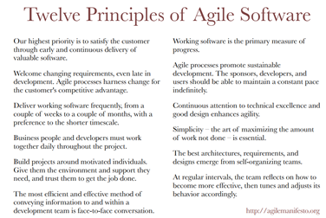
Figure 6: The twelve agile principles [58].

An element of the agile approach is scrum. Scrum is where the requirements from the user are broken down into user stories [66].

These stories are then refined down further into smaller tasks which are allocated in a sprint backlog [59]. The developer will then take a task from the backlog to complete in a sprint.

A sprint is essentially a time block for task to be completed within. This time block has a time to love which is determined by task difficulty [60]. However, sprints usually last four to six weeks. Unfinished tasks are placed back in the backlog for later development.

A key advantage of scrum towards good development is the scrum and sprint review. Enabling these reflection periods assists the individual or team to deliver optimal results [60]. Figure 7 shown below illustrates the scrum process.

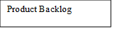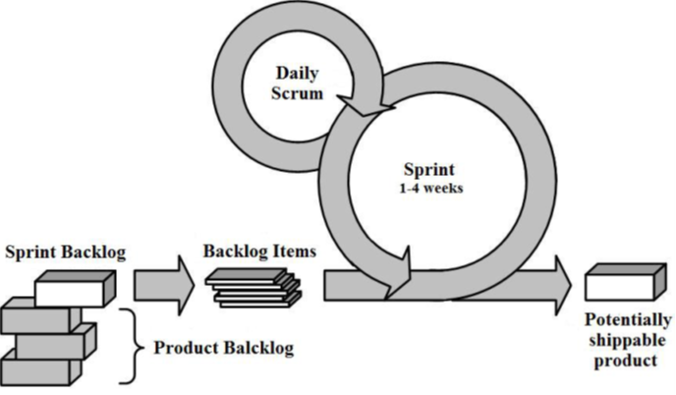
Figure 7: Scrum process [59].

Providing a real-life example, the project notices the civil service follows an Agile approach [61]. Specifically, in several teams of 5-11 (which make up each department), the developers follow a scrum process.

Referencing where this was used is within the application process for tribunal court fees [62]. By adopting this approach, the team were able to develop their service around the user.

An example of a more traditional method is the waterfall model. This model follows the software development life cycle by isolating developing to stages [65].

Figure 8 below shows how the waterfall process would plan a project and then proceed to implement the remaining stages.

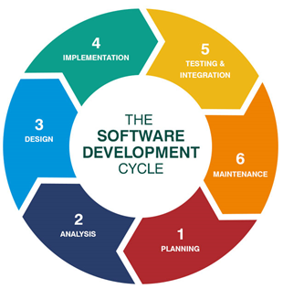
Figure 8: Software development life cycle [63].

The drawback of this method is the lack of client involvement. Once the requirements are set the project is planned and implemented without any regard to changes [64].

The repercussions of this is the restriction around user requirement changes. The project does not change with them and would require a new contract post project completion [65]. This can cause customer dissatisfaction and poor product production. In addition to this, the development process can be both expensive to complete and revaluate [65].

Another disadvantage is the potential for scope creep or miscommunication. Meanwhile, the waterfall approach provides better insight into what the end goal is, as requirements are set early and stuck to throughout development [64]. The process can be seen in figure 9 below.

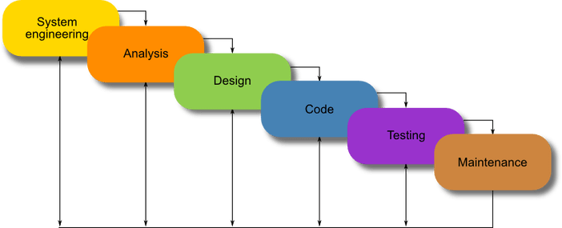
Figure 9: Waterfall method which can be found from [8].

An example where the waterfall approach was used is in services like tacho graphs in the civil service. The approach was to come up with specifications and implement them. A primary disadvantage of this approach was the unforeseen issues, for example the process did not account for duplication of data [61].

The third methodology is prototyping. Prototyping is where a product is made to represent a small sample of a larger potential product. The device and designs are then built on to improve the product in stages [113].

The prototyping approach is centred around six points:

- Determine objectives
- Develop
- Refine
- Demonstrate
- Test
- Implement [113]

The main advantage to this approach is the quick turnover of development and testing cycles. Additionally, another advantage is that flaws in the device are detected quicker [113].

The drawback is the potential complexity that can be added, especially when testing highlights design extensions [113].

4.2 Chosen methodology for project

Evaluating how the methodologies can apply to project is the key to selecting the optimal solution.

Looking at the agile approach, the adapting to change is a desirable trait. However, applying user stories to this project and working in sprints to complete a goal seems inappropriate. Likewise, adopting scrum to achieve this is not the best fit for the purpose. Additionally, agile requires a team; however, there is only one project member.

The waterfall methodology does make sense from the perspective of developing the project based on requirements gathering, development and implementation. However, if the product does not do what the user expects at the project close the result will be an overall fail.

Similarly, if there are any changes needed for the glasses the waterfall method would not allow the incorporation of these changes. Instead another project would need to be scoped.

Meanwhile, the agile approach applied to design has a lot of desirable elements; mainly the concept of cheap and rapid prototyping would imply a good product outcome. In addition to this the added measure of user observations would mean the product is more likely to be developed to fit the user.

Going forward, the best outcome is to adopt elements of both agile and waterfall methodologies in a custom experimental methodology.

To explain the approach in detail, there will be multiple design, development and implementation stages for prototype development of the device. In other words, the process will consist of some prototyping stages following the waterfall method elements wrapped within a larger iteration cycle.

The advantage of this is that the devices can be developed, changed, tested and redeveloped repeatedly until the project had reached its close. Another point is that the adoption of agile elements will ensure that users feel more involved with the device.

To summarise this methodology, the approach is a hybrid between waterfall and prototyping methods combined with iterations and principles of agile. This process is not actually agile as the operation consists of a one-man team, rendering complete agile and scrum involvement impossible

Chapter 5: Requirements analysis

Now that the data collection techniques have been defined, they can now be applied.
In this section, the report will critically analyse the requirements which were retrieved through questionnaires interviews and product testing.

From this data, the author can glean patterns in the subject's responses to define and scope. In particular, the results of the device testing, drawbacks and improvements to be implemented will be solidified through user requirements.

To continue in alignment with the custom methodology approach outlined in the development methodology chapter; the implementation will be followed by a testing and revaluation stage, the process will then repeat.

5.1 Description of the sample

The sample consist of five members from the RNIB connect voices charity. We have categorised them as follows:

- Subject A - 80% occlusion in right eye and 5-6 weeks of wearing an eye patch over each eye as well as being severely myopic.
- Subject B - suffers from frontal blindness but has partial peripheral sight.
- Subject C - suffers from full blindness
- Subject D - suffers from full blindness.
- Subject E - eyesight is deteriorating into blindness. Specifically, the left eye is poor, right eye is mostly blind. However, the peripheral is strong and the subject can distinguish between day and night.

Listed are a wide range of sight deterioration, which provides foundation for testing into how different users will respond to the device capabilities.

For example, a fully blind person would be more reliant on the device when compared to a partially sighted person. The user may need the device to see in front of them, however, the side sensors would provide little help if their peripheral vision is fit for purpose.

It is also useful to engage with subject’s A and E as they will benefit from the device in different ways.

In further detail, subject A will need the glasses just as much as a fully blind person due to the fact they cannot identify shapes, meanwhile subject E will be very useful in understanding the difficulties presented to someone becoming blind and losing aspects of their independence.

5.2 Detailed analysis

The report will now provide multiple breakdowns of the analysis for requirement setting and testing of the BATGLASSES.

The objective of this section is to ensure the device meets the expectations of the end user while opening new potential avenues into the concepts and future solutions.

The questionnaire completed by subject A indicates a significant sight reduction.
An interesting and common aspect of all subjects input is time; when travelling to an unfamiliar setting, all subjects arrive extremely early to gauge their surroundings.

When questioned, subject A informed the author that they would like to see the glasses extended to adapt to change. This can be applied to the MVP adjusting itself to different, varying distances.

The user also wishes to have some form of ground level detection. For example, a common issue described by multiple interviews is the risk to individuals from rubbish and foot level objects. Hazards at ground level include litter, cleaning signs and general bollards or drop-down pavements.

While subject A used verbal instructions to navigate, subject B would make use of a cane.

From reading their questionnaire, the cane has multiple benefits including the detection of different levels of surfaces and terrains. When speaking to subject B, they highlighted that the cane does have some drawbacks.

These drawbacks include trapping; expanding on this, the cane can get caught in corners drain covers and dips in the road. When this happens, the handle is then launched with force into the user's stomach.

After delving further into this issue, the subject revealed they have painful hands as a result. Combining this with the fact that the cane only gives you a limited warning implies shortfalls in the tool.

This point is worth reaffirming, as the glasses would not cause discomfort in the way that the cane does. Up to this moment, the project has stated the glasses will not replace other methods but rather assist. However, if the glasses were able to detect objects at ground level, replacing the cane may be a viable alternative.

For more analysis around discussion with the user please see appendix B.

Initially, even though the user had prior knowledge and understanding of the environment the sudden loss of sight was extremely difficult to comprehend.

Trying to ‘feel’ around for the kettle, mug etc. was proving to be a challenge the difficult aspect was picking up the item itself by fumbling around for it.

A point of note was the inaccuracy in performing everyday tasks. For example, pouring the hot water into a mug made a large amount of spillage and posed a risk to the participant through splashing.

Adding to this point, determining when the mug was full as the sound of the water was the only indication of the level. Transferring this issue, the author asks how users would be able to hear an electric car coming which produces little sound.

When cleaning the surrounding area, simple tasks such as cleaning a surface also proved difficult as there were items on the surface that were moved without tester knowledge.

This opened a path of insight into the main difficulty faced within the home for blind people i.e. other people.

By moving things without care consideration, the other members of the household are placing risk to the user. In short, they could knock something sharp or heavy while trying to complete the chore.

The final point that needs to be raised is furniture and walls. Although this seems like a trivial point to raise the reality is quite the opposite.

In practice, regardless of the fact the author has lived in the house for a decade, they still bumped into objects at knee level and was unable to fully determine distances between themselves and walls resulting in several knocks.

These knocks at first may seem irrelevant; however, over time it became apparent that the cumulative build-up of the minor injuries was presenting a greater risk of major injury.

It is therefore an easy conclusion that the easiest of tasks for one who can see, equates to a major challenge for those who cannot.

After some further experimentation within the household, the author started to become accustomed to the surroundings, while family members became more aware of their knock-on effects.

Upon review, it was then decided that the author would be taken to an unfamiliar setting for outdoor testing in another controlled experiment.

The difference posed between this test environment and the previous environment comes down to familiarity. The first issue presented to the participant was the noise of the surrounding crowds.

To date, the experiment was in a quiet area meaning sound was a sense that the user had become dependent on. The multiple different background noises proved to make general pinpointing of location in a street or café setting more difficult.

Uneven ground and cracks proved to be a major issue. The author was constantly tripping over bits of concrete sticking out of the ground or becoming unbalanced due to verges in the tarmac.

Complementing this problem was drop down pavements, even with the use of the cane the thinking time and reaction time between realising there was a dip or rise and adjusting the step to accommodate this proved to be unsafe and accused trips.

Further issues associated with this, was crossing the road and manoeuvring around stores the supervisor noted on several occasion that the author was knocking over items on shelves and was unable to locate themselves, retrace their steps or identify when cars were coming or moving away.

Chapter 6: Design

Now that the project has covered the theoretical aspects of this device, it needs definitive understanding of the components, designs and code behind the product.

In this critical part of the report, there will be in depth discussion on the individual parts and applications needed to construct the BATGLASSES.

Glasses are an obvious component in the device construction. However, a pair of glasses on their own would not be enough to make the BATGLASSES.

Hence, the other parts will be listed and their relevance to the device explained.

6.1 Hardware design

Firstly, the bat glasses will be steam punk rock design the design is stylish, which will provide the user with flip functionality.

Expanding on this, the use of these glasses (shown in figure 10) means that the user has the option of whether to use the frontal sensor.

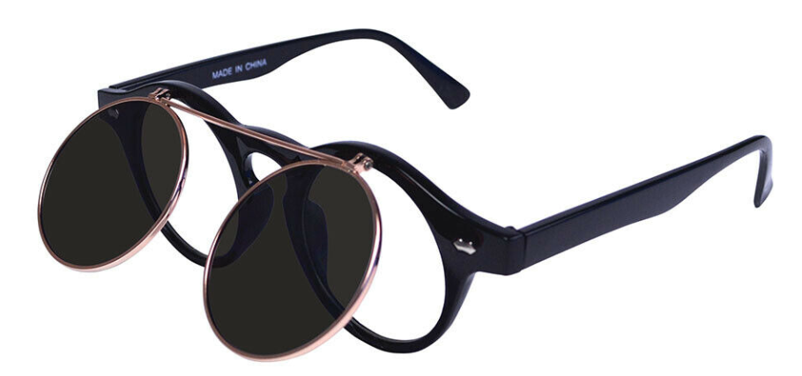
Figure 10: Glasses used to make the BATGLASSES [17].

Programming code for this device will stored on a board. As the device components, are all grove brands and require certain ports, the chosen product is the “Seeeduino V4.2” shown in figure 11 below [16].

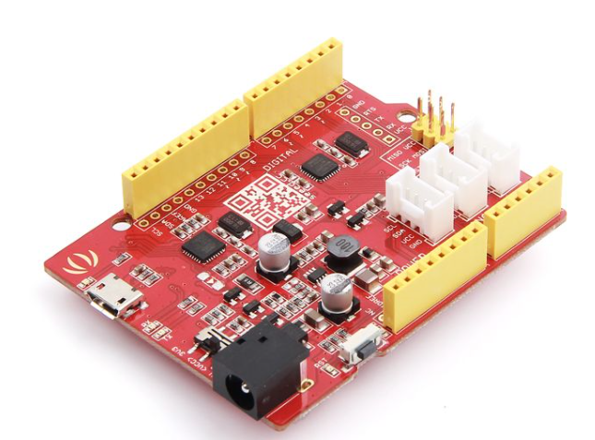
Figure 11: Image of the seeeduino for the BATGLASSES [16].

Seeeduino will ensure that the devices are integrated with the program code. This is essentially the brain of the device. To power the glasses, there will be a small battery pack attached to the seeeduino with a USB 2.0 a-type male-to-male cable.

As the name BATGLASSES suggests, the device will be using ultrasonic sensors to ping back obstacles location. An image of this can be seen in figure 12.

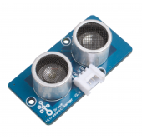
Figure 12: Image of an ultrasonic sensor [13].

Therefore, the component to be used is the ultrasonic sensor. The sensor will release an ultrasonic ping and factor in the time it takes for the response to return.

Sensing an object is half the objective for the MVP, the user also needs to be alerted using a vibration response.

After some deliberation and investigation, it appears that a buzzer (see figure 13) wired to the seeeduino is the best solution.

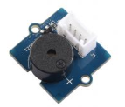
Figure 13: Sensors used to alert device owner [14].

This buzzer will make a noise when an object comes near. In fact, the pitch and frequency will be dependent on the distance between person and object.

As an additional measure, the buzzer also vibrates. This will satisfy both conditions of the MVP previously mentioned. These being that the glasses can alert users who have hearing or suffer from deafness.

For additional components to be used in the glasses please see appendix D.

Now that the reader has seen the components separately, sketches can be drawn to visualize the product assembled.

The first design (seen in figure 14) will consist of the MVP. More specifically, the base design will consist of three buzzers, sensors and a seeeduino with a battery pack attached.

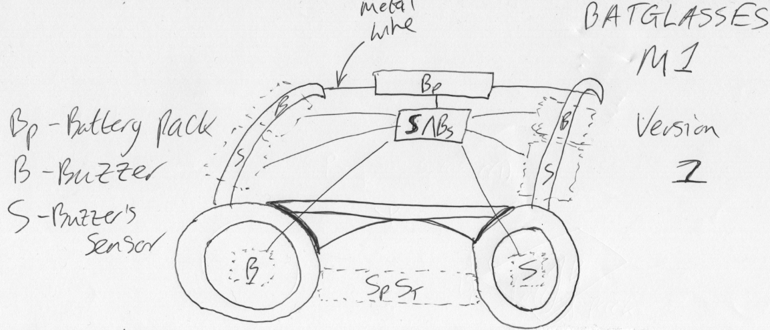
Figure 14: Sketch of the BATGLASSES M1.

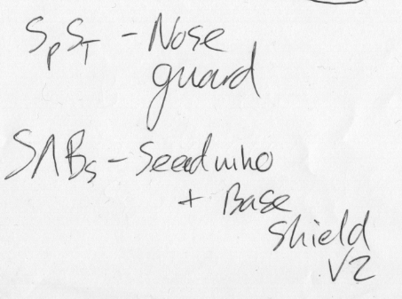
Figure 15: Key displaying the labels for nose guard and seeeduino.

As the reader can clearly see, the glasses main design consideration is space and weight. Specifically, the battery is too heavy for the frame which rests on the nose.

Hence, the sketch was redesigned so that the glasses power source can be worn on the upper arm by using a shoulder strap. This can be seen by the figure shown below (figure 16).

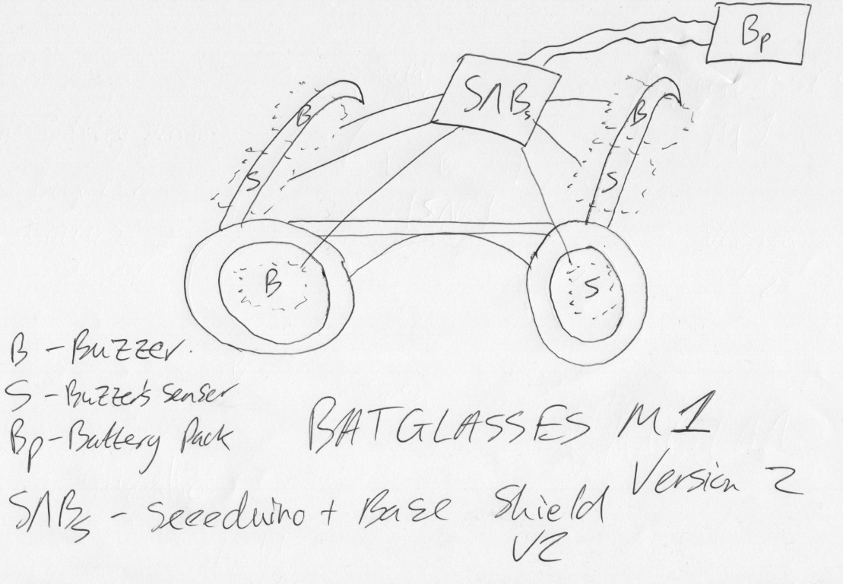
Figure 16: Sketch for BATGLASSES M1 Version 2.

After some consideration, the seeeduino will be rested on the head of the user. This is to prevent unbalanced weighting on one side of the glasses.

Adding to this, by placing the seeeduino on the head, users have the option to cover the seeeduino by using a baseball hat. This reduces any self-conscious issues that may occur.

The buzzers and sensors for sides were placed to the rear of the frame. This ensures the balance is optimal and not too heavy on the front.

Post-MVP, the project is faced with a new extension and new issues i.e. foot level hazards.

Extending upon this and referring to the participant requirements (appendix F), a common issue are objects that users can trip over.

Examples of this include curbs, litter and furniture. The project now conceptualises the extension that the glasses could detect these foot level trip hazards and alert the user.

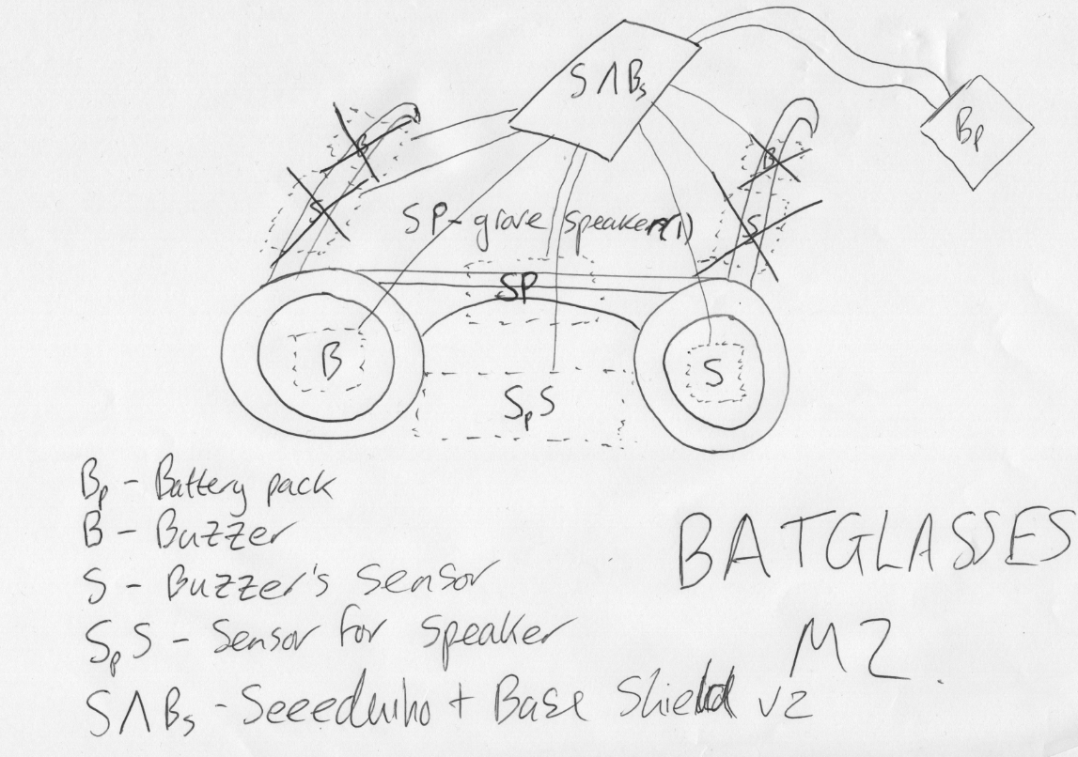
Figure 17: Sketch for the BATGLASSES M2.

A solution to this concept can be seen in the above sketch figure (17) of the BATGLASSES M2, using the previous design, a single speaker can be used and an additional sensor.

Positioning the sensor at an approximate 45-degree angle, it can be calibrated so drastic change in the ping distance can then be used to set off the glasses to alert the user.

6.2 Software design

To extend the designing section of this report there will be some discussion on the software approaches to creating the glasses.

First, the glasses will need to be programmed using a programming language. The chosen IDE is Arduino version 1.8.9; while the language for this project is the Arduino language which adopts C and C++ [37].

Libraries are often needed in development. In this case, the chosen library used is the Arduino grove ultrasound [53]. Specifically, the reason for choosing this library is predominantly down to the fact it can calculate the response from the sensors in inches without the need to programme the ping and the flight time response of the beam.

Functions and classes of the code will be incorporated. A class is an overarching structure of an object [112]. On the other hand, a function is a list of commands which are intricately joined to perform an action and receive a result. [112]. Meanwhile, a method is a process or procedure that is linked to a class [112].

Use of this language with functions and methods, including the setup and loop on serial port 9600 are also desirable to fit the constant need to check for obstacles and alert the user with live feedback.

Structure for the code will be tailored to initiate multiple functions; three of which will relate to each side of the glasses. The theory behind this approach is that the sensors will release a ping which is calculated using the grove library. The response in inches, will then provide a buzzer sound based on distance determined by an if statement

Ensuring the frequency is distinguishable from one distance category to the next, delays will be introduced into the sound response if statements, which will affect buzzer feedback.

Meanwhile the M2 code will have a function which focuses primarily on defining an alternative response. Instead of using buzzers a speaker will be used.

Hence, the speakers will need to have bass sounds programmed into an array. Further, the code structure will need multiple for loops to ensure the speaker emits the sound correctly.

Finally, the program will also need some consideration with regards to standby state of the speaker; in other words, the if statement will need an else component to ensure the speaker is not constantly sounding.

Chapter 7: Implementation and testing of the prototypes

An important chapter, this section of the report will focus on the development of the glasses.

Once the initial design has been implemented the device will undergo a series of tests to assess their relevance to the use case and practical applications.

When testing has been completed, the code and physical product will be redefined and implemented; before undergoing further tests to support final conclusions.

7.1 Implementation of prototype one

Design specifications have now been met; however, the components need instruction. Hence, the report must develop code to meet the objective.

The reader may recall the components include three sensors and three buzzers (see components and previous designs).

However, prior to the design change incorporating the base shield, a single sensor was wired up to an Arduino Uno to see if the principle could be applied. The code for this is shown in appendix G (see G.1).

The reader may notice that this code would not be enough to satisfy the MVP. Hence, the program would need to be modified to consider multiple sensors, buzzers and varying distances using grove components.

Refining this, the sensors must be able to detect different distances between the user and the obstacles. Based on these distances, the code must then provide different buzzer intervals which could also be combined with different pitches (see code G.2 in appendix G).

Looking at the code above, the reader can see that the sensors will send off a ping, wait for the response, calculate the distance in inches then return the buzzer sound and delay based on the distance.

Note, the side buzzers will behave differently to the front buzzer. This is to prevent noisy data and satisfy the understanding that people will pass by much closer to the side than they would in front of the user. Therefore, the distances for the side buzzers are much shorter.

7.2 Testing and analysis of prototype one

Removing bugs and improving the usability of the product would be difficult without testing.

In this instance, testing consisted of experimenting with the glasses (shown by figure 18) in practical environments which includes both the DVLA and general public settings.

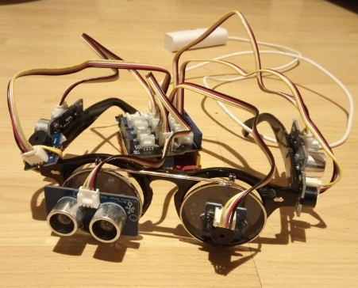
Figure 18: Photo of the BATGLASSES M1.

The first set of tests were conducted within the home environment using the code shown in appendix G (see code G.2).

Use of the glasses really improved the detection of walls and obstacles at head height. The disadvantage that this presented was the overconfidence the glasses gave the user.

Implications from this overconfidence meant that the tester would walk into waist height objects at speed which the glasses failed to pick up. The reader may recall that this is not the goal of BATGLASSES M1 and would be rectified by M2.

An additional point worth mentioning is the effects of gluing components to the glasses. While this meant the sensor could be flipped up to prevent the buzzer (see figure 19) from sounding it meant that the general use of the sensor was poor due to varying angles.

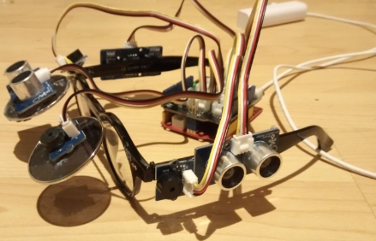
Figure 19: Photo showing flip up functionality.

However, when the glasses were flipped down, the movement would cause extreme angle differences meaning the sensor would read distances differently. This was causing multiple inaccuracies in stopping times.

The solution is to use tie wraps for the M2 design, limiting the movement of the flip sensors.

One of the most common user feedback topics was the noise of the buzzer, due to the delay in pulses, the sound was too loud.

A secondary issue with the BATGLASSES M1 were the distances within the if statements. During preliminary investigation, the supervisor was surprised to find that blind people generally walk at fast speeds.

Hence, when replicating this, the test users found that they would need intervention before they hit the wall. Elaborating on this, the fast pulses (final pattern of pulses) alerted them to the danger too late. Therefore, the glasses would only be suited for those who walked slowly.

Looking at the use case and overarching objectives, the glasses need to be prioritised for wider outdoor areas than tight spaces; hence, the project and device will incorporate the if statement changes.

Following the same approach as the requirements analysis stage, the author then took the glasses to Gwbert to add further credibility to the tests.

Results presented both positive and negative yield. While the glasses were able to detect head objects, the sheer number of people blocking the author meant the alerts were constant.

However, this did mean that people were aware of the tester’s blindness. Through this alerting feature, the amount of people bumping into the user was significantly reduced.

In addition to this, the glasses did prevent head injury and accidents caused by walking into items or walls.

With this new and overall positive review, there is a clear need for a floor level detection and alerting system using BATGLASSES M2.

Requirement for this feature was reinforced from the regular and potentially damaging obstacles that the object could not detect, due to the frontal and side beams emitting at head height only.

To further test the glasses, the device was used against windowpanes. This was to ensure glass would not affect the response from the sensors. Post-test, the author could conclude the glasses were unaffected by windowpanes as the responses were unchanged.

Finally, the glasses required testing in the DVLA. Upon using the glasses in the wide corridors, large rooms and general staircases, test subjects found that the glasses made outstanding impact on the movement and travel around the building.

BATGLASSES not only prevented users from walking into walls. They also were able to alert users to staircases and passers-by.

This provides concrete evidence to support the current situation, future potential benefits and development that the BATGLASSES could have.

7.3 Stage two implementation of prototype one

As this project is following an agile methodology, the product must now be re-evaluated and adjusted based on the new user requirements.

Hence, incorporating the change meant the code for the BATGLASSES M1 had in fact changed. For the benefit of the reader this can be found in appendix G (see G.3).

Readers may recall during testing; the flip function of the glasses was clearly causing issue with the ultrasonic distances.

A proposed and tested solution is to line the rim with putty which the flip frame could stick to. This ensured the glasses sensors were level while keeping the option for flipping.

Another issue was the noise from the buzzers. To this problem, the author has reduced delay period within the function this would mean that the buzzer pace increases while the sound was reduced.

Blind users walking speeds also proved to be an issue as response times were not fast enough. To counter this problem, the distances in all the if statements were increased (see appendix G.3).

7.4 Stage two testing of prototype one

The use of putty to prevent angle variation proved to be effective. Users reported that they were able to use the functionality when flipped up. Likewise, they were also able to maintain the correct sensor angle when glasses were flipped down.

By reducing the delay period, the glasses were quieter. This fix to the function ‘delay()’ in the code meant the buzzers did not have enough time to reach full volume.

As planned if statements were adjusted to assist with walking paces. The results from this change meant that the glasses alerted users sooner to dangers. A knock-on effect of this are the indoor use of the glasses, with the larger distances programmed to the device, resulted in users not being able to use the glasses indoors without the alarm going off frequently.

7.5 Implementation of prototype two

Meanwhile, the BATGLASSES M2 will require different code for the speakers. The objective is to have a pair of glasses which can detect objects at low level. To achieve this, an additional sensor is going to be added as the design shows (see chapter 4).

Overuse of buzzers would be irritating and confusing. Hence, a speaker playing a tune would be singled out more easily.

As an additional measure and for the purposes within the proof of concept, there will only be one sensor (see Code G.4 in appendix G for the code).

The advantage of this code is the flexibility. In short, the response distances can be adjusted to suit the pace and height of the user.

Stressing this, the importance of calibration is key, as users who are too tall or too short would influence the sensor.

For example, the implication for someone who is 6ft tall is the sensor may not sense the curb, which would result in injury. This is expected to become more apparent in the testing stages.

7.6 Testing and analysis of prototype two

With the success of the BATGLASSES M1 came an obvious reinforcement to develop ground level detection and alerting.

Once the BATGLASSES M2 were created and ready for use (see figure 20), the testing course was prepared by laying out several objects which could be trip hazards. These objects include chairs, tables, cans, general litter items and stools.

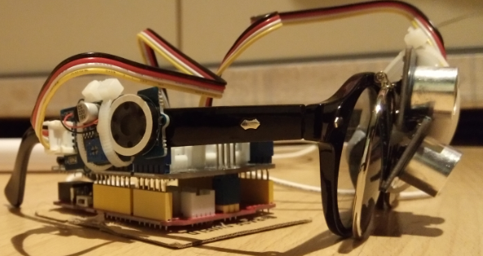
Figure 20: Photo of the BATGLASSES M2
Once testing was complete there were several points that needed to be discussed.

Firstly, the melody used in the code was very different to the buzzer sound; hence, the users were aware of the difference between objects at head height and ground level.

Secondly, although the result from the sounds meant users stopped walking, the distance from the object to the user was too short. Hence, uses with longer thinking times will result in longer stopping distances with the potential risk of walking into obstacles.

Users also reported that the melody was too long and that this meant they were stood still waiting for the sound to stop before they could do anything.

Another note to mention was the detection of objects. The glasses were very effective at detecting wide objects such as chairs and tables. However, smaller items like cans prove to be more of a challenge.

Specifically, the glasses would detect the item if the beam from the sensor passed over it. However, due to the small width of a can the beam may not hit but rather pass by the object meaning it goes undetected.

The project suggests that as a further measurement and a future development, the glasses would need multiple sensors dedicated to the scanning of the ground instead of just single sensor.

The final issue with this model was the angle of the sensor and height of the user.

Expanding this statement, the report states that the code used in this test (see appendix G code G.4), was calibrated for only one user’s height.

However, if a person was shorter or taller than this by a few inches; the result would mean speakers continuously sounded or object weren’t detected at all.

Despite these flaws, the device worked well to detect obstacles and when test was completed in Gwbert, the author found travelling much less risky and more relaxing.

Machine learning calibration when the user is given this device is one of the two solutions to this problem. The other is manual calibration that the user could do at regular intervals. Both are suggested as improvement in future PhD extensions

The main point worthy of note is that the glasses successfully scanned the ground and alerted users to an upcoming curb. Additionally, small items like litter were also detected under the right conditions.

7.7 Stage two implementation of prototype two

The reader can see the code (see G.5 in appendix G) has the necessary change to the if statement. The fix is designed to provide a more accurate response with regards to the user’s height. In this case, the inches for the angled sensor are set to 67 inches for optimal results.

Note, this is again specific to the height of the user and was gauged appropriately for other test subjects. From this information, the earlier assumption that device calibration pre-device use is verified.

Users reported the melody was too long. This meant that they had to wait for the sound to stop before they could assess the environment around them, proving to be irritating the melody had to be changed.

In addition to this, stopping distances were too long. The goal is to have two different alerts which allow for plenty of thinking and stopping time; hence, the codes melody and if statement was changed to meet this need (see appendix G code G.5).

To ensure the litter was not going to cause potential risk to the user further testing of this use case was warranted.

7.8 Stage two testing of prototype two

First tests showed that users were much more satisfied with the sound and the melody was no longer a nuisance with regards to length and responsiveness.

It allowed users to identify and react to objects much quicker which in turn improved the usability of the device.

As an additional observation, the testers were able to recognise that the stopping distance was greatly improved. A direct result of this was the improved confidence in the device and the reduction of stress when travelling in areas with gradients, holes and cracks in the floor.

The testing of the litter again proved to be very variable. While larger litter items like boxes and bottles were easily detected, the smaller items like cans and bottle caps proved to trigger the device. However, the frequency of detection had improved post-redevelopment.

It is therefore necessary that the glasses would have to be refined for smaller items. This is classified as a future improvement for a PhD project.

As an additional note, these results can be tailored so that the user stops closer or further away depending on their preference

Chapter 8: Results of comparison

As stated earlier, the project will be using both measurable and immeasurable data. The testing has covered the qualitative data through the user’s thoughts, feelings and reflections.

It is now necessary that we mention the quantitative data, to test the effectiveness of the device.

Basic final tests were carried out using both BATGLASSES M1, BATGLASSES M2 and an assistive cane. The resulting data from the tests are shown below in table 1.

Table 1: Table of test results.

The results show that the stopping distances were shorter than the cane. This is down to the shorter distance calibration in which the buzzer sounds. See figure 21 below for a scatter diagram of the results.

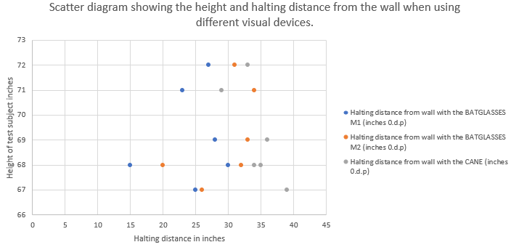
Figure 21: Scatter diagram showing the halting distance from the obstacle for different devices.
As the reader can see, the glasses were more effective than the traditional cane, as users were stopping closer to the obstacle without the risk of a cane driving into their waist.

The most prominent advantage of the BATGLASSES M1 is its ability to mimic a car parking sensor to alert users to head height dangers.

Undergoing this process means users no longer need to worry about the risk of low a hanging objects or walls in front of their face.

Another advantage is the side sensors which notifies users to people or obstacles next to them the benefit to this is the forewarning to someone or something knocking them from the side.

The disadvantage of the BATGLASSES M1 is the lack of detection with regards to lower level objects.

Unless the obstacle is located at head height it would be undetected and hit the user who would be walking at potentially full speed.

A secondary drawback is the noise from the glasses, although reduced, could still distract users from other environmental indicators.

For example, a car coming towards them may approach unnoticed as the glasses would be sounding off based on detection from another object.

Comparing the M1 to the cane clarifies the difference they make. Users who have been using canes to detect walls in front of them often have the cane driven into their stomach or twisting their hand on impact.

The pain this can cause could be severe. The glasses, however, ensure users stop without direct impact on objects.

A point worth mentioning is the advantage of the varying notifications. Users frequently mentioned that the frequency was very useful in judging how close the user was getting to the wall.

The advantage of the BATGLASSES M2 is the foot level detection. In some scenarios, this functionality can replace the cane, allowing for a more pleasant form of travel and less risk of injury.

Furthermore, an additional advantage is the melody that plays instead of a buzzer. Post-refining this melody received a positive response, as users were alerted to the obstacle without the irritating noise buzzers create.

Clearly the main disadvantage of the BATGLASSES M2 is the accuracy to small items on the floor and the height of the user. These two factors could result in the glasses failing to detect a drop, generating a potentially dangerous scenario.

The melody was stated as an advantage. One final potential drawback worthy of discussion is the continuous use of melody. The sound can in fact be very off putting and prolonged use could cause irritation or tinnitus. This is something that could be adjusted by incorporating different sounds or even more noticeable vibrations through a bone conduction pad attached to the skull.

In comparison to the cane, the M2 glasses are less effective at detecting litter in front of the user. However, they avoid the discomfort that using a cane can cause.

Comparing the two devices, the BATGLASSES M1 is clearly the better.

The reasoning behind this comes down to its superior use case, application and user-friendly results.

In further detail, the user can manage without foot level obstacle detection, as they could use M1 with the cane to cover all human height dangers.

However, by just using the M2, users’ faces are at risk of injury regardless as to whether the cane is used or not.

In an ideal device both models should be incorporated, even then, it would be better for the user to use the cane for areas in which the glasses are not appropriate e.g. small confined spaces like tube stations and buses.

This collaboration will also mean that the glasses can act as a redundancy system should the cane fail. As can be seen by the graph (graph 1) the cane resulted with the user stopping further from the object. However, if the cane was shorter, the glasses may provide more alert time than the cane could.

Chapter 9: Conclusion and discussion

As the project comes to a close, the achievements must be reflected upon; hence, in this final chapter, the entire journey of the project will be assessed. There will additionally be an evaluation on the successes, limitations and future of the device.

9.1 Discussion of the results in relation to research questions

The project had three questions to answer which were as follows:

- How can glasses be made to assist the blind community?

- How can the glasses be tested?

- Can the assistive glasses provide a difference in stopping distances and general use for the visually impaired?

To rate the success of the BATGLASSES, the report must evaluate if the objectives have been met.

Addressing the first question, the report can conclude that there are many actual and potential links between the device and autonomous vehicles from the incorporation of parking sensors, GPS, satellite navigation and lane control.

Meanwhile, the requirements gathering, and testing stages have clearly shown the benefit the glasses bring along with the potential that they could deliver to the community.

This conclusion has been solidified not just by the author’s opinion but also the opinion of the end users. Hence, the first line of inquiry has been thoroughly satisfied.

The second question asked how the glasses could be tested. Through literature reviews and analysis of testing strategies adopted by other products, the project was able to determine that it could be tested. Further, the research into testing allowed the report to discover directions into how the product should be tested through evaluation and debate of what fits the scenario the best.

The third and final question was to improve safety and provide more effective stopping distances. As the report investigates within the literature review, the self-driving vehicles will make roads safer. Combined with the improvement in use and the results from the stopping distance analysis, the report can conclude the glasses make a difference.

However, this was not enough; proof was needed. This proof again came from the testing. Both the creator and the end users found that pre and post testing had its risks.

Conversely, there was a clear reduction in danger and an increase in confidence when the glasses were used. It is also to be expected that the safety while using the glasses will continue to improve as advancements are made. Hence, the three questions have been fulfilled.

9.2 Discussion of the results in relation to the literature

Drawing on a wide range of literature, the project was able to develop a scope of the current technology assisting the blind.

Further to this, by fully understanding what autonomous vehicles are and the current developments in the field, the future concepts and their links to self-driving vehicles could also be scoped.

By researching the backgrounds of the target audience, their conditions and current assistive technology, the report was further able to understand the user and the use case meaning the design stage was better prepared for and implemented.

Through in-depth investigation into testing, the moderator was able to weigh the pros and cons associated with the debated usability testing strategies and arrive at the best fit for the purpose.

Supporting the testing stage with this knowledge ensured that the tests of the device would gain the ideal, unbiased and safest path to good, credible and replicable results.

Expanding on the theory behind sonar and ultrasound using real life examples and projects meant that the project aligned with the best sensory perspective that it could find. By following the ideology laid out by nature, the investigation could follow a blueprint refined by evolution and years of adaptation.

Hence, this section of the conclusion states that there is a wide field in which the glasses can be related to, with additional uses in which glasses and self-driving vehicles can work towards.

9.3 Implication of results

To ensure honesty and integrity, it was vital that the glasses and prototypes were heavily scrutinised.

This was to confirm the idea and product would be credible and so the report will now discuss the limitations.

Limitations with regards to both models are mainly down to two points; the first is that the glasses can be influenced by the angle in which users hold their head.

In other words, if the BATGLASSES are angled downwards or upwards the device will respond differently. This is because the distance between user and obstacle is influenced by the angle of deprivation or elevation.

To prevent this, the user must have their head level to ensure the sensor is picking up the correct obstacle.

The second point is the height, taller or shorter people will either set off the device constantly or not at all. To ensure this does not happen, the users height must be taken into consideration when assigning the speakerDetect() variable (see appendix G.5) .

The testing of this project was to follow an experimental set up which adopted large elements of the research onion. Incorporating moderated user testing and agile approaches the devices were tested, reviewed, redeveloped and tested once more to ensure the optimal result was attained within the time frame of the project.

The testing highlighted some weaknesses in the glasses linked to user pace, height and elevation of their heads. All of which affected the glasses response time and response type.

This in turn meant that the guidance and code adjustments that followed would ensure the project followed its development approach, which consisted of a waterfall method adopting agile concepts.

From this chapter, there is undeniable proof from the subject's feedback (see appendix F) of the rift in assistance. The users not only feel they are not always safe but have to employ multiple methods in order to travel which even when combined are insufficient to safely navigate.

As expected, the trials facing the blind community are not easy contenders. The difficulty of simple tasks to those that can see is more difficult and mundane for someone who cannot see.

The controlled tests both in house and outside using the cane provided a great amount of needed detail for the requirement specification during the planning and design stages of the assistive glasses.

Likewise, tests made it clear to the investigator that these glasses were not capable of replacing current methods, but needed to work with them, in order to beneficial to the condition. This result is clear from the inherent risks on the road.

Tests show that the initial code was sound and capable but not fully optimised for walking pace, which means the reaction time between alert and response may not be enough time before the user hits the obstacle.

Therefore, after some deliberation and code revaluation, the device could alert the user with more than adequate response times.

In addition to this, the use of features on and within the device further improved its usability and test subjects were able to provide quality feedback as to how the second model could be improved.

Upon completing the BATGLASSES M2 test, users found the additional level of safety made a real difference to travel and provided a much more comfortable natural alternative to the struggles of using a cane.

9.4 Recommendations for further research

However, the investigation also wishes to look towards the future. This chapter of the report will provide concrete extensions into the development, potential and additional functionality of the device with surrounding concepts.

To achieve this, the report will look at the online interview data and assign new projects that could be taken up by PhD students.

To support these concepts, there will be additional discussion from literature, which is relevant to the concept’s software, hardware and ideology.

The glasses main functionality objectives relate to car parking sensors. The natural question to ask is where the device potential could go?

Using the specifications from the online interviews (see appendix F) the project has compiled a list of potential advancements for the device in relation to self-driving vehicles.

- Object identification and blueprint schematics using machine learning.
- Vehicle-to-BATGLASSES communication (see appendix E).
- GPS ping for emergencies (see appendix E).
- Satellite navigation (see appendix E).
- Bone conduction headphones for usability (see appendix E).
- Lane guidance for users on pavements (see appendix E).
- Shin pad sensors (see appendix E).
- Deep sea exploration (see appendix E).
- Augmented Reality Glasses (see appendix E).
Machine learning is defined as performing decision making processes aided by observations and algorithms completed by an artificial intelligence [24].
It is essentially where a computer learns how a system works. From learning, it can then complete similar tasks based on the data it has gathered [24].
Applying this idea to the device will ensure that objects within the household could be identified allowing ease of use for general day to day tasks.
For example, if the glasses can learn the layout of the user’s home using supervised learning, locating items and house traversing would be simplified [25].
Supervised learning is where the machine learning consists of all the correct answers and can replicate the right answers when prompted essentially it is a happy path solution [25].
Additionally, blueprints of the building could be added to the device or mapped using machine learning and tracking software to guide and locate the user using verbal commands.
An advantage of this is the freedom allowed to a blind person who could navigate their place of work without the need to keep track of where they are and how many steps or turns needed in the upcoming journey.
This can be applied to the glasses by detailing the schematics of user’s home and equipment, which in turn can then guide them in their daily household routines.
Meanwhile machine learning could also then be applied to identify a cyclist or other dangers approaching the user through unsupervised learning. This is learning without the advantage of continuous correct data [28].

9.5 Summary of conclusion

To conclude, the journey of the glasses has been thorough and thought provoking.

The project started by asking the question whether obstacle detection principles can be used to create a pair of glasses for the blind.

It is without question that these glasses can be created. Together, the BATGLASSES and this project have investigated the theory into development and testing to produce the M1 and M2.

From design through to implementation and user testing the project has worked closely with its target audience to ensure there was no deviance from the moral and ethical objectives to which the glasses needed to be held to.

The glasses have clearly made a difference to the user experience both in the work environment and the outside world.

As an additional benefit the investigation has also opened new ideas and pathways, which in turn, will make changes to people’s lives and the lives of those caring for them.

References

[1] M. Hersh and M. Johnson, Assistive technology for visually impaired and blind people. London: Springer-Verlag London, 2008, pp. 167-229.

[2] V. Singh, Education Of The Blind And Visually Impaired, 1st ed. Sarup & Sons, 2004, p. 87.

[3] Civil Service, "Civil Service Disability Network - Civil Service", Civilservice.blog.gov.uk, 2017. [Online]. Available: https://civilservice.blog.gov.uk/civil-service-disability-network/. [Accessed: 12 – June - 2019].

[4] Local Government Association, "Local Government Workforce Survey 2016/17", Local.gov.uk, 2018. [Online]. Available: https://www.local.gov.uk/sites/default/files/documents/LG%20Workforce%20Survey%202016-17%20-%20report%20final%2020180718.pdf . [Accessed: 12 – June - 2019].

[5] IBM, "What is the Internet of Things | IBM Watson IoT", Ibm.com, 2019. [Online]. Available: https://www.ibm.com/internet-of-things/learn/what-is-iot/. [Accessed: 21- Jun- 2019].

[6] E. Alpaydin, Machine learning. Cambridge, Massachusetts: The MIT Press, 2016, pp. 1-16.

[7] R. Reddy, J. Dean and D. Blei, "Artificial Intelligence", Communications of the ACM, vol. 60, no. 2, pp. 10-11, 2017.

[8] Morgan, J. (2019). Can the application of autonomous vehicle principles be used to improve the quality of life for the visually impaired, by using obstacle detection software to create a pair of assistive glasses? pp.5, 9-10.

[9] RNIB (2019). Connect Voices Network. [online] RNIB - See differently. Available at: https://www.rnib.org.uk/rnibconnect/connect-voices [Accessed 26 Jul. 2019].

[10] OrCam, "Glasses for The Blind: These Glasses Change It All - OrCam", OrCam, 2017. [Online]. Available: https://www.orcam.com/en/article/new-lease-sight-glasses-blind-see/ . [Accessed: 28- Feb- 2019].

[11] Aira (2019). How it Works - Aira. [online] Aira. Available at: https://aira.io/how-it-works [Accessed 26 Jul. 2019].

[12] Government, "Data Protection Act 2018", Legislation.gov.uk, 2018. [Online]. Available: http://www.legislation.gov.uk/ukpga/2018/12/contents/enacted. [Accessed: 04- Apr- 2019].

[13] Seeed (2019). Grove - Ultrasonic Distance Sensor. [online] Seeedstudio.com. Available at: https://www.seeedstudio.com/Grove-Ultrasonic-Ranger-p-960.html [Accessed 26 Jul. 2019].

[14] Seeed (2019). Grove - Buzzer. [online] Seeedstudio.com. Available at: https://www.seeedstudio.com/Grove-Buzzer.html [Accessed 26 Jul. 2019].

[15]
Seeed (2019). Grove - Universal 4 Pin Buckled 20cm Cable (5 PCs pack). [online] Seeedstudio.com. Available at: https://www.seeedstudio.com/Grove-Universal-4-Pin-Buckled-20cm-Cable-5-PCs-pack.html [Accessed 26 Jul. 2019].
[16]
SeeedStudio, "Seeeduino V4.2", Seeedstudio.com, 2019. [Online]. Available: https://www.seeedstudio.com/Seeeduino-V4-2-p-2517.html. [Accessed: 02- Aug- 2019].

[17] eBay, "Steam Punk Flip Up Glasses 60s 70s 80s Rock Mod Anarchist Fancy Dress Accessory 5051090902342 | eBay", eBay, 2019. [Online]. Available: https://www.ebay.co.uk/itm/Steam-Punk-Flip-Up-Glasses-60s-70s-80s-Rock-Mod-Anarchist-Fancy-Dress-Accessory/392345639484?epid=1923441726&hash=item5b599f5a3c:g:MA8AAOSwEMddMKVF. [Accessed: 26- Jul- 2019].

[18] SeeedStudio, "Base Shield V2", Seeedstudio.com, 2019. [Online]. Available: https://www.seeedstudio.com/Base-Shield-V2.html. [Accessed: 02- Aug- 2019].

[19] SeeedStudio, "Grove - Speaker", Seeedstudio.com, 2019. [Online]. Available: https://www.seeedstudio.com/Grove-Speaker-p-1445.html. [Accessed: 02- Aug- 2019].

[20] D. Moran, Introduction to phenomenology. London: Routledge, 2000, pp. 3-4.

[21] H. Collins, Creative Research: The Theory and Practice of Research for the Creative Industries. AVA Publishing, 2010, pp. 42-43.

[22] Government Actuary's Department (2017). Self-driving cars. [online] GOV.UK. Available at: https://www.gov.uk/government/publications/self-driving-cars [Accessed 20 Jul. 2019].

[23] Department for Transport (2015). The Pathway to Driverless Cars: detailed review of regulations for automated vehicle technologie. [online] Government Actuary's Department, pp.20-21. Available at: https://webarchive.nationalarchives.gov.uk/20170424183741/https:/www.gov.uk/government/uploads/system/uploads/attachment_data/file/401565/pathway-driverless-cars-main.pdf [Accessed 20 Sep. 2019].

[24] A. Rassõlkin, R. Sell and M. Leier, "Development case study of the first estonian self-driving car, iseauto", Electrical, Control and Communication Engineering, vol. 14, no. 1, pp. 1-5, 2013. Available: 10.2478/ecce-2018-0009.

[25] Dangeti, P. (2017). Statistics for Machine Learning. Packt Publishing Ltd, p.359.

[26] Morgan, D. (2014). Integrating qualitative and quantitative methods. SAGE Publications, Inc, pp.8-9, 10.

[27] Maglogiannis, I., Karpouzis, K. and Maglogiannis, I. (2007). Emerging Artificial Intelligence Applications in Computer Engineering: Real Word AI Systems with Applications in eHealth, HCI, Information Retrieval and Pervasive Technologies. IOS Press, pp.1, 193, 293.

[28] Kodratoff, Y. and Michalski, R. (1990). Machine Learning: An Artificial Intelligence Approach, Volume 3. 3rd ed. Elsevier, pp.1-12.

[29] Currie, S. (2017). Self-driving car. Norwood House Press, pp.31-32.

[30] Dean, T. (2004). Talking with computers. Cambridge: Cambridge University Press, pp.122.

[31] Herrmann, A., Brenner, W. and Stadler, R. (2018). Autonomous Driving: How the Driverless Revolution will Change the World. Emerald Group Publishing, pp.24, 278, 353.

[32] Atcherson, S., Franklin, C. and Smith-Olinde, L. (2015). Hearing Assistive and Access Technology. Plural Publishing, p.263.

[33] Watzenig, D. and Horn, M. (2017). Automated Driving: Safer and More Efficient Future Driving. Springer, pp.138-146.

[34] Hamill, J. and Knutzen, K. (2003). Biomechanical basis of human movement. 2nd ed. Lippincott Williams & Wilkins, pp.312-314.

[35] Ballard, R. and Hively, W. (2000). The eternal darkness: A Personal History of Deep-Sea Exploration. Princeton University Press, pp.8-10.

[36] Karson, J., Kelley, D., Fornari, D., Perfit, M. and Shank, T. (2015). Discovering the Deep. Cambridge: Cambridge University Press, pp.36-37.

[37] Arduino (2019). Arduino Reference. [online] Arduino.cc. Available at: https://www.arduino.cc/reference/en/ [Accessed 11 Oct. 2019].

[38] Marioli, D., Narduzzi, C., Offelli, C., Petri, D., Sardini, E. and Taroni, A. (1992). Digital time-of-flight measurement for ultrasonic sensors. IEEE Transactions on Instrumentation and Measurement, 41(1), p.93.

[39] Badue, C., Guidolini, R., Carneiro, R., Azevedo, P., Cardoso, V., Forechi, A., Jesus, L., Berriel, R., Paixao, T., Mutz, F., Varonese, L., Oliveira-Santos, T. and Souza, A. (2019). Self-Driving Cars: A Survey. [online] Arxiv.org. Available at: https://arxiv.org/pdf/1901.04407 [Accessed 23 Oct. 2019].

[40] Linde, A. (2011). How your car works - Your guide to the components &amp;amp;amp; systems of modern cars, including hybrid &amp;amp;amp; electric vehicles. Veloce Publishing Ltd, p.93.

[41] Turner, J. (2009). Automotive Sensors. Momentum Press, pp.21-26.

[42] Wang, W., Song, Y., Zhang, J. and Deng, H. (2013). Automatic parking of vehicles: A review of literatures. International Journal of Automotive Technology, [online] 15(6), pp.970-973. Available at: https://link.springer.com/content/pdf/10.1007%2Fs12239-014-0102-y.pdf. [Accessed 23 Oct. 2019].

[43] Trautman, P., Ma, J., Murray, R. and Krause, A. (2015). Robot navigation in dense human crowds: Statistical models and experimental studies of human–robot cooperation. The International Journal of Robotics Research, [online] 34(3), pp.353-356. Available at: https://journals.sagepub.com/doi/full/10.1177/0278364914557874 [Accessed 23 Oct. 2019].

[44] Maurer, M., Gerdes, J., Lenz, B. and Winner, H. (2016). Autonomous Driving - Technical, Legal and Social Aspects | Markus Maurer | Springer. [online] Springer.com, pp.2-4. Available at: https://www.springer.com/gp/book/9783662488454 [Accessed 23 Oct. 2019].

[45] Bagloee, S., Tavana, M., Asadi, M. and Oliver, T. (2016). Autonomous vehicles: challenges, opportunities, and future implications for transportation policies. Journal of Modern Transportation, [online] 24(4), p.287. Available at: https://link.springer.com/content/pdf/10.1007%2Fs40534-016-0117-3.pdf [Accessed 23 Oct. 2019].

[46] Agarwal, R., Ladha, N., Agarwal, M., Majee, K., Das, A., Kumar, S., Rai, S., Singh, A., Nayak, S., Dey, S., Dey, R. and Saha, H. (2017). Low cost ultrasonic smart glasses for blind - IEEE Conference Publication. [online] Ieeexplore.ieee.org. Available at: https://ieeexplore.ieee.org/stamp/stamp.jsp?tp=&arnumber=8117194&tag=1 [Accessed 1 Nov. 2019].

[47] Lan, F., Zhai, G. and Lin, W. (2015). Lightweight smart glass system with audio aid for visually impaired people - IEEE Conference Publication. [online] Ieeexplore.ieee.org. Available at: https://ieeexplore.ieee.org/document/7372720 [Accessed 1 Nov. 2019].

[48] The Franklin Institute (2017). What’s the Difference Between AR, VR, and MR?. [online] The Franklin Institute. Available at: https://www.fi.edu/difference-between-ar-vr-and-mr [Accessed 1 Nov. 2019].

[49] UltraCane, "UltraCane ....putting the world at your fingertips.", Ultracane.com, 2019. [Online]. Available: https://www.ultracane.com/. [Accessed: 04- Apr- 2019].

[50] eSight (2019). eSight - Electronic Glasses for the Visually Impaired. [online] Esighteyewear.com. Available at: https://esighteyewear.com/esight3/ [Accessed 1 Nov. 2019].

[51] OrCam (2019). Help People who are Blind or Partially Sighted - OrCam. [online] OrCam. Available at: https://www.orcam.com/en/ [Accessed 1 Nov. 2019].

[52] Farr, C. (2017). How this Google Glass app is providing digital assistance to my blind aunt. [online] CNBC. Available at: https://www.cnbc.com/2017/11/22/how-this-google-glass-app-helped-my-blind-aunt-get-around.html [Accessed 1 Nov. 2019].

[53] Seeed Studio (2019). Seeed-Studio/Seeed_Grove_Ultrasonic_Ranger_g. [online] GitHub. Available at: https://github.com/Seeed-Studio/Seeed_Grove_Ultrasonic_Ranger_g [Accessed 15 May 2019].

[54] Barnum, C. (2011). Usability Testing Essentials: Ready, Set...Test!. Elsevier, pp.13-14.

[55] Allassignmenthelp (2017). Research Onion - Made easy to understand and follow. [online] Allassignmenthelp.co.uk. Available at: https://www.allassignmenthelp.co.uk/blog/research-onion-made-easy-to-understand-and-follow/ [Accessed 15 Nov. 2019].

[56] Beedle, M., Bennekum, A., Cockburn, A., Cunningham, W., Fowler, M., Highsmith, J., Hunt, A., Jeffries, R., Kern, J., Marick, B., Martin, R., Schwaber, K., Sutherland, J. and Thomas, D. (2001). Manifesto for Agile Software Development. [online] Agilemanifesto.org. Available at: https://agilemanifesto.org/ [Accessed 11 Dec. 2019].

[57] Eby, K. (2016). Comprehensive Guide to the Agile Manifesto. [online] Smartsheet. Available at: https://www.smartsheet.com/comprehensive-guide-values-principles-agile-manifesto [Accessed 7 Dec. 2019].

[58] Ken, F. (2001). Agile manifesto. [online] Assets.uits.iu.edu. Available at: https://assets.uits.iu.edu/pdf/Agile-Manifesto.pdf [Accessed 12 Dec. 2019].

[59] Kaleshovska, N., Josimovski, S., Pulevska-Ivanovska, L., Postolov, K. and Janevski, Z. (2015). Contribution of scrum in managing successful software development projects. Skopje: Institute of Economics, pp.182-185.

[60] Rubin, K. (2012). Essential Scrum: A Practical Guide to the Most Popular Agile Process. Upper Saddle River, NJ: Addison-Wesley, pp.1-4, 15-25.

[61] GOV.UK. (2016). Agile and government services: an introduction. [online] Available at: https://www.gov.uk/service-manual/agile-delivery/agile-government-services-introduction [Accessed 7 Dec. 2018].

[62] Fallon, M. (2015). Working together to help people with court fees - MOJ Digital & Technology. [online] Mojdigital.blog.gov.uk. Available at: https://mojdigital.blog.gov.uk/2015/10/23/working-together-to-help-people-with-court-fees [Accessed 22 Nov. 2019].

[63] Hussung, T. (2016). What is the Software Development Cycle?. [online] Husson University. Available at: https://online.husson.edu/software-development-cycle/ [Accessed 4 Dec. 2019].

[64] Lonergan, K. (2016). The Pros and Cons of Agile and Waterfall. [online] Pmis-consulting.com. Available at: https://www.pmis-consulting.com/agile-versus-waterfall/ [Accessed 6 Dec. 2019].

[65] Powell-Morse, A. (2016). Waterfall Model: What Is It and When Should You Use It?. [online] Airbrake Blog. Available at: https://airbrake.io/blog/sdlc/waterfall-model [Accessed 6 Dec. 2019].

[66] Schwaber, K. (1997). SCRUM Development Process. [online] SpringerLink. Available at: https://link.springer.com/chapter/10.1007/978-1-4471-0947-1_11 [Accessed 10 Jan. 2020].

[67] Brown, T. (2009). Change by design. [Concordville, Pa.]: Soundview Executive Book Summaries, pp.4-10.

[68] Hansen, A., Bach, B., MacCormick, H., MacCormick, H. and MacCormick, H. (2018). Data and design thinking to shape the future of medicine, Stanford Medicine X | ED speakers say - Scope. [online] Scope. Available at: https://scopeblog.stanford.edu/2018/04/30/data-and-design-thinking-to-shape-the-future-of-medicine-stanford-medicine-x-ed-speakers-say/ [Accessed 22 Nov. 2019].

[69] Nwlink (2012). Design Methodologies Instructional, Thinking, Agile, System, or X Problem?. [online] Nwlink.com. Available at: http://www.nwlink.com/~donclark/design/design_models.html [Accessed 22 Nov. 2019].

[70] Firstround (2019). How design thinking transformed Airbnb from failing startup to billion dollar business. [online] Firstround.com. Available at: https://firstround.com/review/How-design-thinking-transformed-Airbnb-from-failing-startup-to-billion-dollar-business/ [Accessed 22 Nov. 2019].

[71] Luchs, M., Swam, S. and Griffin, A. (2015). Design Thinking: New Product Development Essentials from the PDMA. John Wiley & Sons, pp.92-110.

[72] Fontichiaro, K. (2015). Design thinking. Cherry Lake, pp.9-29.

[73] Dumas, J. and Loring, B. (2008). Moderating usability tests. Amsterdam: Morgan Kaufmann/Elsevier, pp.3, 7-17, 71-77.

[74] De Bleecker, I. and Okoroji, R. (2018). Remote Usability Testing. Birmingham: Packt Publishing Ltd., pp.13-16.

[75] Stephanidis, C. (2007). Universal Access in Human Computer Interaction. Coping with Diversity: Coping with Diversity, 4th International Conference on Universal Access in Human-Computer Interaction, UAHCI 2007, Held as Part of HCi International 2007, Beijing, China, July 22-27, 2007, Proceedings, Part 1. Spinger, pp.395-397.

[76] Tulathimutte, T. and Bolt, N. (2010). Remote Research. Sebastopol: Rosenfeld Media, pp.11-13, 36-37.

[77] Dustin, E. (2002). Effective Software Testing: 50 Specific Ways to Improve Your Testing. Boston, Mass. [etc.]: Addison-Wesley Professional, pp.139-140.

[78] Hotjar (2019). What Is Website Usability Testing and Why Is It Important | Hotjar. [online] Hotjar.com. Available at: https://www.hotjar.com/usability-testing/methods [Accessed 22 Nov. 2019].

[79] Vaughn, S., Schumm, J. and Sinagub, J. (1996). Focus group interviews in education and psychology. Sage, 1996, pp. 17-18, 132.

[80] Willgerodt, M. (2003). Using Focus Groups to Develop Culturally Relevant Instruments. Western Journal of Nursing Research, 25(7), pp.811-812.

[81] Newman, I., McNeil, K. and MacNeil, K. (1998). Conducting Survey Research in the Social Sciences. University Press of America, pp.48-50.

[82] Daniel, J. (2012). Sampling essentials: Practical Guidelines for Making Sampling Choices. Los Angeles, Calif.: SAGE, pp.237-242.

[83] Desu, M. (1990). Sample Size Methodology. Elsevier, pp.1-5.

[84] Gray, D. (2004). Doing research in the real world. London: Sage Publications, pp.151-153.

[85] Adler, M. (1996). Gazing into the oracle. London: Kingsley, pp.20-22.

[86] Linstone, H. and Turoff, M. (1975). The Delphi method. Reading, Mass.: Addison-Wesley Pub. Co., Advanced Book Program, pp.1-9.

[87] Fletcher, A. and Marchildon, G. (2014). Using the Delphi Method for Qualitative, Participatory Action Research in Health Leadership. International Journal of Qualitative Methods, [online] 13(1), pp.1-7. Available at: https://journals.library.ualberta.ca/ijqm/index.php/IJQM/article/view/19025 [Accessed 29 Nov. 2019].

[88] Custer, R., Scarcella, J. and Stewart, B. (1999). JVTE v15n2 - The Modified Delphi Technique - A Rotational Modification. [online] Virginia Tech Scholarly Communication University Libraries. Available at: https://scholar.lib.vt.edu/ejournals/JVTE/v15n2/custer.html [Accessed 29 Nov. 2019].

[89] Sahay, A. (2016). Peeling Saunders’s Research Onion. [online] Available at: https://www.researchgate.net/publication/309488459_Peeling_Saunder's_Research_Onion [Accessed 29 Nov. 2019].

[90] AllAssignmentHelp (2017). Research Onion - Made easy to understand and follow. [online] Allassignmenthelp.co.uk. Available at: https://www.allassignmenthelp.co.uk/blog/research-onion-made-easy-to-understand-and-follow/ [Accessed 29 Nov. 2019].

[91] Strothotte, T., Fritz, S., Michel, R., Petrie, H., Johnson, V., Reichert, L. and Schalt, A. (1996). Development of Dialogue Systems for a Mobility Aid for Blind People: Initial Design and Usability Testing. [ebook] Vancouver, British Columbia, Canada: ACM, pp.140-144. Available at: https://dl.acm.org/citation.cfm?id=228369 [Accessed 29 Nov. 2019].

[92] D'Atri, E., Medaglia, C., Serbanati, A., Ceipidor, U., Panizzi, E. and D'Atri, A. (2007). A system to aid blind people in the mobility: A usability test and its results. Second International Conference on Systems (ICONS'07), [online] pp.1-5. Available at: https://ieeexplore.ieee.org/abstract/document/4196337 [Accessed 29 Nov. 2019].

[93] World Health Organisation (2019). GLOBAL DATA ON VISUAL IMPAIRMENTS 2010. [ebook] World Health Organisation, pp.1-9. Available at: https://www.who.int/blindness/GLOBALDATAFINALforweb.pdf [Accessed 29 Nov. 2019].

[94] NHS (2018). Blindness and vision loss. [online] nhs.uk. Available at: https://www.nhs.uk/conditions/vision-loss/ [Accessed 29 Nov. 2019].

[95] loss, B. (2019). Blindness and vision loss: MedlinePlus Medical Encyclopedia. [online] Medlineplus.gov. Available at: https://medlineplus.gov/ency/article/003040.htm [Accessed 29 Nov. 2019].

[96] Rumelt, S. (2018). Causes and coping with visual impairment and blindness. Books On Demand, pp.23-55.

[97] NHS (2018). Glaucoma. [online] nhs.uk. Available at: https://www.nhs.uk/conditions/glaucoma/ [Accessed 29 Nov. 2019].

[98] NHS (2019). Diabetes. [online] nhs.uk. Available at: https://www.nhs.uk/conditions/diabetes/ [Accessed 29 Nov. 2019].

[99] NHS (2019). Eye injuries. [online] nhs.uk. Available at: https://www.nhs.uk/conditions/eye-injuries/ [Accessed 29 Nov. 2019].

[100] NHS (2018). Age-related macular degeneration (AMD) - Symptoms. [online] nhs.uk. Available at: https://www.nhs.uk/conditions/age-related-macular-degeneration-amd/symptoms/ [Accessed 29 Nov. 2019].

[101] Cooper, R., Grindle, G., Vazquez, J., Xu, J., Wang, H., Candiotti, J., Chung, C., Salatin, B., Houston, E., Kelleher, A., Cooper, R., Teodorski, E. and Beach, S. (2012). Personal Mobility and Manipulation Appliance—Design, Development, and Initial Testing. Proceedings of the IEEE, [online] 100(8), pp.2505-2510. Available at: https://ieeexplore.ieee.org/stamp/stamp.jsp?tp=&arnumber=6218156 [Accessed 5 Dec. 2019].

[102] Palmer, P. (1995). Manual of diagnostic ultrasound. Geneve: World Health Organization, p.3.

[103] Altringham, J. (2014). British Bats. HarperCollins UK, pp.1-10.

[104] Russ, J. (2012). British Bat Calls: A Guide to Species Identification. Pelagic Publishing, pp.1-30.

[105] Bar, N., Skogestad, S., Marçal, J., Ulanovsky, N. and Yovel, Y. (2015). A Sensory-Motor Control Model of Animal Flight Explains Why Bats Fly Differently in Light Versus Dark. PLOS Biology, [online] 13(1), p.e1002046. Available at: https://journals.plos.org/plosbiology/article?id=10.1371/journal.pbio.1002046#sec005 [Accessed 5 Dec. 2019].

[106] Au, W. (1993). The sonar of dolphins. New York: Springer-Verlag, pp.3-4.

[107] Rake, J. (2011). The Mystery of Whale Strandings: A Cause and Effect Investigation. Capstone, pp.4-20.

[108] Asher, R. (1983). Ultrasonic sensors in the chemical and process industries. Journal of Physics E: Scientific Instruments, [online] 16(10), pp.959-963. Available at: https://iopscience.iop.org/article/10.1088/0022-3735/16/10/004/pdf [Accessed 5 Dec. 2019].

[109] Krug, S. (2014). Don't make me think, revisited. [Berkeley]: New Riders, pp.15-18.

[110] Brynman, A. (1989). Research Methods and Organization Studies. Routledge, pp.37-40.

[111] Parahoo, K. (2014). Nursing research. Macmillan International Higher Education. 3rd ed, pp.285-287.

[112] Langtangen, H. (2016). A Primer on Scientific Programming with Python. 5th ed. Springer, pp.91-94, 409-411.

[113] Volchko, J. (2020). Prototyping Methodology: Steps on How to Use It Correctly. [online] Lumitex.com. Available at: https://www.lumitex.com/blog/prototyping-methodology [Accessed 16 Jan. 2020].

Bibliography

[1] Bojarski, M., Del Testa, D., Dworakowski, D., Firner, B., Flepp, B., Goyal, P., Jackel, L., Monfort, M., Muller, U., Zhang, J., Zhao, J., Zieba, K. and Zang, X. (2016). End to End Learning for Self-Driving Cars. [online] Arxiv.org. Available at: https://arxiv.org/pdf/1604.07316.pdf [Accessed 10 Aug. 2019].

[2] Manduchi, R. and Kurniawan, S. (2018). Assistive technology for blindness and low vision. CR Press.

[3] Avison, D. and Fitzgerald, G. (2007). Information Systems Development: Methodologies, Techniques and Tools,. 5th ed. Maidenhead.

[4] Kranzler, J.H. (2010) Statistics for the Terrified, 5th ed, Pearson, New York.

[5] McCormac, C. and Davies, J. (2012). Research project success: The Essential Guide for Science and Engineering Students. Royal Society of Chemistry.

[6] O’Leary, Z. (2013) Doing Your Research Project, 2nd ed, SAGE Publications Ltd

[7] Saunders, M., Lewis, P. and Thornhill, A. (2012), Research Methods for Business Students, 6th ed, Harlow.

[8] Rubin, J. and Chisnell, D. (2008). Handbook of usability testing. Indianapolis, Ind.: John Wiley & Sons.

[9] Davis, B. (2013). Agile Practices for Waterfall Projects. J. Ross Publishing.

[10] G.Kulkarni, U. (2017). Arduino: A Begineer's Guide.

[11] J. Biamonte et al, "Quantum Machine Learning," ArXiv.Org, 2018. Available: https://search.proquest.com/docview/2074030274?accountid=130472. DOI: http://dx.doi.org/10.1038/nature23474.

[12] R. Sudha and B. Archana, "Wearable sensors for ECG measurement: a review," Sens Rev, vol. 38, (4), pp. 412-419, 2018. Available: https://search.proquest.com/docview/2063170132?accountid=130472. DOI: http://dx.doi.org/10.1108/SR-06-2017-0110.

Appendix A: Research methodology and definitions

To ensure the project is credible, the following sections will address the reliability and ethics behind the entire approach. The reader should expect to understand the drive behind this concept after reading this appendix

To ensure complete understanding of the terms used in this report and to prevent misconceptions, the author provides some definitions of terms for the reader’s benefits.

- MVP - Minimal Viable product, in this case would be the prototype of the glasses where the sole function is to provide adaptive audio feedback as the device approaches a head height obstacle.
- IoT - Internet of Things is where a device is enabled to transfer data over a network without the influence of a human [5].
- AI – Artificial Intelligence is when machines can learn, evaluate and correct during processes. [7]
- ML - Machine Learning is where a system uses AI learning based on observed data [6].
- IDE - Integrated Development Environment in which an application is used to develop programs
- BATGLASSES M1 - Name given to the device’s first model.
- BATGLASSES M2 - Name given to the device’s second model.
- RNIB – Royal National Institute of Blind People.

A.1 Credibility

Credibility is a key question in the report. If the device and proof of concept fail to provide a difference to the blind community then the idea is not valid.

After some initial investigation and discussion with the target audience, the author has discovered that there is a clear need for the product.

Insights on this were drawn from the lack of available assistive methods currently used and available within blind assistance, especially from a technological perspective.

Meanwhile the research methods are indeed credible as they gather information directly from the relevant sources i.e. the people who need them.

Further, the project expects that the end user will have the best understanding of their condition and needs. Hence, asking the participant would be the most credible source this project could possibly attain.

A.2 Transferability

Transferability in this situation refers to how the research, concepts and techniques of the glasses can be used in other projects.

The research gathered in the questionnaires provides an in-depth emotional look at how a blind person lives and perceives the world they live in.

Raw data shows how they maintain their positive outlook on life even when faced with a multitude of struggles which range from how danger is presented to them and how people treat the individual.

These insights will allow multiple psychology investigations into how we can make changes to the general populace with an objective to improve social standing and holistic harmony.

Looking to the future, the research for this device is not limited to obstacle detection. The expansion can extend to multiple functions and uses from deep sea welding to aerospace navigation.

In these situations, the welder is essentially blind as little light reaches those depths; hence, this product can suit a need outside of the initial intended audience.

Meanwhile, the testing techniques, although traditional, do provide a great insight into the benefits of gathering raw data through role-play and interviews.

To summarise transferability, the future applications that this project could ensure that disability is assessed, scoped and improved with technological aid.

A.3 Dependability

Change is inevitable and a common companion to technology. Looking at the development over the past one hundred years alone, humanity has made leaps and bounds with electronic devices and understanding.

Hence, the report recognises the need for the glasses to cope with change and updates.

Therefore, as more versions of the BATGLASSES emerge, there will need to be some consideration into the devices Wi-Fi capabilities and online updates to suit the new developments in artificial intelligence and self-driving car advancements.

Further, the device will also need to be able to change to a user’s needs, this could include both software and hardware changes.

Hence, the glasses from this point will be designed with the frame of mind that all parts can be changed or replaced if they are broken or in need of updating. Thus, this ensures that the product adheres to the ethos of the author.

A.4 Confirmability

One of the main advantages to this product is the real-life application and potential for live testing.

For these reasons, the research and actual device can be reviewed by the target audience, software engineers and supervisors of the product.

To further the project and devices confirmability, users will also be encouraged to assess the project from both ‘for’ and ‘against’ views. Employing this tactic will ensure that the device reaches both its optimal state while simultaneously achieving credibility.

A.5 Ethical issues

Realistically, the risks associated with live testing on blind people are very real. Obstacles which are not detected using the device could cause an injury through impact or tripping.

Therefore, this proposal has completed an ethics form which can be seen in the appendix of the proposal [9].
There will also be supervisors on hand to assist in the event of an injury occurring. In addition to this, testing will be completed on people who can see and not the visually impaired. The results will then be related to the participants to ensure the glasses remain relevant to the specifications.
Adding to this, a UWTSD ethics form has been completed with further consent forms for each user to fill prior to submitting their questionnaire.
This will ensure no user is pressured into providing data and can withdraw from the experiments at any time.
All field notes will be either kept locked in a physical briefcase or within a safe. Similarly, any electronic data will be stored on a password protected laptop.
This is to ensure no sensitive data regarding people's experiences are lost or misplaced.
All data will be kept anonymous and users will have the right to access it in accordance to the Data Protection Act (2018) [12].
As an added measure, participants are informed during every meeting that information will be recorded and reference within the body of this report.
They are also reminded this information can be removed and destroyed at any point prior to submission.

A.6 Researcher's position statement

From the project’s proposal [8] the blind community have a limited number of assistive methodologies especially when related to the tech world.

Hence. a precaution that the researcher takes is to both address this issue with an idea, prototype and pave the way for more innovation in the field.

As an earlier chapter also outlines, the DVLA are keen to improve the disability work experience.

Combined with the new emerging technology of driving cars it is an obvious solution that a blind person can essentially become a self-driving car.

Once the project ends, it is vital that the research is extended and furthered for the benefits it can provide to visually impaired people.

In addition to this, self-driving cars themselves must be developed in order to achieve some of the ideas that exist within the future concepts outlined by this project and will exist in the future.

A.7 Conflict of interest assessment.

The participants from the RNIB mentioned within this project are all either blind or partially blind.

Hence, it is unlikely that there would be a conflict of interest as the glasses would be designed for them as an aid.

Appendix B: Analysis of questionnaires and online interviews continued

Due to the volume of analysis from the data collection methods. it was not viable to house it all in the main report. Therefore, any analysis not relevant to the MVP of the glasses has been included in this appendix.

A note of interest mentioned by subject A, D and B is the look and feel of the glasses. While the appearance needs to be aesthetic to prevent embarrassment, the clients also want to see elements of functionality in the design.

Empathising this, the subjects want to see that the design reflects adaptability. This is interesting as the report previously stated that the software needs to adapt to change. In this sense, so do the physical aspects of the glasses.

Subjects suggested that the glasses need to be adjustable for different sized heads and the battery pack should either be placed on a scalp or shoulder using a strap on device.

An interesting point raised by subject B and subject D is the use of technology. Both subjects have used the glasses for text identification known as the OrCam [10]. While both clients responded positively to the devices use, they expressed concerns that the price is off putting and restricts the use to only those who can afford it.

Meanwhile, subject C use GPS to navigate in outdoor places. Interestingly, this method is one of the key future concepts in this project. The fact that the subject is already using this method provides credit to the fact that it is a viable option. The user describes the technology as being useful for streets and locating their local coffee shop.

The reader may notice that the alternative communication between person and device is a concept, which can be very useful for the glasses. The only potential drawback is the overuse of this notification method.

Referring to general opinions (see appendix B); it is noticeable that a common element referred to is human contact.

In particular, the participants will ask for directions to navigate an unfamiliar area and does not mention the use of walking canes or guide dogs.

The participant say they find it difficult to ask for questions, as people are too busy to help states a difficulty that comes with this.

This adds to the clear need for this device to raise awareness of the neglect that can isolate an individual. Supporting this statement is the information provided during the online interviews (see appendix B), in which multiple users independently refer to the emotional and social stigma attached to blindness.

One subject even goes into lengths of how partially sighted people are treated differently to fully blind people. Specifically, despite good intentions, people can be overbearing and either try to help too much or too little.

Another note on this topic is the ‘Aira’ application. This is a communication between a blind person and a guide using video chats [11]. The drawback of this service is the expense.

Taking this information, it is obvious that the glasses could provide a similar solution but without the need of continuous costs.

Subject C uses a form of audio to navigate; in particular, they will listen to the sounds of footfalls and use this as an additional means of detecting staircases.

To further understanding, subject C explained that they would use the pitch and frequency of steps to decide if someone is walking along a corridor at normal pace, while walking at a slower pace implied someone is walking down a stair.

When faced with emergencies, each participant seems to refer to either a phone, other people or the sounds of movement. The concern attached to these methods is the poor effectiveness they provide.

It is not comforting to know that there is no useful technique for the visually impaired to move to safety.

The solution to this is a proposed extension for future work. Specifically, the concept involves using machine learning and AI navigation to navigate a building during crisis.

This could be further adapted to also react to an emergency, alert the user and sound off a warning to others that this person needs help.

In fact, subject C mentioned in the online interview that they had not considered what to do in an emergency and expressed great concern that the options available to them are limited.

Reponses from subject E are of interest. The reasoning behind this is that the interviewee mentions a real-life emergency where a train breaks down and actual dangers faced on the road all given from a first-hand perspective.

Analysing this further, the questionnaire reveals the trauma behind these events. In particular, the situation where the car was intimidating the client opens a vital concept and that is the use of autonomous recording.

Readers are probably familiar with dash cams, this concept could then be applied to the glasses to reduce intimidation and to send live feeds to the emergency services. In doing so, it could further minimise the stress on the individuals.

A final note on the questionnaire and interviews is the keen response, the users all wish to take part in further roles including the testing of the product.

Appendix C: Additional research methodology (design thinking)

In the research methods outlined within the report, Agile and waterfall were discussed. Another method available for the project was design thinking. For the readers benefit some information on this approach has been provided below.

Design thinking is the approach to apply a solution to solve a large complex problem [67].

The main element of this design is in regard to the user. Specifically, how the user needs the product without perhaps even knowing it [67]. Customer feedback post prototype creation is heavily involved in the development process.

As shown by figure 22 the approach is to understand the audience through observation and define what the product needs through user stories. The goal is to look for social and practical opportunities in the market and make changes to obtain a result around the user [72].

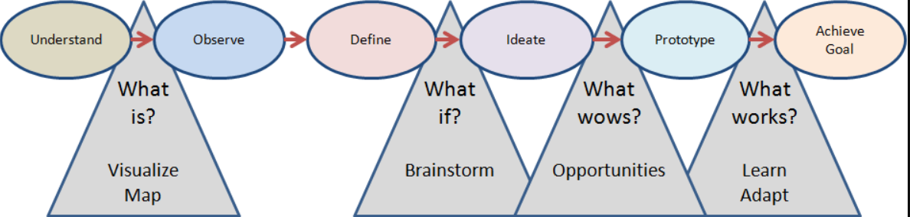
Figure 22: Figure of design thinking approach [69].

Design thinking is a form of rapid testing. This is a form of cheap and quick basic prototyping in order to develop a working adaptable product at a fast pace [71].

Examples of projects and companies that have adopted this approach are numerous. AirBnb took on the methodology when trying to save their failing business [70].

Medical fields have also adopted the approach. One example is Stanford hospital which used design thinking to redesign hospital units, clothing and approaches to better suit their patients [68].

Appendix D: Hardware continuation

In the hardware design section of the report, the glasses and seeeduino were discussed. For the readers understanding the remaining components used for the glasses are show below complemented with discussion around their usage.

Since grove is the common component brand, the project will be using grove to grove jumper cables seen in figure 23.

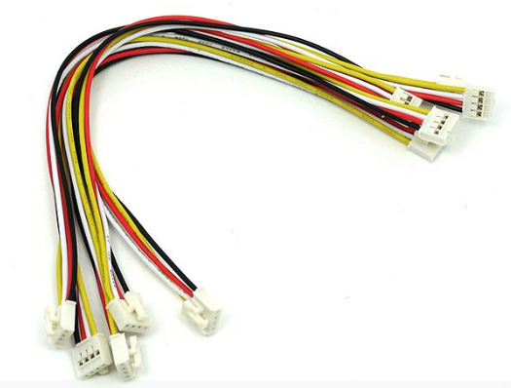
Figure 23: Grove jumper cables [15].

After some consideration, the author realised that the Seeeduino V4.2 would only be able to support a maximum of three grove devices.

Looking at the seeeduino, this is obvious from the fact that it only has three ports suitable for the grove connections. The only other option is to use sensors that are compatible with male-to-female jumper wires.

Presented with this, there were two viable options. The first option was to attach three seeeduino’s to the glasses. Each Arduino would hold a sensor and a buzzer.

An obvious drawback to this concept is the added weight the glasses would sustain. Additionally, this would increase the cost and would be a waste of resources as small amounts of memory and capability would be utilised.

The second option was to add a base shield onto the top of the seeeduino which could then act as a central board for all grove components.

Option two would result in lighter glasses and reduce the excess cost and wiring.

After some research, the chosen component to achieve this is the base shield v2 which can be seen in figure 24 shown below.

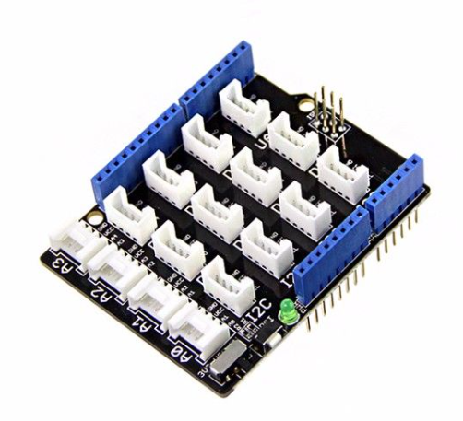
Figure 24: Base shield used to host grove components [18].

Once the MVP is achieved, the project will investigate an extension. In short, to further extend the functionality, an extension was to provide an additional form of notification.

Grove speakers seen in figure 25 are chosen to fulfil this extension, as the components are suited to the base shield and are very lightweight.
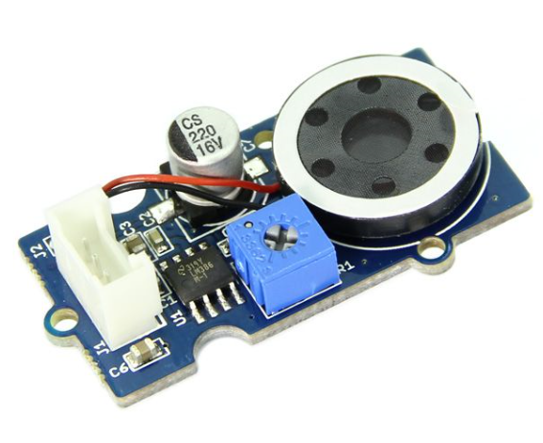
Figure 25: Grove speaker used for alternative notification [19].

The image above shows the grove speakers which will provide an alternative response back to the users.

Appendix E: Recommendations for further research

The sheer number of potential improvements stated in the main project was too large to complete within the word count limit. Hence it is continued in this appendix.
The second item on the future concepts list (see main project) raises some curiosity, assuming vehicles become fully automated and require no human input, could the device and self-driving vehicles communicate to reduce danger?
From reading [27], artificial intelligence is a huge field from smart buildings to medical diagnosis and beyond.
One such area of interest is the current and potential development of communication between AI devices [29].
Communication raises an interesting concept for the glasses. Discussion between computers has been a growing development for some time [30]. Therefore, the report would assume AI-to-AI device communication would also be a future reality.
Relating this to the glasses, the report suggests that self-driving vehicles and the glasses could talk to each other when they are within proximity.
The glasses could then alert the user to the car and likewise the car could slow down or stop depending on risk to the blind person.
Concepts stated, combined with self-driving vehicles could make the roads safer. To support this statement the report states that there is already a large amount of discussion on how autonomous vehicles will reduce road dangers [31].
Extending on this, while also addressing the next two concepts from the list, GPS pings for emergencies and satellite navigation are also outlined as existing or potential devices in autonomous vehicles [31].
Applying these same principles to the glass’s users could send off an emergency beacon if in danger and even use satellite navigation to guide them to their destinations.
An added benefit of this is that users who find out they have become lost could simply be redirected to another route instead of finding themselves in a very stressful situation.
Buzzer noise will eventually become a nuisance to both the user and surrounding crowds.
Although this could be beneficial to alerting crowds to their presence; some users may wish to be more incognito.
Additionally, the glasses would be useless to those who are hard of hearing. Hence, an available feature of the glasses is the use of bone conductors.
Bone conduction headphones are vibration devices that could communicate the glasses intentions by vibrating the sounds through the skull [32]. Thus, ensuring the functionality of the glasses is accessible by different categories of disabled users.
An example of their use is a project which used the information read from signs to wirelessly transmit an audio message through the skull using bone conduction [47].
Lane guidance is an interesting and growing field. Using machine learning a car can take photos of the road ahead and helps ensure the vehicle stays within the lanes [33].
In other words, if a car gets too close or crosses a lane a self-driving car can divert the direction of the wheels to realign the car safely within the lane boundaries.
Figures 26 and 27 visualise how lane control works. The reader should now be able to imagine how the glasses can essentially apply the same software to assist blind users when walking down alley ways and pavements.

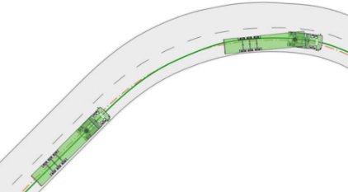
Figure 26: Figure of lane control assisting a car around a corner taken form [33].
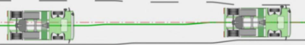
Figure 27: Figure of lane control assisting a car into a narrower lane taken from [33].
To be clear the glasses would not physically move the user but vibrate to direct them left or right and verbally warn them of narrow lanes.
Shin pad sensors with vibrators could be used as another form of foot-level obstacle detection. Similarly, to the glasses, they can be used to detect objects and vibrate on the user’s leg.
The visible drawback to this is the movement of walking which could trick the sensors.
Additionally, when the leg is angled upwards during the step action, the distance from sensor to object will be affected this relates to an absolute angle [34].
The report proposes the question: should the glasses be limited to those who are fully or partially blind?
Simply put, the answer is no. Extending this answer, the glasses have other uses which may not first become apparent.
Take the scenario of deep-sea welders, divers and exploration teams. From reading [35], visibility is low in the depths of the ocean.
This is supported by the quote “the most powerful searchlights don’t penetrate very far in the deep abyss- typically only tens of feet” [35].
In fact, a large issue in deep sea exploration is sediment and changes across the terrain due to tectonic shifts.
These changes and frontal obstacles could be navigated using the glasses in the same way a blind person could navigate the streets. [36].
The final point in the list is visual reality (VR), augmented reality (AR) and mixed reality (MR) the meanings of these technologies are described below:
- VR – Environment completely consisting of digital construction [48].
- AR - Plants digitally generated environments onto a live environment [48].
- MR - Incorporates both AR and VR [48].
This line of research could benefit deep sea divers or partially blind users by producing an AR, VR or MR visual display of the non-visible paths ahead.

Appendix F: Participant raw data collection

The following section contains the questionnaire and interview response data from all participants who took part in the project.

Note for reader: The following data has not been altered and may contain spelling and grammar errors.

F.1 Subject A’s questionnaire raw data

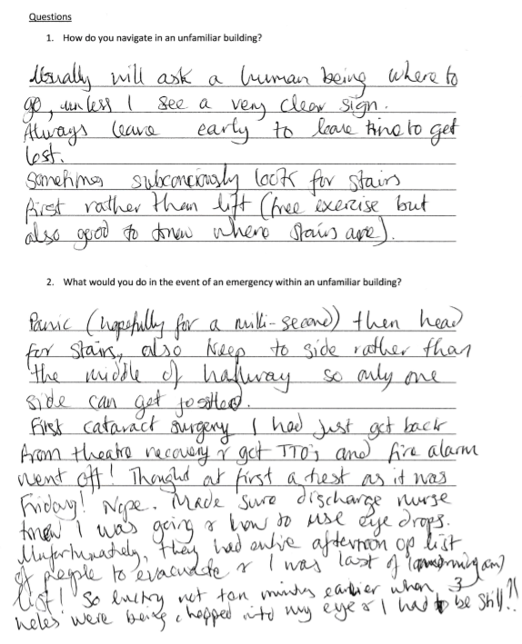
Figure 28: Figure of subject A's questionnaire response (page 1)
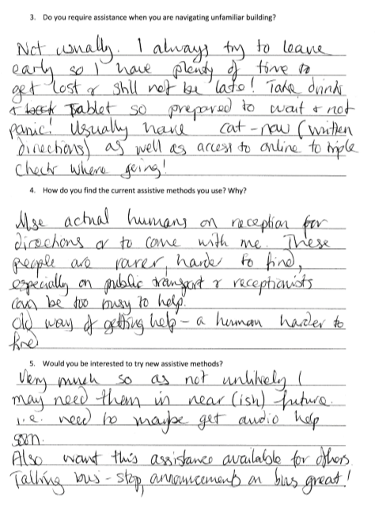
Figure 29: Figure of subject A's questionnaire response (page 2)
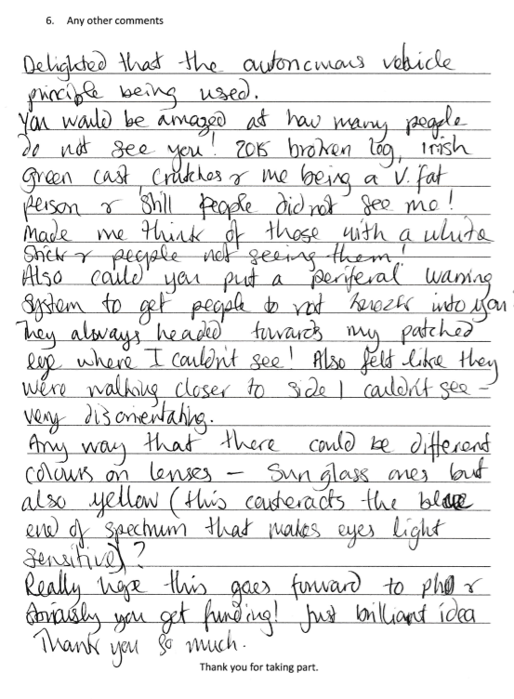
Figure 30: Figure of subject A's questionnaire response (page 3)

F.2 Subject B’s questionnaire raw data:

- How do you navigate in an unfamiliar building?

I use a combination of my long cane, residual peripheral vision and information derived from my other senses. My long cane provides me tactile information about ground level terrain and obstacles up to waist height. This includes, for example, rough underfoot surfaces, stairs, doors that may be closed in front of me et cetera. I also use the long cane to detect what is coming up on either side of me, for example, turnings when walking down a corridor.

I use my residual peripheral vision to try and get an overview of my surroundings. For example, light perception to pick up windows and doorways, contrasting flooring that may indicate different areas of the building, shadows that may indicate walls or surrounding furniture et cetera. As my vision has deteriorated further, I have also found me using the ‘pattern’ of overhead lighting to ‘map” by environment. For example, I may use the shape of overhead lighting when walking down the corridor to pick up turnings, corner lighting to get an idea of the overall size of a room or to identify specific objects (such as the bedside tables in a hotel room). I also find myself increasingly relying on my memory of these “patterns” to recall the layout of an area when visiting thereafter.

Finally, I use information from my other senses to identify features of my environment. For example, a cold draft may signify doors or windows, the sound of people talking or moving about may signify communal areas, I would identify individual objects by their sound (for example computers, taps, the hum of fluorescent lighting, or the sound made by people moving different pieces of furniture such as tables or chairs. Sense of smell is also important to try and determine the purpose of the room, for example, a kitchen, bedroom or meeting room all have different smells. Finally, and most obviously given my visual impairment is my sense of touch for identifying smaller items around me. I also use touch to identify light switches, lift buttons et cetera.

- What would you do in the event of an emergency within an unfamiliar building?

To balance my visual impairment, I have extremely good memory recall for sounds, directions and roots which I have followed. The latter is almost instinctual wherever I go. In the event of an emergency situation where other people are present, I would use my sense of hearing to navigate to where they are and ask for help or failing that to follow the sound of their footsteps to exit the building. I would also use my long cane and the techniques detailed in the above question to try and exit the building. I do sometimes find that I can lose my spatial awareness, particularly where there are large empty spaces, and this can be problematic, for example, where a building’s automatic fire doors have closed and thus the empty space I am navigating during the time of the emergency is not the same as that which I may have navigated previously. In an emergency situation where people are not present I would use the above techniques to try and retrace my steps back to the entrance of the building, or where this may not be possible, t find stairs or an alternative route to reach an area of the building where there may be others present. For my personal safety in the event of just such an incident I have developed a routine of always carrying my phone with me as well as a spare if the battery runs down. This would be standard practice anyway as I also use additional apps on my phone such as an OCR reader to read documents, Google lends and transport navigation apps.

- Do you require assistance when you are navigating unfamiliar building?

Absolutely, as I cannot read signage, follow maps or detect large objects until I am very close to them. In the case of the latter point this is limited to seeing objects a few feet in front of me. This is however dependent on the ambient lighting or my overall visual condition which can fluctuate with tiredness, the effect of regular painkillers which I must take for accompanying Raynaud’s disease, et cetera. Another factor to consider is the additional time it takes me to “investigate” each item or turning I come across to determine if this may be the correct one to reach my destination. This includes, for example, working out the difference between an alcove or an actual corridor, a cupboard door or one which leads into a room or dead ends which I am unable to see from further away. Getting around unfamiliar areas is also hampered by increased pain when Raynaud’s disease is particularly bad or stress when I’m in a rush which can make it harder for me to recognise objects or to focus on where I’m going and the information received from my other senses. It’s also worth noting that my sense of touch is often limited due to my need to wear gloves for pain relief (raynaud’s is affected by hands getting too cold).

- How do you find the current assistive methods you use? Why?

The length of my long cane means that it is only able to effectively pick up obstacles a maximum of 1.5 to 2.0 m in front of me. This is further reduced when walking quickly (I am a naturally fast walker) as I must take my stopping distance into account from the point where my long cane encounters the obstacle. A long cane also cannot pick up obstacles above waist height, especially those which may be a danger to the eyes such as low tree branches or signs. Finally, it cannot pick up obstacles alongside that may be just out of reach of the canes sweep. It is worth noting that most people are taught to use a long cane by holding it at the centre of the body however in practice this is impractical. Given most pavements are uneven it is easy for the cane to ‘jam’ against an uneven paving slab and hence for the handle to be uncomfortably pushed into the stomach. Therefore, many long cane users including myself hold the cane to one side of the body and increase the sweep to compensate. Nevertheless, I still find myself often hitting objects with my shoulder such as doors, bins or other pieces of furniture.

I use GPS and walking directions to get about outdoors however given that GPS is only effectively accurate to within 10 m and as most navigation apps assume that the user will have the visual acuity to see their destination, it is necessary to mentally add on some distance to compensate between the point when the satellite navigation directions end and my intended destination. It also means that I usually must seek sighted assistance to find the specific point I wish to reach, for example, the exact shop door on a high street.

Being unable to read signage, make out the direction of arrows or distinguish pictures is a big barrier to getting around independently especially as many places, such as large hospitals, do not have the facility to provide one-to-one assistance without a delay waiting for staff to become available. Also, many textual signs are being replaced by graphical ones to make them more inclusive to those who cannot understand print. Finally, as I have difficulty judging distance and cannot make out large objects until I am very close to them, there is a constant sense of uncertainty as to whether I have reached where I want to go as many signs within buildings do not give walking distances. This is especially true within larger buildings such as railway stations, airports or those where there are many doors close together.

- Would you be interested to try new assistive methods?
Absolutely. I’m also happy to test methods over a longer period and provide continuous feedback during active use and have experience doing this for both accessibility software and hardware products.

F.3 Subject C’s questionnaire raw data:

- How do you navigate in an unfamiliar building?
I ask to be sighted guided or for people to give me verbal instructions in how to navigate the building. I may use my cane in a large unfamiliar building but not usually in people's houses.

- What would you do in the event of an emergency within an unfamiliar building?
I would call out for someone or use my phone to find the phone number for the owner of the building to ask for assistance. I may also call friends or family on my phone if they are nearby.

- Do you require assistance when you are navigating unfamiliar building?
Most often yes. I may walk around train stations by myself if I have not visited them before by following other people's footsteps and listening for announcements.
- How do you find the current assistive methods you use? Why?
Gps is very useful as it works in most outdoor places and can usually give me a pretty good idea of where I am. It also works well on buses because it is difficult to tell which stop you are at without GPS especially in cities where the roads feel very similar as you are driving along them. I use blindsquare and the Ariadne Gps is very useful as it works in most outdoor places and can usually give me a pretty good idea of where I am. It also works well on buses because it is difficult to tell which stop you are at without GPS especially in cities where the roads feel very similar as you are driving along them. I use blindsquare and the ariadne GPS apps. Initiatives like wayfindr which use bluetooth beacons are very helpful but this technology is rarely used at all. Talking bus stop technology is useful but I find the audio announcements are more useful in actually physically locating the bus stops rather than the next bus information as this can also be found on your smartphone by using apps like UK bus checker. Aira is a great idea where trained agents can guid you around over a video call but this is an expensive option and relies on you holding your phone out in front of you.

- Would you be interested to try new assistive methods?
Yes very much so. I've always been interested in getting round more efficiently and easily and whilst the white cane is useful it is still a challenging to use on its own.

- Any other comments

I have heard about a product called the sunu band which has obstacle detection. I am still yet to find out more about it and hopefully I will get chance to test it at some point. Also the spaces to right my answers in the questionnaire are making my screen reader NVDA run a bit slow. It would be quicker and more accessible to leave a plain blank space for people to write their answers rather than a small table. It sounds like only one or two words can fit on each line but I may have been writing my answers in the wrong place.

Thank you for taking part.

F.4 Subject D’s questionnaire raw data:
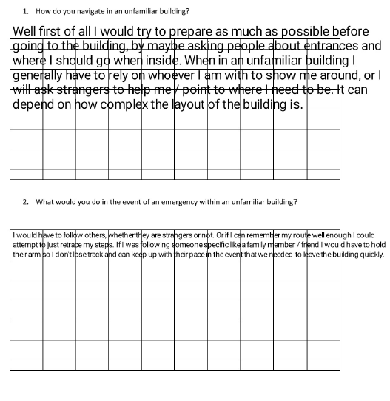
Figure 31: Figure of subject D's questionnaire response (page 1)
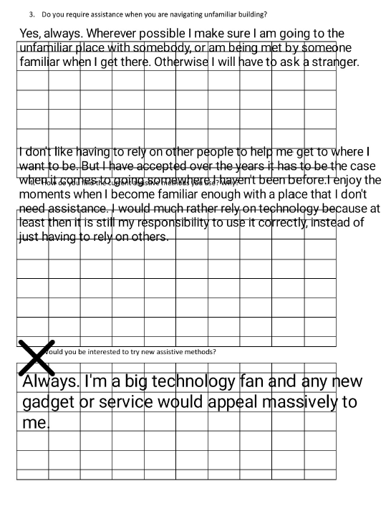
Figure 32: Figure of subject D's questionnaire response (page 2)
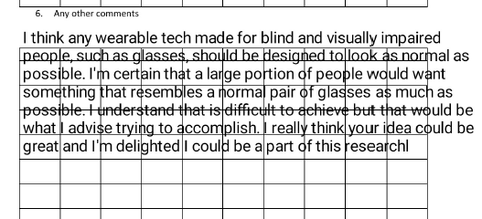
Figure 33: Figure of subject D's questionnaire response (page 3)

F.5 Subject E’s questionnaire raw data
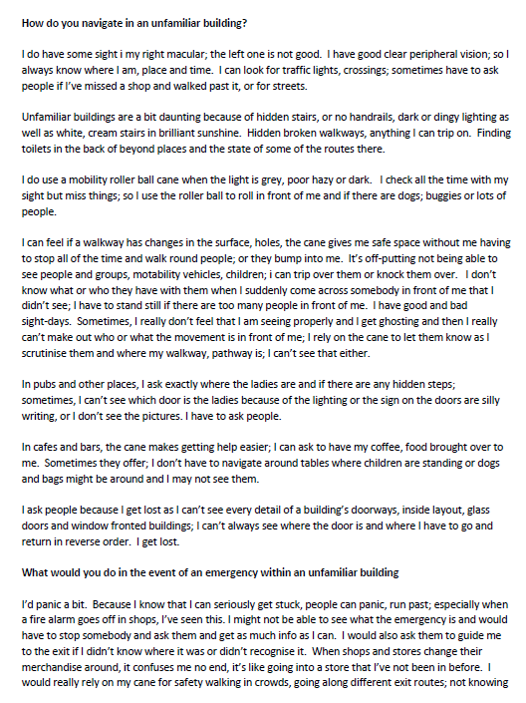
Figure 34: Figure of subject E's questionnaire response (page 1)
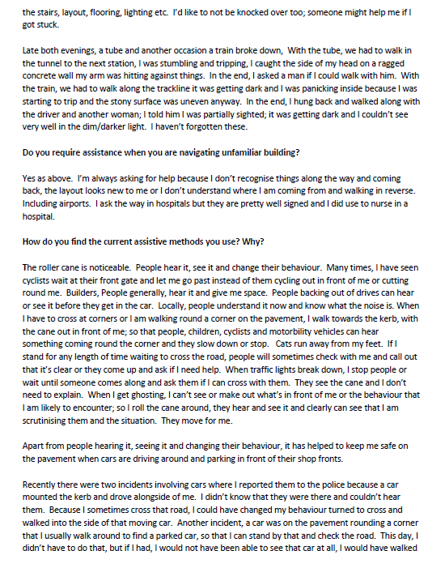
Figure 35: Figure of subject E's questionnaire response (page 2)
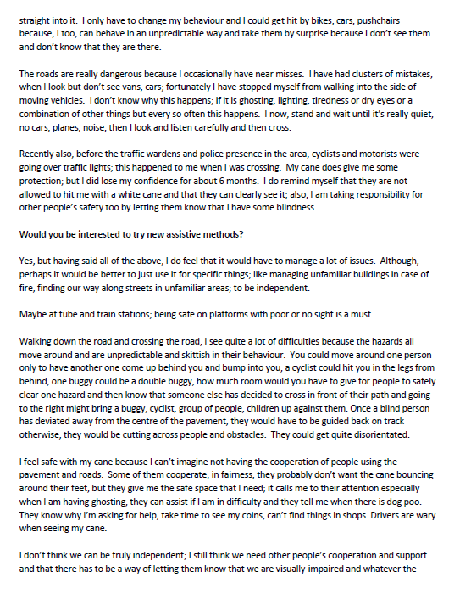
Figure 36: Figure of subject E's questionnaire response (page 3)
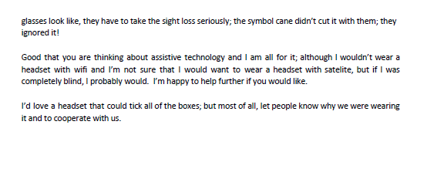
Figure 37: Figure of subject E's questionnaire response (page 4)

Note for reader, the following online interview raw data displays conversation between the author and subjects. Outlined in this area is proposed ideas for the current and future concepts of the glasses. These ideas were presented to the subjects by the author.

F.6 Online interview raw notes with subject A:

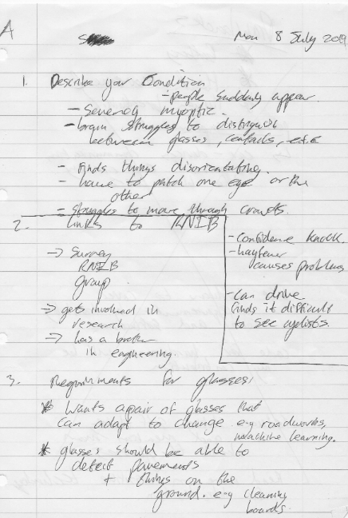
Figure 38: Authors notes of subject A's interview response (page 1)

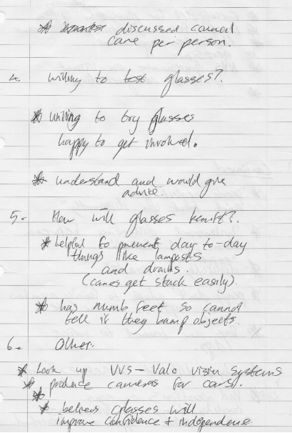
Figure 39: Authors notes of subject A's interview response (page 2)

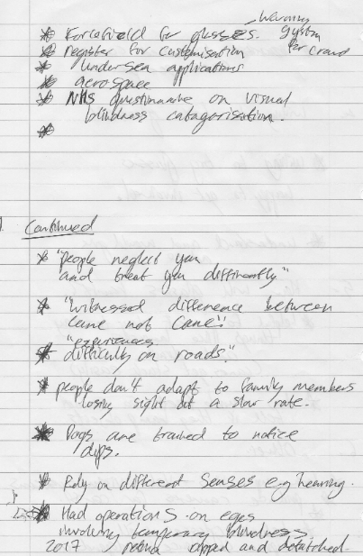
Figure 40: Authors notes of subject A's interview response (page 3)

F.6 Online interview raw notes with subject B:

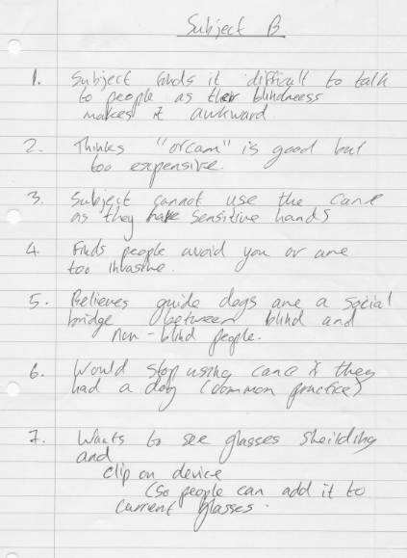
Figure 41: Authors notes of subject B's interview response (page 1)

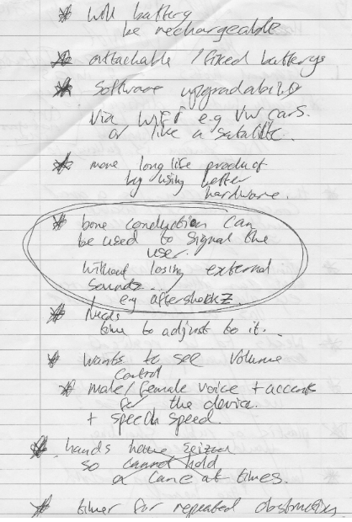
Figure 42: Authors notes of subject B's interview response (page 2)

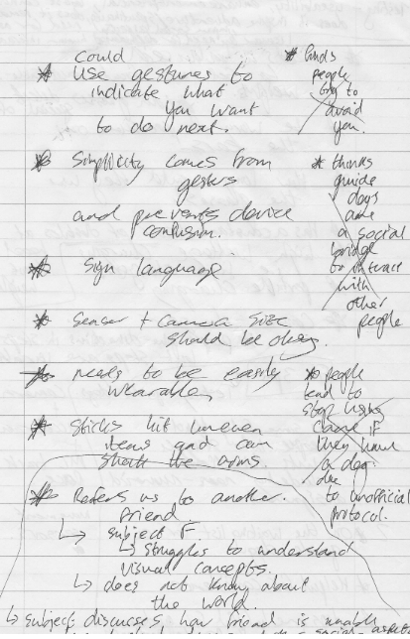
Figure 43: Authors notes of subject B's interview response (page 3)

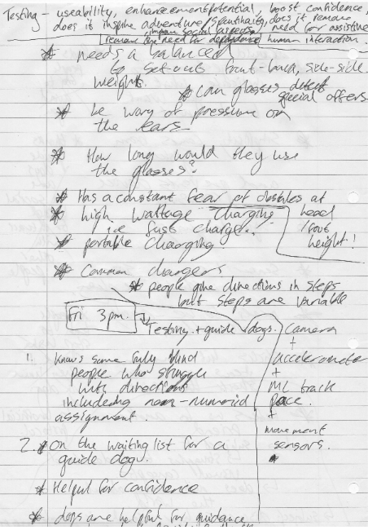
Figure 44: Authors notes of subject B's interview response (page 4)

F.7 Online interview raw notes with subject C:

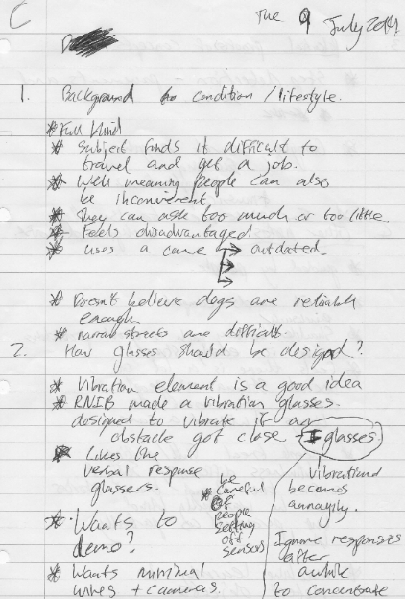
Figure 45: Authors notes of subject C's interview response (page 1)

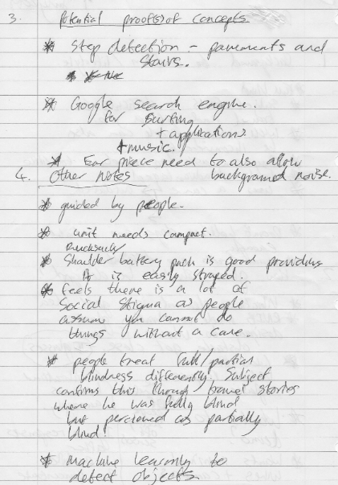
Figure 46: Authors notes of subject C's interview response (page 2)

F.8 Online interview raw notes with subject D:

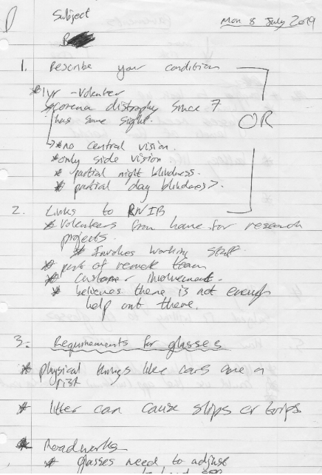
Figure 47: Authors notes of subject D's interview response (page 1)

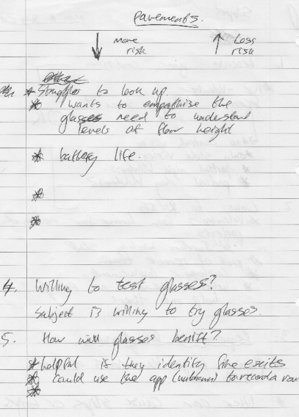
Figure 48: Authors notes of subject D's interview response (page 2)

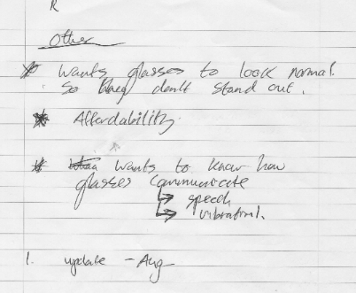
Figure 49: Authors notes of subject D's interview response (page 3)

F.9 Online interview raw notes with subject E:

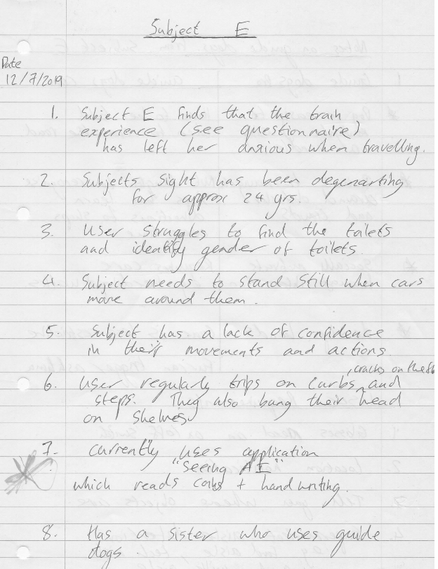
Figure 50: Authors notes of subject E's interview response (page 1)

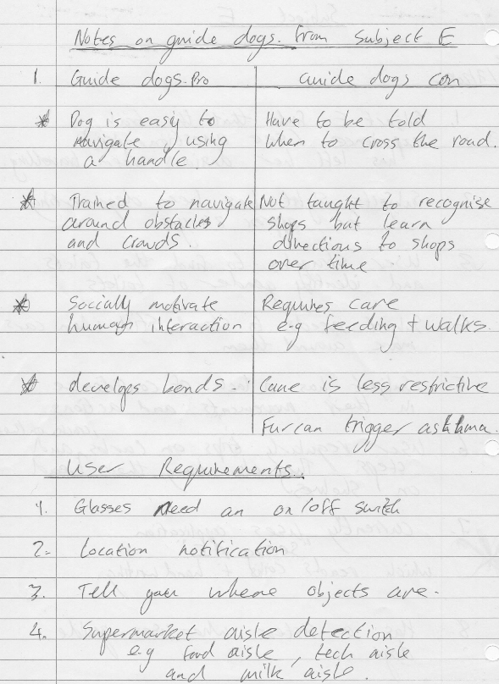
Figure 51: Authors notes of subject E's interview response (page 2)

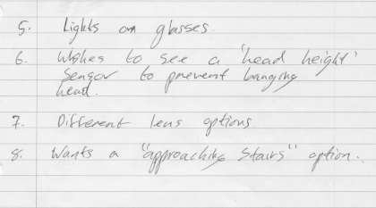
Figure 52: Authors notes of subject E's interview response (page 3)

Appendix G: Code for the BATGLASSES M1 and M2

This section of the report contains the code for both glasses. Codes include the original version and the post-testing improved version.

G.1 Code for basic sensor test using Arduino and pins.

int pinTrigger = 2;
int pinEcho = 3;
float timeForPingFeedback;
float distanceFromSensorToTarget;
float speedOfSound = 758.82; //(mph based on average temperature of the uk which is approx 56 degrrees Fahrenheight)
void setup()
{
Serial.begin(9600);
pinMode(pinTrigger, OUTPUT);
pinMode(pinEcho, INPUT);
}
void loop()
{
digitalWrite(pinTrigger, LOW); //set pin low
delayMicroseconds(2500); //wait signal while
digitalWrite(pinTrigger, HIGH); //creates a pulse
delayMicroseconds(17); //wait for signal to hit
digitalWrite(pinTrigger, LOW); //goes * back to low state
timeForPingFeedback = pulseIn(pinEcho, HIGH); //calculates ping time in ms
distanceFromSensorToTarget = ((speedOfSound * (timeForPingFeedback / 3600000000.)) / 2) * 63360; // converts time for ping to inches
Serial.print("Distance is: ");
Serial.println(distanceFromSensorToTarget);
/*
This next section will output some printed lines based on the distance it obtains.
This can later be used to provide functionality to the responses based on varying distances from the glasses.
*/
if (distanceFromSensorToTarget >= 35.41 && distanceFromSensorToTarget <= 51) {
Serial.println("The distance to the front is between 35.41 and 51 inches");
} else if (distanceFromSensorToTarget >= 23.61 && distanceFromSensorToTarget <= 35.4) {
Serial.println("The distance to the front is between 23.61 and 35.4 inches");
} else if (distanceFromSensorToTarget >= 11.81 && distanceFromSensorToTarget <= 23.6) {
Serial.println("The distance to the front is between 11.81 and 23.6 inches");
} else if (distanceFromSensorToTarget <= 11.8) {
Serial.println("The distance to the front is less than 11.8 inches");
}
}

G.2 Original code for M1.

#include <Ultrasonic.h> //library reference [53]
Ultrasonic ultrasonic(5); // defining the front sensor
Ultrasonic ultrasonicTwo(3); // defining the left sensor
Ultrasonic ultrasonicThree(8); //defining the right sensor
void setup()
{
pinAssign(); // call assignment function
}
void loop()
{
frontApp(); //function to control frontal sensor and buzzer
leftApp(); //function to control frontal sensor and buzzer
rightApp(); //function to control frontal sensor and buzzer
}
void pinAssign()
{
Serial.begin(9600); // begin program on port 9600
pinMode(6, OUTPUT); // assign output for front buzzer
pinMode(2, OUTPUT); // assign output for left side buzzer
pinMode(7, OUTPUT); // assign output for right side buzzer
}
void frontApp()
{
long distanceFromSensorToTarget;
distanceFromSensorToTarget = ultrasonic.MeasureInInches(); //send and receive an ultrasonic ping
if (distanceFromSensorToTarget >= 40 && distanceFromSensorToTarget <= 50)
{
digitalWrite(6, HIGH); // if ping distance is 40-50 inches buzz for half a second
delay(500);
digitalWrite(6, LOW); // switch buzzer of for a second.
delay(1000);
}
else if (distanceFromSensorToTarget >= 30 && distanceFromSensorToTarget < 40)
{
digitalWrite(6, HIGH); // if ping distance is 30 inches or above and less than 40 inches buzz for half a second
delay(500);
digitalWrite(6, LOW); // then rest for half a second
delay(500); // this introduces a faster frequency of pulses
}
else if (distanceFromSensorToTarget >= 20 && distanceFromSensorToTarget < 30)
{
digitalWrite(6, HIGH); // if ping distance is 20 inches or above and less than 30 inches buzz for a quarter of a second
delay(250);
digitalWrite(6, LOW); // rest for a quarter of a second
delay(250);
}
else if (distanceFromSensorToTarget < 20) {
digitalWrite(6, HIGH); // if ping distance is less than 20 inches buzz for one and a half seconds
delay(1500);
digitalWrite(6, LOW); // then rest for a quarter of a second
delay(250);
}
Serial.print("The distance to the front is: "); // used for testing
Serial.print(distanceFromSensorToTarget);
Serial.println(" inches.");
}
void leftApp()
{
long distanceFromSensorToTargetTwo;
distanceFromSensorToTargetTwo = ultrasonicTwo.MeasureInInches();
if (distanceFromSensorToTargetTwo <= 16)
{
digitalWrite(2, HIGH);
delay(10);
digitalWrite(2, LOW);
}
Serial.print("The distance to the left side is: ");
Serial.print(distanceFromSensorToTargetTwo);
Serial.println(" inches.");
}
void rightApp()
{
long distanceFromSensorToTargetThree;
distanceFromSensorToTargetThree = ultrasonicThree.MeasureInInches();
if (distanceFromSensorToTargetThree <= 16)
{
digitalWrite(7, HIGH);
delay(10);
digitalWrite(7, LOW);
}
Serial.print("The distance to the right side is: ");
Serial.print(distanceFromSensorToTargetThree);
Serial.println(" inches.");
}

G.3 Amended code for M1.

#include <Ultrasonic.h> //library reference [53]
Ultrasonic ultrasonic(5);
Ultrasonic ultrasonicTwo(3);
Ultrasonic ultrasonicThree(8);
void setup()
{
pinAssign();
}
void loop()
{
frontApp();
leftApp();
rightApp();
}
void pinAssign()
{
Serial.begin(9600);
pinMode(6, OUTPUT); // front buzzer
pinMode(2, OUTPUT); //left side buzzer
pinMode(7, OUTPUT); //right side buzzer
}
void frontApp()
{
long distanceFromSensorToTarget;
distanceFromSensorToTarget = ultrasonic.MeasureInInches();
if (distanceFromSensorToTarget >= 70 && distanceFromSensorToTarget <= 100)
{
digitalWrite(6, HIGH);
delay(250);
digitalWrite(6, LOW);
delay(250);
}
else if (distanceFromSensorToTarget >= 50 && distanceFromSensorToTarget < 70)
{
digitalWrite(6, HIGH);
delay(150);
digitalWrite(6, LOW);
delay(150);
}
else if (distanceFromSensorToTarget >= 30 && distanceFromSensorToTarget < 50)
{
digitalWrite(6, HIGH);
delay(100);
digitalWrite(6, LOW);
delay(100);
}
else if (distanceFromSensorToTarget < 30) {
digitalWrite(6, HIGH);
delay(10);
digitalWrite(6, LOW);
}
Serial.print("The distance to the front is: ");
Serial.print(distanceFromSensorToTarget);
Serial.println(" inches.");
}
void leftApp()
{
long distanceFromSensorToTargetTwo;
distanceFromSensorToTargetTwo = ultrasonicTwo.MeasureInInches();
if (distanceFromSensorToTargetTwo <= 16)
{
digitalWrite(2, HIGH);
delay(10);
digitalWrite(2, LOW);
}
Serial.print("The distance to the left side is: ");
Serial.print(distanceFromSensorToTargetTwo);
Serial.println(" inches.");
}
void rightApp()
{
long distanceFromSensorToTargetThree;
distanceFromSensorToTargetThree = ultrasonicThree.MeasureInInches();
if (distanceFromSensorToTargetThree <= 16)
{
digitalWrite(7, HIGH);
delay(10);
digitalWrite(7, LOW);
}
Serial.print("The distance to the right side is: ");
Serial.print(distanceFromSensorToTargetThree);
Serial.println(" inches.");
}

G.4 Original code for M2.

#include <Ultrasonic.h> //library reference [53]
Ultrasonic ultrasonic(4); //assign speaker to D4
Ultrasonic ultrasonicFour(5); // assign sensor to D5
void setup()
{
pinAssign(); // set up pins and serial port
}
void loop()
{
speakerDetect(); //run the speakerDetect function
}
void pinAssign()
{
Serial.begin(9600);
}
void speakerDetect()
{
int sound[] = {1012, 1803, 1702, 1431, 1136 , 1702 , 1607, 1275, 1012, 1351, 1431, 1607, 1702, 1803, 1911, 1911}; // melody for speaker
int i;
int j;
long distanceFromSensorToTargetFour; //sensor variable
distanceFromSensorToTargetFour = ultrasonicFour.MeasureInInches();
Serial.print("Distance is: ");
Serial.println(distanceFromSensorToTargetFour);
if (distanceFromSensorToTargetFour <= 50) // if obstacle is less than 50 inches then sound the speaker using the melody
{
for (j = 0 ; j < 16; j++)
{
for (i = 0 ; i < 100; i++)
{
digitalWrite(4, HIGH);
delayMicroseconds(sound[j]);
digitalWrite(4, LOW);
delayMicroseconds(sound[j]);
}
}
}
else
{
for (i = 0; i < 4; i++)
{
digitalWrite(4, HIGH); //this prevent the speaker from continously sounding
delay(10);
}
}
Serial.println(distanceFromSensorToTargetFour);
}

G.5 Amended code for M2.

#include <Ultrasonic.h> //library reference [53]
Ultrasonic ultrasonic(4); ////prep ultrasonic port 4
Ultrasonic ultrasonicFour(5); //prep ultrasonic port 5
void setup()
{
pinAssign(); //run the pinAssignMethod.
}
void loop()
{
speakerDetect(); //loop the speakerDetect function.
}
void pinAssign()
{
Serial.begin(9600); //start the serial port on 9600
}
void speakerDetect()
{
int sound[] = {1012, 1803, 1702, 1431, 1136 , 1702 , 1607 }; // melody for speaker.
int i; //variable used for loop
int j; //variable used for loop
long distanceFromSensorToTargetFour; // variable for the ultrasonic distance.
distanceFromSensorToTargetFour = ultrasonicFour.MeasureInInches(); //measure distance from sensor to obstacle.
Serial.print("Distance is: ");
Serial.println(distanceFromSensorToTargetFour);
if (distanceFromSensorToTargetFour <= 56) //if the obstacle is less than 56 inches then run the loop.
{
for (j = 0 ; j < 7; j++) // this loop will run the sound to alert users to litter or objects on the floor.
{
for (i = 0 ; i < 100; i++)
{
digitalWrite(4, HIGH);
delayMicroseconds(sound[j]);
digitalWrite(4, LOW);
delayMicroseconds(sound[j]);
}
}
}
else // this else staement will prevent the sensor from distracting the user when there is no obstacle detected.
{
for (i = 0; i < 4; i++)
{
digitalWrite(4, HIGH);
delay(10);
}
}
Serial.println(distanceFromSensorToTargetFour);
}

