

Programme: Master of Business Administration
Module Name and Code: International Business Concepts and LCMB7034
Topic name: IKEA in Uzbekistan
Assignment Title: Report
Lecturers’ Name: jean wang
Student Name: Chaklashiya dhruviben mukeshbhai
Student ID:2431413
Word Count: 5173
Submission Date: Friday 14th August 2026 by 2pm

AI Acknowledgement
For having an general idea of different frameworks, such as Bartlett and Ghoshal matrix, OLI Framework and Gibbs reflective cycle, I have used AI tools. It has provided me with the general ideas along with some examples, which has been effective for understanding the frameworks and using those in my report.

Table of Contents
Introduction 4
Section 1: International market entry analysis 4
1. Organisational Classification and Global Strategy of the IKEA 4
1.1 Strategic Categorisation Using Bartlett and Ghoshal's (1989) Model 4
1.2 Global Configuration and Contribution to Competitive Advantage 5
2. Macro-Environmental Appraisal and Market Attractiveness 7
2.1 Host Country Analysis 7
2.2 External environmental factors 8
2.3 Evaluation of Market Attractiveness 14
2.4 Use of OLI framework 15
2.5 Critical Analysis of OLI 18
3. Entry Mode Strategy and Strategic Synthesis 18
3.1 IKEA’s Historical Entry Mode 18
3.2 Evaluation of Historical Entry Strategy 20
3.3 Strategic Fit, Justification for IKEA 20
3.4 Conclusion and Recommendations 21
Section 2: Gibbs Reflective cycle 22
Conclusion 24
References 26

Introduction
IKEA is a worldwide furniture seller company which is known for affordable, Scandinavian-style products. The possible entry of this company to the furniture market of Uzbekistan has been analysed in this report. The global strategy of IKEA is analysed first, then the business environment and market appeal of Uzbekistan are analysed in this report. The OLI framework is used to analyse the possible entry of IKEA into markets and suggest a suitable entry mode.

Section 1: International market entry analysis

1. Organisational Classification and Global Strategy of the IKEA

1.1 Strategic Categorisation Using Bartlett and Ghoshal's (1989) Model
IKEA is one of the world’s biggest multinational corporations in the furniture and home furnishings retail business. It was established in Sweden in 1943 and currently has more than 480 stores across 60 markets in the whole world (IKEA, 2025). The stores some of which are company owned and the remainder are franchises. IKEA has a leading position globally, with retail sales totalling 45.1 billion in FY2024.
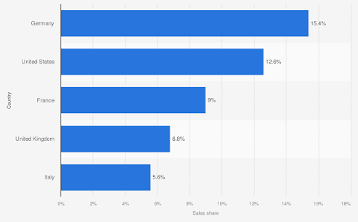
Figure 1: Top retail selling countries IKEA 2025
(Source: Statista, 2025)
According to the Bartlett and Ghoshal’s (1989) model IKEA maintains the transnational strategy. IKEA rapidly increases their efficiency globally while being responsive locally. The company creates multiple advanced products design, store layouts, supply chain and flat-pack packaging (Bouhia, 2022). Thereby lowering its production and transport costs, building economies of scale and accurately establishing a consistent global brand. Moreover, IKEA responds to the various needs of the customers in its area. In China, there are stores selling the small sized furniture for apartment living, but in India the stores are giving those products that are produced for its cooking habits and family size. Many types of local dishes are also served in IKEA restaurants along with Swedish dishes to rapidly enhance the customer experience (Bookman and Hall, 2022).
This approach will make the operations more complicated and involve more sample testing and market research. But it enables IKEA to satisfy the varying needs of its customers at a cost-effective price. Guven (2026) mentioned that in spite of its long global value chain, of its various flexibility when developing many kinds of products, IKEA properly manages to combine standardisation and adaptation well, creating a proper market competitive advantage. These are for that it can count on in foreign markets.

1.2 Global Configuration and Contribution to Competitive Advantage
IKEA has built a very coherent network to properly execute its business around the world. This is the benefit from its long-term competitive advantage. It continues to grow in Europe although it had had the most success in North America, Asia and the Middle East. IKEA has an efficient international production network with approximately 1,600 suppliers in over 50 countries (Rieple, DeFillippi and Schreiber, 2023). This contributes to low production costs and good availability for the various products. The company has a network of 31 distribution centres in the 16 countries (Chen et al., 2024). This is also providing a very efficient management of inventory and worldwide product distribution.
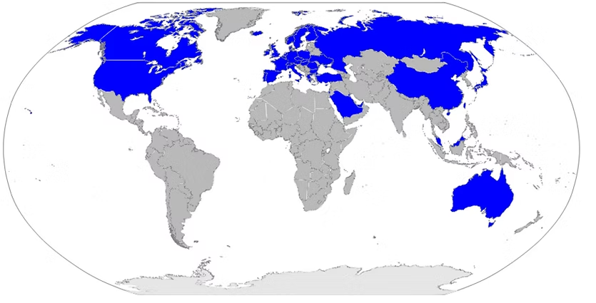
Figure 2: IKEA in the world
(Source: WIX, 2025)
This overall configuration fosters value in a few ways at the global level. IKEA has the various potential of sourcing materials globally at the competitive price, while having proper product quality. Secondly, the economy of scale advantage lowers the company’s manufacturing and shipping costs and serves to continue supplying products at a low price. Third, IKEA puts a lot of work into sustainability, renewable energy and circular business practice. This is boosting the brand in a sustainable way and to deliver better business efficiency in the long-term. The company is also enhancing advanced digital retailing and omnichannel services, giving customers retailing options via an online platform and click-and-collect options in stores.
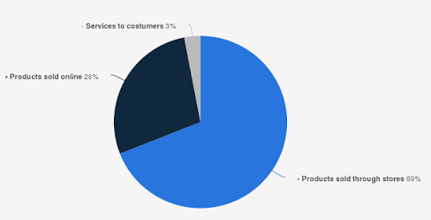
Figure 3: IKEA’s Sales Worldwide
(Source: Statista, 2025)
Overall IKEA by expanding into various countries, they are solidifying their brand and also making it easier. This is for their supply chain to run as efficiently making it hard for other brands to replicate and proving them many kinds of sustainable competitive advantages. IKEA has successfully expanded to many emerging markets, but has no major operations in Uzbekistan, and is therefore a very good option for the future internalisation (Dasgupta and Banik, 2025).

2. Macro-Environmental Appraisal and Market Attractiveness

2.1 Host Country Analysis
The high level of growth has been maintained by the market of Uzbekistan in Central Asia, but the growth should be analysed in a critical way instead of any assumption. The economic reforms have been pushed by the government from the year of 2017, and because of this, the real GDP growth has been increased to 6.5% in the year of 2024 and 7.7% in 2025 (World Bank Group, 2025). Foreign investment has also been increased and over $43 billion was reached in 2025 (Reuters, 2025). So, the strong level of growth is analysed in this market.
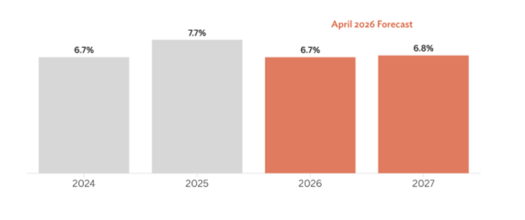
Figure 4: GDP Growth Forecast in Uzbekistan
(Source: AsianDevBank, 2026)
However, the majority of capital was invested in energy, mining and manufacturing sector, rather than in retail sector. As per this, the same level of support or infrastructure may not be provided to the retail sector like furniture. On the other hand, the large number of investments is maintained as public investment instead of private, by which the question about the state of the private retail market is created. Although some challenges can be faced by the company but if the structural and effective plan are maintained by IKEA then the high level of growth will be gained in the market of Uzbekistan.

2.2 External environmental factors
2.2.1 Political
The political and business environment in Uzbekistan has been improved through a series of economic reforms from the year of 2017 (World Bank Group, 2024). The polices has been taken by the government to attract foreign interment, enhance the private sector and increase international trade. So, a more favourable setting has been created by these reforms for international retailers like IKEA by which high investment for the long-term is maintained when entering a new market. The benefit for IKEA is provided by a political stability. Moreover, a stable government has been maintained by Uzbekistan as compared to other developing countries, and because of this, the uncertainty for foreign investors is reduced (Talipova et al., 2022). The business regulations have been enhanced and partnerships with international organisations has been boosted by the government to make them more appealing for foreign direct investments. The expansion of IKEA will be supported by these improvements because the stable policies and predictable business conditions are used by the company.
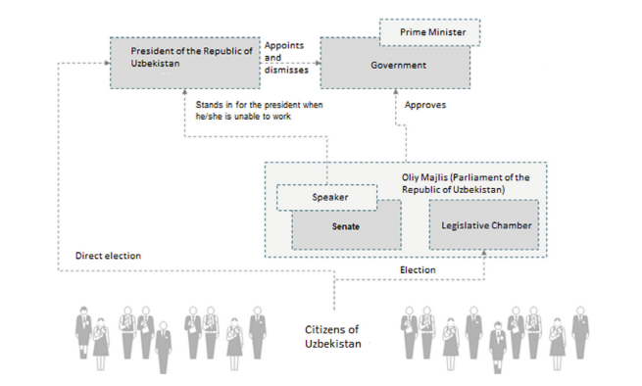
Figure 5: Political System of Uzbekistan
(Source: Burnashev and Chernykh, 2024)
However, some political problems can be faced by the company. The high level of involvement of government in the economy is maintained in Uzbekistan, and the complex and slow administrative procedures can be faced by foreign companies like IKEA. On the other hand, the time and investment for IKEA to set up its operations can be increased because of changes in regulations or delays in policy implementation. The favourable conditions for business development of IKEA will be provided by the support of the government policies of economic reforms and foreign investments. But the close relationship with local authorities and political and regulatory changes should be tracked by IKEA to minimise risk and maintain successful long-term operations.
2.2.2 Economic
The strong level of economic growth has been experienced by Uzbekistan in recent years by which it is being created as an attractive market for international retailers like IKEA. The real GDP of this country has been increased by 6.5% in 2024 and 7.7% in the year of 2025 (CEIC, 2026). Therefore, this growth has been supported by economic reforms, increasing investment and rising household income. The demand of modern furniture and home furnishing products has been increased in rapid way, so the purchasing power of consumers is being improved. On the other hand, the positive importance for this company is provided by the growth of foreign investment. More than US$43 billion was invested in the economy of Uzbekistan in the year of 2025 and the confidence of international companies has been grown in the country's economy (UzDaily, 2025). The benefit for IKEA is also created by rapid urbanisation and the growth of middle class because good quality home products with affordable pricing are being searched by more people.
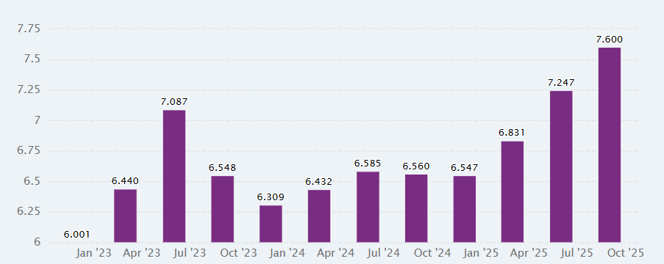
Figure 6: GDP Growth for Uzbekistan from January 2023 – October 2025
(Source: CEIC, 2026)
But some economic issues can be faced by the company. The high level of inflation is maintained, and the purchasing power of customers can be reduced for less essential items like furniture. Moreover, the operational expenses of IKEA can be increased by exchange rate volatility and the escalating cost of imports because many of the products and raw materials may have to be imported initially. The good growth potential for IKEA can be provided by economic environment of Uzbekistan. However, price control, cost of supply chains and risk of currency aspects should be managed by the company in order to maintain competitive price and satisfy local consumers.
2.2.3 Legal
The legal environment of Uzbekistan has been enhanced by it so that more investors and foreign organizations can be attracted (Abdullaeva et al., 2025). The legal reforms have been introduced by the government so that the business registration, contract enforcement can be improved, and foreign investment protection can be provided. Therefore, a better business environment for IKEA to further stabilize the business environment in the country is created through these changes in which clear and stable regulations are needed before creating long term investment. On the other hand, international companies are allowed to set up businesses in Uzbekistan, and several laws and regulatory reforms are created by the government to simplify the investment procedure (Ruziokhunov and Yuldasheva, 2025). Besides that, Consumer Protection laws, Product Safety Standards and international labour laws have been reinforced to enhance good business practice and safeguard customers and workers. So, IKEA will be supported by these legal improvements because high international standards for product quality and responsible business operations are followed the company.
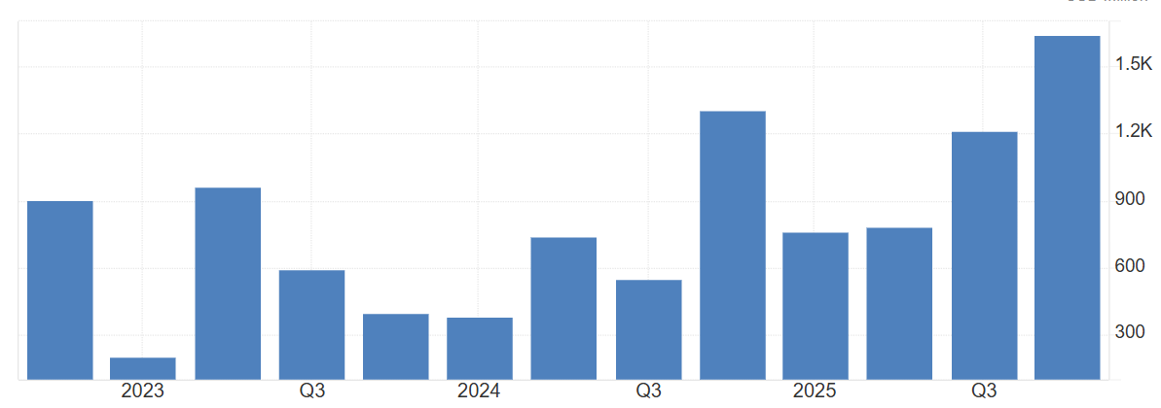
Figure 7: Foreign Direct Investment in Uzbekistan
(Source: Trading Economics, 2026)
But there are some legal challenges which should be managed by the company. Business regulations can be changed because ongoing economic reforms can be created in the country, and delays for licensing, customs, legal clearances can be faced by foreign companies. However, the time and cost of initiating business operations can be increased because of inconsistent enforcement of laws across government departments.
The high level of support for international companies has been provided by legal environment in Uzbekistan. An important opportunity for IKEA to get into the market has been given through these ongoing legal reforms. So full compliance with local laws should be managed, future legal changes should be tracked and collaboration with local legal experts should be maintained to reduce risk and improve long-term business operations.
2.2.4 Cultural
Opportunities and challenges are provided by the cultural environment for IKEA in Uzbekistan. A family-oriented culture has been maintained in this country and a significant part in everyday life and family gatherings is played by homes (Pacala, 2024). So, the comfortable, functional and robust furniture have been valued by consumers and by which the product range of IKEA is connected. The interest in modern home designs and the affordable furniture has been increased by the urban population and middle-income group people. After that, the local traditions and the preferences of their customers should be analysed by IKEA. A strong level of cultural identity is maintained by Uzbekistan and furniture by which local tastes and living styles are reflected, are preferred by consumers. So, some products, colours, and store displays should be used by IKEA to maintain the local expectations and the global brand image of this company. As per the comparison chart, the low level of power distance, masculinity and uncertainty avoidance was maintained by Netherlands as compared to Uzbekistan. So, as per this the same type of business approach cannot be used by IKEA in Uzbekistan.
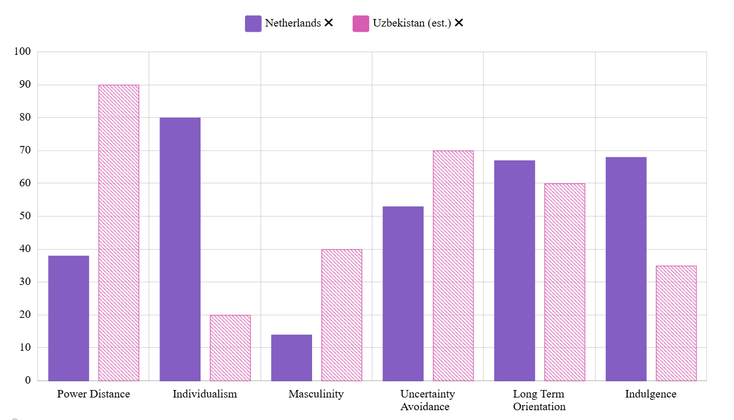
Figure 8: Cultural Differences Chart
(Source: Hofstede, 2025)
On the other hand, the individualism, long term orientation and Indulgence were low in the Uzbekistan as compared to Netherlands so, the consumer buying behaviour can be affected by cultural differences. The traditional shopping methods have been preferred by many customers, and the time will be taken to trust a new international furniture retailer (Kerimova and Ataniyazova, 2024). So effective marketing and local language should be used in marketing process to attract customers in a better way. The strong level of customer relationships can be created and long-term success in the market can be gained through the company by respecting local culture and maintaining its global business model

2.3 Evaluation of Market Attractiveness
2.3.1 Market Opportunities
Various opportunities for IKEA are provided by Uzbekistan because the economic growth and improvement of business environment have been maintained. Strong GDP growth has been maintained and increasing level of foreign investment has been attracted by the country and the better conditions for international retailers has been created through this (U.S. Department of State, 2025). The demand for affordable and modern home furnishing products has been increased by the increment of household incomes and the growth of the middle-income population. The business model of IKEA is supported by this, by which the production of stylish products at affordable prices are focused. On the other hand, the market opportunity for IKEA is being created by the rapid urbanisation of the country. The demand of new homes and furniture has been increased in a rapid way because of this (UzDaily Editorial Team, 2026). So, when the standards of living have been enhanced, the attention of customers in modern home decoration and functional furniture has been increased. Furthermore, the investment environment in Uzbekistan has been enhanced through reforms by the government, and because of this, more attention has been gained by foreign businesses. So, the important market conditions for IKEA have been created by these factors.
2.3.2 Market Challenges
Although good business opportunities have been provided by Uzbekistan, but some challenges can be faced by IKEA in the time of entering this market. The problem can be created because of low pricing power of some consumers as compared to buyers in developed countries. The purchase intention of customers will be reduced, and operations costs will be increased by the inflation and changes in exchange rates (Davlatov et al., 2025). Therefore, the product pricing and profitability will be impacted in a negative way through these factors. On the other hand, the problems will be created because of the poor level of development of the furniture retail market is maintained in this market. The attention of local customers can be attracted by self-service and flat pack business model of IKEA, so the company should have to invest in marketing and customer education to create trust and increase the awareness of products in an effective way. Besides that, the development of transport and logistics are still maintained so because of this the delivery time and supply chain costs can be increased. The market share of IKEA can be impacted because of the competition form local furniture manufacturers and regional retailers. So, the competitive pricing, good customer service and product quality should be maintained by IKEA to maintain the growth and competitive advantage in the market.

2.4 Use of OLI framework
OLI Component | Key Factor | Analysis
Ownership Advantages (O) | Strong global brand | IKEA is one of the greatest furniture and home furnishing companies in the world, by which a strong good global brand and a reputation for affordable, high-quality and functional products is maintained (IKEA, 2022). The trust of customers can be gained, and attention of customers can be increased through this strong brand image of IKEA as compared to a number of local furniture companies
 | Efficient supply chain and flat-pack products | The transport and storage costs can be reduced by flat-pack furniture and global supply chain of IKEA (Sampath and Harshitha, 2023). As a result of this company is allowed to provide quality products at affordable prices, which is appropriate for price-sensitive customers in Uzbekistan.
 | Retail and digital expertise | A numerous number of international markets has been operated by IKEA, and the digital technologies, online shopping and efficient store management are also used by it (IKEA, 2021). So, the company can be able to successfully enter and manage the market of Uzbekistan with the help of these capabilities.
Location Advantages (L) | Growing economy | A strong development of the economy with an improvement in incomes and growth of foreign investments in the field has been maintained by Uzbekistan (OECD, 2026). The opportunities for IKEA will be created by these conditions to increase the business and reach new customers.
 | Urbanisation and market demand | The demand for modern and affordable furniture has been increased by the growing urban population and expanding of middle-income groups in this country (Market Data Forecast, 2025). So, a suitable market for the products of IKEA was created by this.
 | Government support for investment | Reforms have been implemented by the government so that the business climate is improved, and foreign investment is encouraged (Ji et al., 2023). As a result of these policies, Uzbekistan has been made as more attractive for international companies like IKEA.
Internalisation Advantages (I) | Quality control | The product quality, customer service and store experience in all stores can be maintained in an effective way by maintaining own operations of IKEA (Singh et al., 2021). The brand image of IKEA in the world will be protected by this.
 | Protection of business knowledge | IKEA is allowed to maintain the security of their supply chain, store, product design, and business processes through direct control which is beneficial to maintain the long-term competitive advantage (Aro, 2024).
 | Customer experience | The same type of shopping experience, after-sales service and sustainability standards in Uzbekistan can be provided by IKEA through internal management because of this the satisfaction of customer and loyalty of customers will be improved (Moorthy and Parvatiyar, 2023).
Table 1: OLI framework
(Source: Self-created)
The application of OLI Framework of Dunning for the entry of IKEA into Uzbekistan is shown by the table 1. The strong ownership advantages of IKEA, the attractive market conditions in Uzbekistan and the benefits of maintaining direct control instead of operations are analysed by it. So, the successful and sustainable expansion of IKEA into the market of Uzbekistan is supported through these advantages.

2.5 Critical Analysis of OLI
According to the OLI framework Uzbekistan is a viable market for IKEA because the strong level of ownership, location and internalisation advantages are maintained by the company. A strong competitive advantage can be provided by the well-known global brand, efficient supply chain and experience in international markets of IKEA in the time of entering a new market like Uzbekistan. On the other hand, the country is being made as the more attractive location for business expansion because of the growing economy, increasing urban population of Uzbekistan and support of government for foreign investment (Ji et al., 2023). However, some limitations are also analysed by the OLI framework. The reasons for a company to enter a foreign market is mainly analysed by the framework but the analysis of changing market conditions or customer behaviour after entry are not explained by it. For example, although the good level of growth opportunities is provided by Uzbekistan, but the business performance of IKEA can be impacted by differences in culture, consumer preferences and purchasing power. So, the market of Uzbekistan should be analysed in clear way, and structural plan should be created by IKEA to maintain the growth in this market.

3. Entry Mode Strategy and Strategic Synthesis

3.1 IKEA’s Historical Entry Mode
Since its first venture abroad, in Norway in 1963, IKEA’s growth outside of Sweden has mainly taken place by establishing wholly owned subsidiaries and through franchise agreements (Braunerhjelm and Henrekson, 2023). The company now has more than 60 countries, over 490 stores and customer meeting points around the world. According to Yuan (2024), 87% of IKEA’s overall retail sales are accurately handled by the Ingka Group, while the remaining stores are run by authorised franchisees.
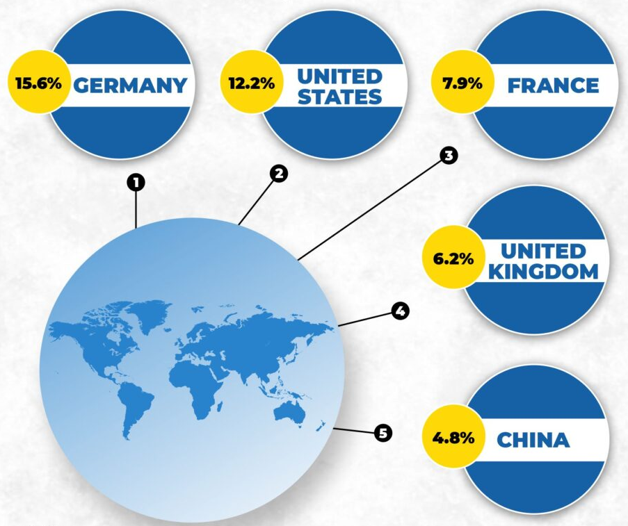
Figure 9: IKEA Sales by Counties
(Source: Business Bar, 2021)
IKEA primarily has wholly owned many kinds or subsidiaries in the main markets which are Germany, UK, US, China and France. All these ways of entry accurately ensure the company complete control over the various quality of the product, its price, client service and the activity of the supply chain. This helps to implement the company’s low-cost and standardised business model. Moreover, some markets of the IKEA branches, makes use of the local market insights and lower investments risks. In 2025, IKEA generated 44.6 billion in retail sales. It added 66 new sales stores and had around 222,000 employees (IKEA Report, 2025). This proved to be more successful application of its entry strategy in the international market.

3.2 Evaluation of Historical Entry Strategy
IKEA’s historical entry strategy has been more than a success and is accurately characterised by operational control whilst offering international flexibility. IKEA’s wholly owned subsidiaries give IKEA a means of safeguarding its brand reputation, properly ensuring the quality of its various products (Izyumenko, 2026). This helps to being able to apply its international business model across the world. This also helps the company to make proper supply chain management and many kinds of benefits in rapidly achieving economies of scale, one of IKEA’s competitive advantages.
Moreover, here are huge capital costs accurately associated with the land, retail stores, warehouse and logistical for wholly owned subsidiaries (Kostecka and Kopczewska, 2023). These investments can raise financial and business risk, especially in emerging markets where demand for the various product and growth may be variable. Moreover, the agile approach has allowed IKEA to rapidly expand its business successfully, as also international business risks have been properly managed.

3.3 Strategic Fit, Justification for IKEA
IKEA has been and continued to be primarily relying on fully owned subsidiaries operations in rapidly developed markets. But it can also be said that such mode may be not optimal to Uzbekistan. Uzbekistan’s government was engaged in a proper process of big changes in the economy sine 2017 (Kuldosheva, 2022). This is with the aim of rapidly increasing foreign investments, facilitating many types of business regulations and promote the role of the private sector. More than 37 million people in the country, the presence of middle-income population and rapidly increasing urbanisation represents a very strong potential demand of the various products with an affordable price for furniture and home furnishing (Mukhammadjon and Nagala, 2025).
But there is still have multiple growing potential in Uzbekistan. Modern retail infrastructure and logistic networks are rapidly improving, and customer in the country are not as rich as many where IKEA exists. It would accurately involve heavy expenditure on hiring staff, training them, purchasing goods and store space and transport networks in order to properly establish a 100% subsidiary (Rieple, DeFillippi and Schreiber, 2023). This would leave IKEA vulnerable to high financial and operational risk, while they wait for all the customer demand too materialise.
It would be better to parter with a local business partner, in a much better format since both they have properly established a very good reputation locally. A local partners will be adequately able to bring in expertise about customer preferences, regulations and distribution networks. This is to enable IKEA to more effectively penetrate the market. As per Li and Ming (2025), meanwhile IKEA can keep up control over its product design, branding, store design, and satisfy requirements for its chain of custody to uphold its worldwide standing.
A joint venture gains easily lower initial cost and also has more flexibility than a wholly owned subsidiary. Moreover, properly building up the business size and marketing demand stabilisation, IKEA can start purchasing various shares from the partners or even open their own shops in the future. So, the joint venture is the optimal way to go into a foreign market, as it would give IKEA the maximum level of risk allocation, investment and further development in Uzbekistan.

Recommendations
IKEA has well gained experience, and the falling market is still expanding, various great opportunities for further investments and creation of 100% stores. All these step-by-step processes will properly help sustain growth for IKEA while further consolidating its competitiveness on the market in Central Asia for the future.

Conclusion
The analysis reveals that IKEA has been quite successful in rapidly establishing itself internationally. It means of 100% owned subsidiaries and franchise agreement. It has helped the company have a powerful brand consistency, a good efficiency and various effective supply chain management. But the optimal entry mode has to be consistent with the various conditions in the host country.
The most appropriate way is a joint venture, as it is the best solution for Uzbekistan as it is a proper balanced between control and flexibility of business. This is along with the minimising the financial, potential and various operational risk. Up-to-the minute information about the customer preferences, regulations and distribution networks can be accurately provided by local partners that will facilitate market entry.

Section 2: Gibbs Reflective cycle
Description
In this assessment I needed to accurately evaluate the progress IKEA could make in the country Uzbekistan. This is using as support the theories and frameworks of international business. The reason the name IKEA was selected is because it is one of the world’s largest furniture companies. At the moment they do not have much of an operational in Uzbekistan (Toktogulov, 2022). While trying to properly prepare a report I used a Bartlett and Ghoshal model to evaluate IKEA’s global strategy, I analysed a political, economic, legal and cultural environment in Uzbakistan. I recommended an appropriate market entry strategy using an OLI Framework. I gathered various data from academic journals, books, company annuals reports, government reports and international organisations like Asian development bank, world bank etc. in order to complete the assignment. I derived knowledge from these various sources on the strategy of the company in its international plan, as well as the many opportunities sand risks in the chosen country.
Feelings
Initially, I believed I understand the theories well but was not sure which would be appropriate for IKEA to accurately use in the market. Firstly, I thought that the principle of use of 100% subsidiaries, which IKEA has used in its history. This would be the optimal solution to Uzbekistan (Bookman and Hall, 2022). As I studies many types of academic paper and real business data, I noticed that each international market has political, economic and operational issues and situations to be more concerned with. It taught me that being able to accurately adjust business approach to the local market conditions is very essential to being successful in the international areas. As my research, I grew more confident in my analysis and understanding of various evidence and how it tied in with business decision.
Evaluation
It was a good thing to properly use a large variety of dependable sources rather than relying on one reference source. I studied the various academic accounting literature with various real facts derived from IKEA reports and from international organisational. This made sure my text was of a higher quality and backed up my arguments with many kinds of evidence. A further advantage was to adequately provide the report in the proper manner. This is including focusing on the assessment requirements and applying each international business framework to the chosen company.
I had some challenges as well. The furniture retail sector was difficult to accurately find reliable, up-to-date information on as there was limited data available (Tsang et al., 2022). Several sources discussed contrasting many types of perspective on the investment climate in the country. So, multiple sources have to be used to make well-rounded decisions. Choosing the right way to enter into this game was also tough for me, as I needed to balance the risk, investment and long-term growth.
Analysis
It was through this assignment that I realised that there is so much that goes into taking business decisions accurately involving the global business, as opposed as there is a single business objective. The lectures about Bartlett and Ghoshal model taught me the various concept of balancing standardisation with responsiveness at the international market level of multinational companies. Moreover, OLI Framework assisted in comprehending the multiple impact of ownership, location and internalisation advantages on the decisions international expansion.
The module rapidly enhanced my knowledge of market entry further through various studies that were discussed. They have proved that business tend to adjust their expansion strategy based on economic, political and cultural climates of each country. This analysis, put inti practice in IKEA, led me to properly believe that various theories would be more flexible and less risky in Uzbekistan. It has been wholly owned subsidiaries that have proven to have been able to properly help the company grow is western markets (Bouhia, 2022). This solidified my contextualisation skills of studying and accurately applying academic theory in the business context, rather than merely talking about it.
Conclusion
This assessment has given a great insight into international business strategy and decisions around market entry into overseas markets. I knew that it is necessary to make a proper judgement regarding both the company's various capabilities and the conditions in the designation country in order to meet the success of international expansion. I also learned how important it is to back up business recommendations with more ad up to date evidence than different opinions. This rapidly improved analytical thinking and academic writing as I carried out independent research, make comparisons and critically evaluated various information from multiple sources. This entire experience has helped me to properly build my confidence around using various relevant theories on international business in real organisations.
Action plan
Moving forward on my assignment, I will start researching earlier to give me more time to work on the academic literature as well as industry reports from recent publications, Also, I want to rapidly develop my ability to critically evaluate the work of other authors and make inferences based on what they say before reaching my own conclusion. Moreover, I will strengthening the theoretical framework and application of the topics in business practice. Lastly, I will provide well-informed and current evidence from more company reports, government materials and international data bases to back up my arguments. The improvement will enable me to rapidly improve my future ability to accurately produce more critically, evidence-based, and professionally laid out reports relating to the internation a business.

Conclusion
The report states that Uzbekistan is a country with various excellent long-term prospects as IKEA. This is due to their advanced development of their economy, urbanisation and various positive investment law. A joint venture is the best model to enter, since it facilitated a proper balance between various risks, investments and control. Overall, this approach can rapidly contribute to IKEA’s sustainable development and resilience in Central Asia’s market.

References
Abdullaeva, G., Turlibekova, O., Khasanova, S. and Sadibekova, B. (2025). The role of economic freedom and development aid in attracting foreign direct investment in Uzbekistan. Open Journal of Business and Management, 13(2), pp.968-984. Available at: https://aps.tsuos.uz/storage/users/164/articles/znALHU3HTx4MWNIJucAAmRbHk7sjJueBEC15Afda.pdf
Aro, O.E. (2024). Circular Economy in Supply Chain Management: Leveraging Technology for Sustainability. International Journal of Research Publication and Reviews, 5(10), pp.4057-4074. Available at: https://www.researchgate.net/profile/Opeyemi-Aro/publication/385494170_Circular_Economy_in_Supply_Chain_Management_Leveraging_Technology_for_Sustainability/links/6734aa50f255d57286696dd5/Circular-Economy-in-Supply-Chain-Management-Leveraging-Technology-for-Sustainability.pdf
AsianDevBank (2026). ADB: Uzbekistan’s economic growth to remain strong in 2026–2027, supported by reforms and investment. [online] Asian Development Bank. Available at: https://www.adb.org/news/adb-uzbekistan-economic-growth-remain-strong-2026-2027-supported-reforms-and-investment [Accessed 23 July 2026].
Bookman, S. and Hall, T. (2022). Global Brands, Cosmopolitan Socialization, and Consumption: the Case of ikea and the ‘Stuff’of Ordinary Cosmopolitanism. Youth and Globalization, 4(1), pp.140-165. Available at: https://brill.com/view/journals/yogo/4/1/article-p140_007.xml
Bouhia, G. (2022). Applying the circular economy concept to a sustainable business model for large retailers: the case of IKEA. International Journal of Competitiveness, 2(3), pp.212-233. Available at: https://www.inderscienceonline.com/doi/abs/10.1504/IJC.2022.127400
Braunerhjelm, P. and Henrekson, M. (2023). Policies to stimulate innovation and entrepreneurship. In Unleashing Society’s Innovative Capacity: An Integrated Policy Framework (pp. 99-143). Cham: Springer International Publishing. Available at: https://link.springer.com/chapter/10.1007/978-3-031-42756-5_4
Burnashev, R. and Chernykh, I. (2024). The political system of Uzbekistan. In Central Asia in a multipolar world: Internal change, external actors, regional cooperation (pp. 57-73). Cham: Springer International Publishing. Available at: https://www.researchgate.net/profile/Dina-Sharipova/publication/384195278_Russia_in_Central_Asia/links/670d268d1a0a901a3e716bdd/Russia-in-Central-Asia.pdf#page=79
Business Bar (2021). The IKEA experience – not just another furniture store! BusinessBar. [online] Business Bar. Available at: https://businessbar.net/all/the-ikea-experience-not-just-another-furniture-store/ [Accessed 23 July 2026].
CEIC (2026). Uzbekistan real GDP growth. [online] Ceicdata.com. CEICdata.com. Available at: https://www.ceicdata.com/en/indicator/uzbekistan/real-gdp-growth [Accessed 23 July 2026].
Chen, Y., Pellemans, M., Richter, F., Roshandel, Y., Schmeits, V., Waldert, P., Wehbi, L. and van der Zanden, T.C. (2024). IKEA: Innovative Know-how for E-commerce Allocation. Proceedings of the Studygroup Mathematics with Industry (SWI), pp.1-33. Available at: https://www.swi-wiskunde.nl/swi2024/wp-content/uploads/sites/29/2024/06/SWI-2024-scientific-proceedings_IKEA-1.pdf
Dasgupta, P. and Banik, A. (2025). Intersectionality of Emerging Markets and Brand Building: Unlocking Global Best Practices. In Rebellious Entrepreneurs: How Breakthrough Branding Uplifts Millions in Emerging Markets (pp. 351-394). Singapore: Springer Nature Singapore. Available at: https://link.springer.com/chapter/10.1007/978-981-96-1914-6_13
Guven, A.A. (2026). Global Marketing Strategy. In Bridging Traditional Theory and Emerging Corporate Strategies (pp. 67-110). IGI Global Scientific Publishing. Available at: https://www.igi-global.com/chapter/global-marketing-strategy/401433
Hofstede, G. (2025). Country comparison bar charts - geert hofstede. [online] Geert Hofstede. Available at: https://geerthofstede.com/country-comparison-bar-charts/ [Accessed 23 July 2026].
IKEA (2021). Using AI for smarter demand forecasting. [online] IKEA. Available at: https://www.ikea.com/global/en/stories/design/using-artificial-intelligence-for-smarter-demand-forecasting-210527/ [Accessed 23 July 2026].
IKEA (2022). IKEA continues to grow in a challenging business environment - IKEA global. [online] IKEA. Available at: https://www.ikea.com/global/en/newsroom/corporate/ikea-continues-to-grow-in-a-challenging-business-environment-221013/ [Accessed 23 July 2026].
IKEA Report (2025). IKEA Report [online] Ikea.com. Available at: https://www.ikea.com/global/en/our-business/how-we-work/year-in-review-fy25/ [Accessed 23 July 2026].
Izyumenko, E. (2026). Trademark Law and Political Expression: The Case of IKEA v. Vlaams Belang and Beyond. IIC-International Review of Intellectual Property and Competition Law, 57(5), pp.807-849. Available at: https://link.springer.com/article/10.1007/s40319-026-01719-4
Ji, Y.J., Sun, M.K., Changho, C.H.O.I., Ji, Y.H., Yong, G.K. and Mamurbek, K.A.R.I.M.O.V. (2023). Development strategies for attracting foreign direct investment in Uzbekistan. 11(5), pp.57-67. Available at: https://accesson.kr/jemm/assets/pdf/51546/journal-11-5-57.pdf
Kerimova, I. and Ataniyazova, Z. (2024). Determining the critical success factors of e-commerce in Uzbekistan. Journal of Eastern European and Central Asian Research (JEECAR), 11(3), pp.409-423. Available at: https://ieeca.org/journal/index.php/JEECAR/article/download/1382/595
Kostecka, Z. and Kopczewska, K. (2023). Spatial CRM and location strategy: E-commerce solutions in the furniture industry. Case of IKEA pick-up points in Poland. Electronic Commerce Research and Applications, 62, p.101308. Available at: https://www.sciencedirect.com/science/article/pii/S156742232300073X
Kuldosheva, G. (2022). Challenges and opportunities for digital transformation in the public sector in transition economies: The case of Uzbekistan. Harnessing Digitalization for Sustainable Economic Development, 365. Available at: https://www.sea-vet.net/images/seb/e-library/doc_file/1023/adbi-harnessing-digitalization-122421compressed.pdf#page=382
Li, S. and Ming, Y. (2025). Russia’s Forest Products Trade from the Perspective of Forest Certification. Chinese Journal of Slavic Studies, 5(2), pp.259-290. Available at: https://www.degruyterbrill.com/document/doi/10.1515/cjss-2025-0017/html
Market Data Forecast (2025). Asia pacific furniture market report. [online] Market Data Forecast. Available at: https://www.marketdataforecast.com/market-reports/asia-pacific-furniture-market [Accessed 23 July 2026].
Moorthy, J. and Parvatiyar, A. (2023). Co-creating aftermarket value in the digital era: Managing transformative customer relationships through stakeholder engagement. In Customer Centric Support Services in the Digital Age: The Next Frontier of Competitive Advantage (pp. 155-198). Cham: Springer International Publishing. Available at: https://www.researchgate.net/profile/Varsha-Jain-6/publication/377012395_Customer-Centric_Support_Services_An_Introduction_to_the_Next_Frontier_for_Competitive_Advantage_in_the_Digital_Era/links/6597c1996f6e450f19cb9788/Customer-Centric-Support-Services-An-Introduction-to-the-Next-Frontier-for-Competitive-Advantage-in-the-Digital-Era.pdf#page=171
Mukhammadjon, F. and Nagala, S. (2025). Development of Uzbekistan's Textile Industry: Challenges, Opportunities, and Strategic Growth. " Navigating Green Economy through Innovations, Policies and Strategies on Sustainable Practices, p.53. Available at: https://www.researchgate.net/profile/Raveenthiran-Vivekanantharasa/publication/394832515_Navigating_Artificial_Intelligence_in_the_Successful_Implementation_of_Inclusive_Education_Practice/links/68a7fec82c7d3e0029b2b510/Navigating-Artificial-Intelligence-in-the-Successful-Implementation-of-Inclusive-Education-Practice.pdf#page=55
OECD (2026). Uzbekistan: Accelerating sustainable infrastructure investments. [online] OECD. Available at: https://www.oecd.org/en/publications/accelerating-sustainable-infrastructure-investments_031d486e-en/full-report/uzbekistan_4d0575e6.html [Accessed 23 July 2026].
Pacala, F.A. (2024). The exodus of Filipino teachers to Uzbekistan: a hermeneutic phenomenological study. Makara Human Behavior Studies in Asia, 28(1), pp.39-48. Available at: https://scholarhub.ui.ac.id/cgi/viewcontent.cgi?article=1521&context=hubsasia
Reuters (2025). An economy that speaks to everyone: Uzbekistan’s rise as central asia’s bridge. [online] Reuters.com. Available at: https://plus.reuters.com/an-economy-that-speaks-to-everyone-uzbekistans-rise-as-central-asias-bridge/p/1 [Accessed 23 July 2026].
Rieple, A., DeFillippi, R. and Schreiber, D. (2023). in Physical. Transformational Innovation in the Creative and Cultural Industries, p.93. Available at: https://books.google.com/books?hl=en&lr=&id=bwG9EAAAQBAJ&oi=fnd&pg=PA93&dq=IKEA+has+an+efficient+international+production+network+with+approximately+1,600+suppliers+in+over+50+countries.+&ots=uZJIZJkBHm&sig=CDb7BKv-Ymt_4IuqFH0xw5TOkQs
Ruziokhunov, D. and Yuldasheva, U. (2025). The role of government tax regulations on attracting foreign investments. Academic Journal of Science, Technology and Education, 1(8), pp.6-10. Available at: https://integrumpublication.org/index.php/ajste/article/download/101/103
Sampath, B. and Harshitha, K.C. (2023). A Study on Inventory Management at IKEA. NEW TRENDS IN PRODUCTS, SERVICES & MANAGEMENT, p.85. Available at: https://www.scripown.com/docs/EBOOK_20230413_104938.pdf#page=89
Singh, P., Rao, K.S., Xuan, L., Kee, D.M.H., Min, F.J., Xuan, T.Y., Ing, T.S., Malhotra, K. and Pandey, R. (2021). Key determinants of international retail success: A case of IKEA retail. Int. J. Tour. Hosp. Asia Pasific, 4, pp.18-33. Available at: https://www.researchgate.net/profile/Rudresh-Pandey-2/publication/353313896_Key_Determinants_of_International_Retail_Success_A_Case_of_IKEA_Retail/links/60f2d9d89541032c6d48054e/Key-Determinants-of-International-Retail-Success-A-Case-of-IKEA-Retail.pdf
Statista. (2025). IKEA’s sales share by sales channel worldwide 2025| statista. [online] Available at: https://www.statista.com/statistics/946210/ikea-sales-share-by-sales-channel-worldwide/?srsltid=afmboookcutllnb1k7fbnkmbfdrzueuz20urwrfaftrywwok4mm-r-ki [Accessed 23 July 2026].
Statista. (2025). Top retail selling countries IKEA 2025| statista. [online] Available at: https://www.statista.com/statistics/255583/leading-5-selling-countries-of-ikea-products/?srsltid=afmboooyv7ej0or8pspywklxeob3wdh6dowtindd-idbfkdagelmsynd [Accessed 23 July 2026].
Talipova, N.T., Makhmutkhodjaeva, L.S. and Khazratkulova, L.N. (2022), December. Evolution of innovative development of foreign economic activity of the Republic of Uzbekistan. In Proceedings of the 6th International Conference on Future Networks & Distributed Systems (pp. 51-59). Available at: https://dl.acm.org/doi/pdf/10.1145/3584202.3584211
Toktogulov, B. (2022). Uzbekistan’s foreign policy under Mirziyoyev: Change or continuity?. Eurasian Research Journal, 4(1), pp.49-67. Available at: https://dergipark.org.tr/en/pub/erj/issue/68365/1066059
Trading Economics (2026). Uzbekistan foreign direct investment - 2022 data - 2023 forecast. [online] tradingeconomics.com. Available at: https://tradingeconomics.com/uzbekistan/foreign-direct-investment [Accessed 23 July 2026].
Tsang, Y.P., Wu, C.H., Lin, K.Y., Tse, Y.K., Ho, G.T.S. and Lee, C.K.M. (2022). Unlocking the power of big data analytics in new product development: An intelligent product design framework in the furniture industry. Journal of Manufacturing Systems, 62, pp.777-791. Available at: https://www.sciencedirect.com/science/article/pii/S0278612521000315
U.S. Department of State (2025). Uzbekistan - united states department of State. [online] United States Department of State. Available at: https://www.state.gov/reports/2025-investment-climate-statements/uzbekistan [Accessed 23 July 2026].
UzDaily (2025). Uzbekistan plans to attract US$43 billion in investments in 2025. [online] UzDaily.uz. Available at: https://www.uzdaily.uz/en/uzbekistan-plans-to-attract-us43-billion-in-investments-in-2025/ [Accessed 23 July 2026].
UzDaily Editorial Team (2026). Uzbekistan housing market sees mortgage growth in 2025. [online] UzDaily.uz. Available at: https://www.uzdaily.uz/en/uzbekistan-housing-market-sees-mortgage-growth-in-2025/ [Accessed 23 July 2026].
WIX. (2025). [online] IKEA -investors Supply chain. Available at: https://pradhanaashish.wixsite.com/ikea-investors/supply-chain [Accessed 23 July 2026].
World Bank Group (2024). Helping uzbekistan undertake a historic social and economic transformation. [online] World Bank. World Bank Group. Available at: https://www.worldbank.org/en/results/2024/07/16/helping-uzbekistan-undertake-a-historic-social-and-economic-transformation [Accessed 23 July 2026].
World Bank Group (2025). Uzbekistan | world bank group. [online] Worldbank.org. Available at: https://www.worldbank.org/ext/en/country/uzbekistan [Accessed 23 July 2026].
Yuan, S. (2024). IKEA's digital transformation: Lessons, achievements, and prospects in supply chain management. Exploring the Financial Landscape in the Digital Age, pp.643-648. Available at: https://www.taylorfrancis.com/chapters/edit/10.1201/9781003508816-92/ikea-digital-transformation-lessons-achievements-prospects-supply-chain-management-shiqi-yuan
Zalkat, G., Barth, H. and Rashid, L. (2023). Refugee entrepreneurship motivations in Sweden and Germany: a comparative case study. Small Business Economics, 63(1), pp.477-499. Available at: https://www.econstor.eu/handle/10419/317722

