Leadership and management, theory and practice
Assesment-2

Module code: LCBB6003

Lecturer: Taye Osadiya
Student Name: Daniel Miroslavov Borisov

Student ID: 1907092

Table of Contents
Evaluation of the effectiveness of the leadership of Jeff Bezos 3
Evaluation of the effectiveness of the leadership of Jeff Bezos (contd.) 3
Conclusion 5
Reference list 6

Evaluation of the effectiveness of the leadership of Jeff Bezos
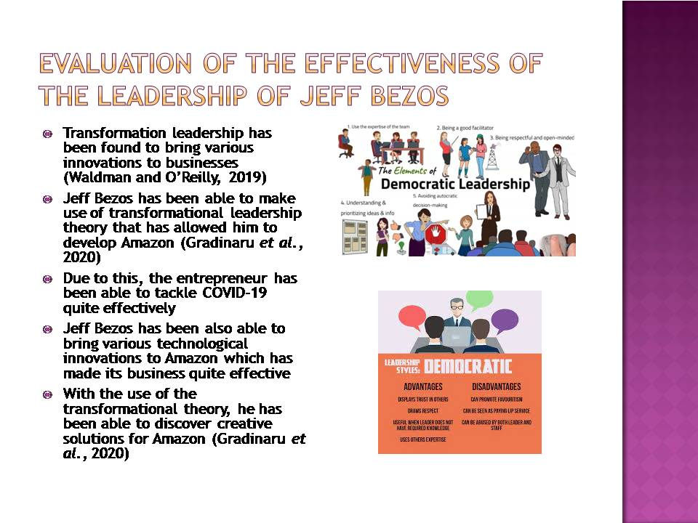
Transformation leadership enables one to be highly innovative for the purpose of management (Waldman and O’Reilly, 2019).. He has been able to make effective use of the leadership styles and has been able to bring a number of innovations to his business which has enabled the development of Amazon. The company has been renowned as an organisation that has been able to make use of most of the latest and advanced technologies in their business globally. Jeff Bezos has been also found to be a person who is highly creative and also tries to find solutions to problems that have been faced by Amazon (Gradinaru et al., 2020). This has been clearly evident in the case of COVID-19 as Jeff Bezos has been able to make use of transformation leadership and increase the shares of Amazon by 70% (Neate, 2020).

Evaluation of the effectiveness of the leadership of Jeff Bezos (contd.)
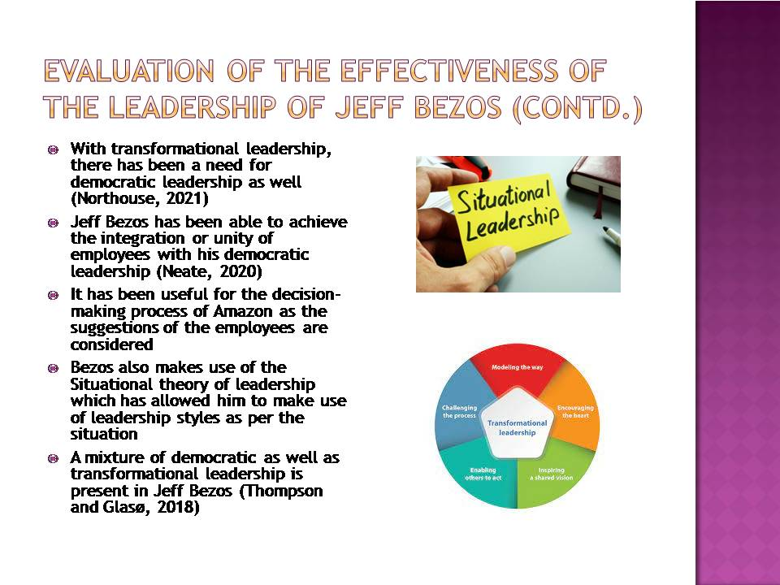
Along with a transformational leadership style, democratic leadership has been also very significant for the management and development of organisations (Northouse, 2021). Jeff Bezos has been also making use of a democratic form of leadership which has allowed Amazon to have strong integration with their employees (Neate, 2020). Jeff Bezos has been able to make use of his democratic views to consider the suggestions and perspectives of his employees for effective decision making. This has allowed the organisation to have strong unity among the employees leading to better organisational performance.Jeff Bezos has made use of transformational as well as a democratic leadership style. However, this has been achieved by him with the use of the situational theory of leadership. Bezos understands the significance of the selection of leadership style as per the demand of the situation or circumstances as switches between the two or makes use of both of them which has been a secret of him being an effective leader and leading Amazon in a proper manner, especially during COVID-19 (Thompson and Glasø, 2018).

Conclusion
As mentioned above under the leadership of Jeff Bezos, the Amazon Company has been able to reach the greatest height of success in short time. The leadership style and approaches of the leader at Amazon looks forward to make the company a customer centric as the management and administration of the company and its operations are based on the principle and notion of customer orientation. The leadership approaches at Amazon includes the idea of creativity and innovation.
The leadership style as mentioned above is quite pragmatist as the leaders accept greater contribution and effectiveness from the workforce at Amazon. Lastly, various principles such as customer – orientation, effective communication and crystal clear setup of the aims and objectives of the company tend to showcase the inspiration and obsession of Jeff Bezos. Therefore, the success and growth of Amazon Company can be traced back to its leadership style and vision of the leader of the company.

Reference list
Gradinaru, C., Toma, S.G., Catana, S. and Andrisán, G., 2020. A view on transformational leadership: The case of Jeff Bezos. Manager, (31), pp.93-100.
Kantor, J. and Streitfeld., 2015. Inside Amazon: Wrestling big ideas in a Bruising workplace [online]. Available at: https://www.nytimes.com/2015/08/16/technology/inside-amazon-wrestling-big-ideas-in-a-bruising workplace.html?action=click&pgtype=Homepage&region=CColumn&module=MostViewed&version=Full&src=mv&WT.nav=MostViewed [Accessed 4 April 2022].
Kibbe, M.R., 2019. Leadership theories and styles. In Leadership in Surgery (pp. 27-36). Springer, Cham.
Neate, R., 2020. Jeff Bezos, the world’s richest man, added £10bn to his fortune in just one day [online]. Available at https://www.theguardian.com/technology/2020/jul/21/jeff-bezos-the-worlds-richest-man-added-10bn-to-his-fortune-in-just-one-day [Accessed 4 April 2022].
Northouse, P.G., 2021. Leadership and Management Theory and Practice, 9th Edition, Sage.
Thompson, G. and Glasø, L., 2018. Situational leadership theory: a test from a leader-follower congruence approach. Leadership & Organization Development Journal.
Waldman, D. C. and O’Reilly, C., 2019. Leadership for Organizations. 1st edn. California: Sage

