MAJOR PRODUCTION PORTFOLIO-
MISS LITTLEWOOD
Name: Freya Bussy
Student No: 2003886

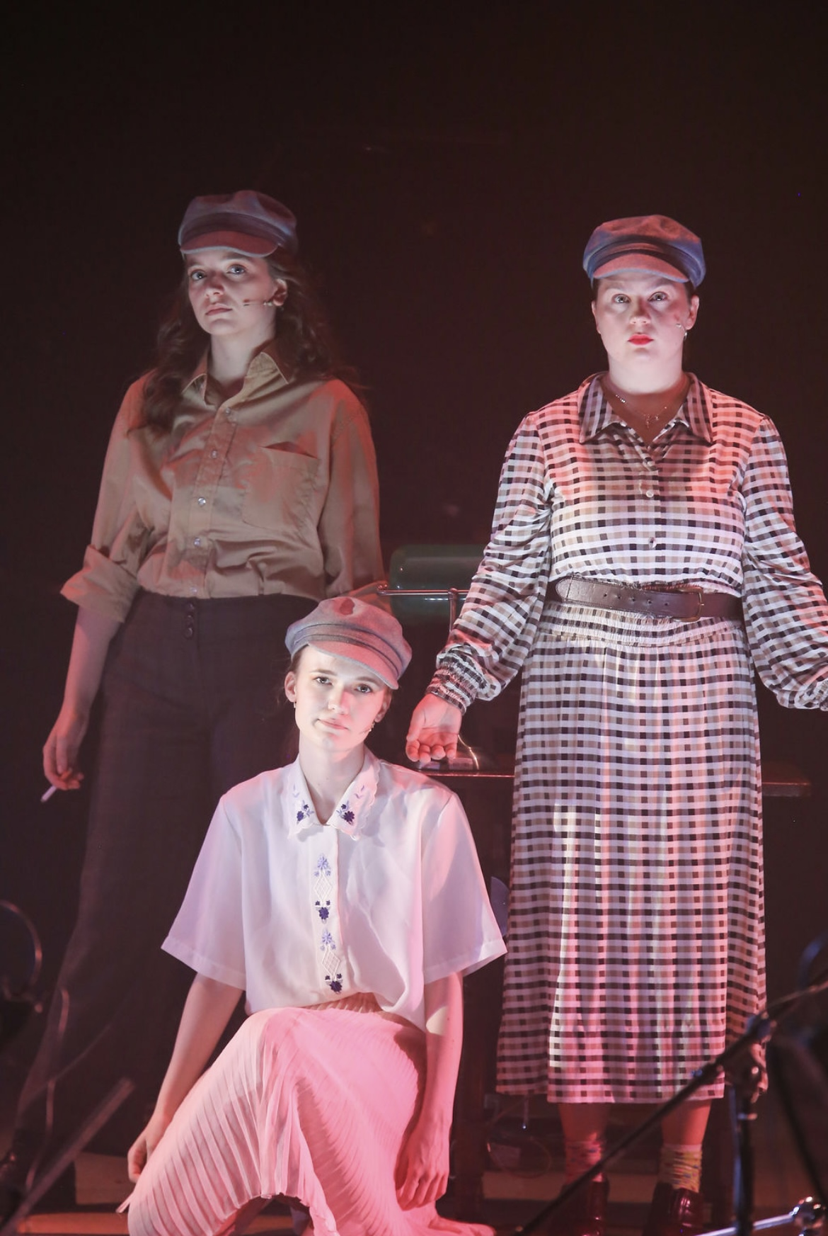

Major Production – Miss Littlewood

At the beginning of the process, it was established that ‘Miss Littlewood’ is biographical as the characters are real people and the story of the show has happened in real time. We had a large discussion on the relevance of doing a musical that is about a female ‘theatrical revolutionary’. ‘If you speak or listen to any of the members of her company, they worship the ground she walked on. She was tough because she was fighting bureaucracy and the establishment for her entire life.’ (Clare Burt, 2018)
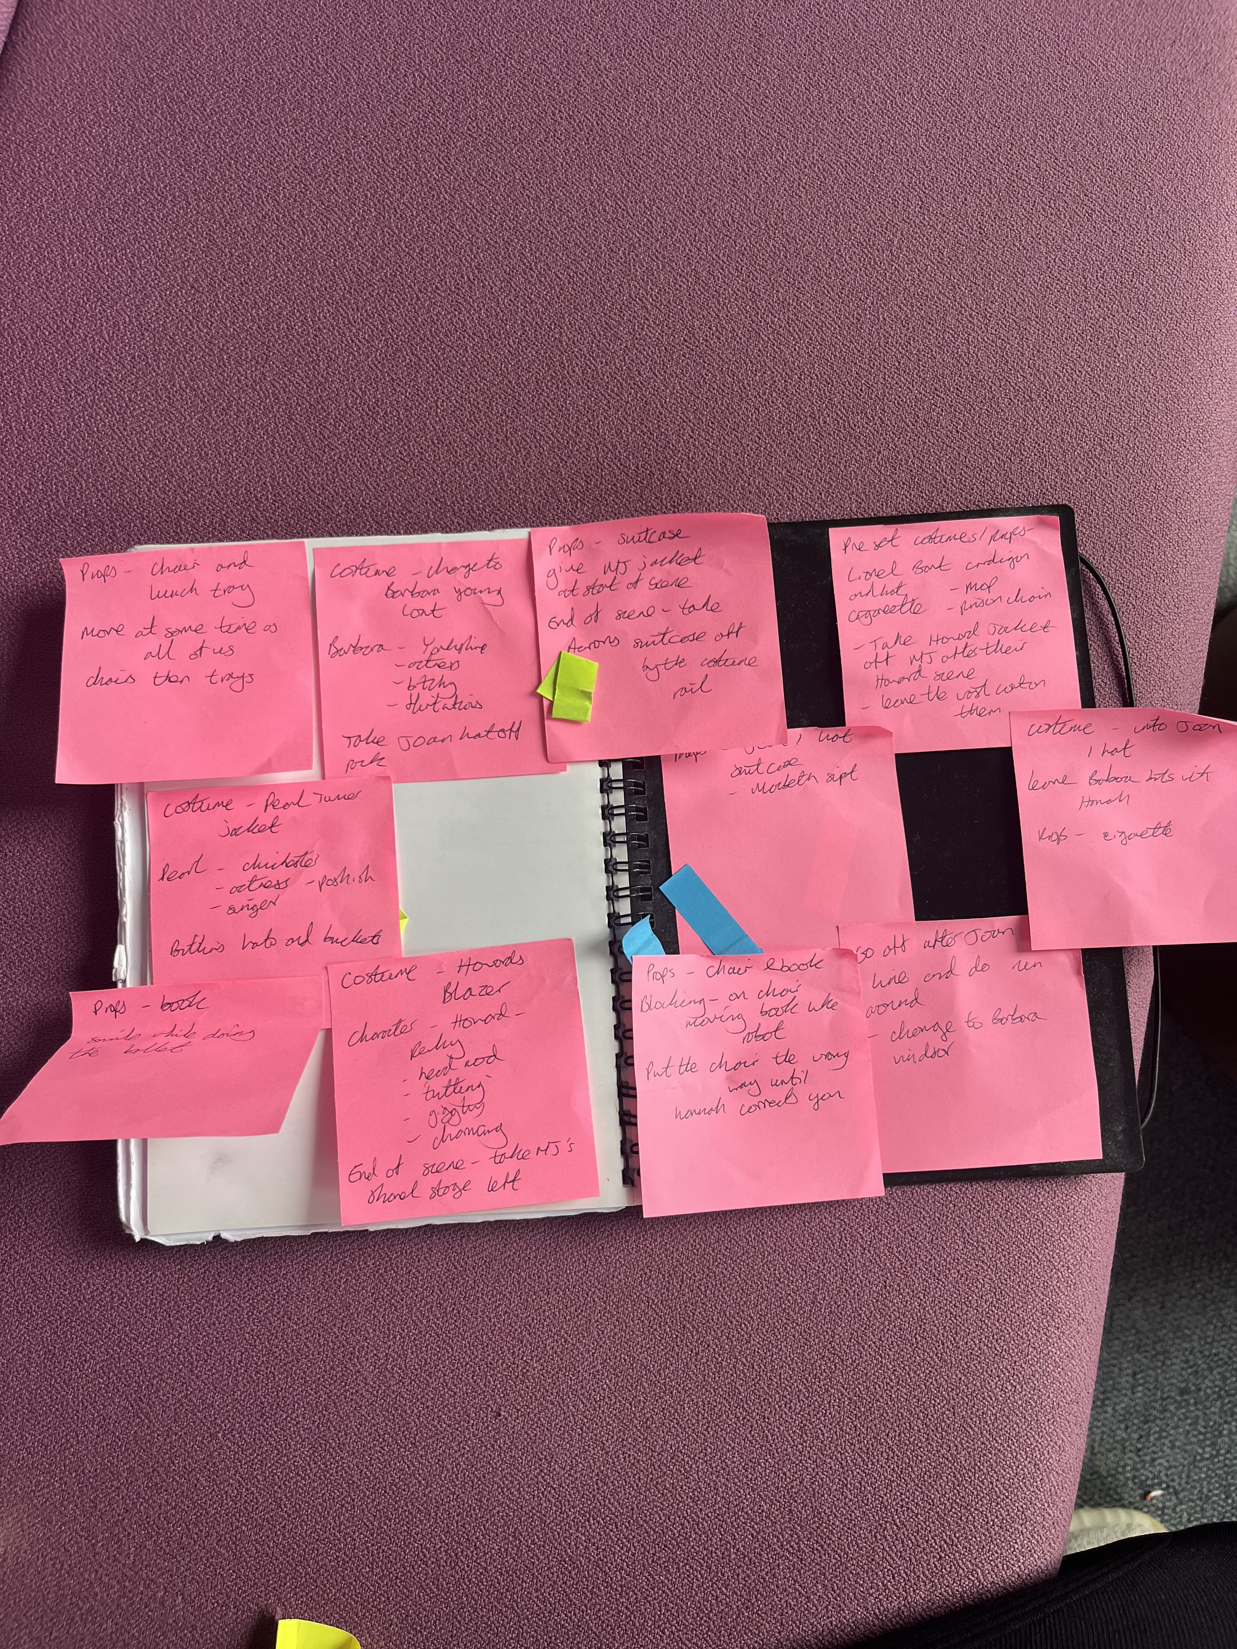
From the first read-through of the show, we realised how large her life story was and how politics played a heavy part in a vast amount of her work. ‘Oh What a Lovely War’, ‘Taste of Honey’ and ‘Fings Ain’t Wot They Used to Be’. Her work was viewed as ‘left wing’ and many of her works were viewed as controversial due to the subject matter of war, weaponry and leaders such as Hitler. She changed the face of theatre, providing for people of the working class who couldn’t afford to attend operas and to bring to light the tough conditions the public live in.

As a way of understanding and embodying the characters we were playing, we placed pictures of each person on the wall with some facts to help us bring specific characteristics to them. This helped us to understand their relationships to Joan and the lives they were living. On the right is a picture of the post it notes I made during rehearsals; I kept these in my script to prompt me on which characters I was playing and what their purpose was in the scene.

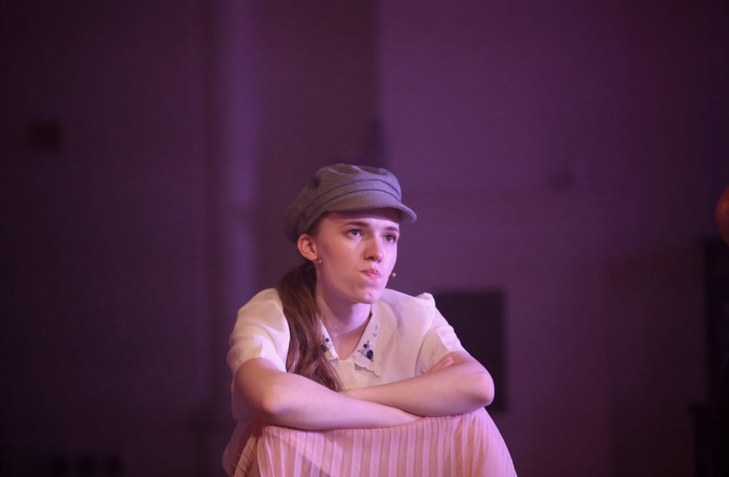
I was given the role of Joan 1, her 12 year old to 16 year old self. I found it challenging to research her at a young age as there’s hardly anything documented on her early life. However from what I had read she was extremely knowledgeable for a girl of her age and was opinionated. She attended ‘La Retraite Convent School’ in Clapham Park; ‘Littlewood was born out of wedlock in Stockwell, south London, to a mother who frowned on books, she wrote later of feeling ugly, untidy and alien. But her grandmother, who raised her, was a fine, sometimes bawdy, storyteller. By candlelight, under the bedclothes, Littlewood read library books as soon as she was old enough.’ (Ezard and Billington, 2002) Her knowledge is mainly apparent in the song ‘The Trouble with Theatre’ that is sung near the start of Act One. I discovered that theatre became her escape from her home life that she thought was uncomfortable. Through text analysis I found her vocabulary to be complex for a 12 year old, proclaiming things such as ‘it smells of expectation, of pleasure and delight’ and ‘the single most authentic moment in the show is ignored’. The language she uses here is metaphorical and grandiose and this helped me to characterise her passion for the theatre and how she ‘falls into a different sort of dream’ when creating theatre herself.
The biggest challenge for her at that time was accepting the absence of her father and the neglect from her mother. This is a topic I personally relate to as my father is absent in my life; so tapping into that feeling of loss was easy for me. ‘Littlewood was the illegitimate daughter of a young housemaid and a working-class father she never knew. Her mother, Littlewood once said, “really hated” her, and she was brought up in Stockwell by her grandparents, who could neither read nor write.’ (Dennis Mclellan, 2002) When working with my classmate Cody (who played Kate, Joan’s mother) we worked on the alienation between herself and her mother by showing no affection in scenes together. This is further shown through Joan calling her mother by her name, viewing her as just a woman who gave birth to her. Their dynamic is more uneasy where as her relationship to her grandmother is encouraging and loving. To add drive to the song ‘Father’s Eyes’ where Joan sings about the loss of her father and dreams of her ideal version of him; I came up with the theory that Kate was jealous of Joan’s relationship with her grandmother as they argue more like siblings than a mother and daughter. ‘Sometimes she couldn’t stand the sight of me. Today, at least, she was leaving me alone’ (Joan Littlewood, 2003) This point is further emphasised as Joan’s mother and grandmother have a distant relationship that could have began from her childhood and continued onwards. In comparison to the sadness of the songs lyrics; we wanted to show Joan’s showmanship from an early age so I worked with our choreographer Amy Guppy. We researched big band hall dance moves such as kicklines and jazz hands that we incorporated into the number; this also provided a more dreamlike tone when singing about her father (through waltzing around with her father’s hat and scarf).
In the show Joan 1 appears in crucial parts of Joan’s life such as her suicide attempt, her leaving Gerry and then visiting Gerry in hospital. In my interpretation; Joan 1 was a symbol of the innocence Joan once had and also where her creativity began as an artist. She’s strong- minded and ruthless as she shrugs off many traumatic events she’s been through from a very young age.
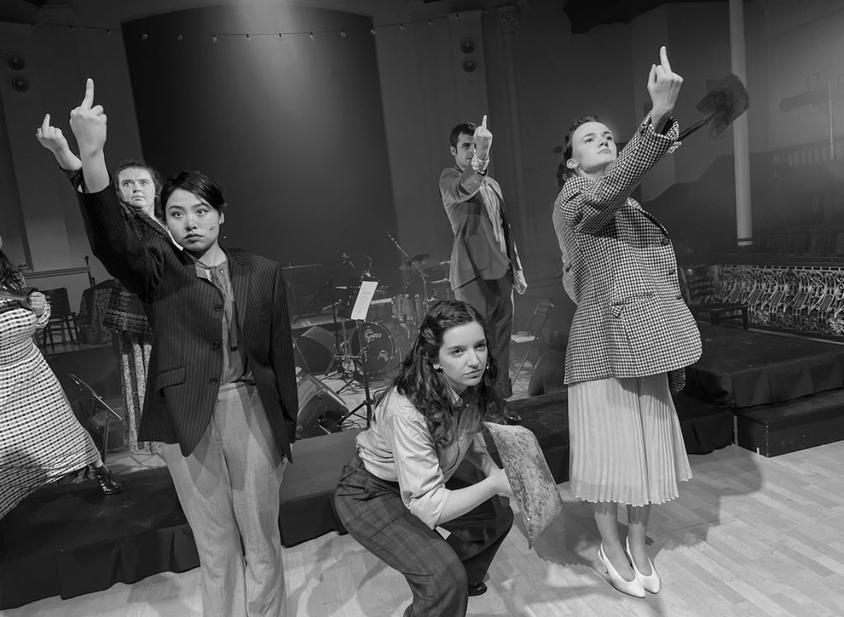
Throughout the show; I was given the chance to multi-role so I played multiple famous actors/actresses of that time. Accompanying Joan 1 I played Howard, Pearl Turner, Barbara Young and Lionel Bart. Even though these parts were smaller I learnt about the lives of these people. Each character I played; I assigned one characteristic so they were recognisable to the audience when switching characters, this made it less confusing and showed a clear change between characters to make the storyline easier to follow. I shared the role of Howard with my classmates MJ and Darcie; therefore as a trio we agreed on making Howard charming and enthusiastic. We showed this through him constantly smiling, giggling and nodding his head at everything each character said. ‘Howard, who has died aged 85, was then a Young Communist, and he liked what he saw at Theatre Union. The following year, he read in the Manchester Guardian that the company was auditioning. Thus did the accountancy clerk, swept into the revolutionary training methods of Littlewood and MacColl, become an actor. Those two people were to colour Howard's career for 30 years and indeed the rest of his life, which encompassed many stage parts and more than 60 television and film appearances.’ (Peter Rankin, 2007)
A visual change that the three of us had was wearing the same check blazer; this helped me with my physicality as Howard as I would sit upright and always walk with a spring in my step. MJ and Darcie did the exact same characteristics and this made the character of Howard consistent and easy to recognise from an audience’s perspective.
A large part of the productions charm was the Brechtian nature of the piece. ‘Brecht wanted to achieve a similar simplicity. His productions concentrated, above all, on the human figure and a few telling objects, set against an empty background and under brilliant light. And he used short dramatisations of episodes from the Bible in his actor training. Brecht hoped that this emphasis on pure action, unmediated by morality or explanation, would guide the audience inexorably towards the play’s pedagogical purpose, event after event, action by action, moment by moment.’ (Stephan Unwin, 2014) We used his method of not exiting the stage therefore costume changes for characters had to be done in front of the audience. These were minimal changes such as changing coats or hats although this enabled us to change persona quickly that was challenging and pushed us as actors.
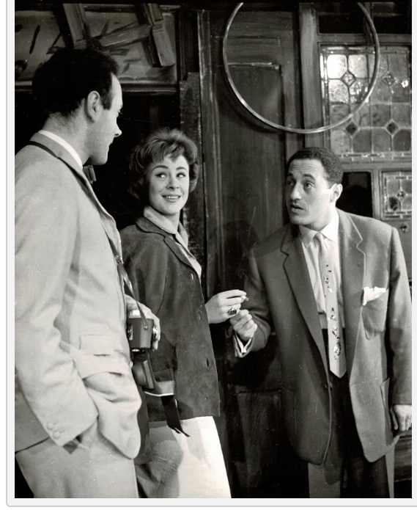
‘The women who knew her in that era talked about her like an annoying aunt…. It wasn’t truly Verbatim but there was that dynamic between Joan and women’ (Sam Kenyon, 2023) When playing Pearl Turner and Barbara Young I wore two different coats which Joan takes off both of them and wears instead. Both actresses were integral to Joan’s theatre workshop and both left the workshop; this left Joan disheartened. ‘Pearl joined Joan Littlewood at 19 and helped to co-found the famous Theatre Workshop, singing with Euan McColl (father of Kirsty) and many actors later to become famous. Pearl married and had three girls. She joined the Chichester Players and took part in a landmark production of A Streetcar Named Desire, a brave choice of play at the time because of the rape scene at the end.’ (The Newsroom, 2018) I characterised Pearl through my vocal quality; I elongated words and spoke in a posh RP accent to highlight her above working class upbringing in Chichester. Her posture was upright and quick as she’s quick with her responses to Joan. My dynamic as her in the show alongside Cody playing Joan 3 and Darcie playing Joan 4 was distant and obnoxious through Joan’s unpredictable behaviour towards her and the narcissistic nature towards other actors. Pearl was the first actor to leave the Theatre Workshop and this took a toll on Joan who was determined not to be alone; ‘Joan all alone no more’.

Barbara Young was polar opposite to Pearl Turner. When researching Barbara Young she had a hostile relationship to Joan due to her involvement with Joan’s lover Gerry Raffles. ‘There was often friction in the company. Once, when Young was late arriving after an emergency dental appointment, Littlewood refused to believe the excuse. “She actually pushed me,” Young recalled, “and it hurt, and I just lashed out and clouted her one.” Littlewood was more riled on walking into the wardrobe room one day to find Young in a compromising position with Gerry Raffles.’ (Anthony Hayward, 2023) Barbara was one of the main reasons for the breakdown of Gerry and Joan’s relationship so I wanted to make her personality polar opposite to Joan’s. I chose to be flirtatious and boisterous as this clashes with Joan’s narcissistic, critical nature. This was shown fully in the middle of Act Two when Gerry is caught having the affair with Barbara; Myself and Aaron who played Gerry made their relationship playful and childish like school kids. This showed the immaturity and reckless nature of their affair and the careless, unprofessional way that Barbara viewed Joan at the time. This scene pushed me as a actor as I find doing more inappropriate scenes uncomfortable however through getting into the character; I was able to disassociate myself with the subject matter.

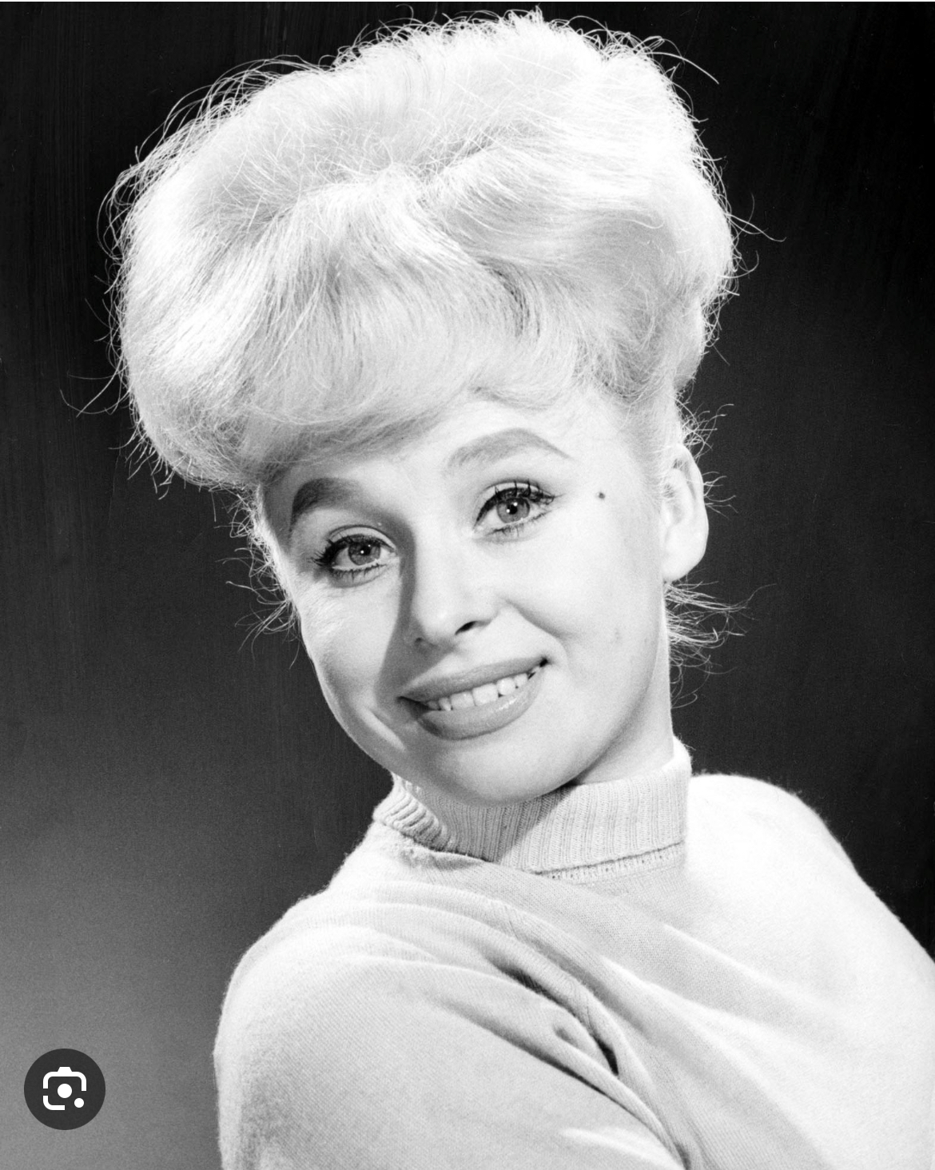
The largest role I had the honor of playing was Barbara Windsor. When given the role I felt a lot of pressure as she is a very well known in British culture. She made a large impact on Joan and became a key member of Joan’s ‘Theatre Workshop’ in the 1960s. ‘She had the priceless gift of being able to project a distinct, unique personality. That made her a natural for Littlewood, who was wary of what she called, in heavily inverted commas, “acting”. Like a lot of the young women at Theatre Workshop, Windsor was previously a performer at Winston’s nightclub in London. “They could all sing, dance, ad lib, change clothes in a matter of seconds,” wrote Littlewood, “and light up the scene.” Barbara Windsor went on lighting up the scene for the rest of her life.’ (Micheal Billington, 2020)
Barbara appears in Act Two, ready to audition for Joan Littlewood. Joan dresses up as a cleaner and interviews Barbara without her knowing it’s really her. She makes a big impression by singing ‘A Little Bit of Business’; a song about the showmanship her dad taught her. This was a physically challenging role for me to perform as she has a lot of well known mannerisms and the dance number required a lot of cardio endurance. In preparation for the role I watched a lot of the ‘Carry On’ films (some of her most famous films) and I watched her in Joan’s movie ‘Sparrows Can’t Sing’. This was a way of finding out what type of presence she had onscreen and the influence she had on other actors. ‘I heard a great guffaw from Gerry and looked down to see a dainty blonde grumbling about being asked to sweep the stage.’ (Joan Littlewood, 2003)
Some of her most well known mannerisms are her laugh and her posture that made her upper body look bigger. Outside of rehearsals I practiced her laugh and then when performing the scene and song I tried to incorporate the laugh as much as possible.
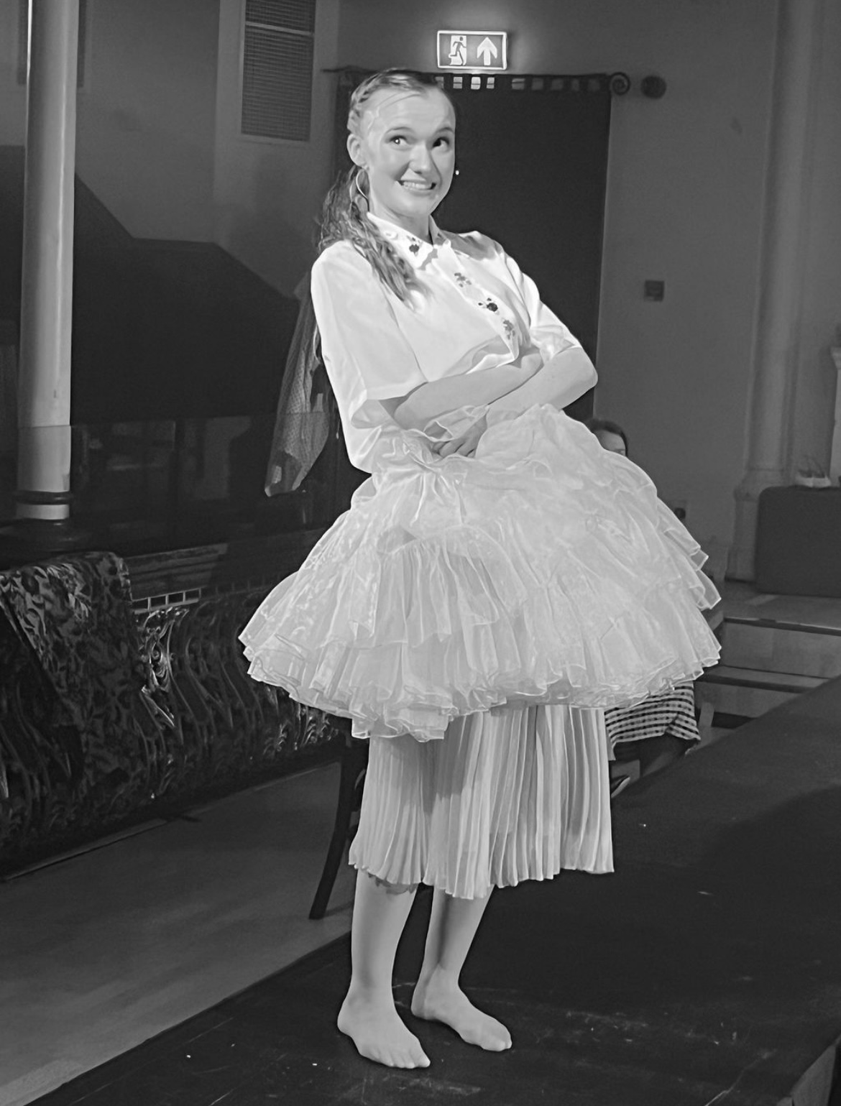
I had the opportunity to speak to Sam Kenyon; the writer of ‘Miss Littlewood’ so I could ask a few questions. I asked him about whether he met Barbara Windsor and if so what was she like. Kenyon did interview Barbara and she said to him ‘of course you’d want to meet me’. I found this charming and knew that I needed to add that characteristic in my interpretation of her. However ‘she did show me something unspeakably precious… I feel wonderful if that one moment when she felt wonderful in that interview’. I felt touched by this comment and that Barbara felt emotional talking about her relationship with Joan. ‘Because she’s known for her tits. it’s all in posture and it was fascinating that she turned into that figure’ I knew that I needed to not play her as that ditsy blonde she was perceived as because she didn’t want to be known as that. ‘Back in the day I was just seen as the beautiful woman sidekick and Joan made me feel really wonderful about myself.’ (Barbara Windsor, 2018) This comment supported the text analysis when I looked into the lyrics of the duet ‘Where Have You Been All My Life’. The lyric ‘I feel wonderful’ is her truly saying that she feels wonderful and that she feels good about herself as Joan saw her for her talent and her worth. This is shown as a strong shift between ‘Little Bit of Business’ and ‘Where Have You Been All My Life’ as she’s going from having to try and impress Joan to then not having to; to Joan making her realise the spark she holds when she performs (A spark that reminded Joan of her childhood self).
Another nugget of information Sam told me was that when Barbara felt an audition was going wrong, she would do a cartwheel at the end of it. This is something that Sam then referenced in Barbara’s song in the show as a ‘little trick I’d do from time to time’. We decided to physically show this so I learnt how to cartwheel into the splits; this further emphasised the showmanship she had. It stretched for a month everyday to improve my flexibility and I worked with our choreographer and dance captain in ‘Cartwheel Calls’ so I was using the correct technique to avoid any injury.

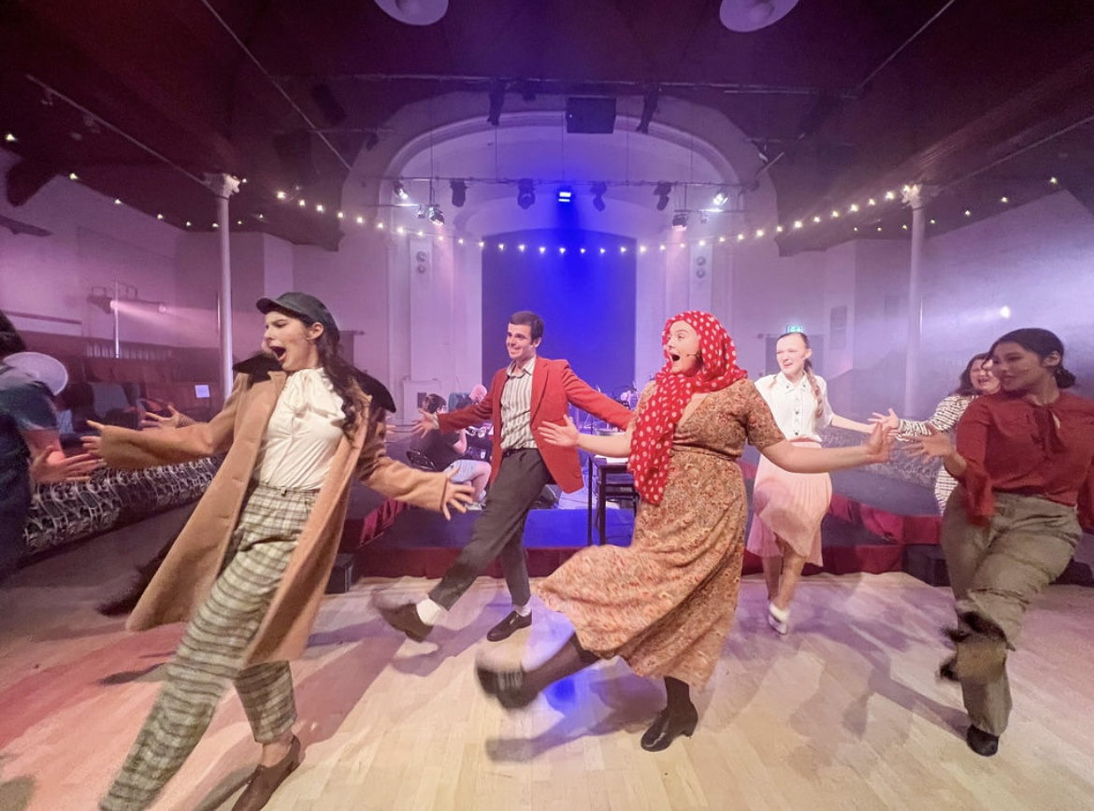
On show week we were introduced to the space and began tech. I found that I was able to experiment during tech week; in particular the dress rehearsals. We had rehearsed the show without an audience so bringing in audiences made a big difference. A Brechtian technique that Joan used in her plays was audience participation; ‘Brecht intended to heighten the spectator’s participation, not by testing the audience’s knowledge of a subject, but instead by inviting the audience to develop their own thoughts and criticisms about the events on the stage’ (Elizabeth Jones, 2010)
As a group we used the audience as a way to play with each character we played and to make the events on stage more immersive for the audience to watch. I found this easy when interacting with audience members when playing Barbara Windsor; every night I’d have different reactions to the audience whether it was me complimenting their appearance or just having a general chat with them about the audition I was about to do. I believe that the audiences’ energy gave us energy on stage and this heightened our performance’s and made them more engaging.

After the show I asked a few audience members for some feedback on their thoughts towards the show. We had a positive response towards the musical considering many of the audience had no idea who Joan Littlewood was. It was great to be able to influence audience members into learning about her work more.

‘ You were absolutely brill! So much improvement in your confidence since the start of the year! Really proud!’ (Zoe Barr, 2023)
‘Freya played each role with massive energy and enthusiasm but she really excelled playing the fabulous Barbara Windsor. She had very obviously studied Barbara for her mannerisms and personality shone through’ (Mike Drury, 2023)

Overall this musical was a learning curve for me as a performer. I not only learnt about politics at the time but also how important character development is in a story. Every character that I played had a pivotal role in the development of Joan’s character. From researching them all, they adored Joan and were the people that provided Joan with the famous plays/musicals she directed. I learnt how to use these real people as influence for my interpretations and how relationships between each character can be the reason why development happens.
I feel that I could have researched more on the wars that went on during the time of the show; especially the wars they were referencing in each Theatre Workshop. I felt I could have furthered some of my knowledge on the terminology used such as words like ‘Black Squad’ and ‘Wayward Woman’; this could have supported some of the text analysis I did.

‘Joan was a genius and loved her actors, and although she was a very tough taskmaster, she made [us] all into the actors [we] are today.’ (Brian Murphy, Rogues & Vagabonds 23-09-02)

Bibliography – Major Production

- Admin (n.d.). ‘It’s a story that should be heard’ – Clare Burt makes her RSC debut in Miss Littlewood | Musical Theatre Review. [online] Available at: https://musicaltheatrereview.com/its-a-story-that-should-be-heard-clare-burt-makes-her-rsc-debut-in-miss-littlewood/ (3rd July 2018)
- Ezard, J. and Billington, M. (23rd September 2002). Obituary: Joan Littlewood. [online] the Guardian. Available at: https://www.theguardian.com/news/2002/sep/23/guardianobituaries.arts.
- McLELLAN, D. (25th September 2002). Joan Littlewood, 87; Innovative Stage Director. [online] Los Angeles Times. Available at: https://www.latimes.com/archives/la-xpm-2002-sep-25-me-littlewood25-story.html [Accessed 27 Jun. 2023].
- Littlewood, J. (2003). Joan’s Book. Bloomsbury Methuen Drama.

- Rankin, P. (16th April 2007). Howard Goorney. The Guardian. [online] 16 Apr. Available at: https://www.theguardian.com/news/2007/apr/16/guardianobituaries.artsobituaries [Accessed 27 Jun. 2023].

- Unwin, S. (2014). Complete brecht toolkit. Nick Hern Books.
- Kenyon, S. (2023). Zoom Call with Sam Kenyon. 16 Jun.
- The Newsroom (2018). Chichester loses its Pearl with the passing of actress, writer and artist Pearl Goodman, aged 98. [online] Sussex World. Available at: https://www.sussexexpress.co.uk/news/chichester-loses-its-pearl-with-the-passing-of-actress-writer-and-artist-pearl-goodman-aged-98-237052.
- guardian.pressreader.com. (n.d.). The Guardian. [online] Available at: https://guardian.pressreader.com/article/281487870698862 [Accessed 27 Jun. 2023].
- Billington, M. (2021) “Barbara Windsor: a priceless and mischievous stage sensation,” The Guardian, 12 January. Available at: https://www.theguardian.com/stage/2020/dec/11/barbara-windsor-a-priceless-and-mischievous-stage-sensation.
- Littlewood, J. (2003). Joan’s Book. Bloomsbury Methuen Drama.

- Kenyon, S. (2023). Zoom Call with Sam Kenyon. 16 Jun.
- Windsor, B. (2018). Interview with Barbara Windsor on Joan Littlewood
- Anon, (n.d.). Available at: https://www.nottingham.ac.uk/english/documents/innervate/09-10/0910jonesebrecht.pdf.
- Brian Murphy, Rogues & Vagabonds 23-09-02

