BMMB7026 Managing Marketing Change

Student Name: Mahbuba Akter Baly
ID: 2514693

Executive Summary
AstraZeneca has seen significant business success in recent years, despite disruptions in the market. However, it is at a strategic crossroads as it pursues its goal of having $80 billion of yearly revenue. This report analyses and evaluates the global landscape of the healthcare and pharmaceutical industry, which is constantly in flux. The report applies PESTEL and Porter’s Five Forces model to identify and analyse macro-environment factors affecting its business performance. The report also analyses the various approaches through which the organization manages customer expectations. The analysis of AstraZeneca’s marketing strategies reveal its key approaches for business success, mostly industry leadership through service-enhanced medicine model. Its marketing strategy is analysed through STP and 7Ps of marketing analysis. The analysis revealed some key insights, such as how the organization moved away from traditional marketing approaches in favour of the AI-integrated omnichannel approach. Lastly, the report addresses the shortcomings in the business approach of AstraZeneca, and offers recommendations for the company to implement.

Contents
Introduction 4
Macro Environment (PESTLE) Analysis 4
Micro Environment Analysis 7
Porter’s Five Forces Analysis 7
Customer Analysis 9
Segmentation of the Customer Ecosystem 9
Personalization and Digital Engagement 10
Trust and Sustainability as a Competitive Advantage 11
Evaluation of Marketing Strategy 11
Segmentation, Targeting, and Positioning (STP) 11
The 7Ps Marketing Mix Evaluation 13
Conclusion and Strategic Shortcomings 17
Recommendations 17
Reference list 19

Introduction
AstraZeneca is a British-Swedish multinational pharmaceutical and biotechnology company (AstraZeneca, 2022). It is currently one of the most prominent innovators in the pharmaceuticals sector, with focus on Oncology, Cardiovascular, Renal, Metabolism, and Rare Diseases (AstraZeneca, 2024). It is also one of the biggest, fastest growing, and most profitable companies in its industry (Johannesson, 2021). In the year 2025, the company reported an increase of 11% to its total revenue, increasing it to $43.2 billion (American Pharmaceutical Review, 2025). The key reason for its business success is mainly its digital, patient-oriented healthcare model (AstraZeneca US, 2025). The pharmaceutical and biotechnology industry is going through massive shifts right now, and AstraZeneca through its innovative approach to healthcare is in a leading position for these changes (Camillus, 2021).
This report analyses and explores AstraZeneca’s marketing department in managing the transitions that the company must go through to stay at the top of its industry. Using the PESTEL framework, it analyses the macro-environmental drivers of change (Surridge, 2022). It also uses Porter’s Five Forces model to analyse the micro-environment (Barney and Hesterly, 2019). It explores the company’s current marketing strategy through the use of the STP framework and the 7Ps of Marketing Mix framework (Kotler and Armstrong, 2018). By finding out the company’s current weaknesses, the report concludes with recommendations for AstraZeneca to improve its business performance further and realize its goal of having $80 billion of revenue by 2030 (AstraZeneca, 2024).

Macro Environment (PESTLE) Analysis
The macro-environment for pharmaceutical and biochemical industry has always been characterized by a balancing act between massive investments in innovation and increasing impediments from governing bodies (Mennen, 2010). The macro-environment analysis for AstraZeneca is done through PESTLE analysis, which stands for Political, Economic, Social, Technological, Legal, and Environmental. The analysis is as follows.
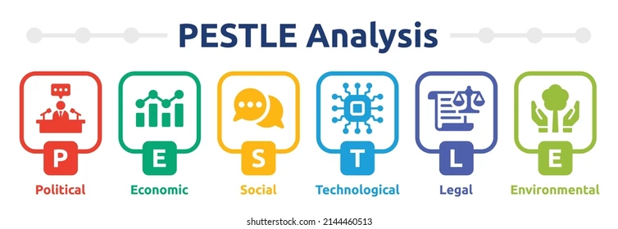
Figure: PESTEL Analysis
- Political Factors: Due to the push by the major economies, namely the US, to protect their own market from outside forces, the global economy has underwent significant bouts of temporary isolationism (Coşar et al., 2021). This is especially true in the context of the geopolitical tension between the US and China (Johannesson, 2021). For a multinational company such as AstraZeneca, it means its supply chains have come under significant risk of disruption (Javaid and Siddiqui, 2018). Although the company has taken major steps to remedy this, notably with its new $4.5bn facility in Virginia, US, it cannot fully protect itself against such unpredictability (Chopra, 2021).
- Economic Factors: The entire healthcare industry is under immense pressure due to slowing GDPs and rising inflation (Johannesson, 2021). The cost of raw materials is rising steadily, as are labour costs (Chopra, 2021). However, the fact that the company has been growing both its revenue and profits in such a situation is a testament to its internal efficiency and operational capability (American Pharmaceutical Review, 2025).
- Social Factors: With the adoption of digital technology every single industry has been going fundamental shifts, and healthcare is no different (Corallo, Passiante and Prencipe, 2017). The current trend in the healthcare industry among the patients is Personalized medicine, as they are no longer comfortable with being passive recipient (AstraZeneca US, 2025). The easier access to healthcare information also means that the customers are today more informed about their own needs than before (Bueschken, 2019). To address such developments, pharmaceutical companies must provide their customers with services that go beyond simple medicine (Goldman, 2018). AstraZeneca is one of the earliest adopters of these new business models, with its AstraZeneca Direct platform offering healthcare support for customers with serious health issues (AstraZeneca US, 2025).
- Technological Factors: As stated previously, the current trend in the healthcare industry is personalized healthcare service (AstraZeneca US, 2025). However, for such a large organization like AstraZeneca, it would be quite impossible to offer its millions of customers with personalized services without data analytics and AI (David Brian Szabla, 2023). AstraZeneca is at the forefront of AI and data analytics revolution (Koch and Windsperger, 2017). With AstraZeneca Direct, the company can store, manage, and utilize user data to provide the best experience (AstraZeneca US, 2025). AI is also effective at diagnosis and drug discovery, although those applications remain in their infancy (AstraZeneca, 2022). The company’s marketing divisions has made the most of new technologies, with the company making personalized content for millions of stakeholders across different regions (Srivastava, 2021).
- Legal Factors: The legislation regulating trade and business operations have significant impact on AstraZeneca’s business (Alexis, 2021). In 2025-2026, the US Inflation Reduction Act (IRA) has posed a significant barrier for the company (Mennen, 2010). According to this legislature, Medicare can now negotiate the prices for top-selling drugs, challenging AstraZeneca’s traditional high profit margin business model (Mennen, 2010). Many of AstraZeneca’s premium selections have been subjected to negotiation, resulting in the company having to move away from a premium only model to a value-based model where the company must justify the prices of its drugs through its benefits (Campbell, 2021).
- Environmental Factors: Sustainable practices are now a key metric of competition among organizations, and stakeholders are more likely to lend their support to company’s that have strong environmental concerns (Farmer and Hogue, 2020). This is true for AstraZeneca as well, and the company is investing $1 billion to reach net zero in carbon emission by 2025 (AstraZeneca, 2024). Marketing a drug as decarbonized, or with little to no global warming potential is now an added value that customers look for when purchasing (Ngek Neneh, 2020).

Micro Environment Analysis
The micro-environment for AstraZeneca includes the immediate forces that characterize its industry, notably competition, customer sway over the company, and supply chain dependencies (Mennen, 2010). Its micro-environment is analysed using Porter’s Five Forces model.

Porter’s Five Forces Analysis
Developed by Michael E. Porter, the Five Forces model defines five key dimensions to analyse a company’s competitive landscape in its market.
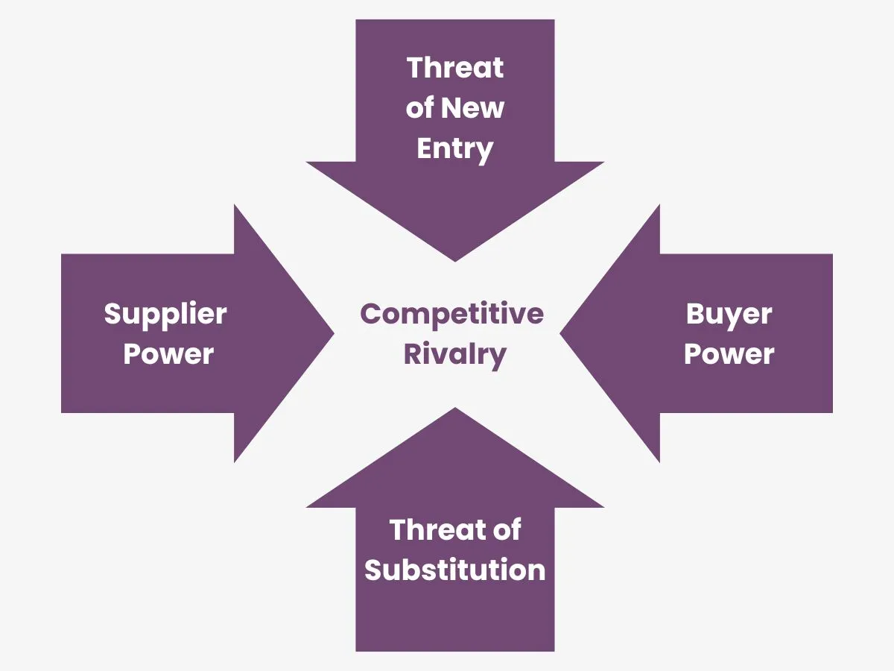
Figure: Porter’s Five Forces Model
- Competitive Rivalry (High): AstraZeneca operates in a highly saturated market (Johannesson, 2021). In its main source of revenue, its Oncology segment, it is in intense competition with pharmaceutical giants such as Pfizer, Roche, and Merck (AstraZeneca, 2024). As such, it must constantly innovate, find new solutions, differentiate itself from its rivals, and provide better value for the customers (Ferdinand, 2019). AstraZeneca proves to be highly successful in retaining its market share and even growing, despite such intense competition (American Pharmaceutical Review, 2025). This could mostly be attributed to its relentless innovation, and its marketing department that translates these successes into market success (Hoeffler and Keller, 2023).
- Threat of New Entrants (Very Low): AstraZeneca is strongly established in its market (Barney and Hesterly, 2019). It is a large corporation, with significant capital and a reputation for excellence and quality (Hoeffler and Keller, 2023). It is one of the most innovative pharmaceutical companies in the world (AstraZeneca, 2022). Any new entrant into its industry will have to achieve all that to be able to effectively compete against AstraZeneca (Johannesson, 2021). However, it will require significant capital investment to be able to achieve the same qualities of AstraZeneca (Burrow and Becraft, 2020). Even still, it would take a lot of time to build a brand image and reputation of excellence, good customer service, and innovativeness that AstraZeneca has (Goldman, 2018). For these reasons, the threat from new entrants coming into the industry and disrupting AstraZeneca’s business success is very low.
- Bargaining Power of Buyers (Very High): AstraZeneca gets most of its sales from governmental bodies or other institutions, such as health insurance providers, instead of individual patients (Mennen, 2010). As these buyers are incredibly price-sensitive, and buy large volumes of medicines, they can easily get the medicines from one of AstraZeneca’s competitors (Campbell, 2021). Moreover, these governmental bodies often have legislative regulations on their side, giving them significant advantage over AstraZeneca (Alexis, 2021). Moreover, the pharmaceutical market is highly saturated, and buyers have a lot of choices (Barney and Hesterly, 2019). This gives them significant bargaining power, resulting in lower profit margins for AstraZeneca (Mennen, 2010).
- Bargaining Power of Suppliers (Medium to High): AstraZeneca only sources its materials from a limited number of suppliers (Chopra, 2021). Moreover, with the massive volume of APIs that it needs, not many suppliers could provide it with raw materials either (Javaid and Siddiqui, 2018). The company sources most of its raw materials from Asia (Coşar et al., 2021). Any switch in the suppliers also comes with its own complications, and it takes time for AstraZeneca to properly qualify a new supplier (Chopra, 2021). Switching costs are also high (Javaid and Siddiqui, 2018). For this reason, suppliers have a lot of bargaining power on AstraZeneca. The company somewhat counters this by creating long-term mutually beneficial partnerships with its suppliers (Farmer and Hogue, 2020).
- Threat of Substitutes (High): Once the patent for a medicine that AstraZeneca developed expires, traditional medicine manufacturers can offer the same medicine for much less the cost than AstraZeneca (Johannesson, 2021). This is one of the biggest threats to AstraZeneca’s business model (Burrow and Becraft, 2020). Moreover, its competitors can also manufacture medicines that are good alternatives for its medicines (Barney and Hesterly, 2019). This makes the threat of substitution incredibly high for the company (Mennen, 2010). In this area, AstraZeneca’s marketing strategy proves to be highly effective, as it convinces the patients and doctors to trust in its brand value rather than other options (Hoeffler and Keller, 2023).

Customer Analysis
AstraZeneca is one of the biggest pharmaceutical giants in the world, and its branches are across every major region, in the markets of every major economy (AstraZeneca, 2024). It has one of the most diverse customer base that a company can ever have, and their needs and demands are constantly changing (Camillus, 2022a). It is impossible for the company to follow and catch up to these changing needs and demands (Camillus, 2022b). So, AstraZeneca instead aims to lead the customers in these changes (Camillus, 2021). In order to do this, however, the company needs to understand its customers well (Lerza, 2021). This is easier said than done, as the customer for AstraZeneca is no single entity, but millions of individuals scattered all around the world (Hoeffler and Keller, 2023). This becomes an incredibly complex change management operation for the company (Camillus, 2022a). At the heart of all of AstraZeneca’s processes, procedures, and practices, is the brand image of a customer-oriented company (Bueschken, 2019).

Segmentation of the Customer Ecosystem
To understand and manage the changing needs of the customers, it is imperative that AstraZeneca divide the customer ecosystem into different segments (Kotler and Armstrong, 2018).
- Healthcare Providers (HCPs): In this segment of AstraZeneca’s customers, there are medical professionals who work closely with patient in either diagnostic or consultancy roles (Goldman, 2018). These are professionals at the top of their fields who rely on tried and tested medicine and real-world evidence to suggest patients medicines according to their needs (Hoeffler and Keller, 2023). In order to be convincing to the customers regarding the quality of its medicines, AstraZeneca approach them through these professionals (Goldman, 2018). Patients are more likely to trust them over any other professional salespeople, and these professionals are more likely to be able to ascertain the quality advantage AstraZeneca has over others (Lerza, 2021).
- Institutional Payers: In this group of AstraZeneca’s customers, governmental healthcare agencies such as the NHS and insurance providers can be found (Mennen, 2010). The main concerns of these organizations or agencies are the cost-effectiveness and budget-friendliness of the medicines that they buy (Campbell, 2021). AstraZeneca approaches them through a value-based business model, where the organization justifies the high prices of its medicines by highlighting the long-term cut in the costs of treatment (Barney and Hesterly, 2019).
- Patients: Patients are the primary recipient and consumer of the health benefits of AstraZeneca’s medicines (AstraZeneca US, 2025). As such, any and all business practices that AstraZeneca takes must ultimately be taken up to provide them with value (Lerza, 2021). Nowadays, patients demand not only effective healthcare, but also a satisfying experience at the same time (Bueschken, 2019). It is their demands that AstraZeneca must remain the most vigilant about (Lerza, 2021).

Personalization and Digital Engagement
Based on the segmentation of customer ecosystem, AstraZeneca designs engagement approaches to ensure that its customers get value beyond mere medicines for their support (AstraZeneca US, 2025).
- Omnichannel Orchestration: Without relying on traditional salespeople, AstraZeneca ensures the promotion of its brand image and products through omnichannel marketing (Corallo, Passiante and Prencipe, 2017). In this way, AstraZeneca integrates every channel that it aims to use in its promotional campaigns and launches unified campaigns across all those platforms (Srivastava, 2021). This process has been improved significantly with the adoption of AI practice (David Brian Szabla, 2023). AstraZeneca can, for example, tailor emails to medical professionals exactly according to their expectations (Goldman, 2018).
- Digital Health Solutions: Instead of just being a just a pharmaceutical company, AstraZeneca offers solutions to the issues that its customers are facing that go beyond simple medicine (AstraZeneca US, 2025). Through its digital platforms, the company offers its customers medicine reminders, makes it easy for them to transfer health information, offers virtual consultations etc (AstraZeneca, 2022). These foster long-term loyalty and help the patients manage chronic diseases (Bueschken, 2019).
- AstraZeneca Direct: With the adoption of AstraZeneca Direct, a direct-to-consumer platform, AstraZeneca has made it much easier for customers to have access to medicines (AstraZeneca US, 2025). They can now just order it from the comfort of their homes, and have the necessary medicines delivered to them (AstraZeneca US, 2025). This allows AstraZeneca to cut across the middlemen straight to the customers, which saves it a lot, gains which the company then transfers to the customers, offering them medicines at much lower prices (AstraZeneca US, 2025).

Trust and Sustainability as a Competitive Advantage
Above all, what truly allows AstraZeneca to retain its loyal customer base and attract new ones is its priority for the wellbeing of the customer above all (Hoeffler and Keller, 2023). It has built through many years of partnership with its customers a reputation and brand image of trust, quality, and customer-friendliness (Bueschken, 2019). These strengths allow the company to weather any temporary changes or disruptions in the market, which not many other companies can boast of doing (Ferdinand, 2019).

Evaluation of Marketing Strategy
AstraZeneca’s marketing strategy is key to its success (Kotler and Armstrong, 2018). Its marketing strategy is analyzed below through STP and 7Ps of marketing mix framework.

Segmentation, Targeting, and Positioning (STP)
STP stands for Segmentation, Targeting, and Positioning. It is a marketing analysis framework that shifts the focus from products to customers. The STP analysis for AstraZeneca is given below.
- Segmentation: AstraZeneca divides the global healthcare market into various manageable segments (Kotler and Armstrong, 2018). When dividing these areas, the company focuses on functional areas (AstraZeneca, 2024). It also has marketing segments based on geography, and developed and developing markets (Coşar et al., 2021). Each of these market segments have different needs, respond to different business and marketing approaches, and different pricings (Burrow and Becraft, 2020). By dividing the market into these segments, AstraZeneca can better understand and consider how to appeal to customers in a specific market region, retain its market share and ensure market growth (Hoeffler and Keller, 2023).
- Targeting: Instead of targeting an entire market through broad and mass market targeting strategies, AstraZeneca has developed and continuously improves on precision and specific targeting practices (Kotler and Armstrong, 2018). Within the market segments that it has chosen, AstraZeneca specifically targets medical specialists (Goldman, 2018). These people would require up-to-date research data to make informed decisions, and AstraZeneca creates a long-term relationship with them by offering its own research data (AstraZeneca, 2022). For the governmental and health insurance buyers, it has its specific outreach programs (Mennen, 2010). For individual patients, it markets its products to them directly through AstraZeneca Direct (AstraZeneca US, 2025). For emerging markets, the organization offers tiered pricing, and discounts (Ngek Neneh, 2020). For developed markets, it offers its premium and value-based selections (Barney and Hesterly, 2019). Through these targeting practices, the company makes sure that it achieves a significant market penetration (American Pharmaceutical Review, 2025).
- Positioning: After the market segmentation and targeting comes the positioning, where the organization positions itself to appeal to those that it targeted for sale (Kotler and Armstrong, 2018). In its brand positioning approach, AstraZeneca uses its innovation and research and development to position itself as a pioneer that constantly pushes the boundaries of medical science for its customers (AstraZeneca, 2022). This positioning would not be possible if the company did not invest significant amount of capital in its innovation and managing customer expectations (AstraZeneca, 2024). The company also presents itself to the market as a customer-oriented company, providing its customers with added value that goes beyond simple medicine (Bueschken, 2019). It creates long-term partnerships through its digital channels (Koch and Windsperger, 2017). Thus, it is not just another pharmaceutical business, it is a healthcare service provider (Hoeffler and Keller, 2023). Another position that the company takes is that of a sustainable partner to many environmental and CSR programs (Farmer and Hogue, 2020). Through these positions in the market, AstraZeneca appeals to its potential customers (Hoeffler and Keller, 2023).

The 7Ps Marketing Mix Evaluation
The 7Ps of the marketing mix refers to the framework that is used to create a comprehensive marketing strategy. It can also be used to analyse the marketing strategy of an organization. The 7Ps in the marketing mix stand for Product, Price, Promotion, Place, People, Process, and Physical Evidence. An analysis of AstraZeneca’s marketing strategy through the use of the 7Ps of marketing is given below.
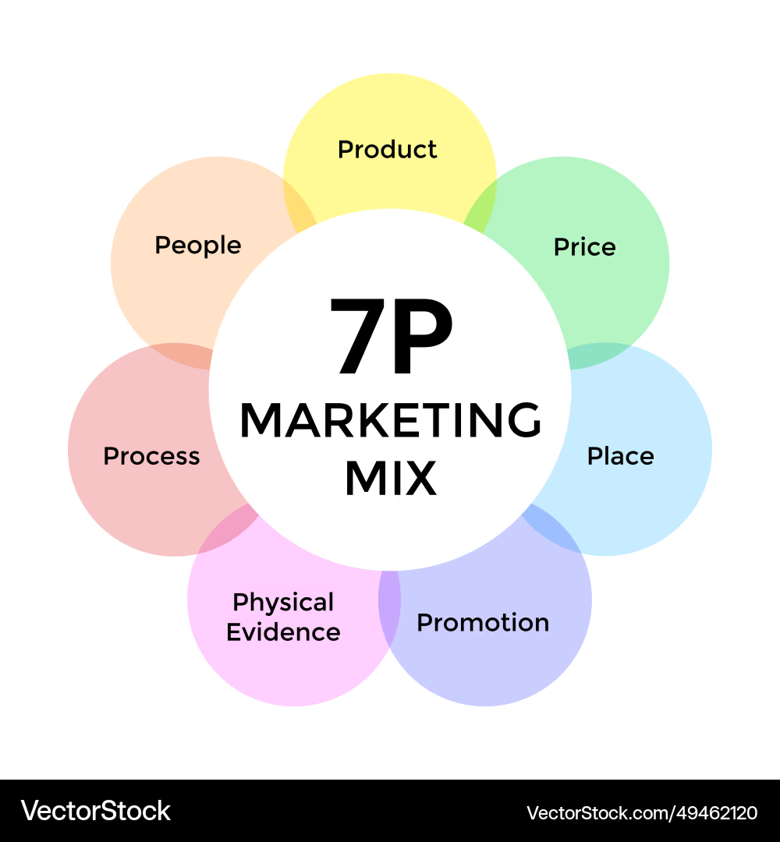
Figure: 7Ps of Marketing Mix
- Product: The marketing mix works especially well for services, and AstraZeneca’s medicines are no longer mere products, but a package of high-quality healthcare service (Polo, 2021). Its medicines are enhanced through its service (Hoeffler and Keller, 2023). Along with its medicines, AstraZeneca offers its customers consultation, personalized attention and healthcare service, and accompanying benefits such as diagnostics (Goldman, 2018). They also come with digital support tools (AstraZeneca US, 2025). The vast majority of AstraZeneca’s medicine sales are now through its personalized healthcare channels, which address the specific needs of each patient to ensure high-quality healthcare (Bueschken, 2019).
- Price: With its significant operational costs, and significant investments in R & D, AstraZeneca cannot compete on prices with organizations (Burrow and Becraft, 2020). As such, it operates on a value-based pricing, where it offers high value for higher prices of its treatments (Campbell, 2021). With a large inventory of innovative drugs and patents, the company can offer its patients fair value for their money (Hoeffler and Keller, 2023). However, this generally causes issues with governmental and insurance organizations, as they are averse to spending more money on drugs (Mennen, 2010). However, for many of the products that AstraZeneca sells, there are no alternatives, forcing the organizations to buy from it (Barney and Hesterly, 2019).
- Place: AstraZeneca has achieved significant penetration across almost every major market, with the country operating in over 125 countries (AstraZeneca, 2024). However, relying on traditional physical locations often come with significant issues, mainly high overhead costs, overreliance on supply chain, and lack of effective quality control (Chopra, 2021). As a landmark move in 2025, the company moved away from physical locations in favour of online platform (AstraZeneca US, 2025). Known as AstraZeneca Direct, it is a direct-to-consumer digital platform operating in the US (AstraZeneca US, 2025). This has bypassed many of the issues with traditional supply chains in favour of delivering medicines directly to the customers (Chopra, 2021). This approach is beneficial not only for the company, but for its customers as well (Bueschken, 2019).
- Promotion: Promotion of the brand is one of the most important marketing practices (Srivastava, 2021). However, the process of promotion has changed significantly (Polo, 2021). Before, companies used to rely mainly on sales rep volume (Kotler and Armstrong, 2018). However, in recent years the industry has moved away from that practice to focus on data analytics and AI (David Brian Szabla, 2023). Through the collection of user data through its digital platform, AstraZeneca offers its individual customers products and services based on their own needs (AstraZeneca US, 2025). Moreover, the company is constantly improving its approach through data analytics (Koch and Windsperger, 2017). It also organizes conferences for any new research finds to make medicine specialists interested in them (AstraZeneca, 2022). This is much more successful rather than depending on physical sales practices (Corallo, Passiante and Prencipe, 2017).
- People: AstraZeneca employs over 94,000 employees across all its locations (AstraZeneca, 2024). Its staff is highly skilled and differentiate the company significantly from its rivals (Johannesson, 2021). One of the key staff for AstraZeneca’s success is Medical Science Liaisons (MSLs) (Hoeffler and Keller, 2023). These people are highly trained experts who work brand educators rather than traditional salespeople (Goldman, 2018). In other words, AstraZeneca employs trained experts so as to influence the decisions of the medical practitioners (Lerza, 2021). They build long-term partnerships with the relevant practitioners (Hoeffler and Keller, 2023).
- Process: The two most important processes for AstraZeneca are marketing and R&D (AstraZeneca, 2022). Much of the procedures of these two processes have become automated with the advent of AI (David Brian Szabla, 2023). AI offers the company a significant advantage (AstraZeneca, 2022). It no longer needs to conduct costly experiments to find the effectiveness of its medicines before moving on to serious trials (AstraZeneca, 2022). AI can significantly narrow the scope and scale of the experiment needed and make them much more effective and efficient (AstraZeneca, 2022). Business analytics also help the company to find suitable clients for clinical trials, or patient cases to study for unlocking potential solutions for other cases (Corallo, Passiante and Prencipe, 2017). AI and data analytics has revolutionized AstraZeneca’s business practices (David Brian Szabla, 2023). From accounting to market analysis, business performance to regulation compliance, everything can be conducted more efficiently and effectively through the use of AI (Srivastava, 2021).
- Physical Evidence: In a company operating in the pharmaceutical sector, physical evidence is generally trial data and evidence (Polo, 2021). AstraZeneca is very strict about its standards of quality and excellence, and goes through rigorous trials after trials to ensure that a drug works the way it should, without having any side-effects (Hoeffler and Keller, 2023). Moreover, it has close relationships with medical practitioners and researchers who can corroborate its findings (Goldman, 2018). It funds and holds open discussions for any new medicines developed (AstraZeneca, 2024). All of these serve to provide the customer with physical proof that the company’s promise of healthcare is true (Bueschken, 2019).

Conclusion and Strategic Shortcomings
One of the main reason behind AstraZeneca’s success is its flexible and innovative business approach. The company is in a relentless drive towards innovation, not only in its products but also in its business structure, performance, and processes. Thus, it swiftly responds to any challenges or complexities that may arise in its markets, often before any other companies has had the chance to do so. This can be seen in its response to the current geopolitical tension and the bargaining power of suppliers. Its marketing strategy also employs intelligent approach by dividing the market into functional segments, and then targeting and positioning itself in an advantageous way. In its marketing approach, it has always kept the customer-first, leading to its near-impeccable brand image.
Although AstraZeneca has witnessed unprecedented business growth and digital success, it still has some key shortcomings that it must address to make itself safe. A large portion of its revenue comes from Oncology division. While this reflects its market success, overreliance on one specific product selection has its downsides. Any market disruption, legislative issues, or breakthrough that might impede the profitability of this segment may result in loss of significant market share for the company. AI diagnosis and healthcare support is still in its infancy, and there have been reports that these platforms have given false or conflicting reports to the customers. Finally, its net-zero commitment is still kept as a CSR initiative, rather than a marketing pillar to appeal to potential customers who are environmentally conscious.

Recommendations
- Unified Platform: Instead of separating its online and physical locations, and AstraZeneca should go forward with an integrated platform where both online and physical locations work together. This could come in the form of self-checkout, online payments, localized delivery systems etc. This not only makes it possible for the company to completely rely on either type of business model, and make the experience much better and easier for the customers.
- "Green Procurement" Strategy: AstraZeneca should put its net zero carbon emission goal as a core marketing USP instead of a mere CSR initiative. The younger generation is significantly more environmentally conscious than the previous ones, and this rate is only projected to increase. In this way it is likely that AstraZeneca would be able to secure another batch of loyal customers from the newer generations.
- Agile Value-Based Pricing (AVBP): High pricing has always been one of the main weaknesses of AstraZeneca. Individual customers and organizations are hesitant to buy AstraZeneca’s medicines due to their perceived high cost. However, if the company could offer some discount schemes, or money-back guarantees to its customers, it might put their minds at ease regarding the high prices of the medicines.

Reference list
Alexis, M. (2021). Marketing Laws and Marketing Strategy. Journal of Marketing, 26(4), p.67.
American Pharmaceutical Review (2025). AstraZeneca Delivers 11% Revenue Growth and Pipeline Progress in First Nine Months of 2025. [online] Americanpharmaceuticalreview.com. Available at: https://www.americanpharmaceuticalreview.com/1315-News/622628-AstraZeneca-Delivers-11-Revenue-Growth-and-Pipeline-Progress-in-First-Nine-Months-of-2025/.
AstraZeneca (2022). Our technologies. [online] www.astrazeneca.com. Available at: https://www.astrazeneca.com/r-d/our-technologies.html.
AstraZeneca (2024). AstraZeneca sets ambition to deliver $80 billion Total Revenue by 2030 and sustained growth post 2030. [online] Astrazeneca.com. Available at: https://www.astrazeneca.com/content/astraz/media-centre/press-releases/2024/astrazeneca-to-deliver-80bn-revenue-by-2030.html.
AstraZeneca US (2025). AstraZeneca launches direct-to-consumer platform to expand access to medications for US patients, including those living with chronic conditions. [online] Astrazeneca.com. Available at: https://www.astrazeneca.com/content/az-us/media/press-releases/2025/AstraZeneca-launches-direct-to-consumer-platform-to-expand-access-to-medications-for-US-patients-including-those-living-with-chronic-conditions.html.
Barney, J.B. and Hesterly, W.S. (2019). Strategic Management and Competitive Advantage: Concepts and Cases. 6th ed. Harlow, England: Pearson.
Bueschken, J. (2019). Does Improving Customer Satisfaction Really Increase the Market Value of Equity? - Revisiting the ACSI Customer Satisfaction Data. SSRN Electronic Journal, 1(1).
Burrow, J. and Becraft, M.B. (2020). Business management. Boston, Ma: South-Western Cengage Learning.
Camillus, J.C. (2021). The wicked challenge of the business environment. International Journal of Business Environment, 8(1), p.19.
Camillus, J.C. (2022a). Organisational Identity and the Business environment: the Strategic Connection. International Journal of Business Environment, 4(4), p.306.
Camillus, J.C. (2022b). Organisational Identity and the Business environment: the Strategic Connection. International Journal of Business Environment, 4(4), p.306.
Campbell, D. (2021). Business Strategy. 5th ed. London: Pearson.
Chopra, S. (2021). Supply Chain Management : Strategy, Planning and Operation. 7th ed. New York, NY: Pearson Education.
Corallo, A., Passiante, G. and Prencipe, A. (2017). The digital business ecosystem. Cheltenham, Uk ; Northampton, Ma: Edward Elgar Pub.
Coşar, A.K., Grieco, P.L.E., Li, S. and Tintelnot, F. (2021). What drives home market advantage? Journal of International Economics, 110(1), pp.135–150.
David Brian Szabla (2023). Management Consulting in the Era of the Digital Organization. IAP.
Farmer, R.N. and Hogue, W.D. (2020). Corporate social responsibility. Lexington, Mass.: Lexington Books.
Ferdinand, A.T. (2019). Company Specific Advantage and Sustainable Competitive Advantage. SSRN Electronic Journal, 1(1).
Goldman, R.L. (2018). Customer Service. Journal of Customer Service in Marketing & Management, 2(1), pp.65–77.
Hoeffler, S. and Keller, K.L. (2023). The marketing advantages of strong brands. Journal of Brand Management, 10(6), pp.421–445.
Javaid, T. and Siddiqui, D.A. (2018). Supply Chain Responsiveness and Supply Chain Performance: The Role of Supply Chain Risk Management. SSRN Electronic Journal, 1(1).
Johannesson, J. (2021). Business growth in a tough economy. International Journal of Business Competition and Growth, 1(3), p.231.
Koch, T. and Windsperger, J. (2017). Seeing through the network: Competitive advantage in the digital economy. Journal of Organization Design, 6(1).
Kotler, P. and Armstrong, G. (2018). Principles of marketing. 17th ed. Hoboken: Pearson Higher Education.
Lerza, R. (2021). Customer satisfaction: what can we save? Emergency Care Journal, 7(1), p.3.
Mennen, M. (2010). Micro and Macro Environmental Analysis of the Health Care Sector in the US and France - Potential Opportunities and Threats. GRIN Verlag.
Ngek Neneh, B. (2020). Market orientation and performance: the contingency role of external environment. Environmental Economics, 7(2), pp.130–137.
Polo, M.P. (2021). Acts or events? A perspective from the marketing mix. IROCAMM-International Review Of Communication And Marketing Mix, 1(1), pp.56–66.
Srivastava, R. (2021). Shift of Marketing Mix to E-Marketing Mix: The Birth to New Era. SSRN Electronic Journal, 1(1).
Surridge, M. (2022). The business environment. 4th ed. London: Collinseducational.

