University of Wales Trinity Saint David
Wales Institute of Science and Art


Waves

ACHA4010 Electrical Control Systems

Mohammed Nasir Mahmood
2003929
Date
Contents
1 Task 2 1
1.1 Scope Time Division Calculations (4) 1
1.2 Function Generator output sine wave (3) 1
1.3 Unsmoothed Rectifier Wave (3) 2
1.4 Smoothed Rectifier Wave with capacitor (3) 2
1.5 Drop in Voltage Question (4) 3
1.6 Different Voltage Readings Question (5) 3
1.7 Rectifiers use in Automotive applications Question. (4) 3
1.8 Probing Question (4) 3
2 Task 3 3
2.1 Scope Time Division Calculations (4) 3
2.2 Function Generator output square wave (3) 3
2.3 Capacitor charge and discharge wave marked at correct points. (3) 4
2.4 Basic Capacitor Calculations (3) 4
2.5 Capacitor discharge table (4) 5
2.6 Gradient Plot and calculations (4) 5
2.7 Capacitor Uses (5) 6
2.8 Inaccuracies Question (4) 6
3 References 7

Task 2

Scope Time Division Calculations (4)
1/10 = 0.1 seconds

Function Generator output sine wave (3)
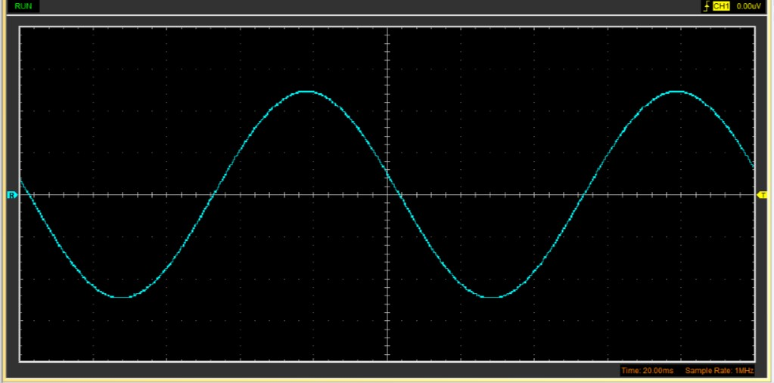

Unsmoothed Rectifier Wave (3)
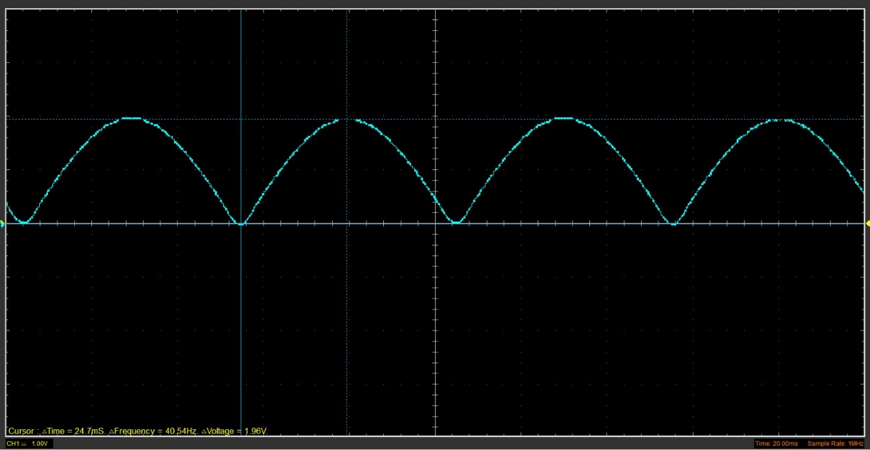

Smoothed Rectifier Wave with capacitor (3)
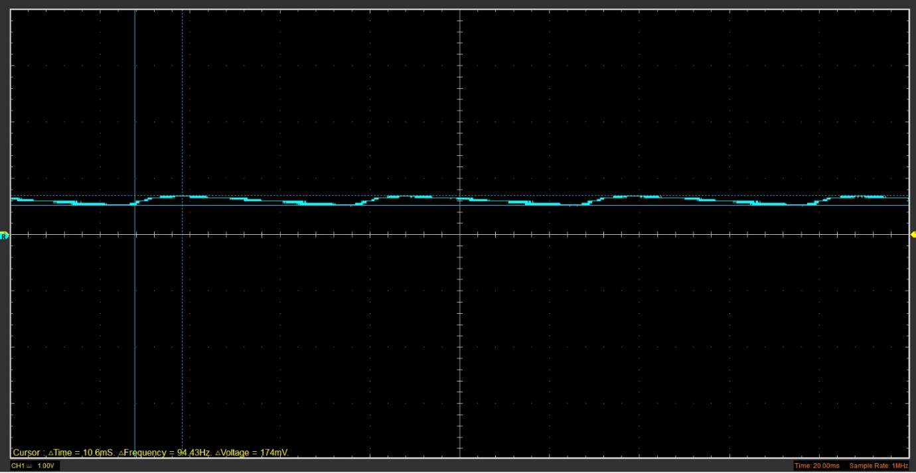

Drop in Voltage Question (4)
The reason for voltage drop is due to the resistance of a material. Materials such as wood, plastic and rubber are high resistance materials also known as electric insulator’s. The length of material is also responsible for voltage drop. and the cross-sectional area for example a material with a smaller cross-sectional area will have a higher resistance therefore there is a greater voltage drop.

Different Voltage Readings Question (5)
 | Peak Input Voltage (V) | Peak to Peak Voltage (V) | Root Mean Square (V)
Function Generator Output | 2.46 V | 9.85 V | 3.42 V

Rectifiers use in Automotive applications Question. (4)
Rectifiers can be used in various scenarios. The use of a rectifier is getting electricity to flow in one specific direction and to avoid it flowing in the opposite direction. In the application of automotive a rectifier will be used to control the electricity flow from the alternator to the vehicles electrical system. As the alternator spins and charges the polarity of each revolution is reversed. Rectifiers can be sued in places where cross feed is not wanted. An example of this can be for a vehicle high beam switch it will prevent it from sending voltage back to the electrical system.

Probing Question (4)
With probing laptop-based oscilloscopes were used to obtain the data. The advantage to this method is that it is portable and the set up and easy to use. Although they lack features that a standalone oscilloscopes have.

Stand alone oscilloscopes have dedicated processing units. They will offer more advanced features also with a stand alone bench top oscilloscope you can see low frequencies such as 196kHz

Task 3

Scope Time Division Calculations (4)
1/50 = 0.02 seconds

Function Generator output square wave (3)

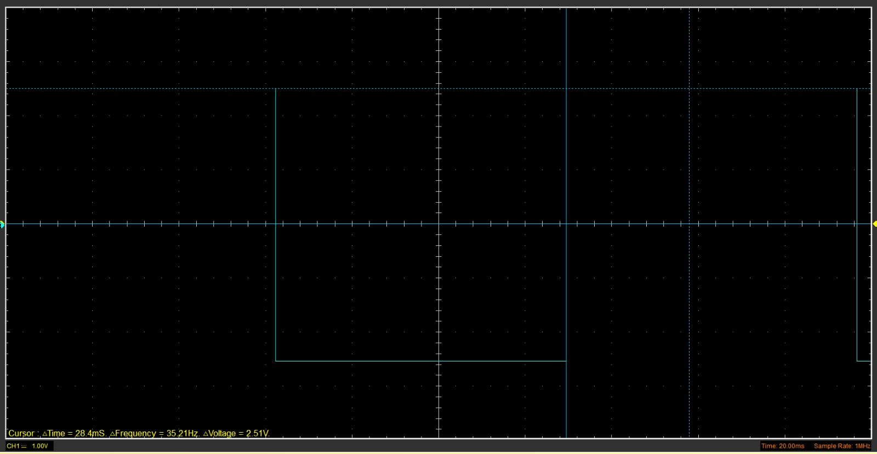

Capacitor charge and discharge wave marked at correct points. (3)
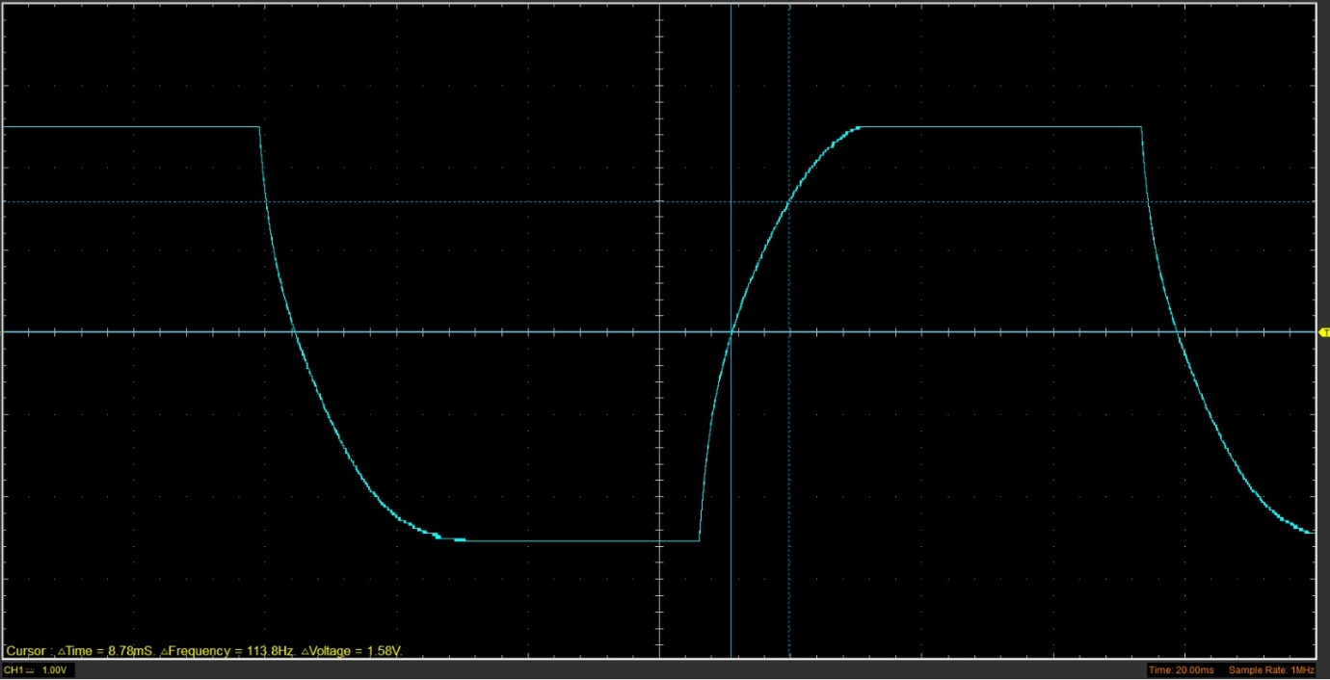

Basic Capacitor Calculations (3)
C= T/R
0.00878/2000 = 4.39X10⁻⁶ (F)

Capacitor discharge table (4)
Time (s) | Voltage (V) | ln (V) | dy = y2 – y1  dy = ln(V)2-ln(V)1 | dx = x2- x1  dx = Time2 – Time1 | dy/dx
0.0032 | 4.0784 | 2.205897966 | x | x | x
0.003533 | 1.6941 | 1.901226541 | 5 | 0.33 | -914.929
0.003866 | 0.3765 | 1.682037605 | 1.31 | 0.33 | -658.225
0.004199 | -0.6275 | 1.475334928 | 2.10 | 0.33 | -620.728
0.004532 | -1.4431 | 1.268889379 | 2.71 | 0.33 | -619.956
0.004865 | -2.1961 | 1.031011305 | 3.23 | 0.33 | -714.348
0.005198 | -2.8863 | 0.748439966 | 3.63 | 0.33 | -848.562
0.005531 | -3.3882 | 0.477351567 | 3.9 | 0.33 | -814.079
0.005864 | -3.8902 | 0.104179819 | 3.99 | 0.33 | -1120.635
0.006197 | -4.2667 | -0.310200384 | 3.96 | 0.33 | -1244.384

Gradient Plot and calculations (4)
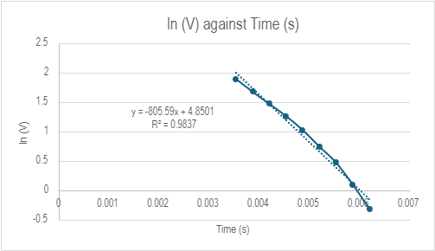

Capacitor Uses (5)
Capacitors are used to for a various application such as. Energy storage, electronic noise filtering, remoter sensing, power conditioning and signal coupling and decoupling. Capacitors are made up of two conductors separated by dielectric material.

Inaccuracies Question (4)
The inaccuracies of the results could be down to the equipment. Some of the equipment may have had defects and some of the equipment used may have been less accurate compared to other substitutes.

References
Garner, R. (2019) List of uses for capacitors, List of Uses for Capacitors. Available at: https://sciencing.com/list-uses-capacitors-8059446.html (Accessed: 14 March 2024).
Edington Agencies (2021) What are capacitors used for?, Edington Agencies. Available at: https://www.edingtonagencies.com.au/what-are-capacitors-used-for/ (Accessed: 14 March 2024).
Automotive applications (2023) GD Rectifiers. Available at: https://www.gdrectifiers.co.uk/automotive/ (Accessed: 14 March 2024).
Gonzalez, G. (2014) What is an automotive rectifier and why would I need one? - quora. Available at: https://www.quora.com/What-is-an-automotive-rectifier-and-why-would-I-need-one (Accessed: 14 March 2024).
Madsen, J. (2023) What causes voltage drop in power supply?, Bravo Electro. Available at: https://www.bravoelectro.com/blog/post/what-causes-voltage-drop-in-power-supply (Accessed: 14 March 2024).
EEVblog Electronics Community Forum (no date) Pros and cons of safe oscilloscope probing methods? - Page 1. Available at: https://www.eevblog.com/forum/testgear/safe-oscilloscope-probing-methods/ (Accessed: 14 March 2024).
(2017) What are the pros and cons of buying a laptop-based oscilloscope? Available at: https://www.quora.com/What-are-the-pros-and-cons-of-buying-a-laptop-based-oscilloscope-Are-they-worth-their-price-compared-to-cheaper-desktop-models-that-can-be-used-with-external-probes-or-portable-ones (Accessed: 14 March 2024).
Sreeraj ChundayilSreeraj Chundayil 30344 silver badges1414 bronze badges et al. (2017) What’s the difference between USB and Non USB oscilloscope?, Electrical Engineering Stack Exchange. Available at: https://electronics.stackexchange.com/questions/321378/whats-the-difference-between-usb-and-non-usb-oscilloscope (Accessed: 24 March 2024).

