Taylor Dawn Hodges
2008862@student.uwtsd.ac.uk
BSc Computing (Software Engineering)
Lecturer: Carlene Campbell
DD: 17/12/21
Data Security and Compliance (ACCA5034)
Research and case scenario in Data Security and Compliance

Contents
Table of Figures 3
Task 1 4
1.0 Abstract 4
1.1 Introduction 5
1.2 Cryptography 5
1.2.1 Private and Public Key 5
1.2.2 Symmetric and Asymmetric Algorithms 6
1.2.3 Cypher Methods 8
1.2.4 Issues Facing Modern Organisations and IT Systems 12
1.3 Physical Security 14
1.3.1 Physical Access Controls 16
1.3.2 Device Safety 20
1.3.3 Modern Organisations and Infrastructure 21
1.4 Conclusion and Recommendations 22
1.4.1 Cryptography 22
1.4.2 Physical Security 22
Task 2 23
2.0 Executive Summary 23
2.1 Introduction 24
2.2 Organisation structure 24
2.3 Policies 26
2.3.1 Bring Your Own Devices (BYOD) 26
2.3.2 External Hard Drives 26
2.4 Compliance (Laws and Ethics) 27
2.4.1 General Data Protection Regulation (GDPR) 27
2.4.2 Data Protection Act 2018 27
2.4.3 Computer Misuse Act 1990 28
2.4.4 Encrypt Personal Data 28
2.5 Governance and Strategic Planning for Security 29
2.5.1 Working from Home with VPNs 29
2.5.2 Physical Security in the Server Room 29
2.6 Risk Management 30
2.7 Conclusion and Recommendations 32
2.7.1 IT Systems and Personal Data 32
2.7.2 Physical Security 33
2.7.3 Risk Management 33
Appendices 34
Appendix A – Organisation structure and roles 34
A.1 Senior Managers 34
A.2 Managers/Leaders 34
A.3 Reporting to IT Infrastructure Security Manager 34
A.4 Reporting to Physical security manager 35
A.5 Reporting to Threat Intelligence Management 35
Appendix B – GDPR 36
Appendix C – Data Protection Act 2018 36
Bibliography 37

Table of Figures
Figure 1: Asymmetric encryption diagram [10] 7
Figure 2: [16] Vigenère square, or tabula recta. 10
Figure 3: A Photo of MOD Bristol, behind the fence is a moat-like lake surrounding the front and sides of the building [27] 14
Figure 4: Aerial view of MOD Bristol. The lake surrounds the front and sides, while the back is secured by 3m fences and roaming guards [28] 15
Figure 5: Large residential security gate [29] 16
Figure 6: Guard and guard dog [31] 17
Figure 7: ID card [32] 18
Figure 8: Common turnstiles at public transport facilities [34] 19
Figure 9: Kensington lock [35] 20
Figure 10: Organisation structure 24
Figure 11: Standard internet use vs VPN use [49] 29
Figure 12: Example Risk matrix [51] 30
Figure 13: Example risk assessment [52] 31

Diagram 1: Symmetric Algorithm shows two copies of the private key (K) used to encrypt and decrypt messages. 6
Diagram 2: Asymmetric algorithm shows the sender using a different key to encrypt the plain text, to the receiver decrypting the cypher text. 7

Table 1: Caesar cypher 8
Table 2: Polyalphabetic cypher 9
Table 3: Polyalphabetic cypher translation 9
Table 4: Vigenère square cypher translation 10
Table 5: Transposition cypher 11
Table 6: Transposition cypher with a key 11
Table 7: Probability and impact/severity scoring system. 30
Table 8: Risk scoring 30

Equation 1: Risk calculation 30

Task 1

Research in Data Security and Compliance

1.0 Abstract
In seeking why organisations need security measures that protect, detect, react, and safeguard data, an investigation was carried out.
The results showed various methods of encryption algorithms and their ever-increasing complexity to keep up with ever developing malware, and a combination of physical access security is required to keep a physical location secure from intruders.
In closing, encryption is required to protect personal data and communications, and the following physical security measures are recommended including but not limited to walls/fences and gates, guards and guard dogs, ID cards/badges, Mantraps and turnstiles, CCTV, detectors, and alarms, as well as device security and Kensington locks.

1.1 Introduction
“Attacks against information systems have grown in sophistication and complexity, making the detection and reaction process a challenging task for security administrators.” [1]
It can be difficult for administrators to set appropriately secure policies to prevent, detect, react, and safeguard from the wide range of attacks, from IT systems to infrastructure.
Cryptography is an important technique that will protect communications from unauthorised third parties; there are various encryption methods of varying strength to reduce the risk of brute-force decryption.
Another valuable layer of protection is physical security, from ID and biometric access, protection of physical devices from theft and malicious activity, to data recovery plans in the event of natural disasters. All events must be anticipated to prepare and protect sensitive information.

1.2 Cryptography
“Cryptography is a method of protecting information and communications through the use of codes so that only those for whom the information is intended can read and process it.” [2]
Cryptography is a secure communication technique that encrypts a message into code before sending it to the receiver to decrypt it. This makes the data unreadable whilst travelling from sender to receiver, requiring the use of the set key to decipher it into a readable form.
There is varying security of cryptography techniques available and as machine power continues to develop, cyphers become quicker and easier to break, therefore more secure algorithms and methods are required.

1.2.1 Private and Public Key
Encryption keys are used to encrypt plain text and decrypt cypher text in secure communications:
“An encryption key is a random string of bits created explicitly for scrambling and unscrambling data” [3]
Keys are used by both the sender and receiver during communications. The key must be sent on a separate channel to the encrypted messages, else an interceptor may take a copy of the key and have access to decrypt all communications without the sender or receiver knowing [4]:
“An exposed crypto-key reveals encrypted messages and compromises the secrecy” [5]

1.2.1.1 Private Key
Private keys are used by both sender and receiver to encrypt and decrypt messages in symmetric algorithms [6]. This makes it faster however more insecure; for example, if a hacker was to infiltrate and secretly take a copy of one of the keys, they would be able to see all communications back and forth.

1.2.1.2 Public Key
A public key is used in combination with a private key in asymmetric algorithms due to the asymmetrical nature of the process. The public key is used to encrypt plain text, while the private key is used to decrypt cypher text; the private key is shared between sender and receiver and kept privately between them, whereas the public key is free to use.
“Anyone can use the public key to encrypt a message for the organisation, knowing that only the possessor of the private key will be able to decrypt it.” [7]

1.2.2 Symmetric and Asymmetric Algorithms
The two key-based algorithms are symmetric and asymmetric, using private keys or private and public respectively:
“Public and private keys are used for encryption and decryption process in asymmetric key cryptography while a single key is used in symmetric cryptography.” [8]

1.2.2.1 Symmetric
“Symmetric encryption, which uses the same key to encrypt and decrypt data” [7]
The symmetric algorithm, or private/secret key algorithm, use one key to encrypt and decrypt; both the sender and receiver have a copy of this key, and can be used to encrypt and decrypt communications [9].
$$Sender, private key (K) <-----------> Reciever, private key (K)$$
Diagram 1: Symmetric Algorithm shows two copies of the private key (K) used to encrypt and decrypt messages.
E.g.:
- The sender encrypts plain text with a private key (K)
- The encrypted message is sent to Receiver
- The receiver decrypts the message with the same private key (K).
Symmetric encryption is preferred over asymmetric encryption for its speed.

1.2.2.2 Asymmetric
Asymmetric algorithms, use public and private keys, using public keys to encrypt plain text, and private keys to decrypt the cypher text. This combination of keys means
“Asymmetric cryptography provides a high level of security.” [8]
$$Sender, public key (P) ---------------> Reciever, private key (K)$$
Diagram 2: Asymmetric algorithm shows the sender using a different key to encrypt the plain text, to the receiver decrypting the cypher text.

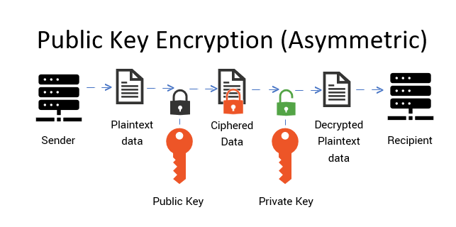
Figure 1: Asymmetric encryption diagram [10]

E.g.:
- The sender encrypts plain text with a public key (P)
- The encrypted message is sent to Receiver
- The receiver decrypts the message with a private key (K), keys are not reversible.
Asymmetric encryption may be used to share a public key with a receiver for asymmetric encryption, the receiver shares a private key, encrypted with the public key for the original sender to receive this private key for symmetric encryption.
An example of Asymmetric encryption is RSA Algorithm, invented by Rivest, Shamir and Adelman in 1978; it is based on sufficiently large prime numbers as these are difficult to solve and cannot be factorised [11].

1.2.3 Cypher Methods
There are two cypher methods: Bitstream, and block cypher methods.
A bitstream cypher is an algorithm that uses substitution techniques to encrypt each bit into cyphertext, one bit at a time [12]. A Block cypher breaks the plaintext into smaller blocks of bits (e.g., 8, 16, 32, or 64-bits), which are encrypted with an algorithm and key one block at a time [4].

1.2.3.1 Stream Cyphers
“Stream cyphers are preferred in many applications since they can destroy statistical properties of natural languages to some extent.” [13]
This means it breaks up alphabetic letter patterns visible in words, e.g., reducing the repetition of the letter ‘E’, the most frequent letter of the English language, commonly used to detect and crack a cypher.
There are several types of substitution cyphers, two of them are monoalphabetic and polyalphabetic substitution. Monoalphabetic substitution is where each letter of the alphabet is mapped to a new letter based on a single numeric key [14]. Whereas polyalphabetic substitution is a cypher
“Using multiple substitution alphabets” [14].
According to the peer-reviewed journal ‘Cryptography and Communications’, Stream cyphers are commonly used in communication channels due to their high-speed encryption and decryption capabilities [15].

Substitution Cypher
A basic example of a stream cypher is the Caesar cypher: using
“a three-position shift to the right” [4],
the new alphabet looks as below. This is a Monoalphabetic substitution.
Plaintext: | A B C D E F G H I J K L M N O P Q R S T U V W X Y Z
Substitution cypher: | D E F G H I J K L M N O P Q R S T U V W X Y Z A B C
Table 1: Caesar cypher
The word ‘Cypher’ in plain text, would read ‘FLSKHU’ in this substitution cypher.

Polyalphabetic Cypher
The following polyalphabetic cypher table shows 3 sets of substitution cyphers.
Plaintext: | A B C D E F G H I J K L M N O P Q R S T U V W X Y Z
Substitution cypher 1: | D E F G H I J K L M N O P Q R S T U V W X Y Z A B C
Substitution cypher 2: | I J K L M N O P Q R S T U V W X Y Z A B C D E F G H
Substitution cypher 3: | R S T U V W X Y Z A B C D E F G H I J K L M N O P Q
Table 2: Polyalphabetic cypher
The word ‘Cypher’ in plain text, would read ‘FQGKMI’ in this polyalphabetic substitution cypher.
This works by taking each letter of the message from the next substitution cypher; therefore, no consecutive letters are taken from the same substitution cypher.
Plain text | Substitution cypher | Encoded text
C | 1 | F
I | 2 | Q
P | 3 | G
H | 1 | K
E | 2 | M
R | 3 | I
Table 3: Polyalphabetic cypher translation
Using various substitution cyphers such as this greatly increases the complexity of the encryption, making it
“Substantially more difficult to decipher when one doesn’t have the algorithm and key.” [4]

Vigenère Cypher
The Vigenère cypher is a polyalphabetic substitution made from a series of substitution cyphers
“Based on the letters of a particular keyword.” [16]
It is much more difficult to crack without the algorithm than other substitution cyphers.

Figure 2: [16] Vigenère square, or tabula recta.
The plain text message ‘To be or not to be’ in combination with the keyword ‘PEAR’, would encode to ‘IS BV DV NFI XO ST.’
Plain text | Substitution cypher | Encoded text
T | P | I
O | E | S
B | A | B
E | R | V
O | P | D
R | E | V
N | A | N
O | R | F
T | P | I
T | E | X
O | A | O
B | R | S
E | P | T
Table 4: Vigenère square cypher translation
It is important to note the weakness of this cypher is that the cyclical key may indicate the length of the key, opening the door to cracking it as a polyalphabetic substitution cypher. In addition to this, when picking a keyword, it is suggested to select one without the letter ‘A’ as row ‘A’ reproduces the same letter as a plain text message [16] [17].

Transposition Cypher
A Transposition Cypher is a cypher where the order of the characters is changed based on an established pattern:
“It changes the position of the character, but it does not change the identity of the character.” [18]
An early example of a transposition cypher was a Scytale, used by the Spartans, where the paper was wrapped around a rod, and the message was written across the adjoining sides [19]. When the paper was removed it would be unreadable until it is wrapped around a rod of the same size [20].
One modern method of a transposition cypher is to write the plain text in rows and create the encryption from the columns [20].
To encrypt the plain text ‘The key is hidden under the big chair’, it is first arranged into rows as the below table.
1 | 2 | 3 | 4 | 5 | 6
T | H | E | K | E | Y
I | S | H | I | D | D
E | N | U | N | D | E
R | T | H | E | B | I
G | C | H | A | I | R
Table 5: Transposition cypher
It is important to remove or replace the spaces as they would reveal the size of the table used. The encrypted text would read ‘TIE RGH SNT CEH UHH KIN EAE DDB IYD EIR.’
More complex versions may use a key to mix the solution further and reduce the chance of brute force attacks. E.g., in the plain text ‘seven ate nine’, with the key ‘MATH’: the length of the key is the number of columns, and the order of the columns relate to the alphabetical structure of the key ascendingly. I.E., in the order 3rd column (M), 1st column (A), 4th column(T), 2nd column (H).
1 | 2 | 3 | 4
S | E | V | E
N | A | T | E
N | I | N | E
Table 6: Transposition cypher with a key
Using the keyword ‘MATH’, we order columns 3,1,4,2. The encrypted text now reads ‘VTNSNNEEEEAI’.

1.2.4 Issues Facing Modern Organisations and IT Systems
With current developments in COVID-19, many people are working more consistently from home, this creates additional security concerns. IT system security is vital, if a hacker enters a system, they can access any data including personal data, bank details, private keys, etc. This can be devastating for a business.
“Breaches of sensitive data expose organisations to many threats, including reputational risk, financial penalties, and other fines for non-compliance with regulations that require high levels of security to protect sensitive data” [21] [22] [23]

1.2.4.1 Working From Home
Working from home can be riskier, this is because it is likely an employee does not have the full extent of network security that an employer does. There may be hidden vulnerabilities within a network that could expose an entry point for hackers:
“With the changes in work practices brought about by the pandemic, security teams have found themselves going back to basics.” [24]
There are also additional risks of leaving a machine unattended at home, which could result in an unauthorised user unknowingly giving a hacker access via phishing or other malware such as key loggers, ransomware, trojans, worms, etc.
E.g., an employee working from home stops for their lunch break but forgets to lock their machine. A child sees a flashing banner appear and clicks it, downloading malware to the machine. This malware opens a backdoor for a hacker to breach the system and its data.

1.2.4.2 Unsecure Networks
Public networks such as café Wi-Fi networks are less secure than private home networks and pose additional risks of man-in-the-middle attacks breaching data.
From here, a hacker can spread onto the network and infect other machines, inflicting malware as they go.
“Organisations need to look at how they can reduce deliberate or inadvertent threats from insiders as working from home becomes the new normal.” [24]

1.2.4.3 Vulnerable to Man-in-the-middle
Hackers may use malicious techniques such as man-in-the-middle attacks to eavesdrop on a victim’s data transfers between IT systems [4].
As discussed, it is vital to ensure keys are protected and not shared on the same channel as communications to prevent hacks from the ability to intercept messages.
These individuals could gain personal details, bank details, event details, passwords, private keys, etc. of employees and customers. This could result in data destruction, loss, alteration, leaks, or breaches and therefore violating GDPRs, leading to large fines.
“Key changing is a modification of the public key exchanged by server and client” [25]

1.3 Physical Security
All organisations need physical security measures, organisations must judge an appropriate level of required security based on their staff, their roles, and the sensitivity of their data:
“We need to be ever vigilant and confident that the work we are doing will be regarded as a necessary operational function for the overall security and protection of the assets – to include employees, information, and property” [26]
For example, the Ministry of Defence (MOD) requires high-security measures, this is to protect their work:
- 3m tall perimeter fencing
- A lake
- 1 manned gate for pedestrians and vehicles
- Roaming guards and defence dogs
- Alarms
- ID cards/biometrics
- Metal detectors
- Mantraps
- CCTV and motion detectors
- POS states no outside devices.
- In certain roles, no recording or mobile devices to enter the building
- No cameras allowed. Mobile phones off
- No visitors are allowed within the building; they hold meetings on a separate building on site
- Various security clearance for confidentiality, new employees cannot work on private projects for several years due to information security.
- Potential employees are vetted on a trial basis before hiring
- No BYOD or personal devices


Figure 3: A Photo of MOD Bristol, behind the fence is a moat-like lake surrounding the front and sides of the building [27]
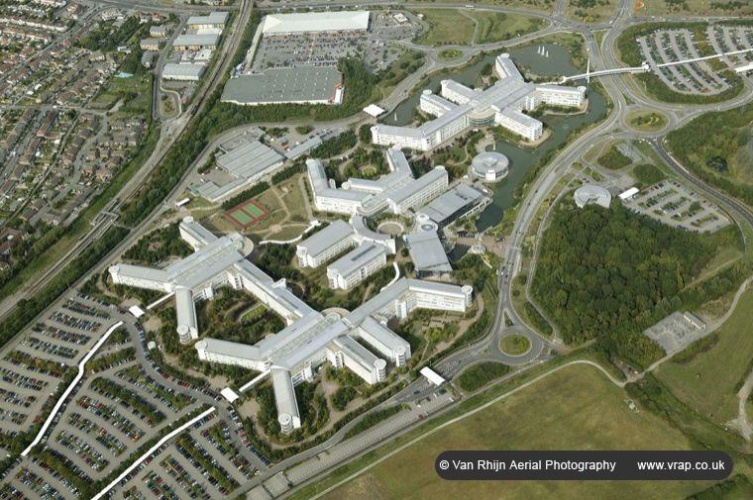
Figure 4: Aerial view of MOD Bristol. The lake surrounds the front and sides, while the back is secured by 3m fences and roaming guards [28]

Although some organisations require this level of security, most do not. Most organisations may use a gated parking system and ID badges for access to buildings and restricted areas they may choose to secure rooms with less access with a mechanical lock, and CCTV to keep a record of staff comings and goings.

1.3.1 Physical Access Controls
The most common security system used in most organisations is identification cards for staff and visitors to use. This is to ensure only staff have access to the site and their respective areas, and all visitors sign in at the reception whilst always accompanied by staff for safety purposes.
This helps identify people with unauthorised access, however, this is not enough security alone.

1.3.1.1 Walls, Fencing, and Gates
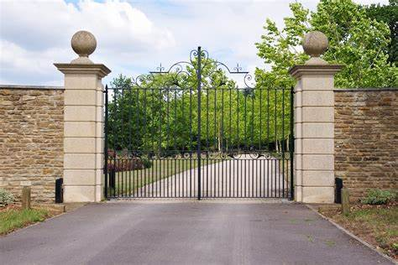
Figure 5: Large residential security gate [29]

Walls, fencing, and gates keep people out of the perimeter of the site. Organisations may choose from a range of security levels from minimal fencing to keep car parking limited to staff vehicles only, secure fencing to keep out all without authorised access, or even
“Concrete or masonry barriers designed to withstand the blast of a car bomb.” [4],
this will depend on the organisation and what is appropriate for their physical security requirements.
Gates may have proximity readers to allow staff entry with an ID card/badge, this will also track comings and goings of staff.
Unfortunately, walls, fencing, gates and lighting alone are not enough to deter a motivated and prepared criminal and therefore additional layers of security should be implemented [30].

1.3.1.2 Guards and Dogs
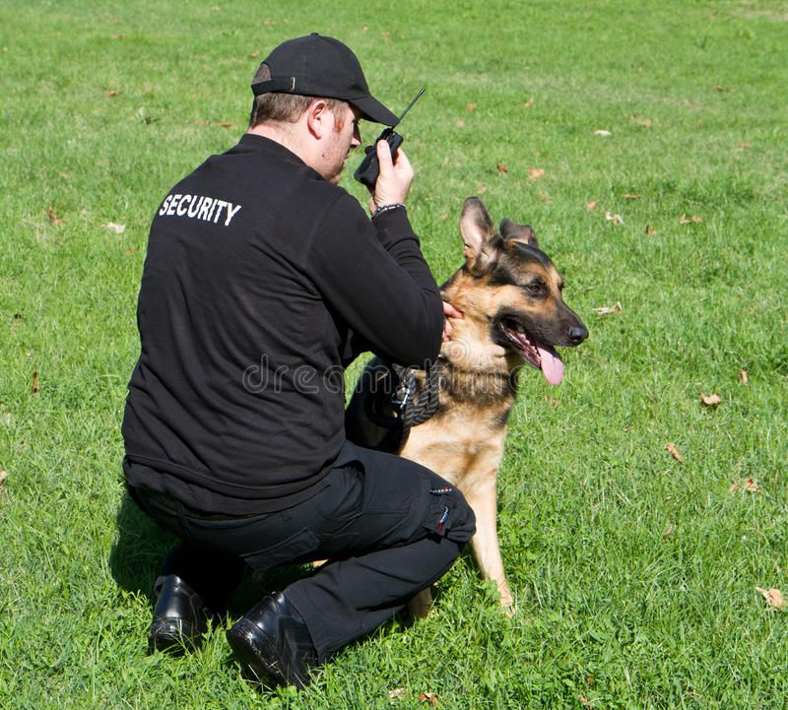
Figure 6: Guard and guard dog [31]

Guards can evaluate a situation and respond as per Standard Operating Procedures (SOP) or special orders, rather than a gate with a lock or proximity readers allowing entry to anyone with the correct key [4].
A guard can
- Check a person against their ID card if they doubt it
- Make a judgment of people’s body language and gestures to spot abnormal behaviour
- Prevent tailgating (closely following someone else and getting in on their entry)
- Etc.
However, human error/tendency must be considered and the risk of boredom and distraction [4].

Guard dogs are commonly used for businesses requiring additional protection of valuable resources. They have a heightened sense of hearing and smell that human guards do not have meaning they can identify risks that humans cannot, and
“They can be placed in harm’s way when necessary to avoid risking the life of a person.” [4]

1.3.1.3 ID Cards/Badges
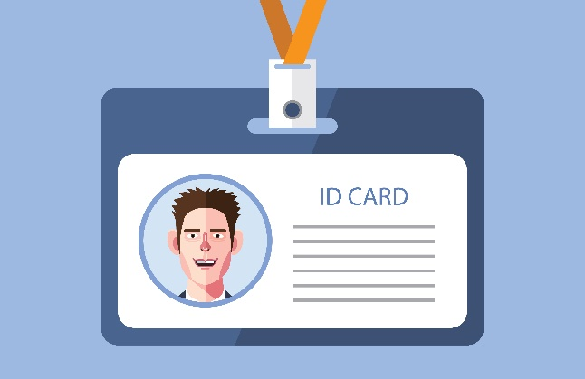
Figure 7: ID card [32]

Identification cards and badges are photo identification for staff members and their names: they are
“The most practical and commonly accepted security system for access.” [30]

They may or may not state the organisation and department name along with the building(s) they have access to.
ID cards with a magnetic strip or radio chip can also be used on proximity readers to gain access to their respective buildings and rooms, and log into equipment such as printers, vending machines, etc.
For organisations requiring more security, turnstiles or mantraps may be implemented to reduce the risk of unauthorised people accessing the building by closely following an authorised person as they enter.
There is a flaw that these chips can be replicated, stolen, or modified therefore an organisation must consider a second layer of security in addition to this.

In an evaluation of magnetic swipe cards, it was recommended to
“Use magnetic card access only in low-security areas, and use a more sophisticated and secure system such as proximity smart cards for access to high-security areas” [33],
this is because magnetic strip card access was not secure enough to prevent unauthorised access, therefore the more secure proximity smart card reader is preferred in secure areas.

1.3.1.4 Mantraps & Turnstiles
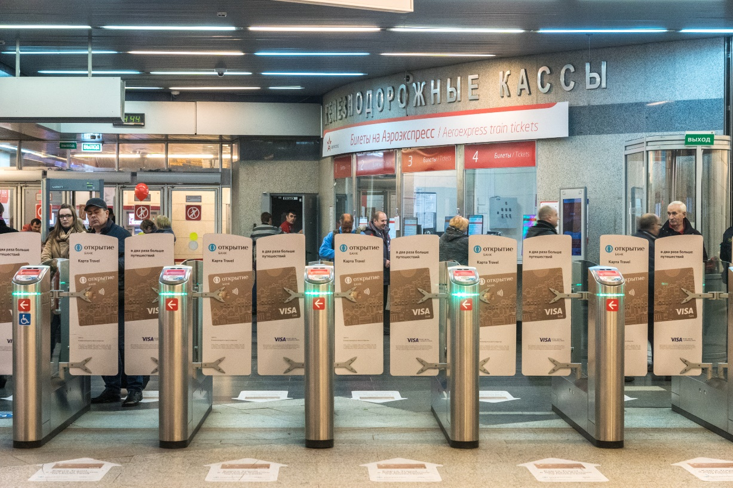
Figure 8: Common turnstiles at public transport facilities [34]

Mantraps are small rooms between two sets of doors where a person attempting to gain unlawful access can be securely held if required until the police arrive. Mantraps provide an additional layer of security usually where a guard or receptionist sits behind a barrier to allow access to staff, and call staff to meet any visitors.
“A correctly constructed mantrap will provide for tailgating detection while it allows roller luggage, briefcases, and other large parcels to pass without causing nuisance alarms.” [26]

Turnstiles will only allow one person to enter at any time, however, multiple will be required as not to bottleneck staff on entry; this can take up much floor space, become costly, and be an inconvenience for staff, therefore it’s important to consider if this is necessary for the organisation before implementing them.

1.3.1.5 CCTV, Detectors and Alarms
Alarms are used to notify people of an event, this may include fire alarm, burglar alarm, EOP alarm, carbon monoxide alarm, environmental disturbance (e.g., flood, earthquake, etc), interruption to services (e.g., power loss), etc.
Alarms such as burglar alarms rely on detectors such as
“Motion detectors, thermal detectors, glass breakage detectors, weight sensors, and contact sensors.” [4]

Detectors generally work by detecting a wave, particle stream, temperature, weight, etc., and triggering when they become broken, interrupted, or affected to a certain degree.

1.3.2 Device Safety

1.3.2.1 Kensington Lock
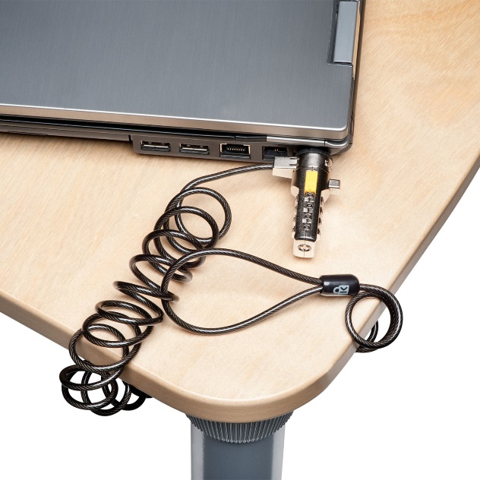
Figure 9: Kensington lock [35]

Kensington lock is a device used to secure a laptop so it cannot be stolen. It works by looping the cable around a secure location such as a table leg and locking the mechanism into the machine, this keeps portable devices attached to something permanent or heavy:
“Security is about more than saving your physical device from theft — it’s also about saving data from falling into the wrong hands, which could be far more costly than simply replacing the device” [36]

1.3.2.2 External Hard Drives
Memory sticks and other external hard drive devices make it easy to copy data onto a portable location, however, there are risks.
- Data can be lost on faulty memory sticks
- Data can be stolen, altered, copied, and shared illegally
- Introducing malware on work machines
To combat this threat, organisations have begun preventing the use of portable memory devices:
“IBM workers banned from using USB sticks.” [37]
While this may be seen as controversial by staff, this is in the organisation’s best interests.

1.3.2.3 Two-factor Authentication
“Malicious attacks against governments, companies, and individuals are more and more common. And there are no signs that the hacks, data breaches, and other forms of cybercrime are slowing down!” [38]
Two-factor authentication is the use of two steps required to log into an account, the first step is a password, and the second is a text or email numerical code, authenticator app, or one of the pre-set memorable questions. Two-step authentication is becoming the standard for organisation security.
In addition to this, most organisations now enforce all staff to change their password every 60 days to a password they have not used before.

1.3.3 Modern Organisations and Infrastructure
As discussed previously, with current developments in COVID-19 and working from home, there are new additional security risks that are very difficult to work around.

1.3.3.1 Working from Home
Employers must weigh up the risks of allowing work devices to leave the premises, or staff using their own devices to work from home. In most cases, the organisation may prefer to supply staff with work devices; this is because work devices can be equipped with more secure anti-malware and firewalls to prevent malware problems.

1.3.3.2 Theft
“The loss and theft of mobile devices is a growing risk.” [39]
Working from home means there is less security and a higher risk of theft, data theft can be very serious as discussed previously, and therefore organisations need to do everything they can to keep data secure including SOPs stating how data is to be kept secure.
Another major threat is device theft. E.g., an employee is working from home in a coffee shop and taking a break to go to the bathroom. The work laptop is left unattended at the table and is swiftly stolen.

1.4 Conclusion and Recommendations
With current developments in COVID-19, many people are working more consistently from home, this creates concerns for the physical and IT system security of personal devices at work, and work devices at home.

1.4.1 Cryptography
In agreement with the peer-reviewed Journal ‘Cryptography’,
“One way to reduce the burden on GDPR is to encrypt personal data” [23]
This can be a slow process especially if these are accessed regularly, therefore only personal data or data relating to a person's whereabouts at a certain time and place are required to be encrypted.
All communications should always be encrypted to reduce the chance of man-in-the-middle attacks and data breaches.

1.4.2 Physical Security
Physical security of the premises should incorporate various security procedures including wall, fence and gates, Guards, ID cards for use on proximity smart cards in secure areas, mantraps, and CCTV, detectors, and alarms. This combination is a good security solution as the various detectors will alert guards of potential intruders, mantraps can catch them, ID cards will allow staff access to their respective areas as well as for guards to check the ID is their own.

Task 2

Case Scenario - FlowTech

2.0 Executive Summary
FlowTech, a cyber-threat intelligence company requires a new Information Security unit.
Firstly, establishing an organisational structure and employee roles.
Secondly, appropriate policies are devised for BYOD, Compliance regulations are incorporated into SOP including GDPR, Data Protection Act 2018, Computer Misuse Act 1990, and general encryption of personal data.
Next, physical security must be maintained not only in terms of walls, guards, alarms, ID cards, etc, but also a second location for backup servers to prevent downtime, and VPNs on home and public networks to protect BYODs from eavesdroppers.
Finally, risk assessments must be maintained regularly to identify and eliminate weaknesses.
These recommendations are then listed in preparation for being incorporated into the SOPs.

2.1 Introduction
FlowTech requires a new information security unit, as part of this it is vital to assess their IT Systems and Physical security and make improvements where possible. Here is the writer of this report’s approach to meeting the needs of FlowTech’s new information security unit.

2.2 Organisation structure

Figure 10: Organisation structure
[As per Figure 10]:
- CEO oversees various managers, leaders, and their teams. This benefits FlowTech as it is a fast-paced growing company needing strong leaders to succeed.
- The chief security officer manages the IT systems, physical security, and threat intelligence departments. This benefits FlowTech as it is a fast-paced growing company needing strong communication lines between staff, management, and CEO.
  - IT infrastructure security manager leads the development in security for IT systems. This benefits FlowTech as they can create more IT infrastructure security for them and their customers and their data.
    - Malware analyst works with understanding malware. This benefits FlowTech as they can use this knowledge to better understand the threats and develop better products for their customers.
    - Cryptographer is fluent in cryptography algorithms and works with Malware Analyst. This benefits FlowTech as they can use this knowledge to better understand the threats and develop better security for their customers and themselves.
    - A software developer writes code such as cypher keys and cypher programs, and they work with Cryptographer. This benefits FlowTech as they can develop new products that are more secure for their customers and organisation.
  - The physical security manager oversees the security of the physical site. This benefits FlowTech as they can secure their servers and data adequately
    - A security guard keeps the site secure. This benefits FlowTech as they can preserve the security of their physical site. These could be external hires.
  - The threat intelligence manager oversees the threat analysis department. This benefits FlowTech as they can assess threats to prevent them for themselves and their customers.
    - Penetration tester tests for weak spots in their systems. This benefits FlowTech as they can assess the strength of their product and identify weaknesses for improvement.
    - The risk mitigation officer assesses the risks of weaknesses and the threats they process. This benefits FlowTech as they can prioritise more severe risks to be resolved first and keep themselves and their customer secure.
    - Threat prevention identifies measures to prevent threats and strengthen weaknesses. This benefits FlowTech as they can create a more secure product for themselves and their customers.
- The data protection officer advises staff on GDPR requirements and other compliance policies. This benefits FlowTech as they are a growing online company that will need good protection of their customer's data and their reputation.
[See Appendix A for more specifics on job roles]

2.3 Policies

2.3.1 Bring Your Own Devices (BYOD)
BYOD is a term used to describe when an employer allows personal devices to be used rather than be provided with one [40] [41]. BYOD would be beneficial to FlowTech as it allows ease in working remotely and saves money on equipment.
Staff can work from anywhere, these devices are mobile, and therefore will be expected to take with them to use in the office, at home, in meetings, on business trips, etc.
BYOD may require having a tracker on them so that the employer can track devices in event of loss or theft. This is important as FlowTech has a large online presence and therefore may have employees working all over the world, a tracker can be beneficial for the physical security of personal devices.
Another advantage of personal devices is that users will take additional care in these devices, therefore providing an additional layer of physical security to the data held within them.
On the other hand, there can be security risks with personal devices. Firstly, these devices may not have as rigorous security measures as a device provided by an organisation. This is because as it is standard practice to pre-install all necessary software on a provided device. It is often common that staff may not have privileges or permission to download anything else on the device; some organisations may have a secure network location where staff can download the necessary software from this library, this is to eliminate the need for staff to use potentially unsafe sites that could download malware with it.
Furthermore, staff may not fully understand the need for protection software such as firewalls, cleaners, anti-malware, etc. Staff may overlook these programs and forget to update them, or to install them at all, leaving their devices exposed.
The writer of this report recommends the use of BYODs, however with policies put into place stating necessary safety requirements for a personal device:
- Acceptable use: BYODs are used solely for work purposes, therefore any programs not vetted by the organisation are not permitted. Software must be downloaded from a secure source such as from a secure location on the network. Personal data is not permitted to be saved to the device.
- Minimum security controls: having and maintaining certain security software (anti-malware, firewalls, etc), annual health checks of devices, secure home networks including VPNs, two-factor authentication, Kensington locks at personal desks, password protected sensitive data, accounts sign user out after 7 days, sensitive data signs users out after 8 hours, etc.
- Company rights for altering the device: E.g., to wipe the device when staff leave the business, devices are lost or stolen
- If a user does not abide by these policies, they were liable for full blame in the circumstance that of a data breach.
- If a user does not wish to agree to these policies on their device, they may be provided with a device with the same policies.

2.3.2 External Hard Drives
[See 1.3.2.2] External hard drives create great risk to company data as well as device safety. Should malware be downloaded onto a machine, it can spread to all over devices on the network in seconds, therefore, as the pose great risk, the writer of this report recommends banning their use.

2.4 Compliance (Laws and Ethics)
Compliance regards various laws and regulations organisations; many of these acts are enforced by law and can induce large fines and reputation blemishes should the organisation be found liable; therefore, all organisations including FlowTech must incorporate these prevention measures into their SOPs.

2.4.1 General Data Protection Regulation (GDPR)
GDPR is a mandatory regulation of personal data protection and must be abided by all organisations [42]. In the event of a data breach, organisations may be awarded large fines and often are seen to have their publicity slashed in news reports.
[See Appendix B for a summary of some of the key requirements of GDPR]
The writer of this report recommend FlowTech implement the flowing as part of SOP:
- Data processing should be conducted for a lawful stated purpose only.
- Any changes to these purposes must require consent from the data subjects.
- Only the necessary data is to be collected and data is destroyed after the purpose has been fulfilled.
- The data subject has the right to view their held data and make amendments as required.
- The data subject can withdraw consent at any point
- Data breaches must be reported to data subjects within 72 hours of identifying the breach.
- Personal data must be encrypted, and password protected with two-factor authentication and a maximum of 8 hours before re-signing in is required.
- Data Protection Impact Assessments must be conducted when significant changes occur in the processing of data [43]
- Data transfers accountability is of the person who shares it.
- The Data Protection Officer would work with staff to enforce GDPR. They will supply staff with training on how to protect personal data, identify potential data breaches, and awareness of the severity of data breaches.

2.4.2 Data Protection Act 2018
In line with GDPR, the Data Protection Act enforces rules on safe storage, sharing, usage, and obtainment of personal data [44]
[See Appendix C for more details on the Data Protection Act 2018]
The writer of this report recommends the following to be incorporated into FlowTech SOP:
- Data transfer is done on a safe network and is encrypted
- Data should be updated regularly to uphold the accuracy of data
- Data subjects have the right to access their data at any time
- Data subjects have the right to request the destruction of their data at any time
- Data transfers accountability is of the person who shares it, and all staff are expected to maintain proper handling of data
- Personal data must be secure and encrypted.
- Data is only used as intended.

2.4.3 Computer Misuse Act 1990
Another enforced data regulation is the Computer Misuse Act; it protects machines and personal data from unauthorised access or modification [45].
The Computer Misuse Act outlines the following offences making them illegal:
- Unauthorised access to a computer system
- Unauthorised access to materials with the intent of committing further offences
- Unauthorised modification of computer materials
[46] [47]
The writer of this report recommends with good security, data/computer materials will be safer, massively reducing the risk of computer misuse. In addition to this, ‘always locking machines before walking away’ should be a standard practice, similarly to ‘never share your password.’

2.4.4 Encrypt Personal Data
[As stated in 1.2] It is important that personal data is kept secure, therefore any databases holding data relating to someone, or their physical whereabouts must be encrypted [4]. Asymmetric encryption should be used to prevent an unauthorised person from having the ability to decrypt data; the private key should only be made available to relevant staff.
Unfortunately, asymmetric encryption with its additional security will also slow down the encryption/decryption process more than symmetric encryption, therefore it is only necessary to use this on personal data.
Indirectly related data, e.g., an order of software for customer ID ScaFro039 is non-specific to their personal details, therefore don’t require as rigorous security, symmetric encryption will suffice.

2.5 Governance and Strategic Planning for Security
Governance is about abiding by compliance regulations and policies [see 2.4]; it is also about security procedures of IT systems and physical security.

2.5.1 Working from Home with VPNs
A Virtual Private Network (VPN) is a secure and encrypted network between a device and another device over the internet. We can protect our data and proceed with anonymity; this includes masking out the IP address to become untraceable. These are typically used on public networks to create a private and secure connection. Public networks without passwords make your data transactions vulnerable and at-risk to attacks from other users on the same network [48].
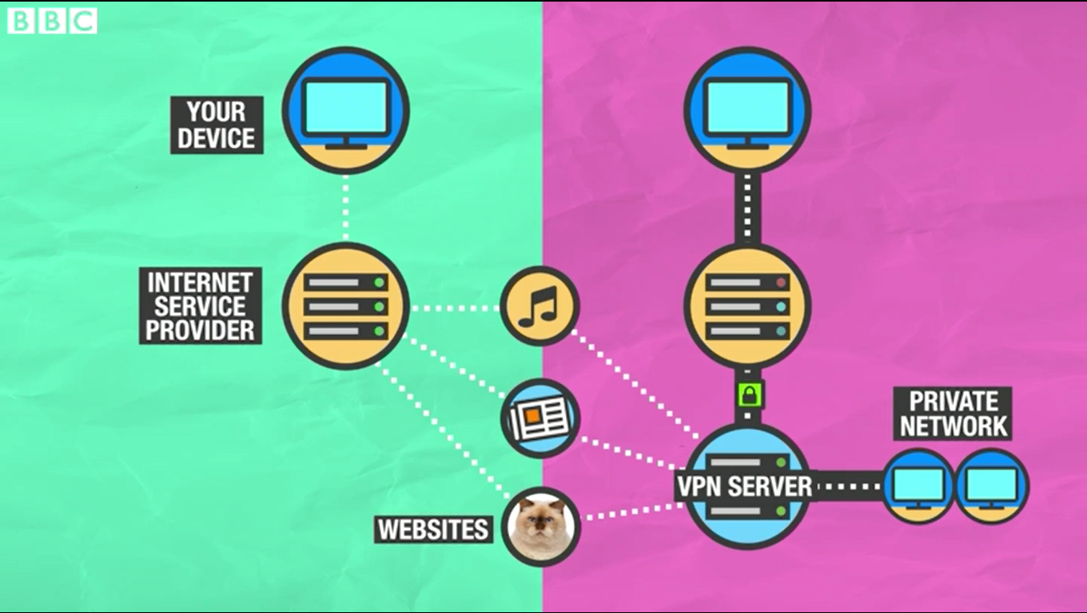
Figure 11: Standard internet use vs VPN use [49]
VPNs can be used to remotely access work systems securely, ensuring your data transmission is not intercepted by hackers’ eavesdropping.
The writer of this report recommends all staff, particularly those working remotely must have a VPN installed on their work device to protect any transactions from breaches.

2.5.2 Physical Security in the Server Room
[As stated in 1.3] Physical security is the first line of defence in protecting an organisation and its data [4]. While FlowTech may not possess the main office building, they do have a server room requiring high security to keep all their data safe, and their system online.
The writer of this report firstly recommends a backup server location in case of power failure, natural disaster or other incidents that may take the servers down.
In terms of physical security, both sites require a wall/fence and gate security with roaming guards to keep an eye out. In addition to this, sensors, and detectors such as burglar alarms, motion detectors, thermal detectors, glass breakage detectors, weight sensors, and contact sensors, will aid the guards in alerting them of potential intruders.
All doors should require an ID card, code, key, or even a guard to grant access; a combination of these would be optimal as an intruder may have one but not all. ID cards should only allow certain staff access and should not be used in secure areas as ID cards can easily be stolen, replicated, or modified. The use of ID cards should also be monitored, and any doors opened outside of standard work hours should be investigated by guards.

2.6 Risk Management
The use of regular risk reports will keep track of all risks, their probability, and their impact, and how to reduce these [50]. These will change over time therefore it is important to do regular assessments of them. Once risk reduction has been identified, the highest risk is prioritised for improvement first.

$$Risk = Probability × Severity$$
Equation 1: Risk calculation
Probability and impact/severity are rated on a scale of 1-5:
Score | Probability | Severity
1 | Very low | Negligible
2 | Low | Low
3 | Moderate | Moderate
4 | High | Severe
5 | Very high | Catastrophic
Table 7: Probability and impact/severity scoring system.
Therefore, risk scores can range from 1-25:
Score | Risk
1-5 | Low risk
6-10 | Moderate risk
11-15 | High risk
16-25 | Extreme risk
Table 8: Risk scoring
The following is an example is a risk matrix:
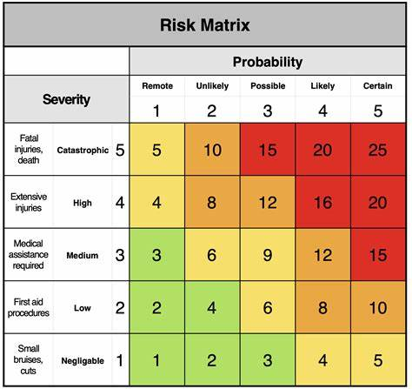
Figure 12: Example Risk matrix [51]

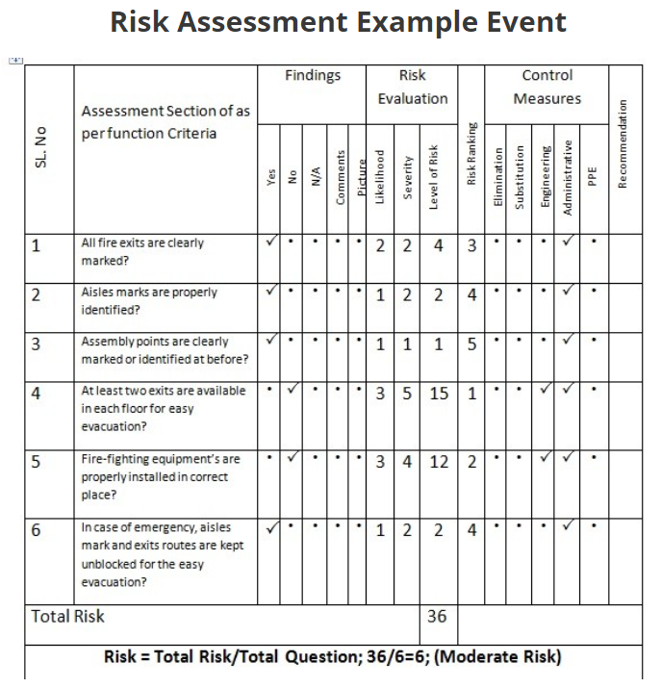
Figure 13: Example risk assessment [52]
It is the responsibility of the Risk Mitigation Officer to conduct regular risk assessments and take note of common incident reports creating policies for a safer working environment in physical and IT system security, for staff and customers.

2.7 Conclusion and Recommendations
To conclude, many rules and regulations must be abided by to succeed. The writer of this report strongly recommends that FlowTech puts the following measures into place to ensure data security from IT systems and physical attacks. Additionally, regular training is also required to educate staff on what to look out for, and how to respond.

2.7.1 IT Systems and Personal Data
- BYOD procedures:
  - BYOD is used solely for work purposes.
  - Software must be downloaded from a secure source.
  - Personal data is not permitted to be saved to the device.
  - Having and maintaining security software (anti-malware, firewalls, etc)
  - Annual health checks of devices
  - Secure home networks including VPNs on all work devices
  - Two-factor authentication
  - Kensington locks at personal desks
  - Password protected sensitive data
  - Accounts sign the user out after 7 days and sensitive data signs users out after 8 hours
  - Company rights for altering the device
  - If a user does not wish to agree to these policies on their personal device, they may be provided with a device with the same policies.
- Data protection regulations
  - Personal data must be secure and encrypted.
  - Data processing should be conducted for a lawful stated purpose only.
  - Any changes to these purposes must require consent from the data subjects.
  - Only the necessary data is to be collected and data is destroyed after the purpose has been fulfilled.
  - The data subject has the right to view their held data and make amendments as required.
  - Data should be updated regularly to uphold its accuracy
  - The data subject can withdraw consent at any point
  - Data breaches must be reported to data subjects within 72 hours of identifying the breach.
  - Personal data must be encrypted
  - Data Protection Impact Assessments must be conducted when significant changes occur in the processing of data [43]
  - Data transfers accountability is of the person who shares it, and all staff are expected to maintain proper handling of data
  - Staff training on Data protection
  - Data transfer is done on a safe network and is encrypted
  - Always locking machines before walking away
If a user does not abide by these policies, they were liable for full blame in the circumstance that of a data breach.

- Encryption
  - All personal data is encrypted
  - All communications are encrypted
  - VPNs and encrypted networks are mandatory
  - Encryption methods are evaluated and updated regularly
- No external hard drives (including USBs)

2.7.2 Physical Security
- A backup server location is required.
- Both sites require a wall/fence and gate security
- Roaming guards
- Sensors and detectors
  - Burglar alarm
  - Motion detectors
  - Thermal detectors
  - Glass breakage detectors
  - Weight sensors
  - Contact sensors
- All doors should require one of the following accesses controls and should be different depending on the security required.
  - ID card (on less secure areas)
  - Code
  - Key
  - a guard allowing access (on more secure areas)
- ID cards monitoring

2.7.3 Risk Management
- Risk assessments are updated regularly
- Incident reports are incorporated into risk assessments

With a good combination of security measures, there is less risk of data breaches, however, they always occur, usually without the organisation knowing until it is too late, the best approach is a regular assessment, good precautions, and a solid response plan.

Appendices

Appendix A – Organisation structure and roles

A.1 Senior Managers
Below the CEO, are 2 senior managers: chief consultant officer, technical officer, and chief security officer. These roles are mostly managerial, responsibilities involve supervising, advising, regular board meetings with the CEO.
The technical officer does not manage any staff, rather works with all staff with IT support and technical help, this includes but is not limited to downloading updates, fixing machines, maintaining the network, etc.
The data protection officer would enforce GDPR and other compliance regulations to protect the organisation. They would work on policies to ensure the abidance of laws and regulations as well as training staff to look out for and prevent potential breaches.
The team of consultants meet with clients to discuss their security needs and match the right solution to them.

A.2 Managers/Leaders
IT infrastructure security manager, physical security manager, threat intelligence management mostly work with staff as a team, with regular meetings regarding their employee’s, setting goals, setting deadlines, brainstorm solutions to issues, training, reviewing performance, making strategy adjustments if necessary, and admin tasks relevant to their department.

A.3 Reporting to IT Infrastructure Security Manager
This team looks at developing, testing, and maintaining software security solutions.
- Malware Analyst
  - Research current developments in malware.
  - Record malware threats.
  - Classify malware.
  - Identify methods to protect against malware.
  - Document threats and alert IT Infrastructure Security Manager of immediate issues.
  - Create security policies.
  - Educate staff on the dangers of malware and how they are attained.
  - Work with Technical Officer in the event of malware incidents.
- Cryptographer
  - Identify weaknesses in cryptography systems.
  - Penetration testing encrypted data and communications.
  - Implement more secure encryption solutions.
  - Develops cryptography techniques and measures.
- Software Developer
  - Consulting with Malware Analyst and Cryptographer.
  - Modify code for cryptography protection.
  - Bug fixing.
  - Testing and validation.
  - Document development.
  - Code maintenance.

A.4 Reporting to Physical security manager
This team maintains the sites physical security while using the physical security solutions they sell to customers.
- Security Guard (these may be hired externally)
  - Implementing secure procedures.
  - Enforcing security protocols.
  - Assessing ID card logs of room access.
  - Maintaining knowledge of the intricate workings of the physical location
  - Patrolling premises.
  - Monitoring and authorising access of people and vehicles onto the premises.
  - Mantrap/Turnstile supervision.
  - Inspecting tripped detectors and alarms.
  - Escorting unauthorised personnel and trespassers off the premises.

A.5 Reporting to Threat Intelligence Management
This team looks at identifying weaknesses in security, assesses their risks, and creates plans for reducing or removing them to prevent threats.
- Penetration Tester
  - Penetration testing and vulnerability assessing of networks
  - Develop security plans
  - Collect risk analysis data
  - Produce actionable, threat-based, reports on security testing results
  - Report imminent risks to Threat Intelligence Management
- Risk Mitigation Officer
  - Consult with Penetration Tester to evaluate risks
  - Evaluate current practices and safety measures
  - Produce risk assessments
  - Document potential threats
- Threat Prevention
  - Create reports on threat risks
  - Create prevention policies and protocols
  - Create contingency plans in preparation for breaches and other threats
  - Work with Threat Intelligence Management to bring in new safety policies

Appendix B – GDPR
A summary of some of the key requirements of GDPR:
- Lawful/fair and transparent data processing:
  - Data processing should be conducted for a lawful purpose and no other purpose.
  - “Data subjects must be informed on the processing activities of their data” [43]
- Limitation of data and storage:
  - Only the necessary data required for its purpose should be collected, no more.
  - Personal data is destroyed after the purpose has been fulfilled.
- The data subject has the right to their held data, and the right to deletion of their data.
- Should the organisation wish to use the collected data for other purposes, it must acquire consent from the data subject. The data subject can withdraw consent at any point.
- “The organisations must maintain a Personal Data Breach Register” [43]
  - data subjects must be informed of the breach within 72 hours of identifying the breach.
- Personal data must be protected with technical and organisational security methods.
- Data Protection Impact Assessments must be conducted when significant changes occur in the processing of data [43]
- Data transfers accountability is of the person who shares it, ensuring protection and abiding by GDPR.
- A Data Protection Officer would work with staff to enforce GDPR.
- Awareness and training for all employees to maintain the knowledge of how to protect personal data, identify potential data breaches, and the awareness of the severity of data breaches.

Appendix C – Data Protection Act 2018
The Data Protection Act aims to:
- Promote secure transfer of information.
- Enforce the accuracy of held data.
- Provide data subjects with the ability to access data held on themselves, and the ability to request destruction of their own held data. Giving data subjects more control over how their data is handled.
- Enforce accountability, and therefore proper handling of personal data and its security.
- Keeping personal data safe.
- Ensure no misuse of data.

Bibliography

[1] | G. Gonzalez Granadillo, M. Belhaouane and H. a. J. Debar, “RORI-based countermeasure selection using the OrBAC formalism,” International Journal of Information Security, vol. 13, no. 1, pp. 63-79, 2014.
[2] | K. Richards, “What is Cryptography? Definition from SearchSecurity,” SearchSecurity, September 2021. [Online]. Available: https://searchsecurity.techtarget.com/definition/cryptography. [Accessed 27 October 2021].
[3] | Techopedia.com, “What is an Encryption Key? - Definition from Techopedia,” Techopedia.com, 20 October 2017. [Online]. Available: http://www.techopedia.com/definition/25403/encryption-key. [Accessed 24 November 2021].
[4] | M. E. Whitman, Principles of Information Security, Sixth Edition, Boston: Cengage Learning, 2018.
[5] | E. A. e. al, “CONFISCA: An SIMD-Based Concurrent FI and SCA Countermeasure with Switchable Performance and Security Modes,” Cryptography, vol. 5, no. 2, p. 13, 2021.
[6] | tutorialspoint, “Difference between Private Key and Public Key,” tutorialspoint, [Online]. Available: https://www.tutorialspoint.com/difference-between-private-key-and-public-key. [Accessed 24 November 2021].
[7] | A. a. S. W. Calder, IT Governance : An International Guide to Data Security and ISO27001/ISO27002, London: Kogan Page, 2012.
[8] | P. M. A. C. B. e. a. Jatoi, “An Efficient Hybrid Cryptographic Algorithm, Consuming Less Time for Exchanging Information in Wireless Sensor Networks.,” Wireless Personal Communications, vol. 85, pp. 449-462, 2015.
[9] | Tutorialspoint, “What are cryptography, symmetric and public key algorithms?,” Tutorialspoint, [Online]. Available: https://www.tutorialspoint.com/what-are-cryptography-symmetric-and-public-key-algorithms. [Accessed 22 November 2021].
[10] | Cheap SSL Security, “What is Public Key and Private Key Cryptography, and How Does It Work?,” Cheap SSL Security, 22 August 2019. [Online]. Available: https://cheapsslsecurity.com/p/what-is-public-key-and-private-key-cryptography-and-how-does-it-work/. [Accessed 6 December 2021].
[11] | tutorialspoint, “Understanding RSA Algorithm,” tutorialspoint, [Online]. Available: https://www.tutorialspoint.com/cryptography_with_python/cryptography_with_python_understanding_rsa_algorithm.htm. [Accessed 1 December 2021].
[12] | J. C. Villanueva, “An Introduction to Stream Ciphers vs. Block Ciphers,” jscape, 12 May 2015. [Online]. Available: https://www.jscape.com/blog/stream-cipher-vs-block-cipher. [Accessed 27 October 2021].
[13] | W. D. C. Si, “A simple stream cipher with proven properties,” Cryptography and Communications, vol. 4, pp. 79-104, 2012.
[14] | GeeksforGeeks, “Difference between Monoalphabetic Cipher and Polyalphabetic Cipher,” GeeksforGeeks, 2 November 2020. [Online]. Available: https://www.geeksforgeeks.org/difference-between-monoalphabetic-cipher-and-polyalphabetic-cipher/. [Accessed 27 October 2021].
[15] | S. R. D. Das, “CAR30: A new scalable stream cipher with rule 30,” Cryptography and Communications , vol. 5, pp. 137-162, 2013.
[16] | P. Y. K. M. Beakal Tiliksew, “Vigenère Cipher | Brilliant Math & Science Wiki,” Brilliant.org, [Online]. Available: https://brilliant.org/wiki/vigenere-cipher/. [Accessed 1 November 2021].
[17] | PlanetCalc, “Online calculator: Vigenère cipher,” PlanetCalc, [Online]. Available: https://planetcalc.com/2468/. [Accessed 1 November 2021].
[18] | GeeksforGeeks, “Difference between Block Cipher and Transposition Cipher,” GeeksforGeeks, 22 April 2020. [Online]. Available: https://www.geeksforgeeks.org/difference-between-block-cipher-and-transposition-cipher/. [Accessed 2 November 2021].
[19] | Merriam-webster, “Definition of SCYTALE,” [Online]. Available: https://www.merriam-webster.com/dictionary/scytale. [Accessed 1 November 2021].
[20] | MathIsPower4U, “Cryptography: Transposition Cipher,” YouTube, 10 October 2013. [Online]. Available: https://www.youtube.com/watch?v=sHsnH1u03e4&t=32s. [Accessed 1 November 2021].
[21] | C. Tankard, “Encryption as the cornerstone of big data security,” network security, vol. 2017, no. 3, pp. 5-7, 2017.
[22] | B. Alabdullah, “Alabdullah, Bayan et al. “Rise of Big Data – Issues and Challenges,” 2018 21st Saudi Computer Society National Computer Conference (NCC), pp. 1-6, 2018.
[23] | Anonymous, “E-ART: A New Encryption Algorithm Based on the Reflection of Binary Search Tree,” Cryptography, vol. 5, no. 1, p. 4, 2021.
[24] | P. Chapman, “Defending against insider threats with network security's eighth layer,” Computer Fraud & Security, vol. 2021, no. 3, pp. 8-13, 2021.
[25] | M. V. O. Alberto, “Man in the middle attacks,” in Blackhat Conference, Europe, 2003.
[26] | D. J. B. P.R. Baker, The complete guide to physical security, CRC Press, 2012.
[27] | H. Pickstock, “The Ministry of Defence is looking for new staff,” Bristol Post, Bristol, 2017.
[28] | V. Rhijn, “Aerial Photograph | Ministry of Defence, Abbey Wood, Bristol | Van Rhijn Aerial Photography,” vrap, [Online]. Available: http://www.vrap.co.uk/photographs/aerial/uk/259. [Accessed 6 December 2021].
[29] | Hercules Fence, “Benefits of Residential Security Gates,” Hercules Fence, 13 October 2017. [Online]. Available: https://www.herculesfence.com/blog/residential-fences/benefits-residential-security-gates/. [Accessed 6 December 2021].
[30] | S. (. Lee, “A Basic Principle of Physical Security and Its Link to Cybersecurity,” International Journal of Cyber Criminology, vol. 14, no. 1, pp. 203-219, 2020.
[31] | Pinterest, “Security guard stock photo. Image of canine, uniform,” Pinterest, [Online]. Available: https://www.pinterest.co.uk/pin/836895543240095505/. [Accessed 6 December 2021].
[32] | J. Singh, “What a Work ID Card Consists Of,” SaveDelete, 19 November 2018. [Online]. Available: https://savedelete.com/internet-tips/what-a-work-id-card-consists-of/200017/. [Accessed 6 December 2021].
[33] | S. M. C. C. D. Ramsbrock, “Magnetic Swipe Card System Security”.
[34] | Advance Systems Access Control, “What Are The Different Types Of Turnstiles?,” Advance Systems Access Control, 26 October 2019. [Online]. Available: https://advanceaccess.ie/what-are-the-different-types-of-turnstiles/. [Accessed 6 December 2021].
[35] | digital paper, “Kensington Portable Combination Laptop Locks | dpaper,” digital paper, 22 April 2015. [Online]. Available: https://dpaper.com.my/product/kensington-portable-combination-laptop-locks-2/. [Accessed 6 December 2021].
[36] | kensington, “Laptop Locks & Security Slots: Physical Security,” kensington.com, [Online]. Available: https://www.kensington.com/solutions/product-category/security/. [Accessed 1 December 2021].
[37] | BBC News, “IBM workers banned from using USB sticks,” BBC News, 2018.
[38] | authy, “What Is Two-Factor Authentication (2FA)?,” authy, [Online]. Available: https://authy.com/what-is-2fa/. [Accessed 1 December 2021].
[39] | Z. Tu, O. Turel and Y. a. A. Yuan, “Learning to cope with information security risks regarding mobile device loss or theft: An empirical examination,” Information & Management, vol. 52, no. 4, pp. 506-517, 2015.
[40] | Y. Song, “Bring Your Own Device (BYOD)’ for seamless science inquiry in a primary school,” Computers and education, vol. 74, pp. 50-60, 2014.
[41] | Digital Guardian, “The Ultimate Guide to BYOD Security: Overcoming Challenges, Creating Effective Policies, and Mitigating Risks to Maximize Benefits,” Digital Guardian, 15 jULY 2020. [Online]. Available: https://digitalguardian.com/blog/ultimate-guide-byod-security-overcoming-challenges-creating-effective-policies-and-mitigating. [Accessed 2 December 2021].
[42] | C. L. a. J. Davies, “GDPR: Implementing the regulations,” Business information review, vol. 35, no. 2, pp. 81-83, 2018.
[43] | P. Bhatia, “GDPR summary: Overview of 10 key requirements,” advisera, [Online]. Available: https://advisera.com/eugdpracademy/knowledgebase/a-summary-of-10-key-gdpr-requirements/. [Accessed 6 December 2021].
[44] | L. Burton, “Summary of the Data Protection Act 2018 (2 Minute Read),” The Hub | High Speed Training, 2018. [Online]. Available: https://www.highspeedtraining.co.uk/hub/data-protection-act-summary/. [Accessed 6 December 2021].
[45] | A. K. G. E. N. A. Butterfield, “Computer Misuse Act 1990,” in A Dictionary of Computer Scienc, Oxford University Press, 2016.
[46] | BBC Bitesize, “Computer Misuse Act (1990) - Ethical, legal and environmental impact - CCEA - GCSE Digital Technology (CCEA) Revision,” BBC Bitesize, [Online]. Available: https://www.bbc.co.uk/bitesize/guides/z8m36yc/revision/5. [Accessed 7 December 2021].
[47] | Becta, “Computer Misuse Act (1990),” ccceducation, [Online]. Available: http://esafety.ccceducation.org/upload/file/Policy/Computer%20Misuse%20Act.pdf. [Accessed 7 December 2021].
[48] | Norton, “What is a VPN? And why you should use a VPN on public Wi-Fi,” Norton, [Online]. Available: What is a VPN? And why you should use a VPN on public Wi-Fi. [Accessed 7 December 2021].
[49] | C. Foxx, “Technology explained: What is a VPN service?,” BBC News, 18 January 2016. [Online]. Available: https://www.bbc.co.uk/news/av/technology-35328636. [Accessed 7 December 2021].
[50] | R. M. H. a. R. E. Hester, “Risk assessment and risk management,” in Cambridge: Royal Society of Chemistry, 1998.
[51] | Event know how, “Event Risk Assessment Made Easy Part 3 - Event Safety,” Event know how, 2020. [Online]. Available: https://eventknowhow.com/event-risk-assessment-made-easy-part-3/. [Accessed 7 December 2021].
[52] | safetysection, “Risk Assessment Calculation Formula,” safetysection, [Online]. Available: https://safetysection.com/risk-assessment-calculation-formula/#:~:text=Risk%20%3D%20Probability%20%28P%29%20x%20Consequence%20%28C%29%20Risk,Impact%20Likelihood%20of%20a%20risk%20event%20occurring%20%28P%29. [Accessed 7 December 2021].
[53] | M. Gupta, Information technology risk management and compliance in modern organizations, Hershey, Pennsylvania: IGI Global, 2018.
[54] | Anonymous, “Partly-Pseudo-Linear Cryptanalysis of Reduced-Round Speck,” Cryptography, vol. 5, no. 1, p. 1, 2021.
[55] | W. J. H. &. Z. D. Rajeh, “Saudi cloud infrastructure: a security analysis,” Science China Information Sciences, vol. 60, 2017.
[56] | W. C. e. al, “Compliance signaling games: toward modeling the deterrence of insider threats,” Computational and Mathematical Organization Theory, vol. 22, no. 3, pp. 318-349, 2016.
[57] | E. O. T. Fujisaki, “Secure Integration of Asymmetric and Symmetric Encryption Schemes,” Journal of Cryptography, vol. 26, pp. 80-101, 2013.
[58] | S. -J. L. H. -H. C. a. D. X. C. -H. Hsia, “Novel Hybrid Public/Private Key Cryptography Based on Perfect Gaussian Integer Sequences,” IEEE Access, vol. 9, pp. 145045-145059, 2021.
[59] | S. Bowcut, “How to Become a Malware Analyst (Updated for 2021),” Cybersecurity Guide, 4 May 2021. [Online]. Available: https://cybersecurityguide.org/careers/malware-analyst/. [Accessed 1 December 2021].

marking criteria and Student FEEDBACK

This section details the assessment criteria. The extent to which these are demonstrated by you determines your mark. The marks available for each criterion are shown. Lecturers will use the space provided to comment on the achievement of the task(s), including those areas in which you have performed well and areas that would benefit from development/improvement.

Common Assessment Criteria Applied (Assignment 1) | Marks available | Marks  awarded
1. Engagement with Literature Skills
Extent of research and/or own reading, selection of credible sources, application of appropriate referencing conventions.
Your work has demonstrated that you have done your own research which supported with relevant and appropriate sources. The recommended referencing techniques used. You have used a wide range of references, not all would deemed as credible such as Pinterest. (Grade mark: 90.00%) | 20 | 18
2. Knowledge and Understanding Skills
Extent of knowledge and understanding of concepts and underlying principles associated with the discipline.
You have appraised your research work demonstrating excellent knowledge of the well-established concepts and principles. (Grade mark: 80.00%) | 10 | 8
3. Cognitive and Intellectual Skills
Analysis, evaluation and synthesis; logic, argument and judgement; analytical reflection; organisation of ideas and evidence
You have discussed all task criteria given with reference to additional information in your appendices. Task 1 on cryptography and physical security. Task 2 discussion interrelate the case study explaining how each aspect would apply to them. Your conclusion should summarize your key areas of the report, you should not introduce any new discussion within your conclusion. (Grade mark: 84.00%) | 25 | 21
4. Practical Application Skills
Deployment of methods, materials, tools and techniques; application of concepts; formulation of innovative and creative solutions to solve problems.
Diagrams provided and discussed; Structure of new dept. VPN diagram, risk management tables and chart. (Grade mark: 88.00%) | 25 | 22
5. Transferable Skills for Life and Professional Practice
Attributes in professional practice: individual and collaborative working; deployment of appropriate media; presentation and organisation.
Your work flow very good but could do with formatting and justify alignment. You have not used the IEEE report format. Note: your reference listing should come after your conclusion and before your appendices. (Grade mark: 75.00%) | 20 | 15

Assignment Mark (Assessment marks are subject to ratification at the Exam Board. These comments and marks are to give feedback on module work and are for guidance only until they are confirmed. ) | Late Submission Penalties (tick if appropriate) |  | 84%
 | Up to four weeks late |  | 84%
 | First Attempt? |  | 84%

